UNITED STATES
SECURITIES AND EXCHANGE COMMISSION
Washington, D.C. 20549
______________________________________
FORM 10-K
______________________________________
☒ |  |  | ANNUAL REPORT PURSUANT TO SECTION 13 OR 15(d) OF THE SECURITIES EXCHANGE ACT OF 1934
For the fiscal year ended December 31, 2023
OR
☐ |  |  | TRANSITION REPORT PURSUANT TO SECTION 13 OR 15(d) OF THE SECURITIES EXCHANGE ACT OF 1934
FOR THE TRANSITION PERIOD FROM TO
Commission File Number: 001-37985
______________________________________
ANAPTYSBIO, INC.
(Exact name of registrant as specified in its charter)
______________________________________
Delaware |  |  |  |  |  | 20-3828755
(State or other jurisdiction of  incorporation or organization) |  |  |  |  |  | (I.R.S. Employer  Identification Number)

10770 Wateridge Circle, Suite 210
San Diego, CA 92121
(Address of principal executive offices and zip code)
(858) 362-6295
(Registrant’s telephone number, including area code)
______________________________________
Securities registered pursuant to Section 12(b) of the Act:
Title of each class |  |  | Trading Symbol(s) |  |  | Name of each exchange on which registered
Common Stock, $0.001 par value |  |  | ANAB |  |  | The Nasdaq Stock Market LLC
Securities registered pursuant to Section 12(g) of the Act: None
Indicate by check mark if the registrant is a well-known seasoned issuer, as defined in Rule 405 of the Securities Act. Yes ☐ No ☒
Indicate by check mark if the registrant is not required to file reports pursuant to Section 13 or Section 15(d) of the Act. Yes ☐ No ☒
Indicate by check mark whether the registrant: (1) has filed all reports required to be filed by Section 13 or 15(d) of the Securities Exchange Act of 1934 during the preceding 12 months (or for such shorter period that the registrant was required to file such reports), and (2) has been subject to such filing requirements for the past 90 days. Yes ☒ No ☐
Indicate by check mark whether the registrant has submitted electronically every Interactive Data File required to be submitted pursuant to Rule 405 of Regulation S-T (§232.405 of this chapter) during the preceding 12 months (or for such shorter period that the registrant was required to submit such files). Yes ☒ No ☐
Indicate by check mark whether the registrant is a large accelerated filer, an accelerated filer, a non-accelerated filer, a smaller reporting company, or an emerging growth company. See the definitions of “large accelerated filer,” “accelerated filer,” “smaller reporting company,” and “emerging growth company” in Rule 12b-2 of the Exchange Act.
Large Accelerated Filer |  |  |  |  |  | ☐ |  |  |  |  |  | Accelerated Filer |  |  |  |  |  | ☐
Non-accelerated Filer |  |  |  |  |  | ☒ |  |  |  |  |  | Smaller Reporting Company |  |  |  |  |  | ☒
 |  |  |  |  |  |  |  |  |  |  |  | Emerging Growth Company |  |  |  |  |  | ☐
If an emerging growth company, indicate by check mark if the registrant has elected not to use the extended transition period for complying with any new or revised financial accounting standards provided pursuant to Section 13(a) of the Exchange Act. ☐
Indicate by check mark whether the registrant has filed a report on and attestation to its management’s assessment of the effectiveness of its internal control over financial reporting under Section 404(b) of the Sarbanes-Oxley Act (15 U.S.C. 7262(b)) by the registered public accounting firm that prepared or issued its audit report. ☐

If securities are registered pursuant to Section 12(b) of the Act, indicate by check mark whether the financial statements of the registrant included in the filing reflect the correction of an error to previously issued financial statements. ☐
Indicate by check mark whether any of those error corrections are restatements that required a recovery analysis of incentive-based compensation received by any of the registrant’s executive officers during the relevant recovery period pursuant to §240.10D-1(b). ☐
Indicate by check mark whether the registrant is a shell company (as defined in Rule 12b-2 of the Exchange Act). Yes ☐ No ☒
The aggregate market value of voting common equity held by non-affiliates of the registrant was $366,560,992 as of June 30, 2023.
The number of shares of Registrant’s Common Stock outstanding was 26,763,081 as of March 5, 2024.
DOCUMENTS INCORPORATED BY REFERENCE
Portions of the registrant’s Definitive Proxy Statement relating to the 2024 Annual Meeting of Stockholders, scheduled to be held on June 12, 2024, are incorporated by reference into Part III of this Annual Report on Form 10-K to the extent stated herein. The Definitive Proxy Statement will be filed within 120 days of the Registrant’s fiscal year ended December 31, 2023. Except with respect to information specifically incorporated by reference in this Form 10-K, the Proxy Statement is not deemed to be filed as part of this Form 10-K.

TABLE OF CONTENTS

 |  |  |  |  |  |  |  |  |  |  |  | Page
PART I
Item 1. |  |  |  |  |  | Business |  |  |  |  |  | 2
Item 1A. |  |  |  |  |  | Risk Factors |  |  |  |  |  | 19
Item 1B. |  |  |  |  |  | Unresolved Staff Comments |  |  |  |  |  | 49
Item 1C. |  |  |  |  |  | Cybersecurity |  |  |  |  |  | 50
Item 2. |  |  |  |  |  | Properties |  |  |  |  |  | 50
Item 3. |  |  |  |  |  | Legal Proceedings |  |  |  |  |  | 51
Item 4. |  |  |  |  |  | Mine Safety Disclosures |  |  |  |  |  | 51
PART II
Item 5. |  |  |  |  |  | Market for Registrant’s Common Equity, Related Stockholder Matters and Issuer Purchases of Equity Securities |  |  |  |  |  | 52
Item 6. |  |  |  |  |  | Reserved |  |  |  |  |  | 52
Item 7. |  |  |  |  |  | Management’s Discussion and Analysis of Financial Condition and Results of Operations |  |  |  |  |  | 53
Item 7A. |  |  |  |  |  | Quantitative and Qualitative Disclosures About Market Risk |  |  |  |  |  | 64
Item 8. |  |  |  |  |  | Consolidated Financial Statements and Supplementary Data |  |  |  |  |  | 66
Item 9. |  |  |  |  |  | Changes in and Disagreements With Accountants on Accounting and Financial Disclosure |  |  |  |  |  | 92
Item 9A. |  |  |  |  |  | Controls and Procedures |  |  |  |  |  | 92
Item 9B. |  |  |  |  |  | Other Information |  |  |  |  |  | 92
Item 9C. |  |  |  |  |  | Disclosure Regarding Foreign Jurisdictions that Prevent Inspections |  |  |  |  |  | 93
PART III
Item 10. |  |  |  |  |  | Directors, Executive Officers and Corporate Governance |  |  |  |  |  | 93
Item 11. |  |  |  |  |  | Executive Compensation |  |  |  |  |  | 93
Item 12. |  |  |  |  |  | Security Ownership of Certain Beneficial Owners and Management and Related Stockholder Matters |  |  |  |  |  | 93
Item 13. |  |  |  |  |  | Certain Relationships and Related Transactions, and Director Independence |  |  |  |  |  | 93
Item 14. |  |  |  |  |  | Principal Accounting Fees and Services |  |  |  |  |  | 93
PART IV
Item 15. |  |  |  |  |  | Exhibits, Consolidated Financial Statement Schedules |  |  |  |  |  | 94
Item 16. |  |  |  |  |  | Form 10-K Summary |  |  |  |  |  | 97
 |  |  |  |  |  | Signatures |  |  |  |  |  | 98

SPECIAL NOTE REGARDING FORWARD-LOOKING STATEMENTS
This Annual Report on Form 10-K (“Annual Report”) contains forward-looking statements within the meaning of Section 21E of the Securities Exchange Act of 1934, as amended (the “Exchange Act”), and section 27A of the Securities Act of 1933, as amended (the “Securities Act”). The words “believe,” “may,” “will,” “potentially,” “estimate,” “continue,” “anticipate,” “intend,” “could,” “would,” “project,” “plan,” and “expect,” and similar expressions that convey uncertainty of future events or outcomes, are intended to identify forward-looking statements.
The forward-looking statements in this report include, among other things, statements about:
•the success, cost, and timing of our product candidate development activities and ongoing and planned clinical trials;
•our plans to develop and commercialize antibodies, including our two checkpoint agonists in clinical-stage development: rosnilimab and ANB032;
•our ability to develop our product candidates;
•the likelihood that the clinical data generated in any study we performed, are performing, or plan to perform in a non-U.S. jurisdiction will be subsequently accepted by the U.S. Food and Drug Administration (“FDA”) and/or by foreign regulatory authorities outside of the jurisdiction where the study was being performed;
•the potential benefits and advantages of our product candidates and approaches versus those of our competitors;
•the success of competing therapies that are or may become available;
•the timing of and the ability to obtain and maintain regulatory approvals for our product candidates, partnered product candidates and/or product candidates for which we may receive royalties;
•the rate and degree of market acceptance and clinical utility of any approved product candidates;
•the size and growth potential of the markets for any approved product candidates, and our ability to serve those markets;
•our commercialization, marketing, and manufacturing capabilities and strategy;
•our expectations regarding our ability to obtain and maintain intellectual property protection for our product candidates;
•regulatory developments in the U.S. and foreign countries;
•the impact of political, economic or public health events on our business and the United States (“U.S.”) and global economies;
•our ability to attract and retain key scientific or management personnel;
•general macro-economic factors, including volatility in equity markets, and fluctuations in interest rates and foreign exchange rates;
•our ability to obtain funding for our operations on favorable terms or at all, including funding necessary to complete further development and commercialization of our product candidates;
•our ability to find a licensing partner for imsidolimab and etokimab;
•the timing and ability of our collaborators to develop and commercialize our partnered product candidates;
•our use of the net proceeds from our public offerings and other financing transactions; and
•our estimates regarding expenses, future revenue, capital requirements, and needs for additional financing.
These forward-looking statements are subject to a number of risks, uncertainties, and assumptions, including those described in Item 1A, “Risk Factors,” and elsewhere in this Annual Report. Moreover, we operate in a competitive and rapidly changing environment, and new risks emerge from time to time. It is not possible for our management to predict all risks, nor can we assess the impact of all factors on our business or the extent to which any factor, or combination of factors, may cause actual results to differ materially from those contained in any forward-looking statements we may make. In light of these risks, uncertainties, and assumptions, the forward-looking events and circumstances discussed in this Annual Report may not occur, and actual results could differ materially and adversely from those anticipated or implied in the forward-looking statements.
You should not rely upon forward-looking statements as predictions of future events. Although we believe that the expectations reflected in the forward-looking statements are reasonable, we cannot guarantee that the future results, levels of activity, performance, or events and circumstances reflected in the forward-looking statements will be achieved or occur. We undertake no obligation to update publicly any forward-looking statements to conform these statements to actual results or to changes in our expectations, except as required by law.
You should read this Annual Report with the understanding that our actual future results, levels of activity, performance, and events and circumstances may be materially different from what we expect.
Unless the context indicates otherwise, as used in this Annual Report, the terms “AnaptysBio,” “Anaptys,” “company,” “we,” “us” and “our” refer to AnaptysBio, Inc., a Delaware corporation, and its subsidiaries taken as a whole, unless otherwise noted. AnaptysBio is our common law trademark. This Annual Report contains additional trade names, trademarks, and service marks of other companies, which are the property of their respective owners. We do not intend our use or display of other companies’ trade names, trademarks, or service marks to imply a relationship with, or endorsement or sponsorship of us by, these other companies.

1

PART I

Item 1. Business
Overview
We are a clinical-stage biotechnology company focused on delivering innovative immunology therapeutics. We are developing immune cell modulating antibodies, including two wholly owned checkpoint agonists in clinical-stage development, for autoimmune and inflammatory diseases: rosnilimab, our PD-1 agonist in a Phase 2b trial for the treatment of moderate-to-severe rheumatoid arthritis (“RA”) and a Phase 2 trial for the treatment of moderate-to-severe ulcerative colitis (“UC”); and ANB032, our BTLA agonist, in a Phase 2b trial for the treatment of moderate-to-severe atopic dermatitis (“AD”). We also have other preclinical immune cell modulator candidates for the treatment of autoimmune and inflammatory diseases in our portfolio, including ANB033, an anti-CD122 antagonist antibody, and ANB101, a BDCA2 modulator antibody. In addition, we have developed two cytokine antagonists that we are exploring options for out-licensing: imsidolimab, our anti-IL-36R antibody, in Phase 3 development for the treatment of generalized pustular psoriasis (“GPP”), and etokimab, our anti-IL-33 antagonist that is Phase 2/3 ready. We have also discovered multiple therapeutic antibodies licensed to GlaxoSmithKline, Inc. (“GSK”) in a financial collaboration for immuno-oncology, including an anti-PD-1 antagonist antibody (Jemperli (dostarlimab-gxly)) and an anti-TIM-3 antagonist antibody (cobolimab, GSK4069889). We currently recognize revenue from milestones and royalties achieved under our immuno-oncology collaboration with GSK.
Our Wholly Owned Product Candidate Pipeline
Our immune cell modulating antibodies, including checkpoint agonists for PD-1 and BTLA, treat inflammatory disorders by down regulating immune responses mediated by multiple immune cell types including T cells, B cells, and dendritic cells. T cells require both antigen presentation to the T cell receptor and co-stimulation to be activated. When these interactions are inhibited, T cells can’t be effectively primed to expand and differentiate into inflammatory T cells. Inhibition of at least one of these signals is the basis of checkpoint agonism.
We believe these molecules have potential applicability across a broad range of autoimmune and inflammatory diseases, including dermatology, rheumatology, gastroenterology, respiratory, and neurology therapeutic areas.
Rosnilimab
PD-1, or programmed cell death protein 1, is an inhibitory checkpoint receptor that regulates T cell proliferation, and cytokine secretion. It is expressed preferentially on activated T cells, reducing the potential for off-target activity by rosnilimab. Genetic mutations in the PD-1 pathway are known to be associated with increased susceptibility to human inflammatory diseases which leads us to believe that rosnilimab is applicable to diseases where PD-1 checkpoint receptor function may be insufficient to maintain immune homeostasis.
Rosnilimab is an IgG1 antibody that directly targets PD-1+ T cells, resulting in their agonism or depletion, broadly impacting pathogenic drivers of autoimmune and inflammatory diseases. An IgG1 PD-1 agonist acts through three distinct mechanisms: depletion of PD-1high effector T cells, depletion of PD-1high Tfh and Tph cells, and agonism of PD-1int T cells. This drives specific immunological outcomes in both inflamed tissue and the periphery, such as reduction in T cell proliferation, migration, and cytokine secretion, and reduction of plasma cell generation and autoantibody levels. Rosnilimab is designed to enable formation of a tight immune synapse by binding to the PD-1 checkpoint receptor on a membrane-proximal epitope, and simultaneously anchoring to an Fc receptor, on an opposing cell, supporting crosslinking and excluding activating phosphatases such as CD45. Rosnilimab also facilitates depletion by bringing effector cells into closer proximity to pathogenically activated PD-1high T cells.
In in vitro studies, when PD-1+ T cells were cocultured in the presence of NK cells, rosnilimab demonstrated potent depletion of PD-1+ T cells. In separate in vitro studies, in which T cells were stimulated in the presence of only dendritic cells (in the absence of any cells capable of mediating depletion), rosnilimab demonstrated potent agonism properties such as a reduction in PD-1+T cell proliferation and reduction in secretion of inflammatory cytokines.
We announced positive top-line data from a healthy volunteer Phase 1 trial of rosnilimab in November 2021. A total of 144 subjects were enrolled in the randomized, double-blind, placebo-controlled healthy volunteer Phase 1 trial, where single ascending dose (“SAD”) cohorts received subcutaneous or intravenous (“IV”) single doses of rosnilimab up to 600mg or placebo, while multiple ascending dose (“MAD”) cohorts received four weekly subcutaneous doses of rosnilimab ranging up to 400mg or placebo. Rosnilimab was generally well-tolerated and no dose limiting toxicities were observed. Two serious adverse events (“SAEs”) were reported in single dose cohorts, including obstructive pancreatitis in a placebo-dosed subject and COVID-19 infection in a rosnilimab-dosed subject leading to discontinuation. The COVID-19 infection was deemed unrelated to treatment. No SAEs were reported in subjects receiving multiple doses of rosnilimab or placebo.
2

Rosnilimab demonstrated a favorable pharmacokinetic (“PK”) profile with an estimated two-week half-life for subcutaneous and IV routes of administration. Full PD-1 receptor occupancy was observed rapidly and was maintained for at least 30 days. Potent and sustained reduction was observed in peripheral PD-1+ T cells for >30 days, including >90% reduction of PD-1high T cells and a >50% reduction of PD-1+ T cells bringing the overall T cell composition to a less activated state, without meaningfully reducing overall T cell numbers.
We also completed a randomized placebo-controlled 45-patient Phase 2 trial assessing a single 400mg monthly dose of rosnilimab over six months in moderate-to-severe alopecia areata patients. In January 2023, we reported interim results of blinded data which suggested that sufficient improvement in the severity of alopecia tool (SALT) endpoint necessary to justify further development in alopecia was not achieved. Furthermore, we reported safety and pharmacodynamics data suggesting that rosnilimab was generally well tolerated, with no dose limiting toxicities observed and no SAEs reported.
We are conducting a randomized placebo-controlled 420-patient global Phase 2b trial assessing three dose levels of subcutaneously administrated rosnilimab in moderate-to-severe RA for up to 28 weeks on well-established endpoints including ACR20/50/70 and DAS28-CRP. We anticipate reporting top-line data on the primary endpoint in the RA trial by mid 2025. We are also conducting a randomized placebo-controlled 130-patient, global Phase 2 trial assessing two dose levels of subcutaneously administered rosnilimab in moderate-to-severe UC for up to 24 weeks on well-established endpoints including clinical remission on the modified Mayo score (“mMS”), clinical response on the mMS and endoscopic remission. We anticipate reporting top-line data on the primary endpoint in the UC trial in the first half of 2026.
ANB032
BTLA, or B and T lymphocyte attenuator, is an inhibitory checkpoint receptor that regulates T cells, B cells, and dendritic cell (“DC”) function. BTLA is expressed only on immune cells and preferentially on activated immune cells, potentially enabling a broad mechanism of action while avoiding off-target activity.
ANB032 is a non-depleting antibody that binds to BTLA, and is anticipated to down-modulate the activity of T cells, B cells and dendritic cells both in inflamed tissue and the periphery via: agonism resulting in inhibition of T cell expansion and migration, broad reduction of inflammatory Th1, Th2, Th17 and Th22 cytokines, and modulation of dendritic cells including inhibition of dendritic cell maturation, reduction in costimulatory molecule expression, and enhanced inducement of Tregs.
In in vitro studies, ANB032 demonstrated potent agonism and, in a murine model of GvHD, demonstrated superior disease-modification compared to control antibodies.
We announced positive top-line data from a healthy volunteer Phase 1 trial of ANB032, under a CTN, in April 2022. A total of 96 subjects were enrolled in the randomized, double-blind, placebo-controlled healthy volunteer Phase 1 trial, where SAD cohorts received subcutaneous or IV single doses of ANB032 or placebo, while MAD cohorts received four weekly subcutaneous doses of ANB032 or placebo. ANB032 was generally well-tolerated and no dose limiting toxicities were observed. No SAEs were reported. ANB032 demonstrated a favorable PK profile with an estimated two-week half-life for subcutaneous and IV routes of administration. Full BTLA receptor occupancy was observed rapidly and was maintained for at least 30 days.
While Th2 targeted therapies provide benefit to patients with chronic moderate-to-severe atopic dermatitis (AD), there is compelling evidence that AD is broader than a Th2 driven disease, as Th1, Th17, Th22 and other cell types, including dendritic cells, contribute significantly to the pathogenesis. ANB032 inhibition of inflammatory Th1, Th2, Th17 and Th22 activity, and modulation of additional cell types such as B cells and dendritic cells, creates the potential for broader, deeper and more durable responses than more narrowly targeted interventions.
We are conducting a randomized placebo-controlled 160 patient global Phase 2b trial assessing three dose levels of subcutaneously administered ANB032 in moderate-to-severe AD for 12 weeks on well-established endpoints including EASI75 and IGA 0/1 measured at week 14. Patients will then be followed for an additional 24 weeks after the final dose at week 12 to understand longer term safety as well as the potential for prolonged and sustained efficacy. We anticipate reporting top-line data on the primary endpoint from this trial by the end of 2024.
ANB033
ANB033 targets CD122, the common beta subunit shared by the IL-15 and IL-2 receptors. IL-15 and IL-2 signaling mediate the proliferation and survival of NK cells and certain CD8 T cell subsets. ANB033 is an antibody designed with an affinity to CD122 that inhibits IL-15 and IL-2 signaling through the low affinity IL-2 receptor (comprised of CD122 and the common gamma subunit, CD132) while sparing IL-2 signaling through the high affinity IL-2 receptor (comprised of CD122, CD132 and the alpha receptor subunit for IL-2, CD25) expressed by regulatory T cells. This leads to the potential to achieve and maintain remission of inflammation through the reduction of disease-causing NK cells and certain CD8 T cell subsets, while sparing regulatory T cells. By preventing the consumption of IL-2 by pathogenic cells that express the low affinity IL-2 receptor, circulating levels of IL-2 may increase, potentially enhancing regulatory T cell numbers that express the high affinity
3

IL-2 receptor in the setting of inflammation. We anticipate submitting an IND for a Phase 1 clinical trial with ANB033 during the second quarter of 2024.
ANB101
Blood dendritic cell antigen 2 (“BDCA2”) is a molecule specifically expressed on plasmacytoid dendritic cells (pDCs), a class of immune cells which, while found in relatively small numbers in healthy patients, are enriched in patients with a variety of inflammatory diseases, that is critical to the regulation of toll-like receptor signaling and interferon secretion. pDCs are a key upstream node in the inflammatory cascade that serve as a bridge between innate and adaptive immunity. They have been shown to be prolific secretors of type I interferons, which drive activation of a variety of downstream cell types including T cells and monocytes. Together with their ability to present antigens to the adaptive immune system, this creates a pro-inflammatory environment for the establishment and perpetuation of autoimmune pathology. BDCA2 has been implicated in the pathophysiology of systemic lupus erythematosus (SLE), where there exists mechanistic clinical proof of concept for pDC modulation. ANB101 is a BDCA2 modulator antibody that targets pDCs and potently inhibits interferon secretion and modulates antigen presentation for the treatment of autoimmune and inflammatory diseases. We anticipate submitting an IND for a Phase 1 clinical trial with ANB101 during the second half of 2024.
Imsidolimab
Imsidolimab is an IgG4 antibody that inhibits the function of the interleukin-36-receptor, or IL-36R, that is being developed for the treatment of GPP. We completed a Phase 1 clinical trial in healthy volunteers, which was presented at the European Academy of Allergy and Clinical Immunology in 2018, where imsidolimab was well-tolerated, no dose-limiting toxicities were observed, and no SAEs were reported. In July 2020, the FDA granted Orphan Drug Designation for imsidolimab for the treatment of patients with GPP.
We initiated two Phase 3 clinical trials for imsidolimab in GPP. We successfully completed the first randomized placebo-controlled trial, called GEMINI-1, in 45 patients, assessing two, single dose levels of IV-administered imsidolimab. As of October 2023, of the patients who received a single dose of 750mg IV imsidolimab, 53.3% achieved Generalized Pustular Psoriasis Physician Global Assessment (GPPPGA) 0/1 (clear or almost clear) at Week 4, our primary endpoint, compared to 13.3% of patients on placebo (p=0.0131). The GPPPGA assessment, representing a stringent and comprehensive characterization of disease severity, required satisfying an overall clinical response score of 0/1 (clear or almost clear) collectively across each GPP disease attribute, including pustulation, erythema and scaling. Imsidolimab demonstrated favorable safety, tolerability, and immunogenicity with no elevation of infection risk compared to placebo, no serious adverse events, and only 1 of 30 patients treated with imsidolimab generating anti-drug antibodies over the course of the study.
Patients completing the GEMINI-1 trial were eligible to be subsequently enrolled in GEMINI-2, our second Phase 3 trial for imsidolimab in GPP, where they receive monthly doses of 200mg subcutaneous imsidolimab or placebo depending upon whether they are responders, partial responders or non-responders to treatment under GEMINI-1. Additionally, 66.7% (10/15) of placebo patients exited GEMINI-1 early, crossed-over to GEMINI-2 and were eligible to receive rescue therapy with a single dose of 750mg IV imsidolimab. The objective of GEMINI-2 is to assess the long-term safety of imsidolimab through 3 years of monthly dosing, as well as assess the efficacy of imsidolimab to reduce the incidence or severity of recurrent flares of GPP.
We intend to out-license imsidolimab in 2024.
Etokimab
Etokimab inhibits IL-33 function and acts upstream of key cell types involved in atopy and the subsequent release of Th2 cytokines. IL-33 is a pro-inflammatory cytokine that signals through the ST2 receptor, which multiple studies suggest serves as a central mediator of various immune responses leading to Th2-type inflammatory disorders, including asthma, COPD, atopic and other epithelial-driven diseases. Individuals with asthma symptoms express higher levels of IL-33 than healthy control subjects. IL-33 initiates a diverse array of cellular immune responses, including the activation of mast cells, basophils and eosinophils, leading to production of downstream cytokines, such as IL-4, IL-5 and IL-13, which are associated with atopic diseases. IL-33 also acts on Th2 effector cells and Innate Lymphoid Cell Type 2 (ILC2), two types of white blood cells that initiate and orchestrate atopic responses.
We have no ongoing clinical trials of etokimab and etokimab is available to out-license.
Collaborative Programs
Multiple Company-discovered antibody programs have been advanced to preclinical and clinical milestones under our collaborations. Our collaborations include an immuno-oncology-focused collaboration with GSK.
Under the GSK Agreement, a Biologics License Application (“BLA”) for our most advanced partnered program, which is an anti-PD-1 antagonist antibody called Jemperli (dostarlimab), was approved by the FDA in April 2021 for the treatment of advanced or recurrent deficient mismatch repair endometrial cancer (dMMREC). In February 2023, the FDA granted full
4

approval for this indication (from an accelerated approval). In addition, in April 2021 the European Medicines Agency (“EMA”) granted conditional marketing authorization in the European Union (“EU”) for Jemperli for use in women with mismatch repair deficient (dMMR)/microsatellite instability-high (MSI-H) recurrent or advanced endometrial cancer who have progressed on or following prior treatment with a platinum containing regimen. A second FDA approval was received in August 2021 for Jemperli in pan-deficient mismatch repair tumors (PdMMRT). In July 2023, the FDA approved Jemperli in combination with chemotherapy for the treatment of adult patients with mismatch repair deficient (dMMR)/microsatellite instability-high (MSI-H) primary advanced or recurrent endometrial cancer. In December 2023, the EMA approved, in the EU, Jemperli plus chemotherapy for dMMR/MSI-H primary advanced or recurrent endometrial cancer.
Jemperli is in clinical trials for various solid tumor indications, including a Phase 3 trial in first-line ovarian cancer with top-line results expected in the first half of 2024.
In addition, under the collaboration, GSK is developing dostarlimab in combination with another development program from the GSK Agreement, including cobolimab, an anti-TIM-3 antibody. GSK is conducting a Phase 3 trial, COSTAR Lung, which is a randomized, open label 3-arm trial comparing cobolimab plus dostarlimab plus docetaxel to dostarlimab plus docetaxel to docetaxel alone in patients with advanced non-small-cell lung cancer (“NSCLC”) who have progressed on prior anti-PD-(L)1 therapy and chemotherapy with top-line results expected in the second half of 2024.
Our Product Candidates
The following table summarizes certain key information about our wholly-owned product candidates:
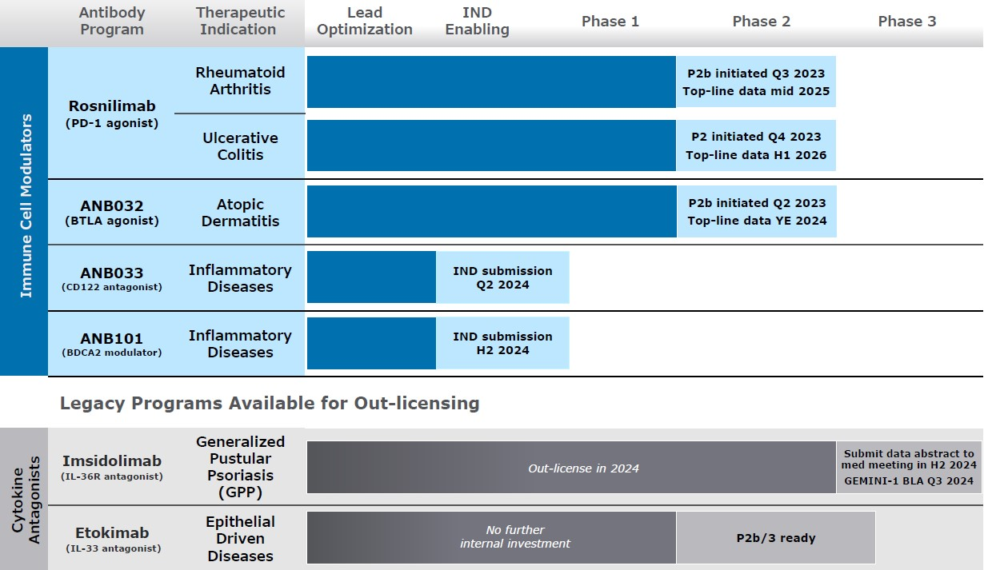
Our Strategy
We are a clinical-stage biotechnology company focused on delivering innovative immunology therapeutics. Our immune cell modulating antibodies modulate key nodes governing the body’s regulation of autoimmunity and inflammation. Dysregulated immune responses may result in abnormal and pathological inflammation in diseases with large and substantially underserved patient populations in the therapeutic areas of dermatology, rheumatology, gastroenterology, respiratory and neurology. The key elements of our strategy include:
•Enabling broad development of our immune cell modulator portfolio, including our checkpoint agonist programs, rosnilimab and ANB032, in indications including moderate-to-severe RA, UC and AD.
•Generating in vitro and in vivo translational and clinical data to characterize the differentiation of our molecules from in-class competitors and, relative to standard of care, treat patient populations most likely to have deeper and/or more durable responses by restoring immune balance.
5

•Facilitating the global commercialization of our checkpoint agonists while retaining rights in key therapeutic areas and/or commercial markets to enable us to become a fully integrated discovery, development and commercial organization.
•Continuing to leverage our research expertise to generate potentially best-in-class antibodies against high-value immunological targets.
•Maximizing return on equity through execution against a multi-year capital and operating plan, including the potential for future royalty revenues from our GSK immuno-oncology collaboration and, where actionable, monetizing our legacy cytokine antagonist programs and enabling further external development and, potentially, commercialization.
As described in the section titled “Risk Factors” and elsewhere in this report, the clinical development of drug product candidates is subject to a wide range of risks and uncertainties, any of which could cause our actual development strategy or timeframes to vary.
Antibody Overview
Antibodies are complex proteins naturally generated by the immune system to neutralize foreign pathogens such as bacteria or viruses. B cells, a white blood cell type responsible for the generation of antibodies in response to pathogens, secrete billions of antibodies with different specificities into the bloodstream. Antibodies are structurally distinct Y-shaped proteins formed through the combination of two long proteins, called heavy chains, and two short proteins, called light chains. Each heavy and light chain pair forms a binding site where the antibody specifically binds its target, otherwise known as an antigen, at the Fab domain of the antibody molecule. The specificity of each antibody to a target, and the potency of its binding strength to that target are defined by the amino acid sequences of heavy and light chains in the Fab domain of the antibody molecule. The other end of the antibody, called the Fc domain, is responsible for communication between the antibody and the rest of the immune system.
Therapeutic antibodies are typically non-naturally occurring, or recombinant, antibodies specifically developed to treat human diseases by binding to certain proteins, and thereby modulating key biological processes. Therapeutic antibodies are injectable products that are typically dosed subcutaneously or intravenously, unlike synthetic chemistry-based “small molecule” therapeutics that may also be administered orally. Therapeutic antibodies have the following key features that we believe make them more predictable than small molecules:
•Fab Domain. Due to the relatively large size and complex nature of the antibody Fab domain, antibodies generally bind with high specificity to the desired therapeutic target and tend to exhibit less off-target binding to unrelated proteins, which lowers the risk of unintended biological side effects such as toxicity. Because target proteins are typically larger than antibody Fab domains, antibodies can be generated against a variety of specific binding epitopes on a given single protein, which can alter the functional activity of the protein. For example, antibodies binding to unique epitopes on a single target protein can act as antagonists or agonists of the natural target protein function.
•Fc Domain. The Fc domain of an antibody is the tail region that interacts with cell surface receptors called Fc receptors and some proteins of the complement system. In humans, there are five Fc domains referred to as isotypes (IgA, IgD, IgM, IgG, IgE) and numerous Fc receptors expressed on specialized immune cells. Many therapeutic antibodies are subtypes of the IgG isotype and are chosen specifically to limit or induce immune system activity for therapeutic purposes. Engagement of Fc domains by specific Fc receptors can modulate biological activity, for example, by clustering the target protein on the cell surface in an immune synapse, leading to modulation of the target protein activity and hence altering the function of the cell expressing the target protein. Specific Fc domain and Fc receptor interactions may also trigger killing of a cell, often referred to as “effector function” of the antibody, via cytotoxic mechanisms depending on the cell type bearing the Fc receptor. In some therapeutic settings, mutations can be made to the Fc domain to weaken or entirely abrogate Fc receptor interactions. In creating the most efficacious therapeutic antibody, an appropriate Fc domain is often utilized to avoid or induce immune system activity that contributes to its broader mechanism of action. We believe that therapeutic antibodies can be significantly de-risked preclinically for specificity, toxicology, pharmacokinetics, and modulation of immune system activity, which is not generally true for small molecule drugs.
•Pharmacokinetics and Dosing Frequency. As complex proteins, antibodies are metabolized and distributed differently than small molecules. Full length antibodies tend to exhibit serum half-lives of seven to 24 days in humans, leading to bi-weekly or monthly dosing as typical practice for therapeutic antibodies.
•Potency and Dose Quantities. Antibodies are typically highly potent in binding affinity to their desired target, with binding dissociation constants in the low nanomolar to picomolar range. Hence, antibodies tend to be dosed at low amounts (less than 1 gram quantities per course of therapy).
6

Our approach to antibody design focuses on discovering and optimizing therapeutic antibodies tailored to modulate immune function. We use a variety of technologies to optimize the Fab domain of an antibody in ways that we believe both create a therapeutic antibody with highly potent functional activity and mitigate potential manufacturing liabilities.
We also optimize the Fc domain of the antibody, when needed, to tailor it for specific activity such as reducing Fc receptor interactions or optimizing Fc receptor interactions, in combination with the Fab domain of the antibody, to specifically modulate immune cell function, engage effector function that kills specific targeted immune cells, or leverage a combination of both activities. We further optimize the overall antibody through humanization and removal of liabilities that could potentially affect the structure, stability, pharmacology, manufacturability or immunogenicity of the antibody.
Optimized antibodies are tested in an extensive suite of immune cell assays, using engineered cell lines, and more relevantly, primary human immune cells from healthy and diseased individuals that we believe most accurately recapitulate the conditions in which the antibody will need to have optimal activity in patients.
We believe that our approach to antibody design allows us to effectively tailor antibody discovery to achieve a unique therapeutic benefit.
Collaborations
GlaxoSmithKline
In March 2014, we entered into a Collaboration and Exclusive License Agreement with GSK (the “GSK Agreement”) with TESARO, Inc. (“Tesaro”), an oncology-focused biopharmaceutical company now a part of GlaxoSmithKline (Tesaro and GlaxoSmithKline are hereinafter referred to, collectively, as “GSK”). Under the terms of the GSK Agreement, as amended, we agreed to perform certain discovery and early preclinical development of therapeutic antibodies with the goal of generating immunotherapy antibodies for subsequent preclinical, clinical, regulatory, and commercial development to be performed by GSK. Under the terms of the GSK Agreement, GSK agreed to provide funding to us for research and development services related to antibody discovery programs for three specific targets. Currently, under the GSK Agreement, GSK is developing Jemperli (dostarlimab), an anti-PD-1 antagonist antibody, as a monotherapy for various solid tumor indications. In addition, GSK is developing dostarlimab in combination with additional therapies under the collaboration, including with another development program from the GSK Agreement: cobolimab, an anti-TIM-3 antibody, in 2L NSCLC. In October 2023, Amendment No. 5 to the GSK Agreement was agreed by both parties to terminate the anti-LAG-3 antagonist antibody development program under the GSK Agreement. In accordance with the GSK Agreement and this amendment, we have regained full global rights to the anti-LAG-3 antagonist antibody development program.
For each remaining development program under the GSK Agreement, we are eligible to receive milestone payments if certain preclinical and clinical trial events are achieved by GSK, if certain U.S. and European regulatory submissions and approvals in multiple indications are achieved, and upon the achievement of specified levels of annual worldwide net sales. We will also be eligible to receive tiered 4-8% royalties related to worldwide net sales of products developed under the collaboration. On October 23, 2020, Amendment No. 3 to the GSK Agreement (the “Amendment”) was agreed to by both parties to permit GSK to conduct development and commercialization in combination with any third-party molecules of Zejula, an oral, once-daily poly (ADP-ribose) polymerase (PARP) inhibitor. Under the Amendment, we were granted increased royalties upon sales of Jemperli, equal to 8% of Net Sales (as defined in the GSK Agreement) below $1.0 billion and from 12% up to 25% of Net Sales above $1.0 billion.
In October 2021, we signed a royalty monetization agreement (the “Jemperli Royalty Monetization Agreement”) with Sagard Healthcare Royalty Partners, LP (“Sagard”). Under the terms of the Jemperli Royalty Monetization Agreement, we received $250.0 million, upon closing in December 2021, in exchange for royalties payable to us under the GSK collaboration on annual global net sales of Jemperli below $1.0 billion, as well as certain milestone payments, starting in October 2021. The aggregate Jemperli royalties and certain future milestones to be received by Sagard under the Jemperli Royalty Monetization Agreement are capped at certain fixed multiples of the upfront payment based on time. For more information see Note 5 — Sale of Future Royalties in the accompanying notes to the consolidated financial statements.
The GSK Agreement, as amended, expires when no further payments are due to us, unless earlier terminated. Either party may terminate the GSK Agreement, as amended, in the event of an uncured material breach by the other party. GSK may terminate the GSK Agreement, as amended, at any time upon 90 days’ prior written notice to us.
Intellectual Property
Our intellectual property is critical to our business and we strive to protect it, including by obtaining and maintaining patent protection in the United States and internationally for product candidates, novel biological discoveries, epitopes, new therapeutic approaches and potential indications, and other inventions that are important to our business. In total, our patent portfolio, including patents co-owned with GSK, patents licensed from Centessa Pharmaceuticals (UK) Ltd., and patents to
7

certain antibody discovery technology consisted of approximately 93 issued patents and 103 pending patent applications as of December 31, 2023.
For our product candidates, generally we initially pursue patent protection covering compositions of matter including antibody sequences, methods of use, and methods of production. Throughout the development of our product candidates, we seek to identify additional means of obtaining patent protection that would potentially enhance commercial success.
The patent portfolios for our internal programs are outlined below:
Rosnilimab
As of December 31, 2023, we owned 16 patent applications in various countries directed to the antibody sequence of rosnilimab and its variants, methods of use and related matters. We intend to prosecute our pending applications, and/or other patent applications claiming priority thereto, and pursue patent issuance and protection in key commercial markets where significant product sales may occur. Patents that may issue from or claim priority to our pending applications could provide protection for aspects of this product candidate until June 2040.
ANB032
As of December 31, 2023, we owned 16 patent applications in various countries, one international (PCT) patent application and one U.S. provisional patent application directed to the antibody sequence of ANB032 and its variants, methods of use and related matters. We intend to prosecute the pending patent applications, and/or other patent applications claiming priority thereto, and pursue patent issuance and protection in key commercial markets where significant product sales may occur. Patents that may issue from or claim priority to our pending applications could provide protection for aspects of this product candidate until May 2044.
ANB033
As of December 31, 2023, we owned one international (PCT) patent application directed to the antibody sequence of ANB033 and its variants, methods of use and related matters. We intend to prosecute the pending international (PCT) patent application, file additional patent applications claiming priority to the international (PCT) patent application, and pursue patent issuance, in key commercial markets where significant product sales may occur. Patents that may issue claiming priority to our international (PCT) patent application could provide protection for aspects of this product candidate until November 2043.
ANB101/102
As of December 31, 2023, we owned rights to 13 patent applications in various countries directed to the antibody sequence of ANB101/102 and their variants, methods of use and related matters. We intend to prosecute the pending applications, and/or other patent applications claiming priority thereto, and pursue patent issuance and protection in key commercial markets where significant product sales may occur. Patents that may issue from or claim priority to the pending applications could provide protection for aspects of these product candidates until August 2040.
Imsidolimab
As of December 31, 2023, we owned 51 patents and patent applications in various countries directed to the antibody sequence of imsidolimab and its variants, methods of use and related matters. We intend to prosecute our pending applications, and/or other patent applications claiming priority thereto, and pursue patent issuance and protection in key commercial markets where significant product sales may occur. Patents that have issued, or that may issue from or claim priority to our pending applications could provide protection for aspects of this product candidate until May 2042.
Etokimab
As of December 31, 2022, we owned 18 patents and patent applications in various countries directed to the antibody sequence of etokimab and its variants, methods of use and related matters. We intend to prosecute our pending applications, and/or other patent applications claiming priority thereto, and pursue patent issuance and protection in key commercial markets where significant product sales may occur. Patents that have issued, or that may issue from or claim priority to our pending applications could provide protection for aspects of this product candidate until January 2035.
Dostarlimab (GSK4057190)
As of December 31, 2023, we owned or co-owned 24 patents and patent applications in various countries directed to the antibody sequence of GSK4057190 (dostarlimab), an anti-PD-1 antagonist, and its variants, methods of use and related matters. We intend to prosecute our pending applications, and/or other patent applications claiming priority thereto, and pursue patent
8

issuance and protection in key commercial markets where significant product sales may occur. Patents that have issued, or that may issue from or claim priority to our pending applications, could provide protection for aspects of this product until June 2038.
Cobolimab (GSK4069889)
As of December 31, 2023, we owned or co-owned 24 patents and patent applications in various countries directed to the antibody sequence of GSK4069889 (cobolimab), an anti-TIM-3 antagonist, and its variants, methods of use and related matters. We intend to prosecute our pending applications, and/or other patent applications claiming priority thereto, and pursue patent issuance and protection in key commercial markets where significant product sales may occur. Patents that have issued, or that may issue from or claim priority to our pending applications, could provide protection for aspects of this product candidate until November 2037.
Other Intellectual Property Matters
The patent positions of biotechnology companies like ours are generally uncertain and involve complex legal, scientific and factual questions. In addition, the coverage claimed in a patent application can be significantly reduced before the patent is issued, and its scope can be reinterpreted after issuance. Consequently, we may not obtain or maintain adequate patent protection for any of our product candidates. We cannot predict whether the patent applications we are currently pursuing will issue as patents in any particular jurisdiction or whether the claims of any issued patents will provide sufficient proprietary protection from competitors. Any patents that we hold may be challenged, circumvented or invalidated by third parties. For a more comprehensive discussion of the risks related to our intellectual property, please see “Risk Factors— Risks Related to Our Intellectual Property.”
The term of individual patents depends upon the legal term of the patents in the countries in which they are obtained. In most countries in which we file, the patent term is 20 years from the earliest date of filing a non-provisional patent application related to the patent. A U.S. patent also may be accorded a patent term adjustment (“PTA”) under certain circumstances to compensate for delays in obtaining the patent from the U.S. Patent and Trademark Office (“USPTO”). In some instances, such a PTA may result in a U.S. patent term extending beyond 20 years from the earliest date of filing a non-provisional patent application related to the U.S. patent. In addition, the term of a U.S. patent that covers an FDA-approved drug may also be eligible for patent term extension, which permits patent term restoration as compensation for the patent term lost during the FDA regulatory review process. The Hatch-Waxman Act permits a patent term extension of up to five years beyond the expiration of the patent. The length of the patent term extension is related to the length of time the drug is under regulatory review. Patent term extension cannot extend the remaining term of a patent beyond a total of 14 years from the date of product approval and only one patent applicable to an approved drug may be extended. Similar provisions are available in Europe and other foreign jurisdictions to extend the term of a patent that covers an approved drug. In the future, if and when our products receive FDA approval, we expect to apply for patent term extensions on patents covering those products. We plan to seek patent term extensions to any of our issued patents in any jurisdiction where these are available, however there is no guarantee that the applicable authorities, including the FDA in the United States, will agree with our assessment of whether such extensions should be granted, and if granted, the length of such extensions.
We also rely on trade secrets relating to our research and development and product candidates and seek to protect and maintain the confidentiality of proprietary information to protect aspects of our business that are not amenable to, or that we do not consider appropriate for, patent protection. Although we take steps to protect our proprietary information and trade secrets, including through contractual means with our employees and consultants, third parties may independently develop substantially equivalent proprietary information and techniques or otherwise gain access to our trade secrets or disclose our technology. Thus, we may not be able to meaningfully protect our trade secrets.
It is our policy to require our employees, consultants, outside scientific collaborators, sponsored researchers and other advisors to execute confidentiality agreements upon the commencement of employment or consulting relationships with us. These agreements provide that all confidential information concerning our business or financial affairs developed or made known to the individual during the course of the individual’s relationship with us is to be kept confidential and not disclosed to third parties except in specific circumstances. Our agreements with employees also provide that all inventions conceived by the employee in the course of employment with us or from the employee’s use of our confidential information are our exclusive property.
Manufacturing
We must manufacture our product candidates for clinical trial use in compliance with current good manufacturing practices (“cGMP”). The cGMP regulations include requirements relating to organization of personnel, buildings and facilities, equipment, control of materials, components and drug product containers and closures, production and process controls, packaging and labeling controls, holding and distribution, laboratory controls, records and reports, and returned or salvaged
9

products. The manufacturing facilities for our product candidates must meet cGMP requirements and global regulatory requirements before any product is approved and we can manufacture commercial products. Our third-party manufacturers will be subject to periodic regulatory inspections of facilities by the FDA and other authorities, including procedures and operations used in the testing and manufacture of our products to assess compliance with applicable regulations.
Our internal manufacturing capabilities include non-cGMP antibody and reagent production using small scale quantities for characterization and in vitro and in vivo preclinical assessment of product candidates. We do not have and we do not currently plan to acquire or develop the facilities or capabilities to manufacture our product candidates for use in human clinical trials.
We rely on third-party manufacturers to generate cGMP compliant cell lines and will rely on them to produce cGMP drug substance and drug product required for our clinical trials, and we expect to continue to rely on third parties to manufacture clinical trial drug supplies for the foreseeable future. We also contract with additional third parties for the testing, labeling, packaging, storage and distribution of investigational drug products. We have personnel with significant technical, manufacturing, analytical, quality, including cGMP, and project management experience to oversee our third-party manufacturers and to manage manufacturing and quality data and information for regulatory compliance purposes. While our contract manufacturers have not yet produced commercially-approved cGMP batches of our product candidates, they have previously manufactured products for other companies in compliance with cGMP and have been previously inspected by regulatory authorities for compliance with cGMP standards.
Failure to comply with statutory and regulatory requirements subjects a manufacturer to possible legal or regulatory action, including warning letters, the seizure or recall of products, injunctions, consent decrees placing significant restrictions on or suspending manufacturing operations and civil and criminal penalties. These actions could have a material impact on the availability of our products. Third-party manufacturers often encounter difficulties involving production yields, quality control and quality assurance, as well as shortages of qualified personnel.
Competition
The biotechnology and pharmaceutical industries are characterized by continuing technological advancement and significant competition. While we believe that our product candidates, technology, knowledge, experience and scientific resources provide us with competitive advantages, we face competition from major pharmaceutical and biotechnology companies, academic institutions, governmental agencies and public and private research institutions, among others. Any product candidates that we successfully develop and commercialize will compete with existing therapies and new therapies that may become available in the future. Key product features that would affect our ability to effectively compete with other therapeutics include the efficacy, safety and convenience of our products and the ease of use and effectiveness of any companion diagnostics. The level of generic competition and the availability of reimbursement from government and other third-party payors will also significantly affect the pricing and competitiveness of our products. Our competitors also may obtain FDA or other regulatory approval for their products more rapidly than we may obtain approval for ours, which could result in our competitors establishing a strong market position before we are able to enter the market.
Many of the companies against which we may compete have significantly greater financial resources and expertise in research and development, manufacturing, preclinical testing, conducting clinical trials, obtaining regulatory approvals and marketing approved products than we do. Smaller or early-stage companies may also prove to be significant competitors, particularly through collaborative arrangements with large and established companies. These competitors also compete with us in recruiting and retaining qualified scientific and management personnel and establishing clinical trial sites and patient registration for clinical trials, as well as in acquiring technologies complementary to, or necessary for, our programs.
Specifically, there are several companies developing or marketing treatments that may be approved for the same indications and/or diseases as our product candidates, including major pharmaceutical companies.
For our PD-1 agonist antibody program, our competitors include other PD-1 agonist antibodies peresolimab (Eli Lilly) in Phase 2b development for the treatment of rheumatoid arthritis, JNJ-67484703 (Janssen) in Phase 2 development for the treatment of atopic dermatitis, a PD-1 agonist antibody (Boehringer Ingelheim) in Phase 1 development, and GS-0151 (Gilead) in preclinical development. Our commercial-stage competitors in moderate-to-severe rheumatoid arthritis include monoclonal antibodies targeting anti-TNF (Humira; Abbvie), IL-6 (Actemra; Roche and Kevzara; Regeneron), CD-80/86 (Orencia; BMS), CD-20 (Rituxan; Roche), and janus kinase inhibitors (Rinvoq; AbbVie, Olumiant; Eli Lilly, and Xeljanz; Pfizer). Commercial-stage competitors in moderate-to-severe ulcerative colitis include monoclonal antibodies targeting anti-TNF (Humira; Abbvie and Remicade; Johnson & Johnson), anti-α4β7 (Entyvio; Takeda), anti-IL-23 (Stelara; Johnson & Johnson and Omvoh; Eli Lilly) and S1P inhibitors (Zeposia; Bristol Myers Squibb and Velsipity; Pfizer) and janus kinase inhibitors (Rinvoq; AbbVie, and Xeljanz; Pfizer) as well as monoclonal antibodies targeting anti-TL1A (PRA023; Merck, RVT-3101; Roche and TEV’574; Teva/Sanofi) in Phase 2 and 3 development.
10

For our BTLA agonist antibody program, our competitors include another BTLA agonist antibody, GS-0272 (Gilead) in Phase 1b development for SLE and rheumatoid arthritis. Commercial-stage competitors in moderate-to-severe atopic dermatitis include topical and oral corticosteroids, calcineurin inhibitors (Protopic; LEO Pharma and Elidel; Bausch Health), monoclonal antibodies targeting IL-4/13 (Dupixent; Regeneron/Sanofi), IL-13 (Adbry; LEO Pharma and Ebglyss; Lilly), IL-31 (nemolizumab; Galderma) and janus kinase inhibitors (Rinvoq; AbbVie and abrocitinib; Pfizer) as well as monoclonal antibodies targeting OX-40/OX40L (rocatinlimab; Amgen and amlitelimab; Sanofi) in Phase 3 development.
For our anti-CD122 antagonist antibody program, our clinical competitors include other anti-CD122 antagonist antibodies, auremolimab (Incyte), in Phase 1 development for vitiligo and FB-102 (Forte Bioscience) in preclinical development, and three anti-IL-15 monoclonal antibodies, AMG 714 (Amgen), currently in Phase 2 development for the treatment of vitiligo, CALY-002 (Calypso, which Novartis has agreed to acquire), currently in Phase 1b development for the treatment of celiac disease and eosinophilic esophagitis, and TEV-‘408 (Teva), currently in Phase 1b development for the treatment of celiac disease.
For our anti-BDCA2 program, our competitors include one other anti-BDCA2 antibody, litifilimab (Biogen) in Phase 3 development for SLE and CLE, and one clinical-stage anti-ILT7 antibodies that target plasmacytoid dendritic cells for depletion, daxdilimab (Amgen) in Phase 2 development for alopecia areata, dermatomyositis or anti-synthetase inflammatory myositis, and discoid lupus erythematosus.
For imsidolimab in the treatment of GPP, our competitors include one other anti-IL-36 receptor antibody called SPEVIGO or spesolimab (Boehringer Ingelheim), approved for GPP flares in adults.
Government Regulation and Product Approval
Government authorities in the United States, at the federal, state and local level, and in other countries and jurisdictions, including the EU, extensively regulate, among other things, the research, development, testing, manufacture, quality control, approval, packaging, storage, recordkeeping, labeling, advertising, promotion, distribution, marketing, post-approval monitoring and reporting, and import and export of pharmaceutical products. The processes for obtaining regulatory approvals in the United States and in foreign countries and jurisdictions, along with subsequent compliance with applicable statutes and regulations and other regulatory authorities, require the expenditure of substantial time and financial resources.
FDA approval process
In the United States, pharmaceutical products are subject to extensive regulation by the FDA. The Federal Food, Drug, and Cosmetic Act (“FDC Act”), and other federal and state statutes and regulations, govern, among other things, the research, development, testing, manufacture, storage, recordkeeping, approval, labeling, promotion and marketing, distribution, post-approval monitoring and reporting, sampling, and import and export of pharmaceutical products. Biological products used for the prevention, treatment, or cure of a disease or condition of a human being are subject to regulation under the FDC Act, except the section of the FDC Act which governs the approval of new drug applications (“NDAs”). Biological products are approved for marketing under provisions of the Public Health Service Act (“PHSA”), via a BLA. However, the application process and requirements for approval of BLAs are similar to those for NDAs, and biologics are associated with similar approval risks and costs as drugs. Failure to comply with applicable U.S. requirements may subject a company to a variety of administrative or judicial sanctions, such as clinical hold, FDA refusal to approve pending NDAs or BLAs, warning or untitled letters, product recalls, product seizures, total or partial suspension of production or distribution, injunctions, fines, civil penalties, and criminal prosecution.
Biological product development for a new product or certain changes to an approved product in the United States typically involves preclinical laboratory and animal tests, the submission to the FDA of an investigational new drug application (“IND”), which must become effective before clinical testing may commence in the United States, and adequate and well-controlled clinical trials to establish the safety and effectiveness of the drug for each indication for which FDA approval is sought. Satisfaction of FDA premarket approval requirements typically takes many years and the actual time required may vary substantially based upon the type, complexity, and novelty of the product or disease.
Preclinical tests include laboratory evaluation of product chemistry, formulation, and toxicity, as well as animal trials to assess the characteristics and potential safety and efficacy of the product. The conduct of the preclinical tests must comply with federal regulations and requirements, including good laboratory practices (“GLPs”). The results of preclinical testing are submitted to the FDA as part of an IND along with other information, including information about product chemistry, manufacturing and controls, and a proposed clinical trial protocol. Long term preclinical tests, such as animal tests of reproductive toxicity and carcinogenicity, may continue after the IND is submitted. A 30-day waiting period after the submission of each IND is required prior to the commencement of clinical testing in humans. If the FDA has neither commented on nor questioned the IND within this 30-day period, the clinical trial proposed in the IND may begin. Clinical trials involve the administration of the investigational biologic to healthy volunteers or patients under the supervision of a qualified investigator. Clinical trials must be conducted: (i) in compliance with federal regulations; (ii) in compliance with good
11

clinical practices (“GCPs”), an international standard meant to protect the rights and health of patients and to define the roles of clinical trial sponsors, administrators, and monitors; as well as (iii) under protocols detailing the objectives of the trial, the parameters to be used in monitoring safety, and the effectiveness criteria to be evaluated. Each protocol involving testing on U.S. patients and subsequent protocol amendments must be submitted to the FDA as part of the IND.
The FDA may order the temporary, or permanent, discontinuation of a clinical trial at any time, or impose other sanctions if it believes that the clinical trial either is not being conducted in accordance with FDA requirements or presents an unacceptable risk to the clinical trial patients. The trial protocol and informed consent information for patients in clinical trials must also be submitted to an institutional review board (“IRB”) for approval. An IRB may also require the clinical trial at the site to be halted, either temporarily or permanently, for failure to comply with the IRB’s requirements, or may impose other conditions.
Clinical trials to support BLAs for marketing approval are typically conducted in three sequential phases, but the phases may overlap. In Phase 1, the initial introduction of the biologic into healthy human subjects or patients, the product is tested to assess metabolism, pharmacokinetics, pharmacological actions, side effects associated with increasing doses, and, if possible, early evidence on effectiveness. Phase 2 usually involves clinical trials in a limited patient population to determine the effectiveness of the drug or biologic for a particular indication, dosage tolerance, and optimal dosage, and to identify common adverse effects and safety risks. If a compound demonstrates evidence of effectiveness and an acceptable safety profile in Phase 2 evaluations, Phase 3 clinical trials are undertaken to obtain the additional information about clinical efficacy and safety in a larger number of patients, typically at geographically dispersed clinical trial sites, to permit the FDA to evaluate the overall benefit risk relationship of the drug or biologic and to provide adequate information for the labeling of the product. In most cases, the FDA requires two adequate and well-controlled Phase 3 clinical trials to demonstrate the efficacy of the biologic. A single Phase 3 clinical trial may be sufficient in rare instances, including (i) where the clinical trial is a large multicenter clinical trial demonstrating internal consistency and a statistically persuasive finding of a clinically meaningful effect on mortality, irreversible morbidity or prevention of a disease with a potentially serious outcome and confirmation of the result in a second clinical trial would be practically or ethically impossible or (ii) when in conjunction with other confirmatory evidence.
After completion of the required clinical testing, a BLA is prepared and submitted to the FDA. FDA approval of the BLA is required before marketing of the product may begin in the United States. The BLA must include the results of all preclinical, clinical, and other testing and a compilation of data relating to the product’s pharmacology, chemistry, manufacture, and controls. The cost of preparing and submitting a BLA is substantial. The submission of most BLAs is additionally subject to a substantial application user fee, and the applicant under an approved BLA is also subject to annual product and establishment user fees. These fees are typically increased annually. The FDA has 60 days from its receipt of a BLA to determine whether the application will be accepted for filing based on the agency’s threshold determination that it is sufficiently complete to permit substantive review. Once the submission is filed, the FDA begins an in-depth review. The FDA has agreed to certain performance goals in the review of BLAs. Most such applications for standard review biologic products are reviewed within 10 months of the date the BLA is filed with the FDA; most applications for priority review biologics are reviewed within six months of the date the BLA is filed with the FDA. Priority review can be applied to a biologic that the FDA determines has the potential to treat a serious or life-threatening condition and, if approved, would be a significant improvement in safety or effectiveness compared to available therapies. The review process for both standard and priority review may be extended by the FDA for three additional months to consider certain late-submitted information or information intended to clarify information already provided in the submission.
The FDA may also refer applications for novel biologic products, or biologic products that present difficult questions of safety or efficacy, to an advisory committee—typically a panel that includes clinicians and other experts—for review, evaluation, and a recommendation as to whether the application should be approved. The FDA is not bound by the recommendation of an advisory committee, but it generally follows such recommendations. Before approving a BLA, the FDA will typically inspect one or more clinical sites to assure compliance with GCP. Additionally, the FDA will inspect the facility or the facilities at which the biologic product is manufactured. The FDA will not approve the product unless compliance with cGMP is satisfactory and the BLA contains data that provide substantial evidence that the biologic is safe, pure, potent and effective in the indication studied.
After the FDA evaluates the BLA and the manufacturing facilities, it issues either an approval letter or a complete response letter. A complete response letter generally outlines the deficiencies in the submission and may require substantial additional testing, or information, in order for the FDA to reconsider the application. If, or when, those deficiencies have been addressed to the FDA’s satisfaction in a resubmission of the BLA, the FDA will issue an approval letter. The FDA has committed to reviewing such resubmissions in two or six months depending on the type of information included. An approval letter authorizes commercial marketing of the biologic with specific prescribing information for specific indications. As a condition of BLA approval, the FDA may require a risk evaluation and mitigation strategy (“REMS”) to help ensure that the benefits of the biologic outweigh the potential risks. REMS can include medication guides, communication plans for health care professionals, and elements to assure safe use (“ETASU”). ETASU can include, but are not limited to, special training or
12

certification for prescribing or dispensing, dispensing only under certain circumstances, special monitoring, and the use of patient registries. The requirement for a REMS can materially affect the potential market and profitability of the product. Moreover, product approval may require substantial post-approval testing and surveillance to monitor the product’s safety or efficacy.
Once granted, product approvals may be withdrawn if compliance with regulatory standards is not maintained or problems are identified following initial marketing. Changes to some of the conditions established in an approved application, including changes in indications, labeling, or manufacturing processes or facilities, require submission and FDA approval of a new BLA or BLA supplement before the change can be implemented. A BLA supplement for a new indication typically requires clinical data similar to that in the original application, and the FDA uses the same procedures and actions in reviewing BLA supplements as it does in reviewing BLAs.
Foreign clinical studies to support an IND
The FDA will accept as support for an IND a well-designed, well-conducted, non-IND foreign clinical study if it was conducted in accordance with GCP and the FDA is able to validate the data from the study through an onsite inspection, if necessary. A sponsor or applicant who wishes to rely on a non-IND foreign clinical study to support an IND must submit the following supporting information to the FDA to demonstrate that the study conformed to GCP:
•the investigator’s qualifications;
•a description of the research facilities;
•a detailed summary of the protocol and study results and, if requested, case records or additional background data;
•a description of the drug substance and drug product, including the components, formulation, specifications, and, if available, the bioavailability of the drug product;
•information showing that the study is adequate and well controlled;
•the name and address of the independent ethics committee that reviewed the study and a statement that the independent ethics committee meets the required definition;
•a summary of the independent ethics committee’s decision to approve or modify and approve the study, or to provide a favorable opinion;
•a description of how informed consent was obtained;
•a description of what incentives, if any, were provided to subjects to participate;
•a description of how the sponsors monitored the study and ensured that the study was consistent with the protocol;
•a description of how investigators were trained to comply with GCP and to conduct the study in accordance with the study protocol; and
•a statement on whether written commitments by investigators to comply with GCP and the protocol were obtained.
Disclosure of clinical trial information
Sponsors of clinical trials of FDA-regulated products, including biological products, are required to register and disclose certain clinical trial information. Information related to the product, patient population, phase of investigation, trial sites and investigators, and other aspects of the clinical trial is then made public as part of the registration. Sponsors are also obligated to discuss the results of their clinical trials after completion. Disclosure of the results of these clinical trials can be delayed in certain circumstances for up to two years after the date of completion of the clinical trial. Competitors may use this publicly available information to gain knowledge regarding the progress of development programs.
Pediatric information
Under the Pediatric Research Equity Act (“PREA”), NDAs or BLAs or supplements to NDAs or BLAs must contain data to assess the safety and effectiveness of the biological product for the claimed indications in all relevant pediatric subpopulations and to support dosing and administration for each pediatric subpopulation for which the biological product is safe and effective. The FDA may grant full or partial waivers, or deferrals, for submission of data. Unless otherwise required by regulation, the PREA does not apply to any biological product for an indication for which Orphan Drug Designation has been granted.
The Best Pharmaceuticals for Children Act (“BPCA”) provides sponsors of NDAs with an additional six-month period of market exclusivity for all unexpired patent or non-patent exclusivity on all forms of the drug containing the active moiety if
13

the sponsor submits results of pediatric studies specifically requested by the FDA under BPCA within required timeframes. The BPCA provides sponsors of BLAs an additional six-month extension for all unexpired non-patent market exclusivity on all forms of the biological containing the active moiety pursuant to the BPCA if the conditions under the BPCA are met.
Additional controls for biologics
To help reduce the increased risk of the introduction of adventitious agents, the PHSA emphasizes the importance of manufacturing controls for products whose attributes cannot be precisely defined. The PHSA also provides authority to the FDA to immediately suspend licenses in situations where there exists a danger to public health, to prepare or procure products in the event of shortages and critical public health needs, and to authorize the creation and enforcement of regulations to prevent the introduction or spread of communicable diseases in the United States and between states.
After a BLA is approved, the product may also be subject to official lot release as a condition of approval. As part of the manufacturing process, the manufacturer is required to perform certain tests on each lot of the product before it is released for distribution. If the product is subject to official release by the FDA, the manufacturer submits samples of each lot of product to the FDA together with a release protocol showing a summary of the history of manufacture of the lot and the results of all of the manufacturer’s tests performed on the lot. The FDA may also perform certain confirmatory tests on lots of some products, such as viral vaccines, before releasing the lots for distribution by the manufacturer.
In addition, the FDA conducts laboratory research related to the regulatory standards on the safety, purity, potency, and effectiveness of biological products. As with drugs, after approval of biologics, manufacturers must address any safety issues that arise, are subject to recalls or a halt in manufacturing, and are subject to periodic inspection after approval.
Patent term restoration
After approval, owners of relevant drug or biologic patents may apply for up to a five year patent extension. The allowable patent term extension is calculated as half of the drug’s testing phase—the time between IND application and NDA or BLA submission—and all of the review phase—the time between NDA or BLA submission and approval up to a maximum of five years. The time can be shortened if FDA determines that the applicant did not pursue approval with due diligence. The total patent term after the extension may not exceed 14 years from the date of marketing approval.
For patents that might expire during the application phase, the patent owner may request an interim patent extension. An interim patent extension increases the patent term by one year and may be renewed up to four times. For each interim patent extension granted, the post-approval patent extension is reduced by one year. The director of the USPTO must determine that approval of the drug covered by the patent for which a patent extension is being sought is likely. Interim patent extensions are not available for a drug or biologic for which an NDA or BLA has not been submitted.
Biosimilars
The Biologics Price Competition and Innovation Act of 2009 (“BPCIA”) created an abbreviated approval pathway for biological products shown to be highly similar to or interchangeable with an FDA licensed reference biological product. Biosimilarity sufficient to reference a prior FDA-approved product requires that there be no differences in conditions of use, route of administration, dosage form, and strength, and no clinically meaningful differences between the biological product and the reference product in terms of safety, purity, and potency. Biosimilarity must be shown through analytical trials, animal trials, and a clinical trial or trials, unless the Secretary of the U.S. Department of Health and Human Services (“HHS”) waives a required element. A biosimilar product may be deemed interchangeable with a prior approved product if it meets the higher hurdle of demonstrating that it can be expected to produce the same clinical results as the reference product and, for products administered multiple times, the biologic and the reference biologic may be switched after one has been previously administered without increasing safety risks or risks of diminished efficacy relative to exclusive use of the reference biologic. The first biosimilar was approved by the FDA in 2015, and the first interchangeable product was approved in 2021.
A reference biologic is granted 12 years of exclusivity from the time of first licensure of the reference product, and no application for a biosimilar can be submitted for four years from the date of licensure of the reference product. The first biologic product submitted under the abbreviated approval pathway that is determined to be interchangeable with the reference product has exclusivity against a finding of interchangeability for other biologics for the same condition of use for the lesser of (i) one year after first commercial marketing of the first interchangeable biosimilar, (ii) 18 months after the first interchangeable biosimilar is approved if there is no patent challenge, (iii) 18 months after resolution of a lawsuit over the patents of the reference biologic in favor of the first interchangeable biosimilar applicant, or (iv) 42 months after the first interchangeable biosimilar’s application has been approved if a patent lawsuit is ongoing within the 42-month period.
Post-approval requirements
14

Once a BLA is approved, a product will be subject to certain post-approval requirements. For instance, the FDA closely regulates the post-approval marketing and promotion of biologics, including standards and regulations for direct-to-consumer advertising, off-label promotion, industry-sponsored scientific and educational activities and promotional activities involving the internet.
Biologics may be marketed only for the approved indications and in accordance with the provisions of the approved labeling. Changes to some of the conditions established in an approved application, including changes in indications, labeling, or manufacturing processes or facilities, may require a submission to and approval by the FDA before the change can be implemented. A BLA supplement for a new indication typically requires clinical data similar to that in the original application and similar procedures and actions in reviewing BLA or supplements as in reviewing BLAs.
Adverse event reporting and submission of periodic reports are required following FDA approval of a BLA. The FDA also may require post-marketing testing, known as Phase 4 testing, REMS, and surveillance to monitor the effects of an approved product, or the FDA may place conditions on an approval that could restrict the distribution or use of the product. In addition, quality control, biological product manufacture, packaging, and labeling procedures must continue to conform to cGMPs after approval. Biologic manufacturers and certain of their subcontractors are required to register their establishments with the FDA and certain state agencies. Registration with the FDA subjects entities to periodic unannounced inspections by the FDA, during which the agency inspects manufacturing facilities to assess compliance with cGMPs. Accordingly, manufacturers must continue to expend time, money, and effort in the areas of production and quality-control to maintain compliance with cGMPs. Regulatory authorities may withdraw product approvals or request product recalls if a company fails to comply with regulatory standards, if it encounters problems following initial marketing, or if previously unrecognized problems are subsequently discovered. In addition, biological product manufacturers in the U.S. must comply with applicable provisions of the Drug Supply Chain Security Act and provide and receive product tracing information, maintain appropriate licenses, ensure they only work with other properly licensed entities and have procedures in place to identify and properly handle suspect and illegitimate products.
Other U.S. health care laws and compliance requirements
In the United States, our activities are potentially subject to regulation by various federal, state and local authorities in addition to the FDA, including but not limited to, the Centers for Medicare and Medicaid Services (“CMS”), other divisions of the HHS (such as the Office of Inspector General), the U.S. Department of Justice (“DOJ”), and individual U.S. Attorney offices within the DOJ, and state and local governments. For example, sales, marketing and scientific/educational grant programs may have to comply with the anti-fraud and abuse provisions of the Social Security Act, anti-kickback statutes, false claims laws, the privacy and security provisions of the Health Insurance Portability and Accountability Act (“HIPAA”), and similar state laws, each as amended, as applicable.
The federal Anti-Kickback Statute prohibits, among other things, any person or entity, from knowingly and willfully offering, paying, soliciting or receiving any remuneration, directly or indirectly, overtly or covertly, in cash or in kind, to induce or in return for purchasing, leasing, ordering or arranging for the purchase, lease or order of any item or service reimbursable under Medicare, Medicaid or other federal health care programs. The term remuneration has been interpreted broadly to include anything of value. The Anti-Kickback Statute has been interpreted to apply to arrangements between pharmaceutical manufacturers on one hand and prescribers, purchasers, and formulary managers on the other. There are a number of statutory exceptions and regulatory safe harbors protecting some common activities from prosecution. The exceptions and safe harbors are drawn narrowly and practices that involve remuneration that may be alleged to be intended to induce prescribing, purchasing or recommending may be subject to scrutiny if they do not qualify for an exception or safe harbor. Failure to meet all of the requirements of a particular applicable statutory exception or regulatory safe harbor does not make the conduct per se illegal under the Anti-Kickback Statute. Instead, the legality of the arrangement will be evaluated on a case-by-case basis based on a cumulative review of all of its facts and circumstances. Our practices may not in all cases meet all of the criteria for protection under a statutory exception or regulatory safe harbor.
Additionally, the intent standard under the Anti-Kickback Statute was amended by the Patient Protection and Affordable Care Act (“ACA”) to a stricter standard such that a person or entity no longer needs to have actual knowledge of the statute or specific intent to violate it in order to have committed a violation. In addition, the ACA codified case law that a claim including items or services resulting from a violation of the federal Anti-Kickback Statute constitutes a false or fraudulent claim for purposes of the federal False Claims Act (discussed below).
The civil monetary penalties statute imposes penalties against any person or entity that, among other things, is determined to have presented or caused to be presented a claim to a federal health program that the person knows or should know is for an item or service that was not provided as claimed or is false or fraudulent.
Federal false claims and false statement laws, including the federal False Claims Act, prohibit, among other things, any person or entity from knowingly presenting, or causing to be presented, a false or fraudulent claim for payment to, or approval
15

by, the federal health care programs, including Medicare and Medicaid, or knowingly making, using, or causing to be made or used a false record or statement material to a false or fraudulent claim to the federal government. As a result of a modification made by the Fraud Enforcement and Recovery Act of 2009, a claim includes “any request or demand” for money or property presented to the U.S. government. Recently, several pharmaceutical and other health care companies have been prosecuted under these laws for allegedly providing free product to customers with the expectation that the customers would bill federal programs for the product. Other companies have been prosecuted for causing false claims to be submitted because of the companies’ marketing of the product for unapproved, and thus generally non-reimbursable, uses.
HIPAA created additional federal criminal statutes that prohibit, among other things, knowingly and willfully executing, or attempting to execute, a scheme to defraud or to obtain, by means of false or fraudulent pretenses, representations or promises, any money or property owned by, or under the control or custody of, any health care benefit program, including private third-party payors, willfully obstructing a criminal investigation of a health care offense, and knowingly and willfully falsifying, concealing or covering up by trick, scheme or device, a material fact or making any materially false, fictitious or fraudulent statement in connection with the delivery of or payment for health care benefits, items or services. Like the Anti-Kickback Statute, the ACA amended the intent standard for certain health care fraud statutes under HIPAA such that a person or entity no longer needs to have actual knowledge of the statute or specific intent to violate it in order to have committed a violation.
Also, many states have similar fraud and abuse statutes or regulations that apply to items and services reimbursed under Medicaid and other state programs, or, in several states, apply regardless of the payor. Additionally, to the extent that our product is sold in a foreign country, we may be subject to similar foreign laws.
We may be subject to data privacy and security regulations by both the federal government and the states in which we conduct our business. HIPAA, as amended by the Health Information Technology for Economic and Clinical Health Act (“HITECH”), and its implementing regulations, imposes requirements relating to the privacy, security and transmission of individually identifiable health information. Among other things, HITECH makes HIPAA’s privacy and security standards directly applicable to business associates, independent contractors or agents of covered entities that receive or obtain protected health information in connection with providing a service on behalf of a covered entity. HITECH also created four new tiers of civil monetary penalties, amended HIPAA to make civil and criminal penalties directly applicable to business associates, and gave state attorneys general new authority to file civil actions for damages or injunctions in federal courts to enforce HIPAA and seek attorneys’ fees and costs associated with pursuing federal civil actions. In addition, many state laws govern the privacy and security of health information in specified circumstances, many of which differ from each other in significant ways and may not have the same effect, thus complicating compliance efforts.
Additionally, the federal Physician Payments Sunshine Act within the ACA, and its implementing regulations, require that certain manufacturers of drugs, devices, biological and medical supplies for which payment is available under Medicare, Medicaid or the Children’s Health Insurance Program (with certain exceptions) report annually to CMS information related to certain payments or other transfers of value made or distributed to physicians and teaching hospitals, or to entities or individuals at the request of, or designated on behalf of, the physicians and teaching hospitals and to report annually certain ownership and investment interests held by physicians and their immediate family members. Moreover, the Drug Supply Chain Security Act imposes new obligations on manufacturers of pharmaceutical products related to product tracking and tracing. Legislative and regulatory proposals have been made to expand post-approval requirements and restrict sales and promotional activities for pharmaceutical products.
In order to distribute products commercially, we must comply with state laws that require the registration of manufacturers and wholesale distributors of drug and biological products in a state, including, in certain states, manufacturers and distributors who ship products into the state even if such manufacturers or distributors have no place of business within the state. Some states also impose requirements on manufacturers and distributors to establish the pedigree of product in the chain of distribution, including some states that require manufacturers and others to adopt new technology capable of tracking and tracing product as it moves through the distribution chain. Several states have enacted legislation requiring pharmaceutical and biotechnology companies to establish marketing compliance programs, file periodic reports with the state, make periodic public disclosures on sales, marketing, pricing, clinical trials and other activities, and/or register their sales representatives, as well as to prohibit pharmacies and other health care entities from providing certain physician prescribing data to pharmaceutical and biotechnology companies for use in sales and marketing, and to prohibit certain other sales and marketing practices. All of our activities are potentially subject to federal and state consumer protection and unfair competition laws.
If our operations are found to be in violation of any of the federal and state health care laws described above or any other governmental regulations that apply to us, we may be subject to penalties, including without limitation, civil, criminal and/or administrative penalties, damages, fines, disgorgement, exclusion from participation in government programs, such as Medicare and Medicaid, injunctions, private “qui tam” actions brought by individual whistleblowers in the name of the government, or refusal to allow us to enter into government contracts, contractual damages, reputational harm, administrative
16

burdens, diminished profits and future earnings, and the curtailment or restructuring of our operations, any of which could adversely affect our ability to operate our business and our results of operations.
Coverage, pricing and reimbursement
Significant uncertainty exists as to the coverage and reimbursement status of any product candidates for which we obtain regulatory approval. In the United States and markets in other countries, sales of any products for which we receive regulatory approval for commercial sale will depend, in part, on the extent to which third- party payors provide coverage, and establish adequate reimbursement levels for such products. In the United States, third-party payors include federal and state health care programs, private managed care providers, health insurers and other organizations. The process for determining whether a third-party payor will provide coverage for a product may be separate from the process for setting the price of a product or for establishing the reimbursement rate that such a payor will pay for the product. Third-party payors may limit coverage to specific products on an approved list, also known as a formulary, which might not include all of the FDA-approved products for a particular indication. Third-party payors are increasingly challenging the price, examining the medical necessity and reviewing the cost-effectiveness of medical products, therapies and services, in addition to questioning their safety and efficacy. We may need to conduct expensive pharmacoeconomic studies in order to demonstrate the medical necessity and cost-effectiveness of our products, in addition to the costs required to obtain the FDA approvals. Our product candidates may not be considered medically necessary or cost-effective. A payor’s decision to provide coverage for a product does not imply that an adequate reimbursement rate will be approved. Further, one payor’s determination to provide coverage for a product does not assure that other payors will also provide coverage for the product. Adequate third-party reimbursement may not be available to enable us to maintain price levels sufficient to realize an appropriate return on our investment in product development.
Different pricing and reimbursement schemes exist in other countries. In the EU, governments influence the price of pharmaceutical products through their pricing and reimbursement rules and control of national health care systems that fund a large part of the cost of those products to consumers. Some jurisdictions operate positive and negative list systems under which products may only be marketed once a reimbursement price has been agreed. To obtain reimbursement or pricing approval, some of these countries may require the completion of clinical trials that compare the cost effectiveness of a particular product candidate to currently available therapies. Other member states allow companies to fix their own prices for medicines, but monitor and control company profits. The downward pressure on health care costs has become intense. As a result, increasingly high barriers are being erected to the entry of new products. In addition, in some countries, cross-border imports from low-priced markets exert a commercial pressure on pricing within a country.
The marketability of any product candidates for which we receive regulatory approval for commercial sale may suffer if the government and third-party payors fail to provide adequate coverage and reimbursement. In addition, emphasis on managed care in the United States has increased and we expect will continue to increase the pressure on health care pricing. Coverage policies and third-party reimbursement rates may change at any time. Even if favorable coverage and reimbursement status is attained for one or more products for which we receive regulatory approval, less favorable coverage policies and reimbursement rates may be implemented in the future.
Healthcare reform
Healthcare reforms that have been adopted, and that may be adopted in the future, could result in further reductions in coverage and levels of reimbursement for pharmaceutical products, increases in rebates payable under U.S. government rebate programs and additional downward pressure on pharmaceutical product prices. Recently, healthcare reform initiatives culminated in the enactment of the Inflation Reduction Act (“IRA”), in August 2022, which, among other things, allows the HHS to negotiate the selling price of certain drugs and biologics that CMS reimburses under Medicare Part B and Part D, although only high-expenditure single-source drugs that have been approved for at least 7 years (11 years for biologics) can be selected by CMS for negotiation, with the negotiated price taking effect two years after the selection year. The negotiated prices, which will first become effective in 2026, will be capped at a statutory ceiling price. Beginning in January 2023 for Medicare Part B and October 2022 for Medicare Part D, the IRA will also penalize drug manufacturers that increase prices of Medicare Part B and Part D drugs at a rate greater than the rate of inflation. The IRA permits the Secretary of HHS to implement many of these provisions through guidance, as opposed to regulation, for the initial years. Manufacturers that fail to comply with the IRA may be subject to various penalties, including civil monetary penalties. The IRA also extends enhanced
17

subsidies for individuals purchasing health insurance coverage in ACA marketplaces through plan year 2025. These provisions began taking effect progressively starting in 2023, although they may be subject to legal challenges.
We expect that additional state and federal healthcare reform measures will be adopted in the future.
The Foreign Corrupt Practices Act
The Foreign Corrupt Practices Act (“FCPA”), prohibits any U.S. individual or business from paying, offering, or authorizing payment or offering of anything of value, directly or indirectly, to any foreign official, political party or candidate for the purpose of influencing any act or decision of the foreign entity in order to assist the individual or business in obtaining or retaining business. The FCPA also obligates companies whose securities are listed in the United States to comply with accounting provisions requiring us to maintain books and records that accurately and fairly reflect all transactions of the corporation, including international subsidiaries, and to devise and maintain an adequate system of internal accounting controls for international operations.
Additional regulation
In addition to the foregoing, we are also subject to numerous federal, state and local laws relating to such matters as safe working conditions, manufacturing practices, environmental protection, fire hazard control, and disposal of hazardous or potentially hazardous substances, including the Occupational Safety and Health Act, the Resource Conservancy and Recovery Act and the Toxic Substances Control Act. These and other laws govern our use, handling and disposal of various biological, chemical and radioactive substances used in, and wastes generated by, our operations. If our operations result in contamination of the environment or expose individuals to hazardous substances, we could be liable for damages and governmental fines. We believe that we are in material compliance with applicable environmental laws and that continued compliance therewith will not have a material adverse effect on our business. We cannot predict, however, how changes in these laws may affect our future operations.
Europe / rest of world government regulation
In addition to regulations in the United States, we will be subject to a variety of regulations in other jurisdictions governing, among other things, clinical trials and any commercial sales and distribution of our products. Whether or not we obtain FDA approval of a product, we must obtain the requisite approvals from regulatory authorities in foreign countries prior to the commencement of clinical trials or marketing of the product in those countries. Certain countries outside of the United States have a similar process that requires the submission of a clinical trial application much like the IND prior to the commencement of human clinical trials. In the United Kingdom (“UK”) and countries in the EU, for example, a Clinical Trial Authorisation (“CTA”) must be submitted to each country’s national health authority and an independent ethics committee, much like the FDA and IRB, respectively. Once the CTA is approved in accordance with a country’s requirements, clinical trial development may proceed. Because biologically sourced raw materials are subject to unique contamination risks, their use may be restricted in some countries. The requirements and process governing the conduct of clinical trials, product licensing, pricing and reimbursement vary from country to country. In all cases, the clinical trials are conducted in accordance with GCP and the applicable regulatory requirements and the ethical principles that have their origin in the Declaration of Helsinki.
To obtain regulatory approval of an investigational drug or biological product under EU and UK regulatory systems, we must submit a marketing authorization application. The application used to file the BLA in the United States is similar to that required in the EU and the UK, with the exception of, among other things, country-specific document requirements. For other countries outside of the EU and the UK, such as countries in Eastern Europe, Latin America or Asia, the requirements governing the conduct of clinical trials, product licensing, pricing and reimbursement vary from country to country. In all cases, again, the clinical trials are conducted in accordance with GCP and the applicable regulatory requirements and the ethical principles that have their origin in the Declaration of Helsinki.
If we or our potential collaborators fail to comply with applicable foreign regulatory requirements, we may be subject to, among other things, fines, suspension or withdrawal of regulatory approvals, product recalls, seizure of products, operating restrictions and criminal prosecution.
Employees and Human Capital Resources
As of December 31, 2023, we had 117 employees. Of these employees, 85 were primarily engaged in research and development activities and 29 held a doctorate degree such as an M.D., Ph.D., or PharmD. None of our employees are represented by a labor union or covered by collective bargaining agreements. We have never experienced a work stoppage and believe that we have good employee relations.
18

We view our diverse employee population and our culture as key to our success. Our company culture prioritizes learning, supports growth and empowers us to reach new heights. We recruit employees with the skills and training relevant to succeed and thrive in their functional responsibilities. We assess the likelihood that a particular candidate will contribute to the Company’s overall goals, and beyond their specifically assigned tasks. Depending on the position, our recruitment reach can be local as well as national. We provide competitive compensation and benefits that are tailored specifically to the needs and requests of our employees.
Corporate Information
We were incorporated under the laws of the State of Delaware in November 2005. Our principal executive offices are located at 10770 Wateridge Circle, Suite 210, San Diego, California 92121, and our telephone number is (858) 362-6295. Our website address is www.anaptysbio.com. The information contained on, or that can be accessed through, our website is not part of, and is not incorporated by reference into, this report.
Available Information
We file Annual Reports on Form 10-K, Quarterly Reports on Form 10-Q, Current Reports on Form 8-K and other information with the Securities and Exchange Commission (“SEC”). Our filings with the SEC are available free of charge on the SEC’s website at www.sec.gov and on our website under the “Investors” tab as soon as reasonably practicable after we electronically file such material with, or furnish it to, the SEC.

Item 1A. Risk Factors
Investing in our common stock involves a high degree of risk. You should carefully consider the risks described below, as well as the other information in this report, including our consolidated financial statements and the related notes and “Management’s Discussion and Analysis of Financial Condition and Results of Operations,” before deciding whether to invest in our common stock. The occurrence of any of the events or developments described below could harm our business, financial condition, results of operations, and growth prospects. In such an event, the market price of our common stock could decline, and you may lose all or part of your investment.
Summary of Risk Factors
An investment in our common stock involves various risks, and prospective investors are urged to carefully consider the matters discussed in the section titled “Risk Factors” prior to making an investment in our common stock. These risks include, but are not limited to, the following:
•Our product candidates are in early stages of development and may fail in development or suffer delays that adversely affect their commercial viability. Results from our initial clinical trials may not be representative of the results we will experience in later clinical trials. If we or our collaborators are unable to complete development of or commercialize our product candidates or experience significant delays in doing so, our business will be materially harmed.
•We have only limited data regarding the safety profile of our product candidates when dosed in humans. Our ongoing and planned clinical trials or those of our collaborators may reveal significant adverse events, toxicities or other side effects and may result in a safety profile that could inhibit regulatory approval or market acceptance of any of our product candidates.
•We and/or our collaborators may be unable to obtain, or may be delayed in obtaining, required regulatory approvals in the United States or in foreign jurisdictions, which would materially impair our ability to commercialize and generate revenue from our product candidates.
•Even if our product candidates receive regulatory approval, they will be subject to significant post-marketing regulatory requirements.
•We may not be successful in our efforts to expand our pipeline of product candidates and develop marketable products.
•We have recently commenced clinical development of rosnilimab and ANB032, and have no history of commercializing biotechnology products, which may make it difficult to evaluate the prospects for our future viability.
•We face significant competition, and if our competitors develop and market products that are more effective, safer or less expensive than our product candidates, our commercial opportunities will be negatively impacted.
19

•Our product candidates may not achieve adequate market acceptance among physicians, patients, health care payors and others in the medical community necessary for commercial success.
•We currently have no marketing and sales force. If we are unable to establish effective sales or marketing capabilities or enter into agreements with third parties to sell or market our product candidates, we may not be able to effectively sell or market our product candidates, if approved, or generate product revenue.
•The manufacture of biologics is complex, and our third-party manufacturers may encounter difficulties in production. If any of our third-party manufacturers encounter such difficulties, our ability to provide supply of our product candidates for clinical trials, our ability to obtain marketing approval, or our ability to provide supply of our products for patients, if approved, could be delayed or stopped.
•Political, economic or public health events may have a material impact on the U.S. and global economies and could have a material adverse impact on our employees, contractors and patients, which could adversely and materially impact our business, financial condition and results of operations.
•We have limited operating revenue and a history of operational losses and may not achieve or sustain profitability.
•We have no products approved for commercial sale, and to date we have not generated any revenue or profit from sales of our product candidates.
•We will require additional capital to finance our operations, which may not be available to us on acceptable terms, or at all. As a result, we may not complete the development and commercialization of our product candidates or develop new product candidates.
•Our existing collaboration with GSK is important to our business, and future collaborations may also be important to us. If we are unable to maintain this collaboration, or if this collaboration is not successful, our business could be adversely affected.
•We may not succeed in establishing and maintaining additional development and commercialization collaborations, including the development or out-licensing of our legacy product candidates, which could adversely affect our ability to develop and commercialize product candidates.
•If we are unable to obtain or protect intellectual property rights in the U.S. and throughout the world, we may not be able to compete effectively in our market.
•We must attract and retain highly skilled employees in order to succeed.
•The market price of our stock has been and may continue to be volatile, and you could lose all or part of your investment.

Risks Related to Discovery and Development of Our Product Candidates
Our product candidates are in early stages of development and may fail in development or suffer delays that adversely affect their commercial viability. Results from our initial clinical trials may not be representative of the results we will experience in later clinical trials. If we or our collaborators are unable to complete development of or commercialize our product candidates or experience significant delays in doing so, our business will be materially harmed.
We are developing therapeutic antibodies, including our wholly-owned product candidates, as well as other programs that are being developed by our collaborators. However, all of our wholly-owned and most of partnered product candidates are in various stages of development, and, for a wide variety of reasons discussed below, may fail in development or suffer delays that adversely affect their commercial viability.
A product candidate can unexpectedly fail at any stage of preclinical and clinical development. The historical failure rate for product candidates is high due to scientific feasibility, safety, efficacy, changing standards of medical care, and other variables. The results from preclinical testing or early clinical trials of a product candidate may not predict the results that will be obtained in later phase clinical trials of the product candidate.
Furthermore, we may conduct clinical trials of a product candidate in multiple indications based on assumptions about the product candidate’s mechanism of action. However, it is possible that our assumptions regarding the effectiveness of a product candidate’s mechanism of action may be incorrect and that the product candidate may be ineffective in certain diseases or disorders. If this were the case, then the results from any clinical trials of a product candidate that we conduct are less likely to be positive. For example, we believed imsidolimab’s mechanism of action, the inhibition of IL-36R, provided the potential for imsidolimab to be effective for treatment of a range of dermatological inflammatory diseases. However, top-line data from clinical trials of imsidolimab in indications other than GPP did not demonstrate efficacy.
20

If our other ongoing or future clinical trials of any of our product candidates, including rosnilimab, ANB032, imsidolimab, ANB033 or ANB101, are unsuccessful, whether for one of the reasons mentioned above or otherwise, our product candidates may be delayed in development or fail entirely, which would have a material adverse impact on our business.
The success of our current product candidates, and any other product candidates we may develop in the future, will depend on many factors, including the following:
•obtaining regulatory permission to initiate clinical trials;
•successful enrollment of patients in, and the completion of, our planned clinical trials;
•receiving marketing approvals from applicable regulatory authorities;
•establishing commercial manufacturing capabilities and/or making arrangements with third-party manufacturers;
•obtaining and maintaining patent and trade secret protection and non-patent exclusivity for our product candidates and their components;
•enforcing and defending intellectual property rights and claims;
•achieving desirable therapeutic properties for our product candidates’ intended indications;
•launching commercial sales of our product candidates, if and when approved, whether alone or in collaboration with third parties;
•acceptance of our product candidates, if and when approved, by patients, the medical community and third-party payors;
•effectively competing with other therapies; and
•maintaining an acceptable safety profile of our product candidates through clinical trials and following regulatory approval.
If we do not achieve one or more of these factors in a timely manner or at all, we could experience significant delays or an inability to successfully commercialize our product candidates, which would harm our business.
Furthermore, delays or difficulties in patient enrollment or difficulties in retaining trial participants can result in increased costs, longer development times, or termination of a clinical trial. Clinical trials of a new product candidate require the enrollment of a sufficient number of patients, including patients who are suffering from the disease the product candidate is intended to treat and who meet other eligibility criteria. Rates of patient enrollment are affected by many factors, including the size of the patient population, the eligibility criteria for the clinical trial, the age and condition of the patients, the stage and severity of disease, the nature of the protocol, the proximity of patients to clinical sites, and the availability of effective treatments for the relevant disease. We may not be able to initiate our planned clinical trials if we are unable to locate and enroll a sufficient number of eligible patients to participate in these trials as required by the FDA or foreign regulatory authorities.
We have only limited data regarding the safety profile of our product candidates when dosed in humans. Our ongoing and planned clinical trials or those of our collaborators may reveal significant adverse events, toxicities or other side effects and may result in a safety profile that could inhibit regulatory approval or market acceptance of any of our product candidates.
In order to obtain marketing approval for any of our product candidates, we must demonstrate the safety and efficacy of the product candidate for the relevant clinical indication or indications through preclinical studies and clinical trials as well as additional supporting data. If our product candidates are associated with undesirable side effects in preclinical studies or clinical trials or have characteristics that are unexpected, we may need to interrupt, delay or abandon their development or limit development to more narrow uses or subpopulations in which the undesirable side effects or other characteristics are less prevalent, less severe or more acceptable from a risk-benefit perspective.
We have conducted various preclinical studies of our product candidates, but we do not know the predictive value of these studies for humans, and we cannot guarantee that any positive results in preclinical studies will successfully translate to human patients. Phase 2 and Phase 3 clinical trials with rosnilimab, ANB032 and imsidolimab are ongoing. It is not uncommon to observe results in human clinical trials that are unexpected based on preclinical testing, or to observe results in later stage clinical trials that are unexpected based on early clinical trials. Many product candidates fail in clinical trials despite promising preclinical and early clinical results. In addition, top-line results of a clinical trial, which generally reflect preliminary reviews of primary efficacy and/or safety results, do not necessarily predict final results, and any top-line findings or assessments are subject to change pending the completion of final data review procedures. Moreover, preclinical and clinical data are often susceptible to varying interpretations and analyses, and many companies that believed their product candidates performed satisfactorily in preclinical studies and clinical trials have nonetheless failed to obtain marketing approval for their products.
21

Some patients in our clinical trials have experienced adverse events, including SAEs. Subjects in our ongoing and planned clinical trials may in the future suffer significant adverse events or other side effects not observed in our preclinical studies or in our Phase 1, Phase 2 or Phase 3 clinical trials. The observed potency and kinetics of our product candidates in preclinical studies may not be observed in human clinical trials. We have tested the dosing frequency and route of administration of our product candidates in preclinical studies, which will inform our dosing strategy for future clinical trials, however such dose and route of administration may not result in sufficient exposure or pharmacological effect in humans and may lead to unforeseen toxicity not previously observed in preclinical testing. If preclinical studies of our product candidates fail to provide preliminary evidence of safety to the satisfaction of regulatory authorities or do not otherwise produce satisfactory results, we may incur additional costs or experience delays in initiating and/or advancing the development and commercialization of our product candidates. Further, if clinical trials of our product candidates fail to demonstrate safety and efficacy to the satisfaction of regulatory authorities or do not otherwise produce positive results, we or our collaborators may incur additional costs or experience delays in completing, or ultimately be unable to complete, the development and commercialization of our product candidates.
If further significant adverse events or other side effects are observed in any of our current or future clinical trials, we may have difficulty recruiting patients to the clinical trial, patients may drop out of our trial, or we may be required to abandon the trial or our development efforts of that product candidate altogether. We, the FDA, or other applicable regulatory authorities, or an institutional review board or ethics committee, may suspend clinical trials of a product candidate at any time for various reasons, including a belief that subjects in such clinical trials are being exposed to unacceptable health risks or adverse side effects. Some potential therapeutics developed in the biotechnology industry that initially showed therapeutic promise in early-stage studies have later been found to cause side effects that prevented their further development. Even if the side effects do not preclude a product candidate from obtaining or maintaining marketing approval, undesirable side effects may inhibit market acceptance of the approved product due to its tolerability versus other therapies. Any of these developments could materially harm our business, financial condition and prospects.
Further, if any of our product candidates obtain marketing approval, toxicities associated with our product candidates may also develop after such approval and lead to a requirement to conduct additional clinical safety trials, additional warnings being added to the labeling, significant restrictions on the use of the product or the withdrawal of the product from the market. We cannot predict whether our product candidates will cause toxicities in humans that would preclude or lead to the revocation of regulatory approval based on preclinical studies or early-stage clinical testing.
We and/or our collaborators may be unable to obtain, or may be delayed in obtaining, required regulatory approvals in the United States or in foreign jurisdictions, which would materially impair our ability to commercialize and generate revenue from our product candidates.
Our ability to continue to develop our product candidates, and to have the potential to achieve and sustain profitability, depends on the FDA and foreign regulatory authorities permitting us to conduct human clinical trials and, if our product candidates are safe and effective, obtaining approval from the FDA and foreign regulatory authorities to market them and subsequently successfully commercializing them, either alone or with our collaborators. The research, testing, manufacturing, labeling, approval, selling, marketing and distribution of drug and biologic products are subject to extensive regulation by the FDA and foreign regulatory authorities. Before commencing clinical trials in the United States for any other product candidate, we must submit an IND to the FDA; foreign regulatory authorities enforce similar requirements for initiation of clinical trials in other countries. An IND or foreign equivalent requires extensive preclinical studies, and there is no guarantee that the FDA or foreign regulatory authorities will allow clinical trials to proceed based on the IND or equivalent submission. For example, although we have initiated toxicology studies for our product candidates, the FDA in the United States, or other foreign regulatory authorities, as applicable, may not allow our clinical trials to proceed in the regulatory authority’s jurisdiction if we are unable to show safety margins acceptable to the particular regulatory authority in appropriate animal species in our preclinical toxicology studies.
Even if we or our collaborators initiate and complete clinical trials for our product candidates, these product candidates will not be permitted to be marketed in the United States until approval of a BLA from the FDA is received, and will not be permitted to be marketed in other countries without marketing approval from foreign regulatory authorities. Obtaining approval of a BLA or other marketing approvals is often a lengthy, expensive and uncertain process over which the FDA and foreign regulatory authorities have substantial discretion. Other than submitting and receiving acceptance for initiation of our previous and current clinical trials in the United States and certain foreign jurisdictions, we have had only limited discussions with the FDA and no discussions with foreign regulatory authorities regarding the development plans for any of our product candidates or the designs of any of our later-stage clinical studies. We thus may not have the full benefit of the FDA’s or foreign regulatory authorities’ current thinking on clinical trial designs or product development for our target indications. For example, although we believe our Phase 3 trials for imsidolimab for GPP, GEMINI-1 and GEMINI-2, with GEMINI-1 having demonstrated evidence of efficacy and safety in GPP patients, will be sufficient to obtain BLA approval, the FDA may determine that we will need additional clinical trials in order to obtain approval of a BLA.
22

Preclinical studies and clinical trials are expensive, difficult to design and implement, can take many years to complete, and are uncertain as to outcome. Product candidates, on average, take 10 to 15 years to be developed from the time they are discovered to the time they are approved and available for treating patients. The start or end of a clinical trial is often delayed or halted for many reasons, including:
•imposition of a clinical hold for safety reasons or following an inspection of clinical trial operations or site by the FDA or other regulatory authorities;
•manufacturing challenges;
•insufficient supply or quality of product candidates or other materials necessary to conduct clinical trials;
•delays in reaching or failure to reach agreement on acceptable clinical trial contracts or clinical trial protocols with prospective trial sites and contract research organizations (“CROs”) or failure by such CROs or trials sites to carry out the clinical trial in accordance with our agreed-upon terms;
•non-clinical or clinical sites becoming unavailable due to political, economic, or public health events;
•clinical sites electing to terminate their participation in one of our clinical trials;
•inability or unwillingness of patients or medical investigators to follow clinical trial protocols;
•required clinical trial administrative actions;
•slower than anticipated patient enrollment;
•changing standards of care;
•safety concerns;
•availability or prevalence of use of a comparative drug or required prior therapy; or
•clinical outcomes or financial constraints.
Our product candidates may not be effective, may be only moderately effective, or may prove to have undesirable or unintended side effects, toxicities or other characteristics that may preclude our obtaining marketing approval or prevent or limit commercial use. Regulatory authorities may refuse to accept any application or may decide that our data are insufficient for approval and require additional preclinical or other studies or clinical trials. In addition, varying interpretations of the data obtained from preclinical and clinical testing could delay, limit or prevent marketing approval of a product candidate. Moreover, regulatory authorities may determine that the clinical and other benefits of a product candidate do not outweigh the safety or other risks. Changes in marketing approval policies during the development period, changes in or the enactment of additional statutes or regulations, or changes in regulatory review for each submitted product application may also cause delays in or prevent the approval of an application.
If we or our collaborators experience any of the issues described above, or other similar or related issues, we or our collaborators may:
•be delayed in obtaining marketing approval for our product candidates;
•not obtain marketing approval at all;
•obtain marketing approval in some countries and not in others;
•obtain approval for indications or patient populations that are not as broad as intended or desired;
•obtain approval with labeling that includes significant use or distribution restrictions or safety warnings, including boxed warnings;
•be subject to additional post-marketing testing requirements; or
•have the product removed from the market after obtaining marketing approval.
Even if our product candidates receive regulatory approval, they will be subject to significant post-marketing regulatory requirements.
Any regulatory approvals that we or our collaborators may receive for our product candidates will require surveillance to monitor the safety and efficacy of the product candidate, may contain significant limitations related to use restrictions for specified age groups, warnings, precautions or contraindications, and may include burdensome post-approval study or risk management requirements. For example, the FDA may require a risk evaluation and mitigation strategy in order to approve our product candidates, which could entail requirements for a medication guide, physician communication plans or additional
23

elements to ensure safe use, such as restricted distribution methods, patient registries and other risk minimization tools. In addition, if the FDA or foreign regulatory authorities approve our product candidates, the manufacturing processes, labeling, packaging, distribution, adverse event reporting, storage, advertising, promotion, import, export and recordkeeping for our product candidates will be subject to extensive and ongoing regulatory requirements. These requirements include submissions of safety and other post-marketing information and reports, registration, as well as continued compliance with cGMPs and good clinical practices for any clinical trials that we conduct post-approval. In addition, manufacturers of drug products and their facilities are subject to continual review and periodic inspections by the FDA and other regulatory authorities for compliance with cGMP regulations and standards. If we, our collaborators or a regulatory agency discover previously unknown problems with a product, such as adverse events of unanticipated severity or frequency, or problems with the facilities where the product is manufactured, a regulatory agency may impose restrictions on that product, the manufacturing facility or us or our collaborators, including requiring recall or withdrawal of the product from the market or suspension of manufacturing. In addition, failure to comply with FDA and foreign regulatory requirements may, either before or after product approval, if any, subject our company or our collaborators to administrative or judicially imposed sanctions, including:
•restrictions on our ability to conduct clinical trials, including full or partial clinical holds on ongoing or planned trials;
•restrictions on the products, manufacturers or manufacturing process;
•warning or untitled letters;
•civil and criminal penalties;
•injunctions;
•suspension or withdrawal of regulatory approvals;
•product seizures, detentions or import bans;
•voluntary or mandatory product recalls and publicity requirements;
•total or partial suspension of production;
•imposition of restrictions on operations, including costly new manufacturing requirements; and
•refusal to approve pending BLAs or supplements to approved BLAs.
The occurrence of any event or penalty described above may inhibit our ability, alone or with our collaborators, to commercialize our product candidates and generate revenue.
Advertising and promotion of any product candidate that obtains approval in the United States will be heavily scrutinized by the FDA, the DOJ, the HHS Office of Inspector General, state attorneys general, members of Congress and the public. Violations, including promotion of our products for unapproved (or off-label) uses, are subject to enforcement letters, inquiries and investigations, and civil and criminal sanctions by the government. Additionally, comparable foreign regulatory authorities will heavily scrutinize advertising and promotion of any product candidate that obtains approval outside of the United States.
In the United States, engaging in the impermissible promotion of our products for off-label uses can also subject us to false claims litigation under federal and state statutes, which can lead to civil and criminal penalties and fines and agreements that materially restrict the manner in which a company promotes or distributes drug products. These false claims statutes include the federal False Claims Act, which allows any individual to bring a lawsuit against a biotechnology company on behalf of the federal government alleging submission of false or fraudulent claims, or causing to present such false or fraudulent claims, for payment by a federal program such as Medicare or Medicaid. If the government prevails in the lawsuit, the individual will share in any fines or settlement funds. Such False Claims Act lawsuits against biotechnology companies have increased significantly in volume and breadth, leading to several substantial civil and criminal settlements regarding certain sales practices promoting off-label drug uses involving fines in excess of $1.0 billion. This growth in litigation has increased the risk that a biotechnology company will have to defend a false claim action, pay settlement fines or restitution, agree to comply with burdensome reporting and compliance obligations, and be excluded from Medicare, Medicaid and other federal and state health care programs. In addition, we may incur liability from claims initiated under the Lanham Act or other federal and state unfair competition laws with respect to how our products are marketed and promoted. Furthermore, the off-label use of our products may increase the risk of product liability claims. If we do not lawfully promote our approved products, we may become subject to such litigation and, if we do not successfully defend against such actions, those actions may have an adverse effect on our business, financial condition and results of operations.
24

We may not be successful in our efforts to expand our pipeline of product candidates and develop marketable products.
Because we have limited financial and managerial resources, we focus on research programs and product candidates that we identify for specific indications. Our business depends on our successful development and commercialization of the limited number of internal product candidates we have in preclinical and early-stage clinical development. Even if we are successful in continuing to build our pipeline, development of the potential product candidates that we identify will require substantial investment in additional clinical development, management of clinical, preclinical and manufacturing activities, regulatory approval in multiple jurisdictions, building a commercial organization, and significant marketing efforts before we generate any revenue from product sales. Furthermore, such product candidates may not be suitable for clinical development, including as a result of their harmful side effects, limited efficacy or other characteristics that indicate that they are unlikely to be products that will receive marketing approval and achieve market acceptance. If we cannot successfully develop, partner and/or commercialize product candidates, we may not be able to obtain product or partnership revenue in future periods, which would adversely affect our business, prospects, financial condition and results of operations.
As a result of our current focus on our lead product candidates, we may forego or delay pursuit of opportunities with other product candidates or for other indications that later prove to have greater commercial potential. Our resource allocation decisions may cause us to fail to capitalize on viable commercial products or profitable market opportunities. Our spending on current and future research and development programs and product candidates for specific indications may not yield any commercially viable products. Our understanding and evaluation of biological targets for the discovery and development of new product candidates may fail to identify challenges encountered in subsequent preclinical and clinical development. If we do not accurately evaluate the commercial potential or target market for a particular product candidate, we may relinquish valuable rights to that product candidate through collaboration, licensing or other royalty arrangements in cases in which it would have been more advantageous for us to retain sole development and commercialization rights.
We have recently commenced Phase 2 clinical development of rosnilimab and ANB032, and have no history of commercializing biotechnology products, which may make it difficult to evaluate the prospects for our future viability.
Our operations to date have been largely limited to financing and staffing our company, developing our technology, and developing our wholly-owned product candidates and other product candidates in partnerships with our collaborators. As a company, we have only very limited experience conducting pivotal Phase 3 clinical trials and have not had previous experience commercializing product candidates, including submitting a BLA to the FDA. In part because of this lack of experience, we cannot be certain that planned clinical trials will begin or be completed on time, if at all, that our planned development programs would be acceptable to the FDA or other regulatory authorities, or that, if approval is obtained, such product candidates can be successfully commercialized. Clinical trials and commercializing our wholly-owned product candidates will require significant additional financial and management resources, and reliance on third-party clinical investigators, CROs, consultants or collaborators. Relying on third-party clinical investigators, CROs or collaborators may result in delays that are outside of our control.
Furthermore, we may not have the financial resources to continue development of, or to enter into collaborations for, a product candidate if we experience any problems or other unforeseen events that delay or prevent regulatory approval of, or our ability to commercialize, product candidates, including:
•negative or inconclusive results from our clinical trials or the clinical trials of others for product candidates similar to ours, leading to a decision or requirement to conduct additional preclinical testing or clinical trials or abandon a program;
•a suspension or termination of a clinical trial once commenced;
•conditions imposed by the FDA or foreign regulatory authorities regarding the number, scope or design of our clinical trials;
•delays in enrolling research subjects in clinical trials;
•high drop-out rates of research subjects;
•inadequate supply or quality of clinical trial materials or other supplies necessary for the conduct of our clinical trials;
•greater than anticipated clinical trial costs;
•poor effectiveness or unacceptable side effects of our product candidates during clinical trials;
•unfavorable FDA or other regulatory agency inspection and review of a clinical trial site;
•failure of our third-party contractors or investigators to comply with regulatory requirements or otherwise meet their contractual obligations in a timely manner, or at all;
25

•serious and unexpected drug-related side effects experienced by participants in our planned clinical trials or by individuals using drugs similar to our product candidates;
•delays and changes in regulatory requirements, policy and guidelines, including the imposition of additional regulatory oversight around clinical testing generally or with respect to our technology in particular; or
•varying interpretations of data by the FDA and foreign regulatory authorities.
Consequently, any predictions you make about our future success or viability based on our operating history may not be as accurate as they could be if we had an established track record in conducting clinical trials or commercializing products.
Further, as a clinical stage business, we may encounter unforeseen expenses, difficulties, complications, delays, and other known and unknown factors. We will need to transition from a company with a research focus to a company capable of supporting commercial activities. We may not be successful in such a transition.
We face significant competition, and if our competitors develop and market products that are more effective, safer or less expensive than our product candidates, our commercial opportunities will be negatively impacted.
The biotechnology industry is highly competitive and subject to rapid and significant technological change. Products we may develop in the future are also likely to face competition from other drugs and therapies, some of which we may not currently be aware of. We have competitors both in the United States and internationally, including major multinational pharmaceutical and biotechnology companies, established biotechnology companies, specialty biotechnology companies, emerging and start-up companies, universities and other research institutions. Many of our competitors have significantly greater financial, manufacturing, marketing, drug development, technical and human resources and commercial expertise than we do. Large pharmaceutical and biotechnology companies, in particular, have extensive experience in clinical testing, obtaining regulatory approvals, recruiting patients and manufacturing biotechnology products. These companies also have significantly greater research and marketing capabilities than we do and may also have products that have been approved or are in late stages of development and collaborative arrangements in our target markets with leading companies and research institutions. Established pharmaceutical and biotechnology companies may also invest heavily to accelerate discovery and development of novel compounds or to in-license novel compounds that could make the product candidates that we develop obsolete. As a result of all of these factors, our competitors may succeed in obtaining patent protection and/or approval from the FDA or foreign regulatory authorities or discovering, developing and commercializing products in our field before we do.
For our PD-1 agonist antibody program, our competitors include other PD-1 agonist antibodies peresolimab (Eli Lilly) in Phase 2b development for the treatment of rheumatoid arthritis, JNJ-67484703 (Janssen) in Phase 2 development for the treatment of atopic dermatitis, a PD-1 agonist antibody (Boehringer Ingelheim) in Phase 1 development, and GS-0151 (Gilead) in preclinical development. Our commercial-stage competitors in moderate-to-severe rheumatoid arthritis include monoclonal antibodies targeting anti-TNF (Humira; Abbvie), IL-6 (Actemra; Roche and Kevzara; Regeneron), CD-80/86 (Orencia; BMS), CD-20 (Rituxan; Roche), and janus kinase inhibitors (Rinvoq; AbbVie, Olumiant; Eli Lilly, and Xeljanz; Pfizer). Commercial-stage competitors in moderate-to-severe ulcerative colitis include monoclonal antibodies targeting anti-TNF (Humira; Abbvie and Remicade; Johnson & Johnson), anti-α4β7 (Entyvio; Takeda), anti-IL-23 (Stelara; Johnson & Johnson and Omvoh; Eli Lilly) and S1P inhibitors (Zeposia; Bristol Myers Squibb and Velsipity; Pfizer) and janus kinase inhibitors (Rinvoq; AbbVie, and Xeljanz; Pfizer) as well as monoclonal antibodies targeting anti-TL1A (PRA023; Merck, RVT-3101; Roche and TEV’574; Teva/Sanofi) in Phase 2 and 3 development.
For our BTLA agonist antibody program, our competitors include another BTLA agonist antibody, GS-0272 (Gilead) in Phase 1b development for SLE and rheumatoid arthritis. Commercial-stage competitors in moderate-to-severe atopic dermatitis include topical and oral corticosteroids, calcineurin inhibitors (Protopic; LEO Pharma and Elidel; Bausch Health), monoclonal antibodies targeting IL-4/13 (Dupixent; Regeneron/Sanofi), IL-13 (Adbry; LEO Pharma and Ebglyss; Lilly), IL-31 (nemolizumab; Galderma) and janus kinase inhibitors (Rinvoq; AbbVie and abrocitinib; Pfizer) as well as monoclonal antibodies targeting OX-40/OX40L (rocatinlimab; Amgen and amlitelimab; Sanofi) in Phase 3 development.
For our anti-CD122 antagonist antibody program, our clinical competitors include other anti-CD122 antagonist antibodies, auremolimab (Incyte), in Phase 1 development for vitiligo and FB-102 (Forte Bioscience) in preclinical development, and three anti-IL-15 monoclonal antibodies, AMG 714 (Amgen), currently in Phase 2 development for the treatment of vitiligo, CALY-002 (Calypso, which Novartis has agreed to acquire), currently in Phase 1b development for the treatment of celiac disease and eosinophilic esophagitis, and TEV-‘408 (Teva), currently in Phase 1b development for the treatment of celiac disease.
For our anti-BDCA2 program, our competitors include one other anti-BDCA2 antibody, litifilimab (Biogen) in Phase 3 development for SLE and CLE, and one clinical-stage anti-ILT7 antibodies that target plasmacytoid dendritic cells for depletion, daxdilimab (Amgen) in Phase 2 development for alopecia areata, dermatomyositis or anti-synthetase inflammatory myositis, and discoid lupus erythematosus.
26

For imsidolimab in the treatment of GPP, our competitors include one other anti-IL-36 receptor antibody called SPEVIGO or spesolimab (Boehringer Ingelheim), approved for GPP flares in adults.
Our commercial opportunity could be reduced or eliminated if our competitors develop and commercialize products that are safer, more effective, have fewer or less severe effects, are more convenient, are less expensive or capture significant market share prior to or during our commercialization. Our competitors also may obtain FDA or other regulatory approval for their products more rapidly than we may obtain approval for ours, which could result in our competitors establishing a strong market position before we are able to enter the market. In addition, our ability to compete may be affected in many cases by insurers or other third-party payors seeking to encourage the use of biosimilar products. Even if our product candidates achieve marketing approval, they may be priced at a significant premium over competitive biosimilar products if any have been approved by then.
Smaller and other early-stage companies may also prove to be significant competitors, particularly through collaborative arrangements with large and established companies. These companies compete with us in recruiting and retaining qualified scientific and management personnel, establishing clinical trial sites and patient registration for planned clinical trials and acquiring technologies complementary to, or necessary for, our programs. In addition, the biotechnology industry is characterized by rapid technological change. If we fail to stay at the forefront of technological change, we may be unable to compete effectively. Technological advances or products developed by our competitors may render our technologies or product candidates obsolete, less competitive or not economical.
Our product candidates may not achieve adequate market acceptance among physicians, patients, health care payors and others in the medical community necessary for commercial success.
Even if our product candidates receive regulatory approval, they may not gain adequate market acceptance among physicians, patients, health care payors and others in the medical community. The degree of market acceptance of any of our approved product candidates will depend on a number of factors, including:
•the efficacy and safety profile as demonstrated in planned clinical trials;
•the timing of market introduction of the product candidate as well as competitive products;
•the clinical indications for which the product candidate is approved;
•restrictions on the use of our products, if approved, such as boxed warnings or contraindications in labeling or a REMS, if any, which may not be required of alternative treatments and competitor products;
•acceptance of the product candidate as a safe and effective treatment by physicians, clinics and patients;
•the potential and perceived advantages of product candidates over alternative treatments, including any similar generic treatments;
•the cost of treatment in relation to alternative treatments;
•the availability of coverage and adequate reimbursement and pricing by third parties and government authorities;
•relative convenience and ease of administration;
•the frequency and severity of adverse events;
•the effectiveness of sales and marketing efforts; and
•unfavorable publicity relating to the product candidate.
If any product candidate is approved but does not achieve an adequate level of acceptance by physicians, hospitals, health care payors and patients, we may not generate or derive sufficient revenue from that product candidate and may not become or remain profitable.
We currently have no marketing and sales force. If we are unable to establish effective sales or marketing capabilities or enter into agreements with third parties to sell or market our product candidates, we may not be able to effectively sell or market our product candidates, if approved, or generate product revenue.
We currently do not have a marketing or sales team for the marketing, sales and distribution of any of our product candidates that are able to obtain regulatory approval. In order to commercialize any product candidates, we must build on a territory-by-territory basis marketing, sales, distribution, managerial and other non-technical capabilities or make arrangements with third parties to perform these services, and we may not be successful in doing so. If our product candidates receive regulatory approval, we may decide to establish an internal sales or marketing team with technical expertise and supporting distribution capabilities to commercialize our product candidates, which will be expensive and time-consuming and will require significant attention of our executive officers to manage. Any failure or delay in the development of our internal sales,
27

marketing and distribution capabilities would adversely impact the commercialization of any of our product candidates that we obtain approval to market. With respect to the commercialization of all or certain of our product candidates, we may choose to collaborate, either globally or on a territory-by-territory basis, with third parties that have direct sales forces and established distribution systems, either to augment our own sales force and distribution systems or in lieu of our own sales force and distribution systems. If we are unable to enter into such arrangements when needed on acceptable terms, or at all, we may not be able to successfully commercialize any of our product candidates that receive regulatory approval, or any such commercialization may experience delays or limitations. If we are not successful in commercializing our product candidates, either on our own or through collaborations with one or more third parties, our future product revenue will suffer and we may incur significant additional losses.
The manufacture of biologics is complex, and our third-party manufacturers may encounter difficulties in production. If any of our third-party manufacturers encounter such difficulties, our ability to provide supply of our product candidates for clinical trials, our ability to obtain marketing approval, or our ability to provide supply of our products for patients, if approved, could be delayed or stopped.
The process of manufacturing biologics is complex, highly regulated and subject to multiple risks, and requires significant expertise and capital investment, including the development of advanced manufacturing techniques and process controls. Manufacturing biologics is highly susceptible to product loss due to contamination, equipment failure, improper installation or operation of equipment, vendor or operator error, inconsistency in yields, variability in product characteristics and difficulties in scaling the production process. Even minor deviations from normal manufacturing processes could result in reduced production yields, product defects and other supply or supply chain disruptions. If microbial, viral or other contaminations are discovered at the facilities of our manufacturer, such facilities may need to be closed for an extended period of time to investigate and remedy the contamination, which could delay clinical trials and adversely harm our business. We and our contract manufacturers must comply with cGMPs for the manufacturing of biologics used in clinical trials and, if approved, marketed products. Moreover, if the FDA determines that our manufacturer is not in compliance with FDA laws and regulations, including cGMPs, the FDA may deny BLA approval until the deficiencies are corrected or we replace the manufacturer in our BLA with a manufacturer that is in compliance.
Furthermore, all of our therapeutic antibodies are manufactured by starting with cells which are stored in a cell bank. We have one master cell bank for each antibody manufactured in accordance with cGMP and create multiple working cell banks to support cGMP manufacturing, and believe we would have adequate backup should any cell bank be lost in a catastrophic event. However, it is possible that we could lose multiple cell banks and have our manufacturing severely impacted by the need to replace the cell banks.
In addition, there are risks associated with large scale manufacturing for clinical trials or commercial scale including, among others, cost overruns, potential problems with process scale-up, process reproducibility, stability issues, compliance with good manufacturing practices, lot consistency and timely availability of raw materials. Even if we or our collaborators obtain regulatory approval for any of our product candidates, there is no assurance that manufacturers will be able to manufacture the approved product to specifications acceptable to the FDA or other regulatory authorities, to produce it in sufficient quantities to meet the requirements for the potential launch of the product or to meet potential future demand. Moreover, we source certain of the raw materials needed for our product candidates from outside the U.S. Although we have not experienced any material supply interruptions to date, it is possible that political, economic or public health events could cause such interruptions in the future. If our manufacturers are unable to produce sufficient quantities for clinical trials or for commercialization, commercialization efforts would be impaired, which would have an adverse effect on our business, financial condition, results of operations and growth prospects. Any delay or interruption in the supply of clinical trial supplies could delay the completion of planned clinical trials, increase the costs associated with maintaining clinical trial programs and, depending upon the period of delay, require us to commence new clinical trials at additional expense or terminate clinical trials completely. Any adverse developments affecting clinical or commercial manufacturing of our product candidates or products may result in shipment delays, inventory shortages, lot failures, product withdrawals or recalls, or other interruptions in the supply of our product candidates or products.
Scaling up a biologic manufacturing process is a difficult and uncertain task, and we may not be successful in transferring our production system or the manufacturer may not have the necessary capabilities to complete the implementation and development process. If we are unable to adequately validate or scale-up the manufacturing process with our current manufacturers, we will need to transfer to other manufacturers and complete the manufacturing validation process, which can be lengthy and costly. Even if we are able to adequately validate and scale-up the manufacturing process for our product candidates with contract manufacturers, we will still need to negotiate with such contract manufacturers agreements for commercial supply, and it is not certain we will be able to come to agreement on terms acceptable to us. Accordingly, failures or difficulties faced at any level of our manufacturing process could adversely affect our business and delay or impede the development and commercialization of our product candidates or products and could have an adverse effect on our business, prospects, financial condition and results of operations.
28

Political, economic or public health events may have a material impact on the U.S. and global economies and could have a material adverse impact on our employees, contractors and patients, which could adversely and materially impact our business, financial condition and results of operations.
Political, economic, or public health events, such as the COVID-19 pandemic and related mitigation measures or actual or perceived instability in the U.S. and global banking systems, have had, and may continue to have, an adverse impact on global economic conditions, which could have an adverse effect on our business and financial condition, including impairing our ability to raise capital when needed. The extent to which any political, economic or public health event impacts our business and operations will depend on future developments that are highly uncertain and cannot be predicted, including new information that may emerge concerning the severity of the event and the actions to contain its impact.

Risks Related to Our Financial Position and Capital Needs
We have limited operating revenue and a history of operational losses and may not achieve or sustain profitability. We have no products approved for commercial sale, and to date we have not generated any revenue or profit from sales of our product candidates.
We are a clinical-stage biotechnology company with a limited operating history. We have no approved products. To date, our revenue has been primarily derived from our GSK research collaboration and license agreement and royalty monetization agreements based on our GSK collaboration, and we are significantly dependent on such collaborators for the successful development of product candidates in these collaborations. Our ability to generate revenue and become profitable depends upon our ability, alone or with our collaborators, to successfully complete the development of our product candidates for our target indications and to obtain necessary regulatory approvals.
Since our inception, we have incurred significant operating losses in every year except fiscal year 2014. For the year ended December 31, 2023, our collaboration revenue was $17.2 million and our net loss was $163.6 million. As of December 31, 2023, we had an accumulated deficit of $614.1 million.
We have financed our operations primarily through our initial public offering of common stock in January 2017, our follow-on public offerings of common stock in October 2017 and September 2018, our Jemperli Royalty Monetization Agreement, and our Zejula Royalty Monetization Agreement. We have devoted substantially all of our efforts to research and development. Rosnilimab and ANB032 are in Phase 2 clinical development and we expect that it will be several years, if ever, before any of our active product candidates are ready for commercialization. We expect to continue to incur significant expenses and increasing operating losses for the foreseeable future, and the net losses we incur may fluctuate significantly from quarter to quarter. Our revenue has been historically derived from amortization of upfront payments, research and development funding, milestone and royalty payments under collaboration and license agreements with our collaborators. Our ability to generate future product revenue from our current or future product candidates depends on a number of additional factors, including our ability (or as applicable our collaborators’ ability) to:
•continue research and preclinical development of our product candidates;
•identify additional product candidates;
•maintain existing and enter into new collaboration agreements;
•conduct additional preclinical studies and initiate clinical trials for our product candidates;
•obtain approvals for the product candidates we develop or developed under our collaboration arrangements;
•establish a sales, marketing and distribution infrastructure to commercialize any product candidates for which we may obtain marketing approval;
•maintain, expand and protect our intellectual property portfolio;
•hire additional executive, clinical, quality control and scientific personnel;
•add operational, financial and management information systems and personnel, including personnel to support our product development and commercialization efforts;
•establish and maintain supply and manufacturing relationships with third parties and ensure adequate and legally compliant manufacturing of our product candidates;
•obtain coverage and adequate product reimbursement from third-party payors, including government payors;
•acquire or in-license other product candidates and technologies; and
•achieve market acceptance for our or our collaborators’ products, if any.
29

We are unable to predict the timing or amount of increased expenses, or when, or if, we will be able to achieve or maintain profitability because of the numerous risks and uncertainties associated with product development. In addition, our expenses could increase significantly beyond expectations if we are required by the FDA or other regulatory authorities to perform studies or clinical trials in addition to those that we currently anticipate. Even if any of our product candidates are approved for commercial sale, we anticipate incurring significant costs associated with the commercial launch of any product candidate.
We are currently only in the clinical development stages for our most advanced product candidates. In order to become and remain profitable we must, alone or with our collaborators, develop and eventually commercialize a product or products with significant market potential. This may require us to be successful in a range of challenging activities, including completing clinical trials of our product candidates, successfully developing companion diagnostics, obtaining marketing approval for these product candidates and manufacturing, marketing and selling those products for which we may obtain marketing approval. We may never succeed in these activities and, even if we do, may never generate revenues that are significant or large enough to achieve profitability. If we do achieve profitability, we may not be able to sustain or increase profitability on a quarterly or annual basis. Our failure to become and remain profitable would decrease the value of our company and could impair our ability to raise capital, maintain or expand our research and development efforts, expand our business or continue our operations. A decline in the value of our company would also cause you to lose part or even all of your investment.
We will require additional capital to finance our operations, which may not be available to us on acceptable terms, or at all. As a result, we may not complete the development and commercialization of our product candidates or develop new product candidates.
As a research and development company, our operations have consumed substantial amounts of cash since our inception. We expect our research and development expenses to increase in connection with our ongoing activities, which expenses may substantially increase if we conduct Phase 3 clinical trials or seek marketing approval for our product candidates without any partnerships. In addition, if we obtain marketing approval for any of our product candidates, we expect to incur significant commercialization expenses related to product sales, marketing, manufacturing and distribution. Furthermore, we incur additional costs associated with operating as a public company. We believe that our existing cash, cash equivalents and investments will fund our current operating plan for at least the next 12 months. However, circumstances may cause us to consume capital more rapidly than we currently anticipate. For example, as we continue to move our product candidates into and through clinical trials, we may have adverse results requiring us to find new product candidates. Any of these events may increase our development costs more than we expect. We may need to raise additional funds or otherwise obtain funding through collaboration agreements to continue development of our product candidates.
If we need to secure additional financing, such additional fundraising efforts may divert our management from our day-to-day activities, which may adversely affect our ability to develop and commercialize our product candidates. In addition, we cannot guarantee that future financing will be available in sufficient amounts or on terms acceptable to us, if at all. If we do not raise additional capital when required or on acceptable terms, we may need to:
•significantly delay, scale back or discontinue the development or commercialization of our product candidates or cease operations altogether;
•seek strategic alliances for research and development programs at an earlier stage than we would otherwise desire or on terms less favorable than might otherwise be available;
•relinquish, or license on unfavorable terms, our rights to technologies or future product candidates that we otherwise would seek to develop or commercialize ourselves; or
•eliminate staff to conserve resources.
If we need to conduct additional fundraising activities and we do not raise additional capital in sufficient amounts or on terms acceptable to us, we may be prevented from pursuing development and commercialization efforts, which will have a material adverse effect on our business, operating results and prospects. Adverse macro-economic conditions, including volatility in equity capital markets, rising interest rates, actual or perceived instability in the U.S. and global banking systems, and fluctuations in foreign exchange rates, could prevent us from raising additional capital in sufficient amounts or on terms acceptable to us or at all. Our forecast of the period of time through which our financial resources will adequately support our operations is a forward-looking statement and involves risks and uncertainties, and actual results could vary as a result of a number of factors, including the factors discussed elsewhere in this “Risk Factors” section. We have based this estimate on assumptions that may prove to be wrong, and we could use our available capital resources sooner than we currently expect. Our future funding requirements, both short and long-term, will depend on many factors, including:
•the initiation, progress, timing, costs and results of preclinical studies and clinical trials for our product candidates and future product candidates we may develop;
30

•the number and size of clinical trials needed to show safety, efficacy and an acceptable risk/benefit profile for any of our product candidates;
•the outcome, timing and cost of seeking and obtaining regulatory approvals from the FDA and foreign regulatory authorities, including the potential for such authorities to require that we perform more studies or trials than those that we currently expect;
•the commercial success or failure of products sold by our collaborators, such as Jemperli by GSK, and the timing thereof;
•our ability to maintain existing and enter into new collaboration agreements;
•the cost to establish, maintain, expand and defend the scope of our intellectual property portfolio, including the amount and timing of any payments we may be required to make, or that we may receive, in connection with licensing, preparing, filing, prosecuting, defending and enforcing of any patents or other intellectual property rights;
•the effect of competing technological and market developments;
•market acceptance of any approved product candidates;
•the costs of acquiring, licensing or investing in additional businesses, products, product candidates and technologies;
•the cost of recruiting and retaining key employees;
•the costs and fees associated with any delays or cancellations of forecasted manufacturing batches;
•the cost and timing of selecting, auditing and potentially validating manufacturing sites for commercial-scale manufacturing; and
•the cost of establishing sales, marketing and distribution capabilities for our product candidates for which we may receive regulatory approval and that we determine to commercialize ourselves or in collaboration with our collaborators.
If we cannot expand our operations or otherwise capitalize on our business opportunities due to a lack of capital, our business, financial condition and results of operations could be adversely affected.
Raising additional capital may cause dilution to our existing stockholders, restrict our operations or require us to relinquish rights to our product candidates on unfavorable terms to us.
We may seek additional capital through a variety of means, including through public or private equity, debt financings or other sources, including up-front payments and milestone payments from strategic collaborations, license agreements and royalty agreements. To the extent that we raise additional capital through the sale of equity or convertible debt securities, your ownership interest will be diluted, and the terms may include liquidation or other preferences that adversely affect your rights as a stockholder. Such financing may result in dilution to stockholders, imposition of debt covenants, increased fixed payment obligations, or other restrictions that may affect our business. If we raise additional funds through up-front payments or milestone payments pursuant to strategic collaborations with third parties, we may have to relinquish valuable rights to our product candidates or grant licenses on terms that are not favorable to us. In addition, we may seek additional capital due to favorable market conditions or strategic considerations even if we believe we have sufficient funds for our current or future operating plans.

Risks Related to Our Dependence on Third Parties
Our existing collaboration with GSK is important to our business, and future collaborations may also be important to us. If we are unable to maintain this collaboration, or if this collaboration is not successful, our business could be adversely affected.
We have entered into collaboration with GSK to develop several of our product candidates. GSK has advanced multiple antibodies generated through our collaboration into clinical trials. If our collaboration with GSK were terminated, we may not receive all or any of the funding potentially coming from such collaboration, which could adversely affect our business or financial condition. For example, in October 2023, we agreed with GSK to terminate the anti-LAG-3 antagonist antibody development program under our existing collaboration. As a result, we will not receive any additional milestones or any royalties from GSK for that development program.
We are unable to predict the success of our collaborations. Our collaborators have discretion in determining and directing the efforts and resources, including the ability to discontinue all efforts and resources, they apply to the development and, if approval is obtained, commercialization and marketing of the product candidates covered by such collaborations. As a
31

result, our collaborators may elect to de-prioritize our programs, change their strategic focus or pursue alternative technologies in a manner that results in reduced, delayed or no revenue to us. Our collaborators may have other marketed products and product candidates under collaboration with other companies, including some of our competitors, and their corporate objectives may not be consistent with our best interests. Our collaborators may also be unsuccessful in developing or commercializing our products. If our collaborations are unsuccessful, our business, financial condition, results of operations and prospects could be adversely affected. In addition, any dispute or litigation proceedings we may have with our collaborators in the future could delay development programs, create uncertainty as to ownership of intellectual property rights, distract management from other business activities and generate substantial expense. For example, in August 2020, we served notice on GSK related to an alleged breach of our collaboration agreement in connection with GSK’s use of certain antibodies originally developed by us for the development of a drug not covered by the agreement. We subsequently settled this matter in October 2020, but there can be no assurance that we will not encounter such issues under our collaborations with GSK or other parties in the future.
We may not succeed in establishing and maintaining additional development and commercialization collaborations, including the development or out-licensing of our legacy product candidates, which could adversely affect our ability to develop and commercialize product candidates.
In addition to our current licensing arrangements, a part of our strategy is to enter into additional strategic product development and commercialization collaborations in the future, including collaborations to broaden and accelerate clinical development and potential commercialization of our product candidates, including our plans to develop and out-license our legacy product candidates, imsidolimab and etokimab. We may face significant competition in seeking appropriate development partners, and the negotiation process is time-consuming and complex. Moreover, we may not succeed in our efforts to establish collaborations or other alternative arrangements for any of our other existing or future product candidates and programs because our research and development pipeline may be insufficient, our product candidates and programs may be deemed to be at too early a stage of development for collaborative effort, and/or third parties may not view our product candidates and programs as having the requisite potential to demonstrate safety and efficacy or to be commercially viable. Even if we are successful in our efforts to establish new collaborations, the terms that we agree upon may not be favorable to us, and we may not be able to maintain such collaborations if, for example, development or approval of a product candidate is delayed or sales of an approved product candidate are disappointing. Any delay in entering into new collaboration agreements related to our product candidates could delay the development and commercialization of our product candidates and reduce their competitiveness if they reach the market.
Moreover, if we fail to establish and maintain additional collaborations related to our product candidates:
•the development of certain of our current or future product candidates may be terminated or delayed;
•our cash expenditures related to development of certain of our current or future product candidates would increase significantly and we may need to seek additional financing;
•we may be required to hire additional employees or otherwise develop expertise, such as sales and marketing expertise, for which we have not budgeted; and
•we will bear all of the risk related to the development and commercialization of any such product candidates.
If third parties on which we depend to conduct our planned preclinical studies and clinical trials do not perform as contractually required, fail to satisfy regulatory or legal requirements or miss expected deadlines, our development program could be delayed with adverse effects on our business, financial condition, results of operations and prospects.
We rely on third-party clinical investigators, CROs, contract manufacturing organizations (“CMOs”) and consultants to design, conduct, supervise and monitor key activities relating to, discovery, manufacturing, non-clinical studies and clinical trials of our product candidates, and we intend to do the same for future activities relating to existing and future programs. Because we rely on third parties and do not have the ability to conduct all required discovery, manufacturing, preclinical studies or clinical trials independently, we have less control over the timing, quality and other aspects of discovery, manufacturing, preclinical studies and clinical trials than we would if we conducted them on our own. These investigators, CROs, CMOs and consultants are not our employees, and we have limited control over the amount of time and resources that they dedicate to our programs. These third parties may have contractual relationships with other entities, some of which may be our competitors, which may draw time and resources from our programs. The third parties we contract with might not be diligent, careful or timely in conducting our discovery, manufacturing, preclinical studies or clinical trials, resulting in discovery, manufacturing, preclinical studies or clinical trials being delayed or unsuccessful, in whole or in part.
If we cannot contract with acceptable third parties on commercially reasonable terms, or at all, or if these third parties do not carry out their contractual duties, satisfy legal and regulatory requirements for the conduct of preclinical studies or clinical trials or meet expected deadlines, our clinical development programs could be delayed and otherwise adversely
32

affected. In all events, we are responsible for ensuring that each of our preclinical studies and clinical trials is conducted in accordance with the general investigational plan and protocols for the trial. Our reliance on third parties that we do not control does not relieve us of these responsibilities and requirements. Any such event could have an adverse effect on our business, financial condition, results of operations and prospects.
We rely completely on third parties to manufacture our nonclinical, clinical and future commercial drug supplies of any approved products.
We outsource the manufacture of our product candidates. We do not currently have the infrastructure or internal capability to manufacture supplies of our product candidates for use in development and commercialization. If we were to experience an unexpected loss of supply of our product candidates for any reason, whether as a result of manufacturing, supply or storage issues or otherwise, our business would be harmed, and we could experience delays, disruptions, suspensions or terminations of, or be required to restart or repeat, any pending or ongoing clinical trials. Although we generally do not begin a clinical trial unless we believe we have a sufficient supply of a product candidate to complete the clinical trial, we may be required to manufacture additional supplies of our product candidates to the extent our estimates of the amounts required prove inaccurate, we suffer unexpected losses of product candidate supplies, or we are required to have fresh product candidate supplies manufactured to satisfy regulatory requirements or specifications. Any significant delay or discontinuation in the supply of a product candidate, or the raw material components thereof, due to the need to replace a contract manufacturer or other third-party manufacturer, could considerably harm our business and ability to generate revenue and delay completion of our clinical trials, product testing and potential regulatory approval of our product candidates.
Any delays in our preclinical or clinical development could lead to delays or cancellations of forecasted manufacturing batches, which would typically result in significant fees owed by us to the manufacture and an uncertainty as to when the manufacturer will have the availability for a new time slot to manufacture the batch, which could lead to further delays in the development of the product candidate and have an adverse effect on our business.
Reliance on third-party manufacturers entails additional risks, including the possible breach of the manufacturing agreement by the third party and the possible termination or nonrenewal of the agreement by the manufacturer at a time that is costly or inconvenient for us. If our contract manufacturers were to breach or terminate their manufacturing arrangements with us, the development or commercialization of the affected product candidates could be significantly delayed, which could have an adverse effect on our business. Any change in our manufacturers could be costly because the commercial terms of any new arrangement could be less favorable and because the expenses relating to the transfer of necessary technology and processes could be significant.
We depend on a small number of suppliers for the raw materials necessary to produce our product candidates. The loss of these suppliers, or their failure to supply us with these raw materials, would materially and adversely affect our business.
We depend on the availability of key raw materials for our product candidates from a small number of third-party suppliers. Because there are a limited number of suppliers for the raw materials that we use to manufacture our product candidates, we may need to engage alternate suppliers to prevent a possible disruption of the manufacture of the materials necessary to produce our product candidates for our clinical trials. We do not have any control over the availability of raw materials. If we or our manufacturers are unable to purchase these raw materials on acceptable terms, at sufficient quality levels, or in adequate quantities, if at all, the development of our product candidates would be delayed or there would be a shortage in supply, which would impair our ability to meet our development objectives for our product candidates or generate revenues from the sale of any approved products. If either we or any third-parties in the supply chain for materials used in the production of our product candidates are disrupted, including by political, economic or public health events, it could limit our ability to manufacture our product candidates for our preclinical or clinical studies.

Risks Related to Regulatory Approval of Our Product Candidates and Other Legal Compliance Matters
The failure to obtain regulatory approval in international jurisdictions would prevent us or our collaborators from marketing our product candidates outside the United States.
In order to market and sell our products in other jurisdictions, we or our collaborators must obtain separate marketing approvals and comply with numerous and varying regulatory requirements. The approval procedure varies among countries and can involve additional testing. The time required to obtain approval may differ substantially from that required to obtain FDA approval. The regulatory approval process outside the United States generally includes all of the risks associated with obtaining FDA approval. In addition, in many countries outside the United States, we or our collaborators must secure product reimbursement approvals before regulatory authorities will approve the product for sale in that country. Obtaining foreign
33

regulatory approvals and compliance with foreign regulatory requirements could result in significant delays, difficulties and costs for us and could delay or prevent the introduction of our products in certain countries.
If we or our collaborators fail to comply with the regulatory requirements in international markets and receive applicable marketing approvals, our target market will be reduced and our ability to realize the full market potential of our product candidates will be harmed, and our business will be adversely affected. We may not obtain foreign regulatory approvals on a timely basis, if at all. The failure to obtain approval of any of our product candidates by regulatory authorities in another country may significantly diminish the commercial prospects of that product candidate and our business prospects could decline.
Any drugs we develop may become subject to unfavorable third-party reimbursement practices and pricing regulations.
The availability and extent of coverage and adequate reimbursement by governmental and private payors is essential for most patients to be able to afford expensive treatments. Sales of any of our product candidates that receive marketing approval will depend substantially, both in the United States and internationally, on the extent to which the costs of our product candidates will be paid by health maintenance, managed care, pharmacy benefit and similar health care management organizations or reimbursed by government health administration authorities, private health coverage insurers and other third-party payors. If reimbursement is not available, or is available only to limited levels, we or our collaborators may not be able to successfully commercialize our product candidates. Even if coverage is provided, the approved reimbursement amount may not be high enough to allow us to establish or maintain pricing sufficient to realize a sufficient return on our investment. Coverage and reimbursement may impact the demand for, or the price of, any product candidate for which marketing approval is obtained. If coverage and reimbursement are not available or reimbursement is available only at limited levels, we or our collaborators may not successfully commercialize any product candidate for which marketing approval is obtained.
There is significant uncertainty related to the insurance coverage and reimbursement of newly approved products. In the United States, the principal decisions about reimbursement for new products are typically made by the Centers for Medicare & Medicaid Services (“CMS”), an agency within the U.S. Department of Health and Human Services, because CMS decides whether and to what extent a new product will be covered and reimbursed under Medicare. Private payors often follow CMS’s decisions regarding coverage and reimbursement to a substantial degree. However, one payor’s determination to provide coverage for a drug product does not assure that other payors will also provide coverage for the drug product. As a result, the coverage determination process is often a time-consuming and costly process that will require us or our collaborators to provide scientific and clinical support for the use of our products to each payor separately, with no assurance that coverage and adequate reimbursement will be applied consistently or obtained in the first instance.
Increasingly, third-party payors are requiring that drug companies provide them with predetermined discounts from list prices and are challenging the prices charged for medical products. Further, such payors are increasingly examining the medical necessity and reviewing the cost effectiveness of medical drug products. There may be especially significant delays in obtaining coverage and reimbursement for newly approved drugs. Third-party payors may limit coverage to specific drug products on an approved list, known as a formulary, which might not include all FDA-approved drugs for a particular indication. We or our collaborators may need to conduct expensive pharmaco-economic studies to demonstrate the medical necessity and cost effectiveness of our products. Nonetheless, our product candidates may not be considered medically necessary or cost effective. We cannot be sure that coverage and reimbursement will be available for any product that we or our collaborators commercialize and, if reimbursement is available, what the level of reimbursement and the timing of achieving a reimbursement determination will be.
Outside the United States, international operations are generally subject to extensive governmental price controls and other market regulations, and we believe the increasing emphasis on cost containment initiatives in Europe, Canada and other countries has and will continue to put pressure on the pricing and usage of therapeutics, including our product candidates. In many countries, particularly the countries of the EU, the prices of medical products are subject to varying price control mechanisms as part of national health systems. In these countries, pricing negotiations with governmental authorities can take considerable time after the receipt of marketing approval for a product. To obtain reimbursement or pricing approval in some countries, we or our collaborators may be required to conduct a clinical trial that compares the cost effectiveness of our product candidate to other available therapies. In general, the prices of products under such systems are substantially lower than in the United States. Other countries allow companies to fix their own prices for products but monitor and control company profits. Additional foreign price controls or other changes in pricing regulation could restrict the amount that we are able to charge for our product candidates. Accordingly, in markets outside the United States, the reimbursement for our product candidates may be reduced compared with the United States and may be insufficient to generate commercially reasonable revenue and profits.
Moreover, increasing efforts by governmental and third-party payors, in the United States and internationally, to cap or reduce health care costs may cause such organizations to limit both coverage and level of reimbursement for new products approved, and, as a result, they may not cover or provide adequate payment for our product candidates. We expect to experience pricing pressures in connection with the sale of any of our product candidates due to the trend toward managed
34

health care, the increasing influence of health maintenance organizations and additional legislative changes. The downward pressure on health care costs in general, particularly prescription drugs and surgical procedures and other treatments, has become very intense. As a result, increasingly high barriers are being erected to the entry of new products into the health care market.
In addition to CMS and private payors, professional organizations such as the American Medical Association can influence decisions about reimbursement for new products by determining standards for care. In addition, many private payors contract with commercial vendors who sell software that provide guidelines that attempt to limit utilization of, and therefore reimbursement for, certain products deemed to provide limited benefit to existing alternatives. Such organizations may set guidelines that limit reimbursement or utilization of our product candidates.
Furthermore, some of our target indications, such as GPP, are rare diseases with small patient populations. In order for therapeutics that are designed to treat smaller patient populations to be commercially viable, the reimbursement for such therapeutics must be higher, on a relative basis, to account for the low volume of sales. Accordingly, we or our collaborators will need to implement a coverage and reimbursement strategy for any approved product candidate that accounts for the smaller potential market size.
If we or our collaborators are unable to establish or sustain coverage and adequate reimbursement for any future product candidates from third-party payors, the adoption of those product candidates and sales revenue will be adversely affected, which, in turn, could adversely affect the ability to market or sell those product candidates, if approved. Coverage policies and third-party reimbursement rates may change at any time. Even if favorable coverage and reimbursement status is attained for one or more products for which we or our collaborators receive regulatory approval, less favorable coverage policies and reimbursement rates may be implemented in the future.
Healthcare legislative reform measures may increase the difficulty and cost for us or our collaborators to obtain marketing approval of and commercialize our product candidates and affect the pricing of our product candidates.
In the United States and some foreign jurisdictions, there have been a number of legislative and regulatory changes and proposed changes regarding the healthcare system that could, among other things, prevent or delay marketing approval of our product candidates, restrict or regulate post-approval activities and affect our or our collaborators’ ability to profitably sell any product candidates for which marketing approval is obtained. The commercial potential for our product candidates, if any, could be affected by changes in healthcare spending and policy in the United States and abroad. New laws, regulations, or judicial decisions or new interpretations of existing laws, regulations, or decisions, related to healthcare availability, the method of delivery, or payment for healthcare products and services could adversely affect our business, operations, and financial condition, if and when we or our collaborators are able to obtain marketing approval and commercialize our product candidates.
For example, the ACA was enacted in 2010, which substantially changed the way healthcare is financed by both governmental and private insurers, and significantly impacts the U.S. pharmaceutical industry. While there have been legislative and judicial efforts to modify, repeal or otherwise invalidate all or certain aspects of the ACA or its implementing regulations, the ACA remains in effect in its current form. It is unclear how any such efforts in the future will impact the ACA or our business.
In addition, other legislative changes have been proposed and adopted in the United States federal and state levels to reduce healthcare expenditures. For example, several healthcare reform initiatives culminated in the enactment of the IRA, in August 2022, which allows, among other things, the HHS to negotiate the selling price of certain drugs and biologics that CMS reimburses under Medicare Part B and Part D, although this only applies to high-expenditure single-source drugs that have been approved for at least 7 years (11 years for biologics). The negotiated prices, which will first become effective in 2026, will be capped at a statutory ceiling price. Beginning in January 2023 for Medicare Part B and October 2022 for Medicare Part D, the IRA also penalizes drug manufacturers that increase prices of Medicare Part B and Part D drugs at a rate greater than the rate of inflation. In addition, the law eliminates the “donut hole” under Medicare Part D beginning in 2025 by significantly lowering the beneficiary maximum out-of-pocket cost and requiring manufacturers to subsidize, through a newly established manufacturer discount program, 10% of Part D enrollees’ prescription costs for brand drugs below the out-of-pocket maximum, and 20% once the out-of-pocket maximum has been reached. The IRA permits the Secretary of HHS to implement many of these provisions through guidance, as opposed to regulation, for the initial years. Manufacturers that fail to comply with the IRA may be subject to various penalties, including civil monetary penalties. The IRA also extends enhanced subsidies for individuals purchasing health insurance coverage in ACA marketplaces through plan year 2025. These provisions will take effect progressively starting in 2023, although they may be subject to legal challenges.
It is likely that federal and state legislatures within the United States and foreign governments will continue to consider changes to existing healthcare legislation. For example, the ACA has faced ongoing legal challenges, including litigation seeking to invalidate some of or all of the law or the manner in which it has been implemented. More recently, the 2017 Tax Cuts and Jobs Act was signed into law, which eliminated certain requirements of the ACA, including the individual mandate.
35

We cannot predict the reform initiatives that may be adopted in the future or whether initiatives that have been adopted will be repealed or modified.
We expect that the ACA, the IRA and other state or federal healthcare reform measures that may be adopted in the future, may result in more rigorous coverage criteria and in additional downward pressure on the price that we receive for any approved product. The implementation of cost containment measures or other healthcare reforms may prevent us from being able to generate revenue, attain profitability, or commercialize our products.
Our business entails a significant risk of product liability, and our ability to obtain sufficient insurance coverage could have an adverse effect on our business, financial condition, results of operations or prospects.
Our business exposes us to significant product liability risks inherent in the development, testing, manufacturing and marketing of therapeutic treatments. Product liability claims could delay or prevent completion of our development programs. If we or our collaborators succeed in marketing any of our product candidates, such claims could result in an FDA investigation of the safety and effectiveness of our product candidates, our manufacturing processes and facilities or our marketing programs and potentially a recall of our products or more serious enforcement action, limitations on the approved indications for which they may be used or suspension or withdrawal of approvals. Regardless of the merits or eventual outcome, liability claims may also result in decreased demand for our products, injury to our reputation, costs to defend the related litigation, a diversion of management’s time and our resources, substantial monetary awards to trial participants or patients and a decline in our stock price. We currently have product liability insurance that we believe is appropriate for our stage of development and may need to obtain higher levels prior to marketing any of our product candidates. Any insurance we have or may obtain may not provide sufficient coverage against potential liabilities. Furthermore, clinical trial and product liability insurance is becoming increasingly expensive. As a result, we may be unable to obtain sufficient insurance at a reasonable cost to protect us against losses caused by product liability claims that could have an adverse effect on our business.
Our relationships with customers and third-party payors will be subject to applicable anti-kickback, fraud and abuse, transparency and other health care laws and regulations, which could expose us to, among other things, criminal sanctions, civil penalties, contractual damages, reputational harm, administrative burdens and diminished profits and future earnings.
Health care providers and third-party payors play a primary role in the recommendation and prescription of any product candidates for which we or our collaborators obtain marketing approval. Our future arrangements with third-party payors and customers may expose us to broadly applicable fraud and abuse and other health care laws and regulations that may constrain the business or financial arrangements and relationships through which we or our collaborators market, sell and distribute our product candidates for which marketing approval is obtained. Restrictions under applicable federal and state health care laws and regulations include the following:
•the federal Anti-Kickback Statute prohibits, among other things, persons and entities from knowingly and willfully soliciting, offering, receiving or providing remuneration, directly or indirectly, in cash or in kind, to induce or reward, or in return for, either the referral of an individual for, or the purchase, order or recommendation of, any good or service, for which payment may be made under a federal health care program such as Medicare and Medicaid;
•the federal false claims and civil monetary penalties laws, including the civil False Claims Act, impose criminal and civil penalties, including civil whistleblower or qui tam actions, against individuals or entities for, among other things, knowingly presenting, or causing to be presented, to the federal government, claims for payment that are false or fraudulent or making a false statement to avoid, decrease or conceal an obligation to pay money to the federal government;
•HIPAA imposes criminal and civil liability for, among other things, executing or attempting to execute a scheme to defraud any health care benefit program or making false statements relating to health care matters;
•HIPAA, as amended by the Health Information Technology for Economic and Clinical Health Act and its implementing regulations, also imposes obligations, including mandatory contractual terms, with respect to safeguarding the privacy, security and transmission of individually identifiable health information;
•the federal Physician Payments Sunshine Act requires applicable manufacturers of covered drugs, devices, biologics, and medical supplies for which payment is available under Medicare, Medicaid, or the Children’s Health Insurance Program, with specific exceptions, to report to CMS annually information regarding payments and other transfers of value to physicians and teaching hospitals as well as information regarding ownership and investment interests held by physicians and their immediate family members. The information was initially made publicly available on a searchable website in September 2014 and is disclosed on an annual basis; and
36

•analogous state and foreign laws and regulations, such as state anti-kickback and false claims laws, may apply to sales or marketing arrangements and claims involving health care items or services reimbursed by non-governmental third-party payors, including private insurers.
The ACA, among other things, amended the intent standard of the federal Anti-Kickback Statute and criminal health care fraud statutes to a stricter standard such that a person or entity no longer needs to have actual knowledge of this statute or specific intent to violate it. In addition, the ACA codified case law that a claim including items or services resulting from a violation of the federal Anti-Kickback Statute constitutes a false or fraudulent claim for purposes of the federal False Claims Act.
Some state laws require biotechnology companies to comply with the biotechnology industry’s voluntary compliance guidelines and the relevant compliance guidance promulgated by the federal government and may require drug manufacturers to report information related to payments and other transfers of value to physicians and other health care providers or marketing expenditures. For example, several states now require prescription drug companies to report certain expenses relating to the marketing and promotion of drug products and to report gifts and payments to individual health care practitioners in these states. Other states prohibit various marketing-related activities, such as the provision of certain kinds of gifts or meals. Still other states require the posting of information relating to clinical studies and their outcomes. Some states require the reporting of certain pricing information, including information pertaining to and justifying price increases. Some states further require pharmaceutical companies to implement compliance programs and/or marketing codes. Compliance with these laws is difficult and time consuming, and companies that do not comply with these state laws face civil penalties.
Our failure to comply with privacy and data security laws, regulations and standards may cause our business to be materially adversely affected.
We maintain a quantity of sensitive information, including confidential business and patient health information in connection with our clinical trials, and are subject to U.S. and international laws and regulations governing the privacy and security of such information. Each of these laws is subject to varying interpretations and constantly evolving. In the United States, there are numerous federal and state privacy and data security laws and regulations governing the collection, use, disclosure and protection of personal information, including federal and state health information privacy laws, federal and state security breach notification laws, and federal and state consumer protection laws. In contrast, the EU and United Kingdom (“UK”) GDPR, which applies extraterritorially, imposes several strict requirements for controllers and processors of personal information. These include higher standards for obtaining consent from individuals to process their personal information, increased requirements pertaining to the processing of special categories of personal information (such as health information) and pseudonymized (i.e., key-coded) data, and heightened transfer requirements of personal information from the European Economic Area/UK/Switzerland to countries not deemed to have adequate data protections laws. The GDPR also provides that countries in the European Economic Area may establish their own laws and regulations further restricting the processing of certain personal information, including genetic data, biometric data, and health data. Companies that must comply with the GDPR face increased compliance obligations and risk, including more robust regulatory enforcement of data protection requirements and potential fines for noncompliance of up to €20 million (approximately $22.6 million) or 4 percent of the annual global revenues of the noncompliant company, whichever is greater.
In the United States, in addition to HIPAA, various federal (for example, the Federal Trade Commission) and state regulators have adopted, or are considering adopting, laws and regulations concerning personal information and data security. Certain state laws may be more stringent or broader in scope, or offer greater individual rights, with respect to personal information than federal, international, or other state laws, and such laws may differ from each other, all of which may complicate compliance efforts. For example, California enacted the California Consumer Privacy Act (the “CCPA”), later amended by ballot measure through the California Privacy Rights Act (the “CPRA”). Failure to comply with the CCPA and the CPRA may result in significant civil penalties, injunctive relief, or statutory or actual damages as determined by the California Privacy Protection Agency and California Attorney General through its investigative authority. Many other states have or are considering enacting comparable consumer privacy laws. Compliance with this new privacy legislation may result in additional costs and expense of resources to maintain compliance. There is also discussion in the U.S. of a new comprehensive federal data privacy law to which we would become subject if it is enacted.
We cannot provide assurance that (i) current or future legislation will not prevent us from generating or maintaining personal information, or (ii) patients will consent to the use of their personal information (as necessary). Either of these circumstances may prevent us from undertaking or continuing essential research and development, manufacturing, and commercialization, which could have a material adverse effect on our business, results of operations, financial condition, and prospects.
Federal, state, and foreign government requirements include obligations to notify regulators and/or individuals of security breaches or other similar reportable incidents experienced by us, or our vendors, contractors, or organizations with whom we had specific contractual obligations to protect our data. Further, the improper access to, use of, or disclosure of our
37

data or a third-party’s personal information could subject us to individual or consumer class action litigation and governmental investigations and proceedings by federal, state, and local regulatory entities in the U.S. and by international regulatory entities. Compliance with these and any other applicable privacy and data security laws and regulations is a rigorous and time-intensive process, and we may be required to put in place additional mechanisms ensuring compliance with existing and new data protection rules and possible government oversight.
In addition to government regulation, privacy advocates and industry groups have and may in the future propose self-regulatory standards from time to time. These and other industry standards may legally or contractually apply to us, or we may elect to comply with such standards. It is possible that if our practices are not consistent or viewed as not consistent with legal and regulatory requirements, including changes in laws, regulations and standards or new interpretations or applications of existing laws, regulations and standards, we may become subject to audits, inquiries, whistleblower complaints, adverse media coverage, investigations, loss of export privileges, or severe criminal or civil sanctions, all of which may have a material adverse effect on our business, operating results, reputation, and financial condition. All of these evolving compliance and operational requirements impose significant costs, such as costs related to organizational changes, implementing additional protection technologies, training employees and engaging consultants, which are likely to increase over time. In addition, such requirements may require us to modify our data processing practices and policies, distract management or divert resources from other initiatives and projects, all of which could have a material adverse effect on our business, financial condition, results of operations and prospects. Any failure or perceived failure by us to comply with any applicable federal, state, or similar foreign laws and regulations relating to data privacy and security could result in damage to our reputation, as well as proceedings or litigation by governmental agencies or other third parties, including class action privacy litigation in certain jurisdictions, which would subject us to significant fines, sanctions, awards, injunctions, penalties, or judgments. Any of the foregoing could have a material adverse effect on our business, results of operations, financial condition, and prospects.
Our employees may engage in misconduct or other improper activities, including noncompliance with regulatory standards and requirements and insider trading.
We are exposed to the risk of employee fraud or other misconduct. Misconduct by employees could include failures to comply with FDA regulations, to provide accurate information to the FDA, to comply with federal and state health care fraud and abuse laws and regulations, to report financial information or data accurately or to disclose unauthorized activities to us. In particular, sales, marketing and business arrangements in the health care industry are subject to extensive laws and regulations intended to prevent fraud, misconduct, kickbacks, self-dealing and other abusive practices. These laws and regulations may restrict or prohibit a wide range of pricing, discounting, marketing and promotion, sales commission, customer incentive programs and other business arrangements. Employee misconduct could also involve the improper use of information obtained in the course of clinical trials, which could result in regulatory sanctions and serious harm to our reputation. We have adopted a code of conduct, but it is not always possible to identify and deter employee misconduct. The precautions we take to detect and prevent this activity may not be effective in controlling unknown or unmanaged risks or losses or in protecting us from governmental investigations or other actions or lawsuits stemming from a failure to comply with these laws or regulations. If any such actions are instituted against us, and we are not successful in defending ourselves or asserting our rights, those actions could have a significant impact on our business, including the imposition of significant fines or other sanctions.

Risks Related to Our Intellectual Property
If we are unable to obtain or protect intellectual property rights, we may not be able to compete effectively in our market.
Our success depends in significant part on our and our licensors’, licensees’ or collaborators’ ability to establish, maintain and protect patents and other intellectual property rights and operate without infringing the intellectual property rights of others. We have filed numerous patent applications both in the United States and in foreign jurisdictions to obtain patent rights to inventions we have discovered. We have also licensed from third parties rights to patent portfolios. Some of these licenses give us the right to prepare, file and prosecute patent applications and maintain and enforce patents we have licensed, and other licenses may not give us such rights. The patent prosecution process is expensive and time-consuming, and we and our current or future licensors, licensees or collaborators may not be able to prepare, file and prosecute all necessary or desirable patent applications at a reasonable cost or in a timely manner. It is also possible that we or our licensors, licensees or collaborators will fail to identify patentable aspects of inventions made in the course of development and commercialization activities before it is too late to obtain patent protection on them. Moreover, in some circumstances, we may not have the right to control the preparation, filing and prosecution of patent applications, or to maintain the patents, covering technology that we license from or license to third parties and are reliant on our licensors, licensees or collaborators. Therefore, these patents and applications may not be prosecuted and enforced in a manner consistent with the best interests of our business. If our current or future licensors, licensees or collaborators fail to establish, maintain or protect such patents and other intellectual property
38

rights, such rights may be reduced or eliminated. If our licensors, licensees or collaborators are not fully cooperative or disagree with us as to the prosecution, maintenance or enforcement of any patent rights, such patent rights could be compromised.
The patent position of biotechnology companies generally is highly uncertain, involves complex legal and factual questions and has in recent years been the subject of much litigation. As a result, the issuance, scope, validity, enforceability and commercial value of our and our current or future licensors’, licensees’ or collaborators’ patent rights are highly uncertain. Our and our licensors’, licensees’ or collaborators’ pending and future patent applications may not result in patents being issued which protect our technology or products, in whole or in part, or which effectively prevent others from commercializing competitive technologies and products. The patent examination process may require us or our licensors, licensees or collaborators to narrow the scope of the claims of our or our licensors’, licensees’ or collaborators’ pending and future patent applications, which may limit the scope of patent protection that may be obtained. In the past, we have not always been able to obtain the full scope of patent protection we have initially sought in our patent applications, and as described above and as is typical for most biotechnology patent prosecution, we have been required to narrow or eliminate patent claims as part of the patent prosecution process. In addition, some patent applications that we or our licensors have filed have not resulted in issued patents because we or our licensors have abandoned those patent applications as changes in business and/or legal strategies dictated.
We cannot assure you that all of the potentially relevant prior art relating to our patents and patent applications has been found. If such prior art exists, it can invalidate a patent or prevent a patent from issuing from a pending patent application. Even if patents do successfully issue and even if such patents cover our product candidates, third parties may initiate opposition, interference, re-examination, post-grant review, inter partes review, nullification or derivation action in court or before patent offices or similar proceedings challenging the validity, enforceability or scope of such patents, which may result in the patent claims being narrowed or invalidated. Our and our licensors’, licensees’ or collaborators’ patent applications cannot be enforced against third parties practicing the technology claimed in such applications unless and until a patent issues from such applications, and then only to the extent the issued claims cover the technology.
Because patent applications in the United States and most other countries are confidential for a period of time after filing, and some remain so until issued, we cannot be certain that we or our licensors, licensees, or collaborators were the first to file any patent application related to a product candidate. Furthermore, if third parties have filed such patent applications on or before March 15, 2013, an interference proceeding in the United States can be initiated by such third parties to determine who was the first to invent any of the subject matter covered by the patent claims of our applications. If third parties have filed such applications after March 15, 2013, a derivation proceeding in the United States can be initiated by such third parties to determine whether our invention was derived from theirs. Even where we have a valid and enforceable patent, we may not be able to exclude others from practicing our invention where the other party can show that they used the invention in commerce before our filing date or the other party benefits from a compulsory license. In addition, patents have a limited lifespan. In the United States, if all maintenance fees are timely paid, the natural expiration of a patent is generally 20 years from its earliest U.S. filing date. Various extensions may be available, but the life of a patent, and the protection it affords, is limited. Even if patents covering our product candidates are obtained, once the patent life has expired for a product, we may be open to competition from competitive medications, including biosimilar or generic medications.
Furthermore, given the amount of time required for the development, testing and regulatory review of new product candidates, patents protecting such candidates might expire before or shortly after such candidates are commercialized. As a result, our owned and licensed patent portfolio may not provide us with sufficient rights to exclude others from commercializing products similar or identical to ours. We expect to seek extensions of patent terms where these are available in any countries where we are prosecuting patents. This includes in the United States under the Drug Price Competition and Patent Term Restoration Act of 1984, which permits a patent term extension of up to five years beyond the expiration of the patent. However the applicable authorities, including the FDA and the U.S. Patent and Trademark Office (“USPTO”) in the United States, and any equivalent foreign regulatory authority, may not agree with our assessment of whether such extensions are available and may refuse to grant extensions to our patents or may grant more limited extensions than we request. If this occurs, our competitors may take advantage of our investment in development and clinical trials by referencing our clinical and preclinical data and launch their product earlier than might otherwise be the case.
39

We may not be able to protect our intellectual property rights throughout the world.
Filing, prosecuting, enforcing and defending patents on product candidates in all countries throughout the world would be prohibitively expensive, and our or our licensors’, licensees’ or collaborators’ intellectual property rights may not exist in some countries outside the United States or may be less extensive in some countries than in the United States. In addition, the laws of some foreign countries do not protect intellectual property rights to the same extent as federal and state laws in the United States. Consequently, we and our licensors, licensees or collaborators may not be able to prevent third parties from practicing our and our licensors’, licensees’ or collaborators’ inventions in all countries outside the United States or from selling or importing products made using our and our licensors’, licensees’ or collaborators’ inventions in and into the United States or other jurisdictions. Competitors may use our and our licensors’, licensees’ or collaborators’ technologies in jurisdictions where we have not obtained patent protection to develop their own products and, further, may export otherwise infringing products to territories where we and our licensors, licensees or collaborators have patent protection but enforcement is not as strong as that in the United States. These products may compete with our product candidates, and our and our licensors’, licensees’ or collaborators’ patents or other intellectual property rights may not be effective or sufficient to prevent them from competing.
Many companies have encountered significant problems in protecting and defending intellectual property rights in foreign jurisdictions. The legal systems of certain countries, particularly certain developing countries, do not favor the enforcement of patents and other intellectual property protection, particularly those relating to biotechnology, which could make it difficult for us and our licensors, licensees or collaborators to stop the infringement of our and our licensors’, licensees’ or collaborators’ patents or marketing of competing products in violation of our and our licensors’, licensees’ or collaborators’ proprietary rights generally. Proceedings to enforce our and our licensors’, licensees’ or collaborators’ patent rights in foreign jurisdictions could result in substantial costs and divert our and our licensors’, licensees’ or collaborators’ efforts and attention from other aspects of our business, could put our and our licensors’, licensees’ or collaborators’ patents at risk of being invalidated or interpreted narrowly and our and our licensors’, licensees’ or collaborators’ patent applications at risk of not issuing and could provoke third parties to assert claims against us or our licensors, licensees or collaborators. We or our licensors, licensees or collaborators may not prevail in any lawsuits that we or our licensors, licensees or collaborators initiate, and the damages or other remedies awarded, if any, may not be commercially meaningful.
Changes in patent law could diminish the value of patents in general, thereby impairing our ability to protect our product candidates.
As is the case with other biopharmaceutical companies, our success is heavily dependent on intellectual property, particularly patents. Obtaining and enforcing patents in the biopharmaceutical industry involve technological and legal complexity, and obtaining and enforcing biopharmaceutical patents is costly, time-consuming, and inherently uncertain.
Patent reform legislation could increase the uncertainties and costs surrounding the prosecution of our and our licensors’, licensees’ or collaborators’ patent applications and the enforcement or defense of our or our licensors’, licensees’ or collaborators’ issued patents. On September 16, 2011, the Leahy-Smith America Invents Act (the “AIA”) was signed into law. The AIA includes a number of significant changes to U.S. patent law. These include provisions that affect the way patent applications are prosecuted and may also affect patent litigation.
An important change introduced by the AIA is that, as of March 16, 2013, the United States transitioned to a “first-to-file” system for deciding which party should be granted a patent when two or more patent applications are filed by different parties claiming the same invention. A third party that files a patent application in the USPTO after that date but before us could therefore be awarded a patent covering an invention of ours even if we had made the invention before it was made by the third party. This will require us to be cognizant going forward of the time from invention to filing of a patent application, but circumstances could prevent us from promptly filing patent applications on our inventions.
Among some of the other changes introduced by the AIA are changes that limit where a patentee may file a patent infringement suit and providing opportunities for third parties to challenge any issued patent in the USPTO. This applies to all of our U.S. patents, even those issued before March 16, 2013. Because of a lower evidentiary standard in USPTO proceedings compared to the evidentiary standard in United States federal courts necessary to invalidate a patent claim, a third party could potentially provide evidence in a USPTO proceeding sufficient for the USPTO to hold a claim invalid even though the same evidence would be insufficient to invalidate the claim if first presented in a district court action. Accordingly, a third party may attempt to use the USPTO procedures to invalidate our patent claims that would not have been invalidated if first challenged by the third party as a defendant in a district court action. The AIA and its implementation could increase the uncertainties and costs surrounding the prosecution of our patent applications and the enforcement or defense of our issued patents.
Moreover, future and recent past changes in the patent laws in the U.S. and abroad could impact or could increase the uncertainties and costs surrounding the prosecution of our and our licensors’, licensees’ or collaborators’ patent applications and the enforcement or defense of our or our licensors’, licensees’ or collaborators’ issued patents, which could have an impact
40

on our business and financial conditions. For example, over the past decade, the U.S. Supreme Court and the U.S. Court of Appeals for the Federal Circuit have rendered decisions in several patent cases such as Association for Molecular Pathology v. Myriad Genetics, Inc., BRCA1- & BRCA2-Based Hereditary Cancer Test Patent Litig., Mayo Collaborative Services v. Prometheus Laboratories, Inc., and Alice Corporation Pty. Ltd. v. CLS Bank International, either narrowing the scope of patent protection available in certain circumstances or weakening the rights of patent owners in certain situations. In addition to increasing uncertainty with regard to our and our licensors’, licensees’ or collaborators’ ability to obtain patents in the future, these type of changes in the patent laws have created uncertainty with respect to the value of patents, once obtained. Depending on decisions by Congress, the federal courts, and the USPTO, the laws and regulations governing patents could change in unpredictable ways that would weaken our and our licensors’, licensees’ or collaborators’ ability to obtain new patents or to enforce existing patents and patents that we and our licensors, licensees or collaborators may obtain in the future.
Obtaining and maintaining our patent protection depends on compliance with various procedural, document submission, fee payment, and other requirements imposed by governmental patent agencies, and our patent protection could be reduced or eliminated for non-compliance with these requirements.
Periodic maintenance and annuity fees on any issued patent are due to be paid to the USPTO and foreign patent agencies in several stages over the lifetime of the patent. The USPTO and various foreign governmental patent agencies require compliance with a number of procedural, documentary, fee payment and other similar provisions during the patent application process. While an inadvertent lapse can in many cases be cured by payment of a late fee or by other means in accordance with the applicable rules, there are situations in which noncompliance can result in abandonment or lapse of the patent or patent application, resulting in partial or complete loss of patent rights in the relevant jurisdiction. Non-compliance events that could result in abandonment or lapse of a patent or patent application include failure to respond to official actions within prescribed time limits, non-payment of fees and failure to properly legalize and submit formal documents. If we or our licensors, licensees or collaborators fail to maintain the patents and patent applications covering our product candidates, our competitors might be able to enter the market, which would have an adverse effect on our business.
Our reliance on third parties requires us to share our trade secrets, which increases the possibility that a competitor will discover them or that our trade secrets will be misappropriated or disclosed.
Because we collaborate with various collaborators on the development and commercialization of one or more of our product candidates and because we rely on third parties to manufacture our product candidates, we must, at times, share trade secrets with them. We seek to protect our wholly-owned technology in part by entering into confidentiality agreements and, if applicable, material transfer agreements, consulting agreements or other similar agreements with our advisors, employees, third-party contractors and consultants prior to disclosing proprietary information. These agreements typically limit the rights of the third parties to use or disclose our confidential information, including our trade secrets. Despite the contractual provisions employed when working with third parties, the need to share trade secrets and other confidential information increases the risk that such trade secrets become known by our competitors, are inadvertently incorporated into the technology of others, or are disclosed or used in violation of these agreements. Given that our proprietary position is based, in part, on our know-how and trade secrets, a competitor’s discovery of our trade secrets or other unauthorized use or disclosure would impair our competitive position and may have an adverse effect on our business.
In addition, these agreements typically restrict the ability of our advisors, employees, third-party contractors and consultants to publish data potentially relating to our trade secrets, although our agreements may contain certain limited publication rights. For example, any academic institution that we may collaborate with in the future may be granted rights to publish data arising out of such collaboration, provided that we are notified in advance and given the opportunity to delay publication for a limited time period in order for us to secure patent protection of intellectual property rights arising from the collaboration, in addition to the opportunity to remove confidential or trade secret information from any such publication. Our existing collaborative research and development programs may require us to share trade secrets under the terms of our research and development collaborations or similar agreements. Despite our efforts to protect our trade secrets, our competitors may discover our trade secrets through breach of our agreements with third parties, independent development or publication of information by any of our third-party collaborators. A competitor’s discovery of our trade secrets would impair our competitive position and have an adverse impact on our business.
We may become involved in lawsuits to protect or enforce our intellectual property, which could be expensive, time-consuming and unsuccessful and have an adverse effect on the success of our business.
Third parties may infringe our or our licensors’, licensees’ or collaborators’ patents or misappropriate or otherwise violate our or our licensors’, licensees’ or collaborators’ intellectual property rights. In the future, we or our licensors, licensees or collaborators may initiate legal proceedings to enforce or defend our or our licensors’, licensees’ or collaborators’ intellectual property rights, such as the litigation we initiated in August 2020 to enforce our rights under our collaboration with GSK, to protect our or our licensors’, licensees’ or collaborators’ trade secrets or to determine the validity or scope of intellectual
41

property rights we own or control. Also, third parties may initiate legal proceedings against us or our licensors, licensees or collaborators to challenge the validity or scope of intellectual property rights we own or control. These proceedings can be expensive and time-consuming, and many of our or our licensors’, licensees’ or collaborators’ adversaries in these proceedings may have the ability to dedicate substantially greater resources to prosecuting these legal actions than we or our licensors, licensees or collaborators. In addition, in an infringement proceeding, a court may decide that a patent owned by or licensed to us is invalid or unenforceable, or may refuse to stop the other party from using the technology at issue on the grounds that our or our licensors’, licensees’ or collaborators’ patents do not cover the technology in question. Furthermore, an adverse result in any litigation or administrative proceeding could put one or more of our or our licensors’, licensees’ or collaborators’ patents at risk of being invalidated, held unenforceable or interpreted narrowly.
Accordingly, despite our or our licensors’, licensees’ or collaborators’ efforts, we or our licensors, licensees or collaborators may not prevent third parties from infringing upon or misappropriating intellectual property rights we own or control, particularly in countries where the laws may not protect those rights as fully as in the United States. In addition, litigation and administrative proceedings could result in substantial costs and diversion of management resources, which could harm our business and financial results.
Within and outside of the United States, there has been a substantial amount of litigation and administrative proceedings regarding patent and other intellectual property rights in the pharmaceutical industry including opposition, derivation, reexamination, inter partes review or interference proceedings, or other preissuance or post-grant proceedings. Such proceedings may be provoked by third parties or by us or our licensors, licensees or collaborators to protect or enforce our or our licensors’, licensees’ or collaborators’ patents or patent applications. Additionally, third-party preissuance submission of prior art to the USPTO or other foreign jurisdictions may jeopardize the issuance or scope of our or our licensors’, licensees’ or collaborators’ patent applications. An unfavorable outcome in any such proceedings could require us or our licensors, licensees or collaborators to cease using the related technology, or to attempt to license rights to it from the prevailing party. Our business could be harmed if the prevailing party does not offer us or our licensors, licensees or collaborators a license on commercially reasonable terms or at all, and we could be forced to stop commercializing our product candidates. Even if we or our licensors, licensees or collaborators obtain a license, it may be non-exclusive, thereby giving our competitors access to the same technologies licensed to us or our licensors, licensees or collaborators.
In addition, if the breadth or strength of protection provided by our or our licensors’, licensees’ or collaborators’ patents and patent applications is threatened, it could dissuade companies from collaborating with us to license, develop or commercialize current or future product candidates. Even if we successfully defend such litigation or proceeding, we may incur substantial costs, and it may distract our management and other employees. We could be found liable for monetary damages, including treble damages and attorneys’ fees, if we are found to have willfully infringed a patent.
Furthermore, because of the substantial amount of discovery required in connection with intellectual property litigation, there is a risk that some of our confidential information could be compromised by disclosure during this type of litigation. There could also be public announcements of the results of hearings, motions or other interim proceedings or developments. If securities analysts or investors perceive these results to be negative, it could have an adverse effect on the price of shares of our common stock.
If we breach the license agreements related to our product candidates, we could lose the ability to continue the development and commercialization of our product candidates.
Our commercial success depends upon our ability, and the ability of our licensors, licensees and collaborators, to develop, manufacture, market and sell our product candidates and use our and our licensors’, licensees’ or collaborators’ wholly-owned technologies without infringing the proprietary rights of third parties. A third party may hold intellectual property, including patent rights that are important or necessary to the development of our products. As a result, we may enter into license agreements in the future with others in order to advance our existing or future research or allow commercialization of our existing or future product candidates. These licenses may not provide exclusive rights to use such intellectual property and technology in all relevant fields of use and in all territories in which we may wish to develop or commercialize our technology and product candidates in the future. If we fail to comply with the obligations under any such agreement, including payment and diligence terms, our licensors may have the right to terminate these agreements, in which event we may not be able to develop, manufacture, market or sell any product that is covered by these agreements or may face other penalties under the agreements. Such an occurrence could adversely affect the value of the product candidate being developed under any such agreement. Termination of these agreements or reduction or elimination of our rights under these agreements may result in our having to negotiate new or reinstated agreements, which may not be available to us on equally favorable terms, or at all, or cause us to lose our rights under these agreements, including our rights to intellectual property or technology important to our development programs.
Disputes may arise regarding intellectual property subject to a licensing agreement, including:
42

•the scope of rights granted under the license agreement and other interpretation-related issues;
•the extent to which our technology and processes infringe on intellectual property of the licensor that is not subject to the licensing agreement;
•the sublicensing of patent and other rights under any collaboration relationships we might enter into in the future;
•our diligence obligations under the license agreement and what activities satisfy those diligence obligations;
•the ownership of inventions and know-how resulting from the joint creation or use of intellectual property by us and our licensors, licensees or collaborators; and
•the priority of invention of patented technology.
If disputes over intellectual property that we have licensed prevent or impair our ability to maintain any future licensing arrangements on acceptable terms, we may be unable to successfully develop and commercialize the affected product candidates.
Third parties may initiate legal proceedings against us alleging that we infringe their intellectual property rights, or we may initiate legal proceedings against third parties to challenge the validity or scope of intellectual property rights controlled by third parties, the outcome of which would be uncertain and could have an adverse effect on the success of our business.
Third parties may initiate legal proceedings against us or our licensors, licensees or collaborators alleging that we or our licensors, licensees or collaborators infringe their intellectual property rights or we or our licensors, licensees or collaborators may initiate legal proceedings against third parties to challenge the validity or scope of intellectual property rights controlled by third parties, including in oppositions, interferences, reexaminations, post-grant reviews, inter partes reviews or derivation proceedings in the United States or other jurisdictions. These proceedings can be expensive and time-consuming, and many of our or our licensors’, licensees’ or collaborators’ adversaries in these proceedings may have the ability to dedicate substantially greater resources to prosecuting these legal actions than we or our licensors, licensees or collaborators.
Parties making claims against us may obtain injunctive or other equitable relief, which could effectively block our ability to further develop and commercialize one or more of our product candidates. Defense of these claims, regardless of their merit, would involve substantial litigation expense and would be a substantial diversion of management and employee resources from our business. An unfavorable outcome could require us or our licensors, licensees or collaborators to cease using the related technology, to cease developing or commercializing our product candidates or to attempt to license rights to it from the prevailing party. Our business could be harmed if the prevailing party does not offer us or our licensors, licensees or collaborators a license on commercially reasonable terms or at all. Even if we or our licensors, licensees or collaborators obtain a license, it may be non-exclusive, thereby giving our competitors access to the same technologies licensed to us or our licensors, licensees or collaborators. In addition, we could be found liable for monetary damages, including treble damages and attorneys’ fees, if we are found to have willfully infringed a patent. A finding of infringement could prevent us from commercializing our product candidates or force us to cease some of our business operations, which could harm our business.
We may be subject to claims by third parties asserting that our employees or we have misappropriated their intellectual property or claiming ownership of what we regard as our own intellectual property.
Many of our employees, including our senior management, were previously employed at universities or at other biopharmaceutical companies, including our competitors or potential competitors. Some of these employees executed proprietary rights, non-disclosure and non-competition agreements in connection with such previous employment. Although we try to ensure that our employees do not use the proprietary information or know-how of others in their work for us, we may be subject to claims that we or these employees have used or disclosed confidential information or intellectual property, including trade secrets or other proprietary information, of any such employee’s former employer. Litigation may be necessary to defend against these claims.
If we fail in prosecuting or defending any such claims, in addition to paying monetary damages, we may lose valuable intellectual property rights or personnel or sustain damages. Such intellectual property rights could be awarded to a third party, and we could be required to obtain a license from such third party to commercialize our technology or products, which license could be non-exclusive, thereby giving our competitors access to the same technologies licensed to us. Such a license may not be available on commercially reasonable terms or at all. Even if we successfully prosecute or defend against such claims, litigation could result in substantial costs and distract management.
Our inability to protect our confidential information and trade secrets would harm our business and competitive position.
43

In addition to seeking patents for some of our technology and products, we also rely on trade secrets, including unpatented know-how, technology and other proprietary information, to maintain our competitive position. We seek to protect these trade secrets, in part, by entering into non-disclosure and confidentiality agreements with parties who have access to them, such as our employees, corporate collaborators, outside scientific collaborators, contract manufacturers, consultants, advisors and other third parties. We also enter into confidentiality and invention or patent assignment agreements with our employees and consultants. Despite these efforts, any of these parties may breach the agreements and disclose our proprietary information, including our trade secrets, and we may not be able to obtain adequate remedies for such breaches. Enforcing a claim that a party illegally disclosed or misappropriated a trade secret is difficult, expensive and time-consuming, and the outcome is unpredictable. In addition, some courts both within and outside the United States may be less willing or unwilling to protect trade secrets. Furthermore, if a competitor lawfully obtained or independently developed any of our trade secrets, we would have no right to prevent such competitor from using that technology or information to compete with us, which could harm our competitive position. Additionally, if the steps taken to maintain our trade secrets are deemed inadequate, we may have insufficient recourse against third parties for misappropriating the trade secret.
If we do not obtain protection under the Hatch-Waxman Amendments and similar foreign legislation for extending the term of patents covering each of our product candidates, our business may be harmed.
Depending upon the timing, duration and conditions of FDA marketing approval of our product candidates, one or more of our U.S. patents may be eligible for limited patent term extension under the Drug Price Competition and Patent Term Restoration Act of 1984 (the “Hatch-Waxman Amendments”). The Hatch-Waxman Amendments permit a patent term extension of up to five years for a patent covering an approved product as compensation for effective patent term lost during product development and the FDA regulatory review process. However, we may not receive an extension if we fail to apply within applicable deadlines, fail to apply prior to expiration of relevant patents or otherwise fail to satisfy applicable requirements. Moreover, the length of the extension could be less than we request. If we are unable to obtain patent term extension or the term of any such extension is less than we request, the period during which we can enforce our patent rights for that product will be shortened, and our competitors may obtain approval to market competing products sooner. As a result, our revenue from applicable products could be reduced, possibly materially.

Risks Related to Managing Growth, Operations and Macroeconomic Conditions
We must attract and retain highly skilled employees in order to succeed.
To succeed, we must recruit, retain, manage and motivate qualified clinical, scientific, technical and management personnel, and we face significant competition for experienced personnel. This is especially critical as we ramp up our hiring needs entering into later-stage product development of our product candidates. If we do not succeed in attracting and retaining qualified personnel, particularly at the management level, it could adversely affect our ability to execute our business plan, harm our operating results and adversely affect our ability to successfully commercialize our product candidates. In particular, we believe that our future success is highly dependent upon the contributions of our senior management, as well as our senior scientists. The loss of services of any of these individuals, who all have at-will employment arrangements with us, could delay or prevent the successful development of our product pipeline, completion of our planned clinical trials or the commercialization of our product candidates, if approved.
Many of the other biotechnology companies that we compete against for qualified personnel have greater financial and other resources, different risk profiles and a longer history in the industry than we do. They also may provide more diverse opportunities and better chances for career advancement. Some of these characteristics may be more appealing to high-quality candidates than what we have to offer. If we are unable to continue to attract and retain high-quality personnel, the rate and success at which we can discover and develop product candidates and our business will be limited.
We expect to expand our development and regulatory capabilities, and as a result, we may encounter difficulties in managing our growth, which could disrupt our operations.
We expect to experience growth in the number of our employees and the scope of our operations, particularly in the areas of product candidate development and growing our capability to conduct clinical trials. To manage our anticipated future growth, we must continue to implement and improve our managerial, operational and financial systems, expand our facilities and continue to recruit and train additional qualified personnel. Due to our limited financial resources and the limited experience of our management team in managing a company with such anticipated growth, we may not be able to effectively manage the expansion of our operations or recruit and train additional qualified personnel. The expansion of our operations may lead to significant costs and may divert our management and business development resources. Any inability to manage growth could delay the execution of our business plans or disrupt our operations.
44

We may be vulnerable to disruption, damage and financial obligation as a result of system failures.
Despite the implementation of security measures, any of the internal computer systems belonging to us, our collaborators or our third-party service providers are vulnerable to damage from computer viruses, unauthorized access, natural disasters, terrorism, war and telecommunication and electrical failure. Any system failure, accident or security breach that causes interruptions in our own, in collaborators’ or in third-party service vendors’ operations could result in a material disruption of our drug discovery and development programs. For example, the loss of clinical trial data from completed or future clinical trials could result in delays in our or our collaborators’ regulatory approval efforts and significantly increase our costs in order to recover or reproduce the lost data. To the extent that any disruption or security breach results in a loss or damage to our data or applications, or inappropriate disclosure of confidential or proprietary information, we may incur liability as a result, our drug discovery programs and competitive position may be adversely affected, and the further development of our product candidates may be delayed. Furthermore, we may incur additional costs to remedy the damages caused by these disruptions or security breaches.
Our operations, or the third parties upon whom we depend, are vulnerable to interruption by fire, earthquake, power loss, telecommunications failure, terrorist activity, health epidemics or pandemics and other events beyond our control, which could harm our business.
Our facilities are located in San Diego, California, which is a seismically active region, and has also historically been subject to wildfires and electrical blackouts as a result of a shortage of available electrical power. We have not undertaken a systematic analysis of the potential consequences to our business and financial results from a major earthquake, fire, power loss, terrorist activity, health epidemics or pandemics or other disasters, including those resulting from or amplified by climate change, and do not have a recovery plan for such disasters. In addition, we do not carry sufficient insurance to compensate us for actual losses from interruption of our business that may occur, and any losses or damages incurred by us could harm our business. We maintain multiple copies of each of our antibody sequences and electronic data records, most of which we maintain at our headquarters. If our facility was impacted by a seismic or wildfire event, we could lose some of our antibody sequences, which would have an adverse effect on our ability to perform our obligations under our collaborations and discover new targets.
Furthermore, integral parties in our supply chain are geographically concentrated and operating from single sites, increasing their vulnerability to natural disasters or other sudden, unforeseen and severe and/or SAEs. If such an event were to affect our supply chain, it could have a material adverse effect on our business.

Risks Related to Ownership of Our Common Stock
The market price of our stock has been and may continue to be volatile, and you could lose all or part of your investment.
The trading price of our common stock may be highly volatile and subject to wide fluctuations in response to various factors, some of which we cannot control. In addition to the factors discussed in this “Risk Factors” section and elsewhere in this report, these factors include:
•the success of competitive products;
•regulatory actions with respect to our products or our competitors’ products;
•actual or anticipated changes in our growth rate relative to our competitors;
•announcements by us or our competitors of significant acquisitions, strategic collaborations, joint ventures, collaborations or capital commitments;
•results of preclinical studies and clinical trials of our product candidates or those of our competitors;
•regulatory or legal developments in the United States and other countries;
•developments or disputes concerning patent applications, issued patents or other proprietary rights;
•the recruitment or departure of key personnel;
•the level of expenses related to any of our product candidates or clinical development programs;
•developments with respect to our existing collaboration agreements and announcements of new collaboration agreements;
•disputes, breaches and terminations of our manufacturing agreements, collaborations agreements or other important agreements;
45

•the results of our efforts to in-license or acquire additional product candidates or products;
•actual or anticipated changes in estimates as to financial results, development timelines or recommendations by securities analysts;
•variations in our financial results or those of companies that are perceived to be similar to us;
•fluctuations in the valuation of companies perceived by investors to be comparable to us;
•share price and volume fluctuations attributable to inconsistent trading volume levels of our shares;
•announcement or expectation of additional financing efforts;
•sales of our common stock by us, our insiders or our other stockholders;
•purchases of our common stock by us pursuant to a stock repurchase program;
•changes in the structure of health care payment systems;
•market conditions in the biotechnology sector; and
•general economic uncertainty and capital markets disruptions, which have been substantially impacted by geopolitical instability, actual or perceived instability in the U.S. and global banking systems, uncertainty with respect to the U.S. federal budget, and rising interest rates and inflation.
In addition, the stock market in general, and the Nasdaq Global Select Market and biotechnology companies in particular, have experienced extreme price and volume fluctuations that have often been unrelated or disproportionate to the operating performance of these companies. Broad market and industry factors may negatively affect the market price of our common stock, regardless of our actual operating performance. In the past, following periods of volatility in the overall market and the market price of a particular company’s securities, securities class action litigation has often been instituted against these companies. We have been subject to securities litigation in the past, and any future securities litigation could result in substantial costs and a diversion of our management’s attention and resources. The realization of any of the above risks or any of a broad range of other risks, including those described in this “Risk Factors” section, could have a dramatic and adverse impact on the market price of our common stock.
We have broad discretion in the use of the net proceeds from our public offerings and may not use them effectively.
Our management has broad discretion in the application of the net proceeds from our public offerings, and you will be relying on the judgment of our management regarding the application of these proceeds. Our management might not apply the net proceeds from our public offerings in ways that ultimately increase the value of your investment. If we do not invest or apply the net proceeds from our public offerings in ways that enhance stockholder value, we may fail to achieve expected financial results, which could cause our stock price to decline.
We may be subject to securities litigation, which is expensive and could divert management attention.
The market price of our common stock is volatile and, in the past, companies that have experienced volatility in the market price of their stock have been subject to securities class action litigation. We have been, and may in the future be, the target of this type of litigation. Regardless of the outcome, future litigation against us could result in substantial costs and divert our management’s attention from other business concerns, which could seriously harm our business.
The requirements of being a public company may strain our resources, divert management’s attention, and affect our ability to attract and retain additional executive management and qualified board members.
We are subject to the reporting requirements of the Exchange Act, the Sarbanes-Oxley Act, the Dodd-Frank Wall Street Reform and Protection Act, as well as rules adopted, and to be adopted, by the SEC and the Nasdaq Global Select Market. Our management and other personnel devote a substantial amount of time to these compliance initiatives. In addition, changing laws, regulations, and standards relating to corporate governance and public disclosure are creating uncertainty for public companies, increasing legal and financial compliance costs, and making some activities more time consuming. We intend to continue to invest resources to comply with evolving laws, regulations, and standards, and this investment may result in increased general and administrative expenses and a diversion of management’s time and attention. If our efforts to comply with new laws, regulations, and standards differ from the activities intended by regulatory or governing bodies due to ambiguities related to their application and practice, regulatory authorities may initiate legal proceedings against us and our business may be adversely affected. For example, we expect these rules and regulations to make it more difficult and more expensive for us to obtain director and officer liability insurance, and we may be required to incur substantial costs to maintain sufficient coverage. We cannot predict or estimate the amount or timing of additional costs we may incur to respond to these
46

and future requirements. The impact of these requirements could also make it more difficult for us to attract and retain qualified persons to serve on our Board of Directors, our board committees or as executive officers.
In addition, we are required to maintain internal control over financial reporting and to report any material weaknesses in such internal control. Section 404 of the Sarbanes-Oxley Act requires that we evaluate and determine the effectiveness of our internal control over financial reporting and provide a management report on our internal controls on an annual basis. If we have material weaknesses in our internal control over financial reporting, we may not detect errors on a timely basis and our financial statements may be materially misstated. We have only recently compiled the systems, processes and documentation necessary to comply with Section 404 of the Sarbanes-Oxley Act. We will need to maintain and enhance these processes and controls as we grow, and we may require additional management and staff resources to do so. Additionally, even if we conclude our internal controls are effective for a given period, we may in the future identify one or more material weaknesses in our internal controls, in which case our management will be unable to conclude that our internal control over financial reporting is effective. Regardless of compliance with Section 404, any failure of our internal control over financial reporting could have a material adverse effect on our reported operating results and harm our reputation. Internal control deficiencies could also result in a restatement of our financial results.
Future sales and issuances of our common stock or rights to purchase common stock, including pursuant to our equity incentive plans, could result in additional dilution of the percentage ownership of our stockholders and could cause our stock price to fall.
We expect that significant additional capital may be needed in the future to continue our planned operations, including conducting clinical trials, commercialization efforts, expanded research and development activities and costs associated with operating a public company. To raise capital, we may sell common stock, convertible securities or other equity securities in one or more transactions at prices and in a manner we determine from time to time. If we sell common stock, convertible securities or other equity securities, investors may be materially diluted by subsequent sales. We also have registered all shares of common stock that we may issue under our equity incentive plans or that are issuable upon exercise of outstanding options. These shares can be freely sold in the public market upon issuance and once vested, subject to volume limitations applicable to affiliates. If any of these additional shares are sold, or if it is perceived that they will be sold, in the public market, the market price of our common stock could decline. Such sales may also result in material dilution to our existing stockholders, and new investors could gain rights, preferences and privileges senior to the holders of our common stock. In November 2022, we entered into a Sales Agreement (the “Cowen Sales Agreement”) with Cowen and Company, LLC (“Cowen”), through which we may offer and sell shares of our common stock, having an aggregate offering of up to $150.0 million through Cowen as our sales agent.
Our disclosure controls and procedures may not prevent or detect all errors or acts of fraud.
We are subject to the periodic reporting requirements of the Exchange Act. We designed our disclosure controls and procedures to reasonably assure that information we must disclose in reports we file or submit under the Exchange Act is accumulated and communicated to management and recorded, processed, summarized and reported within the time periods specified in the rules and forms of the SEC. We believe that any disclosure controls and procedures or internal controls and procedures, no matter how well-conceived and operated, can provide only reasonable, not absolute, assurance that the objectives of the control system are met.
These inherent limitations include the realities that judgments in decision-making can be faulty and that breakdowns can occur because of simple error or mistake. Additionally, controls can be circumvented by the individual acts of some persons, by collusion of two or more people or by an unauthorized override of the controls. Accordingly, because of the inherent limitations in our control system, misstatements due to error or fraud may occur and not be detected.
We do not intend to pay dividends on our common stock, so any returns will be limited to the value of our stock.
We have never declared or paid any cash dividend on our common stock. We currently anticipate that we will retain future earnings for the development, operation and expansion of our business and do not anticipate declaring or paying any cash dividends for the foreseeable future. Any return to stockholders will therefore be limited to the appreciation of their stock.
Our cash and investments could be adversely affected if the financial institutions in which we hold our cash and investments fail.
We regularly maintain cash balances at third-party financial institutions in excess of the Federal Deposit Insurance Corporation insurance limit. Further, if we enter into a credit, loan or other similar facility with a financial institution, certain covenants included in such facility may require as security that we keep a significant portion of our cash with the institution providing such facility. If a depository institution where we maintain deposits fails or is subject to adverse conditions in the
47

financial or credit markets, we may not be able to recover all, if any, of our deposits, which could adversely impact our operating liquidity and financial performance.
Provisions in our restated certificate of incorporation and restated bylaws and Delaware law might discourage, delay or prevent a change in control of our company or changes in our management and, therefore, depress the market price of our common stock.
Our restated certificate of incorporation and restated bylaws contain provisions that could depress the market price of our common stock by acting to discourage, delay or prevent a change in control of our company or changes in our management that the stockholders of our company may deem advantageous. These provisions, among other things:
•establish a classified Board of Directors so that not all members of our board are elected at one time;
•permit only the Board of Directors to establish the number of directors and fill vacancies on the board;
•provide that directors may only be removed “for cause” and only with the approval of two-thirds of our stockholders;
•require super-majority voting to amend some provisions in our restated certificate of incorporation and restated bylaws;
•authorize the issuance of “blank check” preferred stock that our board could use to implement a stockholder rights plan (also known as a “poison pill”);
•eliminate the ability of our stockholders to call special meetings of stockholders;
•prohibit stockholder action by written consent, which requires all stockholder actions to be taken at a meeting of our stockholders;
•prohibit cumulative voting; and
•establish advance notice requirements for nominations for election to our board or for proposing matters that can be acted upon by stockholders at annual stockholder meetings.
In addition, Section 203 of the Delaware General Corporation Law (“DGCL”) may discourage, delay or prevent a change in control of our company. Section 203 of the DGCL imposes certain restrictions on mergers, business combinations and other transactions between us and holders of 15% or more of our common stock.
The exclusive forum provisions in our organizational documents may limit a stockholder’s ability to bring a claim in a judicial forum that it finds favorable for disputes with us or any of our directors, officers, or employees, or the underwriters of any offering giving rise to such claim, which may discourage lawsuits with respect to such claims.
Our restated certificate of incorporation, to the fullest extent permitted by law, provides that the Court of Chancery of the State of Delaware is the exclusive forum for: any derivative action or proceeding brought on our behalf; any action asserting a breach of fiduciary duty; any action asserting a claim against us arising pursuant to the DGCL, our restated certificate of incorporation, or our restated bylaws; or any action asserting a claim that is governed by the internal affairs doctrine. This exclusive forum provision does not apply to suits brought to enforce a duty or liability created by the Securities Exchange Act of 1934, as amended, or Exchange Act. It could apply, however, to a suit that falls within one or more of the categories enumerated in the exclusive forum provision.
This choice of forum provision may limit a stockholder’s ability to bring a claim in a judicial forum that it finds favorable for disputes with us or any of our directors, officers, or other employees, or the underwriters of any offering giving rise to such claims, which may discourage lawsuits with respect to such claims. Alternatively, if a court were to find the choice of forum provisions contained in our restated certificate of incorporation to be inapplicable or unenforceable in an action, we may incur additional costs associated with resolving such action in other jurisdictions, which could harm our business, financial condition, results of operations and prospects.
Section 22 of the Securities Act creates concurrent jurisdiction for federal and state courts over all claims brought to enforce any duty or liability created by the Securities Act or the rules and regulations thereunder. Our restated bylaws provide that the federal district courts of the United States of America will, to the fullest extent permitted by law, be the exclusive forum for resolving any complaint asserting a cause of action arising under the Securities Act, or the Federal Forum Provision, including for all causes of action asserted against any defendant named in such complaint. For the avoidance of doubt, this provision is intended to benefit and may be enforced by us, our officers and directors, the underwriters to any offering giving rise to such complaint, and any other professional entity whose profession gives authority to a statement made by that person or entity and who has prepared or certified any part of the documents underlying the offering. Our decision to adopt a Federal Forum Provision followed a decision by the Supreme Court of the State of Delaware holding that such provisions are facially valid under Delaware law. While federal or other state courts may not follow the holding of the Delaware Supreme Court or
48

may determine that the Federal Forum Provision should be enforced in a particular case, application of the Federal Forum Provision means that suits brought by our stockholders to enforce any duty or liability created by the Securities Act must be brought in federal court and cannot be brought in state court, and our stockholders cannot waive compliance with the federal securities laws and the rules and regulations thereunder. Section 27 of the Exchange Act creates exclusive federal jurisdiction over all claims brought to enforce any duty or liability created by the Exchange Act or the rules and regulations thereunder. In addition, neither the exclusive forum provision nor the Federal Forum Provision applies to suits brought to enforce any duty or liability created by the Exchange Act. Accordingly, actions by our stockholders to enforce any duty or liability created by the Exchange Act or the rules and regulations thereunder must be brought in federal court, and our stockholders cannot waive compliance with the federal securities laws and the rules and regulations thereunder.
Any person or entity purchasing or otherwise acquiring or holding any interest in any of our securities shall be deemed to have notice of and consented to our exclusive forum provisions, including the Federal Forum Provision. These provisions may limit a stockholders’ ability to bring a claim, and may result in increased costs for a stockholder to bring such a claim, in a judicial forum of their choosing for disputes with us or our directors, officers, other employees or agents, which may discourage lawsuits against us and our directors, officers, other employees or agents.
If securities or industry analysts do not publish research or reports about our business, or if they issue an adverse or misleading opinion regarding our stock, our stock price and trading volume could decline.
The trading market for our common stock is influenced by the research and reports that industry or securities analysts publish about us or our business. If any of the analysts who cover us issue an adverse or misleading opinion regarding us, our business model, our intellectual property or our stock performance, or if our clinical trial results or operating results fail to meet the expectations of analysts, our stock price would likely decline. If one or more of these analysts cease coverage of us or fail to publish reports on us regularly, we could lose visibility in the financial markets, which in turn could cause our stock price or trading volume to decline.
We plan to use our federal and state net operating loss (“NOL”) carryforwards to offset taxable income from revenue generated from operations or corporate collaborations. However, our ability to use NOL carryforwards to offset taxable income in future years could be limited.
We plan to use our current year operating losses to offset taxable income from any revenue generated from operations or corporate collaborations. To the extent we have taxable income, we plan to use our NOL carryforwards to offset income that would otherwise be taxable. However, the benefits from the use of our NOL carryforwards may be impaired or limited under Section 382 of the Code, if we incur a cumulative ownership change of more than 50%, as interpreted by the U.S. Internal Revenue Service, over a three-year period. Under legislative changes made by U.S. federal tax legislation, commonly referred to as the Tax Cuts and Jobs Act, or the TCJA, the U.S. federal net operating losses incurred in 2018 and in future years may be carried forward indefinitely, but the ability to utilize such federal net operating losses to offset taxable income is limited to 80% of our taxable income before the deduction for such net operating loss carryovers. Our significant state NOLs were generated in the state of California, which provides a 20 year carry forward. State NOL carryforwards may be similarly limited by cumulative ownership changes. Any such disallowances may result in greater tax liabilities than we would incur in the absence of such a limitation, and any increased liabilities could adversely affect our business, results of operations, financial condition and cash flow.
As of December 31, 2023, we have federal NOLs of approximately $313.8 million. Of this, $52.1 million expire beginning December 31, 2030 through December 31, 2037, if not used to reduce income taxes payable in the future and $261.7 million carry forward indefinitely.
We are a smaller reporting company and may elect to comply with reduced public company reporting requirements applicable to smaller reporting companies, which could make our common stock less attractive to investors.
We are a “smaller reporting company,” meaning that we are not an investment company, an asset-backed issuer, or a majority-owned subsidiary of a parent company that is not a “smaller reporting company,” and have either: (i) a public float of less than $250 million or (ii) annual revenues of less than $100 million during the most recently completed fiscal year and (A) no public float or (B) a public float of less than $700 million. As a “smaller reporting company,” we are subject to reduced disclosure obligations in our SEC filings compared to other issuers, including with respect to disclosure obligations regarding executive compensation in our periodic reports and proxy statements. Until such time as we cease to be a “smaller reporting company,” such reduced disclosure in our SEC filings may make it harder for investors to analyze our operating results and financial prospects.
If some investors find our common stock less attractive as a result of any choices to reduce future disclosure we may make, there may be a less active trading market for our common stock and our stock price may be more volatile.

49

Item 1B. Unresolved Staff Comments
None.

Item 1C. Cybersecurity
We recognize the critical importance of maintaining the trust and confidence of all of our stakeholders. Our business depends on the efficient and uninterrupted operation of our information technology systems and those of our third-party CROs, CMOs, or other vendors, contractors or consultants.
Risk Management and Strategy
The Company’s cybersecurity program is focused on the following key areas:
Governance: The Board’s oversight of cybersecurity risk management is supported by the Audit Committee of the Board (the “Audit Committee”), which regularly interacts with our Head of IT and our executive management team.
Collaborative Approach: We have implemented a cross-functional approach to identifying, preventing, and mitigating cybersecurity threats and incidents, while also implementing controls and procedures that provide for the prompt escalation of certain cybersecurity incidents so that decisions regarding the public disclosure and reporting of such incidents can be made by management in a timely manner.
Technical Safeguards: We deploy technical safeguards that are designed to protect our information systems from cybersecurity threats, including firewalls, intrusion prevention and detection systems, anti-malware functionality and access controls, which are evaluated and improved through vulnerability assessments and cybersecurity threat intelligence.
Incident Response and Recovery Planning: We have established and maintain incident response and recovery plans to address our response to a cybersecurity incident.
Third-Party Risk Management: We strive to proactively manage third-party risks to minimize any adverse effects on our business that may arise due to a cybersecurity incident affecting third-party systems and vendors. While we rely on third-party vendors to manage and maintain their own cybersecurity defense programs, we are developing a vendor risk management program to assess our exposure to these external cybersecurity risks.
Education and Awareness: We provide mandatory training and resources for personnel regarding cybersecurity threats as a means to equip our employees with effective tools to address cybersecurity threats, and to communicate our evolving information security policies, standards, processes and practices.
We engage in the periodic assessment and testing of our cybersecurity program. These efforts include a wide range of activities, including audits, assessments, vulnerability testing and other exercises focused on evaluating the effectiveness of our cybersecurity measures and planning. These activities may be performed by external cybersecurity and application security professionals.
Governance
The Board, in coordination with the Audit Committee, oversees our risk management process. The Board and the Audit Committee also receive prompt and timely information regarding any cybersecurity incident that meets established reporting thresholds, as well as ongoing updates regarding any such incident until it has been addressed. On an annual basis, the Audit Committee discuss our approach to cybersecurity risk management with the Head of IT.
Our Head of IT, in coordination with our executive management team, works collaboratively across the company to implement a program designed to protect our information systems from cybersecurity threats and to promptly respond to any cybersecurity incidents in accordance with our incident response and recovery plans. Through ongoing communications with our entire employee base and appropriate third-party contractors, the Head of IT and the executive management team monitor the prevention, detection, mitigation and remediation of cybersecurity threats and incidents in real time and report such threats and incidents to the Audit Committee when appropriate.
Our Head of IT has over 20 years of IT experience in the pharmaceutical industry and oversees the cybersecurity program at AnaptysBio. He has experience developing and leading cybersecurity programs for pharmaceutical companies, including experience in evaluating and implementing tools and technologies that enable defense and response capabilities and developing critical cybersecurity procedures and training and awareness programs.
Although we are subject to ongoing and evolving cybersecurity threats, we are not aware of any material cybersecurity threats, that have materially affected or are reasonably likely to affect us, including our business strategy, results of operations or financial condition. For more information on our cybersecurity risks, see Item 1A “Risk Factors.”

50

Item 2. Properties
Our principal executive office is located at 10770 Wateridge Circle in San Diego, California, and consists of approximately 45,000 square feet of leased office and laboratory space under a lease for a term of 124 months, beginning on April 5, 2021. We use these facilities for our administrative, research and development and other activities.

Item 3. Legal Proceedings
From time to time, we may be involved in legal proceedings arising in the ordinary course of our business. We investigate these claims as they arise and accrue estimates for resolution of legal and other contingencies when losses are probable and estimable. Regardless of outcome, litigation can have an adverse impact on us due to defense and settlement costs, diversion of management resources, negative publicity and reputational harm, and other factors.

Item 4. Mine Safety Disclosures
Not applicable.

51

PART II

Item 5. Market for Registrant’s Common Equity, Related Stockholder Matters and Issuer Purchases of Equity Securities
Trading Symbol and Holders
Our common stock has been listed on the Nasdaq Global Select market under the symbol “ANAB” since January 26, 2017. As of March 5, 2024, we had approximately 10 holders of record of our common stock. This number does not include beneficial owners whose shares were held in street name.
Dividend Policy
We have never declared or paid cash or stock dividends on our common stock. We currently intend to retain all available funds and any future earnings for use in the operation of our business and do not anticipate paying any dividends on our common stock in the foreseeable future. Any future determination to declare dividends on common stock will be made at the discretion of our board of directors and will depend on our financial condition, operating results, capital requirements, general business conditions and other factors that our board of directors may deem relevant.
Issuer Purchases of Equity Securities
We did not repurchase any of our registered equity securities during the quarter ended December 31, 2023.

Item 6. Reserved

52

Item 7. Management’s Discussion and Analysis of Financial Condition and Results of Operations
You should read the following discussion and analysis of our financial condition and results of operations together with the historical consolidated financial statements and the notes thereto included in Part II, Item 8—Consolidated Financial Statements and Supplementary Data of this Annual Report on Form 10-K. This discussion and other sections of this Annual Report contain forward-looking statements that involve risks and uncertainties, such as our plans, objectives, expectations, intentions, and beliefs. Our actual results could differ materially from those discussed in these forward-looking statements. Factors that could cause or contribute to such differences include, but are not limited to, those identified below and those discussed in the section entitled “Risk Factors” included in Part I, Item 1A of this Annual Report. You should also carefully read “Special Note Regarding Forward-Looking Statements”.
Overview
We are a clinical-stage biotechnology company focused on delivering innovative immunology therapeutics. We are developing immune cell modulating antibodies, including two wholly owned checkpoint agonists in clinical-stage development, for autoimmune and inflammatory diseases: rosnilimab, our PD-1 agonist in a Phase 2b trial for the treatment of moderate-to-severe rheumatoid arthritis (“RA”) and a Phase 2 trial for the treatment of moderate-to-severe ulcerative colitis (“UC”); and ANB032, our BTLA agonist, in a Phase 2b trial for the treatment of moderate-to-severe atopic dermatitis (“AD”). We also have other preclinical immune cell modulator candidates for the treatment of autoimmune and inflammatory diseases in our portfolio, including ANB033, an anti-CD122 antagonist antibody, and ANB101, a BDCA2 modulator antibody. In addition, we have developed two cytokine antagonists that we are exploring options for out-licensing: imsidolimab, our anti-IL-36R antibody, in Phase 3 development for the treatment of generalized pustular psoriasis (“GPP”), and etokimab, our anti-IL-33 antagonist that is Phase 2/3 ready. We have also discovered multiple therapeutic antibodies licensed to GlaxoSmithKline, Inc. (“GSK”) in a financial collaboration for immuno-oncology, including an anti-PD-1 antagonist antibody (Jemperli (dostarlimab-gxly)) and an anti-TIM-3 antagonist antibody (cobolimab, GSK4069889). We currently recognize revenue from milestones and royalties achieved under our immuno-oncology collaboration with GSK.
Our Wholly Owned Product Candidate Pipeline
Our immune cell modulating antibodies, including checkpoint agonists for PD-1 and BTLA, treat inflammatory disorders by down regulating immune responses mediated by multiple immune cell types including T cells, B cells, and dendritic cells. T cells require both antigen presentation to the T cell receptor and co-stimulation to be activated. When these interactions are inhibited, T cells can’t be effectively primed to expand and differentiate into inflammatory T cells. Inhibition of at least one of these signals is the basis of checkpoint agonism.
We believe these molecules have potential applicability across a broad range of autoimmune and inflammatory diseases including dermatology, rheumatology, gastroenterology, respiratory, and neurology therapeutic areas.
Rosnilimab
PD-1, or programmed cell death protein 1, is an inhibitory checkpoint receptor that regulates T cell proliferation, and cytokine secretion. It is expressed preferentially on activated T cells, reducing the potential for off-target activity by rosnilimab. Genetic mutations in the PD-1 pathway are known to be associated with increased susceptibility to human inflammatory diseases which leads us to believe that rosnilimab is applicable to diseases where PD-1 checkpoint receptor function may be insufficient to maintain immune homeostasis.
Rosnilimab is an IgG1 antibody that directly targets PD-1+ T cells, resulting in their agonism or depletion, broadly impacting pathogenic drivers of autoimmune and inflammatory diseases. An IgG1 PD-1 agonist acts through three distinct mechanisms; depletion of PD-1high effector T cells, depletion of PD-1high Tfh and Tph cells, and agonism of PD-1int T cells. This drives specific immunological outcomes in both inflamed tissue and the periphery, such as reduction in T cell proliferation, migration, and cytokine secretion, and reduction of plasma cell generation and autoantibody levels. Rosnilimab is designed to enable formation of a tight immune synapse by binding to the PD-1 checkpoint receptor on a membrane-proximal epitope, and simultaneously anchoring to an Fc receptor, on an opposing cell, supporting crosslinking and excluding activating phosphatases such as CD45. Rosnilimab also facilitates depletion by bringing effector cells into closer proximity to pathogenically activated PD-1high T cells.
In in vitro studies, when PD-1+ T cells were cocultured in the presence of NK cells, rosnilimab demonstrated potent depletion of PD-1+ T cells. In separate in vitro studies, in which T cells were stimulated in the presence of only dendritic cells (in the absence of any cells capable of mediating depletion), rosnilimab demonstrated potent agonism properties such as a reduction in PD-1+T cell proliferation and reduction in secretion of inflammatory cytokines.
We announced positive top-line data from a healthy volunteer Phase 1 trial of rosnilimab in November 2021. A total of 144 subjects were enrolled in the randomized, double-blind, placebo-controlled healthy volunteer Phase 1 trial, where single ascending dose (“SAD”) cohorts received subcutaneous or intravenous (“IV”) single doses of rosnilimab up to 600mg or
53

placebo, while multiple ascending dose (“MAD”) cohorts received four weekly subcutaneous doses of rosnilimab ranging up to 400mg or placebo. Rosnilimab was generally well-tolerated and no dose limiting toxicities were observed. Two serious adverse events (“SAEs”) were reported in single dose cohorts, including obstructive pancreatitis in a placebo-dosed subject and COVID-19 infection in a rosnilimab-dosed subject leading to discontinuation. The COVID-19 infection was deemed unrelated to treatment. No SAEs were reported in subjects receiving multiple doses of rosnilimab or placebo.
Rosnilimab demonstrated a favorable pharmacokinetic (“PK”) profile with an estimated two-week half-life for subcutaneous and IV routes of administration. Full PD-1 receptor occupancy was observed rapidly and was maintained for at least 30 days. Potent and sustained reduction was observed in peripheral PD-1+ T cells for >30 days, including >90% reduction of PD-1high T cells and a >50% reduction of PD-1+ T cells bringing the overall T cell composition to a less activated state, without meaningfully reducing overall T cell numbers.
We also completed a randomized placebo-controlled 45-patient Phase 2 trial assessing a single 400mg monthly dose of rosnilimab over six months in moderate-to-severe alopecia areata patients. In January 2023, we reported interim results of blinded data which suggested that sufficient improvement in the severity of alopecia tool (SALT) endpoint necessary to justify further development in alopecia was not achieved. Furthermore, we reported safety and pharmacodynamics data suggesting that rosnilimab was generally well tolerated, with no dose limiting toxicities observed and no SAEs reported.
We are conducting a randomized placebo-controlled 420-patient global Phase 2b trial assessing three dose levels of subcutaneously administrated rosnilimab in moderate-to-severe RA for up to 28 weeks on well-established endpoints including ACR20/50/70 and DAS28-CRP. We anticipate reporting top-line data on the primary endpoint in the RA trial by mid 2025. We are also conducting a randomized placebo-controlled 130-patient, global Phase 2 trial assessing two dose levels of subcutaneously administered rosnilimab in moderate-to-severe UC for up to 24 weeks on well-established endpoints including clinical remission on the modified Mayo score (“mMS”), clinical response on the mMS and endoscopic remission. We anticipate reporting top-line data on the primary endpoint in the UC trial in the first half of 2026.
ANB032
BTLA, or B and T lymphocyte attenuator, is an inhibitory checkpoint receptor that regulates T cells, B cells, and dendritic cell (“DC”) function. BTLA is expressed only on immune cells and preferentially on activated immune cells, potentially enabling a broad mechanism of action while avoiding off-target activity.
ANB032 is a non-depleting antibody that binds to BTLA, and is anticipated to down-modulate the activity of T cells, B cells and dendritic cells both in inflamed tissue and the periphery via: agonism resulting in inhibition of T cell expansion and migration, broad reduction of inflammatory Th1, Th2, Th17 and Th22 cytokines, and modulation of dendritic cells including inhibition of dendritic cell maturation, reduction in costimulatory molecule expression, and enhanced inducement of Tregs.
In in vitro studies, ANB032 demonstrated potent agonism and, in a murine model of GvHD, demonstrated superior disease-modification compared to control antibodies.
We announced positive top-line data from a healthy volunteer Phase 1 trial of ANB032, under a CTN, in April 2022. A total of 96 subjects were enrolled in the randomized, double-blind, placebo-controlled healthy volunteer Phase 1 trial, where SAD cohorts received subcutaneous or IV single doses of ANB032 or placebo, while MAD cohorts received four weekly subcutaneous doses of ANB032 or placebo. ANB032 was generally well-tolerated and no dose limiting toxicities were observed. No SAEs were reported. ANB032 demonstrated a favorable PK profile with an estimated two-week half-life for subcutaneous and IV routes of administration. Full BTLA receptor occupancy was observed rapidly and was maintained for at least 30 days.
While Th2 targeted therapies provide benefit to patients with chronic moderate-to-severe atopic dermatitis (AD), there is compelling evidence that AD is broader than a Th2 driven disease, as Th1, Th17, Th22 and other cell types, including dendritic cells, contribute significantly to the pathogenesis. ANB032 inhibition of inflammatory Th1, Th2, Th17 and Th22 activity, and modulation of additional cell types such as B cells and dendritic cells, creates the potential for broader, deeper and more durable responses than more narrowly targeted interventions.
We are conducting a randomized placebo-controlled 160 patient global Phase 2b trial assessing three dose levels of subcutaneously administered ANB032 in moderate-to-severe AD for 12 weeks on well-established endpoints including EASI75 and IGA 0/1 measured at week 14. Patients will then be followed for an additional 24 weeks after the final dose at week 12 to understand longer term safety as well as the potential for prolonged and sustained efficacy. We anticipate reporting top-line data on the primary endpoint from this trial by the end of 2024.
ANB033
ANB033 targets CD122, the common beta subunit shared by the IL-15 and IL-2 receptors. IL-15 and IL-2 signaling mediate the proliferation and survival of NK cells and certain CD8 T cell subsets. ANB033 is an antibody designed with an
54

affinity to CD122 that inhibits IL-15 and IL-2 signaling through the low affinity IL-2 receptor (comprised of CD122 and the common gamma subunit, CD132) while sparing IL-2 signaling through the high affinity IL-2 receptor (comprised of CD122, CD132 and the alpha receptor subunit for IL-2, CD25) expressed by regulatory T cells. This leads to the potential to achieve and maintain remission of inflammation through the reduction of disease-causing NK cells and certain CD8 T cell subsets, while sparing regulatory T cells. By preventing the consumption of IL-2 by pathogenic cells that express the low affinity IL-2 receptor, circulating levels of IL-2 may increase, potentially enhancing regulatory T cell numbers that express the high affinity IL-2 receptor in the setting of inflammation. We anticipate submitting an IND for a Phase 1 clinical trial with ANB033 during the second quarter of 2024.
ANB101
Blood dendritic cell antigen 2 (“BDCA2”) is a molecule specifically expressed on plasmacytoid dendritic cells (pDCs), a class of immune cells which, while found in relatively small numbers in healthy patients, are enriched in patients with a variety of inflammatory diseases, that is critical to the regulation of toll-like receptor signaling and interferon secretion. pDCs are a key upstream node in the inflammatory cascade that serve as a bridge between innate and adaptive immunity. They have been shown to be prolific secretors of type I interferons, which drive activation of a variety of downstream cell types including T cells and monocytes. Together with their ability to present antigens to the adaptive immune system, this creates a pro-inflammatory environment for the establishment and perpetuation of autoimmune pathology. BDCA2 has been implicated in the pathophysiology of systemic lupus erythematosus (SLE), where there exists mechanistic clinical proof of concept for pDC modulation. ANB101 is a BDCA2 modulator antibody that targets pDCs and potently inhibits interferon secretion and modulates antigen presentation for the treatment of autoimmune and inflammatory diseases. We anticipate submitting an IND for a Phase 1 clinical trial with ANB101 during the second half of 2024.
Imsidolimab
Imsidolimab is an IgG4 antibody that inhibits the function of the interleukin-36-receptor, or IL-36R, that is being developed for the treatment of GPP. We completed a Phase 1 clinical trial in healthy volunteers, which was presented at the European Academy of Allergy and Clinical Immunology in 2018, where imsidolimab was well-tolerated, no dose-limiting toxicities were observed, and no SAEs were reported. In July 2020, the FDA granted Orphan Drug Designation for imsidolimab for the treatment of patients with GPP.
We initiated two Phase 3 clinical trials for imsidolimab in GPP. We successfully completed the first randomized placebo-controlled trial, called GEMINI-1, in 45 patients, assessing two, single dose levels of IV-administered imsidolimab. As of October 2023, of the patients who received a single dose of 750mg IV imsidolimab, 53.3% achieved Generalized Pustular Psoriasis Physician Global Assessment (GPPPGA) 0/1 (clear or almost clear) at Week 4, our primary endpoint, compared to 13.3% of patients on placebo (p=0.0131). The GPPPGA assessment, representing a stringent and comprehensive characterization of disease severity, required satisfying an overall clinical response score of 0/1 (clear or almost clear) collectively across each GPP disease attribute, including pustulation, erythema and scaling. Imsidolimab demonstrated favorable safety, tolerability, and immunogenicity with no elevation of infection risk compared to placebo, no serious adverse events, and only 1 of 30 patients treated with imsidolimab generating anti-drug antibodies over the course of the study.
Patients completing the GEMINI-1 trial were eligible to be subsequently enrolled in GEMINI-2, our second Phase 3 trial for imsidolimab in GPP, where they receive monthly doses of 200mg subcutaneous imsidolimab or placebo depending upon whether they are responders, partial responders or non-responders to treatment under GEMINI-1. Additionally, 66.7% (10/15) of placebo patients exited GEMINI-1 early, crossed-over to GEMINI-2 and were eligible to receive rescue therapy with a single dose of 750mg IV imsidolimab. The objective of GEMINI-2 is to assess the long-term safety of imsidolimab through 3 years of monthly dosing, as well as assess the efficacy of imsidolimab to reduce the incidence or severity of recurrent flares of GPP.
We intend to out-license imsidolimab in 2024.
Etokimab
Etokimab inhibits IL-33 function and acts upstream of key cell types involved in atopy and the subsequent release of Th2 cytokines. IL-33 is a pro-inflammatory cytokine that signals through the ST2 receptor, which multiple studies suggest serves as a central mediator of various immune responses leading to Th2-type inflammatory disorders, including asthma, COPD, atopic and other epithelial-driven diseases. Individuals with asthma symptoms express higher levels of IL-33 than healthy control subjects. IL-33 initiates a diverse array of cellular immune responses, including the activation of mast cells, basophils and eosinophils, leading to production of downstream cytokines, such as IL-4, IL-5 and IL-13, which are associated with atopic diseases. IL-33 also acts on Th2 effector cells and Innate Lymphoid Cell Type 2 (ILC2), two types of white blood cells that initiate and orchestrate atopic responses. We have no ongoing clinical trials of etokimab and etokimab is available to out-license.
55

Collaborative Programs
Multiple Company-discovered antibody programs have been advanced to preclinical and clinical milestones under our collaborations. Our collaborations include an immuno-oncology-focused collaboration with GSK.
Under the GSK Agreement, a Biologics License Application (“BLA”) for our most advanced partnered program, which is an anti-PD-1 antagonist antibody called Jemperli (dostarlimab), was approved by the FDA in April 2021 for the treatment of advanced or recurrent deficient mismatch repair endometrial cancer (dMMREC). In February 2023, the FDA granted full approval for this indication (from an accelerated approval). In addition, in April 2021 the European Medicines Agency (“EMA”) granted conditional marketing authorization in the European Union (“EU”) for Jemperli for use in women with mismatch repair deficient (dMMR)/microsatellite instability-high (MSI-H) recurrent or advanced endometrial cancer who have progressed on or following prior treatment with a platinum containing regimen. A second FDA approval was received in August 2021 for Jemperli in pan-deficient mismatch repair tumors (PdMMRT). In July 2023, the FDA approved Jemperli in combination with chemotherapy for the treatment of adult patients with mismatch repair deficient (dMMR)/microsatellite instability-high (MSI-H) primary advanced or recurrent endometrial cancer. In December 2023, the EMA approved, in the EU, Jemperli plus chemotherapy for dMMR/MSI-H primary advanced or recurrent endometrial cancer.
Jemperli is in clinical trials for various solid tumor indications, including a Phase 3 trial in first-line ovarian cancer with top-line results expected in the first half of 2024.
In addition, under the collaboration, GSK is developing dostarlimab in combination with another development program from the GSK Agreement, including cobolimab, an anti-TIM-3 antibody. GSK is conducting a Phase 3 trial, COSTAR Lung, which is a randomized, open label 3-arm trial comparing cobolimab plus dostarlimab plus docetaxel to dostarlimab plus docetaxel to docetaxel alone in patients with advanced non-small-cell lung cancer (“NSCLC”) who have progressed on prior anti-PD-(L)1 therapy and chemotherapy with top-line results expected in the second half of 2024.
For more information about these collaborations, see “— Collaborations” included in Part I, Item 1 of this Annual Report.
As of December 31, 2023, we had an accumulated deficit of $614.1 million, primarily as a result of losses incurred since our inception in 2005. We expect to continue to incur net operating losses for at least the next several years as we advance our products through clinical development, seek regulatory approval, prepare for and, if approved, proceed to, commercialization, expand our operations and facilities and grow in new and existing markets, territories and industries.
For our discussion related to the results of our operations and liquidity and capital resources for fiscal year ended December 31, 2022 compared to the year ended December 31, 2021, please refer to Part II, Item 7, “Management’s Discussion and Analysis of Financial Condition and Results of Operations” in our Annual Report on Form 10-K for the year ended December 31, 2022.

Financial Overview
Collaboration Revenue
We have not generated any revenue from product sales. Our revenue has been derived from amortization of upfront license payments, research and development funding, milestone and royalty payments under collaboration and license agreements with our collaborators. From inception through December 31, 2023, we have recognized $255.2 million in revenue from our collaborators.
Collaboration and Exclusive License Agreement with GSK
In March 2014, we entered into a Collaboration and Exclusive License Agreement with GSK (the “GSK Agreement”) with TESARO, Inc. (“Tesaro”), an oncology-focused biopharmaceutical company now a part of GlaxoSmithKline (Tesaro and GlaxoSmithKline are hereinafter referred to, collectively, as “GSK”). Currently, under the GSK Agreement, GSK is developing Jemperli (dostarlimab), an anti-PD-1 antagonist antibody, as a monotherapy for various solid tumor indications. In addition, GSK is developing dostarlimab in combination with additional therapies under the collaboration, including with another development program from the GSK Agreement: cobolimab, an anti-TIM-3 antibody, in 2L NSCLC. In October 2023, Amendment No. 5 to the GSK Agreement was agreed by both parties to terminate the anti-LAG-3 antagonist antibody development program under the GSK Agreement. In accordance with the GSK Agreement and the amendment, we have regained full global rights to the anti-LAG-3 antagonist antibody development program.
For each remaining development program under the GSK Agreement, we are eligible to receive milestone payments if certain clinical trial events are achieved by GSK, if certain U.S. and European regulatory submissions and approvals in multiple indications are achieved, and upon the achievement of specified levels of annual worldwide net sales. We will also be eligible to receive tiered 4-8% royalties related to worldwide net sales of products developed under the collaboration. On October 23,
56

2020, Amendment No. 3 to the GSK Agreement (the “Amendment”) was agreed to by both parties to permit GSK to conduct development and commercialization in combination with any third-party molecules of Zejula, an oral, once-daily poly (ADP-ribose) polymerase (PARP) inhibitor. Under the Amendment, we were granted increased royalties upon sales of Jemperli, equal to 8% of Net Sales (as defined in the GSK Agreement) below $1.0 billion and from 12% up to 25% of Net Sales above $1.0 billion.
In October 2021, we signed a royalty monetization agreement (the “Jemperli Royalty Monetization Agreement”) with Sagard Healthcare Royalty Partners, LP (“Sagard”). Under the terms of the Jemperli Royalty Monetization Agreement, we received $250.0 million, upon closing in December 2021, in exchange for royalties payable to us under the GSK collaboration on annual global net sales of Jemperli below $1.0 billion, as well as certain milestone payments, starting in October 2021. The aggregate Jemperli royalties and certain future milestones to be received by Sagard under the Jemperli Royalty Monetization Agreement are capped at certain fixed multiples of the upfront payment based on time. For more information see Note 5 — Sale of Future Royalties in the accompanying notes to the consolidated financial statements included in Part II, Item 8, “Consolidated Financial Statements and Supplementary Data” of this Annual Report on Form 10-K.
The GSK Agreement, as amended, expires when no further payments are due to us, unless earlier terminated. Either party may terminate the GSK Agreement, as amended, in the event of an uncured material breach by the other party. GSK may terminate the GSK Agreement, as amended, at any time upon 90 days’ prior written notice to us.
Milestones under the GSK Agreement are as follows:
 |  |  | Anti-PD-1  (Jemperli/Dostarlimab) |  |  |  |  |  |  |  |  | Anti-TIM-3  (GSK4069889A/Cobolimab)
Milestone Event |  |  | Amount |  |  | Quarter Recognized |  |  |  |  |  | Amount |  |  | Quarter Recognized
Initiated in vivo toxicology studies using good laboratory practices (GLPs) |  |  | $1.0M |  |  | Q2'15 |  |  |  |  |  | $1.0M |  |  | Q4'15
IND clearance from the FDA |  |  | $4.0M |  |  | Q1'16 |  |  |  |  |  | $4.0M |  |  | Q2'16
Phase 2 clinical trial initiation |  |  | $3.0M |  |  | Q2'17 |  |  |  |  |  | $3.0M |  |  | Q4'17
Phase 3 clinical trial initiation - first indication |  |  | $5.0M |  |  | Q3'18 |  |  |  |  |  | $5.0M |  |  | Q4'22
Phase 3 clinical trial initiation - second indication |  |  | $5.0M |  |  | Q2'19 |  |  |  |  |  | $5.0M |  |  | —
Filing of the first BLA(1) - first indication |  |  | $10.0M |  |  | Q1'20 |  |  |  |  |  | $10.0M |  |  | —
Filing of the first MAA(2) - first indication |  |  | $5.0M |  |  | Q1'20 |  |  |  |  |  | $5.0M |  |  | —
Filing of the first BLA - second indication |  |  | $10.0M |  |  | Q1'21 |  |  |  |  |  | $10.0M |  |  | —
First BLA approval - first indication |  |  | $20.0M |  |  | Q2'21 |  |  |  |  |  | $20.0M |  |  | —
First MAA approval - first indication |  |  | $10.0M |  |  | Q2'21 |  |  |  |  |  | $10.0M |  |  | —
First BLA approval - second indication |  |  | $20.0M |  |  | Q3'21 |  |  |  |  |  | $20.0M |  |  | —
Filing of the first MAA - second indication(3) |  |  | $5.0M |  |  | — |  |  |  |  |  | $5.0M |  |  | —
First MAA approval - second indication(3) |  |  | $10.0M |  |  | — |  |  |  |  |  | $10.0M |  |  | —
First commercial sales milestone(3) |  |  | $15.0M |  |  | — |  |  |  |  |  | $15.0M |  |  | —
Second commercial sales milestone(3) |  |  | $25.0M |  |  | — |  |  |  |  |  | $25.0M |  |  | —
Third commercial sales milestone(3) |  |  | $50.0M |  |  | — |  |  |  |  |  | $50.0M |  |  | —
Fourth commercial sales milestone |  |  | $75.0M |  |  | — |  |  |  |  |  | $75.0M |  |  | —
Milestones recognized through December 31, 2023 |  |  | $93.0M |  |  | — |  |  |  |  |  | $13.0M |  |  | —
Milestones that may be recognized in the future |  |  | $180.0M |  |  | — |  |  |  |  |  | $260.0M |  |  | —
(1)Biologics License Application (“BLA”)
(2)Marketing Authorization Application (“MAA”)
(3)For Jemperli, the filing and approval of the first MAA for a second indication and first three commercial sales milestones are included as part of the royalty monetization agreement with Sagard, see Note 5
In connection with the 2020 Amendment, in October 2020 GSK agreed, under the terms of a settlement agreement (the “GSK Settlement Agreement”), to pay us a royalty on all GSK net sales of Zejula starting January 1, 2021. Zejula is an oral, once-daily poly (ADP-ribose) polymerase (PARP) inhibitor, which has received U.S. and European approval for the maintenance treatment of adult patients with advanced epithelial ovarian, fallopian tube, or primary peritoneal cancer who are
57

in a complete or partial response to first-line platinum-based chemotherapy, has been approved for certain other indications, and is under development for additional cancer indications as well. Under the GSK Settlement Agreement, the royalty is paid at a rate of 1% but is subject to reduction due to royalties paid to third parties, with a minimum royalty payable under the GSK Settlement Agreement of 0.5% of global net sales of Zejula. The current effective royalty rate is 0.5%. In September 2022, we signed a royalty monetization agreement (the “Zejula Royalty Monetization Agreement”) with a wholly-owned subsidiary of DRI Healthcare Trust (“DRI”) to monetize all of our future royalties on global net sales of Zejula under the GSK Settlement Agreement. Under the terms of the Zejula Royalty Monetization Agreement, we received $35.0 million in exchange for all royalties payable by GSK to us under the GSK Settlement Agreement on global net sales of Zejula starting in July 2022. In addition, under the Zejula Royalty Monetization Agreement, we are entitled to receive an additional $10.0 million payment from DRI if Zejula is approved by the FDA for the treatment of endometrial cancer on or prior to December 31, 2025.
Research and Development Expense
Research and development expenses consist of costs associated with our research and development activities, including drug discovery efforts, preclinical and clinical development of our programs, and manufacturing. Our research and development expenses include:
•External research and development expenses incurred under arrangements with third parties, such as contract research organizations (“CROs”), consultants, members of our scientific and therapeutic advisory boards, and contract manufacturing organizations (“CMOs”);
•Employee-related expenses, including salaries, benefits, travel, and stock-based compensation;
•Facilities, depreciation and other allocated expenses, which include direct and allocated expenses for rent and maintenance of facilities, depreciation of leasehold improvements and equipment, and laboratory supplies; and
•License and sub-license fees.
We may also incur in-process research and development expense as we acquire assets from other parties. Acquired in-process research and development costs that have no alternative future use are immediately expensed.
We expense research and development costs as incurred. We account for nonrefundable advance payments for goods and services that will be used in future research and development activities as expense when the service has been performed or when the goods have been received.
We are conducting research and development activities primarily on inflammation programs. We have a research and development team that conducts antibody discovery, characterization, translational studies, IND-enabling preclinical studies, and clinical development. We conduct some of our early research and preclinical activities internally and plan to rely on third parties, such as CROs and CMOs, for the execution of certain of our research and development activities, such as in vivo toxicology and pharmacology studies, drug product manufacturing, and clinical trials.
We expect our research and development expenses to be higher for the foreseeable future as we continue to advance our product candidates.
General and Administrative Expense
General and administrative expenses consist primarily of salaries and related benefits, including stock-based compensation for our executive, finance, legal, business development, human resource, and support functions. Other general and administrative expenses include allocated facility-related costs not otherwise included in research and development expenses, travel expenses, and professional fees for auditing, tax, and legal services.
Non-cash Interest Expense for the Sale of Future Royalties
Non-cash interest expense for the sale of future royalties consists of interest related to the liability for the sale of future royalties, as well as the amortization of debt issuance costs. We impute interest on the unamortized portion of the liability for the sale of future royalties using the effective interest method and record interest expense based on timing of the payments over the term of the Royalty Monetization Agreements. Our estimate of the interest rate under the arrangements is based on forecasted royalty and milestone payments expected to be made over the life of the agreements.
Interest Income
Interest income consists primarily of interest earned on our short-term and long-term investments and is recognized when earned.
58

Net Operating Loss and Research and Development Tax Credit Carryforwards
Since inception, we have accumulated net operating losses (“NOLs”) in all years except December 31, 2022, 2015 and 2014, in which we generated taxable income primarily attributable to our collaboration agreement with GSK in 2014 and 2015, and our Zejula Royalty Monetization Agreement and the requirement to capitalize and amortize R&D expenditure for tax purposes in 2022. While we utilized NOLs in 2022, 2015 and 2014, we continue to incur losses and therefore continue to have a valuation allowance against our net deferred tax assets due to the uncertainty of the realization of such assets.
As of December 31, 2023, we had federal and state NOL carryforwards of $313.8 million and $73.3 million, respectively. The federal and state NOLs generated prior to 2018 will begin to expire in 2030 and 2028, respectively, unless previously utilized. The federal NOL includes $261.7 million of net operating losses generated in 2018 and after. Federal net operating losses generated in 2018 and after carryover indefinitely and may generally be used to offset up to 80% of future taxable income. As of December 31, 2023, we had federal and state research tax credit carryforwards of approximately $12.1 million and $14.4 million, respectively. The federal research tax credit carryforwards will begin to expire in 2041 and the state research tax credits carryforward indefinitely.
The above NOL carryforward and the federal and state research tax credit carryforwards may be subject to an annual limitation under section 382 and 383 of the Internal Revenue Code of 1986, as amended (the “Code”), and similar state provisions if we experience one or more ownership changes which would limit the amount of NOL and tax credit carryforwards that can be utilized to offset future taxable income and tax, respectively. In general, an ownership change as defined by Section 382 and 383, results from transactions increasing ownership of certain stockholders or public groups in the stock of the corporation by more than 50 percentage points over a three-year period. In September 2015, we completed a Section 382 analysis through December 31, 2014 and determined that there was an ownership change in 2007 that may limit the utilization of approximately $5.3 million and $5.4 million in federal and state NOLs, respectively, and $0.2 million in both federal and state research tax credits. We subsequently extended the analysis period of the study through December 31, 2022, noting ownership changes on January 31, 2017 and March 8, 2021. To reflect the impact of the January 31, 2017 and March 8, 2021 ownership changes, we reduced federal research credit carryforwards by approximately $15.0 million. Our use of federal and state NOLs and research credits could be limited further by the provisions of Section 382 of the Code of 1986, as amended, depending upon the timing and amount of additional equity securities that we have issued or will issue. State NOL carryforwards may be similarly limited. If a change in ownership were to have occurred, NOL and tax credits carryforwards could be eliminated or restricted. If eliminated, the related asset would be removed from the deferred tax asset schedule with a corresponding reduction in the valuation allowance. Due to the existence of the valuation allowance, limitations created by ownership changes, if any, will not impact our effective tax rate.
Critical Accounting Policies and Use of Estimates
Our management’s discussion and analysis of our financial condition and results of operations are based on our financial statements, which have been prepared in accordance with U.S. generally accepted accounting principles (“U.S. GAAP”). The preparation of these financial statements requires us to make judgments and estimates that affect the reported amounts of assets, liabilities, revenues, and expenses and the disclosure of contingent assets and liabilities in our financial statements. We base our estimates on historical experience, known trends and events, and various other factors that are believed to be reasonable under the circumstances. Actual results may differ from these estimates under different assumptions or conditions. On an ongoing basis, we evaluate our judgments and estimates in light of changes in circumstances, facts, and experience.
While our significant accounting policies are described in more detail in the notes to our financial statements appearing elsewhere in this Annual Report on Form 10-K, we believe the following accounting policies used in the preparation of our financial statements require the most significant judgments and estimates.
Revenue Recognition
Revenue is recognized in accordance with ASC 606, which utilizes five basic steps to determine whether revenue can be recognized and to what extent: (i) identify the contract with a customer; (ii) identify the performance obligation; (iii) determine the transaction price; (iv) allocate the transaction price; and (v) determine the recognition period.
Performance Obligations. We evaluate promised goods or services on a contract-by-contract basis to determine whether each deliverable represents a good or service that is distinct or has the same pattern of transfer as other deliverables. A promised good or service is considered distinct if the customer can benefit from the good or service independently of other goods/services either in the contract or that can be obtained elsewhere, without regard to contract exclusivity, and the entity’s promise to transfer the good or service to the customer is separately identifiable from other promises in the contact. If the promised good or service is not considered distinct, we combine such deliverables and account for them as a single performance obligation. We allocate the consideration to each performance obligation at the inception of the arrangement based on the transaction price.
59

Our performance obligations may include the following:
•License Arrangements. The performance obligations under our collaboration and license agreements generally include exclusive or nonexclusive licenses to one or more products generated using our technologies. Licenses for multiple antibodies within a single contract are generally combined as they have substantially the same pattern of transfer to the customer. Historically, our licenses have held no value to the customer, as the antibodies were in the discovery phase and required our expertise for further development. Accordingly, licenses are not considered distinct.
•Research and Development Services. The performance obligations under our collaboration and license agreements generally include research and development services we perform on behalf of or with our collaborators. As discussed within license arrangements above, our licenses have historically held no value without the research and development services we provide. As we generally only provide research and development services for internally generated antibodies that require a license to be utilized by a third party, our research and development services are not considered distinct.
•Steering Committee Meetings. The performance obligations under our collaboration and license agreements may also include our participation in a steering committee, which allows us to direct the progression of our discovery programs. As these steering committees would not occur or benefit the customer without the use of our licenses, these are not considered distinct.
We recognize consideration allocated to a performance obligation as the performance obligation is satisfied, and the determination as to whether consideration is recognized over time or at a point in time is made upon contract inception. For our collaboration agreements, this is generally over the period in which research and development services have been performed. There were no new agreements with performance obligations entered into during the year ended December 31, 2023.
Transaction Price. Our collaboration and license agreements generally include both fixed and variable consideration. Fixed payments, such as those for upfront fees are included in the transaction price at contract value, while variable consideration such as reimbursement for research and development services, milestone and royalty payments are estimated and then evaluated for constraints upon inception of the contract and evaluated on a quarterly basis thereafter. Research and development services are updated for actual invoices. Given the nature of our agreements, milestones are estimated using the most likely amount and are evaluated on a quarterly basis. Upon commercialization, royalty payments are recognized in the period incurred.
Research and Development Expenses
As part of the process of preparing our financial statements, we are required to estimate research and development costs incurred during the period, which impacts the amount of accrued expenses and prepaid balances related to such costs as of each balance sheet date. This process involves reviewing open contracts and purchase orders, communicating with our personnel and service providers to identify services that have been performed on our behalf and estimating the level of service performed and the associated cost incurred for the service when we have not yet been invoiced or otherwise notified of the actual cost. The majority of our service providers invoice us monthly in arrears for services performed or when contractual milestones are met. We make estimates of our accrued expenses as of each balance sheet date based on facts and circumstances known to us at that time. We periodically confirm the accuracy of our estimates with the service providers and make adjustments if necessary. The significant estimates in our accrued research and development expenses include the costs incurred for services performed by our vendors in connection with research and development activities for which we have not yet been invoiced.
We base our expenses related to research and development activities on our estimates of the services received and efforts expended pursuant to quotes and contracts with vendors that conduct research and development on our behalf. The financial terms of these agreements are subject to negotiation, vary from contract to contract and may result in uneven payment flows. There may be instances in which payments made to our vendors will exceed the level of services provided and result in a prepayment of the research and development expense. In accruing service fees, we estimate the time period over which services will be performed and the level of effort to be expended in each period. If the actual timing of the performance of services or the level of effort varies from our estimate, we adjust the accrual or prepaid accordingly. Advance payments for goods and services that will be used in future research and development activities are expensed when the activity has been performed or when the goods have been received rather than when the payment is made.
Although we do not expect our estimates to be materially different from amounts actually incurred, if our estimates of the status and timing of services performed differ from the actual status and timing of services performed, it could result in us reporting amounts that are too high or too low in any particular period. To date, there have been no material differences between our estimates of such expenses and the amounts actually incurred.
60

Sale of Future Royalties
We treated the sale of future revenue from the Jemperli Royalty Monetization Agreement with Sagard and the Zejula Royalty Monetization Agreement with DRI as a liability related to the sale of future royalties on the balance sheet. The recorded upfront proceeds, net of transaction costs, will be amortized under the effective interest rate method over the estimated life of the related expected royalty stream. The liability and the related interest expense are based on our current estimates of future royalties and certain milestones expected to be paid over the life of the agreement. We will periodically assess the expected royalty and milestone payments and to the extent our future estimates or timing of such payments are materially different than our previous estimates, we will prospectively recognize related interest expense. Royalty revenue will be recognized as earned on net sales of Jemperli and Zejula, and we will record the royalty payments made as a reduction of the liability when paid. As such payments are made, the balance of the liability will be effectively repaid over the life of the Jemperli Royalty Monetization Agreement and the Zejula Royalty Monetization Agreement. For further discussion of the sale of future revenue, refer to Note 5 — Sale of Future Royalties in the accompanying notes to the consolidated financial statements included in Part II, Item 8, “Consolidated Financial Statements and Supplementary Data” of this Annual Report on Form 10-K.
Recently Issued Accounting Pronouncements
For further information on recently issued accounting pronouncements, see Note 2 — Summary of Significant Accounting Policies in the accompanying notes to the consolidated financial statements included in Part II, Item 8, “Consolidated Financial Statements and Supplementary Data” of this Annual Report on Form 10-K.

Results of Operations
Collaboration Revenue
Collaboration revenue was $17.2 million compared to $10.3 million for the years ended December 31, 2023 and 2022, respectively. A comparison of collaboration revenue is as follows:
 |  |  |  |  |  |  | Year Ended  December 31, |  |  |  |  |  |  |  | Increase/(Decrease)
(in thousands) |  |  |  |  |  |  |  |  | 2023 |  |  |  |  |  | 2022
GSK Milestones |  |  |  |  |  |  |  |  | $ | — |  |  |  |  | $ | 5,000 |  |  |  |  | $ | (5,000)
GSK Royalty Revenue |  |  |  |  |  |  |  |  | 17,157 |  |  |  |  |  | 5,287 |  |  |  |  |  | 11,870
Total collaboration revenue |  |  |  |  |  |  |  |  | $ | 17,157 |  |  |  |  | $ | 10,287 |  |  |  |  | $ | 6,870
Collaboration revenue during the year ended December 31, 2023 increased $6.9 million compared to the year ended December 31, 2022 primarily due to an increase of $11.9 million in royalty revenue, partially offset by one milestone for $5.0 million earned and recognized in 2022.
We expect that any collaboration revenue we generate will continue to fluctuate from period to period as a result of the timing and amount of milestones from our existing collaborations.
Research and Development Expenses
Research and development expenses were $132.3 million during the year ended December 31, 2023 compared to $88.8 million during the year ended December 31, 2022, for an increase of approximately $43.5 million. The increase is primarily attributable to a $22.6 million increase in outside services for manufacturing expenses, a $11.4 million increase in clinical expenses, a $7.5 million increase in personnel costs, including $3.4 million in stock compensation expense, and a $2.0 million increase in other research and development expenses.
We do not track fully burdened research and development costs separately for each of our product candidates. We review our research and development expenses by focusing on external development and internal development costs. External development expenses consist of costs associated with our external preclinical and clinical trials, including pharmaceutical development and manufacturing. Included in preclinical and other unallocated costs are external corporate overhead costs that are not specific to any one program. Internal costs consist of salaries and wages, share-based compensation and benefits, which are not tracked by product candidate as several of our departments support multiple product candidate research and development programs. The following table summarizes the external costs attributable to each program and internal costs:
61

 |  |  | Year Ended  December 31, |  |  |  |  |  |  |  |  |  |  |  | Increase/(Decrease)
(in thousands) |  |  | 2023 |  |  |  |  |  | 2022
External Costs
Rosnilimab |  |  | $ | 25,010 |  |  |  |  | $ | 7,794 |  |  |  |  | $ | 17,216
ANB032 |  |  | 17,197 |  |  |  |  |  | 3,866 |  |  |  |  |  | 13,331
ANB033 |  |  | 11,520 |  |  |  |  |  | 1,706 |  |  |  |  |  | 9,814
Imsidolimab |  |  | 31,769 |  |  |  |  |  | 38,812 |  |  |  |  |  | (7,043)
Preclinical and other unallocated costs |  |  | 14,526 |  |  |  |  |  | 11,838 |  |  |  |  |  | 2,688
Total External Costs |  |  | $ | 100,022 |  |  |  |  | $ | 64,016 |  |  |  |  | $ | 36,006
Internal Costs |  |  | 32,261 |  |  |  |  |  | 24,782 |  |  |  |  |  | 7,479
Total Costs |  |  | $ | 132,283 |  |  |  |  | $ | 88,798 |  |  |  |  | $ | 43,485
General and Administrative Expenses
General and administrative expenses were $41.9 million during the year ended December 31, 2023 compared to $36.6 million during the year ended December 31, 2022, for an increase of approximately $5.3 million. The increase is primarily due to a $4.3 million increase in personnel costs, including $2.5 million in stock compensation expense, a $0.4 million increase in legal cost, a $0.3 million increase in market research cost, and a $0.7 million increase in other general and administrative expense, partially offset by a $0.4 million decrease in insurance expense.
We expect that our general and administrative expenses will increase for the foreseeable future as we incur costs associated with being a publicly traded company, including stock compensation expense, legal, auditing and filing fees, additional insurance premiums, investor relations expenses and general compliance and consulting expenses. We also expect our intellectual property related legal expenses, including those related to preparing, filing, prosecuting and maintaining patent applications, to increase as our intellectual property portfolio expands.
Acquired in-process research and development
Acquired in-process research and development expenses were $7.3 million for the year ended December 31, 2023, due to the assets purchased pursuant to the Centessa Agreement. For more information see Note 4 — Collaborative Research and Development Agreements in the accompanying notes to the consolidated financial statements included in Part II, Item 8, “Consolidated Financial Statements and Supplementary Data” of this Annual Report on Form 10-K.
Non-cash Interest Expense for the Sale of Future Royalties
Interest expense was $18.1 million during the year ended December 31, 2023 compared to $21.1 million during the year ended December 31, 2022. The decrease of $3.0 million in non-cash interest expense is due to a change in the expected timing for Sagard to be paid per the Jemperli Royalty Monetization Agreement, partially offset by $0.9 million in interest recognized on the liability related to Zejula Royalty Monetization Agreement that was completed in September 2022.
Interest Income
Interest income was $18.9 million during the year ended December 31, 2023 compared to $7.6 million during the year ended December 31, 2022. The increase of $11.3 million in interest income was primarily related to our short-term and long-term investments. The increase in interest income is due to higher interest rates during the year ended December 31, 2023.

Liquidity and Capital Resources
From our inception through December 31, 2023, we have received an aggregate of $1.2 billion to fund our operations, which included $637.3 million from the sale of equity securities, $285.0 million from the sale of future royalties, $234.2 million from our collaboration agreements and $19.1 million from venture debt. As of December 31, 2023, we had $417.9 million in cash, cash equivalents and investments.
In addition to our existing cash, cash equivalents and investments, we are eligible to earn milestone and other contingent payments for the achievement of defined collaboration objectives and certain nonclinical, clinical, regulatory and sales-based events, and royalty payments under our collaboration agreements, including the GSK Agreement and the GSK Settlement Agreement. Our ability to earn these milestone and contingent payments and the timing of achieving these milestones is primarily dependent upon the outcome of our collaborators’ research and development activities. Our rights to payments under our collaboration agreements are our only committed external source of funds.
62

In October 2021, we signed the Jemperli Royalty Monetization Agreement with Sagard. Pursuant to this transaction we received a $250.0 million payment upon closing in December 2021, in exchange for Jemperli royalties due to us on annual commercial sales below $1.0 billion and certain future milestones starting in October 2021. We treated the sale of future revenue from the Jemperli Royalty Monetization Agreement with Sagard as debt, which will be amortized under the effective interest rate method over the estimated life of the related expected royalty stream. We recorded the upfront proceeds of $250.0 million, net of $0.4 million of transaction costs, as a liability related to the sale of future revenue. The liability and the related interest expense are based on our current estimates of future royalties and certain milestones expected to be paid over the life of the agreement. We will periodically assess the expected royalty and milestone payments and to the extent our future estimates or timing of such payments are materially different than our previous estimates, we will prospectively recognize related interest expense. Royalty revenue will be recognized as earned on net sales of Jemperli, and we will record the royalty payments to Sagard as a reduction of the liability when paid. As such payments are made to Sagard, the balance of the liability will be effectively repaid over the life of the Jemperli Royalty Monetization Agreement. For further discussion of the sale of future revenue, refer to Note 5 — Sale of Future Royalties in the accompanying notes to the consolidated financial statements included in Part II, Item 8, “Consolidated Financial Statements and Supplementary Data” of this Annual Report on Form 10-K.
In September 2022, we signed the Zejula Royalty Monetization Agreement with DRI. Pursuant to this transaction we received a $35.0 million payment in exchange for all royalties payable by GSK to us under the GSK Settlement Agreement on global net sales of Zejula starting in July 2022. We treated the sale of future revenue from the Zejula Royalty Monetization Agreement with DRI as debt, which will be amortized under the effective interest rate method over the estimated life of the related expected royalty stream. We recorded the upfront proceeds of $35.0 million, net of $0.2 million of transaction costs, as a liability related to the sale of future revenue. The liability and the related interest expense are based on our current estimates of future royalties expected to be paid over the life of the agreement. We will periodically assess the expected royalty and milestone payments and to the extent our future estimates or timing of such payments are materially different than our previous estimates, we will prospectively recognize related interest expense. Royalty Monetization Agreement. Royalty revenue will be recognized as earned on net sales of Zejula, and we will record the royalty payments to DRI as a reduction of the liability when paid. As such payments are made to DRI, the balance of the liability will be effectively repaid over the life of the Zejula Royalty Monetization Agreement. For further discussion of the sale of future revenue, refer to Note 5 — Sale of Future Royalties in the accompanying notes to the consolidated financial statements included in Part II, Item 8, “Consolidated Financial Statements and Supplementary Data” of this Annual Report on Form 10-K.
In November 2022, we entered into a Sales Agreement (the “Cowen Sales Agreement”) with Cowen and Company, LLC (“Cowen”), through which we may offer and sell shares of our common stock, having an aggregate offering of up to $150.0 million through Cowen as our sales agent. As of December 31, 2023, we had sold no shares under this agreement.
Funding Requirements
We may seek to obtain additional financing in the future through equity or debt financings or through collaborations or partnerships with other companies. If we are unable to obtain additional financing on commercially reasonable terms, our business, financial condition and results of operations will be materially adversely affected.
Our primary uses of capital are, and we expect will continue to be, third-party clinical and preclinical research and development services, including manufacturing, laboratory and related supplies, compensation and related expenses, legal, patent and other regulatory expenses, and general overhead costs. We have entered into agreements with certain vendors for the provision of services, including services related to commercial manufacturing, that we are unable to terminate for convenience. Under such agreements, we are contractually obligated to make certain minimum payments to the vendors with the amounts to be based on the timing of the termination and the specific terms of the agreement.
Cash, cash equivalents and investments totaled $417.9 million as of December 31, 2023, compared to $584.2 million as of December 31, 2022. We believe that our existing cash, cash equivalents and investments will fund our current operating plan for at least the next twelve months from the issuance of our consolidated financial statements. We have based this estimate on assumptions that may prove to be wrong, and we could use our capital resources sooner than we expect. Additionally, the process of testing product candidates in clinical trials and seeking regulatory approval is costly, and the timing of progress and expenses in these trials is uncertain.
63

Cash Flows
The following table summarizes our cash flows for the years ended December 31, 2023 and 2022:
Year Ended
December 31,
(in thousands) |  |  | 2023 |  |  |  |  |  | 2022
Net cash (used in) provided by:
Operating activities |  |  | $ | (120,800) |  |  |  |  | $ | (73,593)
Investing activities |  |  | 144,754 |  |  |  |  |  | (394,845)
Financing activities |  |  | (59,297) |  |  |  |  |  | 44,017
Net decrease in cash and cash equivalents |  |  | $ | (35,343) |  |  |  |  | $ | (424,421)
Operating Activities
Net cash used in operating activities during the year ended December 31, 2023 was $120.8 million, primarily due to our net loss of $163.6 million, adjusted for addbacks for non-cash items of $43.1 million which includes stock-based compensation, amortization of operating right-of-use assets, non-cash interest expense, and income from marketable securities and increases in working capital of $0.2 million.
Net cash used in operating activities during the year ended December 31, 2022 was $73.6 million, primarily due to our net loss of $128.7 million, adjusted for addbacks for non-cash items of $48.3 million which includes stock-based compensation, amortization of operating right-of-use assets, non-cash interest expense, and income from marketable securities and increases in working capital of $6.8 million.
Investing Activities
Cash provided by investing activities during the year ended December 31, 2023 was $144.8 million, primarily due to the sale and maturities of investments of $449.5 million, offset by the acquisition of investments of $303.9 million and the purchases of property and equipment of approximately $0.8 million.
Cash used in investing activities during the year ended December 31, 2022 was $394.8 million, primarily due to the sale and maturities of investments of $408.0 million, offset by the acquisition of investments of $802.5 million and the purchases of property and equipment of $0.3 million.
Financing Activities
Cash used in financing activities during the year ended December 31, 2023 was $59.3 million, primarily related to $50.0 million paid for repurchases and retirements of common stock, $11.8 million for repayments of the liability for the sale of future royalties and debt issuance costs, offset by $2.5 million proceeds received from the issuance of common stock.
Cash provided by financing activities during the year ended December 31, 2022 was $44.0 million, primarily related to $35.0 million received for the sale of future royalties, and $11.8 million proceeds received from the issuance of common stock, offset by $2.5 million for repayments of the liability for the sale of future royalties and $0.3 million for payments of issuance costs related to the sale of future royalties.
Contractual Obligations
We have entered into agreements with certain vendors for the provision of goods and services, which includes manufacturing services with contract manufacturing organizations and development services with contract research organizations. These agreements may include certain provisions for purchase obligations and termination obligations that could require payments for the cancellation of committed purchase obligations or for early termination of the agreements. The amount of the cancellation or termination payments vary and are based on the timing of the cancellation or termination and the specific terms of the agreement and therefore are cancellable contracts.
For further information related to our operating lease, see Note 10 — Commitments and Contingencies in the accompanying notes to the consolidated financial statements included in Part II, Item 8, “Consolidated Financial Statements and Supplementary Data” of this Annual Report on Form 10-K.

Item 7A. Quantitative and Qualitative Disclosures About Market Risk
Interest Rate Risk
64

We hold certain financial instruments for which a change in prevailing interest rates may cause the principal amount of the marketable securities to fluctuate. Financial instruments that potentially subject us to significant concentrations of credit risk consist primarily of cash and cash equivalents, short-term and long-term investments. We invest our excess cash primarily in money market funds, commercial paper and debt instruments of financial institutions, corporations, U.S. government-sponsored agencies and the U.S. Treasury. The primary objectives of our investment activities are to ensure liquidity and to preserve principal while at the same time maximizing the income we receive from our marketable securities without significantly increasing risk. Additionally, we established guidelines regarding approved investments and maturities of investments, which are designed to maintain safety and liquidity. As of December 31, 2023, our investment portfolio includes cash, cash equivalents, and investments of $417.9 million that earn interest at market rates. Our investments held during the year were comprised of highly rated instruments such as money market funds, certificates of deposit, agency securities, commercial obligations and U.S. Treasury securities. As of December 31, 2023, the majority of these instruments had a maturity of less than a year. A hypothetical increase or decrease of 100 basis points on the interest rates of our investments would not have a material effect on the fair value of our investment portfolio and any losses would only be realized if we sold the investments prior to maturity.
Foreign Currency Exchange Risk
We conduct a portion of our business with CROs in currencies other than our U.S. dollar functional currency. These transactions give rise to monetary assets and liabilities that are denominated in currencies other than the U.S. dollar. The value of these monetary assets and liabilities are subject to changes in currency exchange rates from the time the transactions are originated until settlement in cash. Our foreign currency exposures are primarily concentrated in the euro, British pound, Australian dollar, and Canadian dollar. Both realized and unrealized gains or losses on the value of these monetary assets and liabilities are included in the determination of net income. We do not hedge our foreign currency exchange rate risk, however, we may do so in the future. As of December 31, 2023, we had no material accounts payable or receivable denominated in foreign currencies, and a hypothetical 10% change in foreign currency exchange rates applicable to our business would not have had a material impact on our consolidated financial statements.
Inflation Risk
Inflation generally affects us by increasing our clinical trial and other operational costs. We do not believe that inflation has had a material effect on our business, financial condition or results of operations during the years ended December 31, 2023, 2022 or 2021.

65

Item 8. Consolidated Financial Statements and Supplementary Data
AnaptysBio, Inc.
Annual Report on Form 10-K
Index to Audited Consolidated Financial Statements

 |  |  |  |  |  | Page
Report of Independent Registered Public Accounting Firm |  |  |  |  |  | 67
Consolidated Financial Statements
Consolidated Balance Sheets |  |  |  |  |  | 69
Consolidated Statements of Operations and Comprehensive Loss |  |  |  |  |  | 70
Consolidated Statements of Stockholders’ Equity |  |  |  |  |  | 71
Consolidated Statements of Cash Flows |  |  |  |  |  | 72
Notes to Consolidated Financial Statements |  |  |  |  |  | 73

66

Report of Independent Registered Public Accounting Firm

To the Stockholders and Board of Directors
AnaptysBio, Inc.:

Opinion on the Consolidated Financial Statements
We have audited the accompanying consolidated balance sheets of AnaptysBio, Inc. and subsidiary (the Company) as of December 31, 2023 and 2022, the related consolidated statements of operations and comprehensive loss, stockholders’ equity, and cash flows for each of the years in the three-year period ended December 31, 2023, and the related notes (collectively, the consolidated financial statements). In our opinion, the consolidated financial statements present fairly, in all material respects, the financial position of the Company as of December 31, 2023 and 2022, and the results of its operations and its cash flows for each of the years in the three-year period ended December 31, 2023, in conformity with U.S. generally accepted accounting principles.
Basis for Opinion
These consolidated financial statements are the responsibility of the Company’s management. Our responsibility is to express an opinion on these consolidated financial statements based on our audits. We are a public accounting firm registered with the Public Company Accounting Oversight Board (United States) (PCAOB) and are required to be independent with respect to the Company in accordance with the U.S. federal securities laws and the applicable rules and regulations of the Securities and Exchange Commission and the PCAOB.
We conducted our audits in accordance with the standards of the PCAOB. Those standards require that we plan and perform the audit to obtain reasonable assurance about whether the consolidated financial statements are free of material misstatement, whether due to error or fraud. The Company is not required to have, nor were we engaged to perform, an audit of its internal control over financial reporting. As part of our audits, we are required to obtain an understanding of internal control over financial reporting but not for the purpose of expressing an opinion on the effectiveness of the Company’s internal control over financial reporting. Accordingly, we express no such opinion.
Our audits included performing procedures to assess the risks of material misstatement of the consolidated financial statements, whether due to error or fraud, and performing procedures that respond to those risks. Such procedures included examining, on a test basis, evidence regarding the amounts and disclosures in the consolidated financial statements. Our audits also included evaluating the accounting principles used and significant estimates made by management, as well as evaluating the overall presentation of the consolidated financial statements. We believe that our audits provide a reasonable basis for our opinion.
Critical Audit Matter
The critical audit matter communicated below is a matter arising from the current period audit of the consolidated financial statements that was communicated or required to be communicated to the audit committee and that: (1) relates to accounts or disclosures that are material to the consolidated financial statements and (2) involved our especially challenging, subjective, or complex judgments. The communication of a critical audit matter does not alter in any way our opinion on the consolidated financial statements, taken as a whole, and we are not, by communicating the critical audit matter below, providing a separate opinion on the critical audit matter or on the accounts or disclosures to which it relates.
Evaluation of Research and Development Costs
As discussed in Note 2 to the consolidated financial statements, the Company has entered into various contracts with third parties to perform research and development, including clinical manufacturing. When billing terms under these contracts do not coincide with the timing of when the work is performed, the Company makes estimates of the costs incurred by third parties during the period and the outstanding obligations to those third parties as of period end. Estimates of costs incurred during the period that are included in period-end prepaid or accrued expense balances are based on a number of factors, including the Company’s knowledge of the research and development programs and clinical manufacturing activities associated with project status and milestones, invoicing to date, and the provisions in the contract. Significant judgments and estimates are made by the Company in determining the costs incurred during the period that are included in prepaid or accrued expense balances at the end of each reporting period.
We identified the evaluation of research and development costs as a critical audit matter. These estimates are based on certain assumptions and inputs that were challenging to assess, including the Company’s knowledge of the status of research and development programs and associated completion status, project milestones achieved, raw materials used in manufacturing,
67

and, for larger clinical trials, per patient costs, patient enrollment status, project costs, and site costs. Significant auditor judgment, subjectivity, and effort were required to evaluate the assumptions and inputs to these estimates.
The following are the primary procedures we performed to address this critical audit matter. On a sample basis, we examined contracts, invoices, and third-party confirmations and compared them to the assumptions and inputs that are described above. We also examined certain invoices received after December 31, 2023 and evaluated whether services received prior to December 31, 2023 were included in the Company’s estimate of costs incurred as of December 31, 2023.
/s/ KPMG LLP
We have served as the Company’s auditor since 2009.
San Diego, California
March 11, 2024

68

AnaptysBio, Inc.
Consolidated Balance Sheets
(in thousands, except par value)
 |  |  | December 31, 2023 |  |  |  |  |  | December 31, 2022
ASSETS
Current assets:
Cash and cash equivalents |  |  | $ | 35,965 |  |  |  |  | $ | 71,308
Receivables from collaborative partners |  |  | 6,851 |  |  |  |  |  | 1,419
Short-term investments |  |  | 354,939 |  |  |  |  |  | 369,933
Prepaid expenses and other current assets |  |  | 9,080 |  |  |  |  |  | 4,545
Total current assets |  |  | 406,835 |  |  |  |  |  | 447,205
Property and equipment, net |  |  | 2,098 |  |  |  |  |  | 2,089
Operating lease right-of-use assets |  |  | 16,174 |  |  |  |  |  | 17,898
Long-term investments |  |  | 27,026 |  |  |  |  |  | 142,935
Other long-term assets |  |  | 256 |  |  |  |  |  | 256
Total assets |  |  | $ | 452,389 |  |  |  |  | $ | 610,383
LIABILITIES AND STOCKHOLDERS’ EQUITY
Current liabilities:
Accounts payable |  |  | $ | 4,698 |  |  |  |  | $ | 2,784
Accrued expenses |  |  | 30,967 |  |  |  |  |  | 21,633
Current portion of operating lease liability |  |  | 1,777 |  |  |  |  |  | 1,637
Total current liabilities |  |  | 37,442 |  |  |  |  |  | 26,054
Liability related to sale of future royalties |  |  | 310,807 |  |  |  |  |  | 304,413
Operating lease liability, net of current portion |  |  | 16,037 |  |  |  |  |  | 17,813
Stockholders’ equity:
Preferred stock, $0.001 par value, 10,000 shares authorized and no shares, issued or outstanding at December 31, 2023 and December 31, 2022, respectively |  |  | — |  |  |  |  |  | —
Common stock, $0.001 par value, 500,000 shares authorized, 26,597 shares and 28,513 shares issued and outstanding at December 31, 2023 and December 31, 2022, respectively |  |  | 27 |  |  |  |  |  | 29
Additional paid in capital |  |  | 702,969 |  |  |  |  |  | 717,797
Accumulated other comprehensive loss |  |  | (797) |  |  |  |  |  | (5,246)
Accumulated deficit |  |  | (614,096) |  |  |  |  |  | (450,477)
Total stockholders’ equity |  |  | 88,103 |  |  |  |  |  | 262,103
Total liabilities and stockholders’ equity |  |  | $ | 452,389 |  |  |  |  | $ | 610,383

See accompanying notes to consolidated financial statements.

69

AnaptysBio, Inc.
Consolidated Statements of Operations and Comprehensive Loss
(in thousands, except per share data)

Year Ended
December 31,
 |  |  |  |  |  |  | 2023 |  |  |  |  |  | 2022 |  |  |  |  |  | 2021
Collaboration revenue |  |  |  |  |  |  | $ | 17,157 |  |  |  |  | $ | 10,287 |  |  |  |  | $ | 63,175
Operating expenses:
Research and development |  |  |  |  |  |  | 132,283 |  |  |  |  |  | 88,798 |  |  |  |  |  | 98,496
General and administrative |  |  |  |  |  |  | 41,946 |  |  |  |  |  | 36,643 |  |  |  |  |  | 21,493
Acquired in-process research and development |  |  |  |  |  |  | 7,339 |  |  |  |  |  | — |  |  |  |  |  | —
Total operating expenses |  |  |  |  |  |  | 181,568 |  |  |  |  |  | 125,441 |  |  |  |  |  | 119,989
Loss from operations |  |  |  |  |  |  | (164,411) |  |  |  |  |  | (115,154) |  |  |  |  |  | (56,814)
Other income (expense), net:
Interest income |  |  |  |  |  |  | 18,873 |  |  |  |  |  | 7,550 |  |  |  |  |  | 431
Non-cash interest expense for the sale of future royalties |  |  |  |  |  |  | (18,083) |  |  |  |  |  | (21,108) |  |  |  |  |  | (1,450)
Other (expense) income, net |  |  |  |  |  |  | (2) |  |  |  |  |  | 12 |  |  |  |  |  | 37
Total other income (expense), net |  |  |  |  |  |  | 788 |  |  |  |  |  | (13,546) |  |  |  |  |  | (982)
Loss before income taxes |  |  |  |  |  |  | (163,623) |  |  |  |  |  | (128,700) |  |  |  |  |  | (57,796)
Benefit (Provision) for income taxes |  |  |  |  |  |  | 4 |  |  |  |  |  | (24) |  |  |  |  |  | —
Net loss |  |  |  |  |  |  | (163,619) |  |  |  |  |  | (128,724) |  |  |  |  |  | (57,796)
Other comprehensive loss:
Unrealized gain (loss) on available for sale securities |  |  |  |  |  |  | 4,449 |  |  |  |  |  | (4,824) |  |  |  |  |  | (418)
Comprehensive loss |  |  |  |  |  |  | $ | (159,170) |  |  |  |  | $ | (133,548) |  |  |  |  | $ | (58,214)
Net loss per common share:
Basic and diluted |  |  |  |  |  |  | $ | (6.08) |  |  |  |  | $ | (4.57) |  |  |  |  | $ | (2.11)
Weighted-average number of shares outstanding:
Basic and diluted |  |  |  |  |  |  | 26,924 |  |  |  |  |  | 28,165 |  |  |  |  |  | 27,431

See accompanying notes to consolidated financial statements.

70

AnaptysBio, Inc.
Consolidated Statements of Stockholders’ Equity
(in thousands)
 |  |  |  |  |  |  |  |  |  |  | Common Stock |  |  |  | Additional  Paid-in Capital |  | Accumulated Other Comprehensive Income (Loss) |  | Accumulated  Deficit |  |  |  |  |  | Total  Stockholders’  Equity
 |  |  |  |  |  |  |  |  |  |  |  |  |  |  | Additional  Paid-in Capital |  | Accumulated Other Comprehensive Income (Loss) |  |  |  |  |  |  |  |  |  |  |  |  |  | Shares |  |  |  |  |  | Amount
Balance, January 1, 2021 |  |  |  |  |  |  |  |  |  |  |  |  |  |  |  |  |  |  | 27,356 |  |  |  |  |  | $ | 27 |  |  |  |  | $ | 660,665 |  |  |  |  | $ | (4) |  |  |  |  | $ | (263,957) |  |  |  |  | $ | 396,731
Issuance of common stock from exercises of options and employee stock purchase plan |  |  |  |  |  |  |  |  |  |  |  |  |  |  |  |  |  |  | 291 |  |  |  |  |  | 1 |  |  |  |  |  | 2,563 |  |  |  |  |  | — |  |  |  |  |  | — |  |  |  |  |  | 2,564
Stock-based compensation |  |  |  |  |  |  |  |  |  |  |  |  |  |  |  |  |  |  | — |  |  |  |  |  | — |  |  |  |  |  | 15,347 |  |  |  |  |  | — |  |  |  |  |  | — |  |  |  |  |  | 15,347
Comprehensive loss |  |  |  |  |  |  |  |  |  |  |  |  |  |  |  |  |  |  | — |  |  |  |  |  | — |  |  |  |  |  | — |  |  |  |  |  | (418) |  |  |  |  |  | — |  |  |  |  |  | (418)
Net loss |  |  |  |  |  |  |  |  |  |  |  |  |  |  |  |  |  |  | — |  |  |  |  |  | — |  |  |  |  |  | — |  |  |  |  |  | — |  |  |  |  |  | (57,796) |  |  |  |  |  | (57,796)
Balance, December 31, 2021 |  |  |  |  |  |  |  |  |  |  |  |  |  |  |  |  |  |  | 27,647 |  |  |  |  |  | 28 |  |  |  |  |  | 678,575 |  |  |  |  |  | (422) |  |  |  |  |  | (321,753) |  |  |  |  |  | 356,428
Issuance of common stock from exercises of options and employee stock purchase plan |  |  |  |  |  |  |  |  |  |  |  |  |  |  |  |  |  |  | 866 |  |  |  |  |  | 1 |  |  |  |  |  | 11,866 |  |  |  |  |  | — |  |  |  |  |  | — |  |  |  |  |  | 11,867
Stock-based compensation |  |  |  |  |  |  |  |  |  |  |  |  |  |  |  |  |  |  | — |  |  |  |  |  | — |  |  |  |  |  | 27,356 |  |  |  |  |  | — |  |  |  |  |  | — |  |  |  |  |  | 27,356
Comprehensive loss |  |  |  |  |  |  |  |  |  |  |  |  |  |  |  |  |  |  | — |  |  |  |  |  | — |  |  |  |  |  | — |  |  |  |  |  | (4,824) |  |  |  |  |  | — |  |  |  |  |  | (4,824)
Net loss |  |  |  |  |  |  |  |  |  |  |  |  |  |  |  |  |  |  | — |  |  |  |  |  | — |  |  |  |  |  | — |  |  |  |  |  | — |  |  |  |  |  | (128,724) |  |  |  |  |  | (128,724)
Balance, December 31, 2022 |  |  |  |  |  |  |  |  |  |  |  |  |  |  |  |  |  |  | 28,513 |  |  |  |  |  | 29 |  |  |  |  |  | 717,797 |  |  |  |  |  | (5,246) |  |  |  |  |  | (450,477) |  |  |  |  |  | 262,103
Issuance of common stock from exercises of options and employee stock purchase plan |  |  |  |  |  |  |  |  |  |  |  |  |  |  |  |  |  |  | 139 |  |  |  |  |  | — |  |  |  |  |  | 2,421 |  |  |  |  |  | — |  |  |  |  |  | — |  |  |  |  |  | 2,421
Issuance of common stock upon vesting of restricted stock units |  |  |  |  |  |  |  |  |  |  |  |  |  |  |  |  |  |  | 69 |  |  |  |  |  | — |  |  |  |  |  | — |  |  |  |  |  | — |  |  |  |  |  | — |  |  |  |  |  | —
Repurchases and retirements of common stock |  |  |  |  |  |  |  |  |  |  |  |  |  |  |  |  |  |  | (2,124) |  |  |  |  |  | (2) |  |  |  |  |  | (50,454) |  |  |  |  |  |  |  |  |  |  |  |  |  |  |  |  |  | (50,456)
Stock-based compensation |  |  |  |  |  |  |  |  |  |  |  |  |  |  |  |  |  |  | — |  |  |  |  |  | — |  |  |  |  |  | 33,205 |  |  |  |  |  | — |  |  |  |  |  | — |  |  |  |  |  | 33,205
Comprehensive income |  |  |  |  |  |  |  |  |  |  |  |  |  |  |  |  |  |  | — |  |  |  |  |  | — |  |  |  |  |  | — |  |  |  |  |  | 4,449 |  |  |  |  |  | — |  |  |  |  |  | 4,449
Net loss |  |  |  |  |  |  |  |  |  |  |  |  |  |  |  |  |  |  | — |  |  |  |  |  | — |  |  |  |  |  | — |  |  |  |  |  | — |  |  |  |  |  | (163,619) |  |  |  |  |  | (163,619)
Balance, December 31, 2023 |  |  |  |  |  |  |  |  |  |  |  |  |  |  |  |  |  |  | 26,597 |  |  |  |  |  | $ | 27 |  |  |  |  | $ | 702,969 |  |  |  |  | $ | (797) |  |  |  |  | $ | (614,096) |  |  |  |  | $ | 88,103

See accompanying notes to consolidated financial statements.

71

AnaptysBio, Inc.
Consolidated Statements of Cash Flows
(in thousands)
Year Ended
December 31,
 |  |  | 2023 |  |  |  |  |  | 2022 |  |  |  |  |  | 2021
CASH FLOWS FROM OPERATING ACTIVITIES:
Net loss |  |  | $ | (163,619) |  |  |  |  | $ | (128,724) |  |  |  |  | $ | (57,796)
Adjustments to reconcile net loss to net cash used in operating activities:
Depreciation and amortization |  |  | 652 |  |  |  |  |  | 675 |  |  |  |  |  | 619
Stock-based compensation |  |  | 33,205 |  |  |  |  |  | 27,356 |  |  |  |  |  | 15,347
Accretion/amortization of investments, net |  |  | (10,521) |  |  |  |  |  | (2,507) |  |  |  |  |  | 493
Amortization of right-of-use assets – operating |  |  | 1,724 |  |  |  |  |  | 1,660 |  |  |  |  |  | 1,471
Non-cash interest expense |  |  | 18,083 |  |  |  |  |  | 21,108 |  |  |  |  |  | 1,450
Gain on disposal of property and equipment |  |  | — |  |  |  |  |  | — |  |  |  |  |  | (15)
Changes in operating assets and liabilities:
Receivables from collaborative partners |  |  | (5,432) |  |  |  |  |  | (543) |  |  |  |  |  | (876)
Prepaid expenses and other assets |  |  | (4,194) |  |  |  |  |  | (813) |  |  |  |  |  | (1,801)
Accounts payable and other liabilities |  |  | 10,938 |  |  |  |  |  | 9,700 |  |  |  |  |  | (4,740)
Operating lease liabilities |  |  | (1,636) |  |  |  |  |  | (1,505) |  |  |  |  |  | (72)
Net cash used in operating activities |  |  | (120,800) |  |  |  |  |  | (73,593) |  |  |  |  |  | (45,920)
CASH FLOWS FROM INVESTING ACTIVITIES:
Purchase of investments |  |  | (303,919) |  |  |  |  |  | (802,503) |  |  |  |  |  | (118,662)
Sales and maturities of investments |  |  | 449,480 |  |  |  |  |  | 408,016 |  |  |  |  |  | 158,848
Proceeds from the sale of property and equipment |  |  | — |  |  |  |  |  | — |  |  |  |  |  | 15
Purchases of property and equipment |  |  | (807) |  |  |  |  |  | (358) |  |  |  |  |  | (1,366)
Net cash provided by (used in) investing activities |  |  | 144,754 |  |  |  |  |  | (394,845) |  |  |  |  |  | 38,835
CASH FLOWS FROM FINANCING ACTIVITIES:
Proceeds from issuance of common stock |  |  | 2,472 |  |  |  |  |  | 11,827 |  |  |  |  |  | 2,553
Proceeds from the sale of future royalties |  |  | — |  |  |  |  |  | 35,000 |  |  |  |  |  | 250,000
Repayment of liability for sale of future royalties |  |  | (11,726) |  |  |  |  |  | (2,474) |  |  |  |  |  | —
Payments for repurchase of common stock |  |  | (50,000) |  |  |  |  |  | — |  |  |  |  |  | —
Payments for issuance costs related to the sale of future royalties |  |  | (43) |  |  |  |  |  | (336) |  |  |  |  |  | (255)
Net cash (used in) provided by financing activities |  |  | (59,297) |  |  |  |  |  | 44,017 |  |  |  |  |  | 252,298
Net (decrease) increase in cash, cash equivalents, and restricted cash |  |  | (35,343) |  |  |  |  |  | (424,421) |  |  |  |  |  | 245,213
Cash, cash equivalents and restricted cash, beginning of period |  |  | 71,308 |  |  |  |  |  | 495,729 |  |  |  |  |  | 250,516
Cash, cash equivalents and restricted cash, end of period |  |  | $ | 35,965 |  |  |  |  | $ | 71,308 |  |  |  |  | $ | 495,729
SUPPLEMENTAL DISCLOSURE OF CASH FLOW INFORMATION
Non-cash investing and financing activities:
Leased assets obtained in exchange for operating lease liabilities |  |  | $ | — |  |  |  |  | $ | — |  |  |  |  | $ | 20,685
Amounts accrued for property and equipment |  |  | $ | 8 |  |  |  |  | $ | 154 |  |  |  |  | $ | 31
Amounts accrued for issuance costs related to the sale of future royalties |  |  | $ | — |  |  |  |  | $ | 80 |  |  |  |  | $ | 102
Amounts accrued for repurchase of common stock |  |  | $ | 456 |  |  |  |  | $ | — |  |  |  |  | $ | —
Receivable related to issuance of common stock, upon exercise of stock options |  |  | $ | (51) |  |  |  |  | $ | 40 |  |  |  |  | $ | 11

See accompanying notes to consolidated financial statements.

72

AnaptysBio, Inc.
Notes to Consolidated Financial Statements

1. Description of the Business
AnaptysBio, Inc. (“we,” “us,” “our,” or the “Company”) was incorporated in the state of Delaware in November 2005. We are a clinical-stage biotechnology company focused on delivering innovative immunology therapeutics. We are developing immune cell modulating antibodies, including two wholly owned checkpoint agonists in clinical-stage development, for autoimmune and inflammatory diseases: rosnilimab, our PD-1 agonist in a Phase 2b trial for the treatment of moderate-to-severe rheumatoid arthritis (“RA”) and a Phase 2 trial for the treatment of moderate-to-severe ulcerative colitis (“UC”); and ANB032, our BTLA agonist, in a Phase 2b trial for the treatment of moderate-to-severe atopic dermatitis (“AD”). We also have other preclinical immune cell modulator candidates for the treatment of autoimmune and inflammatory diseases in our portfolio, including ANB033, an anti-CD122 antagonist antibody, and ANB101, a BDCA2 modulator antibody. In addition, we have developed two cytokine antagonists that we are exploring options for out-licensing: imsidolimab, our anti-IL-36R antibody, in Phase 3 development for the treatment of generalized pustular psoriasis (“GPP”), and etokimab, our anti-IL-33 antagonist that is Phase 2/3 ready. We have also discovered multiple therapeutic antibodies licensed to GlaxoSmithKline, Inc. (“GSK”) in a financial collaboration for immuno-oncology, including an anti-PD-1 antagonist antibody (Jemperli (dostarlimab-gxly)) and an anti-TIM-3 antagonist antibody (cobolimab, GSK4069889). We currently recognize revenue from milestones and royalties achieved under our immuno-oncology collaboration with GSK.
Since our inception, we have devoted our primary effort to research and development activities. Our financial support has been provided primarily from the sale of our common stock, royalty monetizations, as well as through funds received under our collaborative research and development agreements. Going forward, as we continue our expansion, we may seek additional financing and/or strategic investments. However, there can be no assurance that any additional financing or strategic investments will be available to us on acceptable terms, if at all. If events or circumstances occur such that we do not obtain additional funding, we will most likely be required to reduce our plans and/or certain discretionary spending, which could have a material adverse effect on our ability to achieve our intended business objectives. AnaptysBio management believes our currently available resources will provide sufficient funds to enable us to meet our operating plans for at least the next twelve months from the issuance of our consolidated financial statements. The accompanying consolidated financial statements do not include any adjustments that might be necessary if we are unable to continue as a going concern.

2. Summary of Significant Accounting Policies
Basis of Presentation
The accompanying consolidated financial statements have been prepared pursuant to the rules and regulations of the Securities and Exchange Commission (the “SEC”). The accompanying consolidated financial statements have been prepared in conformity with accounting principles generally accepted in the United States of America (“U.S. GAAP”).
Basis of Consolidation
The accompanying consolidated financial statements include us and our wholly-owned Australian subsidiary. All intercompany accounts and transactions have been eliminated in consolidation. We operate in one reportable segment, and our functional and reporting currency is the U.S. dollar.
Use of Estimates
The preparation of the accompanying consolidated financial statements in conformity with U.S. GAAP requires our management to make estimates and assumptions that affect the reported amounts of assets and liabilities, disclosure of contingent assets and liabilities at the date of the financial statements, and reported amounts of revenues and expenses during the reporting periods. Actual results could differ from those estimates. We base our estimates and assumptions on historical experience when available and on various factors that we believe to be reasonable under the circumstances. Significant estimates relied upon in preparing these financial statements include estimates related to revenue recognition, accrued research and development expenses, stock-based compensation, and the liability related to the sale of future royalties. We evaluate our estimates and assumptions on an ongoing basis. Our actual results could differ from these estimates under different assumptions or conditions.
Cash and Cash Equivalents
We consider all highly liquid investments with a maturity at date of purchase of three months or less to be cash equivalents. Cash equivalents consist primarily of money market and mutual funds with original maturities of 90 days or less.
73

Short-Term and Long-Term Investments
All investments have been classified as “available-for-sale” and are carried at fair value as determined based upon quoted market prices or pricing models for similar securities at period end. Investments with contractual maturities less than 12 months at the balance sheet date are considered short-term investments. Those investments with contractual maturities 12 months or greater at the balance sheet date are considered long-term investments. Dividend and interest income are recognized when earned. Realized gains and losses are included in earnings and are derived using the specific identification method for determining the cost of securities sold. Unrealized gains and losses are reported as a component of accumulated other comprehensive income (loss). We review our portfolio of available-for-sale debt securities, using both quantitative and qualitative factors, to determine if declines in fair value below cost have resulted from a credit-related loss or other factors. If the decline in fair value is due to credit-related factors, a loss is recognized in net income, whereas if the decline in fair value is not due to credit-related factors, the loss is recorded in other comprehensive income (loss). No credit impairment losses have been recorded during the years ended December 31, 2023, 2022, or 2021.
Concentration of Credit Risk
Financial instruments that potentially subject us to a concentration of credit risk consist of cash and cash equivalents and certain investments in money market funds, certificates of deposit, agency securities, commercial obligations and U.S. Treasury securities. Bank deposits are diversified between three financial institutions and these deposits may exceed insured limits. We are exposed to credit risk in the event of default by the financial institutions holding our cash and cash equivalents and issuers of investments that are recorded on our consolidated balance sheets. We mitigate our risk by investing in high-grade instruments and limiting the concentration in any one issuer, which limits our exposure.
Property and Equipment
Property and equipment are stated at cost, less accumulated depreciation. Expenditures for major additions and betterments are capitalized. Maintenance and repairs are charged to operations as incurred. Depreciation and amortization are calculated using the straight-line method over the estimated useful lives of the assets, which range from three to seven years. Leasehold improvements are amortized using the straight-line method over the term of the lease. Upon sale or retirement of property and equipment, the related cost and accumulated depreciation are removed from the accounts and any gain or loss is reflected in operations.
Long Lived Assets
Long-lived assets, consisting of property and equipment, are reviewed for impairment whenever events or changes in circumstances indicate that the carrying value of an asset may not be recoverable based on undiscounted cash flows. If long-lived assets are impaired, an impairment loss is recognized and is measured as the amount by which the carrying value exceeds the estimated fair value of the assets. No impairment charges were recorded during the years ended December 31, 2023, 2022, or 2021.
Leases
Our leases consist of a lease for office and lab space that is classified as an operating lease. We determine if an arrangement is a lease at inception. Rent expense is recognized on a straight-line basis. When an operating lease includes rent abatements or requires fixed escalations of the minimum lease payments, the aggregate rental expense is recognized on a straight-line basis over the term of the lease. When an operating lease includes lease incentives such as leasehold improvement allowances, the lease incentive is included in ROU asset. For leases that have greater than a 12-month lease term, the ROU assets and lease liabilities are recognized based on the present value of the future minimum lease payments over the lease term. For this purpose, we consider only payments that are fixed and determinable at the time of commencement.
As our lease does not provide an implicit rate, we use our incremental borrowing rate based on the information available at commencement date in determining the present value of future payments. We account for fixed lease components separately from non-lease components.
We elected the practical expedient to not record leases with an initial term of 12 months or less on the balance sheet and recognize the associated lease payments in the consolidated statements of operations on a straight-line basis over the lease term.
Liability Related to the Sale of Future Royalties
We treat the liability related to the sale of future royalties as debt, amortized under the effective interest rate method over the estimated life of the Jemperli Royalty Monetization Agreement and the Zejula Royalty Monetization Agreement. See Note 5. The amortization of the liability related to the sale of future revenue is based on our current estimates of future royalty
74

payments. Royalty and milestone revenue will be recognized as earned and the payments made will be recorded as a reduction of the liability when paid.
Debt Issuance Costs
Debt issuance costs related to a recognized debt liability are deferred and amortized over the term of the debt using the effective interest method. These costs are recorded as a direct reduction to the carrying value of the debt on the balance sheet and the amortization expense is included in non-cash interest expense in the statement of operations.
Non-Cash Interest Expense on the Liability Related to the Sale of Future Royalties
The total threshold of royalties to be paid, less the net proceeds received will be recorded as non-cash interest expense over the life of the liability. We impute interest on the unamortized portion of the liability using the effective interest method and record expense based on the timing of payments received over the term of the Jemperli Royalty Monetization Agreement and the Zejula Royalty Monetization Agreement. Over the course of the agreement, the actual interest rate will be affected by the timing of royalty and milestone payments made and changes in the forecasted revenue.
Revenue Recognition
Revenue is recognized in accordance with revenue recognition accounting guidance, which utilizes five basic steps to determine whether revenue can be recognized and to what extent: (i) identify the contract with a customer; (ii) identify the performance obligation; (iii) determine the transaction price; (iv) allocate the transaction price; and (v) determine the recognition period.
Performance Obligations. We evaluate deliverables on a contract-by-contract basis to determine whether each deliverable represents a good or service that is distinct or has the same pattern of transfer as other deliverables. A deliverable is considered distinct if the customer can benefit from the good or service independently of other goods/services either in the contract or that can be obtained elsewhere, without regard to contract exclusivity, and the entity’s promise to transfer the good or service to the customer is separately identifiable from other promises in the contact. If the deliverable is not considered distinct, we combine such deliverables and account for them as a single performance obligation. We allocate the consideration to each deliverable at the inception of the arrangement based on the transaction price.
Our performance obligations may include the following:
•License Arrangements. The performance obligations under our collaboration and license agreements generally include exclusive or nonexclusive licenses to one or more products generated using our technologies. Licenses for multiple antibodies within a single contract are generally combined as they have substantially the same pattern of transfer to the customer. Historically, our licenses have held no value to the customer, as the antibodies were in the discovery phase and required our expertise for further development. Accordingly, licenses are not considered distinct.
•Research and Development Services. The performance obligations under our collaboration and license agreements generally include research and development services we perform on behalf of or with our collaborators. As discussed within license arrangements above, our licenses have historically held no value without the research and development services we provide. As we generally only provide research and development services for internally generated antibodies that require a license to be utilized by a third party, our research and development services are not considered distinct.
•Steering Committee Meetings. The performance obligations under our collaboration and license agreements may also include our participation on steering committees, which allows us to direct the progression of our discovery programs. As these steering committees would not occur or benefit the customer without the use of our licenses, these are not considered distinct.
We recognize consideration allocated to a performance obligation as the performance obligation is satisfied, and the determination as to whether consideration is recognized over time or at a point in time is made upon contract inception. For our collaboration agreements, this is generally over the period in which research and development services have been performed. There were no new agreements with performance obligations entered into during the year ended December 31, 2023.
Transaction Price. Our collaboration and license agreements generally include both fixed and variable consideration. Fixed payments, such as those for upfront fees are included in the transaction price at contract value, while variable consideration such as reimbursement for research and development services, milestone and royalty payments are estimated and then evaluated for constraints upon inception of the contract and evaluated on a quarterly basis thereafter. Research and development services are updated for actual invoices. Given the nature of our agreements, milestones are estimated using the most likely amount and are evaluated on a quarterly basis. Upon commercialization, royalty payments will be recognized in the period incurred.
75

Royalty Revenue
We receive royalty revenue on sales by our partners of products covered by patents or contract rights that we own and net sales of their approved drugs, where we have concluded the license is the predominant item to which the royalties relate. We do not have future performance obligations under these license arrangements. We generally satisfy our obligation to grant intellectual property rights on the effective date of the contract. However, we apply the royalty recognition constraint required under the guidance for sales-based royalties, which requires a sales-based royalty to be recorded when the underlying sale occurs. Therefore, royalties on sales of products commercialized by our partners are recognized in the quarter the product is sold. Our partners generally report sales information to us on a quarter lag. Thus, we estimate the expected royalty proceeds based on an analysis of our partners’ historical experience including their publicly announced sales. Differences between actual and estimated royalty revenues are adjusted for in the period in which they become known, typically the following quarter. As of December 31, 2023, there have not been material differences between actual and estimated royalty revenues.
Research and Development Expenses
Research and development costs primarily include third-party clinical and preclinical research and development services such as manufacturing, laboratory and related supplies, salaries and personnel-related costs, in-licensing fees, outside services, and an allocation of information technology, and facility overhead costs.
Costs associated with research and development activities are expensed as incurred. We account for nonrefundable advance payments for goods and services that will be used in future research and development activities as expense when the service has been performed or when the goods have been received. We estimate research and development costs incurred during the period, which impacts the amount of accrued expenses and prepaid balances related to such costs as of each balance sheet date. This process involves reviewing open contracts and purchase orders, communicating with our personnel and service providers to identify services that have been performed on our behalf and estimating the level of service performed and the associated cost incurred for the service when we have not yet been invoiced or otherwise notified of the actual cost. The majority of our service providers invoice us monthly in arrears for services performed or when contractual milestones are met. We make estimates of our accrued expenses as of each balance sheet date based on facts and circumstances known to us at that time. We periodically confirm the accuracy of our estimates with the service providers and make adjustments if necessary. The significant estimates in our accrued research and development expenses include the costs incurred for services performed by our vendors in connection with research and development activities for which we have not yet been invoiced.
Upfront and milestone payments incurred under our in-licensing agreements are expensed as acquired in-process research and development in the period in which they are incurred, provided that the technology or method has no alternative future use.
Acquired In-process Research and Development
Acquired in-process research and development costs consist of upfront payments incurred in connection with the acquisition of licensing of products or technologies that do not meet the definition of a business under the Accounting Standards of Codification Topic 805, Business Combinations.
Stock-Based Compensation
We recognize stock-based compensation expense using a fair-value-based method for costs related to all share-based payments, including stock options. Stock-based compensation cost for stock options granted to our employees and directors is measured at the grant date based on the fair-value of the award which is estimated using the Black-Scholes option-pricing model, and is recognized as expense over the requisite service period on a straight-line basis. We recognize forfeitures in the period in which forfeitures occur and record stock-based compensation expense as though all awards are expected to vest.
We record the expense for stock-based compensation awards subject to performance-based milestone vesting over the requisite service period when management determines that achievement of the milestone is probable. Management evaluates when the achievement of a performance-based milestone is probable based on the expected satisfaction of the performance conditions at each reporting date.
Each Restricted Stock Unit (“RSU”) represents one equivalent share of our common stock to be issued after satisfying the applicable continued service-based vesting criteria over a specified period. The fair value of these RSUs is based on the closing price of our common stock on the date of the grant. We measure compensation expense over the expected vesting period on a straight-line basis.
No tax benefits for stock-based compensation have been recognized in the statements of changes in stockholders’ equity or cash flows. We have not recognized, and do not expect to recognize in the near future, any tax benefit related to stock-based compensation cost as a result of our full valuation allowance on net deferred tax assets and net operating loss carryforwards.
76

Income Taxes
We account for income taxes under the asset and liability method. Under this method, deferred tax assets and liabilities are determined based on differences between financial reporting and tax basis of assets and liabilities and are measured using enacted tax rates and laws that are expected to be in effect when the differences are expected to be recovered or settled. Realization of deferred tax assets is dependent upon future taxable income. A valuation allowance is recognized if it is more likely than not that some portion or all of a deferred tax asset will not be realized based on the weight of available evidence, including expected future earnings.
We recognize an uncertain tax position in our consolidated financial statements when we conclude that a tax position is more likely than not to be sustained upon examination based solely on technical merits. Only after a tax position passes the first step of recognition will measurement be required. Under the measurement step, the tax benefit is measured as the largest amount of benefit that is more likely than not to be realized upon effective settlement. This is determined on a cumulative probability basis. The full impact of any change in recognition or measurement is reflected in the period in which such change occurs. We have elected to accrue any interest or penalties related to income taxes as part of our income tax expense.
Functional Currency of Foreign Operations
Our Australian subsidiary operates in a U.S. dollar functional currency environment. Assets and liabilities of our foreign subsidiary that are not denominated in the functional currency are remeasured into U.S. dollars at foreign currency exchange rates in effect at the balance sheet date except for nonmonetary assets and capital accounts, which are remeasured at historical foreign currency exchange rates in effect at the date of transaction. Expenses are generally remeasured at monthly foreign currency exchange rates which approximate average rates in effect during each period. Net realized and unrealized gains and losses from foreign currency transactions and remeasurement are reported in other income (expense), net, in the consolidated statements of operations.
Comprehensive Income (Loss)
Comprehensive income (loss) represents all changes in stockholders’ equity except those resulting from distributions to stockholders. Our unrealized gain and losses on available for sale investments represent the only component of other comprehensive income (loss) that is excluded from the reported net income (loss).
Net Loss Per Common Share
Basic net loss per common share is computed by dividing net loss by the weighted-average number of common shares outstanding during the period. Diluted net loss per share is computed by dividing net loss by the weighted-average number of common equivalent shares outstanding for the period, as well as any dilutive effect from outstanding stock options and warrants using the treasury stock method. For each period presented, there is no difference in the number of shares used to calculate basic and diluted net loss per share.
The following table sets forth the weighted-average outstanding potentially dilutive securities that have been excluded in the calculation of diluted net loss per share because to do so would be anti-dilutive (in common stock equivalent shares):
Year Ended
December 31,
(in thousands) |  |  |  |  |  |  | 2023 |  |  |  |  |  | 2022 |  |  |  |  |  | 2021
Options to purchase common stock |  |  |  |  |  |  | 4,279 |  |  |  |  |  | 3,602 |  |  |  |  |  | 3,631
Restricted stock units |  |  |  |  |  |  | 521 |  |  |  |  |  | 375 |  |  |  |  |  | —
Total |  |  |  |  |  |  | 4,800 |  |  |  |  |  | 3,977 |  |  |  |  |  | 3,631
77

Accounting Pronouncements
We have implemented all new accounting pronouncements that are in effect and may have an impact on our consolidated financial statements. Unless otherwise discussed, we believe the impact of any recently issued pronouncements, not yet effective will not have a material impact on our consolidated financial statements.
Recent Accounting Pronouncements Not Yet Adopted
In November 2023, the Financial Accounting Standards Board (FASB) issued Accounting Standard Update (ASU) 2023-07, Segment Reporting (Topic 280): Improvements to Reportable Segment Disclosures, which requires enhanced disclosure of significant segment expenses on an annual and interim basis. The guidance will be effective for fiscal years beginning after December 15, 2023, and interim periods within fiscal years beginning December 15, 2024, with early adoption permitted. Upon adoption, the guidance should be applied retrospectively to all prior periods presented in the financial statements. We are currently assessing the impact that this standard will have on our consolidated financial statements.
In December 2023, the FASB issued ASU No. 2023-09, Income Taxes (Topic 740): Improvements to Income Tax Disclosures Income Taxes, which improves the transparency of income tax disclosures by requiring consistent categories and greater disaggregation of information in the effective tax rate reconciliation and income taxes paid disaggregated by jurisdiction. It also includes certain other amendments to improve the effectiveness of income tax disclosures. This guidance will be effective for the annual periods beginning after December 15, 2024. Early adoption is permitted. Upon adoption, the guidance can be applied prospectively or retrospectively. We are currently assessing the impact that this standard will have on our consolidated financial statements.

3. Balance Sheet Accounts and Supplemental Disclosures
Property and Equipment
Property and equipment consist of the following:
(in thousands) |  |  | December 31, 2023 |  |  |  |  |  | December 31, 2022
Laboratory equipment |  |  | $ | 6,473 |  |  |  |  | $ | 5,869
Office furniture and equipment |  |  | 1,640 |  |  |  |  |  | 1,593
Leasehold improvements |  |  | 203 |  |  |  |  |  | 203
Property and equipment, gross |  |  | 8,316 |  |  |  |  |  | 7,665
Less: accumulated depreciation and amortization |  |  | (6,218) |  |  |  |  |  | (5,576)
Total property and equipment, net |  |  | $ | 2,098 |  |  |  |  | $ | 2,089
Accrued Expenses
Accrued expenses consist of the following:
(in thousands) |  |  | December 31, 2023 |  |  |  |  |  | December 31, 2022
Accrued compensation and related expenses |  |  | $ | 7,201 |  |  |  |  | $ | 5,379
Accrued professional fees |  |  | 1,168 |  |  |  |  |  | 607
Accrued research, development and manufacturing expenses |  |  | 21,898 |  |  |  |  |  | 15,351
Accrued for repurchase of common stock |  |  | 456 |  |  |  |  |  | —
Other |  |  | 244 |  |  |  |  |  | 296
Total accrued expenses |  |  | $ | 30,967 |  |  |  |  | $ | 21,633

78

4. Collaborative Research and Development Agreements
GlaxoSmithKline Collaboration
In March 2014, we entered into a Collaboration and Exclusive License Agreement with GSK (the “GSK Agreement”) with TESARO, Inc. (“Tesaro”), an oncology-focused biopharmaceutical company now a part of GlaxoSmithKline (Tesaro and GlaxoSmithKline are hereinafter referred to, collectively, as “GSK”). Currently, under the GSK Agreement, GSK is developing Jemperli (dostarlimab), an anti-PD-1 antagonist antibody, as a monotherapy for various solid tumor indications. In addition, GSK is developing dostarlimab in combination with additional therapies under the collaboration, including with another development program from the GSK Agreement: cobolimab, an anti-TIM-3 antibody, in 2L NSCLC. In October 2023, Amendment No. 5 to the GSK Agreement was agreed by both parties to terminate the anti-LAG-3 antagonist antibody development program under the GSK Agreement. In accordance with the GSK Agreement and the amendment, we have regained full global rights to the anti-LAG-3 antagonist antibody development program.
For each remaining development program under the GSK Agreement, we are eligible to receive milestone payments if certain preclinical and clinical trial events are achieved by GSK, if certain U.S. and European regulatory submissions and approvals in multiple indications are achieved, and upon the achievement of specified levels of annual worldwide net sales. We will also be eligible to receive tiered 4-8% royalties related to worldwide net sales of products developed under the collaboration. On October 23, 2020, Amendment No. 3 to the GSK Agreement (the “Amendment”) was agreed to by both parties to permit GSK to conduct development and commercialization in combination with any third-party molecules of Zejula, an oral, once-daily poly (ADP-ribose) polymerase (PARP) inhibitor. Under the Amendment, we were granted increased royalties upon sales of Jemperli, equal to 8% of Net Sales (as defined in the GSK Agreement) below $1.0 billion and from 12% up to 25% of Net Sales above $1.0 billion. Unless earlier terminated by either party upon specified circumstances, the GSK Agreement will terminate, with respect to each specific developed product, upon the later of the 12th anniversary of the first commercial sale of the product or the expiration of the last to expire of any patent.
We assessed these arrangements in accordance with ASC 606 and concluded that the contract counterparty, GSK, is a customer. We identified the following material promises under the GSK Agreement: (1) the licenses under certain patent rights and transfer of certain development and regulatory information, (2) research and development (“R&D”) services, and (3) joint steering committee meetings. We considered the research and discovery capabilities of GSK for these specific programs and the fact that the discovery and optimization of these antibodies is proprietary and could not, at the time of contract inception, be provided by other vendors, to conclude that the license does not have stand-alone functionality and is therefore not distinct. Additionally, we determined that the joint steering committee participation would not have been provided without the R&D services and GSK Agreement. Based on these assessments, we identified all services to be interrelated and therefore concluded that the promises should be combined into a single performance obligation at the inception of the arrangement.
As of December 31, 2023, the transaction price for the GSK Agreement and Amendments includes the upfront payment, research reimbursement revenue and milestones and royalties earned to date, which are allocated in their entirety to the single performance obligation.
We recognized $17.2 million in royalty revenue during the year ended December 31, 2023 related to GSK’s net sales of Jemperli and Zejula during the period, which we estimate based on either GSK’s prior sales experience or actuals. Of the royalty revenue recognized during the year ended December 31, 2023, $13.8 million is Jemperli non-cash revenue related to the Jemperli Royalty Monetization Agreement, $3.4 million is Zejula non-cash revenue related to the Zejula Monetization Agreement, each of such agreements as described in Note 5. We recognized $5.3 million in royalty revenue during the year ended December 31, 2022, related to GSK’s net sales of Jemperli and Zejula during the period based on GSK’s prior sales experience or actuals. Of the royalty revenue recognized during the year ended December 31, 2022, $2.3 million is Jemperli non-cash revenue related to the Jemperli Royalty Monetization Agreement, $1.6 million is Zejula revenue prior to the Zejula Royalty Monetization Agreement and $1.4 million is Zejula non-cash revenue related to the Zejula Royalty Monetization Agreement. GSK reports sales information to us on a one quarter lag and differences between actual and estimated royalty revenues will be adjusted in the following quarter. All royalty revenue related to Zejula global net sales starting July 2022, will be paid directly to a wholly-owned subsidiary of DRI Healthcare Trust pursuant to the Zejula Royalty Monetization Agreement, as described in Note 5.
No clinical milestones were recognized during the year ended December 31, 2023 and we recognized one clinical milestone for $5.0 million during the year ended December 31, 2022. No other future clinical or regulatory milestones have been included in the transaction price, as all milestone amounts were subject to the revenue constraint. As part of the constraint evaluation, we considered numerous factors including the fact that the receipt of milestones is outside of our control and contingent upon success in future clinical trials, an outcome that is difficult to predict, and GSK’s efforts. Any consideration related to sales-based milestones, including royalties, will be recognized when the related sales occur as they were determined to relate predominantly to the intellectual property license granted to GSK and therefore have also been excluded from the
79

transaction price. We will re-evaluate the variable transaction price in each reporting period and as uncertain events are resolved or other changes in circumstances occur.
Milestones under the GSK Agreement are as follows:
 |  |  | Anti-PD-1  (Jemperli/Dostarlimab) |  |  |  |  |  |  |  |  | Anti-TIM-3  (GSK4069889A/Cobolimab)
Milestone Event |  |  | Amount |  |  | Quarter Recognized |  |  |  |  |  | Amount |  |  | Quarter Recognized
Initiated in vivo toxicology studies using good laboratory practices (GLPs) |  |  | $1.0M |  |  | Q2'15 |  |  |  |  |  | $1.0M |  |  | Q4'15
IND clearance from the FDA |  |  | $4.0M |  |  | Q1'16 |  |  |  |  |  | $4.0M |  |  | Q2'16
Phase 2 clinical trial initiation |  |  | $3.0M |  |  | Q2'17 |  |  |  |  |  | $3.0M |  |  | Q4'17
Phase 3 clinical trial initiation - first indication |  |  | $5.0M |  |  | Q3'18 |  |  |  |  |  | $5.0M |  |  | Q4'22
Phase 3 clinical trial initiation - second indication |  |  | $5.0M |  |  | Q2'19 |  |  |  |  |  | $5.0M |  |  | —
Filing of the first BLA(1) - first indication |  |  | $10.0M |  |  | Q1'20 |  |  |  |  |  | $10.0M |  |  | —
Filing of the first MAA(2) - first indication |  |  | $5.0M |  |  | Q1'20 |  |  |  |  |  | $5.0M |  |  | —
Filing of the first BLA - second indication |  |  | $10.0M |  |  | Q1'21 |  |  |  |  |  | $10.0M |  |  | —
First BLA approval - first indication |  |  | $20.0M |  |  | Q2'21 |  |  |  |  |  | $20.0M |  |  | —
First MAA approval - first indication |  |  | $10.0M |  |  | Q2'21 |  |  |  |  |  | $10.0M |  |  | —
First BLA approval - second indication |  |  | $20.0M |  |  | Q3'21 |  |  |  |  |  | $20.0M |  |  | —
Filing of the first MAA - second indication(3) |  |  | $5.0M |  |  | — |  |  |  |  |  | $5.0M |  |  | —
First MAA approval - second indication(3) |  |  | $10.0M |  |  | — |  |  |  |  |  | $10.0M |  |  | —
First commercial sales milestone(3) |  |  | $15.0M |  |  | — |  |  |  |  |  | $15.0M |  |  | —
Second commercial sales milestone(3) |  |  | $25.0M |  |  | — |  |  |  |  |  | $25.0M |  |  | —
Third commercial sales milestone(3) |  |  | $50.0M |  |  | — |  |  |  |  |  | $50.0M |  |  | —
Fourth commercial sales milestone |  |  | $75.0M |  |  | — |  |  |  |  |  | $75.0M |  |  | —
Milestones recognized through December 31, 2023 |  |  | $93.0M |  |  | — |  |  |  |  |  | $13.0M |  |  | —
Milestones that may be recognized in the future |  |  | $180.0M |  |  | — |  |  |  |  |  | $260.0M |  |  | —
(1)Biologics License Application (“BLA”)
(2)Marketing Authorization Application (“MAA”)
(3)For Jemperli, the filing and approval of the first MAA for a second indication and first three commercial sales milestones are included as part of the royalty monetization agreement with Sagard, see Note 5. Cash is generally received within 30 days of milestone achievement.
We recognized $17.2 million in revenue under the GSK Agreement during the year ended December 31, 2023, of which $17.2 million was related to royalty revenue and none was related to milestone revenue, as there were no milestones earned during the year. We recognized $10.3 million in revenue during the year ended December 31, 2022, of which $5.3 million was related to royalty revenue and $5.0 million was related to one milestone. We recognized $63.2 million in revenue during the year ended December 31, 2021, of which $60.0 million was related to four milestones and $3.2 million was related to royalty revenue.
Centessa
On November 24, 2023, we entered into an exclusive license agreement (the “Centessa Agreement”) with Centessa Pharmaceuticals (UK) Limited (“Centessa”), pursuant to which we acquired the exclusive global development and commercialization rights to a blood dendritic cell antigen 2 (BDCA2) modulator antibody portfolio, including lead asset CBS004 (renamed ANB101), CBS008 (renamed ANB102) and the related family of backup antibodies, for the treatment of autoimmune and inflammatory diseases.
In connection with the Centessa Agreement, we paid Centessa an upfront cash payment of $4.0 million and an additional cash payment of $3.0 million as reimbursement to Centessa for manufacturing costs incurred. There were $0.3 million in transaction costs incurred. The total transaction amount of $7.3 million was expensed as in-process research and development in December 2023, and the $7.0 million in payments made as of December 31, 2023 were classified as an operating activity in
80

the statement of cash flows. We accounted for the transaction as an asset acquisition as the set of acquired assets did not constitute a business.
Under the term of the agreement, Centessa may be entitled to receive potential future payments of up to $10.0 million upon the achievement of a certain event-based milestone and would be entitled to receive on a product-by-product and country-by-country basis, a royalty of low single digits on annual net sales of any product in the territory in each calendar year. As of December 31, 2023, achievement of the milestone is not probable and, therefore, we have not recognized a liability for the associated $10.0 million contingent consideration.

5. Sale of Future Royalties
Jemperli Royalty Monetization Agreement
In October 2021, we signed a royalty monetization agreement (“Jemperli Royalty Monetization Agreement”) with Sagard Healthcare Royalty Partners, LP (“Sagard”). Under the terms of the Jemperli Royalty Monetization Agreement, we received $250.0 million in exchange for royalties and milestones payable to us under our GSK collaboration on annual global net sales of Jemperli below $1.0 billion starting in October 2021 (not including any combination products that contain both Jemperli and another Development Antibody). The aggregate Jemperli royalties and milestones to be received by Sagard under the Jemperli Royalty Monetization Agreement is capped at certain fixed multiples of the upfront payment based on time. Once Sagard receives an aggregate amount of either $312.5 million (125% of the upfront) by the end of 2026, or $337.5 million (135% of the upfront) during 2027, or $412.5 million (165% of the upfront) at any time after 2027, the Jemperli Royalty Monetization Agreement will expire resulting in us regaining all subsequent Jemperli royalties and milestones. As of December 31, 2023, Sagard has received a total of $10.4 million in royalties and milestones.
The Jemperli Royalty Monetization Agreement includes a call option pursuant to which at any time after December 1, 2024, we may reacquire our interest in the specified royalties by paying Sagard (in cash) a specified amount as described in the Jemperli Royalty Monetization Agreement. The exercise of this call option is at our sole discretion, which we currently do not anticipate exercising.
The proceeds received from Sagard of $250.0 million were recorded as a liability, net of transaction costs of $0.4 million, which will be amortized over the estimated life of the arrangement using the effective interest rate method. The aggregate future estimated payments, less the $249.6 million, net of proceeds, will be recognized as non-cash interest expense over the life of the agreement. Royalty and milestone revenue will be recognized as earned on net sales of Jemperli, and these payments to Sagard will be recorded as a reduction of the liability when paid. As such payments are made to Sagard, the balance of the liability will be effectively repaid over the life of the Jemperli Royalty Monetization Agreement.
We estimate the effective interest rate used to record non-cash interest expense under the Jemperli Royalty Monetization Agreement based on the estimate of future royalty payments to be received by Sagard. As of December 31, 2023, the estimated effective rate under the agreement was 8.1%. Over the life of the arrangement, the actual effective interest rate will be affected by the amount and the timing of the royalty payments received by Sagard and changes in our forecasted royalties. At each reporting date, we will reassess our estimate of total future royalty payments to be received and if such payments are materially different than our original estimates, we will prospectively adjust the imputed interest rate and the related amortization of the royalty obligation.
We recognized Jemperli non-cash royalty revenue of approximately $13.8 million and $2.3 million during the years ended December 31, 2023 and 2022, respectively and non-cash interest expense of approximately $17.1 million and $20.4 million during the years ended December 31, 2023 and 2022, respectively. The interest and amortization of issuance costs is reflected as non-cash interest expense for the sale of future royalties in the Consolidated Statements of Operations.
The following table shows the activity within the liability account for the year ended December 31, 2023:
(in thousands) |  |  |  |  |  | December 31, 2023
Liability related to sale of future Jemperli royalties and milestones - balance at 12/31/2022 |  |  |  |  |  | $ | 269,540
Issuance costs related to the sale of future royalties |  |  |  |  |  | 37
Amortization of issuance costs |  |  |  |  |  | 39
Royalty and milestone payments to Sagard |  |  |  |  |  | (8,600)
Non-cash interest expense recognized |  |  |  |  |  | 17,074
Liability related to sale of future royalties and milestones - ending balance |  |  |  |  |  | $ | 278,090
Zejula Royalty Monetization Agreement
81

In October 2020, in connection with Amendment No. 3 to the GSK Agreement, GSK agreed, under the terms of a settlement agreement (the “GSK Settlement Agreement”), to pay us a royalty on all GSK net sales of Zejula starting January 1, 2021. Under the GSK Settlement Agreement, the royalty is paid at a rate of 1.0% but is subject to reduction due to royalties paid to third parties, with a minimum royalty payable under the GSK Settlement Agreement of 0.5% of global net sales of Zejula. The current effective royalty rate is 0.5%.
In September 2022, we signed a purchase and sale agreement (the “Zejula Royalty Monetization Agreement”) with a wholly-owned subsidiary of DRI Healthcare Trust (“DRI”) to monetize all of our future royalties on global net sales of Zejula under the GSK Settlement Agreement. Under the terms of the Zejula Royalty Monetization Agreement, we received $35.0 million in exchange for all royalties payable by GSK to us under the GSK Settlement Agreement on global net sales of Zejula starting in July 2022 (the “Purchased Royalty Interest”). In addition, under the Zejula Royalty Monetization Agreement, we are entitled to receive an additional $10.0 million payment from DRI if Zejula is approved by the U.S. Food and Drug Administration for the treatment of endometrial cancer on or prior to December 31, 2025.
The proceeds received from DRI of $35.0 million were recorded as a liability, net of transaction costs of $0.2 million, which will be amortized over the estimated life of the arrangement using the effective interest rate method. Royalty revenue will be recognized as earned on net sales of Zejula, and these royalty payments to DRI will be recorded as a reduction of the liability when paid. The aggregate future estimated payments, less the $34.8 million, of net proceeds, will be recorded as non-cash interest expense over the life of the agreement. As such payments are made to DRI, the balance of the liability will be effectively repaid over the life of the Zejula Royalty Monetization Agreement.
We estimate the effective interest rate used to record non-cash interest expense under the Zejula Royalty Monetization Agreement based on the estimate of future royalty payments to be received by DRI. As of December 31, 2023, the estimated effective rate under the agreement was 2.7%. Over the life of the arrangement, the actual effective interest rate will be affected by the amount and the timing of the royalty payments received by DRI and the changes in our forecasted royalties. At each reporting date, we will reassess our estimate of total future royalty payments to be received and if such payments are materially different than our original estimates, we will prospectively adjust the imputed interest rate and the related amortization of the royalty obligation.
We recognized Zejula non-cash royalty revenue of approximately $3.4 million and $1.4 million during the years ended December 31, 2023 and 2022, respectively and non-cash interest expense of approximately $1.0 million and $0.7 million during the years ended December 31, 2023 and 2022, respectively. The interest and amortization of issuance costs is reflected as non-cash interest expense for the sale of future royalties in the Consolidated Statements of Operations.
The following table shows the activity within the liability account for the year ended December 31, 2023:
(in thousands) |  |  |  |  |  | December 31, 2023
Liability related to sale of future Zejula royalties - balance at 12/31/2022 |  |  |  |  |  | $ | 34,873
Amortization of issuance costs |  |  |  |  |  | 28
Royalty payments to DRI |  |  |  |  |  | (3,126)
Non-cash interest expense recognized |  |  |  |  |  | 942
Liability related to sale of future royalties - ending balance |  |  |  |  |  | $ | 32,717

6. Fair Value Measurements and Available for Sale Investments
Fair Value Measurements
Our financial instruments consist principally of cash, cash equivalents, short-term and long-term investments, receivables, and accounts payable. Certain of our financial assets and liabilities have been recorded at fair value in the consolidated balance sheet in accordance with the accounting standards for fair value measurements.
Fair value is defined as the price that would be received to sell an asset or paid to transfer a liability in an orderly transaction between market participants on the measurement date. Accounting guidance also establishes a fair value hierarchy that requires an entity to maximize the use of observable inputs and minimize the use of unobservable inputs when measuring fair value. The standard describes three levels of inputs that may be used to measure fair value:
Level 1 - Observable inputs that reflect quoted prices (unadjusted) for identical assets or liabilities in active markets.
Level 2 - Inputs are observable, unadjusted quoted prices in active markets for similar assets or liabilities, unadjusted quoted prices for identical or similar assets or liabilities in markets that are not active, or other inputs that are observable or can be corroborated by observable market data for substantially the full term of the related assets or liabilities; and
82

Level 3 - Unobservable inputs that are supported by little or no market activities, therefore requiring an entity to develop its own assumptions.
Assets and Liabilities Measured at Fair Value on a Recurring Basis
The following table summarizes our assets and liabilities that require fair value measurements on a recurring basis and their respective input levels based on the fair value hierarchy:
 |  |  | Fair Value Measurements at End of Period Using:
(in thousands) |  |  | Fair  Value |  |  |  |  |  | Quoted Market  Prices for  Identical Assets  (Level 1) |  |  |  |  |  | Significant  Other Observable  Inputs  (Level 2) |  |  |  |  |  | Significant  Unobservable  Inputs  (Level 3)
At December 31, 2023
Money market funds(1) |  |  | $ | 27,789 |  |  |  |  | $ | 27,789 |  |  |  |  | $ | — |  |  |  |  | $ | —
Mutual funds(1) |  |  | 6,286 |  |  |  |  |  | 6,286 |  |  |  |  |  | — |  |  |  |  |  | —
U.S. Treasury securities(2) |  |  | 325,714 |  |  |  |  |  | 325,714 |  |  |  |  |  | — |  |  |  |  |  | —
Certificates of deposit(2) |  |  | 244 |  |  |  |  |  | — |  |  |  |  |  | 244 |  |  |  |  |  | —
Agency securities(2) |  |  | 20,253 |  |  |  |  |  | — |  |  |  |  |  | 20,253 |  |  |  |  |  | —
Commercial and corporate obligations(2) |  |  | 35,754 |  |  |  |  |  | — |  |  |  |  |  | 35,754 |  |  |  |  |  | —
At December 31, 2022
Money market funds(1) |  |  | $ | 29,702 |  |  |  |  | $ | 29,702 |  |  |  |  | $ | — |  |  |  |  | $ | —
Mutual funds(1) |  |  | 41,812 |  |  |  |  |  | 41,812 |  |  |  |  |  | — |  |  |  |  |  | —
U.S. Treasury securities(2) |  |  | 374,527 |  |  |  |  |  | 374,527 |  |  |  |  |  | — |  |  |  |  |  | —
Certificates of deposit(2) |  |  | 2,856 |  |  |  |  |  | — |  |  |  |  |  | 2,856 |  |  |  |  |  | —
Agency securities(2) |  |  | 74,602 |  |  |  |  |  | — |  |  |  |  |  | 74,602 |  |  |  |  |  | —
Commercial and corporate obligations(2) |  |  | 60,883 |  |  |  |  |  | — |  |  |  |  |  | 60,883 |  |  |  |  |  | —
(1) Included in cash and cash equivalents in the accompanying consolidated balance sheets.
(2) Included in short-term or long-term investments in the accompanying consolidated balance sheets depending on the respective maturity date.
The following methods and assumptions were used to estimate the fair value of our financial instruments for which it is practicable to estimate that value:
Marketable Securities. For fair values determined by Level 1 inputs, which utilize quoted prices in active markets for identical assets, the level of judgment required to estimate fair value is relatively low. For fair values determined by Level 2 inputs, which utilize quoted prices in less active markets for similar assets, the level of judgment required to estimate fair value is also considered relatively low.
Fair Value of Other Financial Instruments
The carrying amounts of certain of our financial instruments, including cash and cash equivalents, accounts payable, and accrued expenses approximate fair value due to their short-term nature.
Available for Sale Investments
We invest our excess cash in agency securities, debt instruments of financial institutions and corporations, commercial obligations, and U.S. Treasury securities, which we classify as available-for-sale investments. These investments are carried at fair value and are included in the tables above. The aggregate market value, cost basis, and gross unrealized gains and losses of available-for-sale investments by security type, classified in cash equivalents, short-term and long-term investments as of December 31, 2023 are as follows:
83

(in thousands) |  |  | Amortized  Cost |  |  |  |  |  | Gross  Unrealized Gains |  |  |  |  |  | Gross  Unrealized Losses |  |  |  |  |  | Total  Fair Value
Agency securities(1) |  |  | $ | 20,322 |  |  |  |  | $ | — |  |  |  |  | $ | (69) |  |  |  |  | $ | 20,253
Certificates of deposit(2) |  |  | 246 |  |  |  |  |  | — |  |  |  |  |  | (2) |  |  |  |  |  | 244
Commercial and corporate obligations(3) |  |  | 35,760 |  |  |  |  |  | 77 |  |  |  |  |  | (83) |  |  |  |  |  | 35,754
US Treasury securities(4) |  |  | 326,227 |  |  |  |  |  | 122 |  |  |  |  |  | (635) |  |  |  |  |  | 325,714
Total available-for-sale investments |  |  | $ | 382,555 |  |  |  |  | $ | 199 |  |  |  |  | $ | (789) |  |  |  |  | $ | 381,965
(1) Of our outstanding agency securities, $20.3 million have maturity dates of less than one year and $0.0 million have a maturity date of between one to two years as of December 31, 2023.
(2) Of our outstanding certificates of deposit, $0.2 million have a maturity date of less than one year and $0.0 million have a maturity date of between one to two years as of December 31, 2023.
(3) Of our outstanding commercial and corporate obligations, $25.8 million have maturity dates of less than one year and $10.0 million have a maturity date of between one to two years as of December 31, 2023.
(4) Of our outstanding U.S. Treasury securities, $308.6 million have maturity dates of less than one year and $17.1 million have a maturity date of between one to two years as of December 31, 2023.
The aggregate market value, cost basis, and gross unrealized gains and losses of available-for-sale investments by security type, classified in cash equivalents, short-term and long-term investments as of December 31, 2022 are as follows:
(in thousands) |  |  | Amortized  Cost |  |  |  |  |  | Gross  Unrealized Gains |  |  |  |  |  | Gross  Unrealized Losses |  |  |  |  |  | Total  Fair Value
Agency securities(1) |  |  | $ | 75,504 |  |  |  |  | $ | 11 |  |  |  |  | $ | (913) |  |  |  |  | $ | 74,602
Certificates of deposit(2) |  |  | 2,915 |  |  |  |  |  | — |  |  |  |  |  | (59) |  |  |  |  |  | 2,856
Commercial and corporate obligations(3) |  |  | 61,791 |  |  |  |  |  | 8 |  |  |  |  |  | (916) |  |  |  |  |  | 60,883
US Treasury securities(4) |  |  | 377,697 |  |  |  |  |  | 19 |  |  |  |  |  | (3,189) |  |  |  |  |  | 374,527
Total available-for-sale investments |  |  | $ | 517,907 |  |  |  |  | $ | 38 |  |  |  |  | $ | (5,077) |  |  |  |  | $ | 512,868
(1) Of our outstanding agency securities, $57.1 million have maturity dates of less than one year and $17.5 million have a maturity date of between one to two years as of December 31, 2022.
(2) Of our outstanding certificates of deposit, $2.6 million have a maturity date of less than one year and $0.3 million have a maturity date of between one to two years as of December 31, 2022.
(3) Of our outstanding commercial and corporate obligations, $44.0 million have maturity dates of less than one year and $16.9 million have a maturity date of between one to two years as of December 31, 2022.
(4) Of our outstanding U.S. Treasury securities, $266.2 million have maturity dates of less than one year and $108.3 million have a maturity date of between one to two years as of December 31, 2022.
The following tables present gross unrealized losses and fair values for those investments that were in an unrealized loss position as of December 31, 2023 and December 31, 2022, aggregated by investment category and the length of time that individual securities have been in a continuous loss position:
 |  |  | December 31, 2023
 |  |  | Less than 12 Months |  |  |  |  |  |  |  |  |  |  |  | 12 Months or Greater |  |  |  |  |  |  |  |  |  |  |  | Total
(in thousands) |  |  | Fair Value |  |  |  |  |  | Gross  Unrealized Losses |  |  |  |  |  | Fair Value |  |  |  |  |  | Gross  Unrealized Losses |  |  |  |  |  | Fair Value |  |  |  |  |  | Gross  Unrealized Losses
Agency securities |  |  | $ | 2,530 |  |  |  |  | $ | (1) |  |  |  |  | $ | 17,723 |  |  |  |  | $ | (68) |  |  |  |  | $ | 20,253 |  |  |  |  | $ | (69)
Certificates of Deposit |  |  | — |  |  |  |  |  | — |  |  |  |  |  | 244 |  |  |  |  |  | (2) |  |  |  |  |  | 244 |  |  |  |  |  | (2)
Commercial and corporate obligations |  |  | 5,160 |  |  |  |  |  | (9) |  |  |  |  |  | 15,200 |  |  |  |  |  | (74) |  |  |  |  |  | 20,360 |  |  |  |  |  | (83)
US Treasury Securities |  |  | 98,840 |  |  |  |  |  | (110) |  |  |  |  |  | 99,000 |  |  |  |  |  | (525) |  |  |  |  |  | 197,840 |  |  |  |  |  | (635)
Total |  |  | $ | 106,530 |  |  |  |  | $ | (120) |  |  |  |  | $ | 132,167 |  |  |  |  | $ | (669) |  |  |  |  | $ | 238,697 |  |  |  |  | $ | (789)
84

 |  |  | December 31, 2022
 |  |  | Less than 12 Months |  |  |  |  |  |  |  |  |  |  |  | 12 Months or Greater |  |  |  |  |  |  |  |  |  |  |  | Total
(in thousands) |  |  | Fair Value |  |  |  |  |  | Gross  Unrealized Losses |  |  |  |  |  | Fair Value |  |  |  |  |  | Gross  Unrealized Losses |  |  |  |  |  | Fair Value |  |  |  |  |  | Gross  Unrealized Losses
Agency securities |  |  | $ | 61,117 |  |  |  |  | $ | (843) |  |  |  |  | $ | 3,437 |  |  |  |  | $ | (70) |  |  |  |  | $ | 64,554 |  |  |  |  | $ | (913)
Certificates of Deposit |  |  | 481 |  |  |  |  |  | (10) |  |  |  |  |  | 2,375 |  |  |  |  |  | (49) |  |  |  |  |  | 2,856 |  |  |  |  |  | (59)
Commercial and corporate obligations |  |  | 44,213 |  |  |  |  |  | (624) |  |  |  |  |  | 14,778 |  |  |  |  |  | (292) |  |  |  |  |  | 58,991 |  |  |  |  |  | (916)
US Treasury Securities |  |  | 298,575 |  |  |  |  |  | (2,667) |  |  |  |  |  | 41,937 |  |  |  |  |  | (522) |  |  |  |  |  | 340,513 |  |  |  |  |  | (3,189)
Total |  |  | $ | 404,386 |  |  |  |  | $ | (4,144) |  |  |  |  | $ | 62,527 |  |  |  |  | $ | (933) |  |  |  |  | $ | 466,914 |  |  |  |  | $ | (5,077)
As of December 31, 2023 and 2022, unrealized losses on available-for-sale investments were $0.8 million and $5.1 million, respectively, with unrealized losses of $0.7 million, on available for sale investments that were in an unrealized loss position for greater than 12 months as of December 31, 2023. We do not intend to sell the investments and it is not more likely than not that we will be required to sell the investments before recovery of their amortized cost basis, accordingly, no allowance for credit losses was recorded.

7. Stockholders’ Equity
Common Stock
Of the 500,000,000 shares of common stock authorized, 26,596,765 shares were issued and outstanding as of December 31, 2023.
Stock Repurchase Program
In January 2023, our Board of Directors authorized a stock repurchase program (the “Repurchase Program”) to repurchase up to $50.0 million of our outstanding common stock, par value $0.001 per share. The Repurchase Program was completed in May 2023. The following table presents the repurchase activity from January 1, 2023 through May 5, 2023, the end date of the Repurchase Program:
 |  |  | Total number of shares purchased |  |  |  |  |  | Average price paid per share |  |  |  |  |  | Approximate dollar value of shares purchased  (in thousands)
First Quarter 2023 |  |  | 1,589,424 |  |  |  |  |  | $ | 24.19 |  |  |  |  | $ | 38,456
Second Quarter 2023 |  |  | 534,790 |  |  |  |  |  | 21.59 |  |  |  |  |  | 11,544
Total |  |  | 2,124,214 |  |  |  |  |  |  |  |  |  |  |  | $ | 50,000
The repurchased common stock was subsequently retired after the repurchase and the par value of the shares was charged to common stock. The excess of the repurchase price over the par value was applied against additional paid in capital.
Open Market Sales Agreement
In November 2022, we entered into the Cowen Sales Agreement with Cowen, through which we may offer and sell shares of our common stock, having an aggregate offering of up to $150.0 million through Cowen as our sales agent. As of December 31, 2023, we had sold no shares under this agreement.

8. Equity Incentive Plans
2017 Equity Incentive Plan
In January 2017, our Board of Directors and stockholders approved and adopted the 2017 Equity Incentive Plan (the “2017 Plan”). Under the 2017 Plan, we may grant stock options, stock appreciation rights, restricted stock, restricted stock units and other awards to individuals who are then our employees, officers, directors or consultants. In addition, the number of shares of stock available for issuance under the 2017 Plan will be automatically increased each January 1, beginning on January 1, 2018, by 4% of the aggregate number of outstanding shares of our common stock as of the immediately preceding December 31 or such lesser number as determined by our Board of Directors. The 2017 Plan automatically increased by 1,140,527 shares as of January 1, 2023. As of December 31, 2023, 2,272,850 shares were available for future issuance.
85

Employee Stock Purchase Plan
In January 2017, our Board of Directors and stockholders approved and adopted the 2017 Employee Stock Purchase Plan or the ESPP. In addition, the number shares of stock available for issuance under the ESPP will be automatically increased each January 1, beginning on January 1, 2018, by 1% of the aggregate number of outstanding shares of our common stock as of the immediately preceding December 31 or such lesser number as determined by our Board of Directors. The ESPP automatically increased by 285,131 shares as of January 1, 2023. As of December 31, 2023, 98,000 shares have been issued under the ESPP. As of December 31, 2023, 1,734,840 shares were available for future issuance under the ESPP.
Stock Options
Stock options granted to employees and non-employees generally vest over a four-year period while stock options granted to directors generally vest over a one-year period. Each stock option award has a maximum term of 10 years from the date of grant, subject to earlier cancellation prior to vesting upon cessation of service to us. A summary of the activity related to stock option awards during the year ended December 31, 2023 is as follows:
 |  |  | Shares  Subject to  Options |  |  |  |  |  | Weighted-Average  Exercise  Price per  Share |  |  |  |  |  | Weighted-Average  Remaining  Contractual  Term (in years) |  |  |  |  |  | Aggregate  Intrinsic  Value (in  thousands)
Outstanding at January 1, 2023 |  |  | 3,673,208 |  |  |  |  |  | $ | 32.04 |  |  |  |  | 6.28 |  |  |  |  |  | $ | 18,686
Granted |  |  | 1,579,331 |  |  |  |  |  | $ | 22.02
Exercises |  |  | (90,883) |  |  |  |  |  | $ | 18.95
Forfeitures and cancellations |  |  | (936,041) |  |  |  |  |  | $ | 37.52
Outstanding at December 31, 2023 |  |  | 4,225,615 |  |  |  |  |  | $ | 27.36 |  |  |  |  | 7.42 |  |  |  |  |  | $ | 5,827
Exercisable at December 31, 2023 |  |  | 2,154,408 |  |  |  |  |  | $ | 30.60 |  |  |  |  | 6.10 |  |  |  |  |  | $ | 4,741
Total cash received from the exercise of stock options was approximately $1.8 million during the year ended December 31, 2023.
Time-based Restricted Stock Units
Each Restricted Stock Unit (“RSU”) represents one equivalent share of our common stock to be issued after satisfying the applicable continued service-based vesting criteria over a specified period. The fair value of these RSUs is based on the closing price of our common stock on the date of the grant. We measure compensation expense over the expected vesting period on a straight-line basis. The RSUs do not entitle the participants to the rights of holders of common stock, such as voting rights, until the shares are issued.
 |  |  | Number of Restricted Stock Units |  |  |  |  |  | Weighted-Average Grant Date Fair Value |  |  |  |  |  | Weighted-Average  Remaining  Contractual  Term  (in years) |  |  |  |  |  | Aggregate  Intrinsic  Value (in  thousands)
Outstanding at January 1, 2023 |  |  | 1,028,843 |  |  |  |  |  | $ | 26.14 |  |  |  |  | 1.17 |  |  |  |  |  | $ | 31,884
Granted |  |  | 568,574 |  |  |  |  |  | $ | 22.02
Released |  |  | (68,900) |  |  |  |  |  | $ | 23.89
Forfeitures and cancellations |  |  | (46,945) |  |  |  |  |  | $ | 21.87
Outstanding at December 31, 2023 |  |  | 1,481,572 |  |  |  |  |  | $ | 24.80 |  |  |  |  | 0.73 |  |  |  |  |  | $ | 31,735
RSU expected to vest at December 31, 2023 |  |  | 1,481,572 |  |  |  |  |  | $ | 24.80 |  |  |  |  | 0.73 |  |  |  |  |  | $ | 31,735
Stock-Based Compensation Expense
We recognize stock-based compensation expense for awards issued to employees and non-employees over the requisite service period based on the estimated grant-date fair value of such awards. We record the expense for stock-based compensation awards subject to performance-based milestone vesting over the requisite service period when management determines that achievement of the milestone is probable. Management evaluates when the achievement of a performance-based milestone is probable based on the expected satisfaction of the performance conditions at each reporting date. The
86

estimated fair values of stock option awards granted were determined on the date of grant using the Black-Scholes option valuation model with the following weighted-average assumptions:
Year Ended
December 31,
 |  |  |  |  |  | 2023 |  |  |  |  |  | 2022 |  |  |  |  |  | 2021
Risk-free interest rate |  |  |  |  |  | 3.8 |  | % |  |  |  | 2.5 |  | % |  |  |  | 0.7 |  | %
Expected volatility |  |  |  |  |  | 85.7 |  | % |  |  |  | 87.4 |  | % |  |  |  | 92.9 |  | %
Expected dividend yield |  |  |  |  |  | — |  | % |  |  |  | — |  | % |  |  |  | — |  | %
Expected term (in years) |  |  |  |  |  | 5.82 |  |  |  |  |  | 6.09 |  |  |  |  |  | 6.18
Weighted average grant date fair value per share |  |  | $ |  |  | 16.06 |  |  | $ |  |  | 21.58 |  |  | $ |  |  | 22.34
We determine the appropriate risk-free interest rate, expected term for employee stock-based awards, contractual term for non-employee stock-based awards, and volatility assumptions. The weighted-average expected option term for employee and non-employee stock-based awards reflects the historical option term for 2023 and the simplified life method for 2022 and 2021, which defines the life as the average of the contractual term of the options and the weighted-average vesting period for all option tranches. Expected volatility incorporates the historical volatility of our stock price. The risk-free interest rate is based upon U.S. Treasury securities with remaining terms similar to the expected or contractual term of the stock-based payment awards. The assumed dividend yield is based on our expectation of not paying dividends in the foreseeable future.
Total non-cash stock-based compensation expense for all stock awards that was recognized in the consolidated statements of operations and comprehensive loss is as follows:
Year Ended
December 31,
(in thousands) |  |  |  |  |  |  | 2023 |  |  |  |  |  | 2022 |  |  |  |  |  | 2021
Research and development |  |  |  |  |  |  | $ | 10,159 |  |  |  |  | $ | 6,775 |  |  |  |  | $ | 5,856
General and administrative |  |  |  |  |  |  | 23,046 |  |  |  |  |  | 20,581 |  |  |  |  |  | 9,491
Total |  |  |  |  |  |  | $ | 33,205 |  |  |  |  | $ | 27,356 |  |  |  |  | $ | 15,347
On March 20, 2022, our then Chief Executive Officer (“former CEO”), resigned by mutual agreement with the Board of Directors. In connection with his separation agreement, we modified certain equity awards and recognized approximately $3.2 million in non-cash stock-based compensation expense. Given the former CEO had substantially rendered the required services per his separation agreement, we recorded the full expense related to the modification in the period ending March 31, 2022. Additionally, on March 21, 2022, we awarded our newly appointed Interim President and Chief Executive Officer RSUs for 887,043 shares of the Company’s common stock. The fair value of the award will be recognized as part of compensation cost, occurring ratably over the stated 24-month requisite service period. During the year ended December 31, 2023, we recognized $11.7 million and $9.2 million during the year ended December 31, 2022 of non-cash stock-based compensation cost related to the award.
At December 31, 2023, there was $31.6 million of unrecognized compensation cost related to unvested stock option awards, which is expected to be recognized over a remaining weighted average vesting period of 2.67 years, $12.2 million of unrecognized cost related to unvested RSU awards, which is expected to be recognized over a period of 1.23 years, and $0.2 million of unrecognized compensation cost related to the ESPP, which is expected to be recognized over a remaining weighted-average vesting period of 0.37 years.

9. Employee Benefit Plan
We have a defined contribution 401(k) plan available to eligible employees. Employee contributions are voluntary and are determined on an individual basis, limited to the maximum amount allowable under U.S. federal tax regulations. We elected to match 100% of an employee’s contributions up to 10% of the employees’ eligible salary with a maximum limit of $22,500 in 2023, 100% of an employee’s contribution up to 6% of the employees’ salary with a maximum limit of $11,000 in 2022, and $8,000 in 2021. For the years ended December 31, 2023, 2022, and 2021, we incurred approximately $1.6 million, $1.0 million, and $0.6 million, respectively of costs related to the 401(k) plan.

87

10. Commitments and Contingencies
Operating Leases
On May 4, 2020, we entered into a lease agreement with Wateridge Property Owner, LP, with respect to facilities in the building at 10770 Wateridge Circle, San Diego, California 92121 (the “Lease Agreement”). Under the Lease Agreement, we agreed to lease approximately 45,000 square feet of space for a term of 124 months, beginning on April 5, 2021. The terms of the Lease Agreement provide us with an option to extend the term of the lease for an additional five years, as well as a one-time option to terminate the lease after seven years with the payment of a termination fee. The exercise of the lease option is at our sole discretion, which we currently do not anticipate exercising and as such was not recognized as part of the ROU asset and lease liability. The monthly base rent was initially $4.20 per rentable square foot and is increased by 3% annually. Under the Lease Agreement, we are also responsible for our pro rata share of real estate taxes, building insurance, maintenance, direct expenses, and utilities. Upon lease commencement, on April 5, 2021, we recognized an ROU asset of $20.6 million, with a corresponding lease liability of $20.7 million on the consolidated balance sheets. The ROU asset includes adjustments for prepayments, initial direct costs, and lease incentives. As of December 31, 2023, we have recorded $0.3 million as a security deposit in accordance with the terms of the Lease Agreement.
Our lease payments are fixed, and we recognize lease expense for leases on a straight-line basis over the lease term. Operating lease ROU assets and lease liabilities are recorded based on the present value of the future minimum lease payments over the lease term at commencement date. As our lease does not provide an implicit rate, we used our incremental borrowing rate based on the information available at the lease commencement date in determining the present value of future payments. The weighted-average discount rate used was 4.0% and the weighted-average remaining lease term is approximately 7.7 years.
The following non-cancellable office lease costs are included in our consolidated statements of cash flow (in thousands):
 |  |  |  |  |  |  |  |  |  |  |  | Year Ended December 31,
Leases |  |  |  |  |  | Classification on the Cash Flow |  |  |  |  |  | 2023 |  |  |  |  |  | 2022 |  |  |  |  |  | 2021
Operating lease cost |  |  |  |  |  | Operating |  |  |  |  |  | $ | 2,478 |  |  |  |  | $ | 2,478 |  |  |  |  | $ | 2,213
Cash paid for amounts included in the measurement of lease liabilities |  |  |  |  |  | Operating |  |  |  |  |  | 2,386 |  |  |  |  |  | 2,316 |  |  |  |  |  | 705
At December 31, 2023, the future minimum annual obligations for the Company’s operating lease liabilities are as follows:
Years Ending December 31, (in thousands)
2024 |  |  |  |  |  | $ | 2,457
2025 |  |  |  |  |  | 2,531
2026 |  |  |  |  |  | 2,607
2027 |  |  |  |  |  | 2,685
2028 |  |  |  |  |  | 2,766
Thereafter |  |  |  |  |  | 7,788
Total minimum payments required |  |  |  |  |  | $ | 20,834
Less: imputed interest |  |  |  |  |  | (3,020)
Total |  |  |  |  |  | $ | 17,814
Other Commitments and Contingencies
We have entered into agreements with certain vendors for the provision of goods and services, which includes manufacturing services with contract manufacturing organizations and development services with contract research organizations. These agreements may include certain provisions for purchase obligations and termination obligations that could require payments for the cancellation of committed purchase obligations or for early termination of the agreements. The amount of the cancellation or termination payments vary and are based on the timing of the cancellation or termination and the specific terms of the agreement.
88

Guarantees and Indemnifications
We enter into standard indemnification arrangements in the ordinary course of business. Pursuant to certain of these arrangements, we indemnify, hold harmless, and agree to reimburse the indemnified parties for losses suffered or incurred by the indemnified party for third-party claims in connection with our breach of the agreement, our negligence or willful misconduct in connection with the agreement, or any trade secret, copyright, patent or other intellectual property infringement claim with respect to our technology. The term of these indemnification arrangements is generally perpetual. The maximum potential amount of future payments we could be required to make under these agreements is not determinable because it involves claims that may be made against us in the future, but have not yet been made.
We indemnify our officers and directors for certain events or occurrences, subject to certain limits, while the officer or director is or was serving in such capacity, as permitted under Delaware law, in accordance with our certificate of incorporation and bylaws, and pursuant to agreements providing for indemnification entered into with our officers and directors. The term of the indemnification period lasts as long as an officer or director may be subject to any proceeding arising out of acts or omissions of such officer or director in such capacity.
The maximum amount of potential future indemnification of directors and officers is unlimited; however, we currently hold director and officer liability insurance. This insurance allows the transfer of risk associated with our exposure and may enable us to recover a portion of any future amounts paid.
We believe that the fair value of these indemnification obligations is minimal. Accordingly, we have not recognized any liabilities relating to these obligations for any period presented.

11. Income Taxes
The components of loss before income tax provision consist of the following:
 |  |  | Year Ended December 31,
(in thousands) |  |  | 2023 |  |  |  |  |  | 2022 |  |  |  |  |  | 2021
U.S. |  |  | $ | (163,580) |  |  |  |  | $ | (128,650) |  |  |  |  | $ | (57,741)
Foreign |  |  | (43) |  |  |  |  |  | (50) |  |  |  |  |  | (55)
Consolidated net loss before income taxes |  |  | $ | (163,623) |  |  |  |  | $ | (128,700) |  |  |  |  | $ | (57,796)

For the years ended December 31, 2023 and 2022, we recognized an income tax benefit of $4,000 and income tax provision of $24,000, respectively, related to state income taxes. For the year ended December 31, 2021, we recognized no benefit or provision for income taxes.
89

Significant components of our deferred tax assets and liabilities are as follows:
 |  |  | December 31,
(in thousands) |  |  | 2023 |  |  |  |  |  | 2022
Deferred Tax Assets:
Net operating loss carryforwards |  |  | $ | 72,777 |  |  |  |  | $ | 66,160
Section 174 Capitalized R&D |  |  | 37,240 |  |  |  |  |  | 16,570
Research and development credits |  |  | 19,058 |  |  |  |  |  | 12,844
Equity compensation |  |  | 10,533 |  |  |  |  |  | 10,021
Deferred Zejula royalty revenue |  |  | 6,978 |  |  |  |  |  | 7,371
Lease liability |  |  | 3,912 |  |  |  |  |  | 4,194
Other, net |  |  | 7,201 |  |  |  |  |  | 3,458
Total deferred tax assets |  |  | 157,699 |  |  |  |  |  | 120,618
Deferred Tax Liabilities:
ROU asset |  |  | (3,552) |  |  |  |  |  | (3,859)
Other, net |  |  | (2,658) |  |  |  |  |  | —
Fixed assets |  |  | (122) |  |  |  |  |  | (189)
Total deferred tax liabilities |  |  | (6,332) |  |  |  |  |  | (4,048)
Net deferred tax assets |  |  | 151,367 |  |  |  |  |  | 116,570
Less: valuation allowance |  |  | (151,367) |  |  |  |  |  | (116,570)
Deferred tax assets, net of valuation allowance |  |  | $ | — |  |  |  |  | $ | —

We have recorded a full valuation allowance against our net deferred tax assets due to the uncertainty surrounding the realization of such assets. Management has determined it more likely than not that the deferred tax assets are not realizable due to our historical loss position.
As of December 31, 2023, we had federal and state net operating loss carryforwards (“NOLs”), of $313.8 million and $73.3 million, respectively. The federal and state NOLs generated prior to 2018 will begin to expire in 2030 and 2028, respectively, unless previously utilized. The federal NOL includes $261.7 million of net operating losses generated in 2018 and after. Federal net operating losses generated in 2018 and after carryover indefinitely and may generally be used to offset up to 80% of future taxable income. As of December 31, 2023, we had federal and state research tax credit carryforwards of approximately $12.1 million and $14.4 million, respectively. The federal research tax credit carryforwards will begin to expire in 2041 and the state research tax credits carryforward indefinitely. We also have foreign tax losses of $3.2 million, which will carry forward indefinitely, subject to a continuity of ownership test.
The above NOL carryforward and the federal and state research tax credit carryforwards may be subject to an annual limitation under section 382 and 383 of the Internal Revenue Code of 1986, as amended (the “Code”), and similar state provisions if we experience one or more ownership changes which would limit the amount of NOL and tax credit carryforwards that can be utilized to offset future taxable income and tax, respectively. In general, an ownership change as defined by Section 382 and 383, results from transactions increasing ownership of certain stockholders or public groups in the stock of the corporation by more than 50 percentage points over a three-year period. In September 2015, we completed a Section 382 analysis through December 31, 2014 and determined that there was an ownership change in 2007 that may limit the utilization of approximately $5.3 million and $5.4 million in federal and state NOLs, respectively, and $0.2 million in both federal and state research tax credits. We subsequently extended the analysis period of the study through December 31, 2022, noting ownership changes on January 31, 2017 and March 8, 2021. To reflect the impact of the January 31, 2017 and March 8, 2021 ownership changes, we reduced federal research credit carryforwards by approximately $15.0 million. Our use of federal and state NOLs and research credits could be limited further by the provisions of Section 382 of the U.S. Internal Revenue Code of 1986, as amended, depending upon the timing and amount of additional equity securities that we have issued or will issue. State NOL carryforwards may be similarly limited. If a change in ownership were to have occurred, NOL and tax credits carryforwards could be eliminated or restricted. If eliminated, the related asset would be removed from the deferred tax asset schedule with a corresponding reduction in the valuation allowance. Due to the existence of the valuation allowance, limitations created by ownership changes, if any, will not impact our effective tax rate.
90

The following is a reconciliation of the expected statutory federal income tax provision to our actual income tax provision:
 |  |  | Year Ended December 31,
(in thousands) |  |  | 2023 |  |  |  |  |  | 2022 |  |  |  |  |  | 2021
Expected income tax benefit at federal statutory tax rate |  |  | $ | (34,361) |  |  |  |  | $ | (27,026) |  |  |  |  | $ | (12,138)
State income taxes, net of federal benefit |  |  | (1,912) |  |  |  |  |  | (800) |  |  |  |  |  | (142)
Permanent items |  |  | 56 |  |  |  |  |  | 27 |  |  |  |  |  | 17
Equity compensation |  |  | 2,840 |  |  |  |  |  | (297) |  |  |  |  |  | (708)
Non-deductible compensation |  |  | 3,693 |  |  |  |  |  | 2,060 |  |  |  |  |  | —
Research credits |  |  | (6,213) |  |  |  |  |  | (3,319) |  |  |  |  |  | 8,087
Other |  |  | 109 |  |  |  |  |  | (6) |  |  |  |  |  | 42
Change in the valuation allowance |  |  | 35,784 |  |  |  |  |  | 29,385 |  |  |  |  |  | 4,842
Income tax (benefit) expense |  |  | $ | (4) |  |  |  |  | $ | 24 |  |  |  |  | $ | —
We recognize a tax benefit from an uncertain tax position when it is more likely than not that the position will be sustained upon examination, including resolutions of any related appeals or litigation processes, based on the technical merits. Income tax positions must meet a more likely than not recognition at the effective date to be recognized. As of December 31, 2023 and 2022, we had no unrecognized tax benefits that, if recognized and realized, would affect the effective tax rate due to the valuation allowance against deferred tax assets. The following table summarizes the activity related to our unrecognized tax benefits:
 |  |  | Year Ended December 31,
(in thousands) |  |  | 2023 |  |  |  |  |  | 2022
Balance at the beginning of the year |  |  | $ | 3,369 |  |  |  |  | $ | 2,473
Increase related to prior year tax positions |  |  | 153 |  |  |  |  |  | —
Increase related to current year tax positions |  |  | 1,494 |  |  |  |  |  | 896
Balance at the end of the year |  |  | $ | 5,016 |  |  |  |  | $ | 3,369

If recognized, these amounts would not affect our effective tax rate, since they would be offset by an equal corresponding adjustment in the deferred tax asset valuation allowance. We do not anticipate there will be a significant change in unrecognized tax benefits within the next 12 months.
Our policy is to recognize interest and penalties related to income tax matters in the provision for income taxes. As of December 31, 2023 and 2022, there were no interest or penalties on uncertain tax benefits.
We file income tax returns in the United States, California, various U.S. state jurisdictions and Australia. Due to our losses incurred, we are essentially subject to income tax examination by tax authorities from inception to date.

91

Item 9. Changes in and Disagreements with Accountants on Accounting and Financial Disclosure
None.

Item 9A. Controls and Procedures
Evaluation of Disclosure Controls and Procedures
As of December 31, 2023, our management, with the participation of our principal executive officer and principal financial officer, performed an evaluation of the effectiveness of the design and operation of our disclosure controls and procedures as defined in Rules 13a-15(e) and 15d-15(e) of the Exchange Act. Our disclosure controls and procedures are designed to ensure that information required to be disclosed in the reports we file or submit under the Exchange Act is recorded, processed, summarized and reported within the time periods specified in the SEC’s rules and forms, and that such information is accumulated and communicated to our management, including our principal executive officer and principal financial officer, to allow timely decisions regarding required disclosures. Based on this evaluation, our principal executive officer and principal financial officer concluded that, as of December 31, 2023, the design and operation of our disclosure controls and procedures were effective at a reasonable assurance level.
Management’s Annual Report on Internal Control over Financial Reporting
Our management is responsible for establishing and maintaining adequate internal control over financial reporting as defined in Rule 13a-15(f) of the Exchange Act. Management assessed the effectiveness of our internal control over financial reporting as of December 31, 2023. In making this assessment, management used the criteria set forth by the Committee of Sponsoring Organizations of the Treadway Commission (COSO) in Internal Control—Integrated Framework issued in 2013. Based upon the assessments, management has concluded that as of December 31, 2023 our internal control over financial reporting was effective to provide reasonable assurance regarding the reliability of financial reporting and the preparation of financial statements in accordance with GAAP.
This Annual Report on Form 10-K does not include an attestation report on internal control over financial reporting issued by our independent registered accounting firm. Our auditors will not be required to formally opine on the effectiveness of our internal control over financial reporting pursuant to Section 404(b) of the Sarbanes-Oxley Act of 2002 until we are no longer a smaller reporting company.
Changes in Internal Control over Financial Reporting
There were no changes in our internal control over financial reporting identified in connection with the evaluation required by Rule 13a-15(d) and 15d-15(d) of the Exchange Act that occurred during the quarter ended December 31, 2023 that have materially affected, or are reasonably likely to materially affect, our internal control over financial reporting.
Inherent Limitations on Effectiveness of Controls
Internal control over financial reporting may not prevent or detect all errors and all fraud. Any controls and procedures, no matter how well designed and operated, can provide only reasonable assurance of achieving the desired control objective and management necessarily applies its judgment in evaluating the cost-benefit relationship of possible controls and procedures.

Item 9B. Other Information
During the quarter ended December 31, 2023, none of the Company’s directors or officers adopted or terminated any “Rule 10b5-1 trading arrangements” or any “non-Rule 10b5-1 trading arrangement,” as each term is defined in Item 408 of Regulation S-K.

92

Item 9C. Disclosure Regarding Foreign Jurisdictions that Prevent Inspections
None.

PART III

Item 10. Directors, Executive Officers and Corporate Governance
Information required by this Item is incorporated herein by reference to the sections titled “Information about our Executive Officers,” “Election of Class I Directors,” “Corporate Governance Standards and Director Independence” and “Security Ownership of Certain Beneficial Owners and Management” in our Definitive Proxy Statement with respect to our 2024 Annual Meeting of Stockholders to be filed with the SEC within 120 days after the end of the fiscal year covered by this Annual Report on Form 10-K.
With regard to the information required by this item regarding compliance with Section 16(a) of the Exchange Act, we will provide disclosure of delinquent Section 16(a) reports, if any, in our Proxy Statement related to the 2024 Annual Meeting of Stockholders, and such disclosure, if any, is incorporated herein by reference.

Item 11. Executive Compensation
Information required by this Item is incorporated herein by reference to the section titled “Executive Compensation,” “Election of Class I Directors,” and “Corporate Governance Standards and Director Independence” in our Definitive Proxy Statement with respect to our 2024 Annual Meeting of Stockholders to be filed with the SEC within 120 days after the end of the fiscal year covered by this Annual Report on Form 10-K.

Item 12. Security Ownership of Certain Beneficial Owners and Management and Related Stockholder Matters
Information required by this Item is incorporated herein by reference to the section titled “Security Ownership of Certain Beneficial Owners and Management” and “Equity Compensation Plan Information” in our Definitive Proxy Statement with respect to our 2024 Annual Meeting of Stockholders to be filed with the SEC within 120 days after the end of the fiscal year covered by this Annual Report on Form 10-K.

Item 13. Certain Relationships and Related Transactions, and Director Independence
Information required by this Item is incorporated herein by reference to the section titled “Certain Relationships and Related Party Transactions” and “Corporate Governance Standards and Director Independence” in our Definitive Proxy Statement with respect to our 2024 Annual Meeting of Stockholders to be filed with the SEC within 120 days after the end of the fiscal year covered by this Annual Report on Form 10-K.

Item 14. Principal Accounting Fees and Services
Our independent registered public accounting firm is KPMG LLP, San Diego, CA, Auditor Firm ID: 185.
Information required by this Item is incorporated herein by reference to the section titled “Ratification of Independent Registered Public Accounting Firm” in our Definitive Proxy Statement with respect to our 2024 Annual Meeting of Stockholders to be filed with the SEC within 120 days after the end of the fiscal year covered by this Annual Report on Form 10-K.

93

PART IV

Item 15. Exhibits, Consolidated Financial Statement Schedules
(a) The following documents are filed as part of this report:
1. Consolidated Financial Statements
See Index to Consolidated Financial Statements under Part II, Item 8 herein.
2. Consolidated Financial Statement Schedules
No consolidated financial statement schedules are provided because the information called for is not required or is shown either in the consolidated financial statements or notes thereto.
3. Exhibits
EXHIBIT INDEX
 |  |  |  |  |  |  |  |  |  |  |  | Incorporated by reference
Exhibit  Number |  |  |  |  |  | Description of Document |  |  |  |  |  | Form |  |  |  |  |  | File No. |  |  |  |  |  | Exhibit |  |  |  |  |  | Filing  Date |  |  |  |  |  | Filed  Herewith
3.1 |  |  |  |  |  | Amended and Restated Certificate of Incorporation, as currently in effect. |  |  |  |  |  | 10-Q |  |  |  |  |  | 001-37985 |  |  |  |  |  | 10.26 |  |  |  |  |  | August 7, 2023
3.2 |  |  |  |  |  | Restated Bylaws, as currently in effect. |  |  |  |  |  | 8-K |  |  |  |  |  | 001-37985 |  |  |  |  |  | 3.1 |  |  |  |  |  | February 10, 2023
4.1 |  |  |  |  |  | Form of Common Stock Certificate. |  |  |  |  |  | S-1 |  |  |  |  |  | 333-206849 |  |  |  |  |  | 4.1 |  |  |  |  |  | December 23, 2015
4.2 |  |  |  |  |  | Description of the Registrant’s Securities Registered Pursuant to Section 12 of the Securities Exchange Act of 1934 |  |  |  |  |  | 10-K |  |  |  |  |  | 001-37985 |  |  |  |  |  | 4.3 |  |  |  |  |  | March 2, 2020
10.1* |  |  |  |  |  | Form of Indemnity Agreement. |  |  |  |  |  | S-1 |  |  |  |  |  | 333-206849 |  |  |  |  |  | 10.1 |  |  |  |  |  | September 9, 2015
10.2* |  |  |  |  |  | Amended and Restated 2006 Equity Incentive Plan and forms of award agreements. |  |  |  |  |  | S-1 |  |  |  |  |  | 333-206849 |  |  |  |  |  | 10.2 |  |  |  |  |  | January 17, 2017
10.3* |  |  |  |  |  | 2017 Equity Incentive Plan, and forms of award agreements. |  |  |  |  |  | S-1 |  |  |  |  |  | 333-206849 |  |  |  |  |  | 10.3 |  |  |  |  |  | January 17, 2017
10.4* |  |  |  |  |  | 2017 Employee Stock Purchase Plan, and forms of award agreements. |  |  |  |  |  | S-1 |  |  |  |  |  | 333-206849 |  |  |  |  |  | 10.4 |  |  |  |  |  | January 17, 2017
10.5+ |  |  |  |  |  | Collaboration and Exclusive License Agreement, dated March 10, 2014, by and among the Registrant, TESARO, Inc. and TESARO Development, Ltd., as amended. |  |  |  |  |  | S-1 |  |  |  |  |  | 333-206849 |  |  |  |  |  | 10.10 |  |  |  |  |  | May 10, 2016
10.6 |  |  |  |  |  | Wateridge Lease Agreement. |  |  |  |  |  | 10-Q |  |  |  |  |  | 001-37985 |  |  |  |  |  | 10.16 |  |  |  |  |  | May 6, 2020
10.7* |  |  |  |  |  | Amended and Restated Employment Agreement, effective May 8, 2023, by and between the Registrant and Eric Loumeau |  |  |  |  |  | 10-Q |  |  |  |  |  | 001-37985 |  |  |  |  |  | 10.25 |  |  |  |  |  | May 11, 2023
10.8* |  |  |  |  |  | Amended and Restated Employment Agreement, effective April 25, 2022, by and between the Registrant and Dennis Mulroy |  |  |  |  |  | 8-K |  |  |  |  |  | 001-37985 |  |  |  |  |  | 10.3 |  |  |  |  |  | April 29, 2022
10.9* |  |  |  |  |  | Amended and Restated Employment Agreement, effective April 25, 2022, by and between Registrant and Paul Lizzul |  |  |  |  |  | 8-K |  |  |  |  |  | 001-37985 |  |  |  |  |  | 10.1 |  |  |  |  |  | April 29, 2022
10.10++ |  |  |  |  |  | Amendment No. 3 to the Collaboration and Exclusive License Agreement |  |  |  |  |  | 10-K |  |  |  |  |  | 001-37985 |  |  |  |  |  | 10.16 |  |  |  |  |  | February 25, 2021
10.11++ |  |  |  |  |  | Confidential Settlement and Modification Agreement dated as of October 23, 2020 |  |  |  |  |  | 10-K |  |  |  |  |  | 001-37985 |  |  |  |  |  | 10.18 |  |  |  |  |  | February 25, 2021
10.12 |  |  |  |  |  | First Amendment to Lease Agreement |  |  |  |  |  | 10-Q |  |  |  |  |  | 001-37985 |  |  |  |  |  | 10.19 |  |  |  |  |  | August 9, 2021
10.13‡++ |  |  |  |  |  | Royalty Purchase Agreement, dated October 25, 2021, by and between the Registrant and Sagard Healthcare Royalty Partners, LP |  |  |  |  |  | 8-K |  |  |  |  |  | 001-37985 |  |  |  |  |  | 2.1 |  |  |  |  |  | December 1, 2021
94

 |  |  |  |  |  |  |  |  |  |  |  | Incorporated by reference
Exhibit  Number |  |  |  |  |  | Description of Document |  |  |  |  |  | Form |  |  |  |  |  | File No. |  |  |  |  |  | Exhibit |  |  |  |  |  | Filing  Date |  |  |  |  |  | Filed  Herewith
10.14 |  |  |  |  |  | Amendment No. 4 to Tesaro AnaptysBio Collaboration |  |  |  |  |  | 10-K |  |  |  |  |  | 001-37985 |  |  |  |  |  | 10.19 |  |  |  |  |  | March 7, 2022
10.15* |  |  |  |  |  | Amended and Restated Employment Agreement, effective August 4, 2023, by and between the Registrant and Daniel Faga |  |  |  |  |  | 10-Q |  |  |  |  |  | 001-37985 |  |  |  |  |  | 10.27 |  |  |  |  |  | November 2, 2023
10.16‡++ |  |  |  |  |  | Purchase and Sale Agreement, dated September 9, 2022, by and between the Registrant and DRI Healthcare Acquisitions L.P. |  |  |  |  |  | 10-Q |  |  |  |  |  | 001-37985 |  |  |  |  |  | 10.23 |  |  |  |  |  | November 8, 2022
10.17 |  |  |  |  |  | Sales Agreement, dated November 8, 2022, by and between the Registrant and Cowen and Company, LLC |  |  |  |  |  | 10-Q |  |  |  |  |  | 001-37985 |  |  |  |  |  | 10.24 |  |  |  |  |  | November 8, 2022
10.18‡++ |  |  |  |  |  | License Agreement, dated November 24, 2023, by and between the Registrant and Centessa Pharmaceuticals (UK) Limited |  |  |  |  |  |  |  |  |  |  |  |  |  |  |  |  |  |  |  |  |  |  |  |  |  |  |  |  |  | X
10.19‡++ |  |  |  |  |  | Amendment No. 5 to Tesaro AnaptysBio Collaboration |  |  |  |  |  |  |  |  |  |  |  |  |  |  |  |  |  |  |  |  |  |  |  |  |  |  |  |  |  | X
21.1 |  |  |  |  |  | Subsidiaries of the Registrant. |  |  |  |  |  |  |  |  |  |  |  |  |  |  |  |  |  |  |  |  |  |  |  |  |  |  |  |  |  | X
23.1 |  |  |  |  |  | Consent of KPMG LLP, an independent registered public accounting firm. |  |  |  |  |  |  |  |  |  |  |  |  |  |  |  |  |  |  |  |  |  |  |  |  |  |  |  |  |  | X
24.1 |  |  |  |  |  | Power of Attorney |  |  |  |  |  |  |  |  |  |  |  |  |  |  |  |  |  |  |  |  |  |  |  |  |  |  |  |  |  | X
31.1 |  |  |  |  |  | Certification of Principal Executive Officer, pursuant to Rule 13a-14(a)/15d-14(a), as adopted pursuant to Section 302 of the Sarbanes-Oxley Act of 2002. |  |  |  |  |  |  |  |  |  |  |  |  |  |  |  |  |  |  |  |  |  |  |  |  |  |  |  |  |  | X
31.2 |  |  |  |  |  | Certification of Principal Financial Officer, pursuant to Rule 13a-14(a)/15d-14(a), as adopted pursuant to Section 302 of the Sarbanes-Oxley Act of 2002. |  |  |  |  |  |  |  |  |  |  |  |  |  |  |  |  |  |  |  |  |  |  |  |  |  |  |  |  |  | X
32.1** |  |  |  |  |  | Certification of Chief Executive Officer, pursuant to 18 U.S.C. Section 1350, as adopted pursuant to Section 906 of the Sarbanes-Oxley Act of 2002. |  |  |  |  |  |  |  |  |  |  |  |  |  |  |  |  |  |  |  |  |  |  |  |  |  |  |  |  |  | X
32.2** |  |  |  |  |  | Certification of Chief Financial Officer, pursuant to 18 U.S.C. Section 1350, as adopted pursuant to Section 906 of the Sarbanes-Oxley Act of 2002. |  |  |  |  |  |  |  |  |  |  |  |  |  |  |  |  |  |  |  |  |  |  |  |  |  |  |  |  |  | X
97 |  |  |  |  |  | Policy Relating to Recovery of Erroneously Awarded Compensation. |  |  |  |  |  |  |  |  |  |  |  |  |  |  |  |  |  |  |  |  |  |  |  |  |  |  |  |  |  | X
101.INS |  |  |  |  |  | XBRL Report Instance Document - The instance document does not appear in the Interactive Data File because its XBRL tags are embedded within the Inline XBRL document.
101.SCH |  |  |  |  |  | Inline XBRL Taxonomy Extension Schema Document
101.CAL |  |  |  |  |  | Inline XBRL Taxonomy Calculation Linkbase Document
101.LAB |  |  |  |  |  | Inline XBRL Taxonomy Label Linkbase Document
101.PRE |  |  |  |  |  | Inline XBRL Presentation Linkbase Document
101.DEF |  |  |  |  |  | Inline XBRL Taxonomy Extension Definition Linkbase Document
104 |  |  |  |  |  | Cover Page Interactive Data File (formatted as inline XBRL and contained in Exhibit 101)

* Executive compensation plan or agreement.
95

** This certification is deemed not filed for purpose of section 18 of the Exchange Act or otherwise subject to the liability of that section, nor shall it be deemed incorporated by reference into any filing under the Securities Act or the Exchange Act.
+ Registrant has omitted and filed separately with the SEC portions of the exhibit pursuant to a confidential treatment request under Rule 406 promulgated under the Securities Act.
++ Certain portions of this exhibit have been omitted by means of marking such portions with asterisks because the Registrant has determined that the information is not material and is the type that the Registrant treats as private or confidential.
‡ Exhibits and schedules to this agreement have been omitted pursuant to the rules of the SEC. The Registrant will submit copies of such exhibits and schedules to the SEC upon request.

96

Item 16. Form 10-K Summary
None.

97

SIGNATURES
Pursuant to the requirements of Section 13 or 15(d) of the Securities Exchange Act of 1934, as amended, the Registrant has duly caused this Report to be signed on its behalf by the undersigned, thereunto duly authorized.
Date: March 11, 2024
 |  |  | AnaptysBio, Inc.
 |  |  | By: |  |  |  |  |  | /s/ Daniel Faga
 |  |  |  |  |  |  |  |  | Daniel Faga
 |  |  |  |  |  |  |  |  | President and Chief Executive Officer

POWER OF ATTORNEY
Each person whose individual signature appears below hereby authorizes and appoints Daniel Faga and Eric Loumeau, and each of them, with full power of substitution and re-substitution and full power to act without the other, as his or her true and lawful attorney-in-fact and agent to act in his or her name, place and stead and to execute in the name and on behalf of each person, individually and in each capacity stated below, and to file any and all amendments to this annual report on Form 10-K and to file the same, with all exhibits thereto, and other documents in connection therewith, with the Securities and Exchange Commission, granting unto said attorneys-in-fact and agents, and each of them, full power and authority to do and perform each and every act and thing, ratifying and confirming all that said attorneys-in-fact and agents or any of them or their or his substitute or substitutes may lawfully do or cause to be done by virtue thereof.
Pursuant to the requirements of the Securities Exchange Act of 1934, as amended, this Report has been signed below by the following persons on behalf of the Registrant in the capacities and on the dates indicated.

Signature |  |  |  |  |  | Title |  |  |  |  |  | Date
/s/ Daniel Faga |  |  |  |  |  | President, Chief Executive Officer and Director
Daniel Faga |  |  |  |  |  | (Principal Executive Officer) |  |  |  |  |  | March 11, 2024
/s/ Dennis Mulroy |  |  |  |  |  | Chief Financial Officer
Dennis Mulroy |  |  |  |  |  | (Principal Accounting and Financial Officer) |  |  |  |  |  | March 11, 2024
/s/ Dennis Fenton |  |  |  |  |  | Director |  |  |  |  |  | March 11, 2024
Dennis Fenton, Ph.D.
/s/ Rita Jain |  |  |  |  |  | Director |  |  |  |  |  | March 11, 2024
Rita Jain, M.D
/s/ Magda Marquet |  |  |  |  |  | Director |  |  |  |  |  | March 11, 2024
Magda Marquet, Ph.D.
/s/ Oleg Nodelman |  |  |  |  |  | Director |  |  |  |  |  | March 11, 2024
Oleg Nodelman
/s/John Orwin |  |  |  |  |  | Director |  |  |  |  |  | March 11, 2024
John Orwin
/s/ Hollings Renton |  |  |  |  |  | Director |  |  |  |  |  | March 11, 2024
Hollings Renton
/s/ John Schmid |  |  |  |  |  | Director |  |  |  |  |  | March 11, 2024
John Schmid
/s/ J. Anthony Ware |  |  |  |  |  | Director |  |  |  |  |  | March 11, 2024
J. Anthony Ware, M.D.

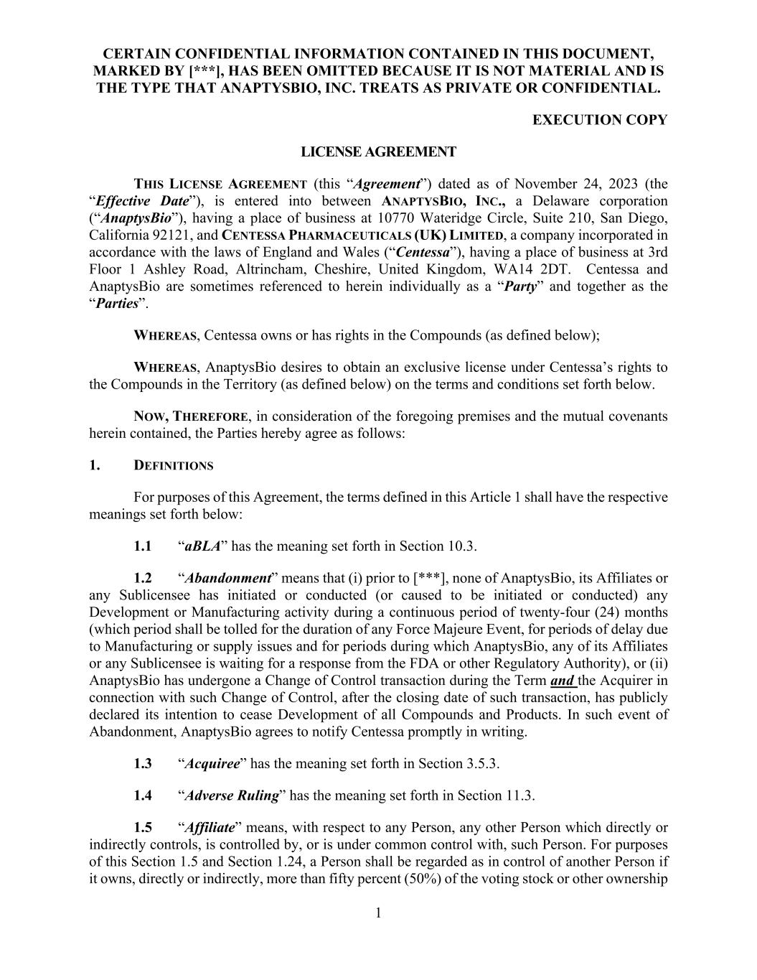
98
CERTAIN CONFIDENTIAL INFORMATION CONTAINED IN THIS DOCUMENT, MARKED BY [***], HAS BEEN OMITTED BECAUSE IT IS NOT MATERIAL AND IS THE TYPE THAT ANAPTYSBIO, INC. TREATS AS PRIVATE OR CONFIDENTIAL. EXECUTION COPY 1 LICENSE AGREEMENT THIS LICENSE AGREEMENT (this “Agreement”) dated as of November 24, 2023 (the “Effective Date”), is entered into between ANAPTYSBIO, INC., a Delaware corporation (“AnaptysBio”), having a place of business at 10770 Wateridge Circle, Suite 210, San Diego, California 92121, and CENTESSA PHARMACEUTICALS (UK) LIMITED, a company incorporated in accordance with the laws of England and Wales (“Centessa”), having a place of business at 3rd Floor 1 Ashley Road, Altrincham, Cheshire, United Kingdom, WA14 2DT. Centessa and AnaptysBio are sometimes referenced to herein individually as a “Party” and together as the “Parties”. WHEREAS, Centessa owns or has rights in the Compounds (as defined below); WHEREAS, AnaptysBio desires to obtain an exclusive license under Centessa’s rights to the Compounds in the Territory (as defined below) on the terms and conditions set forth below. NOW, THEREFORE, in consideration of the foregoing premises and the mutual covenants herein contained, the Parties hereby agree as follows: 1. DEFINITIONS For purposes of this Agreement, the terms defined in this Article 1 shall have the respective meanings set forth below: 1.1 “aBLA” has the meaning set forth in Section 10.3. 1.2 “Abandonment” means that (i) prior to [***], none of AnaptysBio, its Affiliates or any Sublicensee has initiated or conducted (or caused to be initiated or conducted) any Development or Manufacturing activity during a continuous period of twenty-four (24) months (which period shall be tolled for the duration of any Force Majeure Event, for periods of delay due to Manufacturing or supply issues and for periods during which AnaptysBio, any of its Affiliates or any Sublicensee is waiting for a response from the FDA or other Regulatory Authority), or (ii) AnaptysBio has undergone a Change of Control transaction during the Term and the Acquirer in connection with such Change of Control, after the closing date of such transaction, has publicly declared its intention to cease Development of all Compounds and Products. In such event of Abandonment, AnaptysBio agrees to notify Centessa promptly in writing. 1.3 “Acquiree” has the meaning set forth in Section 3.5.3. 1.4 “Adverse Ruling” has the meaning set forth in Section 11.3. 1.5 “Affiliate” means, with respect to any Person, any other Person which directly or indirectly controls, is controlled by, or is under common control with, such Person. For purposes of this Section 1.5 and Section 1.24, a Person shall be regarded as in control of another Person if it owns, directly or indirectly, more than fifty percent (50%) of the voting stock or other ownership

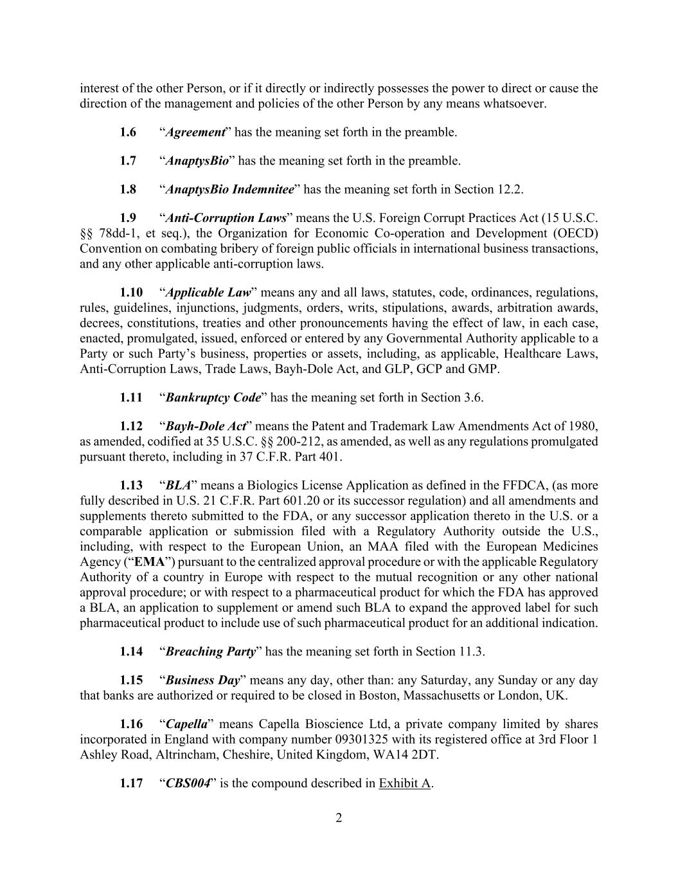
2 interest of the other Person, or if it directly or indirectly possesses the power to direct or cause the direction of the management and policies of the other Person by any means whatsoever. 1.6 “Agreement” has the meaning set forth in the preamble. 1.7 “AnaptysBio” has the meaning set forth in the preamble. 1.8 “AnaptysBio Indemnitee” has the meaning set forth in Section 12.2. 1.9 “Anti-Corruption Laws” means the U.S. Foreign Corrupt Practices Act (15 U.S.C. §§ 78dd-1, et seq.), the Organization for Economic Co-operation and Development (OECD) Convention on combating bribery of foreign public officials in international business transactions, and any other applicable anti-corruption laws. 1.10 “Applicable Law” means any and all laws, statutes, code, ordinances, regulations, rules, guidelines, injunctions, judgments, orders, writs, stipulations, awards, arbitration awards, decrees, constitutions, treaties and other pronouncements having the effect of law, in each case, enacted, promulgated, issued, enforced or entered by any Governmental Authority applicable to a Party or such Party’s business, properties or assets, including, as applicable, Healthcare Laws, Anti-Corruption Laws, Trade Laws, Bayh-Dole Act, and GLP, GCP and GMP. 1.11 “Bankruptcy Code” has the meaning set forth in Section 3.6. 1.12 “Bayh-Dole Act” means the Patent and Trademark Law Amendments Act of 1980, as amended, codified at 35 U.S.C. §§ 200-212, as amended, as well as any regulations promulgated pursuant thereto, including in 37 C.F.R. Part 401. 1.13 “BLA” means a Biologics License Application as defined in the FFDCA, (as more fully described in U.S. 21 C.F.R. Part 601.20 or its successor regulation) and all amendments and supplements thereto submitted to the FDA, or any successor application thereto in the U.S. or a comparable application or submission filed with a Regulatory Authority outside the U.S., including, with respect to the European Union, an MAA filed with the European Medicines Agency (“EMA”) pursuant to the centralized approval procedure or with the applicable Regulatory Authority of a country in Europe with respect to the mutual recognition or any other national approval procedure; or with respect to a pharmaceutical product for which the FDA has approved a BLA, an application to supplement or amend such BLA to expand the approved label for such pharmaceutical product to include use of such pharmaceutical product for an additional indication. 1.14 “Breaching Party” has the meaning set forth in Section 11.3. 1.15 “Business Day” means any day, other than: any Saturday, any Sunday or any day that banks are authorized or required to be closed in Boston, Massachusetts or London, UK. 1.16 “Capella” means Capella Bioscience Ltd, a private company limited by shares incorporated in England with company number 09301325 with its registered office at 3rd Floor 1 Ashley Road, Altrincham, Cheshire, United Kingdom, WA14 2DT. 1.17 “CBS004” is the compound described in Exhibit A.

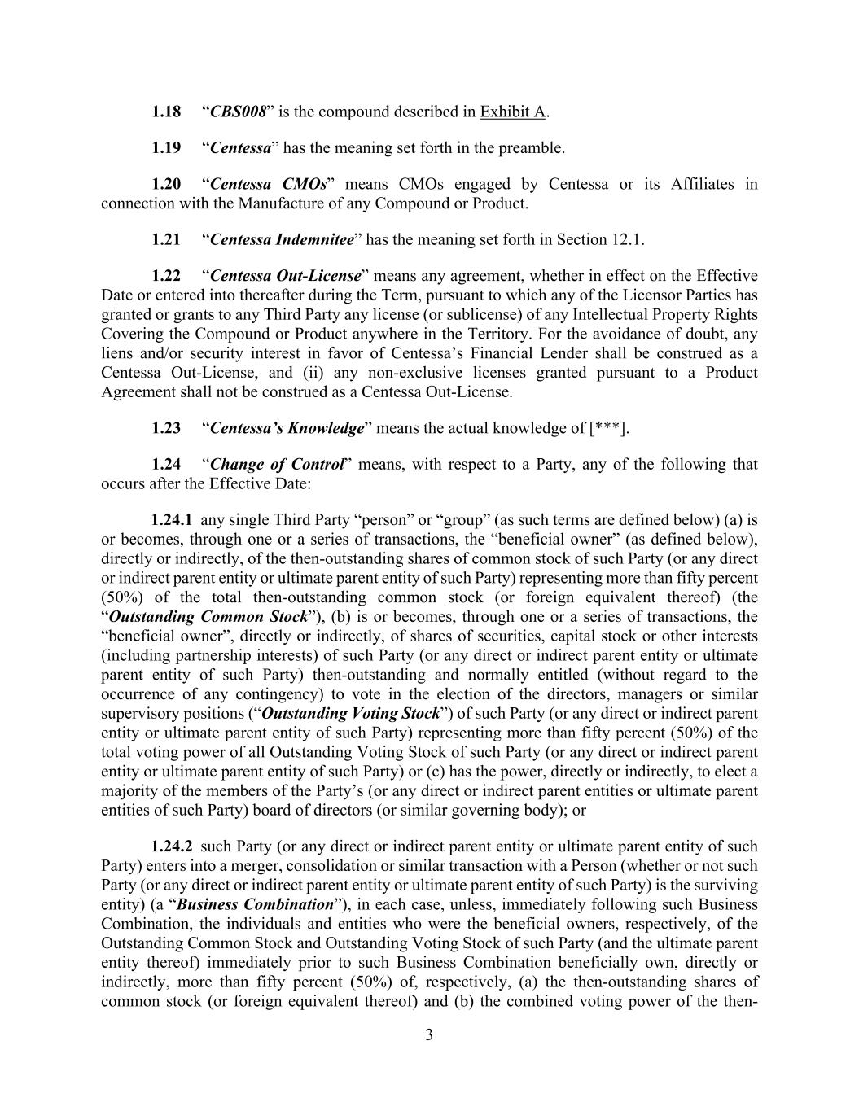
3 1.18 “CBS008” is the compound described in Exhibit A. 1.19 “Centessa” has the meaning set forth in the preamble. 1.20 “Centessa CMOs” means CMOs engaged by Centessa or its Affiliates in connection with the Manufacture of any Compound or Product. 1.21 “Centessa Indemnitee” has the meaning set forth in Section 12.1. 1.22 “Centessa Out-License” means any agreement, whether in effect on the Effective Date or entered into thereafter during the Term, pursuant to which any of the Licensor Parties has granted or grants to any Third Party any license (or sublicense) of any Intellectual Property Rights Covering the Compound or Product anywhere in the Territory. For the avoidance of doubt, any liens and/or security interest in favor of Centessa’s Financial Lender shall be construed as a Centessa Out-License, and (ii) any non-exclusive licenses granted pursuant to a Product Agreement shall not be construed as a Centessa Out-License. 1.23 “Centessa’s Knowledge” means the actual knowledge of [***]. 1.24 “Change of Control” means, with respect to a Party, any of the following that occurs after the Effective Date: 1.24.1 any single Third Party “person” or “group” (as such terms are defined below) (a) is or becomes, through one or a series of transactions, the “beneficial owner” (as defined below), directly or indirectly, of the then-outstanding shares of common stock of such Party (or any direct or indirect parent entity or ultimate parent entity of such Party) representing more than fifty percent (50%) of the total then-outstanding common stock (or foreign equivalent thereof) (the “Outstanding Common Stock”), (b) is or becomes, through one or a series of transactions, the “beneficial owner”, directly or indirectly, of shares of securities, capital stock or other interests (including partnership interests) of such Party (or any direct or indirect parent entity or ultimate parent entity of such Party) then-outstanding and normally entitled (without regard to the occurrence of any contingency) to vote in the election of the directors, managers or similar supervisory positions (“Outstanding Voting Stock”) of such Party (or any direct or indirect parent entity or ultimate parent entity of such Party) representing more than fifty percent (50%) of the total voting power of all Outstanding Voting Stock of such Party (or any direct or indirect parent entity or ultimate parent entity of such Party) or (c) has the power, directly or indirectly, to elect a majority of the members of the Party’s (or any direct or indirect parent entities or ultimate parent entities of such Party) board of directors (or similar governing body); or 1.24.2 such Party (or any direct or indirect parent entity or ultimate parent entity of such Party) enters into a merger, consolidation or similar transaction with a Person (whether or not such Party (or any direct or indirect parent entity or ultimate parent entity of such Party) is the surviving entity) (a “Business Combination”), in each case, unless, immediately following such Business Combination, the individuals and entities who were the beneficial owners, respectively, of the Outstanding Common Stock and Outstanding Voting Stock of such Party (and the ultimate parent entity thereof) immediately prior to such Business Combination beneficially own, directly or indirectly, more than fifty percent (50%) of, respectively, (a) the then-outstanding shares of common stock (or foreign equivalent thereof) and (b) the combined voting power of the then-

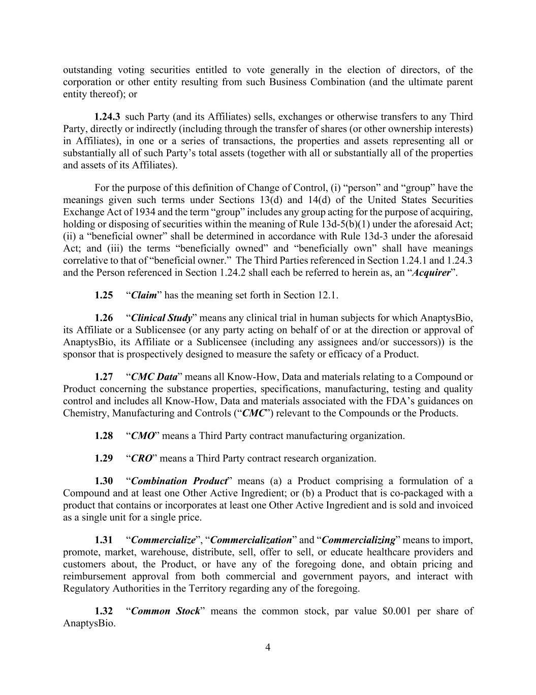
4 outstanding voting securities entitled to vote generally in the election of directors, of the corporation or other entity resulting from such Business Combination (and the ultimate parent entity thereof); or 1.24.3 such Party (and its Affiliates) sells, exchanges or otherwise transfers to any Third Party, directly or indirectly (including through the transfer of shares (or other ownership interests) in Affiliates), in one or a series of transactions, the properties and assets representing all or substantially all of such Party’s total assets (together with all or substantially all of the properties and assets of its Affiliates). For the purpose of this definition of Change of Control, (i) “person” and “group” have the meanings given such terms under Sections 13(d) and 14(d) of the United States Securities Exchange Act of 1934 and the term “group” includes any group acting for the purpose of acquiring, holding or disposing of securities within the meaning of Rule 13d-5(b)(1) under the aforesaid Act; (ii) a “beneficial owner” shall be determined in accordance with Rule 13d-3 under the aforesaid Act; and (iii) the terms “beneficially owned” and “beneficially own” shall have meanings correlative to that of “beneficial owner.” The Third Parties referenced in Section 1.24.1 and 1.24.3 and the Person referenced in Section 1.24.2 shall each be referred to herein as, an “Acquirer”. 1.25 “Claim” has the meaning set forth in Section 12.1. 1.26 “Clinical Study” means any clinical trial in human subjects for which AnaptysBio, its Affiliate or a Sublicensee (or any party acting on behalf of or at the direction or approval of AnaptysBio, its Affiliate or a Sublicensee (including any assignees and/or successors)) is the sponsor that is prospectively designed to measure the safety or efficacy of a Product. 1.27 “CMC Data” means all Know-How, Data and materials relating to a Compound or Product concerning the substance properties, specifications, manufacturing, testing and quality control and includes all Know-How, Data and materials associated with the FDA’s guidances on Chemistry, Manufacturing and Controls (“CMC”) relevant to the Compounds or the Products. 1.28 “CMO” means a Third Party contract manufacturing organization. 1.29 “CRO” means a Third Party contract research organization. 1.30 “Combination Product” means (a) a Product comprising a formulation of a Compound and at least one Other Active Ingredient; or (b) a Product that is co-packaged with a product that contains or incorporates at least one Other Active Ingredient and is sold and invoiced as a single unit for a single price. 1.31 “Commercialize”, “Commercialization” and “Commercializing” means to import, promote, market, warehouse, distribute, sell, offer to sell, or educate healthcare providers and customers about, the Product, or have any of the foregoing done, and obtain pricing and reimbursement approval from both commercial and government payors, and interact with Regulatory Authorities in the Territory regarding any of the foregoing. 1.32 “Common Stock” means the common stock, par value $0.001 per share of AnaptysBio.

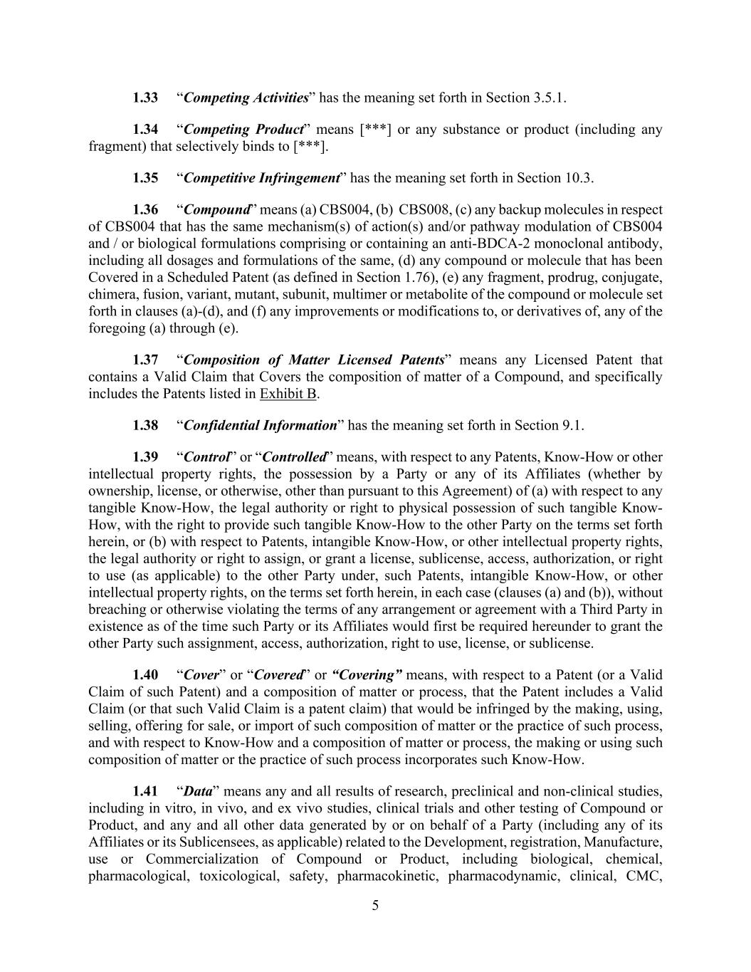
5 1.33 “Competing Activities” has the meaning set forth in Section 3.5.1. 1.34 “Competing Product” means [***] or any substance or product (including any fragment) that selectively binds to [***]. 1.35 “Competitive Infringement” has the meaning set forth in Section 10.3. 1.36 “Compound” means (a) CBS004, (b) CBS008, (c) any backup molecules in respect of CBS004 that has the same mechanism(s) of action(s) and/or pathway modulation of CBS004 and / or biological formulations comprising or containing an anti-BDCA-2 monoclonal antibody, including all dosages and formulations of the same, (d) any compound or molecule that has been Covered in a Scheduled Patent (as defined in Section 1.76), (e) any fragment, prodrug, conjugate, chimera, fusion, variant, mutant, subunit, multimer or metabolite of the compound or molecule set forth in clauses (a)-(d), and (f) any improvements or modifications to, or derivatives of, any of the foregoing (a) through (e). 1.37 “Composition of Matter Licensed Patents” means any Licensed Patent that contains a Valid Claim that Covers the composition of matter of a Compound, and specifically includes the Patents listed in Exhibit B. 1.38 “Confidential Information” has the meaning set forth in Section 9.1. 1.39 “Control” or “Controlled” means, with respect to any Patents, Know-How or other intellectual property rights, the possession by a Party or any of its Affiliates (whether by ownership, license, or otherwise, other than pursuant to this Agreement) of (a) with respect to any tangible Know-How, the legal authority or right to physical possession of such tangible Know- How, with the right to provide such tangible Know-How to the other Party on the terms set forth herein, or (b) with respect to Patents, intangible Know-How, or other intellectual property rights, the legal authority or right to assign, or grant a license, sublicense, access, authorization, or right to use (as applicable) to the other Party under, such Patents, intangible Know-How, or other intellectual property rights, on the terms set forth herein, in each case (clauses (a) and (b)), without breaching or otherwise violating the terms of any arrangement or agreement with a Third Party in existence as of the time such Party or its Affiliates would first be required hereunder to grant the other Party such assignment, access, authorization, right to use, license, or sublicense. 1.40 “Cover” or “Covered” or “Covering” means, with respect to a Patent (or a Valid Claim of such Patent) and a composition of matter or process, that the Patent includes a Valid Claim (or that such Valid Claim is a patent claim) that would be infringed by the making, using, selling, offering for sale, or import of such composition of matter or the practice of such process, and with respect to Know-How and a composition of matter or process, the making or using such composition of matter or the practice of such process incorporates such Know-How. 1.41 “Data” means any and all results of research, preclinical and non-clinical studies, including in vitro, in vivo, and ex vivo studies, clinical trials and other testing of Compound or Product, and any and all other data generated by or on behalf of a Party (including any of its Affiliates or its Sublicensees, as applicable) related to the Development, registration, Manufacture, use or Commercialization of Compound or Product, including biological, chemical, pharmacological, toxicological, safety, pharmacokinetic, pharmacodynamic, clinical, CMC,

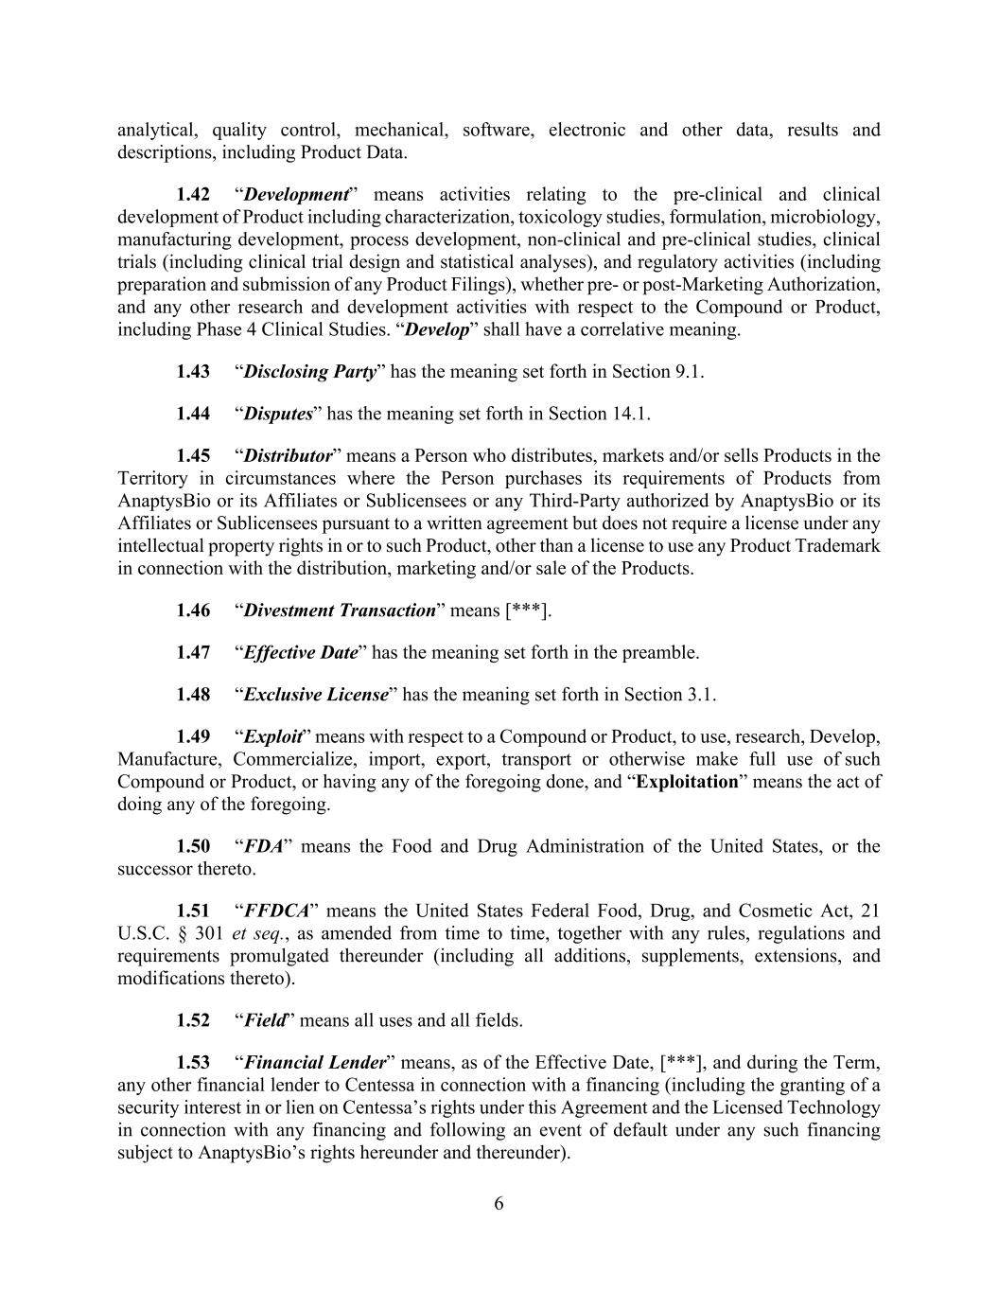
6 analytical, quality control, mechanical, software, electronic and other data, results and descriptions, including Product Data. 1.42 “Development” means activities relating to the pre-clinical and clinical development of Product including characterization, toxicology studies, formulation, microbiology, manufacturing development, process development, non-clinical and pre-clinical studies, clinical trials (including clinical trial design and statistical analyses), and regulatory activities (including preparation and submission of any Product Filings), whether pre- or post-Marketing Authorization, and any other research and development activities with respect to the Compound or Product, including Phase 4 Clinical Studies. “Develop” shall have a correlative meaning. 1.43 “Disclosing Party” has the meaning set forth in Section 9.1. 1.44 “Disputes” has the meaning set forth in Section 14.1. 1.45 “Distributor” means a Person who distributes, markets and/or sells Products in the Territory in circumstances where the Person purchases its requirements of Products from AnaptysBio or its Affiliates or Sublicensees or any Third-Party authorized by AnaptysBio or its Affiliates or Sublicensees pursuant to a written agreement but does not require a license under any intellectual property rights in or to such Product, other than a license to use any Product Trademark in connection with the distribution, marketing and/or sale of the Products. 1.46 “Divestment Transaction” means [***]. 1.47 “Effective Date” has the meaning set forth in the preamble. 1.48 “Exclusive License” has the meaning set forth in Section 3.1. 1.49 “Exploit” means with respect to a Compound or Product, to use, research, Develop, Manufacture, Commercialize, import, export, transport or otherwise make full use of such Compound or Product, or having any of the foregoing done, and “Exploitation” means the act of doing any of the foregoing. 1.50 “FDA” means the Food and Drug Administration of the United States, or the successor thereto. 1.51 “FFDCA” means the United States Federal Food, Drug, and Cosmetic Act, 21 U.S.C. § 301 et seq., as amended from time to time, together with any rules, regulations and requirements promulgated thereunder (including all additions, supplements, extensions, and modifications thereto). 1.52 “Field” means all uses and all fields. 1.53 “Financial Lender” means, as of the Effective Date, [***], and during the Term, any other financial lender to Centessa in connection with a financing (including the granting of a security interest in or lien on Centessa’s rights under this Agreement and the Licensed Technology in connection with any financing and following an event of default under any such financing subject to AnaptysBio’s rights hereunder and thereunder).

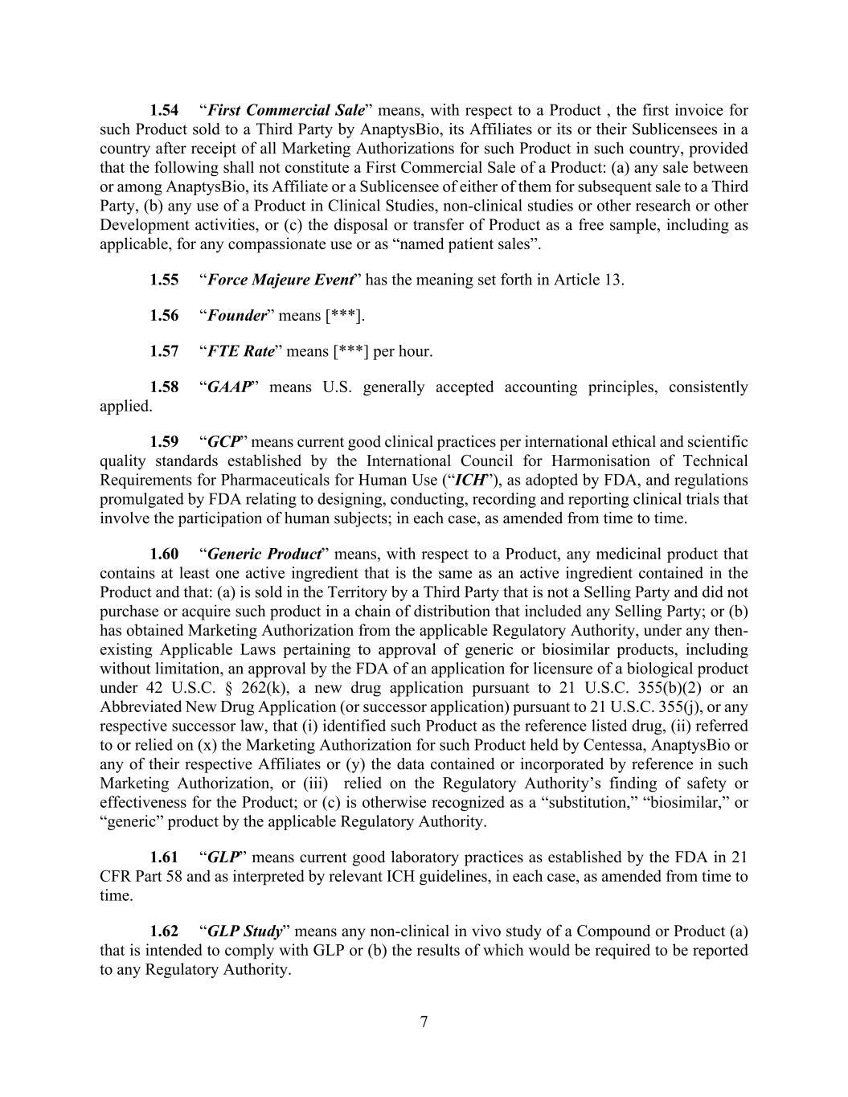
7 1.54 “First Commercial Sale” means, with respect to a Product , the first invoice for such Product sold to a Third Party by AnaptysBio, its Affiliates or its or their Sublicensees in a country after receipt of all Marketing Authorizations for such Product in such country, provided that the following shall not constitute a First Commercial Sale of a Product: (a) any sale between or among AnaptysBio, its Affiliate or a Sublicensee of either of them for subsequent sale to a Third Party, (b) any use of a Product in Clinical Studies, non-clinical studies or other research or other Development activities, or (c) the disposal or transfer of Product as a free sample, including as applicable, for any compassionate use or as “named patient sales”. 1.55 “Force Majeure Event” has the meaning set forth in Article 13. 1.56 “Founder” means [***]. 1.57 “FTE Rate” means [***] per hour. 1.58 “GAAP” means U.S. generally accepted accounting principles, consistently applied. 1.59 “GCP” means current good clinical practices per international ethical and scientific quality standards established by the International Council for Harmonisation of Technical Requirements for Pharmaceuticals for Human Use (“ICH”), as adopted by FDA, and regulations promulgated by FDA relating to designing, conducting, recording and reporting clinical trials that involve the participation of human subjects; in each case, as amended from time to time. 1.60 “Generic Product” means, with respect to a Product, any medicinal product that contains at least one active ingredient that is the same as an active ingredient contained in the Product and that: (a) is sold in the Territory by a Third Party that is not a Selling Party and did not purchase or acquire such product in a chain of distribution that included any Selling Party; or (b) has obtained Marketing Authorization from the applicable Regulatory Authority, under any then- existing Applicable Laws pertaining to approval of generic or biosimilar products, including without limitation, an approval by the FDA of an application for licensure of a biological product under 42 U.S.C. § 262(k), a new drug application pursuant to 21 U.S.C. 355(b)(2) or an Abbreviated New Drug Application (or successor application) pursuant to 21 U.S.C. 355(j), or any respective successor law, that (i) identified such Product as the reference listed drug, (ii) referred to or relied on (x) the Marketing Authorization for such Product held by Centessa, AnaptysBio or any of their respective Affiliates or (y) the data contained or incorporated by reference in such Marketing Authorization, or (iii) relied on the Regulatory Authority’s finding of safety or effectiveness for the Product; or (c) is otherwise recognized as a “substitution,” “biosimilar,” or “generic” product by the applicable Regulatory Authority. 1.61 “GLP” means current good laboratory practices as established by the FDA in 21 CFR Part 58 and as interpreted by relevant ICH guidelines, in each case, as amended from time to time. 1.62 “GLP Study” means any non-clinical in vivo study of a Compound or Product (a) that is intended to comply with GLP or (b) the results of which would be required to be reported to any Regulatory Authority.

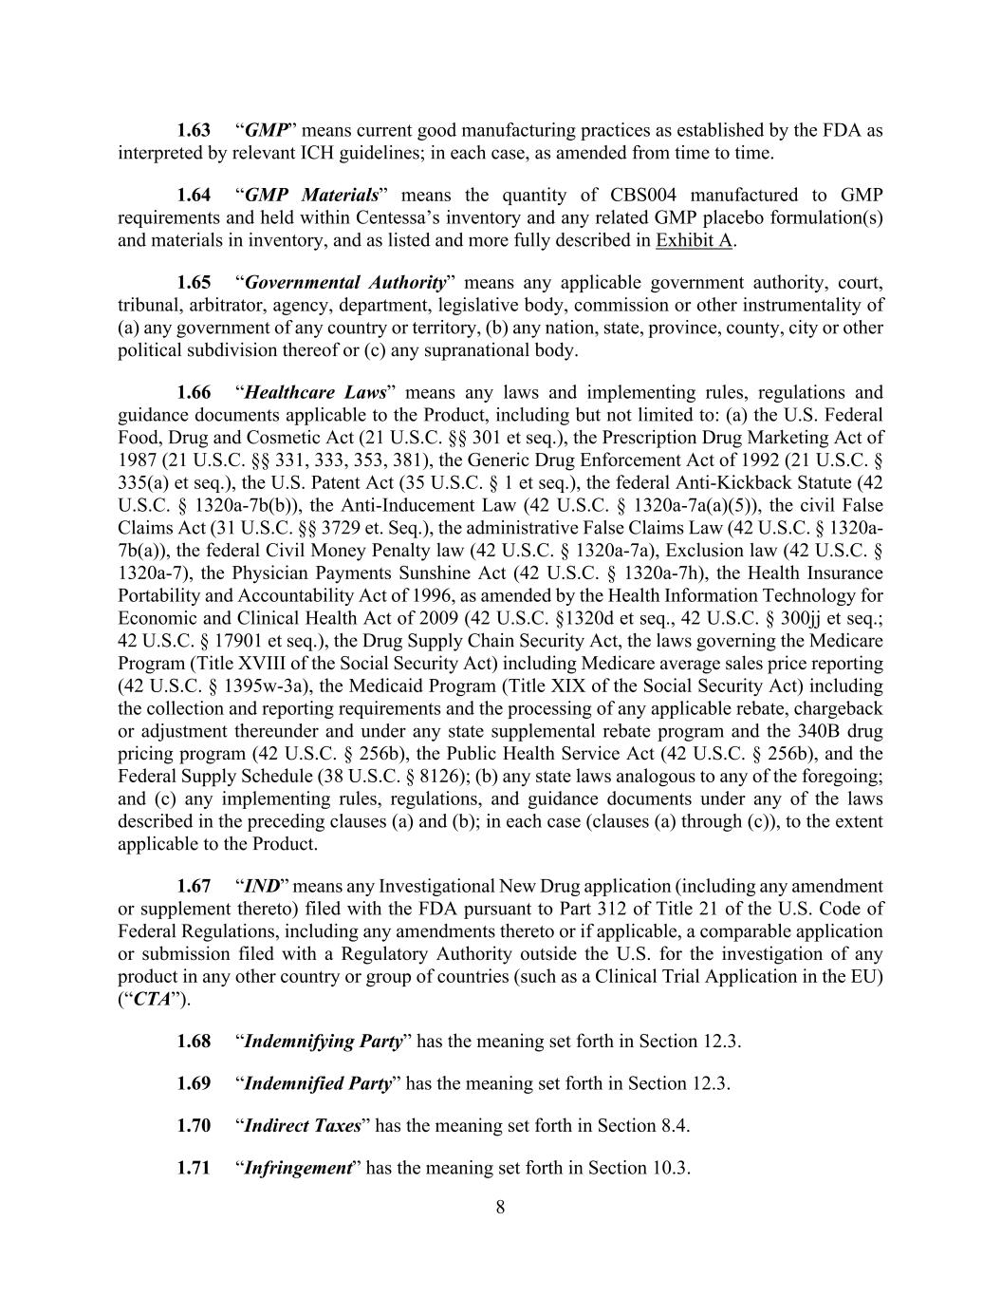
8 1.63 “GMP” means current good manufacturing practices as established by the FDA as interpreted by relevant ICH guidelines; in each case, as amended from time to time. 1.64 “GMP Materials” means the quantity of CBS004 manufactured to GMP requirements and held within Centessa’s inventory and any related GMP placebo formulation(s) and materials in inventory, and as listed and more fully described in Exhibit A. 1.65 “Governmental Authority” means any applicable government authority, court, tribunal, arbitrator, agency, department, legislative body, commission or other instrumentality of (a) any government of any country or territory, (b) any nation, state, province, county, city or other political subdivision thereof or (c) any supranational body. 1.66 “Healthcare Laws” means any laws and implementing rules, regulations and guidance documents applicable to the Product, including but not limited to: (a) the U.S. Federal Food, Drug and Cosmetic Act (21 U.S.C. §§ 301 et seq.), the Prescription Drug Marketing Act of 1987 (21 U.S.C. §§ 331, 333, 353, 381), the Generic Drug Enforcement Act of 1992 (21 U.S.C. § 335(a) et seq.), the U.S. Patent Act (35 U.S.C. § 1 et seq.), the federal Anti-Kickback Statute (42 U.S.C. § 1320a-7b(b)), the Anti-Inducement Law (42 U.S.C. § 1320a-7a(a)(5)), the civil False Claims Act (31 U.S.C. §§ 3729 et. Seq.), the administrative False Claims Law (42 U.S.C. § 1320a- 7b(a)), the federal Civil Money Penalty law (42 U.S.C. § 1320a-7a), Exclusion law (42 U.S.C. § 1320a-7), the Physician Payments Sunshine Act (42 U.S.C. § 1320a-7h), the Health Insurance Portability and Accountability Act of 1996, as amended by the Health Information Technology for Economic and Clinical Health Act of 2009 (42 U.S.C. §1320d et seq., 42 U.S.C. § 300jj et seq.; 42 U.S.C. § 17901 et seq.), the Drug Supply Chain Security Act, the laws governing the Medicare Program (Title XVIII of the Social Security Act) including Medicare average sales price reporting (42 U.S.C. § 1395w-3a), the Medicaid Program (Title XIX of the Social Security Act) including the collection and reporting requirements and the processing of any applicable rebate, chargeback or adjustment thereunder and under any state supplemental rebate program and the 340B drug pricing program (42 U.S.C. § 256b), the Public Health Service Act (42 U.S.C. § 256b), and the Federal Supply Schedule (38 U.S.C. § 8126); (b) any state laws analogous to any of the foregoing; and (c) any implementing rules, regulations, and guidance documents under any of the laws described in the preceding clauses (a) and (b); in each case (clauses (a) through (c)), to the extent applicable to the Product. 1.67 “IND” means any Investigational New Drug application (including any amendment or supplement thereto) filed with the FDA pursuant to Part 312 of Title 21 of the U.S. Code of Federal Regulations, including any amendments thereto or if applicable, a comparable application or submission filed with a Regulatory Authority outside the U.S. for the investigation of any product in any other country or group of countries (such as a Clinical Trial Application in the EU) (“CTA”). 1.68 “Indemnifying Party” has the meaning set forth in Section 12.3. 1.69 “Indemnified Party” has the meaning set forth in Section 12.3. 1.70 “Indirect Taxes” has the meaning set forth in Section 8.4. 1.71 “Infringement” has the meaning set forth in Section 10.3.

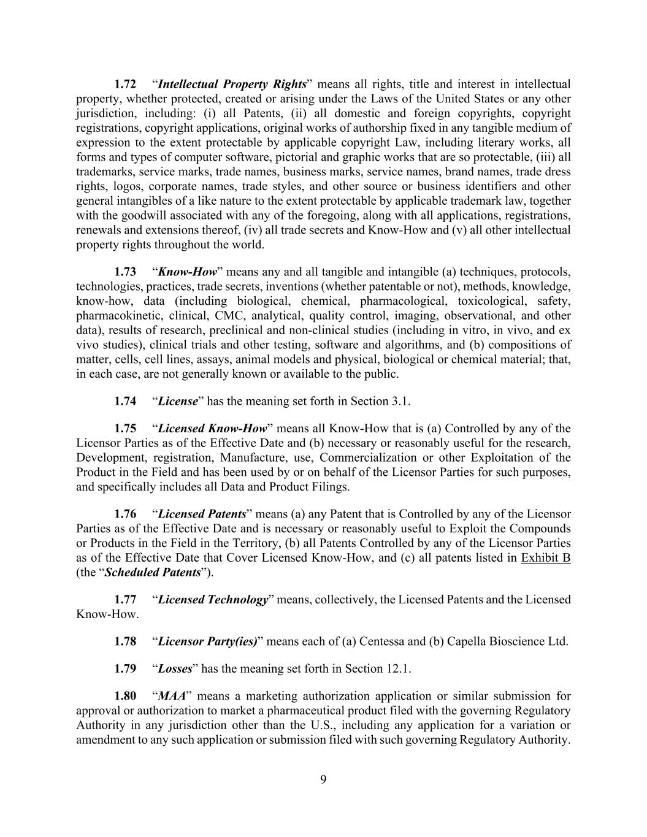
9 1.72 “Intellectual Property Rights” means all rights, title and interest in intellectual property, whether protected, created or arising under the Laws of the United States or any other jurisdiction, including: (i) all Patents, (ii) all domestic and foreign copyrights, copyright registrations, copyright applications, original works of authorship fixed in any tangible medium of expression to the extent protectable by applicable copyright Law, including literary works, all forms and types of computer software, pictorial and graphic works that are so protectable, (iii) all trademarks, service marks, trade names, business marks, service names, brand names, trade dress rights, logos, corporate names, trade styles, and other source or business identifiers and other general intangibles of a like nature to the extent protectable by applicable trademark law, together with the goodwill associated with any of the foregoing, along with all applications, registrations, renewals and extensions thereof, (iv) all trade secrets and Know-How and (v) all other intellectual property rights throughout the world. 1.73 “Know-How” means any and all tangible and intangible (a) techniques, protocols, technologies, practices, trade secrets, inventions (whether patentable or not), methods, knowledge, know-how, data (including biological, chemical, pharmacological, toxicological, safety, pharmacokinetic, clinical, CMC, analytical, quality control, imaging, observational, and other data), results of research, preclinical and non-clinical studies (including in vitro, in vivo, and ex vivo studies), clinical trials and other testing, software and algorithms, and (b) compositions of matter, cells, cell lines, assays, animal models and physical, biological or chemical material; that, in each case, are not generally known or available to the public. 1.74 “License” has the meaning set forth in Section 3.1. 1.75 “Licensed Know-How” means all Know-How that is (a) Controlled by any of the Licensor Parties as of the Effective Date and (b) necessary or reasonably useful for the research, Development, registration, Manufacture, use, Commercialization or other Exploitation of the Product in the Field and has been used by or on behalf of the Licensor Parties for such purposes, and specifically includes all Data and Product Filings. 1.76 “Licensed Patents” means (a) any Patent that is Controlled by any of the Licensor Parties as of the Effective Date and is necessary or reasonably useful to Exploit the Compounds or Products in the Field in the Territory, (b) all Patents Controlled by any of the Licensor Parties as of the Effective Date that Cover Licensed Know-How, and (c) all patents listed in Exhibit B (the “Scheduled Patents”). 1.77 “Licensed Technology” means, collectively, the Licensed Patents and the Licensed Know-How. 1.78 “Licensor Party(ies)” means each of (a) Centessa and (b) Capella Bioscience Ltd. 1.79 “Losses” has the meaning set forth in Section 12.1. 1.80 “MAA” means a marketing authorization application or similar submission for approval or authorization to market a pharmaceutical product filed with the governing Regulatory Authority in any jurisdiction other than the U.S., including any application for a variation or amendment to any such application or submission filed with such governing Regulatory Authority.

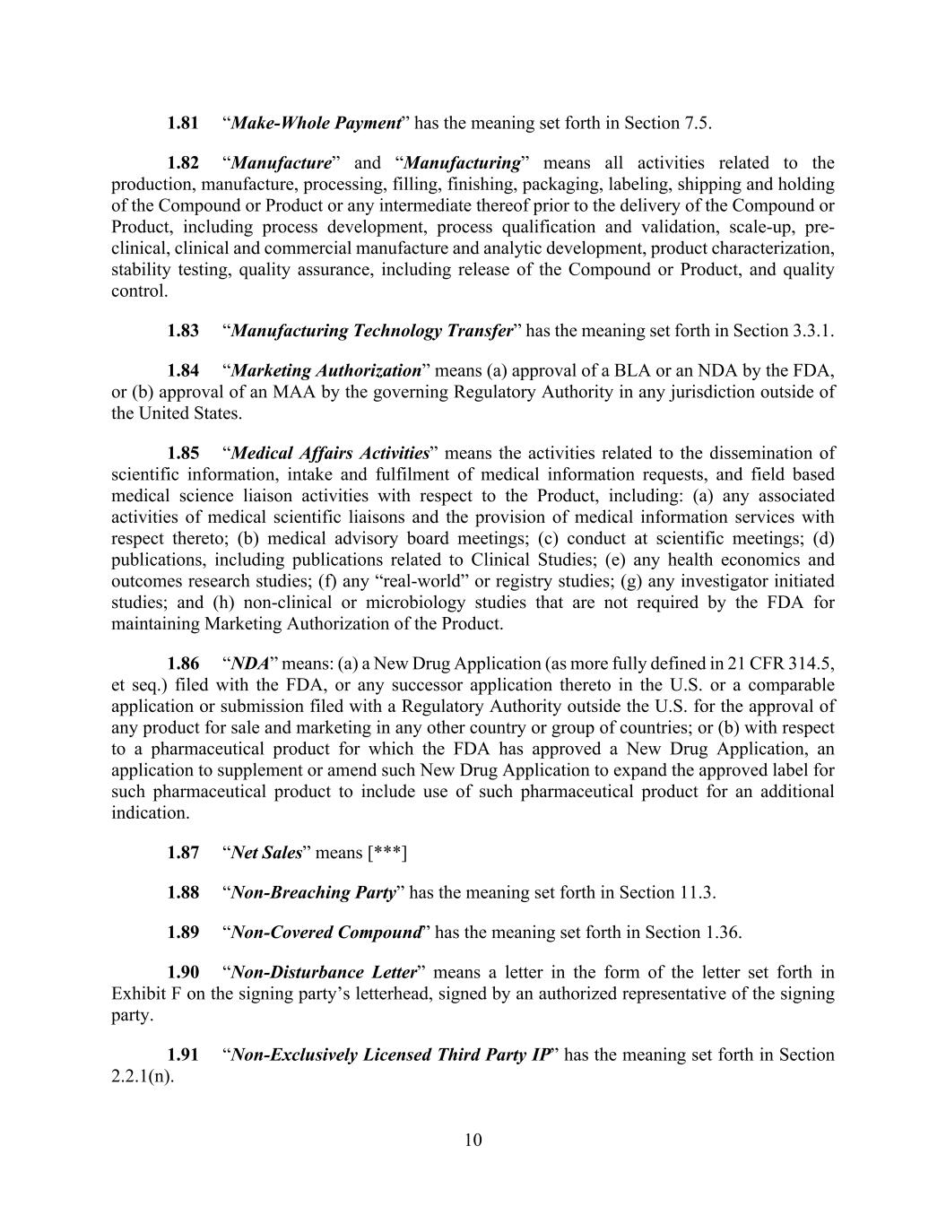
10 1.81 “Make-Whole Payment” has the meaning set forth in Section 7.5. 1.82 “Manufacture” and “Manufacturing” means all activities related to the production, manufacture, processing, filling, finishing, packaging, labeling, shipping and holding of the Compound or Product or any intermediate thereof prior to the delivery of the Compound or Product, including process development, process qualification and validation, scale-up, pre- clinical, clinical and commercial manufacture and analytic development, product characterization, stability testing, quality assurance, including release of the Compound or Product, and quality control. 1.83 “Manufacturing Technology Transfer” has the meaning set forth in Section 3.3.1. 1.84 “Marketing Authorization” means (a) approval of a BLA or an NDA by the FDA, or (b) approval of an MAA by the governing Regulatory Authority in any jurisdiction outside of the United States. 1.85 “Medical Affairs Activities” means the activities related to the dissemination of scientific information, intake and fulfilment of medical information requests, and field based medical science liaison activities with respect to the Product, including: (a) any associated activities of medical scientific liaisons and the provision of medical information services with respect thereto; (b) medical advisory board meetings; (c) conduct at scientific meetings; (d) publications, including publications related to Clinical Studies; (e) any health economics and outcomes research studies; (f) any “real-world” or registry studies; (g) any investigator initiated studies; and (h) non-clinical or microbiology studies that are not required by the FDA for maintaining Marketing Authorization of the Product. 1.86 “NDA” means: (a) a New Drug Application (as more fully defined in 21 CFR 314.5, et seq.) filed with the FDA, or any successor application thereto in the U.S. or a comparable application or submission filed with a Regulatory Authority outside the U.S. for the approval of any product for sale and marketing in any other country or group of countries; or (b) with respect to a pharmaceutical product for which the FDA has approved a New Drug Application, an application to supplement or amend such New Drug Application to expand the approved label for such pharmaceutical product to include use of such pharmaceutical product for an additional indication. 1.87 “Net Sales” means [***] 1.88 “Non-Breaching Party” has the meaning set forth in Section 11.3. 1.89 “Non-Covered Compound” has the meaning set forth in Section 1.36. 1.90 “Non-Disturbance Letter” means a letter in the form of the letter set forth in Exhibit F on the signing party’s letterhead, signed by an authorized representative of the signing party. 1.91 “Non-Exclusively Licensed Third Party IP” has the meaning set forth in Section 2.2.1(n).

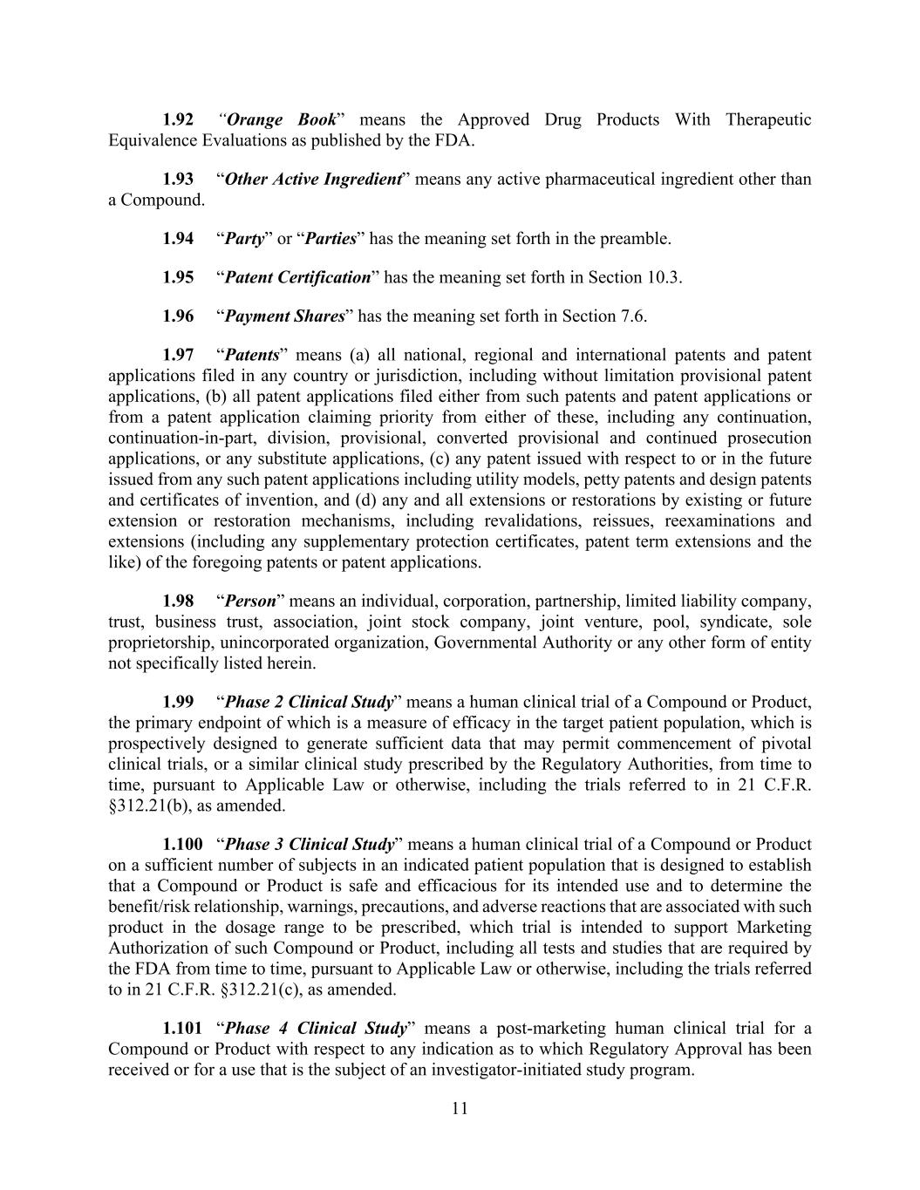
11 1.92 “Orange Book” means the Approved Drug Products With Therapeutic Equivalence Evaluations as published by the FDA. 1.93 “Other Active Ingredient” means any active pharmaceutical ingredient other than a Compound. 1.94 “Party” or “Parties” has the meaning set forth in the preamble. 1.95 “Patent Certification” has the meaning set forth in Section 10.3. 1.96 “Payment Shares” has the meaning set forth in Section 7.6. 1.97 “Patents” means (a) all national, regional and international patents and patent applications filed in any country or jurisdiction, including without limitation provisional patent applications, (b) all patent applications filed either from such patents and patent applications or from a patent application claiming priority from either of these, including any continuation, continuation-in-part, division, provisional, converted provisional and continued prosecution applications, or any substitute applications, (c) any patent issued with respect to or in the future issued from any such patent applications including utility models, petty patents and design patents and certificates of invention, and (d) any and all extensions or restorations by existing or future extension or restoration mechanisms, including revalidations, reissues, reexaminations and extensions (including any supplementary protection certificates, patent term extensions and the like) of the foregoing patents or patent applications. 1.98 “Person” means an individual, corporation, partnership, limited liability company, trust, business trust, association, joint stock company, joint venture, pool, syndicate, sole proprietorship, unincorporated organization, Governmental Authority or any other form of entity not specifically listed herein. 1.99 “Phase 2 Clinical Study” means a human clinical trial of a Compound or Product, the primary endpoint of which is a measure of efficacy in the target patient population, which is prospectively designed to generate sufficient data that may permit commencement of pivotal clinical trials, or a similar clinical study prescribed by the Regulatory Authorities, from time to time, pursuant to Applicable Law or otherwise, including the trials referred to in 21 C.F.R. §312.21(b), as amended. 1.100 “Phase 3 Clinical Study” means a human clinical trial of a Compound or Product on a sufficient number of subjects in an indicated patient population that is designed to establish that a Compound or Product is safe and efficacious for its intended use and to determine the benefit/risk relationship, warnings, precautions, and adverse reactions that are associated with such product in the dosage range to be prescribed, which trial is intended to support Marketing Authorization of such Compound or Product, including all tests and studies that are required by the FDA from time to time, pursuant to Applicable Law or otherwise, including the trials referred to in 21 C.F.R. §312.21(c), as amended. 1.101 “Phase 4 Clinical Study” means a post-marketing human clinical trial for a Compound or Product with respect to any indication as to which Regulatory Approval has been received or for a use that is the subject of an investigator-initiated study program.

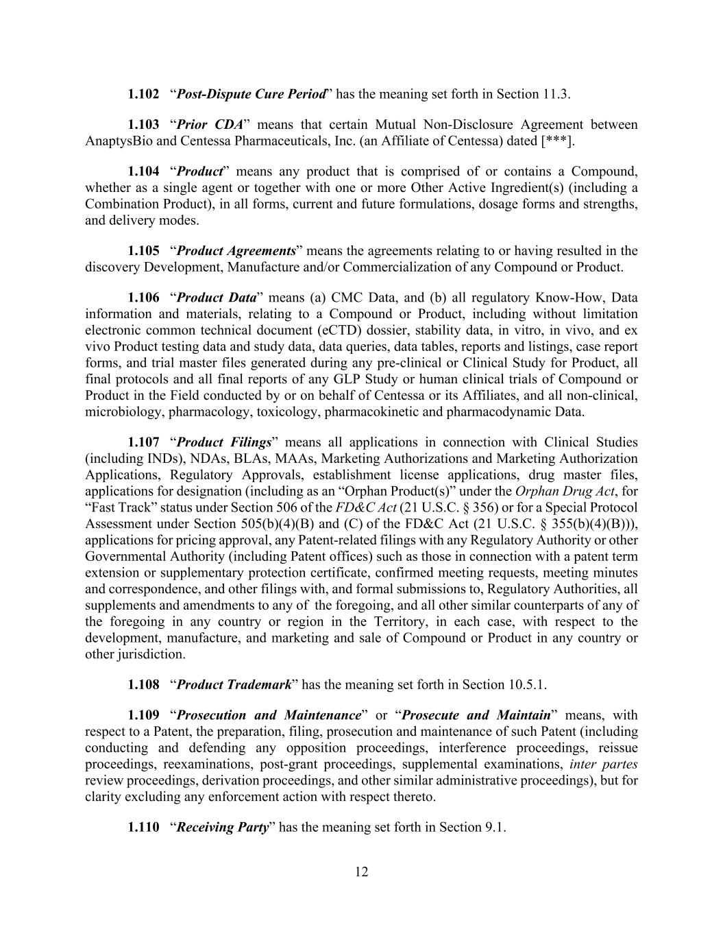
12 1.102 “Post-Dispute Cure Period” has the meaning set forth in Section 11.3. 1.103 “Prior CDA” means that certain Mutual Non-Disclosure Agreement between AnaptysBio and Centessa Pharmaceuticals, Inc. (an Affiliate of Centessa) dated [***]. 1.104 “Product” means any product that is comprised of or contains a Compound, whether as a single agent or together with one or more Other Active Ingredient(s) (including a Combination Product), in all forms, current and future formulations, dosage forms and strengths, and delivery modes. 1.105 “Product Agreements” means the agreements relating to or having resulted in the discovery Development, Manufacture and/or Commercialization of any Compound or Product. 1.106 “Product Data” means (a) CMC Data, and (b) all regulatory Know-How, Data information and materials, relating to a Compound or Product, including without limitation electronic common technical document (eCTD) dossier, stability data, in vitro, in vivo, and ex vivo Product testing data and study data, data queries, data tables, reports and listings, case report forms, and trial master files generated during any pre-clinical or Clinical Study for Product, all final protocols and all final reports of any GLP Study or human clinical trials of Compound or Product in the Field conducted by or on behalf of Centessa or its Affiliates, and all non-clinical, microbiology, pharmacology, toxicology, pharmacokinetic and pharmacodynamic Data. 1.107 “Product Filings” means all applications in connection with Clinical Studies (including INDs), NDAs, BLAs, MAAs, Marketing Authorizations and Marketing Authorization Applications, Regulatory Approvals, establishment license applications, drug master files, applications for designation (including as an “Orphan Product(s)” under the Orphan Drug Act, for “Fast Track” status under Section 506 of the FD&C Act (21 U.S.C. § 356) or for a Special Protocol Assessment under Section 505(b)(4)(B) and (C) of the FD&C Act (21 U.S.C. § 355(b)(4)(B))), applications for pricing approval, any Patent-related filings with any Regulatory Authority or other Governmental Authority (including Patent offices) such as those in connection with a patent term extension or supplementary protection certificate, confirmed meeting requests, meeting minutes and correspondence, and other filings with, and formal submissions to, Regulatory Authorities, all supplements and amendments to any of the foregoing, and all other similar counterparts of any of the foregoing in any country or region in the Territory, in each case, with respect to the development, manufacture, and marketing and sale of Compound or Product in any country or other jurisdiction. 1.108 “Product Trademark” has the meaning set forth in Section 10.5.1. 1.109 “Prosecution and Maintenance” or “Prosecute and Maintain” means, with respect to a Patent, the preparation, filing, prosecution and maintenance of such Patent (including conducting and defending any opposition proceedings, interference proceedings, reissue proceedings, reexaminations, post-grant proceedings, supplemental examinations, inter partes review proceedings, derivation proceedings, and other similar administrative proceedings), but for clarity excluding any enforcement action with respect thereto. 1.110 “Receiving Party” has the meaning set forth in Section 9.1.

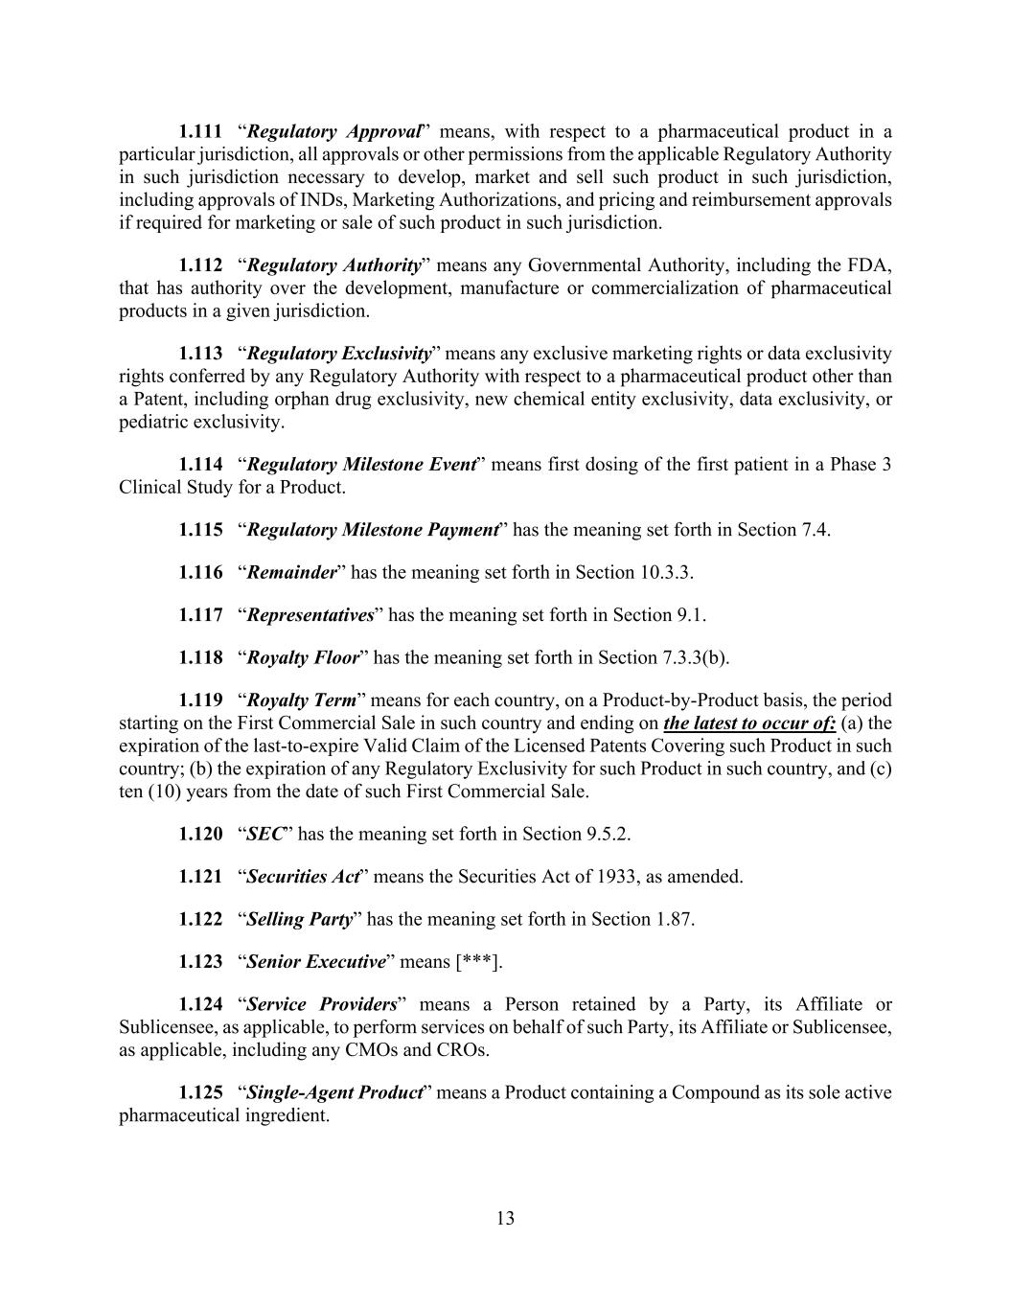
13 1.111 “Regulatory Approval” means, with respect to a pharmaceutical product in a particular jurisdiction, all approvals or other permissions from the applicable Regulatory Authority in such jurisdiction necessary to develop, market and sell such product in such jurisdiction, including approvals of INDs, Marketing Authorizations, and pricing and reimbursement approvals if required for marketing or sale of such product in such jurisdiction. 1.112 “Regulatory Authority” means any Governmental Authority, including the FDA, that has authority over the development, manufacture or commercialization of pharmaceutical products in a given jurisdiction. 1.113 “Regulatory Exclusivity” means any exclusive marketing rights or data exclusivity rights conferred by any Regulatory Authority with respect to a pharmaceutical product other than a Patent, including orphan drug exclusivity, new chemical entity exclusivity, data exclusivity, or pediatric exclusivity. 1.114 “Regulatory Milestone Event” means first dosing of the first patient in a Phase 3 Clinical Study for a Product. 1.115 “Regulatory Milestone Payment” has the meaning set forth in Section 7.4. 1.116 “Remainder” has the meaning set forth in Section 10.3.3. 1.117 “Representatives” has the meaning set forth in Section 9.1. 1.118 “Royalty Floor” has the meaning set forth in Section 7.3.3(b). 1.119 “Royalty Term” means for each country, on a Product-by-Product basis, the period starting on the First Commercial Sale in such country and ending on the latest to occur of: (a) the expiration of the last-to-expire Valid Claim of the Licensed Patents Covering such Product in such country; (b) the expiration of any Regulatory Exclusivity for such Product in such country, and (c) ten (10) years from the date of such First Commercial Sale. 1.120 “SEC” has the meaning set forth in Section 9.5.2. 1.121 “Securities Act” means the Securities Act of 1933, as amended. 1.122 “Selling Party” has the meaning set forth in Section 1.87. 1.123 “Senior Executive” means [***]. 1.124 “Service Providers” means a Person retained by a Party, its Affiliate or Sublicensee, as applicable, to perform services on behalf of such Party, its Affiliate or Sublicensee, as applicable, including any CMOs and CROs. 1.125 “Single-Agent Product” means a Product containing a Compound as its sole active pharmaceutical ingredient.

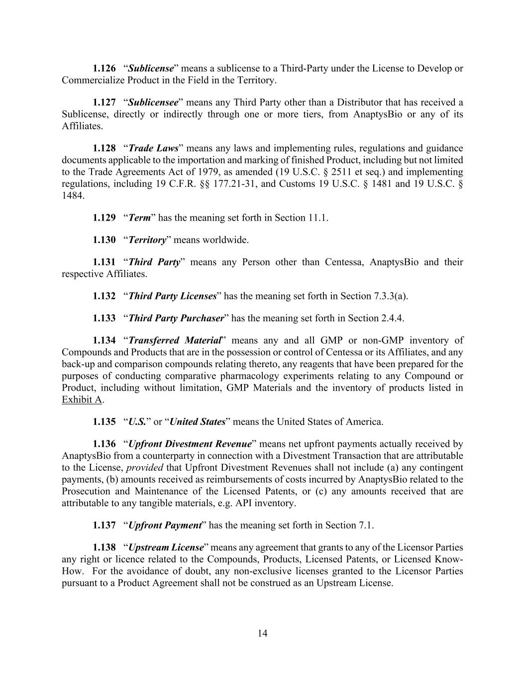
14 1.126 “Sublicense” means a sublicense to a Third-Party under the License to Develop or Commercialize Product in the Field in the Territory. 1.127 “Sublicensee” means any Third Party other than a Distributor that has received a Sublicense, directly or indirectly through one or more tiers, from AnaptysBio or any of its Affiliates. 1.128 “Trade Laws” means any laws and implementing rules, regulations and guidance documents applicable to the importation and marking of finished Product, including but not limited to the Trade Agreements Act of 1979, as amended (19 U.S.C. § 2511 et seq.) and implementing regulations, including 19 C.F.R. §§ 177.21-31, and Customs 19 U.S.C. § 1481 and 19 U.S.C. § 1484. 1.129 “Term” has the meaning set forth in Section 11.1. 1.130 “Territory” means worldwide. 1.131 “Third Party” means any Person other than Centessa, AnaptysBio and their respective Affiliates. 1.132 “Third Party Licenses” has the meaning set forth in Section 7.3.3(a). 1.133 “Third Party Purchaser” has the meaning set forth in Section 2.4.4. 1.134 “Transferred Material” means any and all GMP or non-GMP inventory of Compounds and Products that are in the possession or control of Centessa or its Affiliates, and any back-up and comparison compounds relating thereto, any reagents that have been prepared for the purposes of conducting comparative pharmacology experiments relating to any Compound or Product, including without limitation, GMP Materials and the inventory of products listed in Exhibit A. 1.135 “U.S.” or “United States” means the United States of America. 1.136 “Upfront Divestment Revenue” means net upfront payments actually received by AnaptysBio from a counterparty in connection with a Divestment Transaction that are attributable to the License, provided that Upfront Divestment Revenues shall not include (a) any contingent payments, (b) amounts received as reimbursements of costs incurred by AnaptysBio related to the Prosecution and Maintenance of the Licensed Patents, or (c) any amounts received that are attributable to any tangible materials, e.g. API inventory. 1.137 “Upfront Payment” has the meaning set forth in Section 7.1. 1.138 “Upstream License” means any agreement that grants to any of the Licensor Parties any right or licence related to the Compounds, Products, Licensed Patents, or Licensed Know- How. For the avoidance of doubt, any non-exclusive licenses granted to the Licensor Parties pursuant to a Product Agreement shall not be construed as an Upstream License.

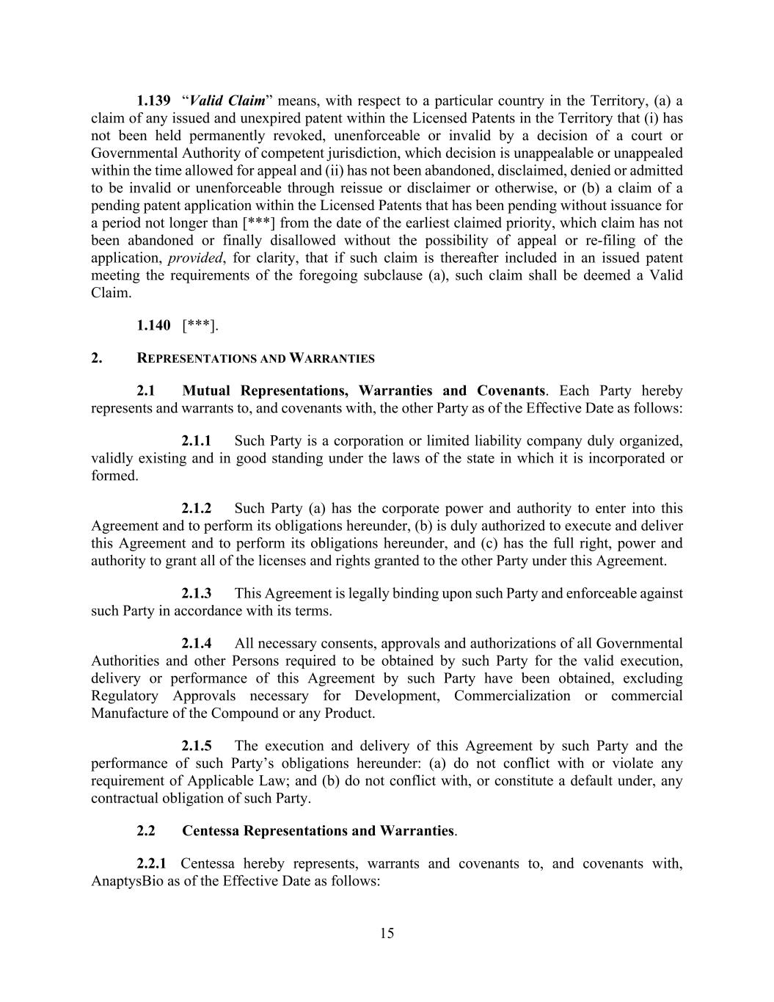
15 1.139 “Valid Claim” means, with respect to a particular country in the Territory, (a) a claim of any issued and unexpired patent within the Licensed Patents in the Territory that (i) has not been held permanently revoked, unenforceable or invalid by a decision of a court or Governmental Authority of competent jurisdiction, which decision is unappealable or unappealed within the time allowed for appeal and (ii) has not been abandoned, disclaimed, denied or admitted to be invalid or unenforceable through reissue or disclaimer or otherwise, or (b) a claim of a pending patent application within the Licensed Patents that has been pending without issuance for a period not longer than [***] from the date of the earliest claimed priority, which claim has not been abandoned or finally disallowed without the possibility of appeal or re-filing of the application, provided, for clarity, that if such claim is thereafter included in an issued patent meeting the requirements of the foregoing subclause (a), such claim shall be deemed a Valid Claim. 1.140 [***]. 2. REPRESENTATIONS AND WARRANTIES 2.1 Mutual Representations, Warranties and Covenants. Each Party hereby represents and warrants to, and covenants with, the other Party as of the Effective Date as follows: 2.1.1 Such Party is a corporation or limited liability company duly organized, validly existing and in good standing under the laws of the state in which it is incorporated or formed. 2.1.2 Such Party (a) has the corporate power and authority to enter into this Agreement and to perform its obligations hereunder, (b) is duly authorized to execute and deliver this Agreement and to perform its obligations hereunder, and (c) has the full right, power and authority to grant all of the licenses and rights granted to the other Party under this Agreement. 2.1.3 This Agreement is legally binding upon such Party and enforceable against such Party in accordance with its terms. 2.1.4 All necessary consents, approvals and authorizations of all Governmental Authorities and other Persons required to be obtained by such Party for the valid execution, delivery or performance of this Agreement by such Party have been obtained, excluding Regulatory Approvals necessary for Development, Commercialization or commercial Manufacture of the Compound or any Product. 2.1.5 The execution and delivery of this Agreement by such Party and the performance of such Party’s obligations hereunder: (a) do not conflict with or violate any requirement of Applicable Law; and (b) do not conflict with, or constitute a default under, any contractual obligation of such Party. 2.2 Centessa Representations and Warranties. 2.2.1 Centessa hereby represents, warrants and covenants to, and covenants with, AnaptysBio as of the Effective Date as follows:

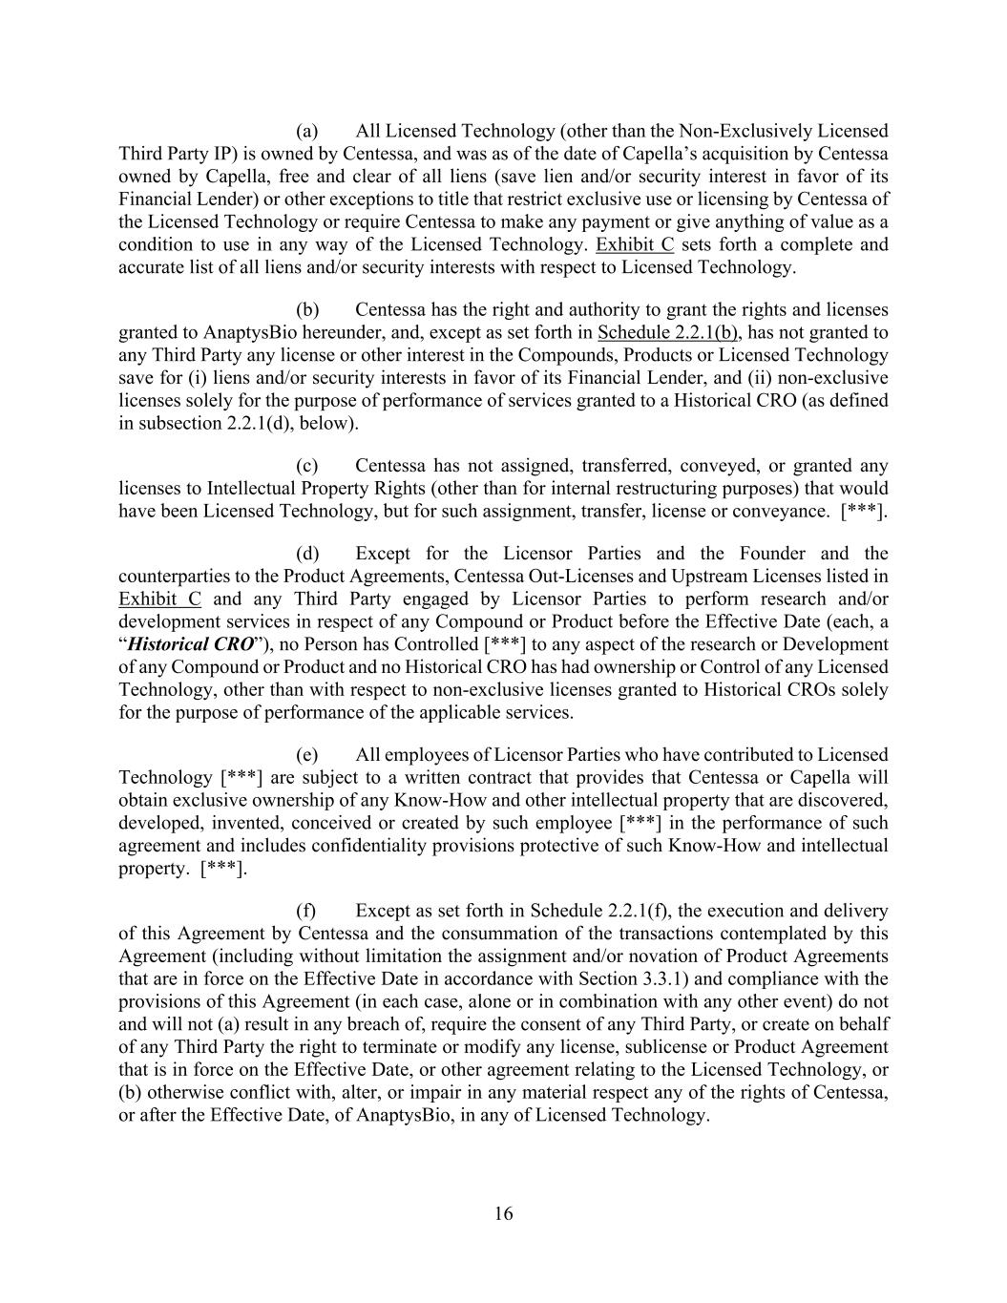
16 (a) All Licensed Technology (other than the Non-Exclusively Licensed Third Party IP) is owned by Centessa, and was as of the date of Capella’s acquisition by Centessa owned by Capella, free and clear of all liens (save lien and/or security interest in favor of its Financial Lender) or other exceptions to title that restrict exclusive use or licensing by Centessa of the Licensed Technology or require Centessa to make any payment or give anything of value as a condition to use in any way of the Licensed Technology. Exhibit C sets forth a complete and accurate list of all liens and/or security interests with respect to Licensed Technology. (b) Centessa has the right and authority to grant the rights and licenses granted to AnaptysBio hereunder, and, except as set forth in Schedule 2.2.1(b), has not granted to any Third Party any license or other interest in the Compounds, Products or Licensed Technology save for (i) liens and/or security interests in favor of its Financial Lender, and (ii) non-exclusive licenses solely for the purpose of performance of services granted to a Historical CRO (as defined in subsection 2.2.1(d), below). (c) Centessa has not assigned, transferred, conveyed, or granted any licenses to Intellectual Property Rights (other than for internal restructuring purposes) that would have been Licensed Technology, but for such assignment, transfer, license or conveyance. [***]. (d) Except for the Licensor Parties and the Founder and the counterparties to the Product Agreements, Centessa Out-Licenses and Upstream Licenses listed in Exhibit C and any Third Party engaged by Licensor Parties to perform research and/or development services in respect of any Compound or Product before the Effective Date (each, a “Historical CRO”), no Person has Controlled [***] to any aspect of the research or Development of any Compound or Product and no Historical CRO has had ownership or Control of any Licensed Technology, other than with respect to non-exclusive licenses granted to Historical CROs solely for the purpose of performance of the applicable services. (e) All employees of Licensor Parties who have contributed to Licensed Technology [***] are subject to a written contract that provides that Centessa or Capella will obtain exclusive ownership of any Know-How and other intellectual property that are discovered, developed, invented, conceived or created by such employee [***] in the performance of such agreement and includes confidentiality provisions protective of such Know-How and intellectual property. [***]. (f) Except as set forth in Schedule 2.2.1(f), the execution and delivery of this Agreement by Centessa and the consummation of the transactions contemplated by this Agreement (including without limitation the assignment and/or novation of Product Agreements that are in force on the Effective Date in accordance with Section 3.3.1) and compliance with the provisions of this Agreement (in each case, alone or in combination with any other event) do not and will not (a) result in any breach of, require the consent of any Third Party, or create on behalf of any Third Party the right to terminate or modify any license, sublicense or Product Agreement that is in force on the Effective Date, or other agreement relating to the Licensed Technology, or (b) otherwise conflict with, alter, or impair in any material respect any of the rights of Centessa, or after the Effective Date, of AnaptysBio, in any of Licensed Technology.

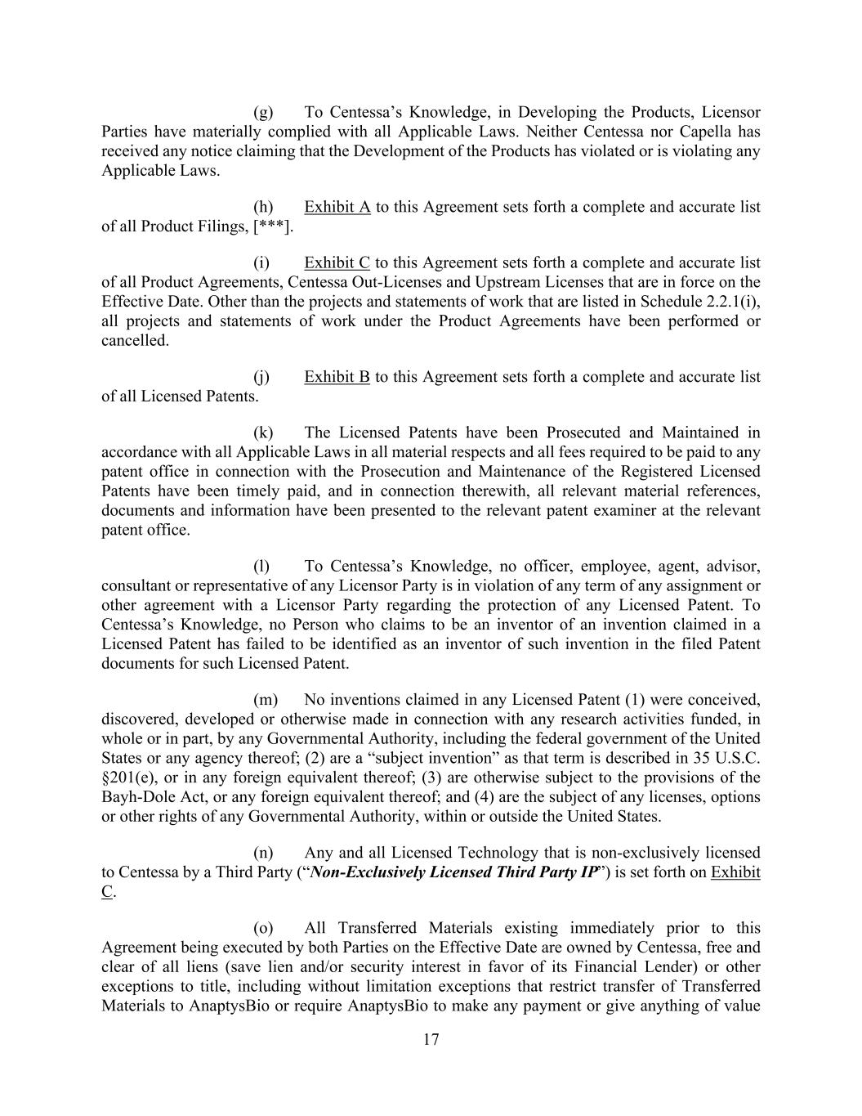
17 (g) To Centessa’s Knowledge, in Developing the Products, Licensor Parties have materially complied with all Applicable Laws. Neither Centessa nor Capella has received any notice claiming that the Development of the Products has violated or is violating any Applicable Laws. (h) Exhibit A to this Agreement sets forth a complete and accurate list of all Product Filings, [***]. (i) Exhibit C to this Agreement sets forth a complete and accurate list of all Product Agreements, Centessa Out-Licenses and Upstream Licenses that are in force on the Effective Date. Other than the projects and statements of work that are listed in Schedule 2.2.1(i), all projects and statements of work under the Product Agreements have been performed or cancelled. (j) Exhibit B to this Agreement sets forth a complete and accurate list of all Licensed Patents. (k) The Licensed Patents have been Prosecuted and Maintained in accordance with all Applicable Laws in all material respects and all fees required to be paid to any patent office in connection with the Prosecution and Maintenance of the Registered Licensed Patents have been timely paid, and in connection therewith, all relevant material references, documents and information have been presented to the relevant patent examiner at the relevant patent office. (l) To Centessa’s Knowledge, no officer, employee, agent, advisor, consultant or representative of any Licensor Party is in violation of any term of any assignment or other agreement with a Licensor Party regarding the protection of any Licensed Patent. To Centessa’s Knowledge, no Person who claims to be an inventor of an invention claimed in a Licensed Patent has failed to be identified as an inventor of such invention in the filed Patent documents for such Licensed Patent. (m) No inventions claimed in any Licensed Patent (1) were conceived, discovered, developed or otherwise made in connection with any research activities funded, in whole or in part, by any Governmental Authority, including the federal government of the United States or any agency thereof; (2) are a “subject invention” as that term is described in 35 U.S.C. §201(e), or in any foreign equivalent thereof; (3) are otherwise subject to the provisions of the Bayh-Dole Act, or any foreign equivalent thereof; and (4) are the subject of any licenses, options or other rights of any Governmental Authority, within or outside the United States. (n) Any and all Licensed Technology that is non-exclusively licensed to Centessa by a Third Party (“Non-Exclusively Licensed Third Party IP”) is set forth on Exhibit C. (o) All Transferred Materials existing immediately prior to this Agreement being executed by both Parties on the Effective Date are owned by Centessa, free and clear of all liens (save lien and/or security interest in favor of its Financial Lender) or other exceptions to title, including without limitation exceptions that restrict transfer of Transferred Materials to AnaptysBio or require AnaptysBio to make any payment or give anything of value

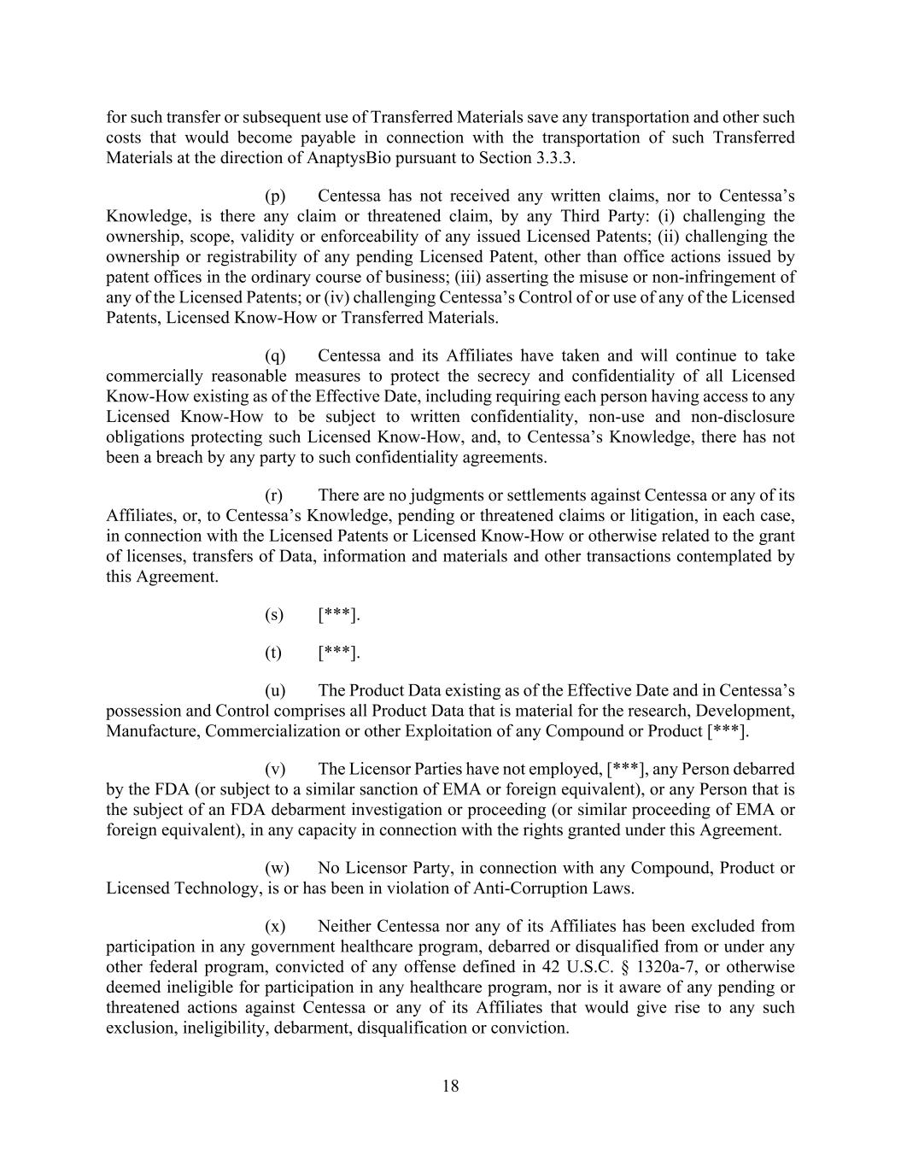
18 for such transfer or subsequent use of Transferred Materials save any transportation and other such costs that would become payable in connection with the transportation of such Transferred Materials at the direction of AnaptysBio pursuant to Section 3.3.3. (p) Centessa has not received any written claims, nor to Centessa’s Knowledge, is there any claim or threatened claim, by any Third Party: (i) challenging the ownership, scope, validity or enforceability of any issued Licensed Patents; (ii) challenging the ownership or registrability of any pending Licensed Patent, other than office actions issued by patent offices in the ordinary course of business; (iii) asserting the misuse or non-infringement of any of the Licensed Patents; or (iv) challenging Centessa’s Control of or use of any of the Licensed Patents, Licensed Know-How or Transferred Materials. (q) Centessa and its Affiliates have taken and will continue to take commercially reasonable measures to protect the secrecy and confidentiality of all Licensed Know-How existing as of the Effective Date, including requiring each person having access to any Licensed Know-How to be subject to written confidentiality, non-use and non-disclosure obligations protecting such Licensed Know-How, and, to Centessa’s Knowledge, there has not been a breach by any party to such confidentiality agreements. (r) There are no judgments or settlements against Centessa or any of its Affiliates, or, to Centessa’s Knowledge, pending or threatened claims or litigation, in each case, in connection with the Licensed Patents or Licensed Know-How or otherwise related to the grant of licenses, transfers of Data, information and materials and other transactions contemplated by this Agreement. (s) [***]. (t) [***]. (u) The Product Data existing as of the Effective Date and in Centessa’s possession and Control comprises all Product Data that is material for the research, Development, Manufacture, Commercialization or other Exploitation of any Compound or Product [***]. (v) The Licensor Parties have not employed, [***], any Person debarred by the FDA (or subject to a similar sanction of EMA or foreign equivalent), or any Person that is the subject of an FDA debarment investigation or proceeding (or similar proceeding of EMA or foreign equivalent), in any capacity in connection with the rights granted under this Agreement. (w) No Licensor Party, in connection with any Compound, Product or Licensed Technology, is or has been in violation of Anti-Corruption Laws. (x) Neither Centessa nor any of its Affiliates has been excluded from participation in any government healthcare program, debarred or disqualified from or under any other federal program, convicted of any offense defined in 42 U.S.C. § 1320a-7, or otherwise deemed ineligible for participation in any healthcare program, nor is it aware of any pending or threatened actions against Centessa or any of its Affiliates that would give rise to any such exclusion, ineligibility, debarment, disqualification or conviction.

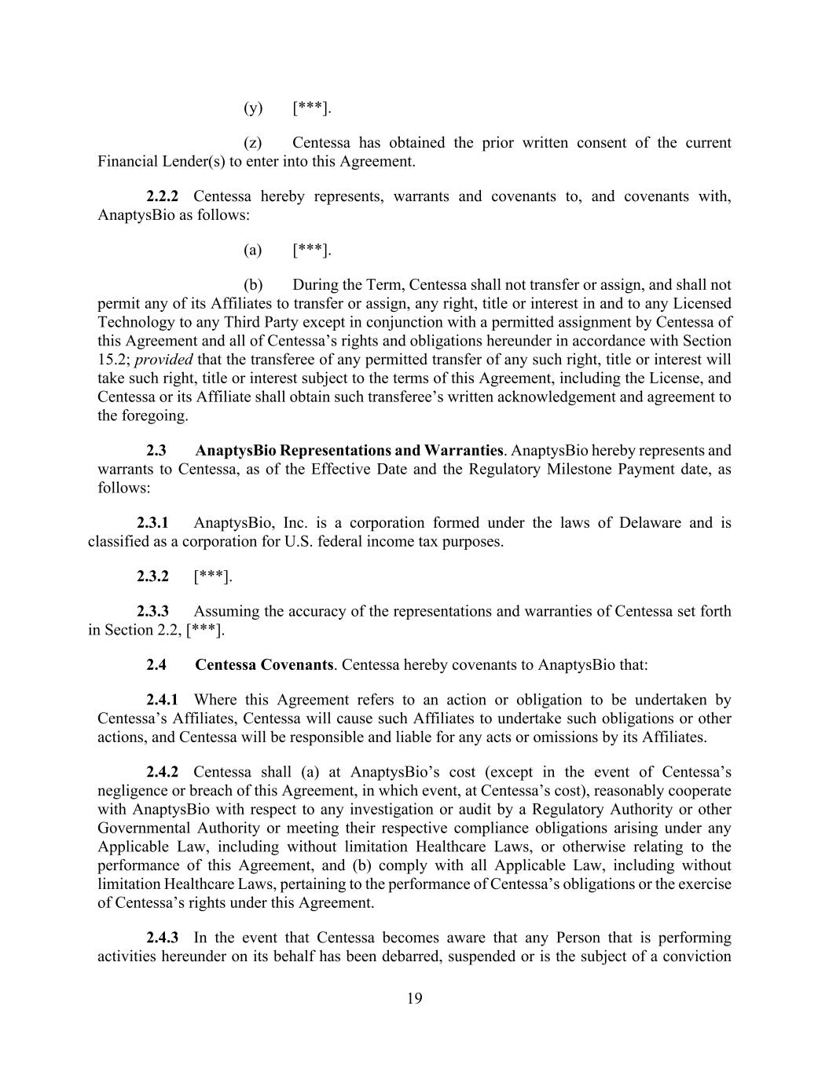
19 (y) [***]. (z) Centessa has obtained the prior written consent of the current Financial Lender(s) to enter into this Agreement. 2.2.2 Centessa hereby represents, warrants and covenants to, and covenants with, AnaptysBio as follows: (a) [***]. (b) During the Term, Centessa shall not transfer or assign, and shall not permit any of its Affiliates to transfer or assign, any right, title or interest in and to any Licensed Technology to any Third Party except in conjunction with a permitted assignment by Centessa of this Agreement and all of Centessa’s rights and obligations hereunder in accordance with Section 15.2; provided that the transferee of any permitted transfer of any such right, title or interest will take such right, title or interest subject to the terms of this Agreement, including the License, and Centessa or its Affiliate shall obtain such transferee’s written acknowledgement and agreement to the foregoing. 2.3 AnaptysBio Representations and Warranties. AnaptysBio hereby represents and warrants to Centessa, as of the Effective Date and the Regulatory Milestone Payment date, as follows: 2.3.1 AnaptysBio, Inc. is a corporation formed under the laws of Delaware and is classified as a corporation for U.S. federal income tax purposes. 2.3.2 [***]. 2.3.3 Assuming the accuracy of the representations and warranties of Centessa set forth in Section 2.2, [***]. 2.4 Centessa Covenants. Centessa hereby covenants to AnaptysBio that: 2.4.1 Where this Agreement refers to an action or obligation to be undertaken by Centessa’s Affiliates, Centessa will cause such Affiliates to undertake such obligations or other actions, and Centessa will be responsible and liable for any acts or omissions by its Affiliates. 2.4.2 Centessa shall (a) at AnaptysBio’s cost (except in the event of Centessa’s negligence or breach of this Agreement, in which event, at Centessa’s cost), reasonably cooperate with AnaptysBio with respect to any investigation or audit by a Regulatory Authority or other Governmental Authority or meeting their respective compliance obligations arising under any Applicable Law, including without limitation Healthcare Laws, or otherwise relating to the performance of this Agreement, and (b) comply with all Applicable Law, including without limitation Healthcare Laws, pertaining to the performance of Centessa’s obligations or the exercise of Centessa’s rights under this Agreement. 2.4.3 In the event that Centessa becomes aware that any Person that is performing activities hereunder on its behalf has been debarred, suspended or is the subject of a conviction

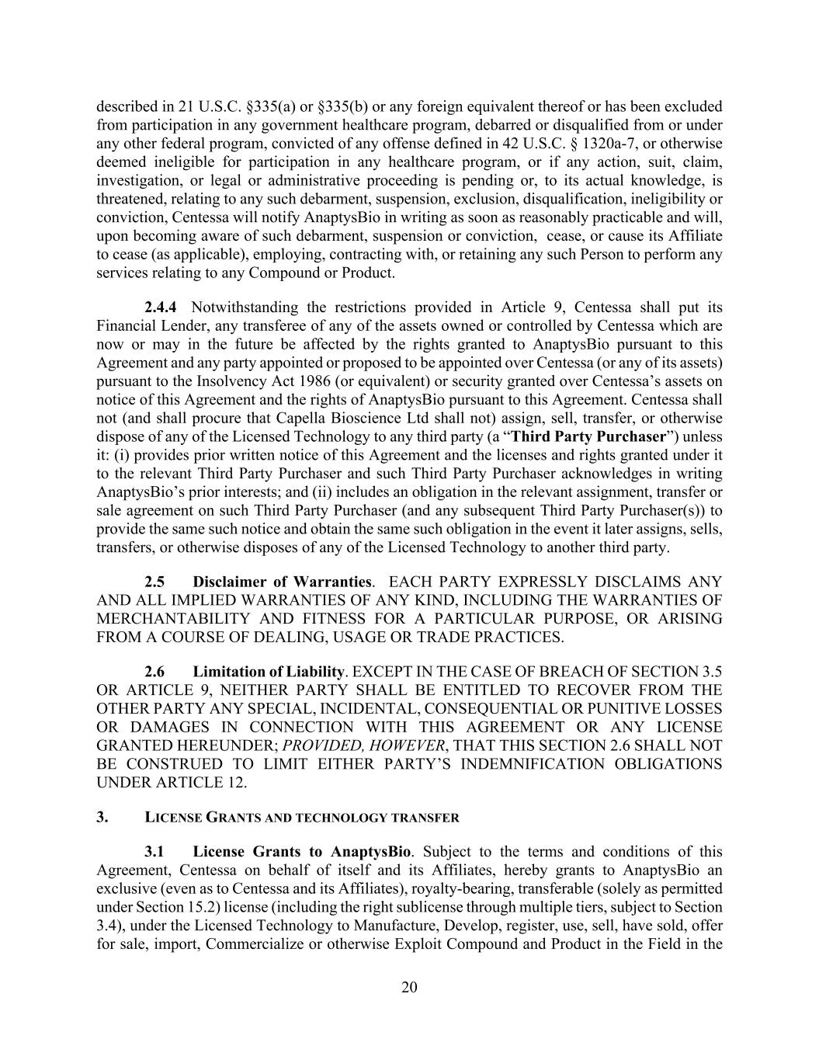
20 described in 21 U.S.C. §335(a) or §335(b) or any foreign equivalent thereof or has been excluded from participation in any government healthcare program, debarred or disqualified from or under any other federal program, convicted of any offense defined in 42 U.S.C. § 1320a-7, or otherwise deemed ineligible for participation in any healthcare program, or if any action, suit, claim, investigation, or legal or administrative proceeding is pending or, to its actual knowledge, is threatened, relating to any such debarment, suspension, exclusion, disqualification, ineligibility or conviction, Centessa will notify AnaptysBio in writing as soon as reasonably practicable and will, upon becoming aware of such debarment, suspension or conviction, cease, or cause its Affiliate to cease (as applicable), employing, contracting with, or retaining any such Person to perform any services relating to any Compound or Product. 2.4.4 Notwithstanding the restrictions provided in Article 9, Centessa shall put its Financial Lender, any transferee of any of the assets owned or controlled by Centessa which are now or may in the future be affected by the rights granted to AnaptysBio pursuant to this Agreement and any party appointed or proposed to be appointed over Centessa (or any of its assets) pursuant to the Insolvency Act 1986 (or equivalent) or security granted over Centessa’s assets on notice of this Agreement and the rights of AnaptysBio pursuant to this Agreement. Centessa shall not (and shall procure that Capella Bioscience Ltd shall not) assign, sell, transfer, or otherwise dispose of any of the Licensed Technology to any third party (a “Third Party Purchaser”) unless it: (i) provides prior written notice of this Agreement and the licenses and rights granted under it to the relevant Third Party Purchaser and such Third Party Purchaser acknowledges in writing AnaptysBio’s prior interests; and (ii) includes an obligation in the relevant assignment, transfer or sale agreement on such Third Party Purchaser (and any subsequent Third Party Purchaser(s)) to provide the same such notice and obtain the same such obligation in the event it later assigns, sells, transfers, or otherwise disposes of any of the Licensed Technology to another third party. 2.5 Disclaimer of Warranties. EACH PARTY EXPRESSLY DISCLAIMS ANY AND ALL IMPLIED WARRANTIES OF ANY KIND, INCLUDING THE WARRANTIES OF MERCHANTABILITY AND FITNESS FOR A PARTICULAR PURPOSE, OR ARISING FROM A COURSE OF DEALING, USAGE OR TRADE PRACTICES. 2.6 Limitation of Liability. EXCEPT IN THE CASE OF BREACH OF SECTION 3.5 OR ARTICLE 9, NEITHER PARTY SHALL BE ENTITLED TO RECOVER FROM THE OTHER PARTY ANY SPECIAL, INCIDENTAL, CONSEQUENTIAL OR PUNITIVE LOSSES OR DAMAGES IN CONNECTION WITH THIS AGREEMENT OR ANY LICENSE GRANTED HEREUNDER; PROVIDED, HOWEVER, THAT THIS SECTION 2.6 SHALL NOT BE CONSTRUED TO LIMIT EITHER PARTY’S INDEMNIFICATION OBLIGATIONS UNDER ARTICLE 12. 3. LICENSE GRANTS AND TECHNOLOGY TRANSFER 3.1 License Grants to AnaptysBio. Subject to the terms and conditions of this Agreement, Centessa on behalf of itself and its Affiliates, hereby grants to AnaptysBio an exclusive (even as to Centessa and its Affiliates), royalty-bearing, transferable (solely as permitted under Section 15.2) license (including the right sublicense through multiple tiers, subject to Section 3.4), under the Licensed Technology to Manufacture, Develop, register, use, sell, have sold, offer for sale, import, Commercialize or otherwise Exploit Compound and Product in the Field in the

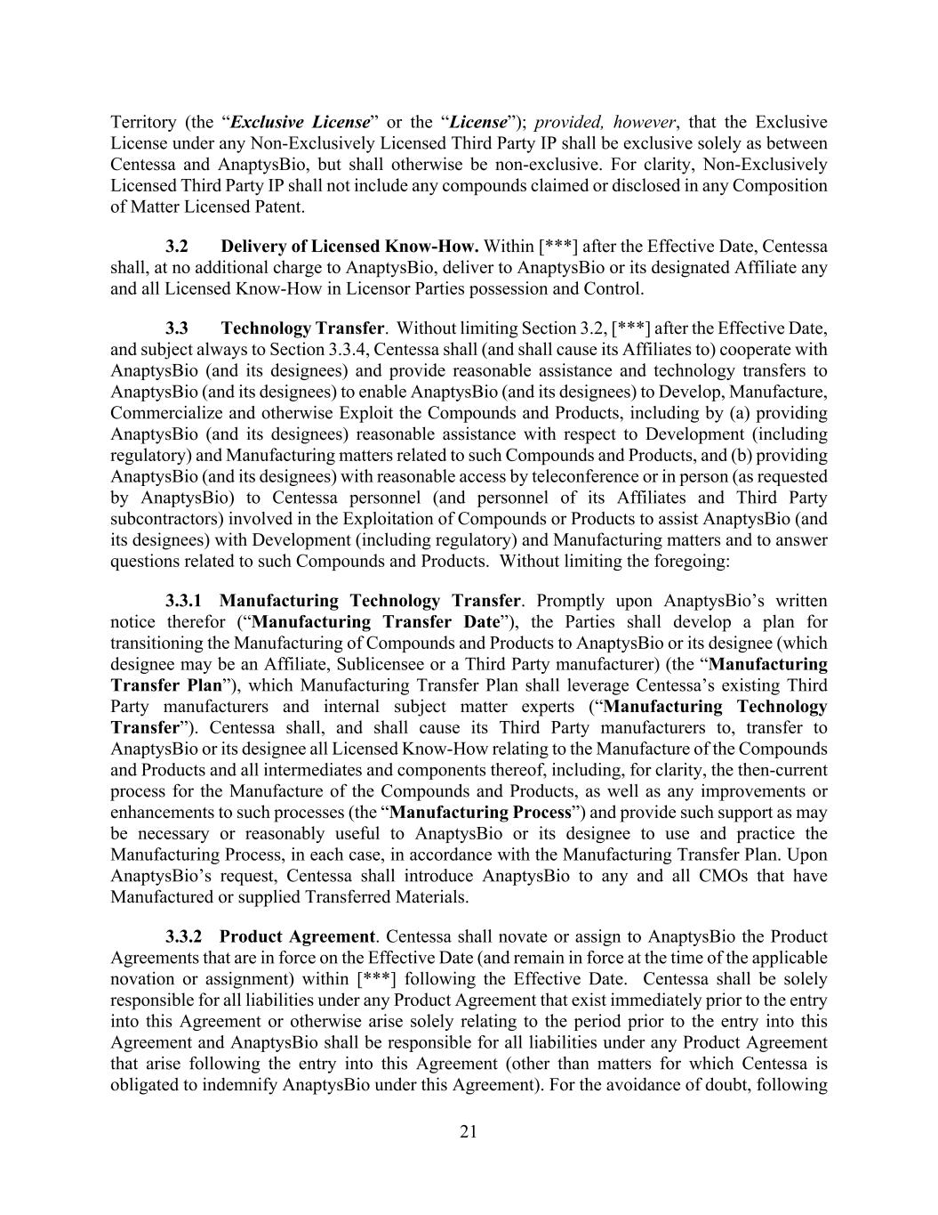
21 Territory (the “Exclusive License” or the “License”); provided, however, that the Exclusive License under any Non-Exclusively Licensed Third Party IP shall be exclusive solely as between Centessa and AnaptysBio, but shall otherwise be non-exclusive. For clarity, Non-Exclusively Licensed Third Party IP shall not include any compounds claimed or disclosed in any Composition of Matter Licensed Patent. 3.2 Delivery of Licensed Know-How. Within [***] after the Effective Date, Centessa shall, at no additional charge to AnaptysBio, deliver to AnaptysBio or its designated Affiliate any and all Licensed Know-How in Licensor Parties possession and Control. 3.3 Technology Transfer. Without limiting Section 3.2, [***] after the Effective Date, and subject always to Section 3.3.4, Centessa shall (and shall cause its Affiliates to) cooperate with AnaptysBio (and its designees) and provide reasonable assistance and technology transfers to AnaptysBio (and its designees) to enable AnaptysBio (and its designees) to Develop, Manufacture, Commercialize and otherwise Exploit the Compounds and Products, including by (a) providing AnaptysBio (and its designees) reasonable assistance with respect to Development (including regulatory) and Manufacturing matters related to such Compounds and Products, and (b) providing AnaptysBio (and its designees) with reasonable access by teleconference or in person (as requested by AnaptysBio) to Centessa personnel (and personnel of its Affiliates and Third Party subcontractors) involved in the Exploitation of Compounds or Products to assist AnaptysBio (and its designees) with Development (including regulatory) and Manufacturing matters and to answer questions related to such Compounds and Products. Without limiting the foregoing: 3.3.1 Manufacturing Technology Transfer. Promptly upon AnaptysBio’s written notice therefor (“Manufacturing Transfer Date”), the Parties shall develop a plan for transitioning the Manufacturing of Compounds and Products to AnaptysBio or its designee (which designee may be an Affiliate, Sublicensee or a Third Party manufacturer) (the “Manufacturing Transfer Plan”), which Manufacturing Transfer Plan shall leverage Centessa’s existing Third Party manufacturers and internal subject matter experts (“Manufacturing Technology Transfer”). Centessa shall, and shall cause its Third Party manufacturers to, transfer to AnaptysBio or its designee all Licensed Know-How relating to the Manufacture of the Compounds and Products and all intermediates and components thereof, including, for clarity, the then-current process for the Manufacture of the Compounds and Products, as well as any improvements or enhancements to such processes (the “Manufacturing Process”) and provide such support as may be necessary or reasonably useful to AnaptysBio or its designee to use and practice the Manufacturing Process, in each case, in accordance with the Manufacturing Transfer Plan. Upon AnaptysBio’s request, Centessa shall introduce AnaptysBio to any and all CMOs that have Manufactured or supplied Transferred Materials. 3.3.2 Product Agreement. Centessa shall novate or assign to AnaptysBio the Product Agreements that are in force on the Effective Date (and remain in force at the time of the applicable novation or assignment) within [***] following the Effective Date. Centessa shall be solely responsible for all liabilities under any Product Agreement that exist immediately prior to the entry into this Agreement or otherwise arise solely relating to the period prior to the entry into this Agreement and AnaptysBio shall be responsible for all liabilities under any Product Agreement that arise following the entry into this Agreement (other than matters for which Centessa is obligated to indemnify AnaptysBio under this Agreement). For the avoidance of doubt, following

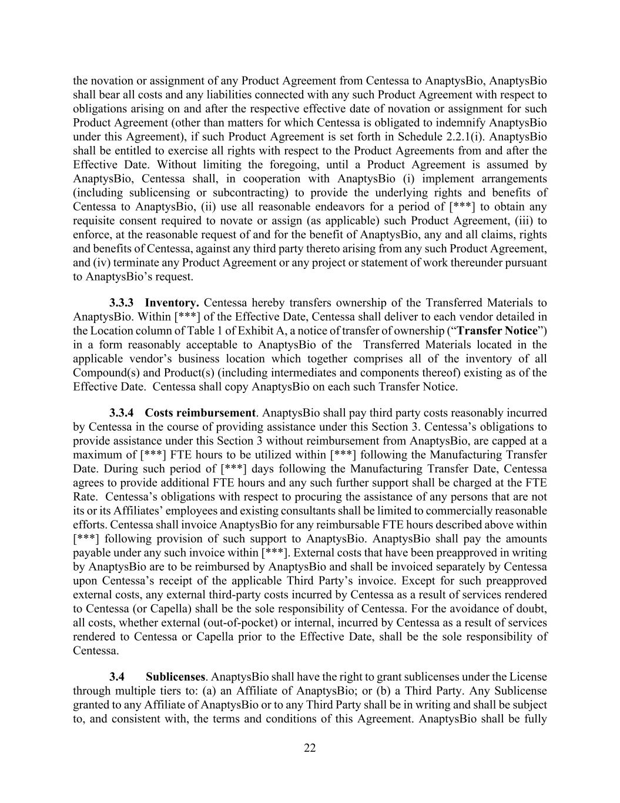
22 the novation or assignment of any Product Agreement from Centessa to AnaptysBio, AnaptysBio shall bear all costs and any liabilities connected with any such Product Agreement with respect to obligations arising on and after the respective effective date of novation or assignment for such Product Agreement (other than matters for which Centessa is obligated to indemnify AnaptysBio under this Agreement), if such Product Agreement is set forth in Schedule 2.2.1(i). AnaptysBio shall be entitled to exercise all rights with respect to the Product Agreements from and after the Effective Date. Without limiting the foregoing, until a Product Agreement is assumed by AnaptysBio, Centessa shall, in cooperation with AnaptysBio (i) implement arrangements (including sublicensing or subcontracting) to provide the underlying rights and benefits of Centessa to AnaptysBio, (ii) use all reasonable endeavors for a period of [***] to obtain any requisite consent required to novate or assign (as applicable) such Product Agreement, (iii) to enforce, at the reasonable request of and for the benefit of AnaptysBio, any and all claims, rights and benefits of Centessa, against any third party thereto arising from any such Product Agreement, and (iv) terminate any Product Agreement or any project or statement of work thereunder pursuant to AnaptysBio’s request. 3.3.3 Inventory. Centessa hereby transfers ownership of the Transferred Materials to AnaptysBio. Within [***] of the Effective Date, Centessa shall deliver to each vendor detailed in the Location column of Table 1 of Exhibit A, a notice of transfer of ownership (“Transfer Notice”) in a form reasonably acceptable to AnaptysBio of the Transferred Materials located in the applicable vendor’s business location which together comprises all of the inventory of all Compound(s) and Product(s) (including intermediates and components thereof) existing as of the Effective Date. Centessa shall copy AnaptysBio on each such Transfer Notice. 3.3.4 Costs reimbursement. AnaptysBio shall pay third party costs reasonably incurred by Centessa in the course of providing assistance under this Section 3. Centessa’s obligations to provide assistance under this Section 3 without reimbursement from AnaptysBio, are capped at a maximum of [***] FTE hours to be utilized within [***] following the Manufacturing Transfer Date. During such period of [***] days following the Manufacturing Transfer Date, Centessa agrees to provide additional FTE hours and any such further support shall be charged at the FTE Rate. Centessa’s obligations with respect to procuring the assistance of any persons that are not its or its Affiliates’ employees and existing consultants shall be limited to commercially reasonable efforts. Centessa shall invoice AnaptysBio for any reimbursable FTE hours described above within [***] following provision of such support to AnaptysBio. AnaptysBio shall pay the amounts payable under any such invoice within [***]. External costs that have been preapproved in writing by AnaptysBio are to be reimbursed by AnaptysBio and shall be invoiced separately by Centessa upon Centessa’s receipt of the applicable Third Party’s invoice. Except for such preapproved external costs, any external third-party costs incurred by Centessa as a result of services rendered to Centessa (or Capella) shall be the sole responsibility of Centessa. For the avoidance of doubt, all costs, whether external (out-of-pocket) or internal, incurred by Centessa as a result of services rendered to Centessa or Capella prior to the Effective Date, shall be the sole responsibility of Centessa. 3.4 Sublicenses. AnaptysBio shall have the right to grant sublicenses under the License through multiple tiers to: (a) an Affiliate of AnaptysBio; or (b) a Third Party. Any Sublicense granted to any Affiliate of AnaptysBio or to any Third Party shall be in writing and shall be subject to, and consistent with, the terms and conditions of this Agreement. AnaptysBio shall be fully

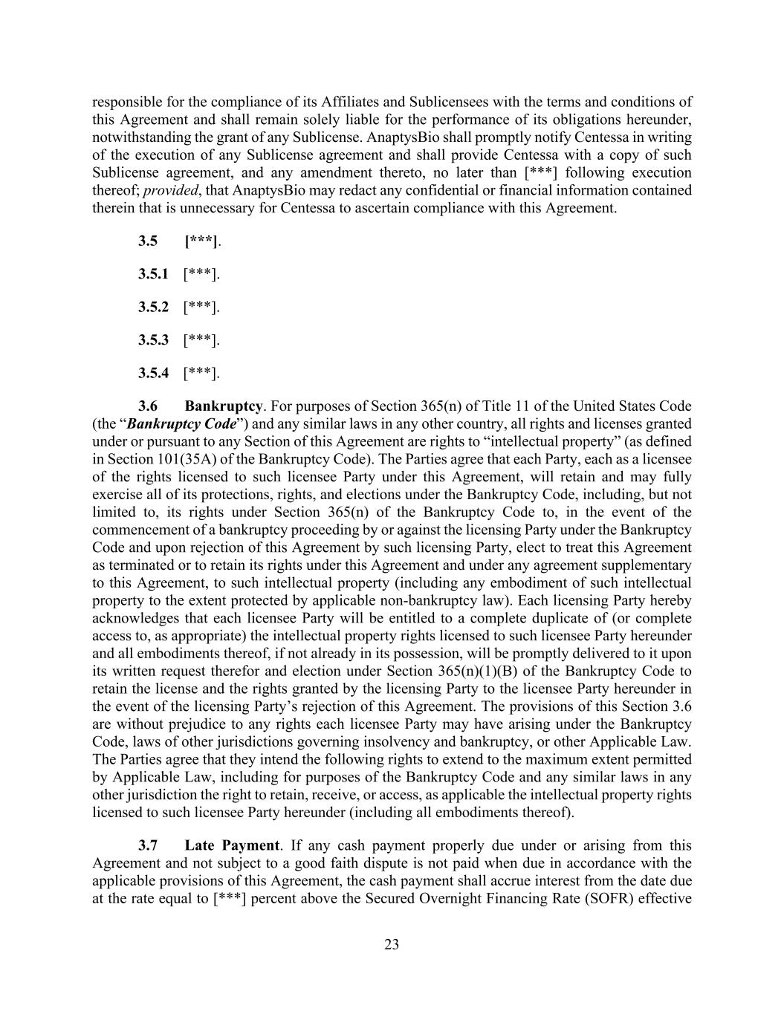
23 responsible for the compliance of its Affiliates and Sublicensees with the terms and conditions of this Agreement and shall remain solely liable for the performance of its obligations hereunder, notwithstanding the grant of any Sublicense. AnaptysBio shall promptly notify Centessa in writing of the execution of any Sublicense agreement and shall provide Centessa with a copy of such Sublicense agreement, and any amendment thereto, no later than [***] following execution thereof; provided, that AnaptysBio may redact any confidential or financial information contained therein that is unnecessary for Centessa to ascertain compliance with this Agreement. 3.5 [***]. 3.5.1 [***]. 3.5.2 [***]. 3.5.3 [***]. 3.5.4 [***]. 3.6 Bankruptcy. For purposes of Section 365(n) of Title 11 of the United States Code (the “Bankruptcy Code”) and any similar laws in any other country, all rights and licenses granted under or pursuant to any Section of this Agreement are rights to “intellectual property” (as defined in Section 101(35A) of the Bankruptcy Code). The Parties agree that each Party, each as a licensee of the rights licensed to such licensee Party under this Agreement, will retain and may fully exercise all of its protections, rights, and elections under the Bankruptcy Code, including, but not limited to, its rights under Section 365(n) of the Bankruptcy Code to, in the event of the commencement of a bankruptcy proceeding by or against the licensing Party under the Bankruptcy Code and upon rejection of this Agreement by such licensing Party, elect to treat this Agreement as terminated or to retain its rights under this Agreement and under any agreement supplementary to this Agreement, to such intellectual property (including any embodiment of such intellectual property to the extent protected by applicable non-bankruptcy law). Each licensing Party hereby acknowledges that each licensee Party will be entitled to a complete duplicate of (or complete access to, as appropriate) the intellectual property rights licensed to such licensee Party hereunder and all embodiments thereof, if not already in its possession, will be promptly delivered to it upon its written request therefor and election under Section 365(n)(1)(B) of the Bankruptcy Code to retain the license and the rights granted by the licensing Party to the licensee Party hereunder in the event of the licensing Party’s rejection of this Agreement. The provisions of this Section 3.6 are without prejudice to any rights each licensee Party may have arising under the Bankruptcy Code, laws of other jurisdictions governing insolvency and bankruptcy, or other Applicable Law. The Parties agree that they intend the following rights to extend to the maximum extent permitted by Applicable Law, including for purposes of the Bankruptcy Code and any similar laws in any other jurisdiction the right to retain, receive, or access, as applicable the intellectual property rights licensed to such licensee Party hereunder (including all embodiments thereof). 3.7 Late Payment. If any cash payment properly due under or arising from this Agreement and not subject to a good faith dispute is not paid when due in accordance with the applicable provisions of this Agreement, the cash payment shall accrue interest from the date due at the rate equal to [***] percent above the Secured Overnight Financing Rate (SOFR) effective

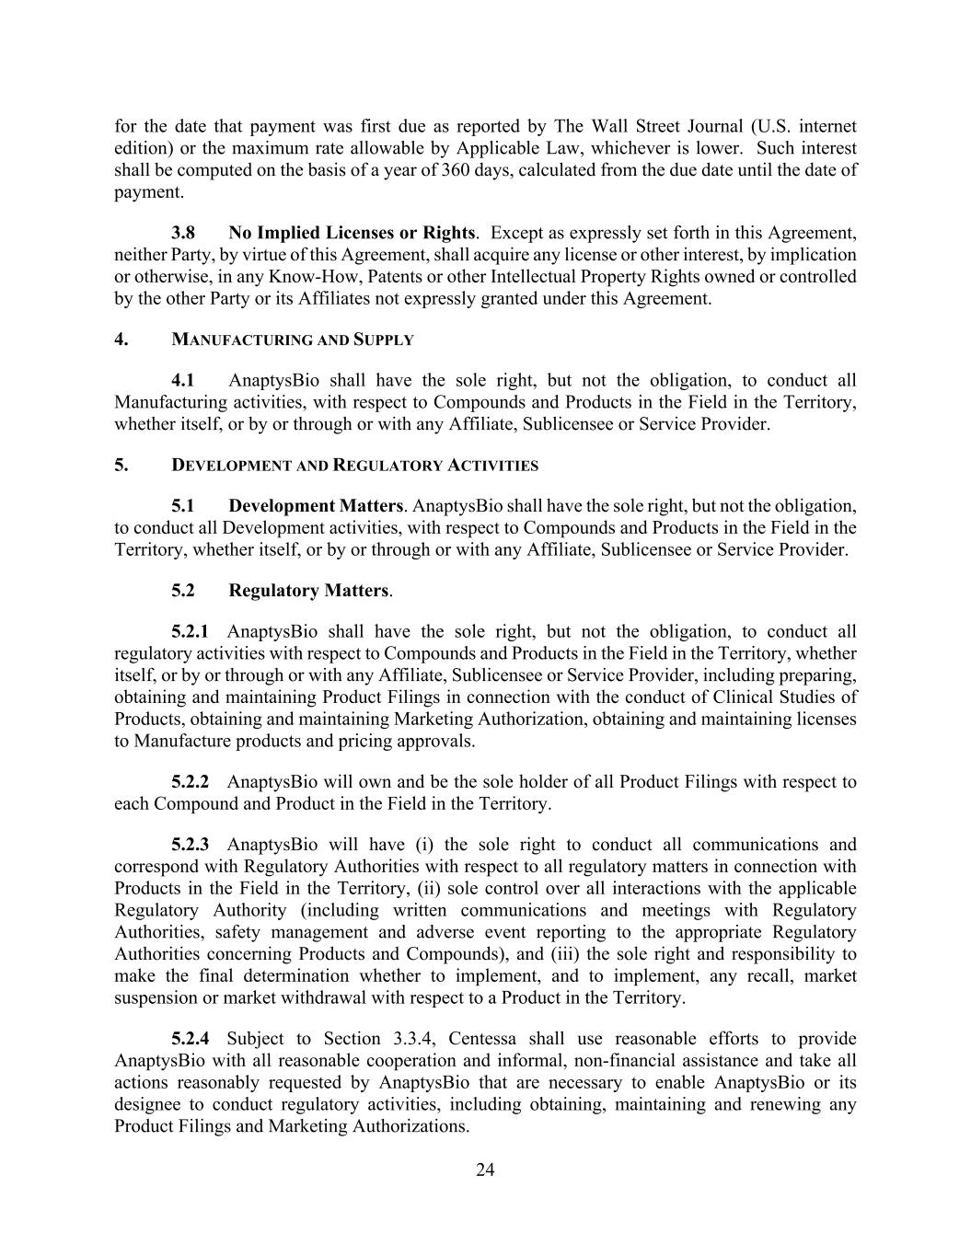
24 for the date that payment was first due as reported by The Wall Street Journal (U.S. internet edition) or the maximum rate allowable by Applicable Law, whichever is lower. Such interest shall be computed on the basis of a year of 360 days, calculated from the due date until the date of payment. 3.8 No Implied Licenses or Rights. Except as expressly set forth in this Agreement, neither Party, by virtue of this Agreement, shall acquire any license or other interest, by implication or otherwise, in any Know-How, Patents or other Intellectual Property Rights owned or controlled by the other Party or its Affiliates not expressly granted under this Agreement. 4. MANUFACTURING AND SUPPLY 4.1 AnaptysBio shall have the sole right, but not the obligation, to conduct all Manufacturing activities, with respect to Compounds and Products in the Field in the Territory, whether itself, or by or through or with any Affiliate, Sublicensee or Service Provider. 5. DEVELOPMENT AND REGULATORY ACTIVITIES 5.1 Development Matters. AnaptysBio shall have the sole right, but not the obligation, to conduct all Development activities, with respect to Compounds and Products in the Field in the Territory, whether itself, or by or through or with any Affiliate, Sublicensee or Service Provider. 5.2 Regulatory Matters. 5.2.1 AnaptysBio shall have the sole right, but not the obligation, to conduct all regulatory activities with respect to Compounds and Products in the Field in the Territory, whether itself, or by or through or with any Affiliate, Sublicensee or Service Provider, including preparing, obtaining and maintaining Product Filings in connection with the conduct of Clinical Studies of Products, obtaining and maintaining Marketing Authorization, obtaining and maintaining licenses to Manufacture products and pricing approvals. 5.2.2 AnaptysBio will own and be the sole holder of all Product Filings with respect to each Compound and Product in the Field in the Territory. 5.2.3 AnaptysBio will have (i) the sole right to conduct all communications and correspond with Regulatory Authorities with respect to all regulatory matters in connection with Products in the Field in the Territory, (ii) sole control over all interactions with the applicable Regulatory Authority (including written communications and meetings with Regulatory Authorities, safety management and adverse event reporting to the appropriate Regulatory Authorities concerning Products and Compounds), and (iii) the sole right and responsibility to make the final determination whether to implement, and to implement, any recall, market suspension or market withdrawal with respect to a Product in the Territory. 5.2.4 Subject to Section 3.3.4, Centessa shall use reasonable efforts to provide AnaptysBio with all reasonable cooperation and informal, non-financial assistance and take all actions reasonably requested by AnaptysBio that are necessary to enable AnaptysBio or its designee to conduct regulatory activities, including obtaining, maintaining and renewing any Product Filings and Marketing Authorizations.

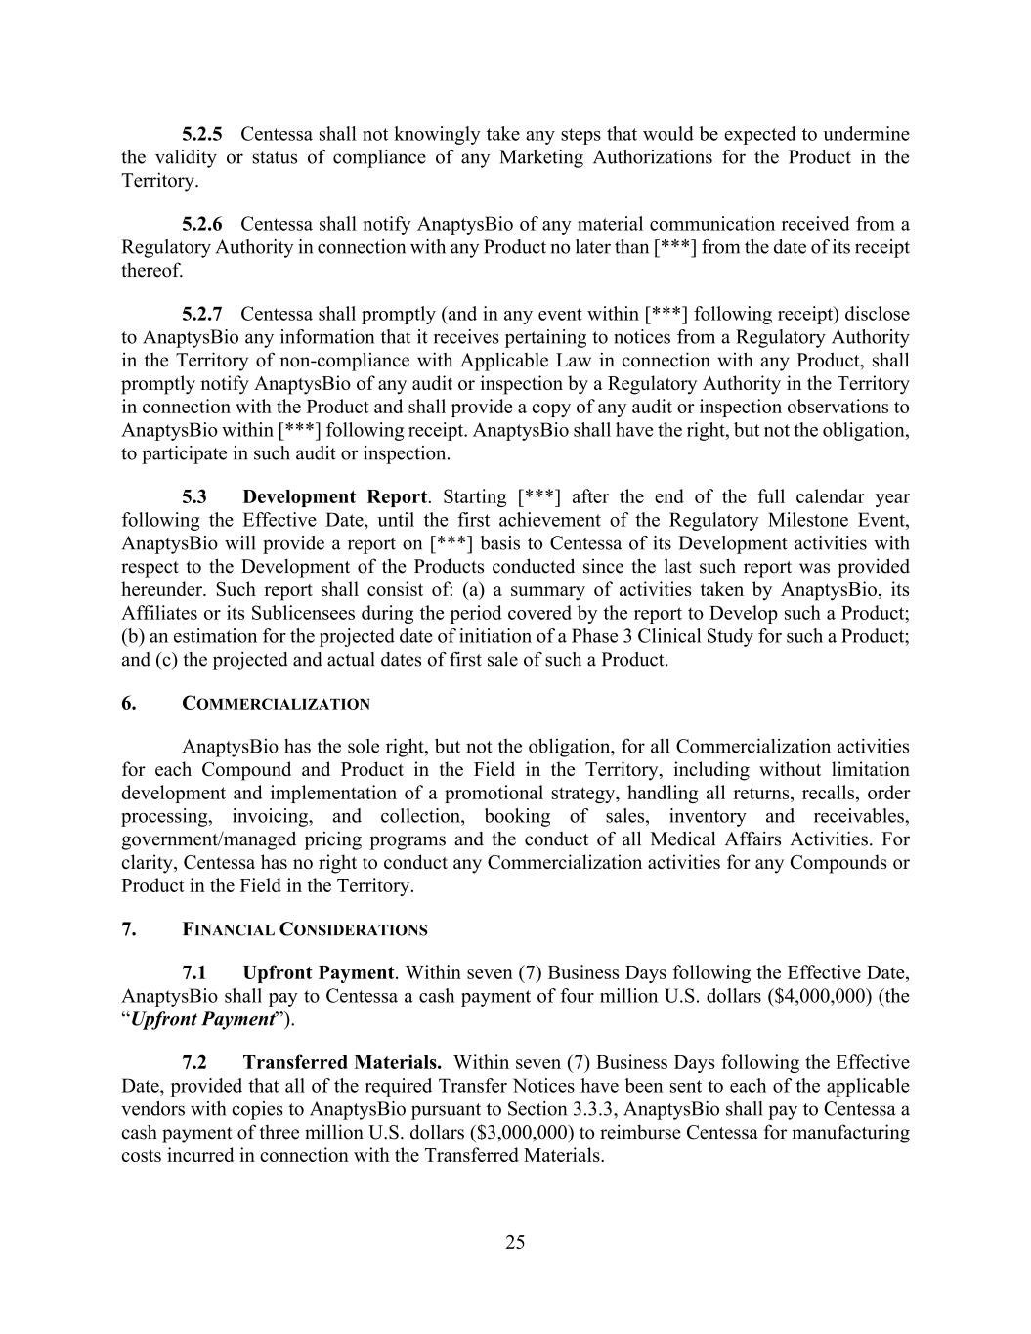
25 5.2.5 Centessa shall not knowingly take any steps that would be expected to undermine the validity or status of compliance of any Marketing Authorizations for the Product in the Territory. 5.2.6 Centessa shall notify AnaptysBio of any material communication received from a Regulatory Authority in connection with any Product no later than [***] from the date of its receipt thereof. 5.2.7 Centessa shall promptly (and in any event within [***] following receipt) disclose to AnaptysBio any information that it receives pertaining to notices from a Regulatory Authority in the Territory of non-compliance with Applicable Law in connection with any Product, shall promptly notify AnaptysBio of any audit or inspection by a Regulatory Authority in the Territory in connection with the Product and shall provide a copy of any audit or inspection observations to AnaptysBio within [***] following receipt. AnaptysBio shall have the right, but not the obligation, to participate in such audit or inspection. 5.3 Development Report. Starting [***] after the end of the full calendar year following the Effective Date, until the first achievement of the Regulatory Milestone Event, AnaptysBio will provide a report on [***] basis to Centessa of its Development activities with respect to the Development of the Products conducted since the last such report was provided hereunder. Such report shall consist of: (a) a summary of activities taken by AnaptysBio, its Affiliates or its Sublicensees during the period covered by the report to Develop such a Product; (b) an estimation for the projected date of initiation of a Phase 3 Clinical Study for such a Product; and (c) the projected and actual dates of first sale of such a Product. 6. COMMERCIALIZATION AnaptysBio has the sole right, but not the obligation, for all Commercialization activities for each Compound and Product in the Field in the Territory, including without limitation development and implementation of a promotional strategy, handling all returns, recalls, order processing, invoicing, and collection, booking of sales, inventory and receivables, government/managed pricing programs and the conduct of all Medical Affairs Activities. For clarity, Centessa has no right to conduct any Commercialization activities for any Compounds or Product in the Field in the Territory. 7. FINANCIAL CONSIDERATIONS 7.1 Upfront Payment. Within seven (7) Business Days following the Effective Date, AnaptysBio shall pay to Centessa a cash payment of four million U.S. dollars ($4,000,000) (the “Upfront Payment”). 7.2 Transferred Materials. Within seven (7) Business Days following the Effective Date, provided that all of the required Transfer Notices have been sent to each of the applicable vendors with copies to AnaptysBio pursuant to Section 3.3.3, AnaptysBio shall pay to Centessa a cash payment of three million U.S. dollars ($3,000,000) to reimburse Centessa for manufacturing costs incurred in connection with the Transferred Materials.

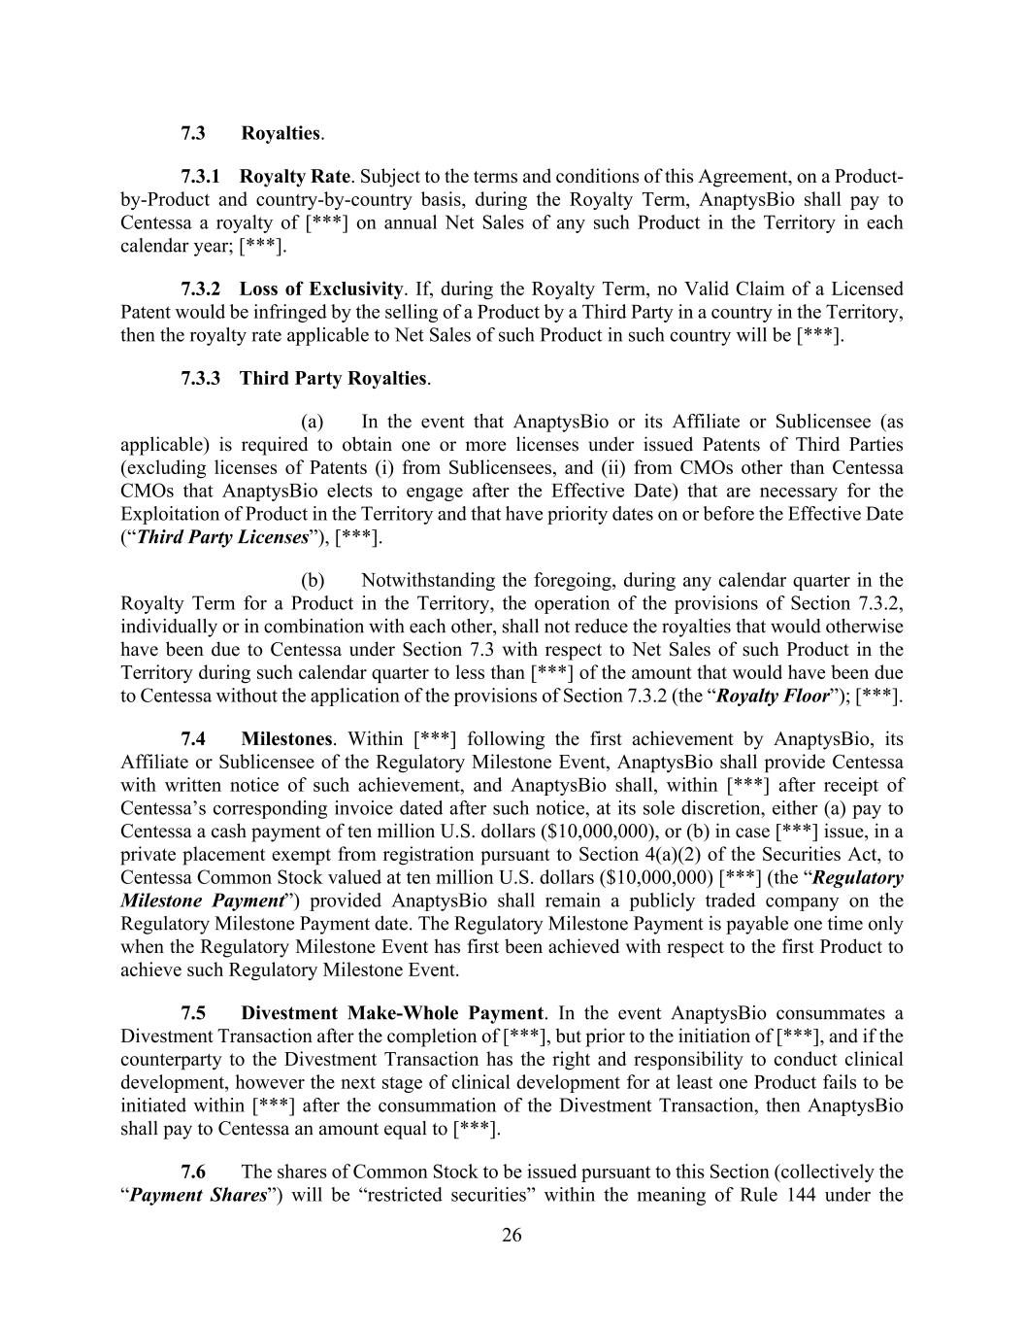
26 7.3 Royalties. 7.3.1 Royalty Rate. Subject to the terms and conditions of this Agreement, on a Product- by-Product and country-by-country basis, during the Royalty Term, AnaptysBio shall pay to Centessa a royalty of [***] on annual Net Sales of any such Product in the Territory in each calendar year; [***]. 7.3.2 Loss of Exclusivity. If, during the Royalty Term, no Valid Claim of a Licensed Patent would be infringed by the selling of a Product by a Third Party in a country in the Territory, then the royalty rate applicable to Net Sales of such Product in such country will be [***]. 7.3.3 Third Party Royalties. (a) In the event that AnaptysBio or its Affiliate or Sublicensee (as applicable) is required to obtain one or more licenses under issued Patents of Third Parties (excluding licenses of Patents (i) from Sublicensees, and (ii) from CMOs other than Centessa CMOs that AnaptysBio elects to engage after the Effective Date) that are necessary for the Exploitation of Product in the Territory and that have priority dates on or before the Effective Date (“Third Party Licenses”), [***]. (b) Notwithstanding the foregoing, during any calendar quarter in the Royalty Term for a Product in the Territory, the operation of the provisions of Section 7.3.2, individually or in combination with each other, shall not reduce the royalties that would otherwise have been due to Centessa under Section 7.3 with respect to Net Sales of such Product in the Territory during such calendar quarter to less than [***] of the amount that would have been due to Centessa without the application of the provisions of Section 7.3.2 (the “Royalty Floor”); [***]. 7.4 Milestones. Within [***] following the first achievement by AnaptysBio, its Affiliate or Sublicensee of the Regulatory Milestone Event, AnaptysBio shall provide Centessa with written notice of such achievement, and AnaptysBio shall, within [***] after receipt of Centessa’s corresponding invoice dated after such notice, at its sole discretion, either (a) pay to Centessa a cash payment of ten million U.S. dollars ($10,000,000), or (b) in case [***] issue, in a private placement exempt from registration pursuant to Section 4(a)(2) of the Securities Act, to Centessa Common Stock valued at ten million U.S. dollars ($10,000,000) [***] (the “Regulatory Milestone Payment”) provided AnaptysBio shall remain a publicly traded company on the Regulatory Milestone Payment date. The Regulatory Milestone Payment is payable one time only when the Regulatory Milestone Event has first been achieved with respect to the first Product to achieve such Regulatory Milestone Event. 7.5 Divestment Make-Whole Payment. In the event AnaptysBio consummates a Divestment Transaction after the completion of [***], but prior to the initiation of [***], and if the counterparty to the Divestment Transaction has the right and responsibility to conduct clinical development, however the next stage of clinical development for at least one Product fails to be initiated within [***] after the consummation of the Divestment Transaction, then AnaptysBio shall pay to Centessa an amount equal to [***]. 7.6 The shares of Common Stock to be issued pursuant to this Section (collectively the “Payment Shares”) will be “restricted securities” within the meaning of Rule 144 under the

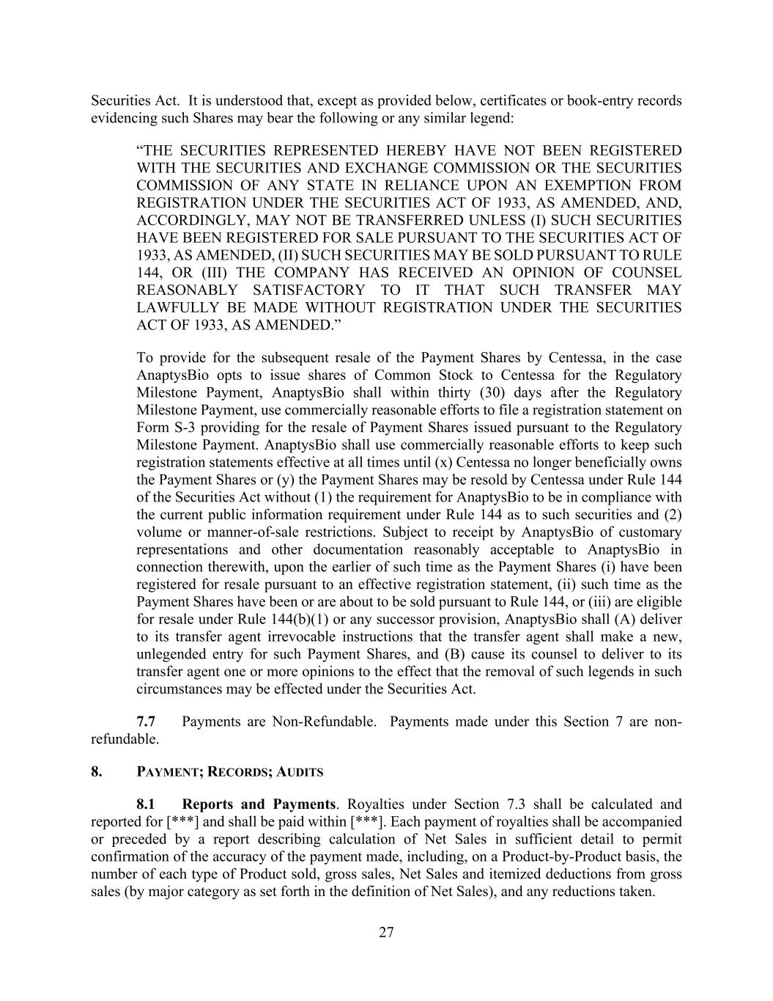
27 Securities Act. It is understood that, except as provided below, certificates or book-entry records evidencing such Shares may bear the following or any similar legend: “THE SECURITIES REPRESENTED HEREBY HAVE NOT BEEN REGISTERED WITH THE SECURITIES AND EXCHANGE COMMISSION OR THE SECURITIES COMMISSION OF ANY STATE IN RELIANCE UPON AN EXEMPTION FROM REGISTRATION UNDER THE SECURITIES ACT OF 1933, AS AMENDED, AND, ACCORDINGLY, MAY NOT BE TRANSFERRED UNLESS (I) SUCH SECURITIES HAVE BEEN REGISTERED FOR SALE PURSUANT TO THE SECURITIES ACT OF 1933, AS AMENDED, (II) SUCH SECURITIES MAY BE SOLD PURSUANT TO RULE 144, OR (III) THE COMPANY HAS RECEIVED AN OPINION OF COUNSEL REASONABLY SATISFACTORY TO IT THAT SUCH TRANSFER MAY LAWFULLY BE MADE WITHOUT REGISTRATION UNDER THE SECURITIES ACT OF 1933, AS AMENDED.” To provide for the subsequent resale of the Payment Shares by Centessa, in the case AnaptysBio opts to issue shares of Common Stock to Centessa for the Regulatory Milestone Payment, AnaptysBio shall within thirty (30) days after the Regulatory Milestone Payment, use commercially reasonable efforts to file a registration statement on Form S-3 providing for the resale of Payment Shares issued pursuant to the Regulatory Milestone Payment. AnaptysBio shall use commercially reasonable efforts to keep such registration statements effective at all times until (x) Centessa no longer beneficially owns the Payment Shares or (y) the Payment Shares may be resold by Centessa under Rule 144 of the Securities Act without (1) the requirement for AnaptysBio to be in compliance with the current public information requirement under Rule 144 as to such securities and (2) volume or manner-of-sale restrictions. Subject to receipt by AnaptysBio of customary representations and other documentation reasonably acceptable to AnaptysBio in connection therewith, upon the earlier of such time as the Payment Shares (i) have been registered for resale pursuant to an effective registration statement, (ii) such time as the Payment Shares have been or are about to be sold pursuant to Rule 144, or (iii) are eligible for resale under Rule 144(b)(1) or any successor provision, AnaptysBio shall (A) deliver to its transfer agent irrevocable instructions that the transfer agent shall make a new, unlegended entry for such Payment Shares, and (B) cause its counsel to deliver to its transfer agent one or more opinions to the effect that the removal of such legends in such circumstances may be effected under the Securities Act. 7.7 Payments are Non-Refundable. Payments made under this Section 7 are non- refundable. 8. PAYMENT; RECORDS; AUDITS 8.1 Reports and Payments. Royalties under Section 7.3 shall be calculated and reported for [***] and shall be paid within [***]. Each payment of royalties shall be accompanied or preceded by a report describing calculation of Net Sales in sufficient detail to permit confirmation of the accuracy of the payment made, including, on a Product-by-Product basis, the number of each type of Product sold, gross sales, Net Sales and itemized deductions from gross sales (by major category as set forth in the definition of Net Sales), and any reductions taken.

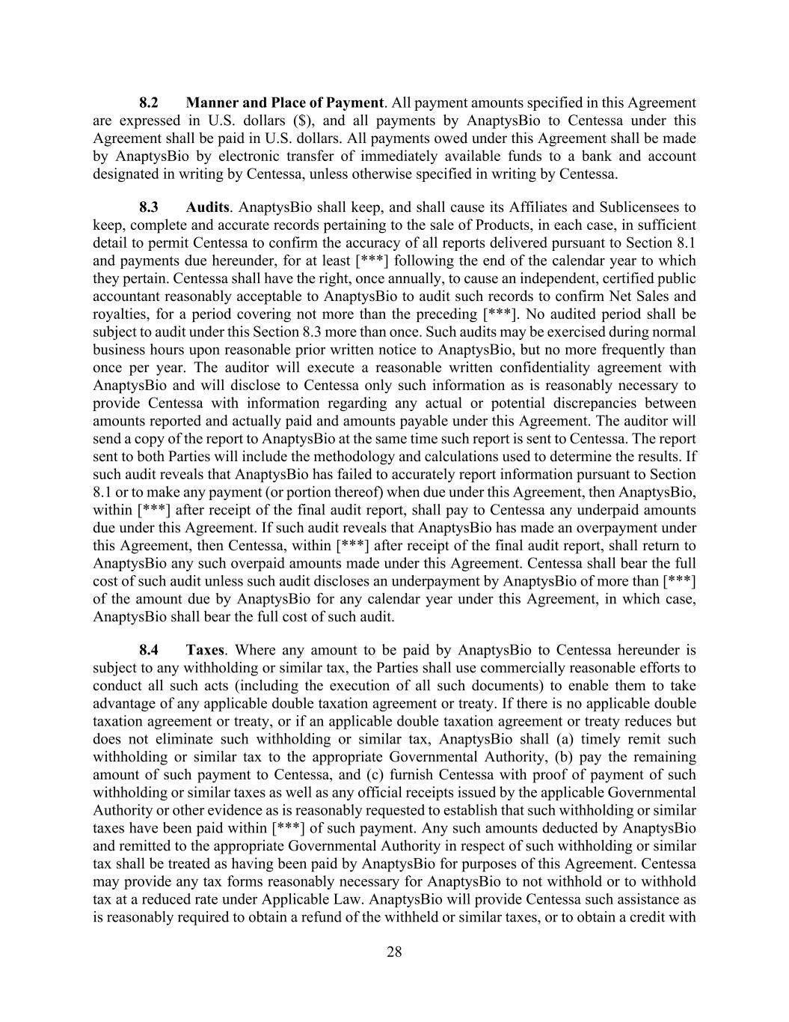
28 8.2 Manner and Place of Payment. All payment amounts specified in this Agreement are expressed in U.S. dollars ($), and all payments by AnaptysBio to Centessa under this Agreement shall be paid in U.S. dollars. All payments owed under this Agreement shall be made by AnaptysBio by electronic transfer of immediately available funds to a bank and account designated in writing by Centessa, unless otherwise specified in writing by Centessa. 8.3 Audits. AnaptysBio shall keep, and shall cause its Affiliates and Sublicensees to keep, complete and accurate records pertaining to the sale of Products, in each case, in sufficient detail to permit Centessa to confirm the accuracy of all reports delivered pursuant to Section 8.1 and payments due hereunder, for at least [***] following the end of the calendar year to which they pertain. Centessa shall have the right, once annually, to cause an independent, certified public accountant reasonably acceptable to AnaptysBio to audit such records to confirm Net Sales and royalties, for a period covering not more than the preceding [***]. No audited period shall be subject to audit under this Section 8.3 more than once. Such audits may be exercised during normal business hours upon reasonable prior written notice to AnaptysBio, but no more frequently than once per year. The auditor will execute a reasonable written confidentiality agreement with AnaptysBio and will disclose to Centessa only such information as is reasonably necessary to provide Centessa with information regarding any actual or potential discrepancies between amounts reported and actually paid and amounts payable under this Agreement. The auditor will send a copy of the report to AnaptysBio at the same time such report is sent to Centessa. The report sent to both Parties will include the methodology and calculations used to determine the results. If such audit reveals that AnaptysBio has failed to accurately report information pursuant to Section 8.1 or to make any payment (or portion thereof) when due under this Agreement, then AnaptysBio, within [***] after receipt of the final audit report, shall pay to Centessa any underpaid amounts due under this Agreement. If such audit reveals that AnaptysBio has made an overpayment under this Agreement, then Centessa, within [***] after receipt of the final audit report, shall return to AnaptysBio any such overpaid amounts made under this Agreement. Centessa shall bear the full cost of such audit unless such audit discloses an underpayment by AnaptysBio of more than [***] of the amount due by AnaptysBio for any calendar year under this Agreement, in which case, AnaptysBio shall bear the full cost of such audit. 8.4 Taxes. Where any amount to be paid by AnaptysBio to Centessa hereunder is subject to any withholding or similar tax, the Parties shall use commercially reasonable efforts to conduct all such acts (including the execution of all such documents) to enable them to take advantage of any applicable double taxation agreement or treaty. If there is no applicable double taxation agreement or treaty, or if an applicable double taxation agreement or treaty reduces but does not eliminate such withholding or similar tax, AnaptysBio shall (a) timely remit such withholding or similar tax to the appropriate Governmental Authority, (b) pay the remaining amount of such payment to Centessa, and (c) furnish Centessa with proof of payment of such withholding or similar taxes as well as any official receipts issued by the applicable Governmental Authority or other evidence as is reasonably requested to establish that such withholding or similar taxes have been paid within [***] of such payment. Any such amounts deducted by AnaptysBio and remitted to the appropriate Governmental Authority in respect of such withholding or similar tax shall be treated as having been paid by AnaptysBio for purposes of this Agreement. Centessa may provide any tax forms reasonably necessary for AnaptysBio to not withhold or to withhold tax at a reduced rate under Applicable Law. AnaptysBio will provide Centessa such assistance as is reasonably required to obtain a refund of the withheld or similar taxes, or to obtain a credit with

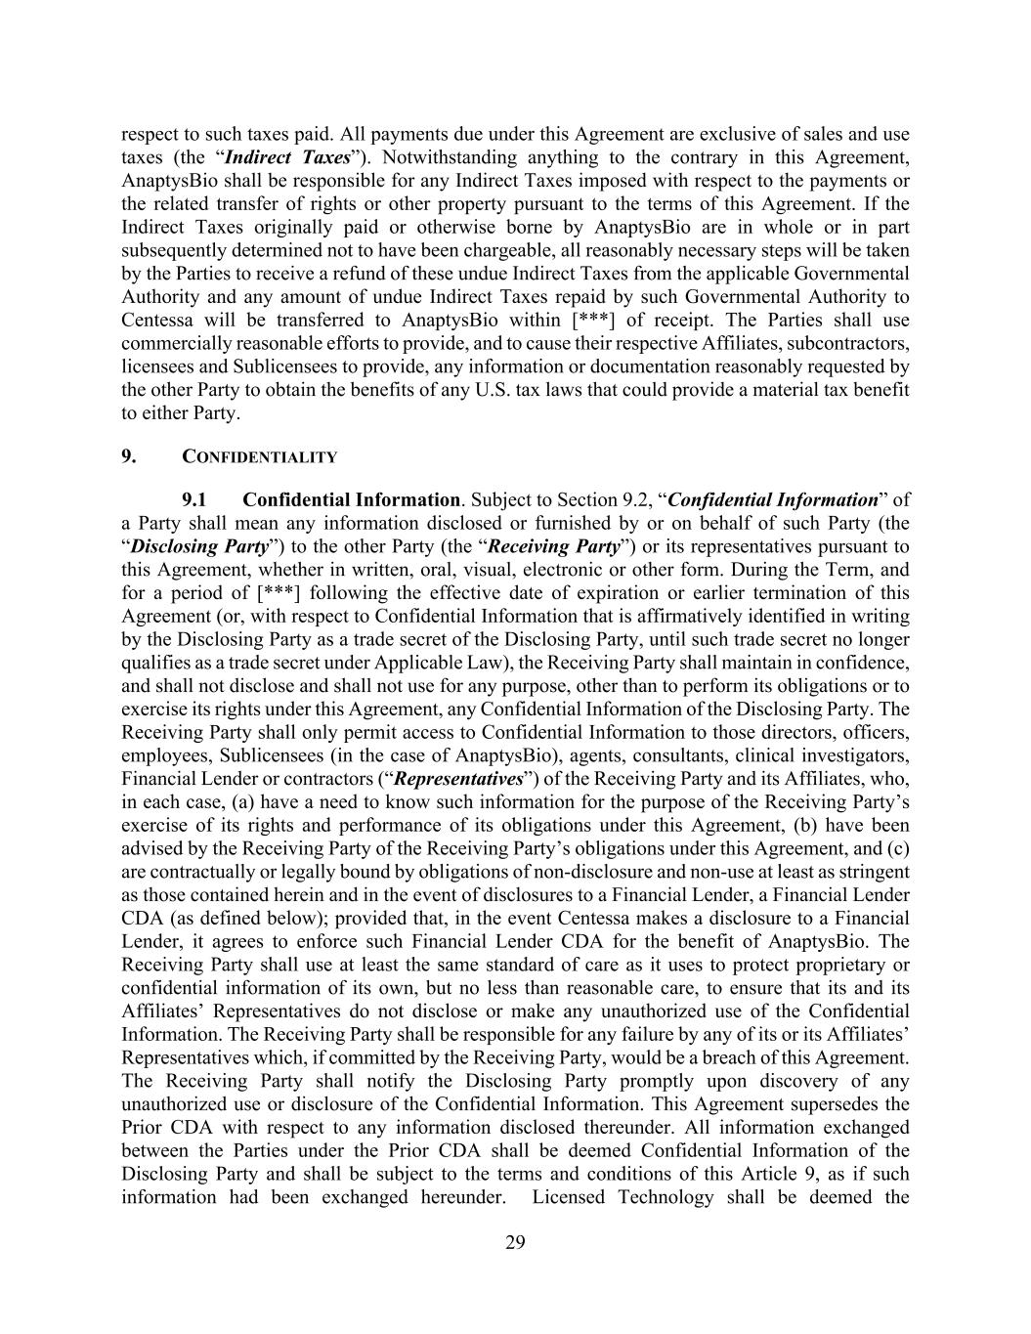
29 respect to such taxes paid. All payments due under this Agreement are exclusive of sales and use taxes (the “Indirect Taxes”). Notwithstanding anything to the contrary in this Agreement, AnaptysBio shall be responsible for any Indirect Taxes imposed with respect to the payments or the related transfer of rights or other property pursuant to the terms of this Agreement. If the Indirect Taxes originally paid or otherwise borne by AnaptysBio are in whole or in part subsequently determined not to have been chargeable, all reasonably necessary steps will be taken by the Parties to receive a refund of these undue Indirect Taxes from the applicable Governmental Authority and any amount of undue Indirect Taxes repaid by such Governmental Authority to Centessa will be transferred to AnaptysBio within [***] of receipt. The Parties shall use commercially reasonable efforts to provide, and to cause their respective Affiliates, subcontractors, licensees and Sublicensees to provide, any information or documentation reasonably requested by the other Party to obtain the benefits of any U.S. tax laws that could provide a material tax benefit to either Party. 9. CONFIDENTIALITY 9.1 Confidential Information. Subject to Section 9.2, “Confidential Information” of a Party shall mean any information disclosed or furnished by or on behalf of such Party (the “Disclosing Party”) to the other Party (the “Receiving Party”) or its representatives pursuant to this Agreement, whether in written, oral, visual, electronic or other form. During the Term, and for a period of [***] following the effective date of expiration or earlier termination of this Agreement (or, with respect to Confidential Information that is affirmatively identified in writing by the Disclosing Party as a trade secret of the Disclosing Party, until such trade secret no longer qualifies as a trade secret under Applicable Law), the Receiving Party shall maintain in confidence, and shall not disclose and shall not use for any purpose, other than to perform its obligations or to exercise its rights under this Agreement, any Confidential Information of the Disclosing Party. The Receiving Party shall only permit access to Confidential Information to those directors, officers, employees, Sublicensees (in the case of AnaptysBio), agents, consultants, clinical investigators, Financial Lender or contractors (“Representatives”) of the Receiving Party and its Affiliates, who, in each case, (a) have a need to know such information for the purpose of the Receiving Party’s exercise of its rights and performance of its obligations under this Agreement, (b) have been advised by the Receiving Party of the Receiving Party’s obligations under this Agreement, and (c) are contractually or legally bound by obligations of non-disclosure and non-use at least as stringent as those contained herein and in the event of disclosures to a Financial Lender, a Financial Lender CDA (as defined below); provided that, in the event Centessa makes a disclosure to a Financial Lender, it agrees to enforce such Financial Lender CDA for the benefit of AnaptysBio. The Receiving Party shall use at least the same standard of care as it uses to protect proprietary or confidential information of its own, but no less than reasonable care, to ensure that its and its Affiliates’ Representatives do not disclose or make any unauthorized use of the Confidential Information. The Receiving Party shall be responsible for any failure by any of its or its Affiliates’ Representatives which, if committed by the Receiving Party, would be a breach of this Agreement. The Receiving Party shall notify the Disclosing Party promptly upon discovery of any unauthorized use or disclosure of the Confidential Information. This Agreement supersedes the Prior CDA with respect to any information disclosed thereunder. All information exchanged between the Parties under the Prior CDA shall be deemed Confidential Information of the Disclosing Party and shall be subject to the terms and conditions of this Article 9, as if such information had been exchanged hereunder. Licensed Technology shall be deemed the

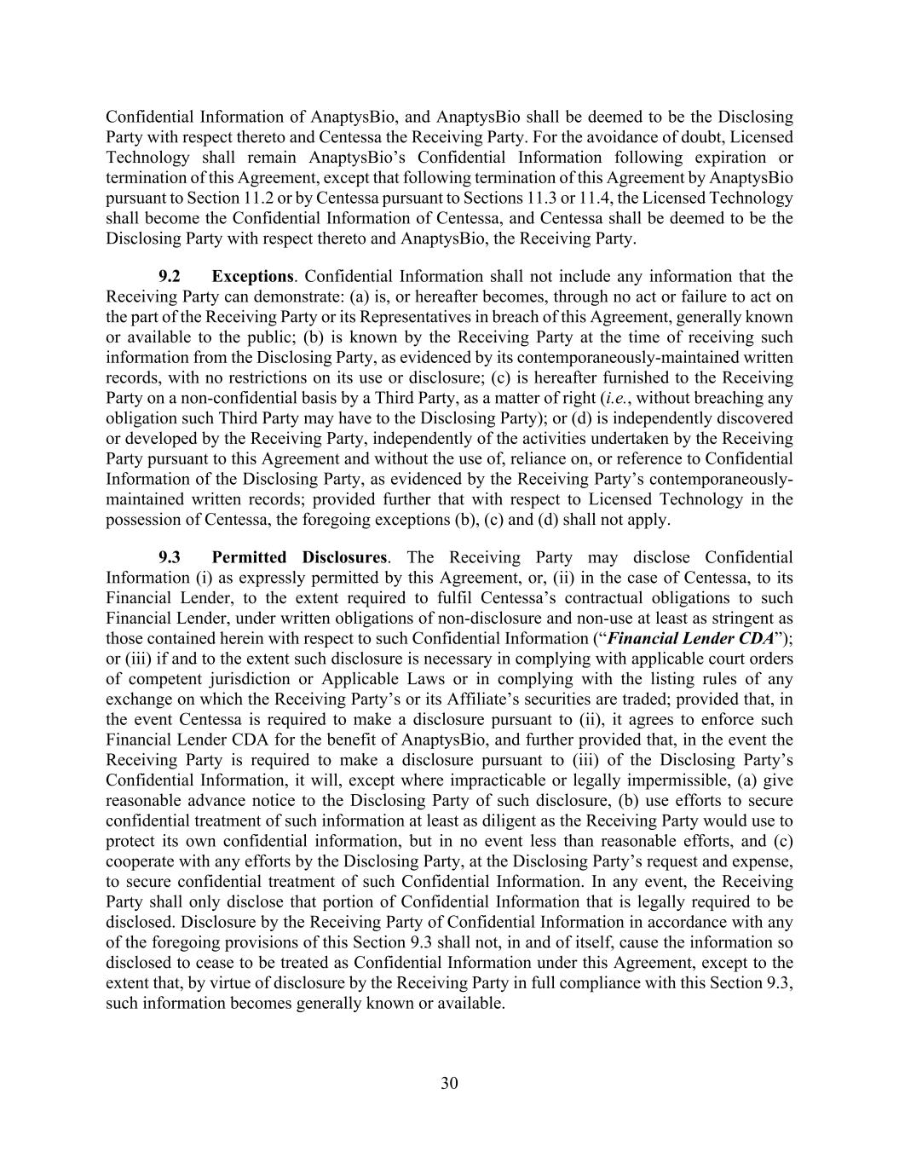
30 Confidential Information of AnaptysBio, and AnaptysBio shall be deemed to be the Disclosing Party with respect thereto and Centessa the Receiving Party. For the avoidance of doubt, Licensed Technology shall remain AnaptysBio’s Confidential Information following expiration or termination of this Agreement, except that following termination of this Agreement by AnaptysBio pursuant to Section 11.2 or by Centessa pursuant to Sections 11.3 or 11.4, the Licensed Technology shall become the Confidential Information of Centessa, and Centessa shall be deemed to be the Disclosing Party with respect thereto and AnaptysBio, the Receiving Party. 9.2 Exceptions. Confidential Information shall not include any information that the Receiving Party can demonstrate: (a) is, or hereafter becomes, through no act or failure to act on the part of the Receiving Party or its Representatives in breach of this Agreement, generally known or available to the public; (b) is known by the Receiving Party at the time of receiving such information from the Disclosing Party, as evidenced by its contemporaneously-maintained written records, with no restrictions on its use or disclosure; (c) is hereafter furnished to the Receiving Party on a non-confidential basis by a Third Party, as a matter of right (i.e., without breaching any obligation such Third Party may have to the Disclosing Party); or (d) is independently discovered or developed by the Receiving Party, independently of the activities undertaken by the Receiving Party pursuant to this Agreement and without the use of, reliance on, or reference to Confidential Information of the Disclosing Party, as evidenced by the Receiving Party’s contemporaneously- maintained written records; provided further that with respect to Licensed Technology in the possession of Centessa, the foregoing exceptions (b), (c) and (d) shall not apply. 9.3 Permitted Disclosures. The Receiving Party may disclose Confidential Information (i) as expressly permitted by this Agreement, or, (ii) in the case of Centessa, to its Financial Lender, to the extent required to fulfil Centessa’s contractual obligations to such Financial Lender, under written obligations of non-disclosure and non-use at least as stringent as those contained herein with respect to such Confidential Information (“Financial Lender CDA”); or (iii) if and to the extent such disclosure is necessary in complying with applicable court orders of competent jurisdiction or Applicable Laws or in complying with the listing rules of any exchange on which the Receiving Party’s or its Affiliate’s securities are traded; provided that, in the event Centessa is required to make a disclosure pursuant to (ii), it agrees to enforce such Financial Lender CDA for the benefit of AnaptysBio, and further provided that, in the event the Receiving Party is required to make a disclosure pursuant to (iii) of the Disclosing Party’s Confidential Information, it will, except where impracticable or legally impermissible, (a) give reasonable advance notice to the Disclosing Party of such disclosure, (b) use efforts to secure confidential treatment of such information at least as diligent as the Receiving Party would use to protect its own confidential information, but in no event less than reasonable efforts, and (c) cooperate with any efforts by the Disclosing Party, at the Disclosing Party’s request and expense, to secure confidential treatment of such Confidential Information. In any event, the Receiving Party shall only disclose that portion of Confidential Information that is legally required to be disclosed. Disclosure by the Receiving Party of Confidential Information in accordance with any of the foregoing provisions of this Section 9.3 shall not, in and of itself, cause the information so disclosed to cease to be treated as Confidential Information under this Agreement, except to the extent that, by virtue of disclosure by the Receiving Party in full compliance with this Section 9.3, such information becomes generally known or available.

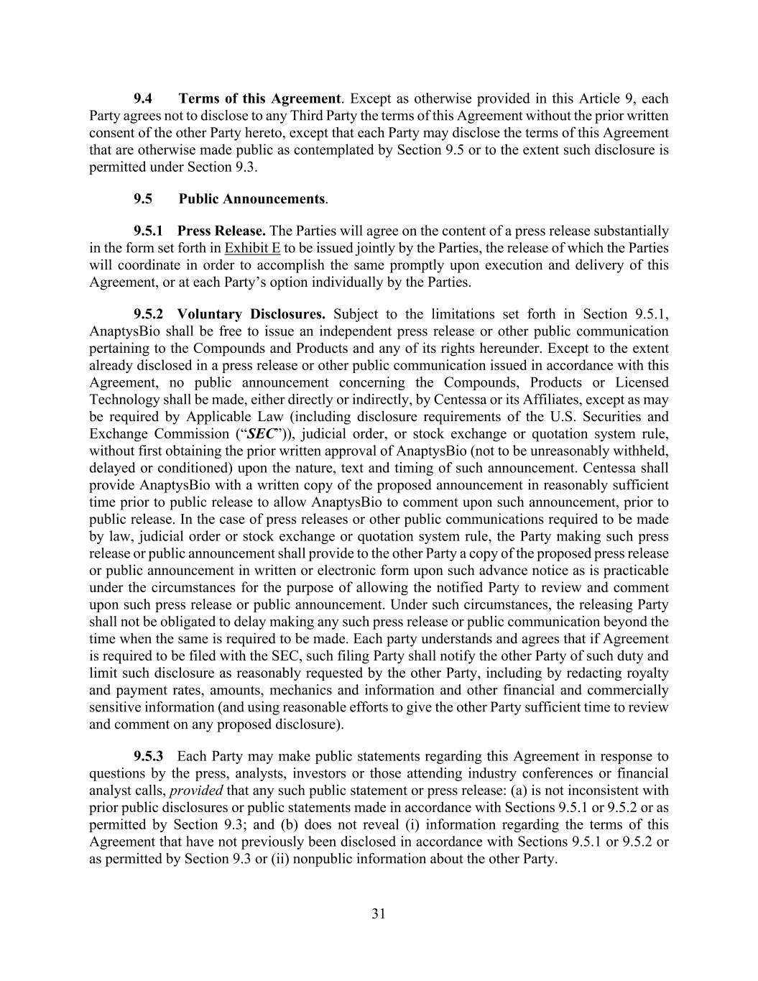
31 9.4 Terms of this Agreement. Except as otherwise provided in this Article 9, each Party agrees not to disclose to any Third Party the terms of this Agreement without the prior written consent of the other Party hereto, except that each Party may disclose the terms of this Agreement that are otherwise made public as contemplated by Section 9.5 or to the extent such disclosure is permitted under Section 9.3. 9.5 Public Announcements. 9.5.1 Press Release. The Parties will agree on the content of a press release substantially in the form set forth in Exhibit E to be issued jointly by the Parties, the release of which the Parties will coordinate in order to accomplish the same promptly upon execution and delivery of this Agreement, or at each Party’s option individually by the Parties. 9.5.2 Voluntary Disclosures. Subject to the limitations set forth in Section 9.5.1, AnaptysBio shall be free to issue an independent press release or other public communication pertaining to the Compounds and Products and any of its rights hereunder. Except to the extent already disclosed in a press release or other public communication issued in accordance with this Agreement, no public announcement concerning the Compounds, Products or Licensed Technology shall be made, either directly or indirectly, by Centessa or its Affiliates, except as may be required by Applicable Law (including disclosure requirements of the U.S. Securities and Exchange Commission (“SEC”)), judicial order, or stock exchange or quotation system rule, without first obtaining the prior written approval of AnaptysBio (not to be unreasonably withheld, delayed or conditioned) upon the nature, text and timing of such announcement. Centessa shall provide AnaptysBio with a written copy of the proposed announcement in reasonably sufficient time prior to public release to allow AnaptysBio to comment upon such announcement, prior to public release. In the case of press releases or other public communications required to be made by law, judicial order or stock exchange or quotation system rule, the Party making such press release or public announcement shall provide to the other Party a copy of the proposed press release or public announcement in written or electronic form upon such advance notice as is practicable under the circumstances for the purpose of allowing the notified Party to review and comment upon such press release or public announcement. Under such circumstances, the releasing Party shall not be obligated to delay making any such press release or public communication beyond the time when the same is required to be made. Each party understands and agrees that if Agreement is required to be filed with the SEC, such filing Party shall notify the other Party of such duty and limit such disclosure as reasonably requested by the other Party, including by redacting royalty and payment rates, amounts, mechanics and information and other financial and commercially sensitive information (and using reasonable efforts to give the other Party sufficient time to review and comment on any proposed disclosure). 9.5.3 Each Party may make public statements regarding this Agreement in response to questions by the press, analysts, investors or those attending industry conferences or financial analyst calls, provided that any such public statement or press release: (a) is not inconsistent with prior public disclosures or public statements made in accordance with Sections 9.5.1 or 9.5.2 or as permitted by Section 9.3; and (b) does not reveal (i) information regarding the terms of this Agreement that have not previously been disclosed in accordance with Sections 9.5.1 or 9.5.2 or as permitted by Section 9.3 or (ii) nonpublic information about the other Party.

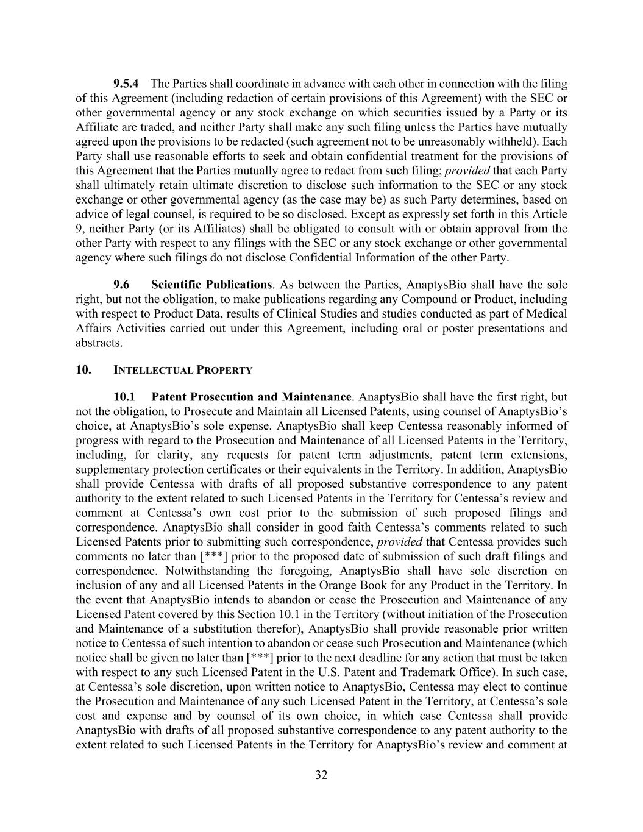
32 9.5.4 The Parties shall coordinate in advance with each other in connection with the filing of this Agreement (including redaction of certain provisions of this Agreement) with the SEC or other governmental agency or any stock exchange on which securities issued by a Party or its Affiliate are traded, and neither Party shall make any such filing unless the Parties have mutually agreed upon the provisions to be redacted (such agreement not to be unreasonably withheld). Each Party shall use reasonable efforts to seek and obtain confidential treatment for the provisions of this Agreement that the Parties mutually agree to redact from such filing; provided that each Party shall ultimately retain ultimate discretion to disclose such information to the SEC or any stock exchange or other governmental agency (as the case may be) as such Party determines, based on advice of legal counsel, is required to be so disclosed. Except as expressly set forth in this Article 9, neither Party (or its Affiliates) shall be obligated to consult with or obtain approval from the other Party with respect to any filings with the SEC or any stock exchange or other governmental agency where such filings do not disclose Confidential Information of the other Party. 9.6 Scientific Publications. As between the Parties, AnaptysBio shall have the sole right, but not the obligation, to make publications regarding any Compound or Product, including with respect to Product Data, results of Clinical Studies and studies conducted as part of Medical Affairs Activities carried out under this Agreement, including oral or poster presentations and abstracts. 10. INTELLECTUAL PROPERTY 10.1 Patent Prosecution and Maintenance. AnaptysBio shall have the first right, but not the obligation, to Prosecute and Maintain all Licensed Patents, using counsel of AnaptysBio’s choice, at AnaptysBio’s sole expense. AnaptysBio shall keep Centessa reasonably informed of progress with regard to the Prosecution and Maintenance of all Licensed Patents in the Territory, including, for clarity, any requests for patent term adjustments, patent term extensions, supplementary protection certificates or their equivalents in the Territory. In addition, AnaptysBio shall provide Centessa with drafts of all proposed substantive correspondence to any patent authority to the extent related to such Licensed Patents in the Territory for Centessa’s review and comment at Centessa’s own cost prior to the submission of such proposed filings and correspondence. AnaptysBio shall consider in good faith Centessa’s comments related to such Licensed Patents prior to submitting such correspondence, provided that Centessa provides such comments no later than [***] prior to the proposed date of submission of such draft filings and correspondence. Notwithstanding the foregoing, AnaptysBio shall have sole discretion on inclusion of any and all Licensed Patents in the Orange Book for any Product in the Territory. In the event that AnaptysBio intends to abandon or cease the Prosecution and Maintenance of any Licensed Patent covered by this Section 10.1 in the Territory (without initiation of the Prosecution and Maintenance of a substitution therefor), AnaptysBio shall provide reasonable prior written notice to Centessa of such intention to abandon or cease such Prosecution and Maintenance (which notice shall be given no later than [***] prior to the next deadline for any action that must be taken with respect to any such Licensed Patent in the U.S. Patent and Trademark Office). In such case, at Centessa’s sole discretion, upon written notice to AnaptysBio, Centessa may elect to continue the Prosecution and Maintenance of any such Licensed Patent in the Territory, at Centessa’s sole cost and expense and by counsel of its own choice, in which case Centessa shall provide AnaptysBio with drafts of all proposed substantive correspondence to any patent authority to the extent related to such Licensed Patents in the Territory for AnaptysBio’s review and comment at

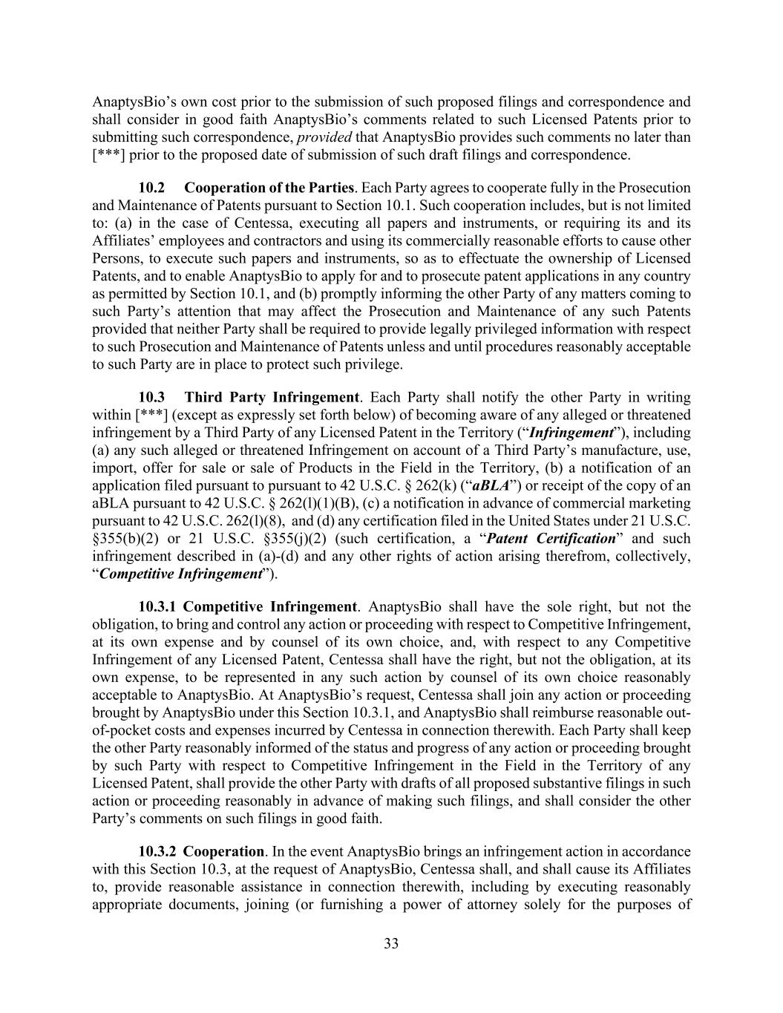
33 AnaptysBio’s own cost prior to the submission of such proposed filings and correspondence and shall consider in good faith AnaptysBio’s comments related to such Licensed Patents prior to submitting such correspondence, provided that AnaptysBio provides such comments no later than [***] prior to the proposed date of submission of such draft filings and correspondence. 10.2 Cooperation of the Parties. Each Party agrees to cooperate fully in the Prosecution and Maintenance of Patents pursuant to Section 10.1. Such cooperation includes, but is not limited to: (a) in the case of Centessa, executing all papers and instruments, or requiring its and its Affiliates’ employees and contractors and using its commercially reasonable efforts to cause other Persons, to execute such papers and instruments, so as to effectuate the ownership of Licensed Patents, and to enable AnaptysBio to apply for and to prosecute patent applications in any country as permitted by Section 10.1, and (b) promptly informing the other Party of any matters coming to such Party’s attention that may affect the Prosecution and Maintenance of any such Patents provided that neither Party shall be required to provide legally privileged information with respect to such Prosecution and Maintenance of Patents unless and until procedures reasonably acceptable to such Party are in place to protect such privilege. 10.3 Third Party Infringement. Each Party shall notify the other Party in writing within [***] (except as expressly set forth below) of becoming aware of any alleged or threatened infringement by a Third Party of any Licensed Patent in the Territory (“Infringement”), including (a) any such alleged or threatened Infringement on account of a Third Party’s manufacture, use, import, offer for sale or sale of Products in the Field in the Territory, (b) a notification of an application filed pursuant to pursuant to 42 U.S.C. § 262(k) (“aBLA”) or receipt of the copy of an aBLA pursuant to 42 U.S.C. § 262(l)(1)(B), (c) a notification in advance of commercial marketing pursuant to 42 U.S.C. 262(l)(8), and (d) any certification filed in the United States under 21 U.S.C. §355(b)(2) or 21 U.S.C. §355(j)(2) (such certification, a “Patent Certification” and such infringement described in (a)-(d) and any other rights of action arising therefrom, collectively, “Competitive Infringement”). 10.3.1 Competitive Infringement. AnaptysBio shall have the sole right, but not the obligation, to bring and control any action or proceeding with respect to Competitive Infringement, at its own expense and by counsel of its own choice, and, with respect to any Competitive Infringement of any Licensed Patent, Centessa shall have the right, but not the obligation, at its own expense, to be represented in any such action by counsel of its own choice reasonably acceptable to AnaptysBio. At AnaptysBio’s request, Centessa shall join any action or proceeding brought by AnaptysBio under this Section 10.3.1, and AnaptysBio shall reimburse reasonable out- of-pocket costs and expenses incurred by Centessa in connection therewith. Each Party shall keep the other Party reasonably informed of the status and progress of any action or proceeding brought by such Party with respect to Competitive Infringement in the Field in the Territory of any Licensed Patent, shall provide the other Party with drafts of all proposed substantive filings in such action or proceeding reasonably in advance of making such filings, and shall consider the other Party’s comments on such filings in good faith. 10.3.2 Cooperation. In the event AnaptysBio brings an infringement action in accordance with this Section 10.3, at the request of AnaptysBio, Centessa shall, and shall cause its Affiliates to, provide reasonable assistance in connection therewith, including by executing reasonably appropriate documents, joining (or furnishing a power of attorney solely for the purposes of

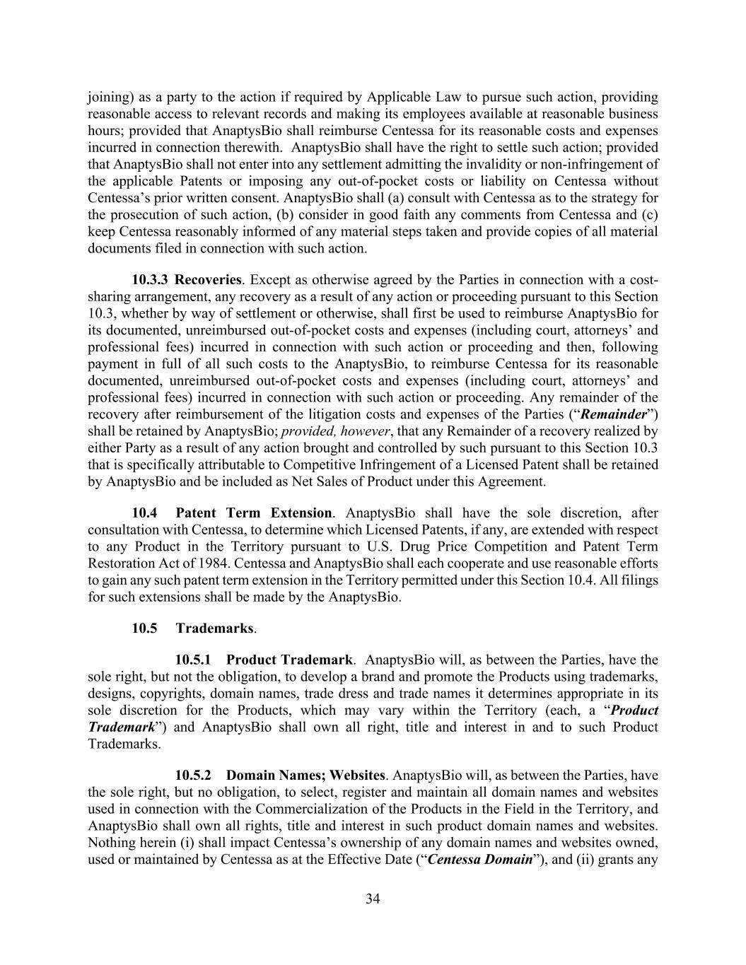
34 joining) as a party to the action if required by Applicable Law to pursue such action, providing reasonable access to relevant records and making its employees available at reasonable business hours; provided that AnaptysBio shall reimburse Centessa for its reasonable costs and expenses incurred in connection therewith. AnaptysBio shall have the right to settle such action; provided that AnaptysBio shall not enter into any settlement admitting the invalidity or non-infringement of the applicable Patents or imposing any out-of-pocket costs or liability on Centessa without Centessa’s prior written consent. AnaptysBio shall (a) consult with Centessa as to the strategy for the prosecution of such action, (b) consider in good faith any comments from Centessa and (c) keep Centessa reasonably informed of any material steps taken and provide copies of all material documents filed in connection with such action. 10.3.3 Recoveries. Except as otherwise agreed by the Parties in connection with a cost- sharing arrangement, any recovery as a result of any action or proceeding pursuant to this Section 10.3, whether by way of settlement or otherwise, shall first be used to reimburse AnaptysBio for its documented, unreimbursed out-of-pocket costs and expenses (including court, attorneys’ and professional fees) incurred in connection with such action or proceeding and then, following payment in full of all such costs to the AnaptysBio, to reimburse Centessa for its reasonable documented, unreimbursed out-of-pocket costs and expenses (including court, attorneys’ and professional fees) incurred in connection with such action or proceeding. Any remainder of the recovery after reimbursement of the litigation costs and expenses of the Parties (“Remainder”) shall be retained by AnaptysBio; provided, however, that any Remainder of a recovery realized by either Party as a result of any action brought and controlled by such pursuant to this Section 10.3 that is specifically attributable to Competitive Infringement of a Licensed Patent shall be retained by AnaptysBio and be included as Net Sales of Product under this Agreement. 10.4 Patent Term Extension. AnaptysBio shall have the sole discretion, after consultation with Centessa, to determine which Licensed Patents, if any, are extended with respect to any Product in the Territory pursuant to U.S. Drug Price Competition and Patent Term Restoration Act of 1984. Centessa and AnaptysBio shall each cooperate and use reasonable efforts to gain any such patent term extension in the Territory permitted under this Section 10.4. All filings for such extensions shall be made by the AnaptysBio. 10.5 Trademarks. 10.5.1 Product Trademark. AnaptysBio will, as between the Parties, have the sole right, but not the obligation, to develop a brand and promote the Products using trademarks, designs, copyrights, domain names, trade dress and trade names it determines appropriate in its sole discretion for the Products, which may vary within the Territory (each, a “Product Trademark”) and AnaptysBio shall own all right, title and interest in and to such Product Trademarks. 10.5.2 Domain Names; Websites. AnaptysBio will, as between the Parties, have the sole right, but no obligation, to select, register and maintain all domain names and websites used in connection with the Commercialization of the Products in the Field in the Territory, and AnaptysBio shall own all rights, title and interest in such product domain names and websites. Nothing herein (i) shall impact Centessa’s ownership of any domain names and websites owned, used or maintained by Centessa as at the Effective Date (“Centessa Domain”), and (ii) grants any

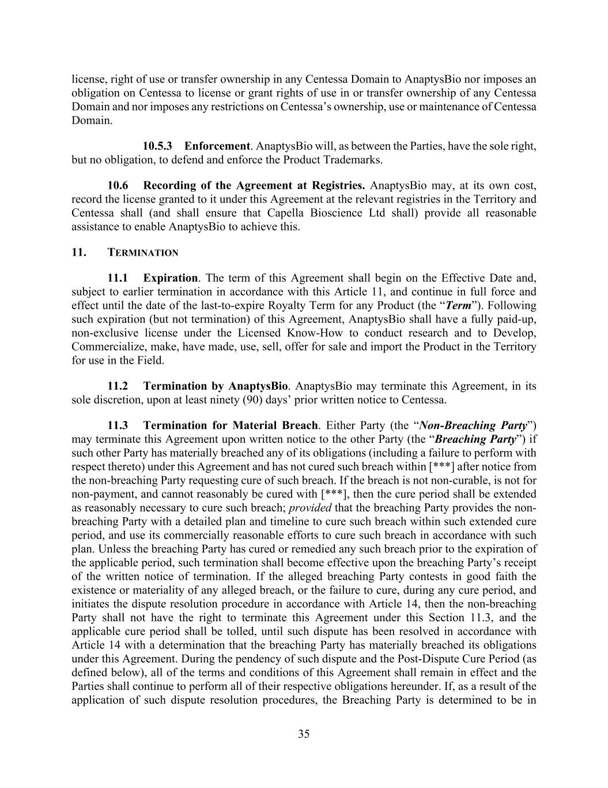
35 license, right of use or transfer ownership in any Centessa Domain to AnaptysBio nor imposes an obligation on Centessa to license or grant rights of use in or transfer ownership of any Centessa Domain and nor imposes any restrictions on Centessa’s ownership, use or maintenance of Centessa Domain. 10.5.3 Enforcement. AnaptysBio will, as between the Parties, have the sole right, but no obligation, to defend and enforce the Product Trademarks. 10.6 Recording of the Agreement at Registries. AnaptysBio may, at its own cost, record the license granted to it under this Agreement at the relevant registries in the Territory and Centessa shall (and shall ensure that Capella Bioscience Ltd shall) provide all reasonable assistance to enable AnaptysBio to achieve this. 11. TERMINATION 11.1 Expiration. The term of this Agreement shall begin on the Effective Date and, subject to earlier termination in accordance with this Article 11, and continue in full force and effect until the date of the last-to-expire Royalty Term for any Product (the “Term”). Following such expiration (but not termination) of this Agreement, AnaptysBio shall have a fully paid-up, non-exclusive license under the Licensed Know-How to conduct research and to Develop, Commercialize, make, have made, use, sell, offer for sale and import the Product in the Territory for use in the Field. 11.2 Termination by AnaptysBio. AnaptysBio may terminate this Agreement, in its sole discretion, upon at least ninety (90) days’ prior written notice to Centessa. 11.3 Termination for Material Breach. Either Party (the “Non-Breaching Party”) may terminate this Agreement upon written notice to the other Party (the “Breaching Party”) if such other Party has materially breached any of its obligations (including a failure to perform with respect thereto) under this Agreement and has not cured such breach within [***] after notice from the non-breaching Party requesting cure of such breach. If the breach is not non-curable, is not for non-payment, and cannot reasonably be cured with [***], then the cure period shall be extended as reasonably necessary to cure such breach; provided that the breaching Party provides the non- breaching Party with a detailed plan and timeline to cure such breach within such extended cure period, and use its commercially reasonable efforts to cure such breach in accordance with such plan. Unless the breaching Party has cured or remedied any such breach prior to the expiration of the applicable period, such termination shall become effective upon the breaching Party’s receipt of the written notice of termination. If the alleged breaching Party contests in good faith the existence or materiality of any alleged breach, or the failure to cure, during any cure period, and initiates the dispute resolution procedure in accordance with Article 14, then the non-breaching Party shall not have the right to terminate this Agreement under this Section 11.3, and the applicable cure period shall be tolled, until such dispute has been resolved in accordance with Article 14 with a determination that the breaching Party has materially breached its obligations under this Agreement. During the pendency of such dispute and the Post-Dispute Cure Period (as defined below), all of the terms and conditions of this Agreement shall remain in effect and the Parties shall continue to perform all of their respective obligations hereunder. If, as a result of the application of such dispute resolution procedures, the Breaching Party is determined to be in

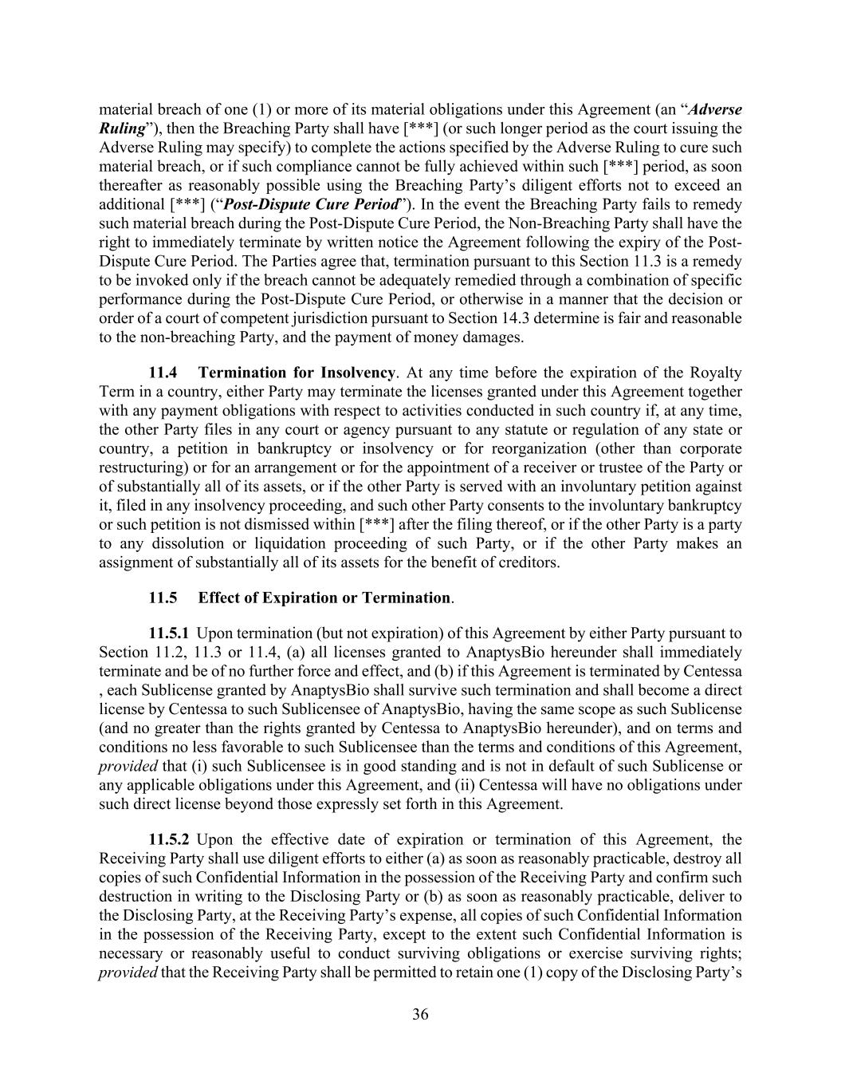
36 material breach of one (1) or more of its material obligations under this Agreement (an “Adverse Ruling”), then the Breaching Party shall have [***] (or such longer period as the court issuing the Adverse Ruling may specify) to complete the actions specified by the Adverse Ruling to cure such material breach, or if such compliance cannot be fully achieved within such [***] period, as soon thereafter as reasonably possible using the Breaching Party’s diligent efforts not to exceed an additional [***] (“Post-Dispute Cure Period”). In the event the Breaching Party fails to remedy such material breach during the Post-Dispute Cure Period, the Non-Breaching Party shall have the right to immediately terminate by written notice the Agreement following the expiry of the Post- Dispute Cure Period. The Parties agree that, termination pursuant to this Section 11.3 is a remedy to be invoked only if the breach cannot be adequately remedied through a combination of specific performance during the Post-Dispute Cure Period, or otherwise in a manner that the decision or order of a court of competent jurisdiction pursuant to Section 14.3 determine is fair and reasonable to the non-breaching Party, and the payment of money damages. 11.4 Termination for Insolvency. At any time before the expiration of the Royalty Term in a country, either Party may terminate the licenses granted under this Agreement together with any payment obligations with respect to activities conducted in such country if, at any time, the other Party files in any court or agency pursuant to any statute or regulation of any state or country, a petition in bankruptcy or insolvency or for reorganization (other than corporate restructuring) or for an arrangement or for the appointment of a receiver or trustee of the Party or of substantially all of its assets, or if the other Party is served with an involuntary petition against it, filed in any insolvency proceeding, and such other Party consents to the involuntary bankruptcy or such petition is not dismissed within [***] after the filing thereof, or if the other Party is a party to any dissolution or liquidation proceeding of such Party, or if the other Party makes an assignment of substantially all of its assets for the benefit of creditors. 11.5 Effect of Expiration or Termination. 11.5.1 Upon termination (but not expiration) of this Agreement by either Party pursuant to Section 11.2, 11.3 or 11.4, (a) all licenses granted to AnaptysBio hereunder shall immediately terminate and be of no further force and effect, and (b) if this Agreement is terminated by Centessa , each Sublicense granted by AnaptysBio shall survive such termination and shall become a direct license by Centessa to such Sublicensee of AnaptysBio, having the same scope as such Sublicense (and no greater than the rights granted by Centessa to AnaptysBio hereunder), and on terms and conditions no less favorable to such Sublicensee than the terms and conditions of this Agreement, provided that (i) such Sublicensee is in good standing and is not in default of such Sublicense or any applicable obligations under this Agreement, and (ii) Centessa will have no obligations under such direct license beyond those expressly set forth in this Agreement. 11.5.2 Upon the effective date of expiration or termination of this Agreement, the Receiving Party shall use diligent efforts to either (a) as soon as reasonably practicable, destroy all copies of such Confidential Information in the possession of the Receiving Party and confirm such destruction in writing to the Disclosing Party or (b) as soon as reasonably practicable, deliver to the Disclosing Party, at the Receiving Party’s expense, all copies of such Confidential Information in the possession of the Receiving Party, except to the extent such Confidential Information is necessary or reasonably useful to conduct surviving obligations or exercise surviving rights; provided that the Receiving Party shall be permitted to retain one (1) copy of the Disclosing Party’s

37 Confidential Information, as required by Applicable Law, or for litigation or archival purposes. Notwithstanding the foregoing, nothing contained in this Agreement shall be construed to require the Receiving Party to alter, modify, delete or destroy any electronic copy of files created automatically in the ordinary course of business pursuant to the Receiving Party’s standard electronic back-up and archival procedures so long as such electronic files are (i) maintained only on centralized storage servers (and not on personal computers or devices), (ii) not readily accessible by the Receiving Party’s Representatives (other than its information technology specialists), and (iii) not otherwise accessed subsequently except with the written consent of the Disclosing Party or as required by Applicable Law or legal process. Any Confidential Information so retained under this Section 11.5.2 shall remain subject to the obligations of confidentiality and non-use set forth in Article 9 insofar as such information is retained by the Receiving Party. 11.5.3 Upon any expiration or termination of this Agreement, all obligations of the Parties under this Agreement (including without limitation AnaptysBio’s payment obligations under Article 7) shall cease except as otherwise set forth in this Section 11.5 or elsewhere in this Agreement. 11.5.4 Expiration or termination of this Agreement shall not relieve the Parties of any obligation accruing prior to such expiration or termination, and the provisions of Articles 9, 11, 12, 14 and 15 shall survive the expiration or termination of this Agreement. 11.6 Termination Not Sole Remedy. Termination is not the sole remedy under this Agreement and, whether or not termination is effected, all other remedies will remain available except as agreed to otherwise herein. 11.7 Abandonment. In the event of an Abandonment, this Agreement shall be deemed terminated and all licenses granted to AnaptysBio hereunder shall immediately terminate and be of no further force and effect. [***]. 12. INDEMNIFICATION 12.1 Indemnification by AnaptysBio. AnaptysBio hereby agrees to indemnify, defend and hold Centessa and its Affiliates and their respective directors, officers, employees and agents (each, a “Centessa Indemnitee”) harmless from and against any and all liabilities, expenses and/or loss, including reasonable legal expense and attorneys’ fees (collectively, “Losses”), to which any Centessa Indemnitee may become subject as a result of any claim, demand, action or other proceeding by any Third Party (each, a “Claim”) to the extent such Losses arise directly or indirectly out of: (a) the Development, use, Commercialization or other exploitation of Compound or Product by or on behalf of AnaptysBio or any of its Affiliates or Sublicensees; (b) the breach by AnaptysBio of any provision of this Agreement (including any warranty, representation, covenant or agreement made by AnaptysBio herein); or (c) the gross negligence or willful misconduct of any AnaptysBio Indemnitee; except, in each case ((a) through (c)), to the extent such Losses result from the gross negligence or willful misconduct of any Centessa Indemnitee or the breach by Centessa of any provision of this Agreement (including any warranty, representation, covenant or agreement made by Centessa herein).

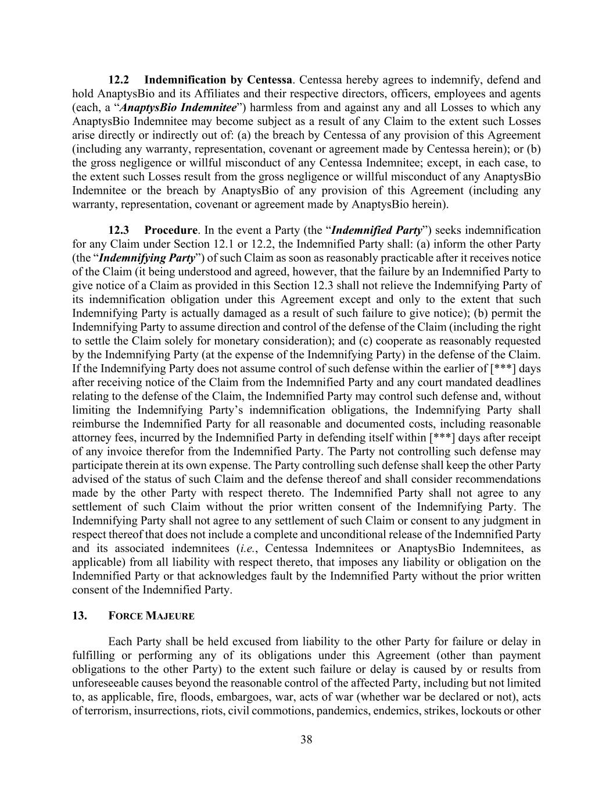
38 12.2 Indemnification by Centessa. Centessa hereby agrees to indemnify, defend and hold AnaptysBio and its Affiliates and their respective directors, officers, employees and agents (each, a “AnaptysBio Indemnitee”) harmless from and against any and all Losses to which any AnaptysBio Indemnitee may become subject as a result of any Claim to the extent such Losses arise directly or indirectly out of: (a) the breach by Centessa of any provision of this Agreement (including any warranty, representation, covenant or agreement made by Centessa herein); or (b) the gross negligence or willful misconduct of any Centessa Indemnitee; except, in each case, to the extent such Losses result from the gross negligence or willful misconduct of any AnaptysBio Indemnitee or the breach by AnaptysBio of any provision of this Agreement (including any warranty, representation, covenant or agreement made by AnaptysBio herein). 12.3 Procedure. In the event a Party (the “Indemnified Party”) seeks indemnification for any Claim under Section 12.1 or 12.2, the Indemnified Party shall: (a) inform the other Party (the “Indemnifying Party”) of such Claim as soon as reasonably practicable after it receives notice of the Claim (it being understood and agreed, however, that the failure by an Indemnified Party to give notice of a Claim as provided in this Section 12.3 shall not relieve the Indemnifying Party of its indemnification obligation under this Agreement except and only to the extent that such Indemnifying Party is actually damaged as a result of such failure to give notice); (b) permit the Indemnifying Party to assume direction and control of the defense of the Claim (including the right to settle the Claim solely for monetary consideration); and (c) cooperate as reasonably requested by the Indemnifying Party (at the expense of the Indemnifying Party) in the defense of the Claim. If the Indemnifying Party does not assume control of such defense within the earlier of [***] days after receiving notice of the Claim from the Indemnified Party and any court mandated deadlines relating to the defense of the Claim, the Indemnified Party may control such defense and, without limiting the Indemnifying Party’s indemnification obligations, the Indemnifying Party shall reimburse the Indemnified Party for all reasonable and documented costs, including reasonable attorney fees, incurred by the Indemnified Party in defending itself within [***] days after receipt of any invoice therefor from the Indemnified Party. The Party not controlling such defense may participate therein at its own expense. The Party controlling such defense shall keep the other Party advised of the status of such Claim and the defense thereof and shall consider recommendations made by the other Party with respect thereto. The Indemnified Party shall not agree to any settlement of such Claim without the prior written consent of the Indemnifying Party. The Indemnifying Party shall not agree to any settlement of such Claim or consent to any judgment in respect thereof that does not include a complete and unconditional release of the Indemnified Party and its associated indemnitees (i.e., Centessa Indemnitees or AnaptysBio Indemnitees, as applicable) from all liability with respect thereto, that imposes any liability or obligation on the Indemnified Party or that acknowledges fault by the Indemnified Party without the prior written consent of the Indemnified Party. 13. FORCE MAJEURE Each Party shall be held excused from liability to the other Party for failure or delay in fulfilling or performing any of its obligations under this Agreement (other than payment obligations to the other Party) to the extent such failure or delay is caused by or results from unforeseeable causes beyond the reasonable control of the affected Party, including but not limited to, as applicable, fire, floods, embargoes, war, acts of war (whether war be declared or not), acts of terrorism, insurrections, riots, civil commotions, pandemics, endemics, strikes, lockouts or other

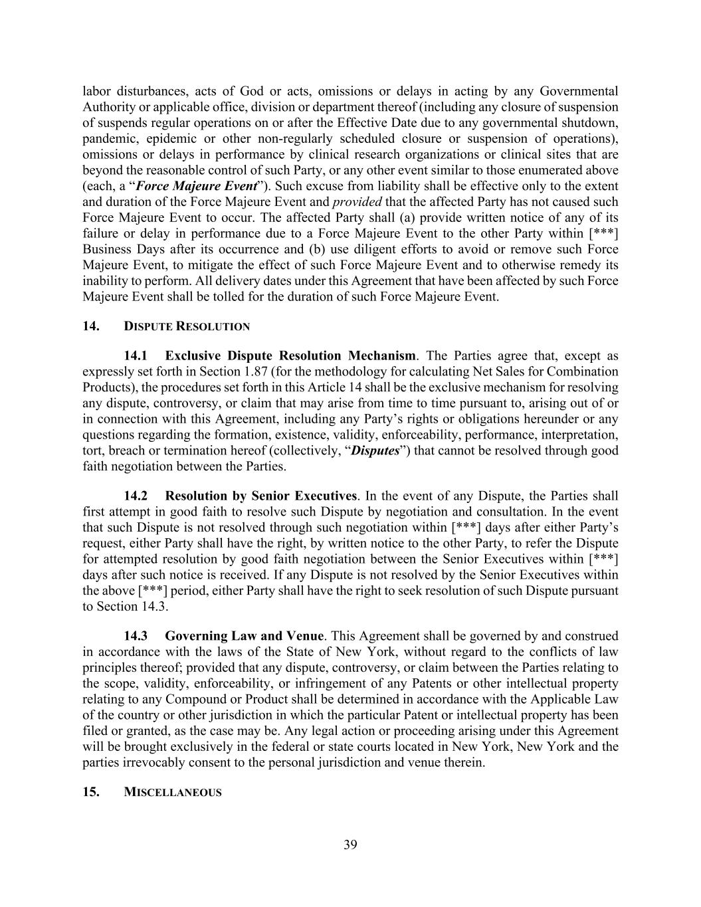
39 labor disturbances, acts of God or acts, omissions or delays in acting by any Governmental Authority or applicable office, division or department thereof (including any closure of suspension of suspends regular operations on or after the Effective Date due to any governmental shutdown, pandemic, epidemic or other non-regularly scheduled closure or suspension of operations), omissions or delays in performance by clinical research organizations or clinical sites that are beyond the reasonable control of such Party, or any other event similar to those enumerated above (each, a “Force Majeure Event”). Such excuse from liability shall be effective only to the extent and duration of the Force Majeure Event and provided that the affected Party has not caused such Force Majeure Event to occur. The affected Party shall (a) provide written notice of any of its failure or delay in performance due to a Force Majeure Event to the other Party within [***] Business Days after its occurrence and (b) use diligent efforts to avoid or remove such Force Majeure Event, to mitigate the effect of such Force Majeure Event and to otherwise remedy its inability to perform. All delivery dates under this Agreement that have been affected by such Force Majeure Event shall be tolled for the duration of such Force Majeure Event. 14. DISPUTE RESOLUTION 14.1 Exclusive Dispute Resolution Mechanism. The Parties agree that, except as expressly set forth in Section 1.87 (for the methodology for calculating Net Sales for Combination Products), the procedures set forth in this Article 14 shall be the exclusive mechanism for resolving any dispute, controversy, or claim that may arise from time to time pursuant to, arising out of or in connection with this Agreement, including any Party’s rights or obligations hereunder or any questions regarding the formation, existence, validity, enforceability, performance, interpretation, tort, breach or termination hereof (collectively, “Disputes”) that cannot be resolved through good faith negotiation between the Parties. 14.2 Resolution by Senior Executives. In the event of any Dispute, the Parties shall first attempt in good faith to resolve such Dispute by negotiation and consultation. In the event that such Dispute is not resolved through such negotiation within [***] days after either Party’s request, either Party shall have the right, by written notice to the other Party, to refer the Dispute for attempted resolution by good faith negotiation between the Senior Executives within [***] days after such notice is received. If any Dispute is not resolved by the Senior Executives within the above [***] period, either Party shall have the right to seek resolution of such Dispute pursuant to Section 14.3. 14.3 Governing Law and Venue. This Agreement shall be governed by and construed in accordance with the laws of the State of New York, without regard to the conflicts of law principles thereof; provided that any dispute, controversy, or claim between the Parties relating to the scope, validity, enforceability, or infringement of any Patents or other intellectual property relating to any Compound or Product shall be determined in accordance with the Applicable Law of the country or other jurisdiction in which the particular Patent or intellectual property has been filed or granted, as the case may be. Any legal action or proceeding arising under this Agreement will be brought exclusively in the federal or state courts located in New York, New York and the parties irrevocably consent to the personal jurisdiction and venue therein. 15. MISCELLANEOUS

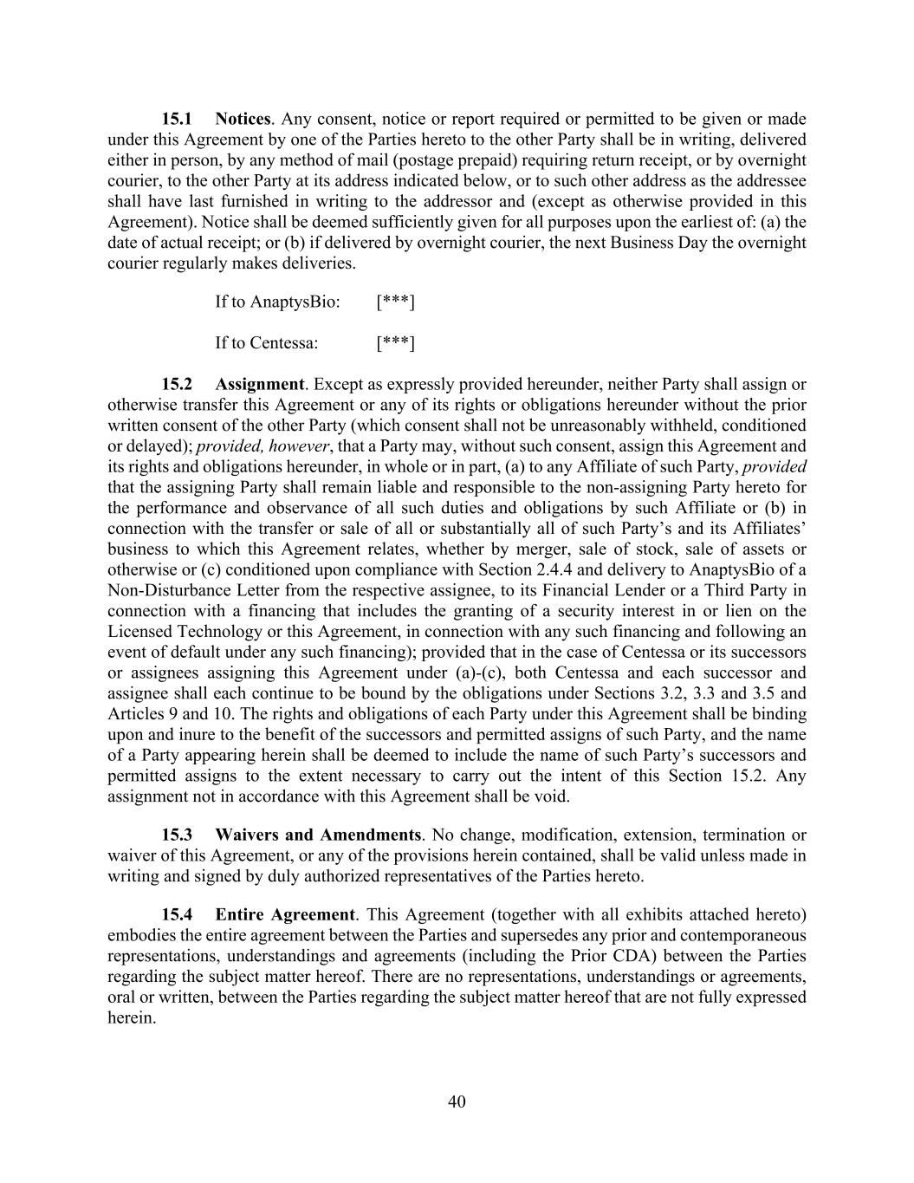
40 15.1 Notices. Any consent, notice or report required or permitted to be given or made under this Agreement by one of the Parties hereto to the other Party shall be in writing, delivered either in person, by any method of mail (postage prepaid) requiring return receipt, or by overnight courier, to the other Party at its address indicated below, or to such other address as the addressee shall have last furnished in writing to the addressor and (except as otherwise provided in this Agreement). Notice shall be deemed sufficiently given for all purposes upon the earliest of: (a) the date of actual receipt; or (b) if delivered by overnight courier, the next Business Day the overnight courier regularly makes deliveries. If to AnaptysBio: [***] If to Centessa: [***] 15.2 Assignment. Except as expressly provided hereunder, neither Party shall assign or otherwise transfer this Agreement or any of its rights or obligations hereunder without the prior written consent of the other Party (which consent shall not be unreasonably withheld, conditioned or delayed); provided, however, that a Party may, without such consent, assign this Agreement and its rights and obligations hereunder, in whole or in part, (a) to any Affiliate of such Party, provided that the assigning Party shall remain liable and responsible to the non-assigning Party hereto for the performance and observance of all such duties and obligations by such Affiliate or (b) in connection with the transfer or sale of all or substantially all of such Party’s and its Affiliates’ business to which this Agreement relates, whether by merger, sale of stock, sale of assets or otherwise or (c) conditioned upon compliance with Section 2.4.4 and delivery to AnaptysBio of a Non-Disturbance Letter from the respective assignee, to its Financial Lender or a Third Party in connection with a financing that includes the granting of a security interest in or lien on the Licensed Technology or this Agreement, in connection with any such financing and following an event of default under any such financing); provided that in the case of Centessa or its successors or assignees assigning this Agreement under (a)-(c), both Centessa and each successor and assignee shall each continue to be bound by the obligations under Sections 3.2, 3.3 and 3.5 and Articles 9 and 10. The rights and obligations of each Party under this Agreement shall be binding upon and inure to the benefit of the successors and permitted assigns of such Party, and the name of a Party appearing herein shall be deemed to include the name of such Party’s successors and permitted assigns to the extent necessary to carry out the intent of this Section 15.2. Any assignment not in accordance with this Agreement shall be void. 15.3 Waivers and Amendments. No change, modification, extension, termination or waiver of this Agreement, or any of the provisions herein contained, shall be valid unless made in writing and signed by duly authorized representatives of the Parties hereto. 15.4 Entire Agreement. This Agreement (together with all exhibits attached hereto) embodies the entire agreement between the Parties and supersedes any prior and contemporaneous representations, understandings and agreements (including the Prior CDA) between the Parties regarding the subject matter hereof. There are no representations, understandings or agreements, oral or written, between the Parties regarding the subject matter hereof that are not fully expressed herein.

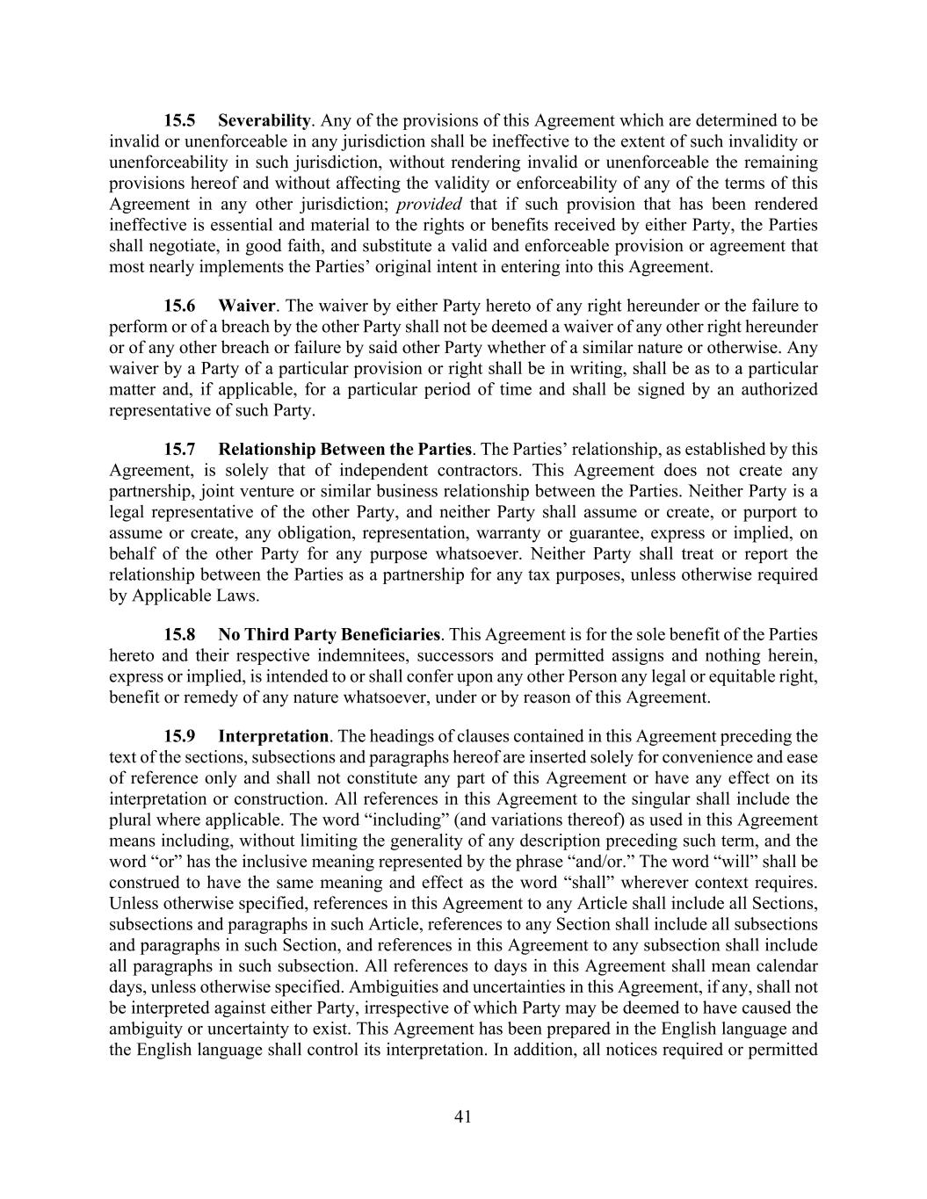
41 15.5 Severability. Any of the provisions of this Agreement which are determined to be invalid or unenforceable in any jurisdiction shall be ineffective to the extent of such invalidity or unenforceability in such jurisdiction, without rendering invalid or unenforceable the remaining provisions hereof and without affecting the validity or enforceability of any of the terms of this Agreement in any other jurisdiction; provided that if such provision that has been rendered ineffective is essential and material to the rights or benefits received by either Party, the Parties shall negotiate, in good faith, and substitute a valid and enforceable provision or agreement that most nearly implements the Parties’ original intent in entering into this Agreement. 15.6 Waiver. The waiver by either Party hereto of any right hereunder or the failure to perform or of a breach by the other Party shall not be deemed a waiver of any other right hereunder or of any other breach or failure by said other Party whether of a similar nature or otherwise. Any waiver by a Party of a particular provision or right shall be in writing, shall be as to a particular matter and, if applicable, for a particular period of time and shall be signed by an authorized representative of such Party. 15.7 Relationship Between the Parties. The Parties’ relationship, as established by this Agreement, is solely that of independent contractors. This Agreement does not create any partnership, joint venture or similar business relationship between the Parties. Neither Party is a legal representative of the other Party, and neither Party shall assume or create, or purport to assume or create, any obligation, representation, warranty or guarantee, express or implied, on behalf of the other Party for any purpose whatsoever. Neither Party shall treat or report the relationship between the Parties as a partnership for any tax purposes, unless otherwise required by Applicable Laws. 15.8 No Third Party Beneficiaries. This Agreement is for the sole benefit of the Parties hereto and their respective indemnitees, successors and permitted assigns and nothing herein, express or implied, is intended to or shall confer upon any other Person any legal or equitable right, benefit or remedy of any nature whatsoever, under or by reason of this Agreement. 15.9 Interpretation. The headings of clauses contained in this Agreement preceding the text of the sections, subsections and paragraphs hereof are inserted solely for convenience and ease of reference only and shall not constitute any part of this Agreement or have any effect on its interpretation or construction. All references in this Agreement to the singular shall include the plural where applicable. The word “including” (and variations thereof) as used in this Agreement means including, without limiting the generality of any description preceding such term, and the word “or” has the inclusive meaning represented by the phrase “and/or.” The word “will” shall be construed to have the same meaning and effect as the word “shall” wherever context requires. Unless otherwise specified, references in this Agreement to any Article shall include all Sections, subsections and paragraphs in such Article, references to any Section shall include all subsections and paragraphs in such Section, and references in this Agreement to any subsection shall include all paragraphs in such subsection. All references to days in this Agreement shall mean calendar days, unless otherwise specified. Ambiguities and uncertainties in this Agreement, if any, shall not be interpreted against either Party, irrespective of which Party may be deemed to have caused the ambiguity or uncertainty to exist. This Agreement has been prepared in the English language and the English language shall control its interpretation. In addition, all notices required or permitted

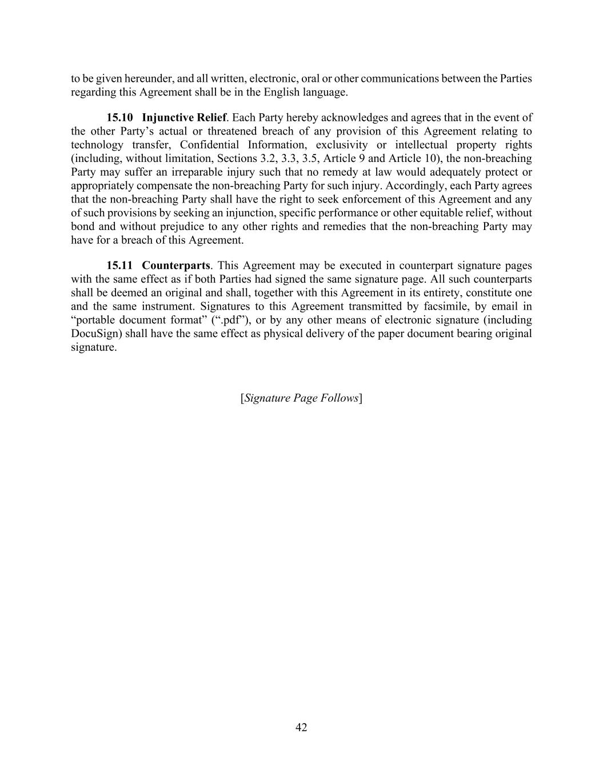
42 to be given hereunder, and all written, electronic, oral or other communications between the Parties regarding this Agreement shall be in the English language. 15.10 Injunctive Relief. Each Party hereby acknowledges and agrees that in the event of the other Party’s actual or threatened breach of any provision of this Agreement relating to technology transfer, Confidential Information, exclusivity or intellectual property rights (including, without limitation, Sections 3.2, 3.3, 3.5, Article 9 and Article 10), the non-breaching Party may suffer an irreparable injury such that no remedy at law would adequately protect or appropriately compensate the non-breaching Party for such injury. Accordingly, each Party agrees that the non-breaching Party shall have the right to seek enforcement of this Agreement and any of such provisions by seeking an injunction, specific performance or other equitable relief, without bond and without prejudice to any other rights and remedies that the non-breaching Party may have for a breach of this Agreement. 15.11 Counterparts. This Agreement may be executed in counterpart signature pages with the same effect as if both Parties had signed the same signature page. All such counterparts shall be deemed an original and shall, together with this Agreement in its entirety, constitute one and the same instrument. Signatures to this Agreement transmitted by facsimile, by email in “portable document format” (“.pdf”), or by any other means of electronic signature (including DocuSign) shall have the same effect as physical delivery of the paper document bearing original signature. [Signature Page Follows]

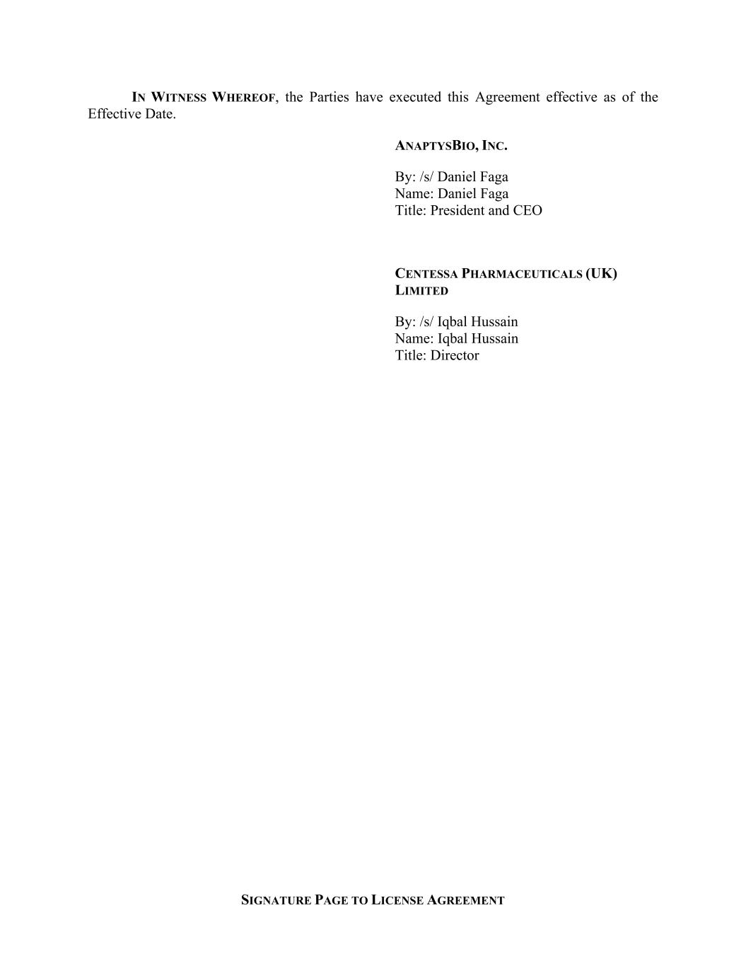
SIGNATURE PAGE TO LICENSE AGREEMENT IN WITNESS WHEREOF, the Parties have executed this Agreement effective as of the Effective Date. ANAPTYSBIO, INC. By: /s/ Daniel Faga Name: Daniel Faga Title: President and CEO CENTESSA PHARMACEUTICALS (UK) LIMITED By: /s/ Iqbal Hussain Name: Iqbal Hussain Title: Director

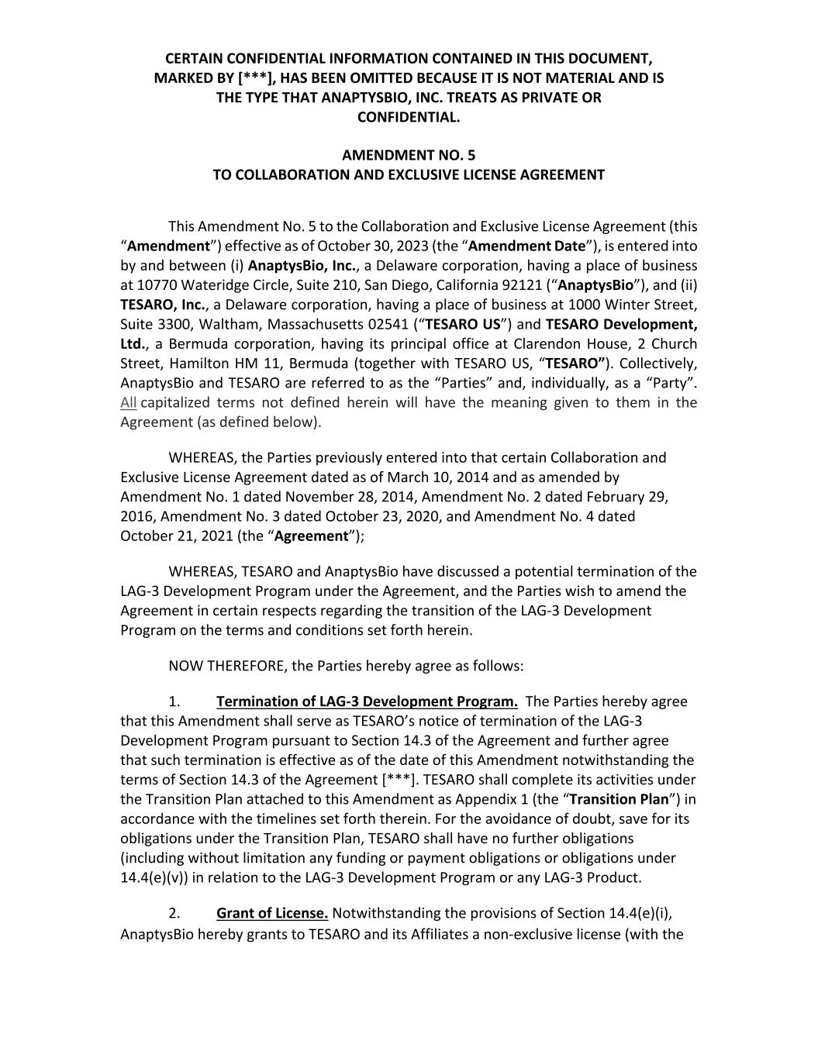
CERTAIN CONFIDENTIAL INFORMATION CONTAINED IN THIS DOCUMENT, MARKED BY [***], HAS BEEN OMITTED BECAUSE IT IS NOT MATERIAL AND IS THE TYPE THAT ANAPTYSBIO, INC. TREATS AS PRIVATE OR CONFIDENTIAL. AMENDMENT NO. 5 TO COLLABORATION AND EXCLUSIVE LICENSE AGREEMENT This Amendment No. 5 to the Collaboration and Exclusive License Agreement (this “Amendment”) effective as of October 30, 2023 (the “Amendment Date”), is entered into by and between (i) AnaptysBio, Inc., a Delaware corporation, having a place of business at 10770 Wateridge Circle, Suite 210, San Diego, California 92121 (“AnaptysBio”), and (ii) TESARO, Inc., a Delaware corporation, having a place of business at 1000 Winter Street, Suite 3300, Waltham, Massachusetts 02541 (“TESARO US”) and TESARO Development, Ltd., a Bermuda corporation, having its principal office at Clarendon House, 2 Church Street, Hamilton HM 11, Bermuda (together with TESARO US, “TESARO”). Collectively, AnaptysBio and TESARO are referred to as the “Parties” and, individually, as a “Party”. All capitalized terms not defined herein will have the meaning given to them in the Agreement (as defined below). WHEREAS, the Parties previously entered into that certain Collaboration and Exclusive License Agreement dated as of March 10, 2014 and as amended by Amendment No. 1 dated November 28, 2014, Amendment No. 2 dated February 29, 2016, Amendment No. 3 dated October 23, 2020, and Amendment No. 4 dated October 21, 2021 (the “Agreement”); WHEREAS, TESARO and AnaptysBio have discussed a potential termination of the LAG‐3 Development Program under the Agreement, and the Parties wish to amend the Agreement in certain respects regarding the transition of the LAG‐3 Development Program on the terms and conditions set forth herein. NOW THEREFORE, the Parties hereby agree as follows: 1. Termination of LAG‐3 Development Program. The Parties hereby agree that this Amendment shall serve as TESARO’s notice of termination of the LAG‐3 Development Program pursuant to Section 14.3 of the Agreement and further agree that such termination is effective as of the date of this Amendment notwithstanding the terms of Section 14.3 of the Agreement [***]. TESARO shall complete its activities under the Transition Plan attached to this Amendment as Appendix 1 (the “Transition Plan”) in accordance with the timelines set forth therein. For the avoidance of doubt, save for its obligations under the Transition Plan, TESARO shall have no further obligations (including without limitation any funding or payment obligations or obligations under 14.4(e)(v)) in relation to the LAG‐3 Development Program or any LAG‐3 Product. 2. Grant of License. Notwithstanding the provisions of Section 14.4(e)(i), AnaptysBio hereby grants to TESARO and its Affiliates a non‐exclusive license (with the

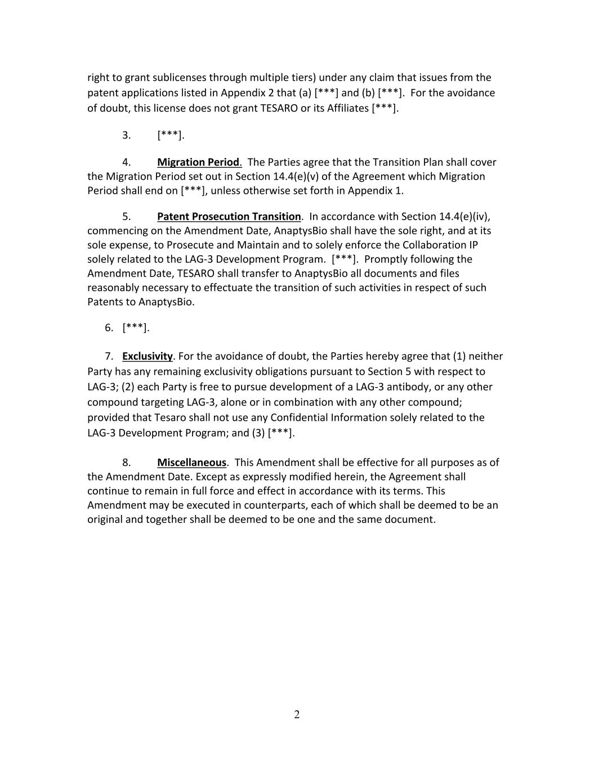
2 right to grant sublicenses through multiple tiers) under any claim that issues from the patent applications listed in Appendix 2 that (a) [***] and (b) [***]. For the avoidance of doubt, this license does not grant TESARO or its Affiliates [***]. 3. [***]. 4. Migration Period. The Parties agree that the Transition Plan shall cover the Migration Period set out in Section 14.4(e)(v) of the Agreement which Migration Period shall end on [***], unless otherwise set forth in Appendix 1. 5. Patent Prosecution Transition. In accordance with Section 14.4(e)(iv), commencing on the Amendment Date, AnaptysBio shall have the sole right, and at its sole expense, to Prosecute and Maintain and to solely enforce the Collaboration IP solely related to the LAG‐3 Development Program. [***]. Promptly following the Amendment Date, TESARO shall transfer to AnaptysBio all documents and files reasonably necessary to effectuate the transition of such activities in respect of such Patents to AnaptysBio. 6. [***]. 7. Exclusivity. For the avoidance of doubt, the Parties hereby agree that (1) neither Party has any remaining exclusivity obligations pursuant to Section 5 with respect to LAG‐3; (2) each Party is free to pursue development of a LAG‐3 antibody, or any other compound targeting LAG‐3, alone or in combination with any other compound; provided that Tesaro shall not use any Confidential Information solely related to the LAG‐3 Development Program; and (3) [***]. 8. Miscellaneous. This Amendment shall be effective for all purposes as of the Amendment Date. Except as expressly modified herein, the Agreement shall continue to remain in full force and effect in accordance with its terms. This Amendment may be executed in counterparts, each of which shall be deemed to be an original and together shall be deemed to be one and the same document.

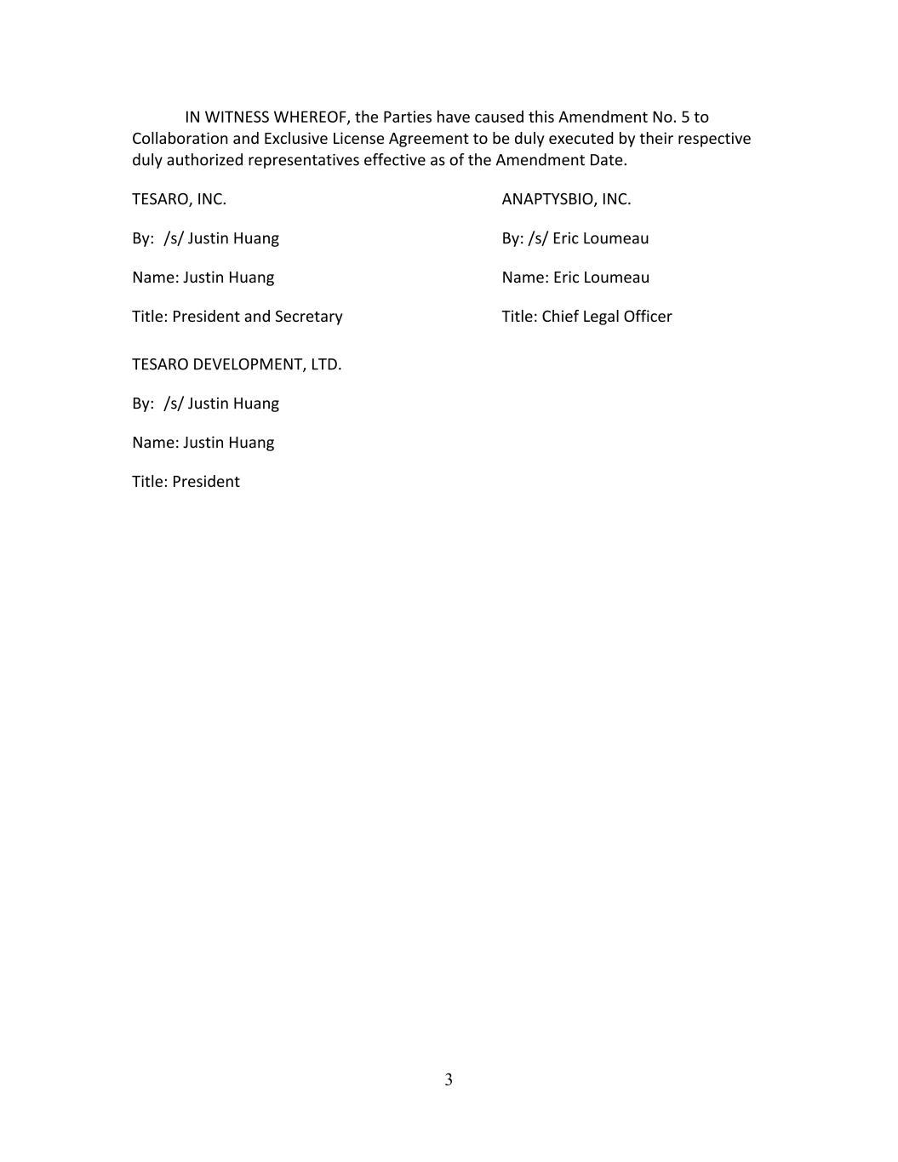
3 IN WITNESS WHEREOF, the Parties have caused this Amendment No. 5 to Collaboration and Exclusive License Agreement to be duly executed by their respective duly authorized representatives effective as of the Amendment Date. TESARO, INC. ANAPTYSBIO, INC. By: /s/ Justin Huang By: /s/ Eric Loumeau Name: Justin Huang Name: Eric Loumeau Title: President and Secretary Title: Chief Legal Officer TESARO DEVELOPMENT, LTD. By: /s/ Justin Huang Name: Justin Huang Title: President


Appendix 1 [***]


Appendix 2 [***]

EXHIBIT 21.1
SUBSIDIARIES OF THE REGISTRANT

Name of Subsidiary |  |  | Jurisdiction of Incorporation or Organization
AnaptysBio Pty Ltd |  |  | Australia

Exhibit 23.1
Consent of Independent Registered Public Accounting Firm
We consent to the incorporation by reference in the registration statements (Nos. 333-215741, 333-223446, 333-229927, 333-236805, 333-253504, 333-263332 and 333-270175) on Form S-8 and in the registration statement (No. 333-261953) on Form S-3 of our report dated March 11, 2024, with respect to the consolidated financial statements of AnaptysBio, Inc.

/s/ KPMG LLP
San Diego, California
March 11, 2024

EXHIBIT 31.1
CERTIFICATION OF PERIODIC REPORT UNDER SECTION 302 OF
THE SARBANES-OXLEY ACT OF 2002
I, Daniel Faga, certify that:
1. I have reviewed this annual report on Form 10-K of AnaptysBio, Inc.;
2. Based on my knowledge, this report does not contain any untrue statement of a material fact or omit to state a material fact necessary to make the statements made, in light of the circumstances under which such statements were made, not misleading with respect to the period covered by this report;
3. Based on my knowledge, the financial statements, and other financial information included in this report, fairly present in all material respects the financial condition, results of operations and cash flows of the registrant as of, and for, the periods presented in this report;
4. The registrant’s other certifying officer and I are responsible for establishing and maintaining disclosure controls and procedures (as defined in Exchange Act Rules 13a-15(e) and 15d-15(e)) and internal control over financial reporting (as defined in Exchange Act Rules 13a-15(f) and 15d-15(f)) for the registrant and have:
a) Designed such disclosure controls and procedures, or caused such disclosure controls and procedures to be designed under our supervision, to ensure that material information relating to the registrant, including its consolidated subsidiaries, is made known to us by others within those entities, particularly during the period in which this report is being prepared;
b) Designed such internal control over financial reporting, or caused such internal control over financial reporting to be designed under our supervision, to provide reasonable assurance regarding the reliability of financial reporting and the preparation of financial statements for external purposes in accordance with generally accepted accounting principles;
c) Evaluated the effectiveness of the registrant’s disclosure controls and procedures and presented in this report our conclusions about the effectiveness of the disclosure controls and procedures, as of the end of the period covered by this report based on such evaluation; and
d) Disclosed in this report any change in the registrant’s internal control over financial reporting that occurred during the registrant’s most recent fiscal quarter (the registrant’s fourth fiscal quarter in the case of an annual report) that has materially affected, or is reasonably likely to materially affect, the registrant’s internal control over financial reporting; and
5. The registrant’s other certifying officer and I have disclosed, based on our most recent evaluation of internal control over financial reporting, to the registrant’s auditors and the audit committee of the registrant’s board of directors (or persons performing the equivalent functions):
a) All significant deficiencies and material weaknesses in the design or operation of internal control over financial reporting which are reasonably likely to adversely affect the registrant’s ability to record, process, summarize and report financial information; and
b) Any fraud, whether or not material, that involves management or other employees who have a significant role in the registrant’s internal control over financial reporting.
Date: March 11, 2024

/s/ Daniel Faga
Daniel Faga
President and Chief Executive Officer
(Principal Executive Officer)

EXHIBIT 31.2
CERTIFICATION OF PERIODIC REPORT UNDER SECTION 302 OF
THE SARBANES-OXLEY ACT OF 2002
I, Dennis Mulroy, certify that:
1. I have reviewed this annual report on Form 10-K of AnaptysBio, Inc.;
2. Based on my knowledge, this report does not contain any untrue statement of a material fact or omit to state a material fact necessary to make the statements made, in light of the circumstances under which such statements were made, not misleading with respect to the period covered by this report;
3. Based on my knowledge, the financial statements, and other financial information included in this report, fairly present in all material respects the financial condition, results of operations and cash flows of the registrant as of, and for, the periods presented in this report;
4. The registrant’s other certifying officer and I are responsible for establishing and maintaining disclosure controls and procedures (as defined in Exchange Act Rules 13a-15(e) and 15d-15(e)) and internal control over financial reporting (as defined in Exchange Act Rules 13a-15(f) and 15d-15(f)) for the registrant and have:
a) Designed such disclosure controls and procedures, or caused such disclosure controls and procedures to be designed under our supervision, to ensure that material information relating to the registrant, including its consolidated subsidiaries, is made known to us by others within those entities, particularly during the period in which this report is being prepared;
b) Designed such internal control over financial reporting, or caused such internal control over financial reporting to be designed under our supervision, to provide reasonable assurance regarding the reliability of financial reporting and the preparation of financial statements for external purposes in accordance with generally accepted accounting principles;
c) Evaluated the effectiveness of the registrant’s disclosure controls and procedures and presented in this report our conclusions about the effectiveness of the disclosure controls and procedures, as of the end of the period covered by this report based on such evaluation; and
d) Disclosed in this report any change in the registrant’s internal control over financial reporting that occurred during the registrant’s most recent fiscal quarter (the registrant’s fourth fiscal quarter in the case of an annual report) that has materially affected, or is reasonably likely to materially affect, the registrant’s internal control over financial reporting; and
5. The registrant’s other certifying officer and I have disclosed, based on our most recent evaluation of internal control over financial reporting, to the registrant’s auditors and the audit committee of the registrant’s board of directors (or persons performing the equivalent functions):
a) All significant deficiencies and material weaknesses in the design or operation of internal control over financial reporting which are reasonably likely to adversely affect the registrant’s ability to record, process, summarize and report financial information; and
b) Any fraud, whether or not material, that involves management or other employees who have a significant role in the registrant’s internal control over financial reporting.
Date: March 11, 2024

/s/ Dennis Mulroy
Dennis Mulroy
Chief Financial Officer
(Principal Financial Officer)

EXHIBIT 32.1
CERTIFICATION PURSUANT TO
18 U.S.C. SECTION 1350
AS ADOPTED PURSUANT TO SECTION 906
OF THE SARBANES-OXLEY ACT OF 2002
I, Daniel Faga, Chief Executive Officer of AnaptysBio, Inc. (Company), do hereby certify, pursuant to 18 U.S.C. Section 1350, as adopted pursuant to Section 906 of the Sarbanes-Oxley Act of 2002, that to the best of my knowledge:
•the Annual Report on Form 10-K of the Company for the year ended December 31, 2023 (the “Report”), as filed with the Securities and Exchange Commission, fully complies with the requirements of Section 13(a) or 15(d) of the Securities Exchange Act of 1934; and
•the information contained in the Report fairly presents, in all material respects, the financial condition and results of operations of the Company for the periods presented therein.
Date: March 11, 2024

/s/ Daniel Faga
Daniel Faga
President and Chief Executive Officer
(Principal Executive Officer)

EXHIBIT 32.2
CERTIFICATION PURSUANT TO
18 U.S.C. SECTION 1350
AS ADOPTED PURSUANT TO SECTION 906
OF THE SARBANES-OXLEY ACT OF 2002
I, Dennis Mulroy, Chief Financial Officer of AnaptysBio, Inc. (Company), do hereby certify, pursuant to 18 U.S.C. Section 1350, as adopted pursuant to Section 906 of the Sarbanes-Oxley Act of 2002, that to the best of my knowledge:
•the Annual Report on Form 10-K of the Company for the year ended December 31, 2023 (the “Report”), as filed with the Securities and Exchange Commission, fully complies with the requirements of Section 13(a) or 15(d) of the Securities Exchange Act of 1934; and
•the information contained in the Report fairly presents, in all material respects, the financial condition and results of operations of the Company for the periods presented therein.
Date: March 11, 2024

/s/ Dennis Mulroy
Dennis Mulroy
Chief Financial Officer
(Principal Financial Officer)

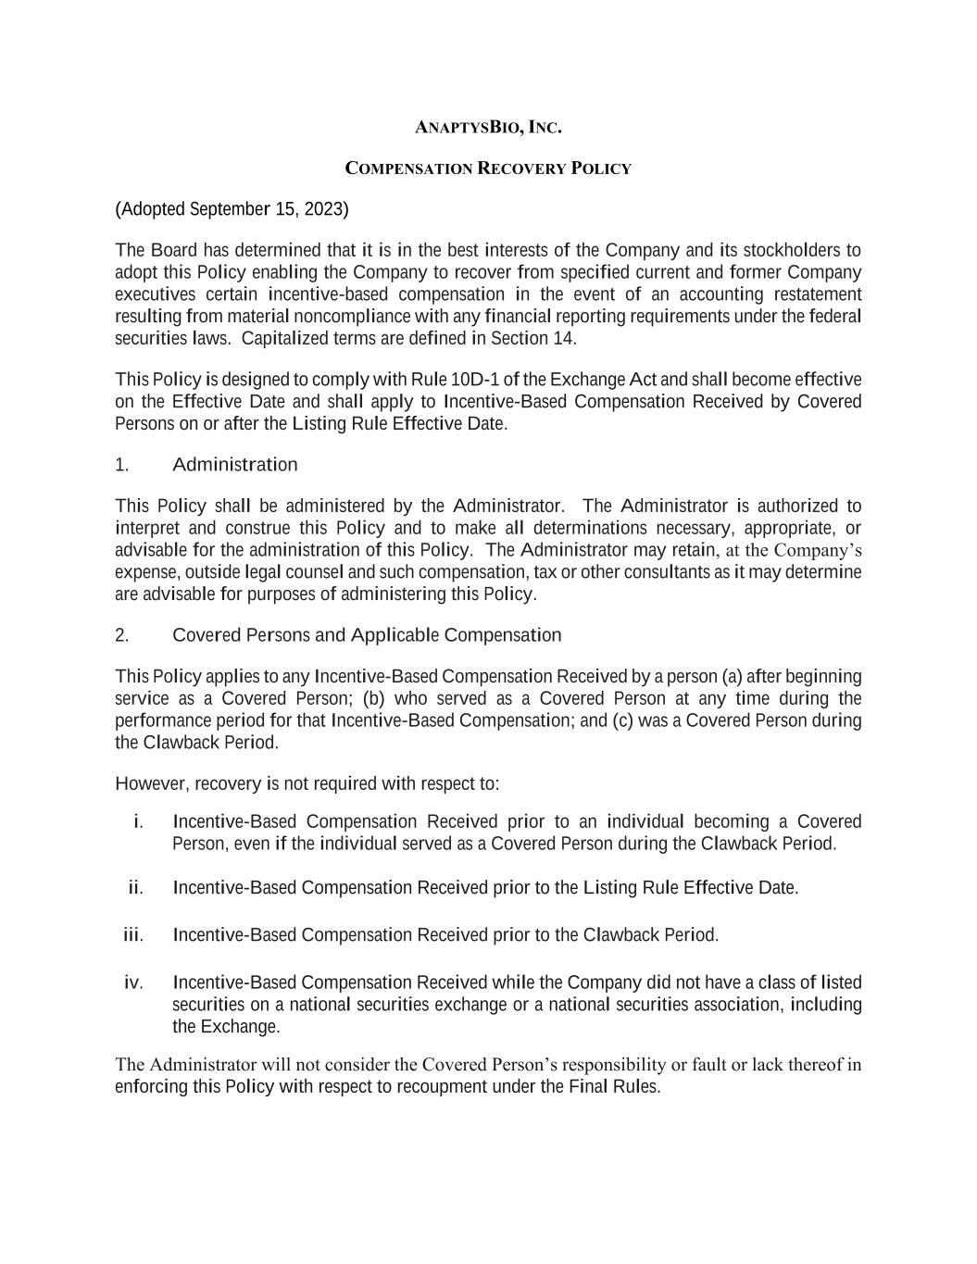

ANAPTYSBIO, INC. COMPENSATION RECOVERY POLICY (Adopted September 15, 2023) The Board has determined that it is in the best interests of the Company and its stockholders to adopt this Policy enabling the Company to recover from specified current and former Company executives certain incentive-based compensation in the event of an accounting restatement resulting from material noncompliance with any financial reporting requirements under the federal securities laws. Capitalized terms are defined in Section 14. This Policy is designed to comply with Rule 10D-1 of the Exchange Act and shall become effective on the Effective Date and shall apply to Incentive-Based Compensation Received by Covered Persons on or after the Listing Rule Effective Date. 1. Administration This Policy shall be administered by the Administrator. The Administrator is authorized to interpret and construe this Policy and to make all determinations necessary, appropriate, or advisable for the administration of this Policy. The Administrator may retain, at the Company’s expense, outside legal counsel and such compensation, tax or other consultants as it may determine are advisable for purposes of administering this Policy. 2. Covered Persons and Applicable Compensation This Policy applies to any Incentive-Based Compensation Received by a person (a) after beginning service as a Covered Person; (b) who served as a Covered Person at any time during the performance period for that Incentive-Based Compensation; and (c) was a Covered Person during the Clawback Period. However, recovery is not required with respect to: i. Incentive-Based Compensation Received prior to an individual becoming a Covered Person, even if the individual served as a Covered Person during the Clawback Period. ii. Incentive-Based Compensation Received prior to the Listing Rule Effective Date. iii. Incentive-Based Compensation Received prior to the Clawback Period. iv. Incentive-Based Compensation Received while the Company did not have a class of listed securities on a national securities exchange or a national securities association, including the Exchange. The Administrator will not consider the Covered Person’s responsibility or fault or lack thereof in enforcing this Policy with respect to recoupment under the Final Rules.

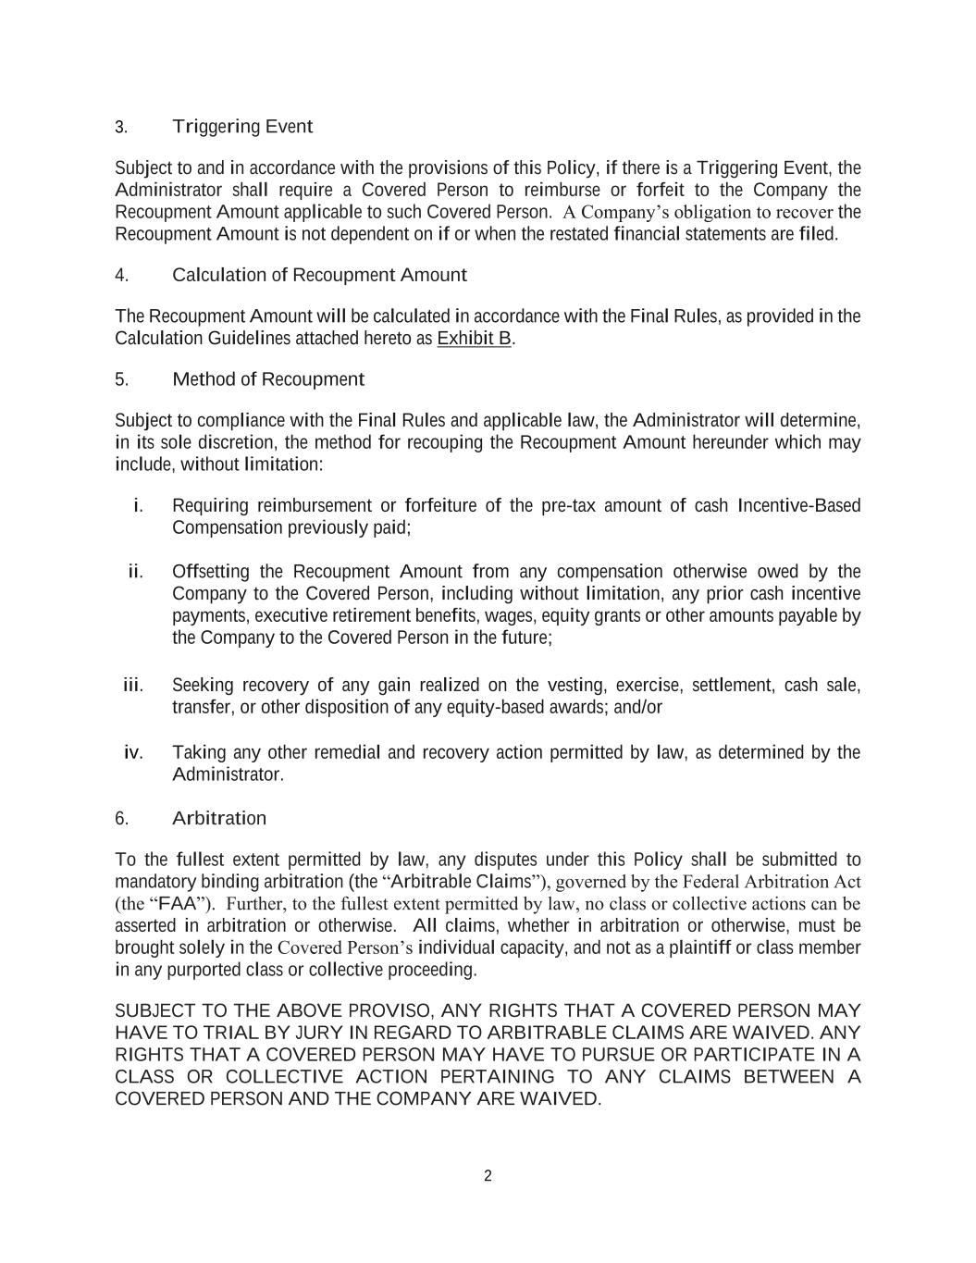
2 3. Triggering Event Subject to and in accordance with the provisions of this Policy, if there is a Triggering Event, the Administrator shall require a Covered Person to reimburse or forfeit to the Company the Recoupment Amount applicable to such Covered Person. A Company’s obligation to recover the Recoupment Amount is not dependent on if or when the restated financial statements are filed. 4. Calculation of Recoupment Amount The Recoupment Amount will be calculated in accordance with the Final Rules, as provided in the Calculation Guidelines attached hereto as Exhibit B. 5. Method of Recoupment Subject to compliance with the Final Rules and applicable law, the Administrator will determine, in its sole discretion, the method for recouping the Recoupment Amount hereunder which may include, without limitation: i. Requiring reimbursement or forfeiture of the pre-tax amount of cash Incentive-Based Compensation previously paid; ii. Offsetting the Recoupment Amount from any compensation otherwise owed by the Company to the Covered Person, including without limitation, any prior cash incentive payments, executive retirement benefits, wages, equity grants or other amounts payable by the Company to the Covered Person in the future; iii. Seeking recovery of any gain realized on the vesting, exercise, settlement, cash sale, transfer, or other disposition of any equity-based awards; and/or iv. Taking any other remedial and recovery action permitted by law, as determined by the Administrator. 6. Arbitration To the fullest extent permitted by law, any disputes under this Policy shall be submitted to mandatory binding arbitration (the “Arbitrable Claims”), governed by the Federal Arbitration Act (the “FAA”). Further, to the fullest extent permitted by law, no class or collective actions can be asserted in arbitration or otherwise. All claims, whether in arbitration or otherwise, must be brought solely in the Covered Person’s individual capacity, and not as a plaintiff or class member in any purported class or collective proceeding. SUBJECT TO THE ABOVE PROVISO, ANY RIGHTS THAT A COVERED PERSON MAY HAVE TO TRIAL BY JURY IN REGARD TO ARBITRABLE CLAIMS ARE WAIVED. ANY RIGHTS THAT A COVERED PERSON MAY HAVE TO PURSUE OR PARTICIPATE IN A CLASS OR COLLECTIVE ACTION PERTAINING TO ANY CLAIMS BETWEEN A COVERED PERSON AND THE COMPANY ARE WAIVED.

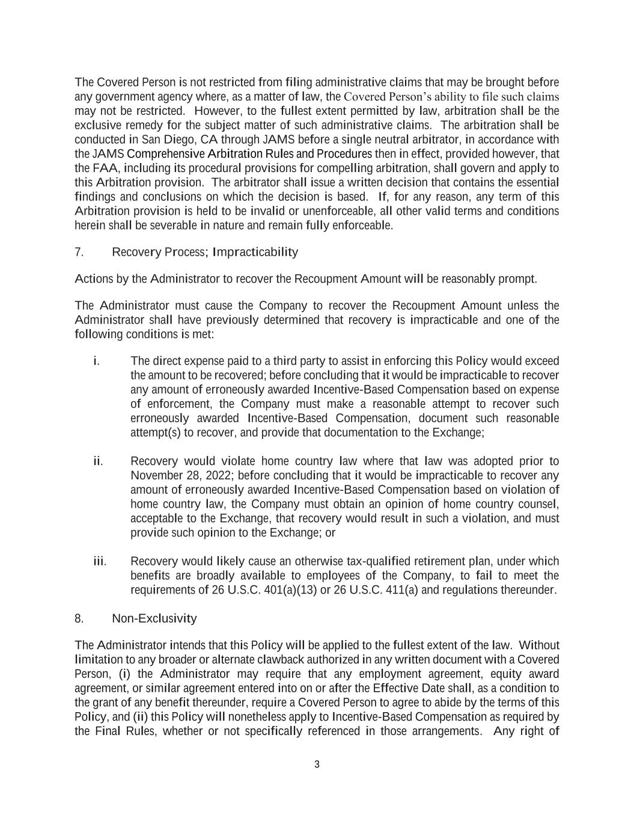
3 The Covered Person is not restricted from filing administrative claims that may be brought before any government agency where, as a matter of law, the Covered Person’s ability to file such claims may not be restricted. However, to the fullest extent permitted by law, arbitration shall be the exclusive remedy for the subject matter of such administrative claims. The arbitration shall be conducted in San Diego, CA through JAMS before a single neutral arbitrator, in accordance with the JAMS Comprehensive Arbitration Rules and Procedures then in effect, provided however, that the FAA, including its procedural provisions for compelling arbitration, shall govern and apply to this Arbitration provision. The arbitrator shall issue a written decision that contains the essential findings and conclusions on which the decision is based. If, for any reason, any term of this Arbitration provision is held to be invalid or unenforceable, all other valid terms and conditions herein shall be severable in nature and remain fully enforceable. 7. Recovery Process; Impracticability Actions by the Administrator to recover the Recoupment Amount will be reasonably prompt. The Administrator must cause the Company to recover the Recoupment Amount unless the Administrator shall have previously determined that recovery is impracticable and one of the following conditions is met: i. The direct expense paid to a third party to assist in enforcing this Policy would exceed the amount to be recovered; before concluding that it would be impracticable to recover any amount of erroneously awarded Incentive-Based Compensation based on expense of enforcement, the Company must make a reasonable attempt to recover such erroneously awarded Incentive-Based Compensation, document such reasonable attempt(s) to recover, and provide that documentation to the Exchange; ii. Recovery would violate home country law where that law was adopted prior to November 28, 2022; before concluding that it would be impracticable to recover any amount of erroneously awarded Incentive-Based Compensation based on violation of home country law, the Company must obtain an opinion of home country counsel, acceptable to the Exchange, that recovery would result in such a violation, and must provide such opinion to the Exchange; or iii. Recovery would likely cause an otherwise tax-qualified retirement plan, under which benefits are broadly available to employees of the Company, to fail to meet the requirements of 26 U.S.C. 401(a)(13) or 26 U.S.C. 411(a) and regulations thereunder. 8. Non-Exclusivity The Administrator intends that this Policy will be applied to the fullest extent of the law. Without limitation to any broader or alternate clawback authorized in any written document with a Covered Person, (i) the Administrator may require that any employment agreement, equity award agreement, or similar agreement entered into on or after the Effective Date shall, as a condition to the grant of any benefit thereunder, require a Covered Person to agree to abide by the terms of this Policy, and (ii) this Policy will nonetheless apply to Incentive-Based Compensation as required by the Final Rules, whether or not specifically referenced in those arrangements. Any right of

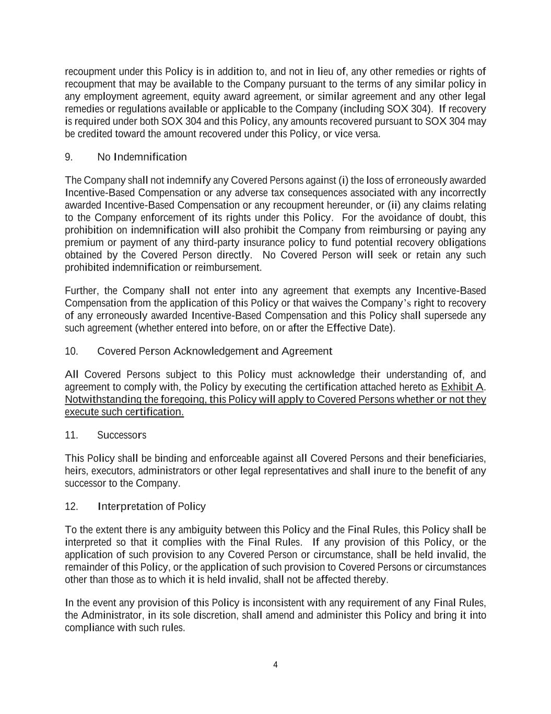
4 recoupment under this Policy is in addition to, and not in lieu of, any other remedies or rights of recoupment that may be available to the Company pursuant to the terms of any similar policy in any employment agreement, equity award agreement, or similar agreement and any other legal remedies or regulations available or applicable to the Company (including SOX 304). If recovery is required under both SOX 304 and this Policy, any amounts recovered pursuant to SOX 304 may be credited toward the amount recovered under this Policy, or vice versa. 9. No Indemnification The Company shall not indemnify any Covered Persons against (i) the loss of erroneously awarded Incentive-Based Compensation or any adverse tax consequences associated with any incorrectly awarded Incentive-Based Compensation or any recoupment hereunder, or (ii) any claims relating to the Company enforcement of its rights under this Policy. For the avoidance of doubt, this prohibition on indemnification will also prohibit the Company from reimbursing or paying any premium or payment of any third-party insurance policy to fund potential recovery obligations obtained by the Covered Person directly. No Covered Person will seek or retain any such prohibited indemnification or reimbursement. Further, the Company shall not enter into any agreement that exempts any Incentive-Based Compensation from the application of this Policy or that waives the Company’s right to recovery of any erroneously awarded Incentive-Based Compensation and this Policy shall supersede any such agreement (whether entered into before, on or after the Effective Date). 10. Covered Person Acknowledgement and Agreement All Covered Persons subject to this Policy must acknowledge their understanding of, and agreement to comply with, the Policy by executing the certification attached hereto as Exhibit A. Notwithstanding the foregoing, this Policy will apply to Covered Persons whether or not they execute such certification. 11. Successors This Policy shall be binding and enforceable against all Covered Persons and their beneficiaries, heirs, executors, administrators or other legal representatives and shall inure to the benefit of any successor to the Company. 12. Interpretation of Policy To the extent there is any ambiguity between this Policy and the Final Rules, this Policy shall be interpreted so that it complies with the Final Rules. If any provision of this Policy, or the application of such provision to any Covered Person or circumstance, shall be held invalid, the remainder of this Policy, or the application of such provision to Covered Persons or circumstances other than those as to which it is held invalid, shall not be affected thereby. In the event any provision of this Policy is inconsistent with any requirement of any Final Rules, the Administrator, in its sole discretion, shall amend and administer this Policy and bring it into compliance with such rules.

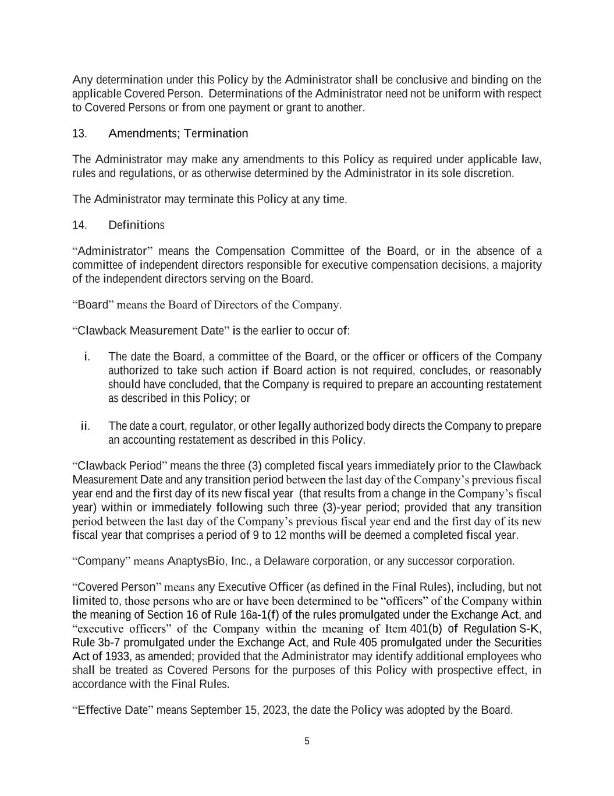
5 Any determination under this Policy by the Administrator shall be conclusive and binding on the applicable Covered Person. Determinations of the Administrator need not be uniform with respect to Covered Persons or from one payment or grant to another. 13. Amendments; Termination The Administrator may make any amendments to this Policy as required under applicable law, rules and regulations, or as otherwise determined by the Administrator in its sole discretion. The Administrator may terminate this Policy at any time. 14. Definitions “Administrator” means the Compensation Committee of the Board, or in the absence of a committee of independent directors responsible for executive compensation decisions, a majority of the independent directors serving on the Board. “Board” means the Board of Directors of the Company. “Clawback Measurement Date” is the earlier to occur of: i. The date the Board, a committee of the Board, or the officer or officers of the Company authorized to take such action if Board action is not required, concludes, or reasonably should have concluded, that the Company is required to prepare an accounting restatement as described in this Policy; or ii. The date a court, regulator, or other legally authorized body directs the Company to prepare an accounting restatement as described in this Policy. “Clawback Period” means the three (3) completed fiscal years immediately prior to the Clawback Measurement Date and any transition period between the last day of the Company’s previous fiscal year end and the first day of its new fiscal year (that results from a change in the Company’s fiscal year) within or immediately following such three (3)-year period; provided that any transition period between the last day of the Company’s previous fiscal year end and the first day of its new fiscal year that comprises a period of 9 to 12 months will be deemed a completed fiscal year. “Company” means AnaptysBio, Inc., a Delaware corporation, or any successor corporation. “Covered Person” means any Executive Officer (as defined in the Final Rules), including, but not limited to, those persons who are or have been determined to be “officers” of the Company within the meaning of Section 16 of Rule 16a-1(f) of the rules promulgated under the Exchange Act, and “executive officers” of the Company within the meaning of Item 401(b) of Regulation S-K, Rule 3b-7 promulgated under the Exchange Act, and Rule 405 promulgated under the Securities Act of 1933, as amended; provided that the Administrator may identify additional employees who shall be treated as Covered Persons for the purposes of this Policy with prospective effect, in accordance with the Final Rules. “Effective Date” means September 15, 2023, the date the Policy was adopted by the Board.

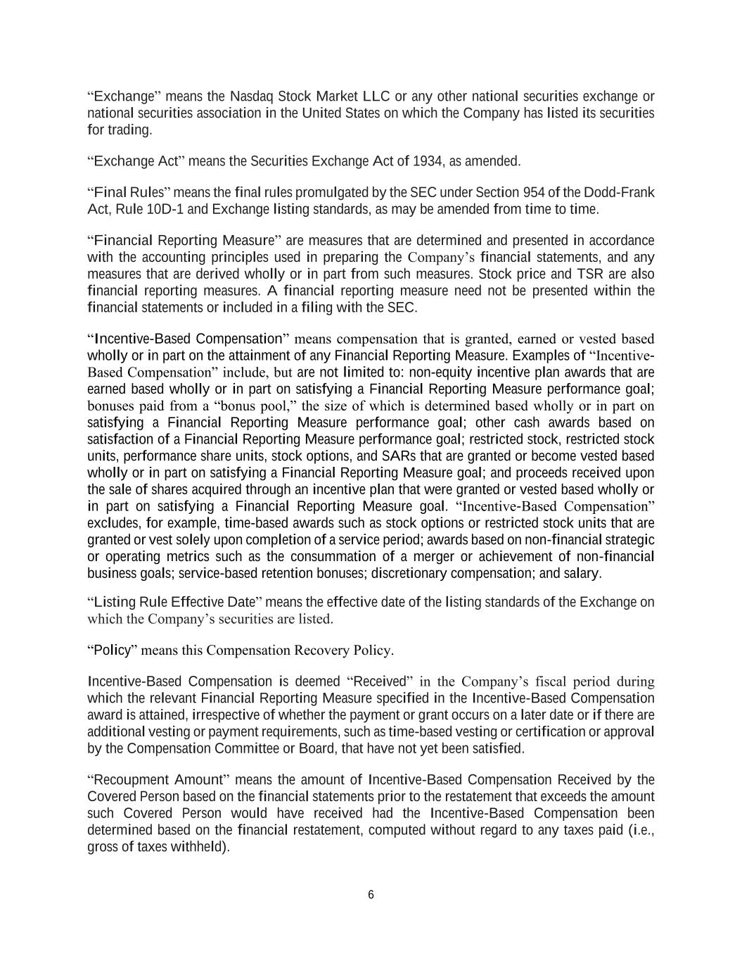
6 “Exchange” means the Nasdaq Stock Market LLC or any other national securities exchange or national securities association in the United States on which the Company has listed its securities for trading. “Exchange Act” means the Securities Exchange Act of 1934, as amended. “Final Rules” means the final rules promulgated by the SEC under Section 954 of the Dodd-Frank Act, Rule 10D-1 and Exchange listing standards, as may be amended from time to time. “Financial Reporting Measure” are measures that are determined and presented in accordance with the accounting principles used in preparing the Company’s financial statements, and any measures that are derived wholly or in part from such measures. Stock price and TSR are also financial reporting measures. A financial reporting measure need not be presented within the financial statements or included in a filing with the SEC. “Incentive-Based Compensation” means compensation that is granted, earned or vested based wholly or in part on the attainment of any Financial Reporting Measure. Examples of “Incentive- Based Compensation” include, but are not limited to: non-equity incentive plan awards that are earned based wholly or in part on satisfying a Financial Reporting Measure performance goal; bonuses paid from a “bonus pool,” the size of which is determined based wholly or in part on satisfying a Financial Reporting Measure performance goal; other cash awards based on satisfaction of a Financial Reporting Measure performance goal; restricted stock, restricted stock units, performance share units, stock options, and SARs that are granted or become vested based wholly or in part on satisfying a Financial Reporting Measure goal; and proceeds received upon the sale of shares acquired through an incentive plan that were granted or vested based wholly or in part on satisfying a Financial Reporting Measure goal. “Incentive-Based Compensation” excludes, for example, time-based awards such as stock options or restricted stock units that are granted or vest solely upon completion of a service period; awards based on non-financial strategic or operating metrics such as the consummation of a merger or achievement of non-financial business goals; service-based retention bonuses; discretionary compensation; and salary. “Listing Rule Effective Date” means the effective date of the listing standards of the Exchange on which the Company’s securities are listed. “Policy” means this Compensation Recovery Policy. Incentive-Based Compensation is deemed “Received” in the Company’s fiscal period during which the relevant Financial Reporting Measure specified in the Incentive-Based Compensation award is attained, irrespective of whether the payment or grant occurs on a later date or if there are additional vesting or payment requirements, such as time-based vesting or certification or approval by the Compensation Committee or Board, that have not yet been satisfied. “Recoupment Amount” means the amount of Incentive-Based Compensation Received by the Covered Person based on the financial statements prior to the restatement that exceeds the amount such Covered Person would have received had the Incentive-Based Compensation been determined based on the financial restatement, computed without regard to any taxes paid (i.e., gross of taxes withheld).

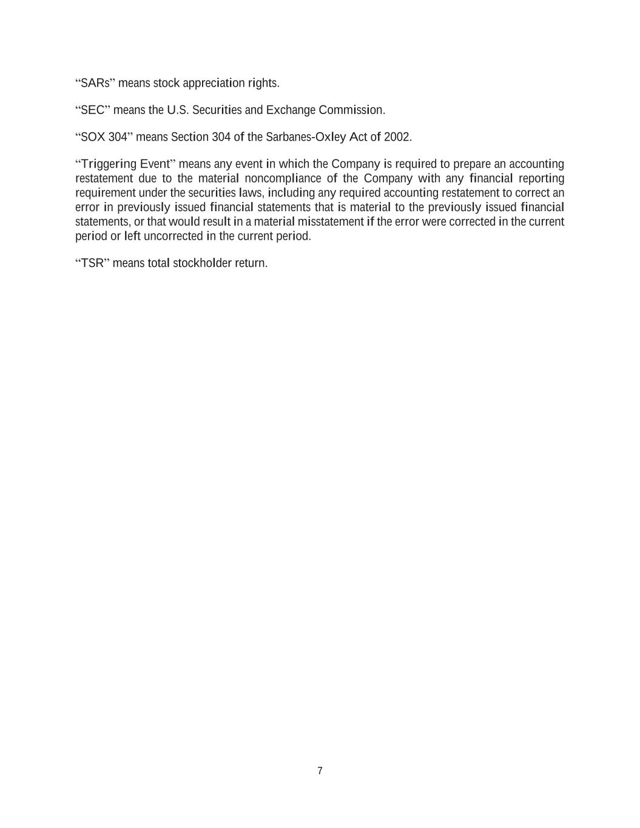
7 “SARs” means stock appreciation rights. “SEC” means the U.S. Securities and Exchange Commission. “SOX 304” means Section 304 of the Sarbanes-Oxley Act of 2002. “Triggering Event” means any event in which the Company is required to prepare an accounting restatement due to the material noncompliance of the Company with any financial reporting requirement under the securities laws, including any required accounting restatement to correct an error in previously issued financial statements that is material to the previously issued financial statements, or that would result in a material misstatement if the error were corrected in the current period or left uncorrected in the current period. “TSR” means total stockholder return.

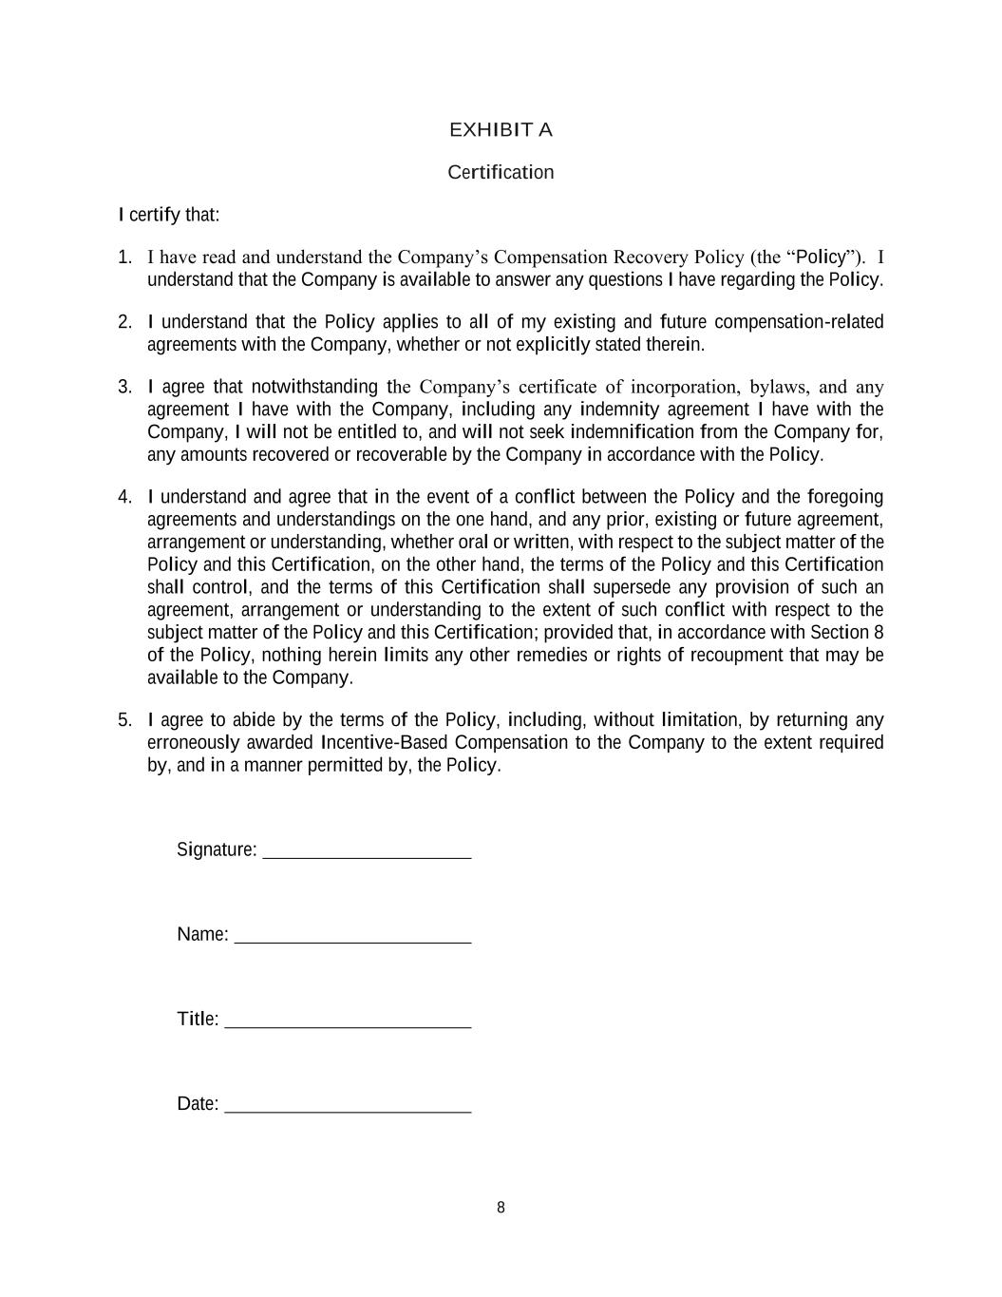
8 EXHIBIT A Certification I certify that: 1. I have read and understand the Company’s Compensation Recovery Policy (the “Policy”). I understand that the Company is available to answer any questions I have regarding the Policy. 2. I understand that the Policy applies to all of my existing and future compensation-related agreements with the Company, whether or not explicitly stated therein. 3. I agree that notwithstanding the Company’s certificate of incorporation, bylaws, and any agreement I have with the Company, including any indemnity agreement I have with the Company, I will not be entitled to, and will not seek indemnification from the Company for, any amounts recovered or recoverable by the Company in accordance with the Policy. 4. I understand and agree that in the event of a conflict between the Policy and the foregoing agreements and understandings on the one hand, and any prior, existing or future agreement, arrangement or understanding, whether oral or written, with respect to the subject matter of the Policy and this Certification, on the other hand, the terms of the Policy and this Certification shall control, and the terms of this Certification shall supersede any provision of such an agreement, arrangement or understanding to the extent of such conflict with respect to the subject matter of the Policy and this Certification; provided that, in accordance with Section 8 of the Policy, nothing herein limits any other remedies or rights of recoupment that may be available to the Company. 5. I agree to abide by the terms of the Policy, including, without limitation, by returning any erroneously awarded Incentive-Based Compensation to the Company to the extent required by, and in a manner permitted by, the Policy. Signature: Name: Title: Date:

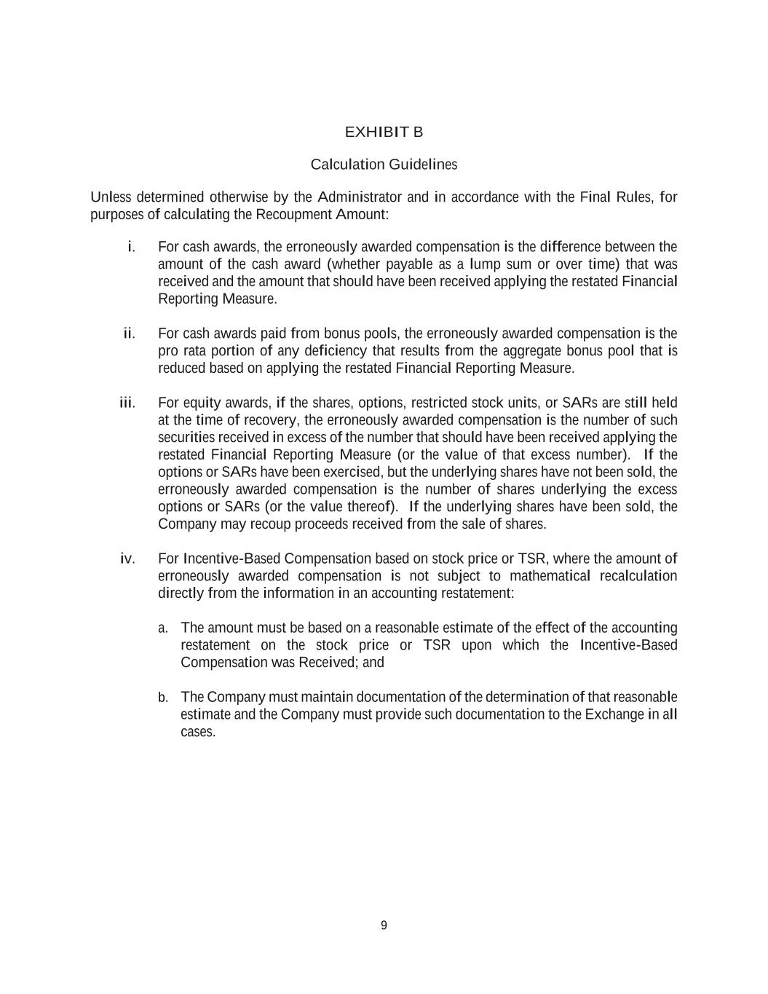
9 EXHIBIT B Calculation Guidelines Unless determined otherwise by the Administrator and in accordance with the Final Rules, for purposes of calculating the Recoupment Amount: i. For cash awards, the erroneously awarded compensation is the difference between the amount of the cash award (whether payable as a lump sum or over time) that was received and the amount that should have been received applying the restated Financial Reporting Measure. ii. For cash awards paid from bonus pools, the erroneously awarded compensation is the pro rata portion of any deficiency that results from the aggregate bonus pool that is reduced based on applying the restated Financial Reporting Measure. iii. For equity awards, if the shares, options, restricted stock units, or SARs are still held at the time of recovery, the erroneously awarded compensation is the number of such securities received in excess of the number that should have been received applying the restated Financial Reporting Measure (or the value of that excess number). If the options or SARs have been exercised, but the underlying shares have not been sold, the erroneously awarded compensation is the number of shares underlying the excess options or SARs (or the value thereof). If the underlying shares have been sold, the Company may recoup proceeds received from the sale of shares. iv. For Incentive-Based Compensation based on stock price or TSR, where the amount of erroneously awarded compensation is not subject to mathematical recalculation directly from the information in an accounting restatement: a. The amount must be based on a reasonable estimate of the effect of the accounting restatement on the stock price or TSR upon which the Incentive-Based Compensation was Received; and b. The Company must maintain documentation of the determination of that reasonable estimate and the Company must provide such documentation to the Exchange in all cases.

