UNITED STATES

SECURITIES AND EXCHANGE COMMISSION
WASHINGTON, D.C. 20549

FORM 8-K

CURRENT REPORT PURSUANT TO

SECTION 13 OR 15(d) OF THE
SECURITIES EXCHANGE ACT OF 1934

Date of Report: September 24, 2018

(Date of earliest event reported)

ANAPTYSBIO, INC.

(Exact Name of Registrant as Specified in Its Charter)

Delaware
(State or Other Jurisdiction of Incorporation)
001-37985 | 20-3828755
(Commission | (IRS Employer
File Number) | Identification No.)
10421 Pacific Center Court, Suite 200
San Diego, CA | 92121
(Address of Principal Executive Offices) | (Zip Code)
(858) 362-6295
(Registrant’s Telephone Number, Including Area Code)
Not Applicable
(Former name or former address, if changed since last report.)

Check the appropriate box below if the Form 8-K filing is intended to simultaneously satisfy the filing obligation of the registrant under any of the following provisions (see General Instruction A.2. below):

- Written communications pursuant to Rule 425 under the Securities Act (17 CFR 230.425)

- Soliciting material pursuant to Rule 14a-12 under the Exchange Act (17 CFR 240.14a-12)

- Pre-commencement communications pursuant to Rule 14d-2(b) under the Exchange Act (17 CFR 240.14d-2(b))

- Pre-commencement communications pursuant to Rule 13e-4(c) under the Exchange Act (17 CFR 240.13e-4(c))

Indicate by check mark whether the registrant is an emerging growth company as defined in Rule 405 of the Securities Act of 1933 (§230.405 of this chapter) or Rule 12b-2 of the Securities Exchange Act of 1934 (§240.12b-2 of this chapter).

Emerging growth company ☒

If an emerging growth company, indicate by check mark if the registrant has elected not to use the extended transition period for complying with any new or revised financial accounting standards provided pursuant to Section 13(a) of the Exchange Act. ☒

Item 7.01 Regulation FD.

On September 24, 2018, AnaptysBio, Inc. (“AnaptysBio”) issued a press release announcing top line proof of concept data from an interim analysis of AnaptysBio’s ongoing etokimab Phase 2a trial in severe eosinophilic asthma. A copy of the press release is furnished as Exhibit 99.1 to this report and incorporated herein by reference.

On September 24, 2018, AnaptysBio held an investor conference call. A copy of the slides presented during the investor conference call are furnished as Exhibit 99.2 to this report and incorporated herein by reference.

The information furnished with this report, including Exhibit 99.1 and Exhibit 99.2, shall not be deemed “filed” for purposes of Section 18 of the Securities Exchange Act of 1934, as amended (“Exchange Act”), or otherwise subject to the liabilities of that section, nor shall it be deemed incorporated by reference into any other filing under the Securities Act of 1933, as amended, or the Exchange Act, except as expressly set forth by specific reference in such a filing.

Item 9.01 Financial Statements and Exhibits.

(d) Exhibits.

Exhibit |  | Description of Exhibit
Number |  | Description of Exhibit
99.1 |  | Press release dated September 24, 2018.
99.2 |  | Slides presented by AnaptysBio on September 24, 2018.

SIGNATURES

Pursuant to the requirements of the Securities Exchange Act of 1934, the registrant has duly caused this report to be signed on its behalf by the undersigned hereunto duly authorized.

 | AnaptysBio, Inc.
Date: September 24, 2018 | By: | /s/ Dominic Piscitelli
 | Name: | Dominic Piscitelli
 | Title: | Chief Financial Officer

Exhibit 99.1


AnaptysBio Reports Positive Topline Data from Phase 2a Proof-of-Concept Clinical Trial of Etokimab in Severe Eosinophilic Asthma

- Lung function improvement occurred rapidly following a single dose of etokimab, with an 8 percent increase in FEV1 over placebo at Day 2

- FEV1 improvement was sustained throughout the interim analysis period, with an 11 percent increase over placebo at Day 64

- Blood eosinophil reduction was consistent with lung function improvement, with 31 percent and 46 percent reduction over placebo at Day 2 and Day 64, respectively

- Management to host conference call today at 8:30 a.m. EDT

SAN DIEGO, Sept. 24, 2018 — AnaptysBio, Inc. (Nasdaq: ANAB), a clinical-stage biotechnology company developing first-in-class antibody product candidates focused on unmet medical needs in inflammation, today announced positive topline proof-of-concept data for etokimab, its investigational anti-IL-33 therapeutic antibody, in an ongoing single dose Phase 2a clinical trial in adult patients with severe eosinophilic asthma. Patients administered with etokimab rapidly improved their Forced Exhaled Volume In One Second (FEV1), which is a measure of lung function, with an 8 percent FEV1 improvement over placebo at Day 2. FEV1 improvement was sustained through Day 64, with an 11 percent increase over placebo. Blood eosinophil reduction was sustained through the interim analysis period, with a 31 percent reduction at Day 2 and a 46 percent reduction at Day 64 over placebo, which was consistent with FEV1 improvement observed in this trial. Etokimab was generally well tolerated in all patients and no serious adverse events were reported as of this interim analysis.

“Eosinophilic asthma is a debilitating medical condition that results from severe inflammation and airway obstruction,” said Dr. Ian Pavord, professor of Respiratory Medicine at University of Oxford and principal investigator of the Phase 2a trial. “The benefit observed in this trial after a single dose of etokimab demonstrates the potential for IL-33 inhibition in treating severe eosinophilic asthma. I look forward to the continued advancement of etokimab in subsequent clinical trials for patients suffering from this chronic life-long disease.”

Phase 2a Trial Design

This Phase 2a proof-of-concept trial enrolled 25 adult severe eosinophilic asthma patients, who were randomized between a single 300mg intravenous dose of etokimab or placebo upon enrollment (Day 1) at six sites located in the United States and the United Kingdom. Upon screening, which occurred seven to 14 days prior to enrollment, patients were required to have a blood eosinophil count of at least 300 per microliter, confirmed clinical diagnosis of severe asthma according to the Global Initiative for Asthma (GINA) 2016, pre-bronchodilator FEV1 of less than 80 percent of predicted and at least one asthma exacerbation within the past 12 months requiring use of rescue medication. Patients were required to be stably maintained on high-dose inhaled corticosteroids (ICS) and long-acting beta-2-agonists (LABA) for at least three months prior to screening and were required to continue ICS/LABA therapy during the course of this trial. Baseline clinical assessments were conducted for each patient on Day 1 prior to etokimab or placebo dose, and patients completed follow-up clinical assessments on Days 2, 8, 22, 36 and

64 as of this interim analysis. The last follow-up visit for each patient will occur on Day 127 post-dose.

Interim Analysis

Key data and observations as of this interim analysis indicate the following:

- Baseline parameters of etokimab-dosed patients (n=12) were 545 blood eosinophils per microliter, 2.5 liters FEV1 and 65 percent predicted FEV1, while placebo-dosed patients (n=13) had 705 blood eosinophils per microliter, 2.5 liters FEV1 and 66 percent predicted FEV1. Nine of 12 (75%) etokimab-dosed patients were male with an average age of 41, while nine of 13 (69%) placebo-dosed patients were male with an average age of 36.

- Etokimab-dosed patients rapidly improved lung function by Day 2, where FEV1 increased by 8 percent over placebo.

- FEV1 increase was sustained at Day 64, where etokimab-dosed patients demonstrated an 11 percent increase over placebo.

- Blood eosinophil reduction, which is a biomarker illustrative of etokimab’s mechanistic breadth, was observed at

31 percent over placebo at Day 2 and sustained to 46 percent over placebo at Day 64. This reduction correlated with FEV1 improvement and was consistent with the blood eosinophil effects observed in a prior single dose etokimab trial in moderate-to-severe atopic dermatitis patients.

 |  |  |  |  |  | Change Relative to
 |  |  |  |  |  |  | Day 1 Baseline
Parameter |  |  | Timepoint |  | Etokimab |  |  | Placebo |  | Net
 |  |  | Timepoint |  |  | (n=12) |  | (n=13)
 |  |  | Day 2 |  | 12% |  |  | 4% |  | 8%
FEV1 |  |  | Day 8 | 9% |  |  |  | 5% |  | 4%
 |  |  | Day 22 |  | 16% |  |  | 8% |  | 8%
Increase (%) |  |  | Day 22
 |  |  | Day 36 |  |  | 14% |  | 8% |  | 6%
 |  |  | Day 64 |  |  | 15% |  | 4% |  | 11%
 |  |  | Day 2 |  |  | -22% |  | 9% |  | -31%
Blood Eosinophil |  |  | Day 8 | -34% |  |  |  | -15% |  | -19%
 |  |  | Day 22 | -30% |  |  |  | -10% |  | -20%
Level (%)
 |  |  | Day 36 | -43% |  |  |  | 1% |  | -44%
 |  |  | Day 64 | -40% |  |  |  | 6% |  | -46%

- Etokimab was generally well-tolerated by all patients and no serious adverse events were reported as of this interim analysis. No treatment-emergent adverse events were deemed to be etokimab-related, and the most frequent treatment-emergent adverse events reported were single occurrences of moderate strep throat in two etokimab-dosed patients and single occurrences of mild vomiting in two placebo-dosed patients. No exacerbations or rescue therapy usage has been reported as of the interim analysis.

“We are thrilled to have demonstrated proof-of-concept in this single dose Phase 2a trial and look forward to advancing the development of etokimab for patients suffering from eosinophilic asthma,” said Hamza Suria, president and chief executive officer of AnaptysBio. “Genotypic studies have validated the key role played by IL-33 in asthma, and we believe etokimab’s upstream mechanism has the potential for a broad therapeutic benefit across multiple atopic disorders.”

This Phase 2a trial is currently ongoing and the company plans to report full data from this trial at a medical conference in 2019 following trial completion.

AnaptysBio plans to continue development of etokimab in eosinophilic asthma with a multi-dose Phase 2b randomized, double-blinded, placebo-controlled trial, which is expected to be initiated in 2019.

Conference Call & Webcast Information

The AnaptysBio management team will host a conference call and live webcast on Monday Sept. 24, 2018, at 8:30 a.m. EDT to discuss the information in this press release.

Dial-in: (833) 696-8361 (domestic) or (430) 775-1625 (international)

Conference ID: 5798647

The live webcast and accompanying slides can be accessed under the investor relations section of AnaptysBio’s website at www.anaptysbio.com. A replay of the conference call will be archived under the investor relations section of the AnaptysBio website for 30 days shortly after the call.

About Etokimab

Etokimab, previously referred to as ANB020, is an antibody that potently binds and inhibits the activity of interleukin-33 (IL-33), a pro-inflammatory cytokine that multiple studies have indicated is a central mediator of atopic diseases, which AnaptysBio believes is broadly applicable to the treatment of atopic inflammatory disorders, such as moderate-to-severe atopic dermatitis, severe eosinophilic asthma, chronic rhinosinusitis with nasal polyps (CRSwNP) and potentially other allergic conditions. Following completion of a healthy volunteer Phase 1 trial of etokimab, AnaptysBio continued clinical development of etokimab into a Phase 2a trial for moderate-to-severe adult atopic dermatitis and a placebo-controlled Phase 2a trial in severe adult eosinophilic asthma patients. AnaptysBio is enrolling its ATLAS trial, a randomized, double-blinded, placebo-controlled multi-dose Phase 2b clinical trial of etokimab in 300 moderate-to-severe adult atopic dermatitis patients where data is anticipated in the second half of 2019. The company also plans to initiate its ECLIPSE trial, a randomized, double-blinded, placebo-controlled Phase 2 trial of etokimab in approximately 100 adult patients with CRSwNP by the end of 2018 with data anticipated in the second half of 2019. AnaptysBio also plans to initiate a randomized, double-blinded, placebo-controlled, multi-dose Phase 2b trial of etokimab in patients with eosinophilic asthma in 2019.

About AnaptysBio

AnaptysBio is a clinical-stage biotechnology company developing first-in-class antibody product candidates focused on unmet medical needs in inflammation. The company’s proprietary anti-inflammatory pipeline includes its anti-IL-33 antibody (etokimab, previously referred to as ANB020) for the treatment of moderate-to-severe atopic dermatitis, severe eosinophilic asthma, chronic rhinosinusitis with nasal polyps (CRSwNP); its anti-IL-36R antibody (ANB019) for the treatment of rare inflammatory diseases, including generalized pustular psoriasis (GPP) and palmoplantar pustulosis (PPP), previously referred to as palmo-plantar pustular psoriasis; and

novel anti-inflammatory checkpoint receptor modulator antibodies for treatment of certain autoimmune diseases where immune checkpoint receptors are insufficiently activated. AnaptysBio’s antibody pipeline has been developed using its proprietary somatic hypermutation (SHM) platform, which uses in vitro SHM for antibody discovery and is designed to replicate key features of the human immune system to overcome the limitations of competing antibody discovery technologies. AnaptysBio has also developed multiple therapeutic antibodies in an immuno-oncology partnership with TESARO and an inflammation partnership with Celgene, including an anti-PD-1 antagonist antibody (TSR-042), an anti-TIM-3 antagonist antibody (TSR-022) and an anti-LAG-3 antagonist antibody (TSR-033), which are currently under clinical development with TESARO, and an anti-PD-1 checkpoint agonist antibody (CC-90006) currently in the clinic with Celgene.

Forward-Looking Statements

This press release contains “forward-looking” statements within the meaning of the “safe harbor” provisions of the Private Securities Litigation Reform Act of 1995, including, but not limited to: the timing of the release of data from our clinical trials, including etokimab’s Phase 2b clinical trial in moderate-to-severe adult atopic dermatitis patients and etokimab’s Phase 2 clinical trial in adult patients with CRSwNP; our design of and our ability to launch a Phase 2 clinical trial of etokimab in adults patients with CRSwNP and a Phase 2b clinical trial of etokimab in eosinophilic asthma; and statements by AnaptysBio’s president and chief executive officer. Statements including words such as “plan,” “continue,” “expect,” or “ongoing” and statements in the future tense are forward-looking statements. These forward-looking statements involve risks and uncertainties, as well as assumptions, which, if they do not fully materialize or prove incorrect, could cause our results to differ materially from those expressed or implied by such forward-looking statements. Forward-looking statements are subject to risks and uncertainties that may cause the company’s actual activities or results to differ significantly from those expressed in any forward-looking statement, including risks and uncertainties related to the company’s ability to advance its product candidates, obtain regulatory approval of and ultimately commercialize its product candidates, the timing and results of preclinical and clinical trials, the company’s ability to fund development activities and achieve development goals, the company’s ability to protect intellectual property and other risks and uncertainties described under the heading “Risk Factors” in documents the company files from time to time with the Securities and Exchange Commission. These forward-looking statements speak only as of the date of this press release, and the company undertakes no obligation to revise or update any forward-looking statements to reflect events or circumstances after the date hereof.

###

Contacts:

Monique Allaire

THRUST Investor Relations

617.895.9511

monique@thrustir.com

Chelcie Lister

THRUST Investor Relations

910.777.3049

chelcie@thrustir.com

Exhibit 99.2


Etokimab (Anti-IL-33) Program

Phase 2a Eosinophilic Asthma Clinical Trial Interim Data Update

September 24th 2018

Nasdaq: ANAB


Safe Harbor Statement

This presentation and the accompanying oral presentation contain “forward-looking” statements within the meaning of the "safe harbor" provisions of the Private Securities Litigation Reform Act of 1995, including, but not limited to: the timing of the release of data from our clinical trials, including etokimab’s Phase 2b clinical trial in moderate-to-severe adult atopic dermatitis patients, etokimab’s Phase 2 clinical trial in adult chronic rhinosinusitis with nasal polyps patients and ANB019’s Phase 2 trials in GPP and PPP patients; the design of and our ability to launch a Phase 2 clinical trial of etokimab in adult chronic rhinosinusitis with nasal polyps patients, a Phase 2b clinical trial of etokimab in severe eosinophilic asthma patients and a Phase 2 clinical trial of ANB019 in PPP patients; the timing of detailed data presentation of etokimab’s Phase 2a clinical trial in severe adult eosinophilic asthma patients; the timing of an IND filing for an anti-inflammatory checkpoint modulator; and the success of our partnership with TESARO and Celgene. Statements including words such as “plan,” “continue,” “expect,” or “ongoing” and statements in the future tense are forward-looking statements. These forward-looking statements involve risks and uncertainties, as well as assumptions, which, if they do not fully materialize or prove incorrect, could cause our results to differ materially from those expressed or implied by such forward-looking statements. Forward-looking statements are subject to risks and uncertainties that may cause the company’s actual activities or results to differ significantly from those expressed in any forward-looking statement, including risks and uncertainties related to the company’s ability to advance its product candidates, obtain regulatory approval of and ultimately commercialize its product candidates, the timing and results of preclinical and clinical trials, the company’s ability to fund development activities and achieve development goals, the company’s ability to protect intellectual property and other risks and uncertainties described under the heading “Risk Factors” in documents the company files from time to time with the Securities and Exchange Commission (SEC). These forward-looking statements speak only as of the date of this presentation, and the company undertakes no obligation to revise or update any forward-looking statements to reflect events or circumstances after the date hereof.

Certain information contained in this presentation may be derived from information provided by industry sources. The Company believes such information is accurate and that the sources from which it has been obtained are reliable. However, the Company cannot guarantee the accuracy of, and has not independently verified, such information.

The trademarks included herein are the property of the owners thereof and are used for reference purposes only. Such use should not be construed as an endorsement of such products.

2

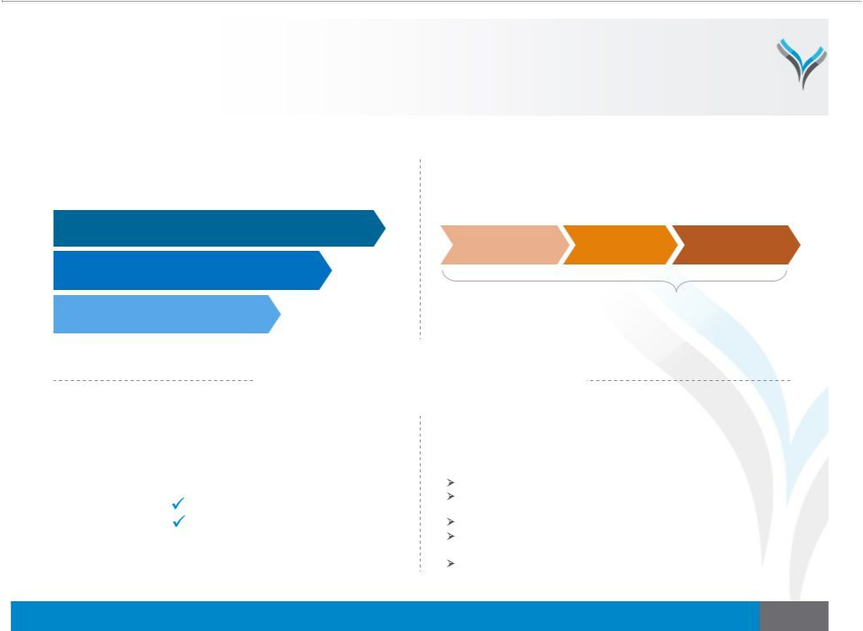
AnaptysBio: Clinical-Stage Antibody Development Company

Focused on Novel Antibody Medicines for Severe Inflammatory Diseases

Wholly-Owned | Rapid Antibody Generation
Anti-Inflammatory Pipeline |  | Platform Technology
Etokimab (ANB020, Anti-IL-33)
Atopic Dermatitis, Eosinophilic Asthma & Chronic Rhinosinusitis with Nasal Polyps | Antibody | Preclinical & | IND or
 | Discovery | Translational | Equivalent Filing
ANB019 (Anti-IL-36R)

Generalized Pustular Psoriasis & Palmoplantar Pustulosis

Checkpoint Modulator | ~2.5 years
Inflammatory Diseases

Antibody Medicines

For Severe Diseases

Validating Product Partnerships

Generated ~$75MM*

TESARO

Celgene

4 Additional Efficacy Readouts

Anticipated By End 2019

Etokimab Eosinophilic Asthma Phase 2a: Top-line data today

ANB019 Generalized Pustular Psoriasis Phase 2: Top-line data in early 2019
Etokimab Atopic Dermatitis Phase 2b: Top-line data in H2 2019 Etokimab Chronic Rhinosinusitis With Nasal Polyps Phase 2: Top-line data in H2 2019
ANB019 Palmoplantar Pustulosis Phase 2: Top-line data in H2 2019

* Asof June30th 2018

3

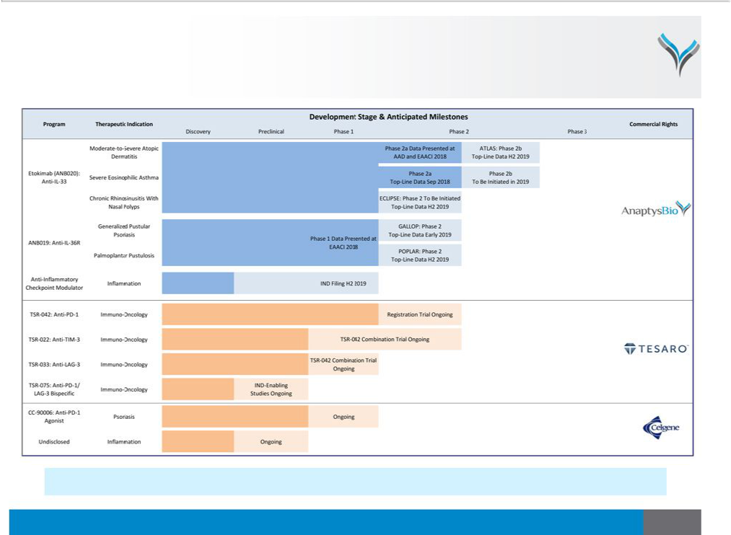
Wholly-Owned and Partnered Product Pipeline

6 AnaptysBio-Generated Antibodies Advanced to Clinic Since Q1 2016

All programs generated internally using AnaptysBio’s proprietary antibody generation platform technology

4

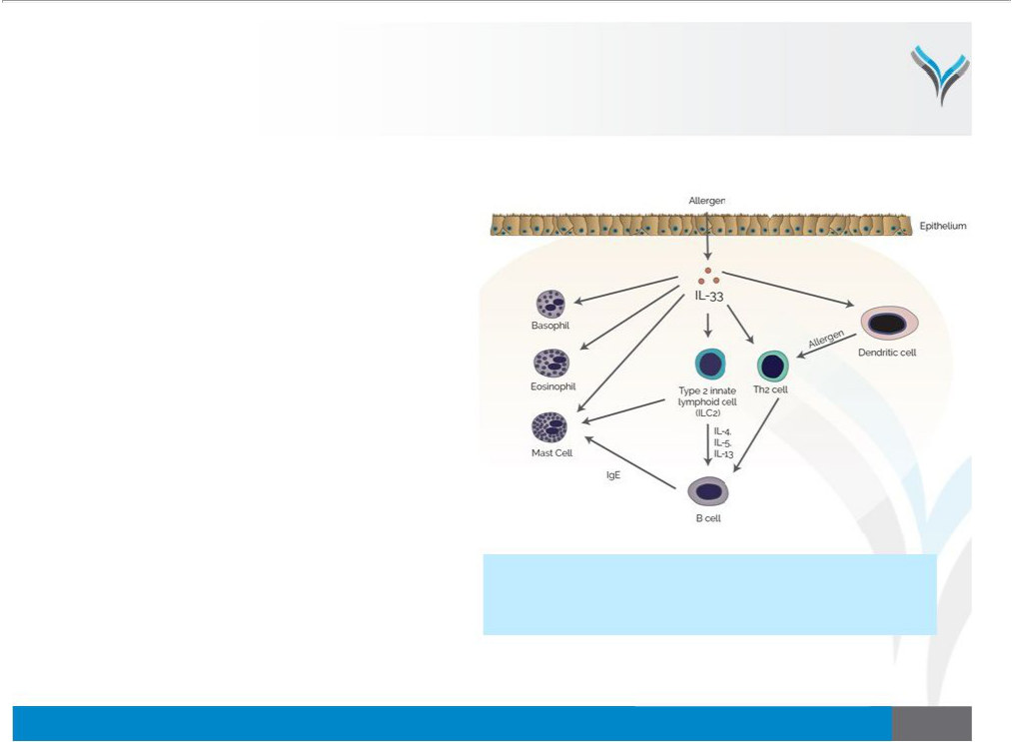
Etokimab: First-in-Class Anti-IL-33 Antibody

Broadly Applicable to Atopic Diseases

- IL-33 is an upstream driver of atopic disease

– Human genetics validate key role of IL-33 in atopic dermatitis and asthma

– Pro-inflammatory cytokine released upon allergen contact with epithelium

– Activates downstream release of IL-4, IL-5 and IL-13

– Modulates IgE-mediated mast cell and basophil degranulation

- Etokimab is a potentially first-in-class anti-IL-33 cytokine antibody

– Phase I healthy volunteer trial completed without dose-limiting toxicities

– AnaptysBio pursuing development in moderate-to-severe atopic dermatitis, eosinophilic asthma and chronic rhinosinusitis with nasal polyps

IL-33 acts as a gatekeeperof allergic responsewith demonstrated 1
activityin the initiation (activationof ILC2cells) , propagation(activation
of allergen-specificT and B cells)² and amplification(degranulationof 3

mastcellsandbasophils) .

1. Cayrolet al. Curr OpinImmunol (2014) 31:31

2. Peineet al. TrendsImmunol (2016) 37(5):321

3. Salujaet al. ClinTranslAllergy (2015) 5:33

5

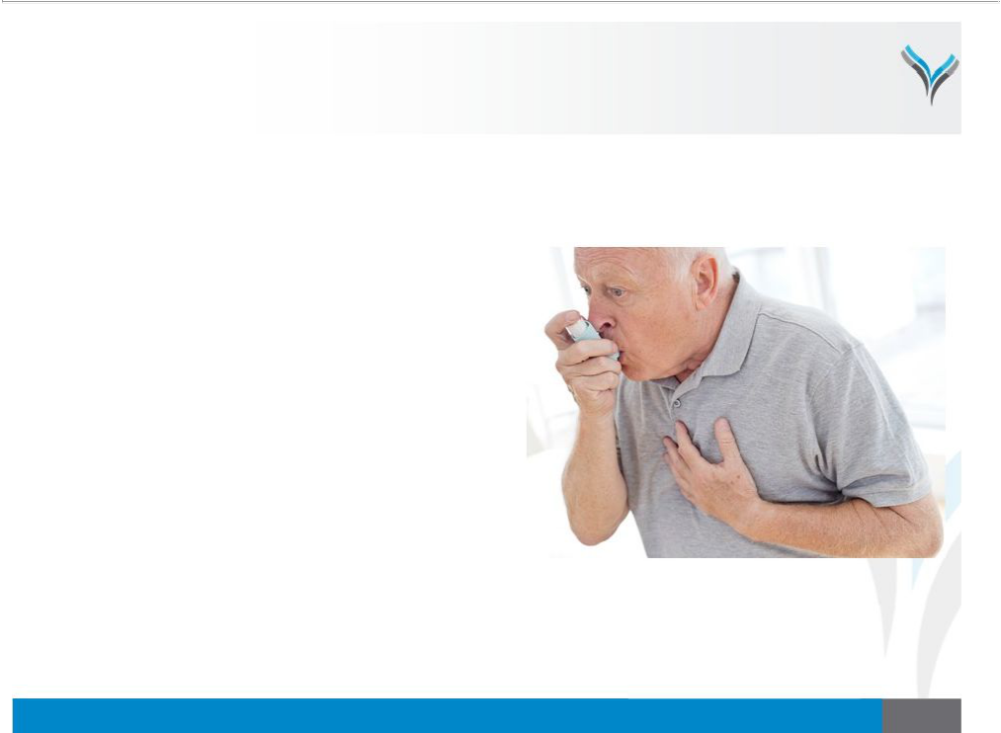
Eosinophilic Asthma

Focus on Severe Patients Inadequately Controlled With ICS/LABA

- Eosinophilic asthma is a debilitating, chronic atopic disease

  - Decreased lung function associated with poor quality-of-life and exacerbations

  - Often concomitant with other atopic diseases, such as chronic rhinosinusitis with nasal polyps and atopic dermatitis

- Significant unmet medical need

  - ~1.1 million US adults diagnosed with severe asthma and inadequately controlled with inhaled corticosteroids and long-acting-beta-agonists (ICS/LABA)

  - Approximately 50% estimated to be eosinophilic asthmatics

6

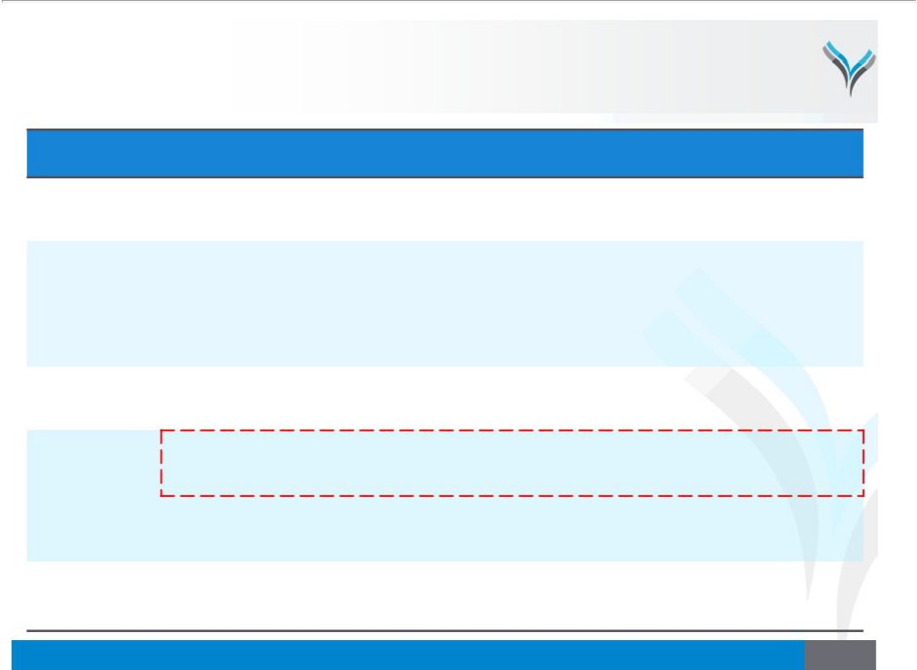
Etokimab Clinical Trials

Subjects | Trial | TrialDesign | Key Clinical | Timing
Subjects | Trial | TrialDesign | Endpoint(s) | Timing

Healthy Volunteers | Phase 1
 | Phase 2a
Moderate-to-Severe
Adult Atopic
Dermatitis | ATLAS
 | Phase 2b
Moderate-to-Severe
Baseline Adult Peanut | Phase 2a
Allergy
 | Phase 2a
Eosinophilic Asthma
 | Phase 2b
Adult Chronic
Rhinosinusitis with | ECLIPSE
Nasal Polyps | Phase 2
(CRSwNP)

n=96, SAD and MADcohorts, IV and SC dosing, randomized,

placebo-controlled

n=12, single IV dose

n=300,SC multi-dose, randomized, placebo-controlled

n=20, single IVdose, randomized,

placebo-controlled

n=25,single IV dose, randomized, placebo-controlled

Undisclosed

n=100, SC multi-dose,randomized,

placebo-controlled

Safety, PK and PD

EczemaArea & Severity Index (EASI)

EASI

Oral Food

Challenge (OFC)

ForcedExpiratory

Volume in 1

Second (FEV1)

Undisclosed

Nasal Polyps

Score (NPS); Sino-

Nasal Outcome

Test-22 (SNOT-22)

Top-line data announced October 2016 Detailed data presented at AAD and AAAAI 2017

Top-line data announced October 2017 Detailed data presented at AAD and EAACI 2018

Anticipate top-line data in H2 2019

Top-line data announced March 2018 De-prioritizedfor commercial reasons

Top-line data announced today Detailed data presentation anticipated in 2019

Anticipate initiation in 2019

Anticipate top-line data in H2 2019

7

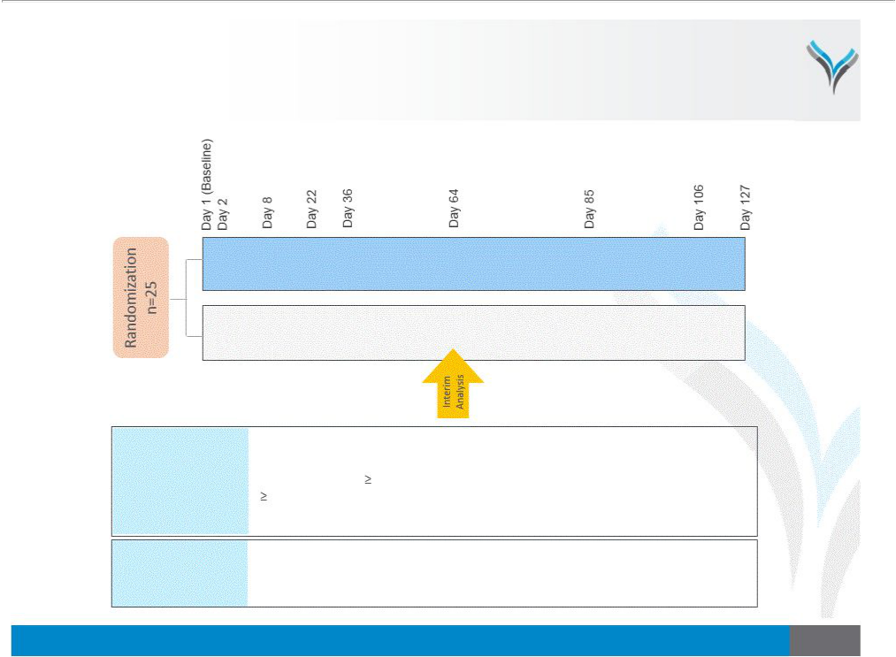
Etokimab Eosinophilic Asthma Phase 2a Trial

Single Dose of Etokimab or Placebo Administered on Day 1

Etokimab300mg IV Single Dose + High Dose ICS/LABA n=12

Placebo Single Dose + High Dose ICS/LABA | n=13

Patient

Population

Adults with severe asthma (according to GINA 2016)

Pre-bronchodilator FEV1 <80% of predicted

Blood eosinophils300 cells/microliter

1 asthma exacerbation in past year requiring rescue medication

Stably maintained on ICS/LABA dose for at least 3 months prior to screening

Efficacy: % change in FEV1 relative to baseline
Key Endpoints Biomarker: change in blood eosinophil levels

Safety

ClinicalTrials.gov: NCT03469934

8

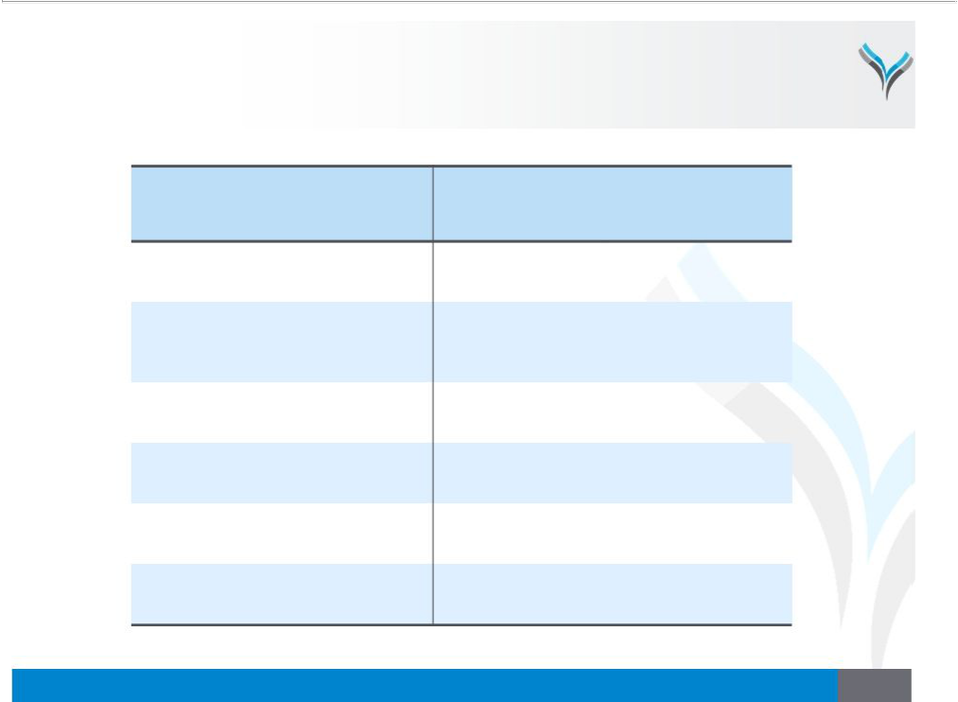
Key Baseline Parameters

Average Baseline Parameters of | Etokimab Arm | PlaceboArm
EnrolledPatients(Day 1 Pre-Dose) | Etokimab Arm | PlaceboArm

n

BloodEosinophils

per microliter

FEV1(Liters)

- PredictedFEV1 Age (years)
Male %

12 13

545 705

2.5 2.5

65% 66%

41 36

75% (9 of 12) 69% (9of 13)

9

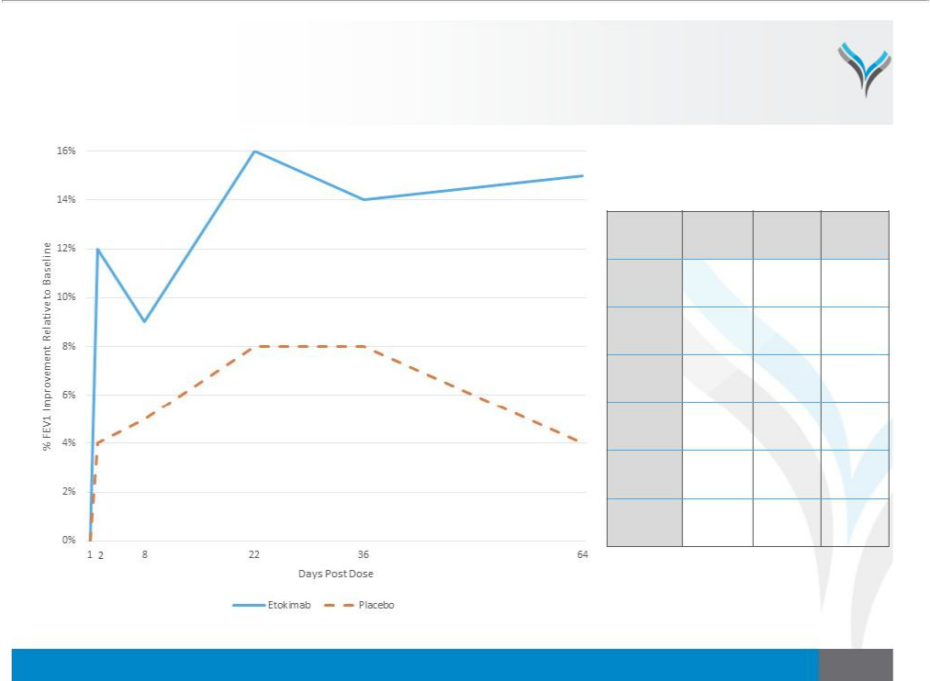
% FEV1 Improvement Relative to Baseline After Single Dose

Rapid and Sustained FEV1 Improvement Post-Etokimab Administration

Timepoint | Etokimab | Placebo | Net
Day 1 | 0% | 0% | 0%
(Baseline) | 0% | 0% | 0%
Day 2 | 12% | 4% | 8%
Day 8 | 9% | 5% | 4%
Day 22 | 16% | 8% | 8%
Day 36 | 14% | 8% | 6%
Day 64 | 15% | 4% | 11%

10

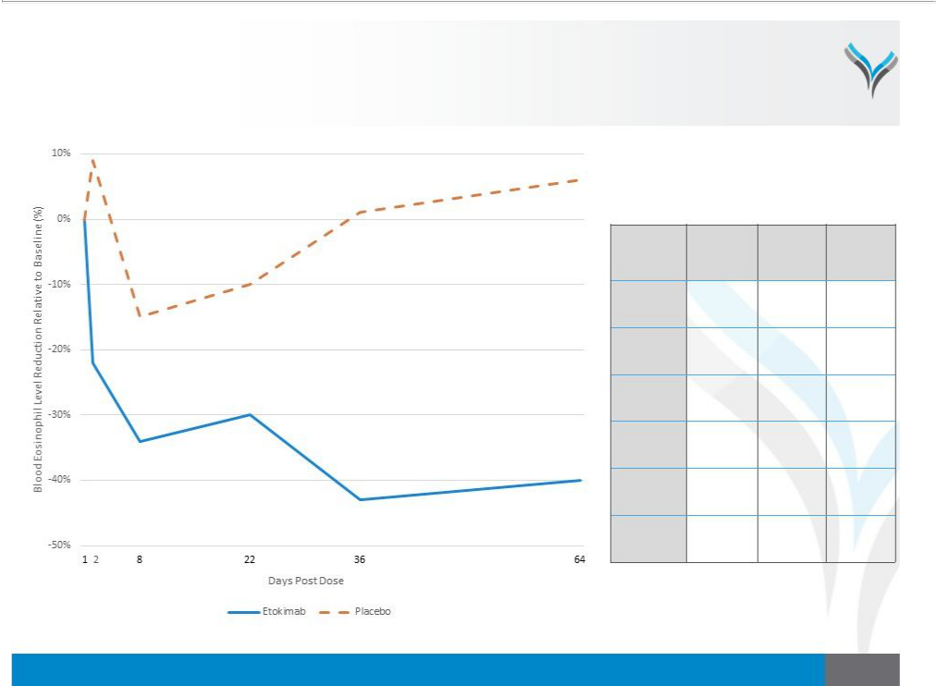
Blood Eosinophil Reduction Relative to Baseline After Single Dose

Correlates with FEV1 Improvement and Consistent With Phase 2a Atopic Dermatitis Trial

Timepoint | Etokimab | Placebo | Net
Day 1 | 0% | 0% | 0%
(Baseline) | 0% | 0% | 0%
Day 2 | -22% | 9% | -31%
Day 8 | -34% | -15% | -19%
Day 22 | -30% | -10% | -20%
Day 36 | -43% | 1% | -44%
Day 64 | -40% | 6% | -46%

11


Eosinophilic Asthma Phase 2a Day 64 Interim Analysis

Supports Advancement of Etokimab Into Phase 2b Eosinophilic Asthma Trial

Interim Analysis Summary

- Etokimab demonstrated proof-of-concept in eosinophilic asthma

- Single dose of etokimab resulted in rapid and sustained improvement in FEV1 over placebo

- Blood eosinophil biomarker reduction correlated with FEV1 improvement and is consistent with prior etokimab Phase 2a atopic dermatitis trial

- Etokimab was generally well-tolerated and no serious adverse events reported

  - No treatment-emergent adverse events were deemed to be etokimab-related

  - The most frequent treatment-emergent adverse events reported were single occurrences of moderate strep throat in two etokimab-dosed patients and single occurrences of mild vomiting in two placebo-dosed patients

  - No exacerbations or rescue therapy usage was reported

Next Steps

- Complete ongoing Phase 2a trial and present detailed data at a medical conference in 2019

- Initiate Phase 2b randomized, double-blinded, placebo-controlled, multi-dose trial of etokimab in eosinophilic asthma during 2019

12


Anticipated Milestones

4 Additional Efficacy Readouts Anticipated By End 2019

Program

Etokimab

(anti-IL-33)

ANB019

(anti-IL-36R)

Milestone

Moderate-to-Severe Adult

Atopic Dermatitis Phase 2a Trial

ATLAS: Moderate-to-Severe Adult Atopic Dermatitis Phase 2b Trial

Severe Adult Eosinophilic

Asthma Phase 2a Trial

Eosinophilic Asthma Phase 2b Trial

ECLIPSE: Adult Chronic Rhinosinusitis with

Nasal Polyps Phase 2 Trial

Healthy Volunteer Top-line Phase I Trial

GALLOP: GPP Phase 2 Trial

POPLAR: PPP Phase 2 Trial

Timing

Top-line data announced October 2017 Detailed data presented at AAD and EAACI 2018

Initiated H1 2018

Top-line data anticipated in H2 2019

Top-line data presented today

Detailed data to be presented in 2019

To be initiated in 2019

To be initiated by end 2018

Top-line data anticipated in H2 2019

Top-line data announced November 2017 Detailed data presented at EAACI 2018

Initiated H1 2018

Top-line data anticipated in early 2019

Initiated H2 2018

Top-line data anticipated in H2 2019

Approximately $300MM in cash, cash equivalents and investments as of June 30th 2018

13

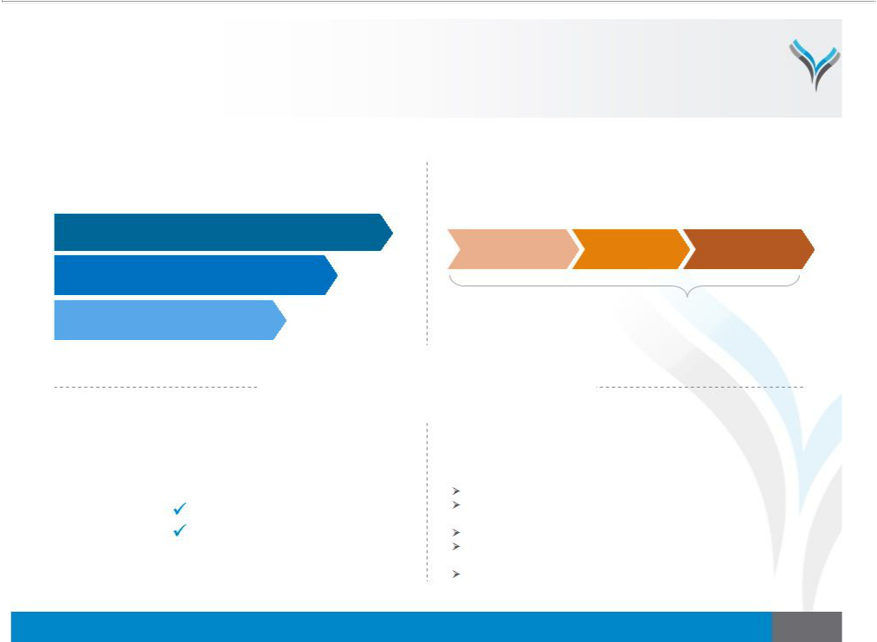
AnaptysBio: Clinical-Stage Antibody Development Company

Focused on Novel Antibody Medicines for Severe Inflammatory Diseases

Wholly-Owned | Rapid Antibody Generation
Anti-Inflammatory Pipeline |  | Platform Technology
Etokimab (ANB020, Anti-IL-33)
Atopic Dermatitis, Eosinophilic Asthma & Chronic Rhinosinusitis with Nasal Polyps | Antibody | Preclinical & | IND or
 | Discovery | Translational | Equivalent Filing
ANB019 (Anti-IL-36R)

Generalized Pustular Psoriasis & Palmoplantar Pustulosis

Checkpoint Modulator | ~2.5 years
Inflammatory Diseases

Antibody Medicines

For Severe Diseases

Validating Product Partnerships

Generated ~$75MM*

TESARO

Celgene

4 Additional Efficacy Readouts

Anticipated By End 2019

Etokimab Eosinophilic Asthma Phase 2a: Top-line data today ANB019 Generalized Pustular Psoriasis Phase 2: Top-line data in early 2019
Etokimab Atopic Dermatitis Phase 2b: Top-line data in H2 2019 Etokimab Chronic Rhinosinusitis With Nasal Polyps Phase 2: Top-line data in H2 2019
ANB019 Palmoplantar Pustulosis Phase 2: Top-line data in H2 2019

th
* As of June 30 2018

14



