UNITED STATES

SECURITIES AND EXCHANGE COMMISSION

Washington, D.C. 20549

FORM 10-Q

- Quarterly Report pursuant to Section 13 or 15(d) of the Securities Exchange Act of 1934

For the quarterly period ended September 30, 2023

OR

- Transition report pursuant to Section 13 or 15(d) of the Securities Exchange Act of 1934

For the transition period from |  | to |  | .
Commission File Number: 001-37985

 |  |  | ANAPTYSBIO, INC.
 |  |  | (Exact name of registrant as specified in its charter)
Delaware |  |  |  |  | 20-3828755
(State or other jurisdiction of |  |  |  |  | (I.R.S. Employer
incorporation or organization) |  |  |  |  | Identification Number)
 |  |  | 10770 Wateridge Circle, Suite 210
 |  |  | San Diego, CA 92121
 |  |  | (Address of principal executive offices and zip code)
 |  | (858) 362-6295
 |  |  | (Registrant’s telephone number, including area code)
 |  | Securities registered pursuant to Section 12(b) of the Act:
Title of each class |  |  | Trading Symbol(s) |  | Name of each exchange on which registered
Common Stock, $0.001 par value |  |  | ANAB |  | The Nasdaq Stock Market LLC

Indicate by check mark whether the Registrant (1) has filed all reports required to be filed by Section 13 or 15(d) of the Securities Exchange Act of 1934 during the preceding 12 months (or for such shorter period that the Registrant was required to file such reports), and (2) has been subject to such filing requirements for the past 90 days: Yes ☒ No ☐
Indicate by check mark whether the Registrant has submitted electronically every Interactive Data File required to be submitted pursuant to Rule 405 of Regulation S-T (§232.405 of this chapter)

during the preceding 12 months (or for such shorter period that the Registrant was required to submit such files). |  | Yes ☒ No ☐
Indicate by check mark whether the Registrant is a large accelerated filer, an accelerated filer, a non-accelerated filer, a smaller reporting company, or an emerging growth company. See the
definitions of “large accelerated filer,” “accelerated filer,” “smaller reporting company” and “emerging growth company” in Rule 12b-2 of the Exchange Act.
Large Accelerated Filer | ☐ | Accelerated Filer | ☐
Non-accelerated Filer | ☒ | Smaller Reporting Company | ☒
 |  | Emerging Growth Company | ☐

If an emerging growth company, indicate by check mark if the registrant has elected not to use the extended transition period for complying with any new or revised financial accounting standards provided pursuant to Section 13(a) of the Exchange Act. ☐

Indicate by check mark whether the Registrant is a shell company (as defined in Rule 12b-2 of the Act). Yes ☐ No ☒

As of October 30, 2023, there were 26,575,178 shares of the Registrant’s Common Stock outstanding.

 |  |  |  |  |  |  |  |  |  |  |  | AnaptysBio, Inc.
 |  |  |  |  |  |  |  |  |  |  |  | Table of Contents
 |  |  |  |  |  |  |  |  |  | PART I. FINANCIAL INFORMATION
Item 1. | Consolidated Financial Statements (unaudited)
 | Consolidated Balance Sheets as of September 30, 2023 and December 31, 2022
 | Consolidated Statements of Operations and Comprehensive Loss for the Three and Nine Months Ended September 30, 2023 and 2022
 | Consolidated Statements of Stockholders' Equity for the Three and Nine Months Ended September 30, 2023
 | Consolidated Statements of Stockholders’ Equity for the Three and Nine Months Ended September 30, 2022
 | Consolidated Statements of Cash Flows for the Nine Months Ended September 30, 2023 and 2022
 | Notes to the Unaudited Consolidated Financial Statements
Item 2. | Management’s Discussion and Analysis of Financial Condition and Results of Operations
Item 3. | Quantitative and Qualitative Disclosures About Market Risk
Item 4. | Controls and Procedures
 |  |  |  |  |  |  |  |  |  | PART II. OTHER INFORMATION
Item 1. | Legal Proceedings
Item 1A. | Risk Factors
Item 2. | Unregistered Sales of Equity Securities, Use of Proceeds and Issuer Purchases of Equity Securities
Item 3. | Defaults Upon Senior Securities
Item 4. | Mine Safety Disclosures
Item 5. | Other Information
Item 6. | Exhibits
 | Exhibit Index
 | Signatures

Page Number

1

1

2

3

4

5

6

22

31

31

32

32

65

65

66

66

66

66

67

PART I. FINANCIAL INFORMATION

Item 1. Consolidated Financial Statements (unaudited)

AnaptysBio, Inc.

Consolidated Balance Sheets

(in thousands, except par value data)

(unaudited)

 |  | September 30, 2023 |  |  | December 31, 2022
ASSETS
Current assets:
Cash and cash equivalents | $ | 26,295 |  | $ | 71,308
Receivables from collaborative partners |  | 3,269 |  |  | 1,419
Short-term investments |  | 386,752 |  |  | 369,933
Prepaid expenses and other current assets |  | 11,684 |  |  | 4,545
Total current assets |  | 428,000 |  |  | 447,205
Property and equipment, net |  | 2,254 |  |  | 2,089
Operating lease right-of-use assets |  | 16,613 |  |  | 17,898
Long-term investments |  | 40,203 |  |  | 142,935
Other long-term assets |  | 256 |  |  | 256
Total assets | $ | 487,326 |  | $ | 610,383
LIABILITIES AND STOCKHOLDERS’ EQUITY
Current liabilities:
Accounts payable | $ | 6,521 |  | $ | 2,784
Accrued expenses |  | 30,916 |  |  | 21,633
Current portion of operating lease liability |  | 1,741 |  |  | 1,637
Total current liabilities |  | 39,178 |  |  | 26,054
Liability related to sale of future royalties |  | 311,272 |  |  | 304,413
Operating lease liability, net of current portion |  | 16,493 |  |  | 17,813
Stockholders’ equity:
Preferred stock, $0.001 par value, 10,000 shares authorized and no shares, issued or outstanding at September 30, 2023 and December 31, 2022, |  | — |  |  | —
respectively |  |  |  |  | —
Common stock, $0.001 par value, 500,000 shares authorized, 26,575 shares and 28,513 shares issued and outstanding at September 30, 2023 and |  | 27 |  |  | 29
December 31, 2022, respectively |  | 27 |  |  | 29
Additional paid in capital |  | 694,591 |  |  | 717,797
Accumulated other comprehensive loss |  | (2,350) |  |  | (5,246)
Accumulated deficit |  | (571,885) |  |  | (450,477)
Total stockholders’ equity |  | 120,383 |  |  | 262,103
Total liabilities and stockholders’ equity | $ | 487,326 |  | $ | 610,383

See accompanying notes to unaudited consolidated financial statements.

1

AnaptysBio, Inc.

Consolidated Statements of Operations and Comprehensive Loss

(in thousands, except per share data)

(unaudited)

 |  | Three Months Ended |  |  |  |  |  | Nine Months Ended
 |  | September 30, |  |  |  |  |  | September 30,
 | 2023 |  |  |  | 2022 |  |  | 2023 |  |  | 2022
Collaboration revenue | $ | 3,318 |  | $ | 1,293 |  | $ | 8,152 |  | $ | 3,479
Operating expenses:
Research and development |  | 30,878 |  |  | 22,064 |  |  | 98,758 |  |  | 65,424
General and administrative |  | 10,172 |  |  | 8,862 |  |  | 31,670 |  |  | 27,236
Total operating expenses |  | 41,050 |  |  | 30,926 |  |  | 130,428 |  |  | 92,660
Loss from operations |  | (37,732) |  |  | (29,633) |  |  | (122,276) |  |  | (89,181)
Other income (expense), net:
Interest income |  | 4,854 |  |  | 2,262 |  |  | 13,993 |  |  | 3,711
Non-cash interest expense for the sale of future royalties |  | (4,431) |  |  | (6,135) |  |  | (13,125) |  |  | (16,857)
Other income, net |  | 1 |  |  | 4 |  |  | — |  |  | 16
Total other income (expense), net |  | 424 |  |  | (3,869) |  |  | 868 |  |  | (13,130)
Net loss |  | (37,308) |  |  | (33,502) |  |  | (121,408) |  |  | (102,311)
Unrealized gain (loss) on available for sale securities |  | 1,261 |  |  | (2,146) |  |  | 2,896 |  |  | (5,585)
Comprehensive loss | $ | (36,047) |  | $ | (35,648) |  | $ | (118,512) |  | $ | (107,896)
Net loss per common share:
Basic and diluted | $ | (1.41) |  | $ | (1.18) |  | $ | (4.49) |  | $ | (3.64)
Weighted-average number of shares outstanding:
Basic and diluted |  | 26,546 |  |  | 28,289 |  |  | 27,038 |  |  | 28,071

See accompanying notes to unaudited consolidated financial statements.

2

AnaptysBio, Inc.

Consolidated Statement of Stockholders’ Equity

(in thousands)

(unaudited)

 | Common Stock |  |  |  |  |  | Additional |  |  |  |  |  |  |  |  | Total
 | Shares |  |  | Amount |  |  | Paid-in |  |  | Accumulated Other |  |  | Accumulated |  |  | Stockholders’
 |  |  |  |  |  |  | Capital |  |  | Comprehensive Loss |  |  | Deficit |  |  | Equity
Balance, December 31, 2022 | 28,513 |  | $ | 29 |  | $ | 717,797 |  | $ | (5,246) |  | $ | (450,477) |  | $ | 262,103
Issuance of common stock from exercises of options and employee stock purchase plan | 55 |  |  | — |  |  | 1,222 |  |  | — |  |  | — |  |  | 1,222
Issuance of common stock upon vesting of restricted stock units | 39 |  |  | — |  |  | — |  |  | — |  |  | — |  |  | —
Repurchases and retirements of common stock | (1,589) |  |  | (2) |  |  | (38,814) |  |  | — |  |  | — |  |  | (38,816)
Stock-based compensation | — |  |  | — |  |  | 8,860 |  |  | — |  |  | — |  |  | 8,860
Comprehensive gain, net | — |  |  | — |  |  | — |  |  | 1,979 |  |  | — |  |  | 1,979
Net loss | — |  |  | — |  |  | — |  |  | — |  |  | (44,255) |  |  | (44,255)
Balance, March 31, 2023 | 27,018 |  |  | 27 |  |  | 689,065 |  |  | (3,267) |  |  | (494,732) |  |  | 191,093
Issuance of common stock from exercises of options and employee stock purchase plan | 48 |  |  | — |  |  | 775 |  |  | — |  |  | — |  |  | 775
Repurchases and retirements of common stock | (535) |  |  | — |  |  | (11,656) |  |  | — |  |  | — |  |  | (11,656)
Stock-based compensation | — |  |  | — |  |  | 8,427 |  |  | — |  |  | — |  |  | 8,427
Comprehensive loss, net | — |  |  | — |  |  | — |  |  | (344) |  |  | — |  |  | (344)
Net loss | — |  |  | — |  |  | — |  |  | — |  |  | (39,845) |  |  | (39,845)
Balance, June 30, 2023 | 26,531 |  |  | 27 |  |  | 686,611 |  |  | (3,611) |  |  | (534,577) |  |  | 148,450
Issuance of common stock from exercises of options and employee stock purchase plan | 14 |  |  | — |  |  | 160 |  |  | — |  |  | — |  |  | 160
Issuance of common stock upon vesting of restricted stock units | 30 |  |  | — |  |  | — |  |  | — |  |  | — |  |  | —
Repurchases and retirements of common stock | — |  |  | — |  |  | 13 |  |  | — |  |  | — |  |  | 13
Stock-based compensation | — |  |  | — |  |  | 7,807 |  |  | — |  |  | — |  |  | 7,807
Comprehensive gain, net | — |  |  | — |  |  | — |  |  | 1,261 |  |  | — |  |  | 1,261
Net loss | — |  |  | — |  |  | — |  |  | — |  |  | (37,308) |  |  | (37,308)
Balance, September 30, 2023 | 26,575 |  | $ | 27 |  | $ | 694,591 |  | $ | (2,350) |  | $ | (571,885) |  | $ | 120,383

See accompanying notes to unaudited consolidated financial statements.

3

AnaptysBio, Inc.

Consolidated Statement of Stockholders’ Equity

(in thousands)

(unaudited)

 | Common Stock |  |  |  |  |  | Additional |  |  |  |  |  |  |  |  | Total
 | Shares |  |  | Amount |  |  | Paid-in |  |  | Accumulated Other |  |  | Accumulated |  |  | Stockholders’
 |  |  |  |  |  |  | Capital |  |  | Comprehensive Loss |  |  | Deficit |  |  | Equity
Balance, December 31, 2021 | 27,647 |  | $ | 28 |  | $ | 678,575 |  | $ | (422) |  | $ | (321,753) |  | $ | 356,428
Issuance of common stock from exercises of options and employee stock purchase plan | 531 |  |  | — |  |  | 4,844 |  |  | — |  |  | — |  |  | 4,844
Stock-based compensation | — |  |  | — |  |  | 7,742 |  |  | — |  |  | — |  |  | 7,742
Comprehensive loss, net | — |  |  | — |  |  | — |  |  | (2,012) |  |  | — |  |  | (2,012)
Net loss | — |  |  | — |  |  | — |  |  | — |  |  | (36,255) |  |  | (36,255)
Balance, March 31, 2022 | 28,178 |  |  | 28 |  |  | 691,161 |  |  | (2,434) |  |  | (358,008) |  |  | 330,747
Issuance of common stock from exercises of options and employee stock purchase plan | 53 |  |  | — |  |  | 882 |  |  | — |  |  | — |  |  | 882
Stock-based compensation | — |  |  | — |  |  | 6,658 |  |  | — |  |  | — |  |  | 6,658
Comprehensive loss, net | — |  |  | — |  |  | — |  |  | (1,427) |  |  | — |  |  | (1,427)
Net loss | — |  |  | — |  |  | — |  |  | — |  |  | (32,554) |  |  | (32,554)
Balance, June 30, 2022 | 28,231 |  |  | 28 |  |  | 698,701 |  |  | (3,861) |  |  | (390,562) |  |  | 304,306
Issuance of common stock from exercises of options and employee stock purchase plan | 123 |  |  | — |  |  | 2,690 |  |  | — |  |  | — |  |  | 2,690
Stock-based compensation | — |  |  | — |  |  | 6,271 |  |  | — |  |  | — |  |  | 6,271
Comprehensive loss, net | — |  |  | — |  |  | — |  |  | (2,146) |  |  | — |  |  | (2,146)
Net loss | — |  |  | — |  |  | — |  |  | — |  |  | (33,502) |  |  | (33,502)
Balance, September 30, 2022 | 28,354 |  | $ | 28 |  | $ | 707,662 |  | $ | (6,007) |  | $ | (424,064) |  | $ | 277,619

See accompanying notes to unaudited consolidated financial statements.

4

AnaptysBio, Inc.

Consolidated Statements of Cash Flows

(in thousands)

(unaudited)

Nine Months Ended
September 30,

 | 2023 |  |  |  | 2022
CASH FLOWS FROM OPERATING ACTIVITIES:
Net loss | $ | (121,408) |  | $ | (102,311)
Adjustments to reconcile net loss to net cash used in operating activities:
Depreciation and amortization |  | 487 |  |  | 491
Stock-based compensation |  | 25,094 |  |  | 20,671
Accretion/amortization of investments, net |  | (7,367) |  |  | (784)
Amortization of right-of-use assets – operating |  | 1,285 |  |  | 1,238
Non-cash interest expense |  | 13,125 |  |  | 16,857
Changes in operating assets and liabilities:
Receivables from collaborative partners |  | (1,850) |  |  | (304)
Prepaid expenses and other assets |  | (7,037) |  |  | (2,518)
Accounts payable and other liabilities |  | 12,436 |  |  | 4,868
Operating lease liabilities |  | (1,216) |  |  | (1,116)
Net cash used in operating activities |  | (86,451) |  |  | (62,908)
CASH FLOWS FROM INVESTING ACTIVITIES:
Purchases of investments |  | (237,612) |  |  | (674,925)
Sales and maturities of investments |  | 333,715 |  |  | 258,766
Purchases of property and equipment |  | (527) |  |  | (183)
Net cash provided by (used in) investing activities |  | 95,576 |  |  | (416,342)
CASH FLOWS FROM FINANCING ACTIVITIES:
Proceeds from issuance of common stock |  | 2,208 |  |  | 8,408
Repurchase and retirements of common stock |  | (50,000) |  |  | —
Proceeds from the sale of future royalties |  | — |  |  | 35,000
Repayment of liability for sale of future royalties |  | (6,303) |  |  | (1,050)
Payments for debt issuance costs |  | (43) |  |  | (290)
Net cash (used in) provided by financing activities |  | (54,138) |  |  | 42,068
Net decrease in cash and cash equivalents |  | (45,013) |  |  | (437,182)
Cash, cash equivalents and restricted cash, beginning of period |  | 71,308 |  |  | 495,729
Cash, cash equivalents and restricted cash, end of period | $ | 26,295 |  | $ | 58,547
SUPPLEMENTAL DISCLOSURE OF CASH FLOW INFORMATION
Non-cash investing and financing activities:
Amounts accrued for property and equipment | $ | 279 |  | $ | 28
Amounts accrued for issuance costs related to the sale of future royalties | $ | — |  | $ | 24
Amounts accrued for repurchases of common stock | $ | 459 |  | $ | —
Receivable related to issuance of common stock, upon exercise of stock options | $ | (51) |  | $ | 8

See accompanying notes to unaudited consolidated financial statements.

5

AnaptysBio, Inc.

Notes to Unaudited Consolidated Financial Statements

1. Description of the Business

AnaptysBio, Inc. (“we,” “us,” “our,” or the “Company”) was incorporated in the state of Delaware in November 2005. We are a clinical-stage biotechnology company focused on delivering innovative immunology therapeutics. We are developing immune cell modulating antibodies, including two wholly owned checkpoint agonists in clinical-stage development, for autoimmune and inflammatory disease: rosnilimab, our PD-1 agonist, previously referred to as ANB030, in a Phase 2b trial for the treatment of moderate-to-severe rheumatoid arthritis (“RA”) and a planned Phase 2 trial for the treatment of moderate-to-severe ulcerative colitis (“UC”); and ANB032, our BTLA agonist, in a Phase 2b trial for the treatment of moderate-to-severe atopic dermatitis (“AD”). We also have other preclinical immune cell modulator candidates in our portfolio, including ANB033, an anti-CD122 antagonist antibody for the treatment of autoimmune and inflammatory diseases. In addition, we have developed two cytokine antagonists that we are exploring options for out-licensing: imsidolimab, our anti-IL-36R antibody, in a Phase 3 trial for the treatment of generalized pustular psoriasis (“GPP”), and etokimab, our anti-IL-33 antagonist that is Phase 2/3 ready. We have also discovered multiple therapeutic antibodies licensed to GlaxoSmithKline, Inc. (“GSK”) in a financial collaboration for immuno-oncology, including an anti-PD-1 antagonist antibody (Jemperli (dostarlimab-gxly)) and an anti-TIM-3 antagonist antibody (cobolimab, GSK4069889). We currently recognize revenue from milestones and royalties achieved under our immuno-oncology collaboration with GSK.

Since our inception, we have devoted our primary effort to research and development activities. Our financial support has been provided primarily from the sale of our common stock, royalty monetizations, as well as through funds received under our collaborative research and development agreements. Going forward, as we continue our expansion, we may seek additional financing and/or strategic investments. However, there can be no assurance that any additional financing or strategic investments will be available to us on acceptable terms, if at all. If events or circumstances occur such that we do not obtain additional funding, we will most likely be required to reduce our plans and/or certain discretionary spending, which could have a material adverse effect on our ability to achieve our intended business objectives. AnaptysBio management believes our currently available resources will provide sufficient funds to enable us to meet our operating plans for at least the next twelve months from the issuance of our consolidated financial statements. The accompanying consolidated financial statements do not include any adjustments that might be necessary if we are unable to continue as a going concern.

- Summary of Significant Accounting Policies Basis of Presentation

The accompanying unaudited consolidated financial statements have been prepared pursuant to the rules and regulations of the Securities and Exchange Commission (the “SEC”). Certain information and note disclosures normally included in annual financial statements prepared in accordance with U.S. generally accepted accounting principles (“U.S. GAAP”) have been omitted. The accompanying unaudited consolidated financial statements include all known adjustments necessary for a fair presentation of the results of interim periods as required by U.S. GAAP. These adjustments consist primarily of normal recurring accruals and estimates that impact the carrying value of assets and liabilities. Operating results for the nine months ended September 30, 2023 are not necessarily indicative of the results that may be expected for the year ending December 31, 2023. The financial statements should be read in conjunction with our audited financial statements for the year ended December 31, 2022 included in our Annual Report on Form 10-K.

Basis of Consolidation

The accompanying consolidated financial statements include us and our wholly owned Australian subsidiary. All intercompany accounts and transactions have been eliminated in consolidation. We operate in one reportable segment, and our functional and reporting currency is the U.S. dollar.

Use of Estimates

The preparation of the accompanying consolidated financial statements in conformity with U.S. GAAP requires our management to make estimates and assumptions that affect the reported amounts of assets and liabilities, disclosure of contingent assets and liabilities at the date of the financial statements, and reported amounts of revenues and expenses during

6

the reporting periods. Actual results could differ from those estimates. We base our estimates and assumptions on historical experience when available and on various factors that we believe to be reasonable under the circumstances. Significant estimates relied upon in preparing these financial statements include estimates related to revenue recognition, accrued research and development expenses, stock-based compensation, and the liability related to the sale of future royalties. We evaluate our estimates and assumptions on an ongoing basis. Our actual results could differ from these estimates under different assumptions or conditions.

Net Loss Per Common Share

Basic net loss per common share is computed by dividing net loss by the weighted-average number of common shares outstanding during the period. Diluted net loss per share is computed by dividing net loss by the weighted-average number of common equivalent shares outstanding for the period, as well as any dilutive effect from outstanding stock options and warrants using the treasury stock method. For each period presented, there is no difference in the number of shares used to calculate basic and diluted net loss per share.

The following table sets forth the weighted-average outstanding potentially dilutive securities that have been excluded in the calculation of diluted net loss per share because to do so would be anti-dilutive (in common stock equivalent shares):

 |  | Three Months Ended |  |  |  |  |  | Nine Months Ended
 |  | September 30, |  |  |  |  |  | September 30,
(in thousands) | 2023 | 2022 |  |  |  |  |  | 2023 |  |  | 2022
Options to purchase common stock |  | 4,043 |  |  | 3,772 |  |  | 4,308 |  |  |  | 3,888
Restricted Stock Units |  | 557 |  |  | 99 |  |  |  | 468 |  | 65
Total |  | 4,600 |  |  | 3,871 |  |  | 4,776 |  |  |  | 3,953
3. Balance Sheet Accounts and Supplemental Disclosures
Property and Equipment, net
Property and equipment, net consist of the following:
(in thousands) |  |  |  |  |  |  |  | September 30, 2023 |  |  |  | December 31, 2022
Laboratory equipment |  |  |  |  |  | $ | 6,470 |  |  | $ | 5,869
Office furniture and equipment |  |  |  |  |  |  | 1,645 |  |  |  | 1,593
Leasehold improvements |  |  |  |  |  |  | 202 |  |  |  | 203
Property and equipment, gross |  |  |  |  |  |  | 8,317 |  |  |  | 7,665
Less: accumulated depreciation and amortization |  |  |  |  |  |  | (6,063) |  |  |  | (5,576)
Total property and equipment, net |  |  |  |  |  | $ | 2,254 |  |  | $ | 2,089
Accrued Expenses
Accrued expenses consist of the following:
(in thousands) |  |  |  |  |  |  |  | September 30, 2023 |  |  |  | December 31, 2022
Accrued compensation and related expenses |  |  |  |  |  | $ | 5,427 |  |  | $ | 5,379
Accrued professional fees |  |  |  |  |  |  | 1,021 |  |  |  | 607
Accrued research, development and manufacturing expenses |  |  |  |  |  |  | 23,314 |  |  |  | 15,351
Accrued for repurchases of common stock |  |  |  |  |  |  | 459 |  |  |  |  | —
Other |  |  |  |  |  |  | 695 |  |  |  | 296
Total accrued expenses |  |  |  |  |  | $ | 30,916 |  |  | $ | 21,633

7

4. Collaborative Research and Development Agreements

GlaxoSmithKline Collaboration

In March 2014, we entered into a Collaboration and Exclusive License Agreement (the “GSK Agreement”) with TESARO, Inc. (“Tesaro”), an oncology-focused biopharmaceutical company now a part of GlaxoSmithKline (Tesaro and GlaxoSmithKline are hereinafter referred to, collectively, as “GSK”). Under the terms of the GSK Agreement, we agreed to perform certain discovery and early preclinical development of therapeutic antibodies with the goal of generating immunotherapy antibodies for subsequent preclinical, clinical, regulatory, and commercial development to be performed by GSK. Under the terms of the GSK Agreement, GSK paid an upfront license fee of $17.0 million in March 2014 and agreed to provide funding to us for research and development services related to antibody discovery programs for three specific targets. In November 2014, Amendment No. 1 to the GSK Agreement was agreed by both parties to add an additional antibody discovery program for an upfront license fee of $2.0 million. Currently, under the GSK Agreement, GSK is developing Jemperli (dostarlimab), an anti-PD-1 antagonist antibody, as a monotherapy for various solid tumor indications. In addition, GSK is developing dostarlimab in combination with additional therapies under the collaboration, including with another development program from the GSK Agreement: cobolimab, an anti-TIM-3 antibody, in 2L NSCLC. In October 2023, Amendment No. 5 to the GSK Agreement was agreed by both parties to terminate the anti-LAG-3 antagonist antibody development program under the GSK Agreement. In accordance with the GSK Agreement and the amendment, we have regained full global rights to the anti-LAG-3 antagonist antibody development program.

For each remaining development program under the GSK Agreement, we are eligible to receive, in total, milestone payments of up to $18.0 million if certain preclinical and clinical trial events are achieved by GSK, up to an additional $90.0 million if certain U.S. and European regulatory submissions and approvals in multiple indications are achieved, and up to an additional $165.0 million upon the achievement of specified levels of annual worldwide net sales. We will also be eligible to receive tiered 4-8% royalties related to worldwide net sales of products developed under the collaboration. Unless earlier terminated by either party upon specified circumstances, the GSK Agreement will terminate, with respect to each specific developed product, upon the later of the 12th anniversary of the first commercial sale of the product or the expiration of the last to expire of any patent. Prior to the adoption of ASC 606, Revenue from Contracts with Customers, we determined that the upfront license fees and research funding under the GSK Agreement, as amended, should be accounted for as a single unit of accounting and that the upfront license fees should be deferred and recognized as revenue over the same period that the research and development services are performed. In February 2016, Amendment No. 2 to the GSK Agreement was agreed by both parties to define the effective dates of the development programs of the GSK Agreement. We determined that the research and development services would be extended through December 31, 2016. As a result, the period over which the unrecognized license fees and discovery milestones were recognized was extended through December 31, 2016 and have since been recognized in full.

We assessed these arrangements in accordance with ASC 606 and concluded that the contract counterparty, GSK, is a customer. We identified the following material promises under the GSK Agreement: (1) the licenses under certain patent rights relating to six discovery programs (four targets) and transfer of certain development and regulatory information, (2) research and development (“R&D”) services, and (3) joint steering committee meetings. We considered the research and discovery capabilities of GSK for these specific programs and the fact that the discovery and optimization of these antibodies is proprietary and could not, at the time of contract inception, be provided by other vendors, to conclude that the license does not have stand-alone functionality and is therefore not distinct. Additionally, we determined that the joint steering committee participation would not have been provided without the R&D services and GSK Agreement. Based on these assessments, we identified all services to be interrelated and therefore concluded that the promises should be combined into a single performance obligation at the inception of the arrangement.

8

On October 23, 2020, Amendment No. 3 to the GSK Agreement (the “Amendment”) was agreed to by both parties to permit GSK to conduct development and commercialization in combination with any third-party molecules of Zejula, an oral, once-daily poly (ADP-ribose) polymerase (PARP) inhibitor. Under the Amendment, we were granted increased royalties upon sales of Jemperli, equal to 8% of Net Sales (as defined in the GSK Agreement) below $1.0 billion and from 12% up to 25% of Net Sales above $1.0 billion. The Amendment also provided for a one-time,

non-refundable cash payment of $60.0 million that we received and recognized as revenue in the fourth quarter of 2020. Additionally, under the terms of the Amendment, GSK has agreed to certain diligence commitments with respect to the future development of Jemperli, and the parties have agreed to review such commitments under regular joint review committee meetings going forward.

We assessed this Amendment in accordance with ASC 606 and concluded the Amendment was a contract modification to the GSK Agreement. Based on our assessment, we identified the terms of the Amendment to be interrelated to the GSK Agreement’s single performance obligation, noting completion and delivery of terms under the Amendment were satisfied by both parties with the execution of the Amendment.

As of September 30, 2023, the transaction price for the GSK Agreement and Amendment includes the upfront payment, research reimbursement revenue, one-time payment associated with the Amendment, and milestones and royalties earned to date, which are allocated in their entirety to the single performance obligation.

We recognized $3.3 million and $8.2 million in royalty revenue during the three and nine months ended September 30, 2023 related to GSK’s net sales of Jemperli and Zejula during the period which we estimate based on either GSK’s prior sales experience or actuals. Of the royalty revenue recognized during the three and nine months ended September 30, 2023, $2.5 million and
$5.8 million is Jemperli non-cash revenue related to the Jemperli Royalty Monetization Agreement and $0.8 million and $2.4 million is Zejula non-cash revenue related to the Zejula Royalty Monetization Agreement, each of such agreements as described in Note 5. We recognized $1.3 million and $3.5 million in royalty revenue during the three and nine months ended September 30, 2022, related to GSK’s net sales of Zejula and Jemperli during the period based on GSK’s prior sales experience. Of the royalty revenue recognized during the three and nine months ended September 30, 2022, $0.3 million and $1.2 million is Jemperli non-cash revenue related to the Jemperli Royalty Monetization Agreement. Of the royalty revenue recognized during both the three and nine months ended September 30, 2022, $0.7 million is Zejula non-cash revenue related to the Zejula Royalty Monetization Agreement. GSK reports sales information to us on a one quarter lag and differences between actual and estimated royalty revenues will be adjusted in the following quarter. All royalty revenue related to Zejula global net sales starting July 2022 are paid directly to a wholly owned subsidiary of DRI Healthcare Trust pursuant to the Zejula Royalty Monetization Agreement, as described in Note 5.

No clinical milestones were recognized during the three and nine months ended September 30, 2023 and 2022. No other future clinical or regulatory milestones have been included in the transaction price, as all milestone amounts were subject to the revenue constraint. As part of the constraint evaluation, we considered numerous factors including the fact that the receipt of milestones is outside of our control and contingent upon success in future clinical trials, an outcome that is difficult to predict, and GSK’s efforts. Any consideration related to sales-based milestones, including royalties, will be recognized when the related sales occur as they were determined to relate predominantly to the intellectual property license granted to GSK and therefore have also been excluded from the transaction price. We will re-evaluate the variable transaction price in each reporting period and as uncertain events are resolved or other changes in circumstances occur.

9

Milestones under the GSK Agreement are as follows:

 |  | Anti-PD-1 |  |  | Anti-TIM-3
 | (Jemperli/Dostarlimab) |  |  | (GSK4069889A/Cobolimab)
Milestone Event | Amount | Quarter Recognized |  | Amount |  | Quarter Recognized
Initiated in vivo toxicology studies using good laboratory practices (GLPs) | $1.0M | Q2'15 |  | $1.0M |  | Q4'15
IND clearance from the FDA | $4.0M | Q1'16 |  | $4.0M |  | Q2'16
Phase 2 clinical trial initiation | $3.0M | Q2'17 |  | $3.0M |  | Q4'17
Phase 3 clinical trial initiation - first indication | $5.0M | Q3'18 |  | $5.0M |  | Q4'22
Phase 3 clinical trial initiation - second indication | $5.0M | Q2'19 |  | $5.0M |  | —
Filing of the first BLA⁽¹⁾ - first indication | $10.0M | Q1'20 |  | $10.0M |  | —
Filing of the first MAA⁽²⁾ - first indication | $5.0M | Q1'20 |  | $5.0M |  | —
Filing of the first BLA - second indication | $10.0M | Q1'21 |  | $10.0M |  | —
First BLA approval - first indication | $20.0M | Q2'21 |  | $20.0M |  | —
First MAA approval - first indication | $10.0M | Q2'21 |  | $10.0M |  | —
First BLA approval - second indication | $20.0M | Q3'21 |  | $20.0M |  | —
Filing of the first MAA - second indication⁽³⁾ | $5.0M | — |  | $5.0M |  | —
First MAA approval - second indication⁽³⁾ | $10.0M | — |  | $10.0M |  | —
First commercial sales milestone⁽³⁾ | $15.0M | — |  | $15.0M |  | —
Second commercial sales milestone⁽³⁾ | $25.0M | — |  | $25.0M |  | —
Third commercial sales milestone⁽³⁾ | $50.0M | — |  | $50.0M |  | —
Fourth commercial sales milestone | $75.0M | — |  | $75.0M |  | —
Milestones recognized through September 30, 2023 | $93.0M | — |  | $13.0M |  | —
Milestones that may be recognized in the future | $180.0M | — |  | $260.0M |  | —

  - Biologics License Application (“BLA”)

  - Marketing Authorization Application (“MAA”)

  - For Jemperli, the filing and approval of the first MAA for a second indication and first three commercial sales milestones are included as part of the royalty monetization agreement with Sagard, see Note 5

- Sale of Future Royalties

Jemperli Royalty Monetization Agreement

In October 2021, we signed a royalty monetization agreement (“Jemperli Royalty Monetization Agreement”) with Sagard Healthcare Royalty Partners, LP (“Sagard”). Under the terms of the Jemperli Royalty Monetization Agreement, we received $250.0 million in exchange for royalties and milestones payable to us under our GSK collaboration on annual global net sales of Jemperli below $1.0 billion starting in October 2021 (not including any combination products that contain both Jemperli and another Development Antibody). The aggregate Jemperli royalties and milestones to be received by Sagard under the Jemperli Royalty Monetization Agreement is capped at certain fixed multiples of the upfront payment based on time. Once Sagard receives an aggregate amount of either $312.5 million (125% of the upfront) by the end of 2026, or $337.5 million (135% of the upfront) during 2027, or $412.5 million (165% of the upfront) at any time after 2027, the Jemperli Royalty Monetization Agreement will expire resulting in us regaining all subsequent Jemperli royalties and milestones. As of September 30, 2023, Sagard has received a total of $5.8 million in royalties and milestones.

The Jemperli Royalty Monetization Agreement includes a call option pursuant to which at any time after December 1, 2024, we may reacquire our interest in the specified royalties by paying Sagard (in cash) a specified amount as described in the Jemperli Royalty Monetization Agreement. The exercise of this call option is at our sole discretion, which we currently do not anticipate exercising.

10

The proceeds received from Sagard of $250.0 million were recorded as a liability, net of transaction costs of $0.4 million, which will be amortized over the estimated life of the arrangement using the effective interest rate method. The aggregate future estimated payments, less the $249.6 million, net of proceeds, will be recognized as non-cash interest expense over the life of the agreement. Royalty and milestone revenue will be recognized as earned on net sales of Jemperli, and these payments to Sagard will be recorded as a reduction of the liability when paid. As such payments are made to Sagard, the balance of the liability will be effectively repaid over the life of the Jemperli Royalty Monetization Agreement.

We estimate the effective interest rate used to record non-cash interest expense under the Jemperli Royalty Monetization Agreement based on the estimate of future royalty payments to be received by Sagard. As of September 30, 2023, the estimated effective rate under the agreement was 6.2%. Over the life of the arrangement, the actual effective interest rate will be affected by the amount and the timing of the royalty payments received by Sagard and changes in our forecasted royalties. At each reporting date, we will reassess our estimate of total future royalty payments to be received and if such payments are materially different than our original estimates, we will prospectively adjust the imputed interest rate and the related amortization of the royalty obligation.

We recognized Jemperli non-cash royalty revenue of approximately $2.5 million and $5.8 million for the three and nine months ended September 30, 2023, respectively, and $0.3 million and

$1.2 million for the three and nine months ended September 30, 2022, respectively, and non-cash interest expense of approximately $4.2 million and $12.4 million for the three and nine months ended

September 30, 2023, and $5.9 million and $16.7 million for the three and nine months ended September 30, 2022, respectively. The interest and amortization of issuance costs is reflected as non-cash

interest expense for the sale of future royalties in the Consolidated Statements of Operations.

The following table shows the activity within the liability account for the nine months ended September 30, 2023:

(in thousands) |  | September 30, 2023
Liability related to sale of future Jemperli royalties and milestones - balance at 12/31/2022 | $ | 269,540
Issuance costs related to the sale of future royalties |  | 37
Amortization of issuance costs |  | 28
Royalty and milestone payments to Sagard |  | (4,043)
Non-cash interest expense recognized |  | 12,332
Liability related to sale of future royalties and milestones - ending balance | $ | 277,894

Zejula Royalty Monetization Agreement

In October 2020, in connection with Amendment No. 3 to the GSK Agreement, GSK agreed, under the terms of a settlement agreement (the “GSK Settlement Agreement”), to pay us a royalty on all GSK net sales of Zejula starting January 1, 2021. Under the GSK Settlement Agreement, the royalty is paid at a rate of 1.0% but is subject to reduction due to royalties paid to third parties, with a minimum royalty payable under the GSK Settlement Agreement of 0.5% of global net sales of Zejula. The current effective royalty rate is 0.5%.

In September 2022, we signed a purchase and sale agreement (the “Zejula Royalty Monetization Agreement”) with a wholly owned subsidiary of DRI Healthcare Trust (“DRI”) to monetize all of our future royalties on global net sales of Zejula under the GSK Settlement Agreement. Under the terms of the Zejula Royalty Monetization Agreement, we received $35.0 million in exchange for all royalties payable by GSK to us under the GSK Settlement Agreement on global net sales of Zejula starting in July 2022 (the “Purchased Royalty Interest”). In addition, under the Zejula Royalty Monetization Agreement, we are entitled to receive an additional $10.0 million payment from DRI if Zejula is approved by the U.S. Food and Drug Administration for the treatment of endometrial cancer on or prior to December 31, 2025.

The proceeds received from DRI of $35.0 million were recorded as a liability, net of transaction costs of $0.2 million, which will be amortized over the estimated life of the arrangement using the effective interest rate method. Royalty revenue will be recognized as earned on net sales of Zejula, and these royalty payments to DRI will be recorded as a reduction of the liability when paid. The aggregate future estimated payments, less the $34.8 million, of net proceeds, will be recorded as non-cash interest expense over the life of the agreement. As such payments are made to DRI, the balance of the liability will be effectively repaid over the life of the Zejula Royalty Monetization Agreement.

11

We estimate the effective interest rate used to record non-cash interest expense under the Zejula Royalty Monetization Agreement based on the estimate of future royalty payments to be received by DRI. As of September 30, 2023, the estimated effective rate under the agreement was 2.3%. Over the life of the arrangement, the actual effective interest rate will be affected by the amount and the timing of the royalty payments received by DRI and the changes in our forecasted royalties. At each reporting date, we will reassess our estimate of total future royalty payments to be received and if such payments are materially different than our original estimates, we will prospectively adjust the imputed interest rate and the related amortization of the royalty obligation.

We recognized Zejula non-cash royalty revenue of approximately $0.8 million and $2.4 million for the three and nine months ended September 30, 2023, respectively, and $0.7 million for both the three and nine months ended September 30, 2022, and non-cash interest expense of approximately $0.2 million and $0.7 million for the three and nine months ended September 30, 2023, respectively, and $0.2 million for both the three and nine months ended September 30, 2022. The interest and amortization of issuance costs is reflected as non-cash interest expense for the sale of future royalties in the Consolidated Statements of Operations.

The following table shows the activity within the liability account for the nine months ended September 30, 2023:

(in thousands)

Liability related to sale of future Zejula royalties and milestones - balance at 12/31/2022

Amortization of issuance costs

Royalty and milestone payments to DRI
Non-cash interest expense recognized

Liability related to sale of future royalties and milestones - ending balance

- Fair Value Measurements and Available for Sale Investments Fair Value Measurements

 | September 30, 2023
$ | 34,873
 | 21
 | (2,260)
 | 744
$ | 33,378

Our financial instruments consist principally of cash, cash equivalents, short-term and long-term investments, receivables, and accounts payable. Certain of our financial assets and liabilities have been recorded at fair value in the consolidated balance sheet in accordance with the accounting standards for fair value measurements.

Fair value is defined as the price that would be received to sell an asset or paid to transfer a liability in an orderly transaction between market participants on the measurement date. Accounting guidance also establishes a fair value hierarchy that requires an entity to maximize the use of observable inputs and minimize the use of unobservable inputs when measuring fair value. The standard describes three levels of inputs that may be used to measure fair value:

Level 1 - Observable inputs that reflect quoted prices (unadjusted) for identical assets or liabilities in active markets.

Level 2 - Inputs are observable, unadjusted quoted prices in active markets for similar assets or liabilities, unadjusted quoted prices for identical or similar assets or liabilities in markets that are not active, or other inputs that are observable or can be corroborated by observable market data for substantially the full term of the related assets or liabilities; and

Level 3 - Unobservable inputs that are supported by little or no market activities, therefore requiring an entity to develop its own assumptions.

12

Assets and Liabilities Measured at Fair Value on a Recurring Basis

The following table summarizes our assets and liabilities that require fair value measurements on a recurring basis and their respective input levels based on the fair value hierarchy:

 |  |  |  |  |  |  |  | Fair Value Measurements at End of Period Using:
 |  |  |  |  |  |  |  | Quoted Market |  |  | Significant |  |  | Significant
 |  |  |  |  |  |  |  | Prices for |  |  | Other Observable |  |  | Unobservable
 |  |  |  | Fair |  |  |  | Identical Assets |  |  | Inputs |  |  | Inputs
 | (in thousands) |  |  | Value |  |  |  | (Level 1) |  |  | (Level 2) |  |  | (Level 3)
 | At September 30, 2023
 | Money market funds⁽¹⁾ |  |  | $ | 15,229 |  | $ | 15,229 |  | $ | — |  | $ | —
 | Mutual funds⁽¹⁾ |  |  |  | 8,295 |  |  | 8,295 |  |  | — |  |  | —
 | U.S. Treasury securities⁽²⁾ |  |  |  | 350,739 |  |  | 350,739 |  |  | — |  |  | —
 | Certificates of deposit⁽²⁾ |  |  |  | 731 |  |  | — |  |  | 731 |  |  | —
 | Agency securities⁽²⁾ |  |  |  | 34,359 |  |  | — |  |  | 34,359 |  |  | —
 | Commercial and corporate obligations⁽²⁾ |  |  |  | 41,126 |  |  | — |  |  | 41,126 |  |  | —
 | At December 31, 2022
 | Money market funds⁽¹⁾ |  |  | $ | 29,702 |  | $ | 29,702 |  | $ | — |  | $ | —
 | Mutual funds⁽¹⁾ |  |  |  | 41,812 |  |  | 41,812 |  |  | — |  |  | —
 | U.S. Treasury securities⁽²⁾ |  |  |  | 374,527 |  |  | 374,527 |  |  | — |  |  | —
 | Certificates of deposit⁽²⁾ |  |  |  | 2,856 |  |  | — |  |  | 2,856 |  |  | —
 | Agency securities⁽²⁾ |  |  |  | 74,602 |  |  | — |  |  | 74,602 |  |  | —
 | Commercial and corporate obligations⁽²⁾ |  |  |  | 60,883 |  |  | — |  |  | 60,883 |  |  | —

- Included in cash and cash equivalents in the accompanying consolidated balance sheets.

- Included in short-term or long-term investments in the accompanying consolidated balance sheets depending on the respective maturity date.

The following methods and assumptions were used to estimate the fair value of our financial instruments for which it is practicable to estimate that value:

Marketable Securities. For fair values determined by Level 1 inputs, which utilize quoted prices in active markets for identical assets, the level of judgment required to estimate fair value is relatively low. For fair values determined by Level 2 inputs, which utilize quoted prices in less active markets for similar assets, the level of judgment required to estimate fair value is also considered relatively low.

Fair Value of Other Financial Instruments

The carrying amounts of certain of our financial instruments, including cash and cash equivalents, accounts payable, and accrued expenses approximate fair value due to their short-term

nature.

13

Available for Sale Investments

We invest our excess cash in agency securities, debt instruments of financial institutions and corporations, commercial obligations, and U.S. Treasury securities, which we classify as available for sale investments. These investments are carried at fair value and are included in the tables above. The aggregate market value, cost basis, and gross unrealized gains and losses of available for sale investments by security type, classified in cash equivalents, short-term and long-term investments as of September 30, 2023 are as follows:

(in thousands) |  | Amortized |  |  | Gross |  |  | Gross |  |  | Total
(in thousands) |  | Cost |  |  | Unrealized Gains |  |  | Unrealized Losses |  |  | Fair Value
Agency securities⁽¹⁾ | $ | 34,577 |  | $ | — |  | $ | (218) |  | $ | 34,359
Certificates of deposit⁽²⁾ |  | 737 |  |  | — |  |  | (6) |  |  | 731
Commercial and corporate obligations⁽³⁾ |  | 41,370 |  |  | — |  |  | (244) |  |  | 41,126
U.S. Treasury securities⁽⁴⁾ |  | 352,414 |  |  | 1 |  |  | (1,676) |  |  | 350,739
Total available for sale investments | $ | 429,098 |  | $ | 1 |  | $ | (2,144) |  | $ | 426,955

- Of our outstanding agency securities, $31.9 million have maturity dates of less than one year and $2.5 million have maturity dates between one to two years as of September 30, 2023.

- Of our outstanding certificates of deposit, $0.7 million have maturity dates of less than one year as of September 30, 2023.

- Of our outstanding commercial and corporate obligations, $32.5 million have maturity dates of less than one year and $8.6 million have a maturity date of between one to two years as of September 30, 2023.

- Of our outstanding U.S. Treasury securities, $321.6 million have maturity dates of less than one year and $29.1 million have a maturity date of between one to two years as of September 30, 2023.

The aggregate market value, cost basis, and gross unrealized gains and losses of available for sale investments by security type, classified in short-term and long-term investments as of

December 31, 2022 are as follows:

(in thousands) |  | Amortized |  |  | Gross |  |  | Gross |  |  | Total
(in thousands) |  | Cost |  |  | Unrealized Gains |  |  | Unrealized Losses |  |  | Fair Value
Agency securities⁽¹⁾ | $ | 75,504 |  | $ | 11 |  | $ | (913) |  | $ | 74,602
Certificates of deposit⁽²⁾ |  | 2,915 |  |  | — |  |  | (59) |  |  | 2,856
Commercial and corporate obligations⁽³⁾ |  | 61,791 |  |  | 8 |  |  | (916) |  |  | 60,883
US Treasury securities⁽⁴⁾ |  | 377,697 |  |  | 19 |  |  | (3,189) |  |  | 374,527
Total available for sale investments | $ | 517,907 |  | $ | 38 |  | $ | (5,077) |  | $ | 512,868

- Of our outstanding agency securities, $57.1 million have maturity dates of less than one year and $17.5 million have a maturity date of between one to two years as of December 31, 2022.

- Of our outstanding certificates of deposit, $2.6 million have a maturity date of less than one year and $0.3 million have a maturity date of between one to two years as of December 31, 2022.

- Of our outstanding commercial and corporate obligations, $44.0 million have maturity dates of less than one year and $16.9 million have a maturity date of between one to two years as of December 31, 2022.

- Of our outstanding U.S. Treasury securities, $266.2 million have maturity dates of less than one year and $108.3 million have a maturity date of between one to two years as of December 31, 2022.

The following tables present gross unrealized losses and fair values for those investments that were in an unrealized loss position as of September 30, 2023 and December 31, 2022, aggregated by investment category and the length of time that individual securities have been in a continuous loss position:

14

 |  |  |  |  |  |  |  | September 30, 2023
 |  | Less than 12 Months |  |  |  |  |  | 12 Months or Greater |  |  |  |  |  | Total
(in thousands) |  | Fair Value |  |  | Gross |  |  | Fair Value |  |  | Gross |  |  | Fair Value |  |  | Gross
(in thousands) |  |  |  |  | Unrealized Losses |  |  |  |  |  | Unrealized Losses |  |  |  |  |  | Unrealized Losses
Agency securities | $ | 20,125 |  | $ | (65) |  | $ | 14,234 |  | $ | (154) |  | $ | 34,359 |  | $ | (219)
Commercial and corporate obligations |  | 13,274 |  |  | (45) |  |  | 23,401 |  |  | (199) |  |  | 36,675 |  |  | (244)
Certificates of deposit |  | — |  |  | — |  |  | 731 |  |  | (6) |  |  | 731 |  |  | (6)
US Treasury Securities |  | 237,400 |  |  | (625) |  |  | 103,467 |  |  | (1,050) |  |  | 340,867 |  |  | (1,675)
Total | $ | 270,799 |  | $ | (735) |  | $ | 141,833 |  | $ | (1,409) |  | $ | 412,632 |  | $ | (2,144)
 |  |  |  |  |  |  |  | December 31, 2022
 |  | Less than 12 Months |  |  |  |  |  | 12 Months or Greater |  |  |  |  |  | Total
(in thousands) |  | Fair Value |  |  | Gross |  |  | Fair Value |  |  | Gross |  |  | Fair Value |  |  | Gross
(in thousands) |  |  |  |  | Unrealized Losses |  |  |  |  |  | Unrealized Losses |  |  |  |  |  | Unrealized Losses
Agency securities | $ | 61,117 |  | $ | (843) |  | $ | 3,437 |  | $ | (70) |  | $ | 64,554 |  | $ | (913)
Certificates of Deposit |  | 481 |  |  | (10) |  |  | 2,375 |  |  | (49) |  |  | 2,856 |  |  | (59)
Commercial and corporate obligations |  | 44,213 |  |  | (624) |  |  | 14,778 |  |  | (292) |  |  | 58,991 |  |  | (916)
US Treasury Securities |  | 298,575 |  |  | (2,667) |  |  | 41,937 |  |  | (522) |  |  | 340,513 |  |  | (3,189)
Total | $ | 404,386 |  | $ | (4,144) |  | $ | 62,527 |  | $ | (933) |  | $ | 466,914 |  | $ | (5,077)

As of September 30, 2023 and December 31, 2022, unrealized losses on available-for-sale investments were $2.1 million and $5.1 million, respectively, with unrealized losses of $1.4 million, on available for sale investments that were in an unrealized loss position for greater than 12 months as of September 30, 2023. We do not intend to sell the investments and it is not more likely than not that we will be required to sell the investments before recovery of their amortized cost basis, accordingly, no allowance for credit losses was recorded.

- Stockholders’ Equity Common Stock
Of the 500,000,000 shares of common stock authorized, 26,575,178 shares were issued and outstanding as of September 30, 2023.

Stock Repurchase Program

In January 2023, our Board of Directors authorized a stock repurchase program (the “Repurchase Program”) to repurchase up to $50.0 million of our outstanding common stock, par value $0.001 per share. The Repurchase Program was completed in May 2023.

The following table presents the Repurchase Program activity through May 5, 2023, the end date of the Repurchase Program:

 |  |  |  |  |  |  | Approximate dollar value of
 | Total number of shares purchased |  |  | Average price paid per share |  |  | shares purchased
 | Total number of shares purchased |  |  |  |  |  | (in thousands)
First Quarter 2023 | 1,589,424 |  | $ | 24.19 |  | $ | 38,456
Second Quarter 2023 | 534,790 |  |  | 21.59 |  |  | 11,544
Total | 2,124,214 |  |  |  |  | $ | 50,000

15

The repurchased common stock was subsequently retired after the repurchase and the par value of the shares was charged to common stock. The excess of the repurchase price over the par value was applied against additional paid in capital.

Open Market Sales Agreement

In November 2022, we entered into the Cowen Sales Agreement with Cowen and Company, LLC, through which we may offer and sell shares of our common stock, having an aggregate offering of up to $150.0 million through Cowen and Company, LLC as our sales agent. As of September 30, 2023, we had sold no shares under this agreement.

- Equity Incentive Plans 2017 Equity Incentive Plan
In January 2017, our Board of Directors and stockholders approved and adopted the 2017 Equity Incentive Plan (the “2017 Plan”). Under the 2017 Plan, we may grant stock options, stock appreciation rights, restricted stock, restricted stock units and other awards to individuals who are then our employees, officers, directors or consultants. In addition, the number of shares of stock available for issuance under the 2017 Plan will be automatically increased each January 1, beginning on January 1, 2018, by 4% of the aggregate number of outstanding shares of our common stock as of the immediately preceding December 31 or such lesser number as determined by our Board of Directors. The 2017 Plan automatically increased by 1,140,527 shares as of January 1, 2023. As of September 30, 2023, 2,457,312 shares were available for future issuance.

Employee Stock Purchase Plan

In January 2017, our Board of Directors and stockholders approved and adopted the 2017 Employee Stock Purchase Plan or the ESPP. In addition, the number shares of stock available for issuance under the ESPP will be automatically increased each January 1, beginning on January 1, 2018, by 1% of the aggregate number of outstanding shares of our common stock as of the immediately preceding December 31 or such lesser number as determined by our Board of Directors. The ESPP automatically increased by 285,131 shares as of January 1, 2023. As of September 30, 2023, 76,413 shares have been issued under the ESPP. As of September 30, 2023, 1,756,427 shares were available for future issuance under the ESPP.

Stock Options

Stock options granted to employees and non-employees generally vest over a four-year period while stock options granted to directors generally vest over a one year period. Each stock option award has a maximum term of 10 years from the date of grant, subject to earlier cancellation prior to vesting upon cessation of service to us. A summary of the activity related to stock option awards during the nine months ended September 30, 2023 is as follows:

 |  |  |  |  |  | Weighted-Average
 |  |  |  | Weighted-Average |  | Remaining |  |  | Aggregate
 | Shares |  |  | Exercise |  | Contractual |  |  | Intrinsic
 | Subject to |  |  | Price per |  | Term |  |  | Value (in
 | Options |  |  | Share |  | (in years) |  |  | thousands)
Outstanding at January 1, 2023 | 3,673,208 |  | $ | 32.04 |  | 6.28 |  | $ | 18,686
Granted | 1,426,831 | $ |  | 22.39
Exercised | (90,883) | $ |  | 18.95
Forfeitures and cancellations | (912,703) | $ |  | 37.71
Outstanding at September 30, 2023 | 4,096,453 | $ |  | 27.71 |  | 7.76 |  | $ | 2,603
Exercisable at September 30, 2023 |  | $ |  | 31.07 |  | 6.52 |  | $ | 2,499
Exercisable at September 30, 2023 | 2,007,556 |  |  | 31.07 |  | 6.52 |  | $ | 2,499

Total cash received from the exercise of stock options was approximately $1.8 million during the nine months ended September 30, 2023.

Time-based Restricted Stock Units

Each Restricted Stock Unit (“RSU”) represents one equivalent share of our common stock to be issued after satisfying the applicable continued service-based vesting criteria over a specified period. The fair value of these RSUs is based on the closing price of our common stock on the date of the grant. We measure compensation expense over the expected vesting period on a

16

straight-line basis. The RSUs do not entitle the participants to the rights of holders of common stock, such as voting rights, until the shares are issued.

 |  |  |  |  | Weighted-Average
 |  |  |  |  | Remaining |  | Aggregate
 | Number of Restricted Stock |  |  | Weighted-Average Grant | Contractual |  | Intrinsic
 | Number of Restricted Stock |  |  | Weighted-Average Grant | Term |  | Value (in
 | Units |  |  | Date Fair Value | (in years) |  | thousands)
Outstanding at January 1, 2023 | 1,028,843 |  | $ | 26.14 | 1.17 | $ | 31,884
Granted | 513,274 | $ |  | 22.40
Released | (68,900) | $ |  | 23.89
Forfeitures and cancellations | (46,945) | $ |  | 21.87
Outstanding at September 30, 2023 | 1,426,272 | $ |  | 25.04 | 0.92 | $ | 25,616
RSU expected to vest at September 30, 2023 |  | $ |  | 25.04 | 0.92 | $ | 25,616
RSU expected to vest at September 30, 2023 | 1,426,272

Stock-Based Compensation Expense

We recognize stock-based compensation expense for awards issued to employees and non-employees over the requisite service period based on the estimated grant-date fair value of such awards. We record the expense for stock-based compensation awards subject to performance-based milestone vesting over the requisite service period when management determines that achievement of the milestone is probable. Management evaluates when the achievement of a performance-based milestone is probable based on the expected satisfaction of the performance conditions at each reporting date. The estimated fair values of stock option awards granted were determined on the date of grant using the Black-Scholes option valuation model with the following weighted-average assumptions:

Nine Months Ended

September 30,

 | 2023 |  |  |  |  | 2022
Risk-free interest rate |  | 3.7 | % |  |  | 2.2 | %
Expected volatility |  | 85.9 | % |  |  | 88.2 | %
Expected dividend yield |  | — % |  |  |  | — | %
Expected term (in years) |  | 5.78 |  |  |  | 6.15
Weighted-average grant date fair value per share | $ | 16.31 | $ |  |  | 21.89

We determine the appropriate risk-free interest rate, expected term for employee stock-based awards, contractual term for non-employee stock-based awards, and volatility assumptions. The weighted-average expected option term for employee and non-employee stock-based awards reflects the historical option term for 2023 and the simplified life method for 2022, which defines the life as the average of the contractual term of the options and the weighted-average vesting period for all option tranches. Expected volatility incorporates the historical volatility of our stock price. The risk-free interest rate is based upon U.S. Treasury securities with remaining terms similar to the expected or contractual term of the stock-based payment awards. The assumed dividend yield is based on our expectation of not paying dividends in the foreseeable future.

17

Total non-cash stock-based compensation expense for all stock awards that was recognized in the consolidated statements of operations and comprehensive loss is as follows:

 |  | Three Months Ended |  |  |  |  |  | Nine Months Ended
 |  | September 30, |  |  |  |  |  | September 30,
(in thousands) |  | 2023 |  |  | 2022 |  |  | 2023 |  |  | 2022
Research and development | $ | 2,222 |  | $ | 1,547 |  | $ | 7,675 |  | $ | 4,997
General and administrative |  | 5,585 |  |  | 4,724 |  |  | 17,419 |  |  | 15,674
Total | $ | 7,807 |  | $ | 6,271 |  | $ | 25,094 |  | $ | 20,671

On March 20, 2022, our then Chief Executive Officer (“former CEO”), resigned by mutual agreement with the Board of Directors. In connection with his separation agreement, we modified certain equity awards and recognized approximately $3.2 million in non-cash stock-based compensation expense. Given the former CEO had substantially rendered the required services per his separation agreement, we recorded the full expense related to the modification in the period ending March 31, 2022. Additionally, on March 21, 2022, we awarded our newly appointed Interim President and Chief Executive Officer RSUs for 887,043 shares of the Company’s common stock. The fair value of the award will be recognized as part of compensation cost, occurring ratably over the stated 24-month requisite service period. During the three and nine months ended September 30, 2023, we recognized $3.0 million and $8.8 million, respectively, and $3.0 million and

$6.2 million during the three and nine months ended September 30, 2022, respectively, of non-cash stock-based compensation cost related to the award.

At September 30, 2023, there was $33.8 million of unrecognized compensation cost related to unvested stock option awards, which is expected to be recognized over a remaining weighted-average vesting period of 2.73 years and $15.3 million of unrecognized cost related to unvested RSU awards, which is expected to be recognized over a period of 1.38 years.

- Commitments and Contingencies Operating Leases
On May 4, 2020, we entered into a lease agreement with Wateridge Property Owner, LP, with respect to facilities in the building at 10770 Wateridge Circle, San Diego, California 92121 (the “Lease Agreement”). Under the Lease Agreement, we agreed to lease approximately 45,000 square feet of space for a term of 124 months, beginning on April 5, 2021. The terms of the Lease Agreement provide us with an option to extend the term of the lease for an additional five years, as well as a one-time option to terminate the lease after seven years with the payment of a termination fee. The exercise of the lease option is at our sole discretion, which we currently do not anticipate exercising and as such was not recognized as part of the ROU asset and lease liability. The monthly base rent was initially $4.20 per rentable square foot and is increased by 3% annually. Under the Lease Agreement, we are also responsible for our pro rata share of real estate taxes, building insurance, maintenance, direct expenses, and utilities. Upon lease commencement, on April 5, 2021, we recognized an ROU asset of $20.6 million, with a corresponding lease liability of

$20.7 million on the consolidated balance sheets. The ROU asset includes adjustments for prepayments, initial direct costs, and lease incentives. As of September 30, 2023, we have recorded $0.3 million as a security deposit in accordance with the terms of the Lease Agreement.

Our lease payments are fixed, and we recognize lease expense for leases on a straight-line basis over the lease term. Operating lease ROU assets and lease liabilities are recorded based on the present value of the future minimum lease payments over the lease term at commencement date. As our lease does not provide an implicit rate, we used our incremental borrowing rate based on the information available at the lease commencement date in determining the present value of future payments. The weighted-average discount rate used was 4.0% and the weighted-average remaining lease term is approximately 7.9 years.

The following non-cancellable office lease costs are included in our consolidated statements of cash flow (in thousands):

 |  |  |  |  | Nine Months Ended
 |  |  |  |  | September 30,
Leases |  | Classification on the Cash Flow |  |  | 2023 |  |  | 2022
Operating lease cost |  | Operating |  | $ | 1,858 |  | $ | 1,858
Cash paid for amounts included in the measurement of lease liabilities |  | Operating |  |  | 1,783 |  |  | 1,732

18

At September 30, 2023, the future minimum annual obligations for the Company’s operating lease liabilities are as follows (in thousands):
Years Ending December 31,
2023 | $ | 602
2024 |  | 2,457
2025 |  | 2,531
2026 |  | 2,607
2027 |  | 2,685
Thereafter |  | 10,554
Total minimum payments required |  | 21,436
Less imputed interest |  | (3,202)
Total | $ | 18,234

- Subsequent Events

Collaborative Research and Development Agreements

GSK

In October 2023, GSK terminated the anti-LAG-3 antagonist antibody development program under the GSK Agreement and, as a result, we have regained full global rights to the anti-LAG-3 antagonist antibody development program.

19

SPECIAL NOTE REGARDING FORWARD-LOOKING STATEMENTS

This Quarterly Report on Form 10-Q (“Quarterly Report”) contains forward-looking statements within the meaning of Section 21E of the Securities Exchange Act of 1934, as amended (the “Exchange Act”), and section 27A of the Securities Act of 1933, as amended (the “Securities Act”). The words “believe,” “may,” “will,” “potentially,” “estimate,” “continue,” “anticipate,” “intend,” “could,” “would,” “project,” “plan,” and “expect,” and similar expressions that convey uncertainty of future events or outcomes, are intended to identify forward-looking statements.

The forward-looking statements in this report include, among other things, statements about:

- the success, cost, and timing of our product candidate development activities and ongoing and planned clinical trials;

- our plans to develop and commercialize antibodies, including our two checkpoint agonists in clinical-stage development: rosnilimab and ANB032;

- the impact of political, economic or public health events, such as the coronavirus (“COVID-19”) pandemic on our business and the United States (“U.S.”) and global economies;

- the likelihood that the clinical data generated in any study we performed, are performing, or plan to perform in a non-U.S. jurisdiction will be subsequently accepted by the U.S. Food and Drug Administration (“FDA”) and/or by foreign regulatory authorities outside of the jurisdiction where the study was being performed;

- the timing and ability of our collaborators to develop and commercialize our partnered product candidates;

- the potential benefits and advantages of our product candidates and approaches versus those of our competitors;

- our ability to find a licensing partner for imsidolimab and etokimab;

- our ability to obtain funding for our operations on favorable terms or at all, including funding necessary to complete further development and commercialization of our product candidates;

- general macro-economic factors, including volatility in equity markets, and fluctuations in interest rates and foreign exchange rates;

- the timing of and the ability to obtain and maintain regulatory approvals for our product candidates, partnered product candidates and/or product candidates for which we may receive royalties;

- our ability to develop our product candidates;

- the rate and degree of market acceptance and clinical utility of any approved product candidates;

- the size and growth potential of the markets for any approved product candidates, and our ability to serve those markets;

- our commercialization, marketing, and manufacturing capabilities and strategy;

- our expectations regarding our ability to obtain and maintain intellectual property protection for our product candidates;

- regulatory developments in the U.S. and foreign countries;

- the success of competing therapies that are or may become available;

- our ability to attract and retain key scientific or management personnel;

- our use of the net proceeds from our public offerings and other financing transactions; and

- our estimates regarding expenses, future revenue, capital requirements, and needs for additional financing.

These forward-looking statements are subject to a number of risks, uncertainties, and assumptions, including those described in Part II, Item 1A, “Risk Factors,” and elsewhere in this Quarterly Report. Moreover, we operate in a competitive and rapidly changing environment, and new risks emerge from time to time. It is not possible for our management to predict all risks, nor can we assess the impact of all factors on our business or the extent to which any factor, or combination of factors, may cause actual results to differ materially from those contained in any forward-looking statements we may make. In light of these risks, uncertainties, and assumptions, the forward-looking events and circumstances discussed in this Quarterly Report

20

may not occur, and actual results could differ materially and adversely from those anticipated or implied in the forward-looking statements.

You should not rely upon forward-looking statements as predictions of future events. Although we believe that the expectations reflected in the forward-looking statements are reasonable, we cannot guarantee that the future results, levels of activity, performance, or events and circumstances reflected in the forward-looking statements will be achieved or occur. We undertake no obligation to update publicly any forward-looking statements to conform these statements to actual results or to changes in our expectations, except as required by law.

You should read this Quarterly Report with the understanding that our actual future results, levels of activity, performance, and events and circumstances may be materially different from what we expect.

Unless the context indicates otherwise, as used in this Quarterly Report, the terms “AnaptysBio,” “company,” “we,” “us” and “our” refer to AnaptysBio, Inc., a Delaware corporation, and its subsidiaries taken as a whole, unless otherwise noted. AnaptysBio is our common law trademark. This Quarterly Report contains additional trade names, trademarks, and service marks of other companies, which are the property of their respective owners. We do not intend our use or display of other companies’ trade names, trademarks, or service marks to imply a relationship with, or endorsement or sponsorship of us by, these other companies.

21

Item 2. Management’s Discussion and Analysis of Financial Condition and Results of Operations

You should read the following discussion and analysis of our financial condition and results of operations together with our unaudited consolidated financial statements and related notes for the nine months ended September 30, 2023, included in Part I, Item 1 of this report and with our audited consolidated financial statements and related notes thereto for the year ended December 31, 2022 included in our Annual Report on Form 10-K. This discussion and other sections of this Quarterly Report contain forward-looking statements that involve risks and uncertainties, such as our plans, objectives, expectations, intentions, and beliefs. Our actual results could differ materially from those discussed in these forward-looking statements. Factors that could cause or contribute to such differences include, but are not limited to, those identified below and those discussed in the section entitled “Risk Factors” included in Part II, Item 1A of this Quarterly Report. You should also carefully read “Special Note Regarding Forward-Looking Statements.”

Overview

We are a clinical-stage biotechnology company focused on delivering innovative immunology therapeutics. We are developing immune cell modulating antibodies, including two wholly owned checkpoint agonists in clinical-stage development, for autoimmune and inflammatory disease: rosnilimab, our PD-1 agonist, previously referred to as ANB030, in a Phase 2b trial for the treatment of moderate-to-severe rheumatoid arthritis (“RA”) and a planned Phase 2 trial for the treatment of moderate-to-severe ulcerative colitis (“UC”); and ANB032, our BTLA agonist, in a Phase 2b trial for the treatment of moderate-to-severe atopic dermatitis (“AD”). We also have other preclinical immune cell modulator candidates in our portfolio, including ANB033, an anti-CD122 antagonist antibody for the treatment of autoimmune and inflammatory diseases. In addition, we have developed two cytokine antagonists that we are exploring options for out-licensing: imsidolimab, our anti-IL-36R antibody, in a Phase 3 trial for the treatment of generalized pustular psoriasis (“GPP”), and etokimab, our anti-IL-33 antagonist that is Phase 2/3 ready. We have also discovered multiple therapeutic antibodies licensed to GlaxoSmithKline, Inc. (“GSK”) in a financial collaboration for immuno-oncology, including an anti-PD-1 antagonist antibody (Jemperli (dostarlimab-gxly)) and an anti-TIM-3 antagonist antibody (cobolimab, GSK4069889). We currently recognize revenue from milestones and royalties achieved under our immuno-oncology collaboration with GSK.

Our Wholly Owned Product Candidate Pipeline

Our immune cell modulating antibodies, including anti-inflammatory checkpoint agonists for PD-1 and BTLA, treat inflammatory disorders by down regulating immune responses mediated by multiple immune cell types including T cells, B cells, and dendritic cells. T cells require both antigen presentation to the T cell receptor and co-stimulation to be activated. When these interactions are inhibited, T cells can’t be effectively primed to expand and differentiate into inflammatory T cells. Inhibition of these signals is the basis of checkpoint agonism.

We believe these molecules have potential applicability across a broad range of autoimmune and inflammatory disorders including dermatology, rheumatology, gastroenterology, respiratory, and neurology therapeutic areas.

Rosnilimab

PD-1, or programmed cell death protein 1, is an inhibitory checkpoint receptor that regulates T cells. It is expressed preferentially on activated T cells, reducing potential off-target activity by rosnilimab. Genetic mutations in the PD-1 pathway are known to be associated with increased susceptibility to human inflammatory diseases, and hence we believe that rosnilimab is applicable to diseases where PD-1 checkpoint receptor function may be insufficient to maintain immune homeostasis.

Rosnilimab is an IgG1 antibody that targets PD-1+ T cells broadly impacting pathogenic drivers of autoimmune and inflammatory diseases. Rosnilimab is optimized to enable a tight immune synapse formation by binding to the PD-1 checkpoint receptor on a membrane-proximal epitope, and simultaneously anchoring to an FC receptor, on an opposing cell, supporting crosslinking. Rosnilimab is anticipated to specifically reduce PD-1+ T cell activity via three distinct mechanisms of action: to deplete PD-1^{high} effector T cells, to deplete PD-1^{high} Tfh and Tph cells, and to agonize PD-1 intermediate T cells. This drives specific immunological outcomes in both inflamed tissue and the periphery, such as reduction in T cell migration, proliferation and cytokine secretion, and reduction of plasma cell generation & autoantibody levels.

In in vitro studies, when PD-1+ T cells were cocultured in the presence of NK cells, rosnilimab demonstrated potent depletion of PD-1+ T cells. In separate in vitro studies, activating T cells in the presence of only dendritic cells (in the absence of any cells capable of mediating depletion), rosnilimab demonstrated promising agonism properties such as reduction of PD-1+T cell proliferation with a deep level of inhibition.

22

We announced positive top-line data from a healthy volunteer Phase 1 trial of rosnilimab in November 2021. A total of 144 subjects were enrolled in the randomized, double-blind, placebo-controlled healthy volunteer Phase 1 trial, where single ascending dose (“SAD”) cohorts received subcutaneous or intravenous (“IV”) single doses of rosnilimab up to 600mg or placebo, while multiple ascending dose (“MAD”) cohorts received four weekly subcutaneous doses of rosnilimab ranging up to 400mg or placebo. Rosnilimab was generally well-tolerated and no dose limiting toxicities were observed. Two serious adverse events (“SAEs”) were reported in single dose cohorts, including obstructive pancreatitis in a placebo-dosed subject and COVID-19 infection in a rosnilimab-dosed subject leading to discontinuation. The COVID-19 infection was deemed unrelated to treatment. No SAEs were reported in subjects receiving multiple doses of rosnilimab or

placebo.

Rosnilimab demonstrated a favorable pharmacokinetic (“PK”) profile with an estimated two-week half-life for subcutaneous and IV routes of administration. Full PD-1 receptor occupancy was observed rapidly and was maintained for at least 30 days. Potent and sustained reduction was observed in peripheral PD-1+ T cells for >30 days, including >90% reduction of PD-1^{high} T cells and a >50% reduction of PD-1+ T cells while bringing the overall T cell composition to a less activated state.

We executed a randomized placebo-controlled 45-patient Phase 2 trial assessing a single 400mg monthly dose of rosnilimab in moderate-to-severe alopecia areata patients. In January 2023, we reported interim results of blinded data which suggested that target improvement in severity of alopecia tool was not achieved. In October 2023, we reported rosnilimab was generally well tolerated; no dose limiting toxicities were observed and no SAEs were reported. Potent and sustained reduction was observed in peripheral PD-1+ T cells for greater than 30 days, including >90% reduction of PD-1^{high} T cells and a >50% reduction of PD-1+ T cells while bringing the overall T cell composition to a less activated state. Further development in alopecia areata will not be pursued.

We are conducting a randomized placebo-controlled 420-patient global Phase 2b trial assessing three dose levels of subcutaneously administrated rosnilimab in moderate-to-severe RA for up to 28 weeks on well-established endpoints including ACR20/50/70 and DAS28. We anticipate reporting top-line data on the primary endpoint in the RA trial by mid 2025. In the fourth quarter of 2023, we plan to initiate a randomized placebo-controlled 130-patient, global Phase 2 trial assessing two dose levels of subcutaneously administered rosnilimab in moderate-to-severe UC for up to 24 weeks on well established endpoints including clinical remission on the modified Mayo score (“mMS”), clinical response on the mMS and endoscopic remission. We anticipate reporting top-line data on the primary endpoint in the UC trial in the first half of 2026.

ANB032

BTLA, or B and T lymphocyte attenuator, is an inhibitory checkpoint receptor that regulates T cells, B cells, and dendritic cell (DC) function. It’s expressed only on immune cells and preferentially on activated immune cells, avoiding off-target activity by ANB032.

BTLA signaling has proven to be a highly potent modality in preclinical models for reducing inflammatory disease, by reducing T cell expansion, inflammatory cytokine secretion and migration into tissues.

ANB032 is a non-depleting antibody that binds to the BTLA checkpoint receptor and inhibits activated T cell proliferation, reduces inflammatory cytokine secretion and modulates dendritic cell (DC) function, including inducing Tregs, both in inflamed tissue and the periphery. In addition, by acting in the periphery, ANB032 prevents further migration of pathogenic T cells into the inflamed tissue.

ANB032 is anticipated to down-modulate the activity of T cells, B cells and dendritic cells via several potential mechanisms: BTLA agonistic activity (resulting in inhibition of T cell expansion, broad reduction of inflammatory Th1, Th2, Th17 and Th22 cytokines, inhibition of dendritic cell maturation, reduction in costimulatory molecule expression, and enhanced generation of Tregs), stabilization of the interaction of BTLA and HVEM in cis which prevents pro-inflammatory signaling mediated by HVEM ligands, and abrogation of pro-inflammatory HVEM signaling mediated by BTLA in trans.

In in vitro studies, ANB032 demonstrated inhibition of T cell proliferation and reduction of inflammatory cytokine secretion (Th1, Th2, Th17 and Th22). While Th2 targeted therapies provide benefit to patients with chronic moderate-to-severe atopic dermatitis (AD), there is compelling evidence that AD is broader than a Th2 driven disease, as Th1, Th17, Th22 and other cell types, including dendritic cells, contribute significantly to the pathogenesis. ANB032 inhibition of inflammatory Th1, Th2, Th17 and Th22 activity, and modulation of additional cell types such as B cells and dendritic cells, creates the potential for broader, deeper and more durable responses than more narrowly targeted interventions.

We announced positive top-line data from a healthy volunteer Phase 1 trial of ANB032, under a CTN, in April 2022. A total of 96 subjects were enrolled in the randomized, double-blind, placebo-controlled healthy volunteer Phase 1 trial, where

23

SAD cohorts received subcutaneous or IV single doses of ANB032 or placebo, while MAD cohorts received four weekly subcutaneous doses of ANB032 or placebo. ANB032 was generally well-tolerated and no dose limiting toxicities were observed. No SAEs were reported. ANB032 demonstrated a favorable PK profile with an estimated two-week half-life for subcutaneous and IV routes of administration. Full BTLA receptor occupancy was observed rapidly and was maintained for at least 30 days.

We are conducting a randomized placebo-controlled 160 patient global Phase 2b trial assessing three dose levels of subcutaneously administrated ANB032 in moderate-to-severe AD for 12 weeks on well-established endpoints including EASI75 and IGA 0/1 at week 14. Patients will then be followed for an additional 24 weeks after treatment to understand longer term safety as well as the potential for prolonged and sustained efficacy. We anticipate reporting top-line data on the primary endpoint from this trial by the end of 2024.

ANB033

ANB033 targets CD122, the common beta subunit shared by the IL-15 and IL-2 receptors. IL-15 and IL-2 signaling mediate the proliferation and survival of NK cells and subsets of T cells, including tissue resident memory T cells (T_{RM}), as well as inflammatory cytokine secretion (IFNγ) during T cell activation. ANB033 is designed with an affinity to CD122 that inhibits IL-15 and IL-2 signaling through the low affinity IL-2 receptor (comprised of CD122 and the common gamma subunit, CD132) while sparing IL-2 signaling through the high affinity IL-2 receptor (comprised of CD122, CD132 and the alpha receptor subunit for IL-2, CD25) expressed by regulatory T cells. This leads to reduced pathogenic T_{RM} cell numbers in diseased tissue, as well as reduced numbers of cell types that are particularly dependent on IL-15 and/or IL-2 signaling, such as NK cells and certain CD8 T cell subsets, with the potential to achieve and maintain remission of inflammation through the elimination of these disease-causing cells, while sparing regulatory T cells. By preventing the consumption of IL-2 by pathogenic cells that express the low affinity IL-2 receptor, circulating levels of IL-2 may increase, potentially enhancing regulatory T cell numbers that express the high affinity IL-2 receptor in the setting of inflammation. We anticipate submitting an IND for a Phase 1 clinical trial with ANB033 during the first half of 2024.

Imsidolimab

Imsidolimab is an IgG4 antibody that inhibits the function of the interleukin-36-receptor, or IL-36R, that is being developed for the treatment of GPP. We completed a Phase 1 clinical trial in healthy volunteers, which was presented at the European Academy of Allergy and Clinical Immunology in 2018, where imsidolimab was well-tolerated, no dose-limiting toxicities were observed, and no SAEs were reported. In July 2020, the FDA granted Orphan Drug Designation for imsidolimab for the treatment of patients with GPP. We completed an open-label, multi-dose, single-arm Phase 2 clinical trial of imsidolimab in 8 GPP patients, also referred to as the GALLOP clinical trial, where top-line data through week 16 was presented at the European Academy of Dermatology and Venerology (EADV) Congress in October 2021.

We initiated two Phase 3 clinical trials for imsidolimab in GPP. We completed the first randomized placebo-controlled trial, called GEMINI-1, in 45 patients, assessing two, single dose levels of IV-administered imsidolimab. As of October 2023, of the patients who received a single dose of 750mg IV imsidolimab, 53.3% achieved Generalized Pustular Psoriasis Physician Global Assessment (GPPPGA) 0/1 (clear or almost clear) at Week 4, our primary endpoint, compared to 13.3% of patients on placebo (p=0.0131). The GPPPGA assessment, representing a stringent and comprehensive characterization of disease severity, required satisfying an overall clinical response score of 0/1 (clear or almost clear) collectively across each GPP disease attribute, including pustulation, erythema and scaling. Imsidolimab demonstrated favorable safety and tolerability with no serious adverse effects.

Patients completing the GEMINI-1 trial were eligible to be subsequently enrolled in GEMINI-2, our second Phase 3 trial for imsidolimab in GPP, where they will receive monthly doses of 200mg subcutaneous imsidolimab or placebo depending upon whether they are responders, partial responders or non-responders to treatment under GEMINI-1. Additionally, 66.7% (10/15) of placebo patients exited GEMINI-1 early, crossed-over to GEMINI-2 and were eligible to receive rescue therapy with a single dose of 750mg IV imsidolimab. The objective of GEMINI-2 is to assess the efficacy and safety of imsidolimab after 3 years of monthly dosing.

We intend to out-license imsidolimab in 2024 prior to potential FDA approval.

Etokimab

Etokimab inhibits IL-33 function and acts upstream of key cell types involved in atopy and the subsequent release of Th2 cytokines. IL-33 is a pro-inflammatory cytokine that signals through the ST2 receptor, which multiple studies suggest serves as

24

a central mediator of various immune responses leading to Th2-type inflammatory disorders, including asthma, COPD, atopic and epithelial diseases. Individuals with asthma symptoms express higher levels of IL-33 than healthy control subjects. IL-33 initiates a diverse array of cellular immune responses, including the activation of mast cells, basophils and eosinophils, leading to production of downstream cytokines, such as IL-4, IL-5 and IL-13, which are associated with atopic diseases. IL-33 also acts on Th2 effector cells and Innate Lymphoid Cell Type 2 (ILC2), two types of white blood cells that initiate and orchestrate atopic responses. We have no ongoing clinical trials of etokimab and etokimab is available to out-license.

The following table summarizes certain key information about our wholly owned product candidates:
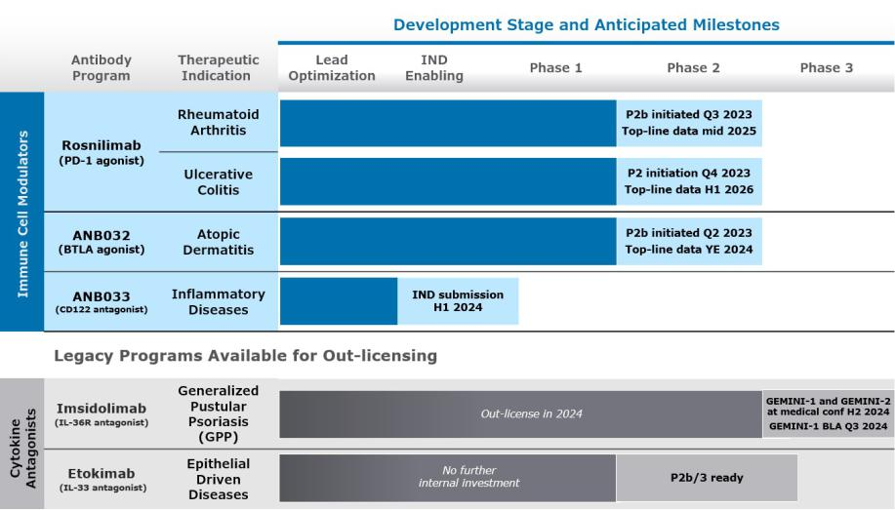

Collaborative Programs

Multiple Company-discovered antibody programs have been advanced to preclinical and clinical milestones under our collaborations. Our collaborations include an immuno-oncology-focused collaboration with GSK.

Under the GSK Agreement, a BLA for our most advanced partnered program, which is an anti-PD-1 antagonist antibody called Jemperli (dostarlimab), was approved by the FDA in April 2021 for the treatment of advanced or recurrent deficient mismatch repair endometrial cancer (dMMREC). In February 2023, the FDA granted full approval for this indication (from an accelerated approval). In addition, in April 2021 the European Medicines Agency (“EMA”) granted conditional marketing authorization in the European Union (EU) for Jemperli for use in women with mismatch repair deficient (dMMR)/microsatellite instability-high (MSI-H) recurrent or advanced endometrial cancer who have progressed on or following prior treatment with a platinum containing regimen. A second FDA approval was received in August 2021 for Jemperli in pan-deficient mismatch repair tumors (PdMMRT). In July 2023, the FDA approved Jemperli in combination with chemotherapy for the treatment of adult patients with mismatch repair deficient (dMMR)/microsatellite instability-high (MSI-H) primary advanced or recurrent endometrial cancer. A marketing authorization application is also under review by the European Medicines Agency.

Jemperli is currently in Phase 3 trials for various solid tumor indications, including a Phase 3 trial in first-line ovarian cancer with top-line results expected in the first half of 2024.

25

In addition, under the collaboration, GSK is developing dostarlimab in combination with another development program from the GSK Agreement: cobolimab, an anti-TIM-3 antibody. GSK is conducting a Phase 3 trial, COSTAR Lung, which is a randomized, open label 3-arm trial comparing cobolimab plus dostarlimab plus docetaxel to dostarlimab plus docetaxel to docetaxel alone in patients with advanced non-small-cell lung cancer (“NSCLC”) who have progressed on prior anti-PD-(L)1 therapy and chemotherapy with top-line results expected in the second half of 2024.

For more information about these collaborations, see Note 4 — Collaborative Research and Development Agreements in the accompanying notes to the consolidated financial statements.

Components of Operating Results

Collaboration Revenue

We have not generated any revenue from product sales. Our revenue has been derived from amortization of upfront license payments, research and development funding, milestone and royalty payments under collaboration and license agreements with our collaborators. From inception through September 30, 2023, we have recognized $246.2 million in revenue from our collaborators.

Research and Development Expense

Research and development expenses consist of costs associated with our research and development activities, including drug discovery efforts, preclinical and clinical development of our programs, and manufacturing. Our research and development expenses include:

- External research and development expenses incurred under arrangements with third parties, such as contract research organizations (“CROs”), consultants, members of our scientific and therapeutic advisory boards, and contract manufacturing organizations (“CMOs”);

- Employee-related expenses, including salaries, benefits, travel, and stock-based compensation;

- Facilities, depreciation and other allocated expenses, which include direct and allocated expenses for rent and maintenance of facilities, depreciation of leasehold improvements and equipment, and laboratory supplies; and

- License and sub-license fees.

We expense research and development costs as incurred. We account for nonrefundable advance payments for goods and services that will be used in future research and development activities as expense when the service has been performed or when the goods have been received.

We are conducting research and development activities primarily on inflammation programs. We have a research and development team that conducts antibody discovery, characterization, translational studies, IND-enabling preclinical studies, and clinical development. We conduct some of our early research and preclinical activities internally and plan to rely on third parties, such as CROs and CMOs, for the execution of certain of our research and development activities, such as in vivo toxicology and pharmacology studies, drug product manufacturing, and clinical trials.

We expect our research and development expenses to be higher for the foreseeable future as we continue to advance our product candidates.

General and Administrative Expense

General and administrative expenses consist primarily of salaries and related benefits, including stock-based compensation for our executive, finance, legal, business development, human resource, and support functions. Other general and administrative expenses include allocated facility-related costs not otherwise included in research and development expenses, travel expenses, and professional fees for auditing, tax, and legal services.

Non-cash Interest Expense for the Sale of Future Royalties

Non-cash interest expense for the sale of future royalties consists of interest related to the liability for the sale of future royalties, as well as the amortization of debt issuance costs. We impute interest on the unamortized portion of the liability for the sale of future royalties using the effective interest method and record interest expense based on timing of the payments over

26

the term of the Royalty Monetization Agreements. Our estimate of the interest rate under the arrangements is based on forecasted royalty and milestone payments expected to be made over the life of the agreements.

Interest Income

Interest income consists primarily of interest earned on our short-term and long-term investments and is recognized when earned.

Critical Accounting Policies and Use of Estimates

Our management’s discussion and analysis of our financial condition and results of operations are based on our financial statements, which have been prepared in accordance with U.S. generally accepted accounting principles (“U.S. GAAP”). The preparation of these financial statements requires us to make judgments and estimates that affect the reported amounts of assets, liabilities, revenues, and expenses and the disclosure of contingent assets and liabilities in our financial statements. We base our estimates on historical experience, known trends and events, and various other factors that are believed to be reasonable under the circumstances. Actual results may differ from these estimates under different assumptions or conditions. On an ongoing basis, we evaluate our judgments and estimates in light of changes in circumstances, facts, and experience. We believe there have been no significant changes in our critical accounting policies as discussed in our Annual Report on Form 10-K filed with the Securities and Exchange Commission (the “SEC”) on March 1, 2023.

Results of Operations - Comparison of the Three and Nine Months Ended September 30, 2023 and 2022

Collaboration Revenue

Collaboration revenue consists of both milestone payments under the collaborations, and royalty payments. We recognized $0 in milestone revenue during each of the three and nine months ended September 30, 2023 and 2022. We expect that any collaboration revenue we generate will continue to fluctuate from period to period as a result of the timing and amount of milestones from our existing collaborations.

Royalty revenue is a function of our partners' product sales and the applicable royalty rate. During the three months ended September 30, 2023 and 2022, we recognized $3.3 million and

$1.3 million, respectively, related to the net sales of GSK’s Jemperli and Zejula, which we estimate based on either GSK’s prior sales experience or actuals. During the nine months ended September

30, 2023 and 2022, we recognized $8.2 million and $3.5 million, respectively, of royalty revenue related to the net sales of GSK’s Jemperli and Zejula. All royalty revenue related to Zejula global net

sales starting July 2022 are paid directly to a wholly owned subsidiary of DRI Healthcare Trust pursuant to the Zejula Royalty Monetization Agreement. For more information see Note 5 — Sale of

Future Royalties in the accompanying notes to the consolidated financial statements.

Research and Development Expenses

Research and development expenses were $30.9 million during the three months ended September 30, 2023 compared to $22.1 million during the three months ended September 30, 2022 for an increase of $8.8 million, primarily due to a $4.0 million increase in outside services for manufacturing expenses, $2.7 million increase in clinical expenses, $1.5 million increase in salaries and related expenses, including stock-based compensation expense, and $0.6 million increase in other research and development expenses.

Research and development expenses were $98.8 million during the nine months ended September 30, 2023 compared to $65.4 million during the nine months ended September 30, 2022 for an increase of $33.4 million, primarily due to a $21.2 million increase in outside services for manufacturing expenses, $5.3 million increase in clinical expenses, $5.5 million increase in salaries and related expenses, including stock-based compensation expense, and $1.4 million increase in other research and development expenses.

We do not track fully burdened research and development costs separately for each of our product candidates. We review our research and development expenses by focusing on external development and internal development costs. External development expenses consist of costs associated with our external preclinical and clinical trials, including pharmaceutical development and manufacturing. Included in preclinical and other unallocated costs are external corporate overhead costs that are not specific to any one program. Internal costs consist of salaries and wages, share-based compensation and benefits, which

27

are not tracked by product candidate as several of our departments support multiple product candidate research and development programs. The following table summarizes the external costs attributable to each program and internal costs:

 |  | Three Months Ended |  |  |  |  |  |  |  |  | Nine Months Ended
 |  | September 30, |  |  |  |  |  |  |  |  | September 30,
(in thousands) |  | 2023 |  |  | 2022 |  |  | Increase/(Decrease) |  |  | 2023 |  |  | 2022 |  | Increase/(Decrease)
External Costs
Rosnilimab | $ | 8,071 |  | $ | 1,733 |  | $ | 6,338 |  | $ | 16,456 |  | $ | 5,425 |  | $ | 11,031
ANB032 |  | 5,024 |  |  | 1,083 |  |  | 3,941 |  |  | 11,583 |  |  | 2,223 |  |  | 9,360
Imsidolimab |  | 3,219 |  |  | 9,946 |  |  | (6,727) |  |  | 27,517 |  |  | 30,485 |  |  | (2,968)
Preclinical and other unallocated costs |  | 7,333 |  |  | 2,853 |  |  | 4,480 |  |  | 19,711 |  |  | 7,683 |  |  | 12,028
Total External Costs |  | 23,647 |  |  | 15,615 |  |  | 8,032 |  |  | 75,267 |  |  | 45,816 |  |  | 29,451
Internal Costs |  | 7,231 |  |  | 6,449 |  |  | 782 |  |  | 23,491 |  |  | 19,608 |  |  | 3,883
Total Costs | $ | 30,878 |  | $ | 22,064 |  | $ | 8,814 |  | $ | 98,758 |  | $ | 65,424 |  | $ | 33,334

General and Administrative Expenses

General and administrative expenses were $10.2 million during the three months ended September 30, 2023 compared to $8.9 million during the three months ended September 30, 2022 for an increase of $1.3 million, primarily due to a $1.5 million increase in personnel costs, including stock-based compensation expense, $0.3 million increase in legal and other general and administrative expenses, offset by a $0.5 million decrease in market research cost and insurance expense.

General and administrative expenses were $31.7 million during the nine months ended September 30, 2023 compared to $27.2 million during the nine months ended September 30, 2022 for an increase of $4.5 million, primarily due to a $3.2 million increase in personnel costs, including stock-based compensation expense, $0.6 million increase in market research cost, $0.6 million increase in other general and administrative expenses, and $0.4 million increase in legal cost offset by a $0.3 million decrease in insurance expense.

We expect that our general and administrative expenses will increase for the foreseeable future due to compliance costs associated with being a publicly traded company and intellectual property related legal expenses as our intellectual property portfolio expands.

Non-cash Interest Expense for the Sale of Future Royalties

Non-cash interest expense was $4.4 million and $6.1 million during the three months ended September 30, 2023 and 2022, respectively. The decrease of $1.7 million in non-cash interest expense is due to a change in the expected timing for Sagard to be paid per the Jemperli Royalty Monetization Agreement, partially offset by interest recognized on the liability related to Zejula Royalty Monetization Agreement that was completed in September 2022.

Non-cash interest expense was $13.1 million and $16.9 million during the nine months ended September 30, 2023 and 2022, respectively. The decrease of $3.8 million in non-cash interest expense is due to a change in the expected timing for Sagard to be paid per the Jemperli Royalty Monetization Agreement, partially offset by interest recognized on the liability related to Zejula Royalty Monetization Agreement that was completed in September 2022.

Interest Income

Interest income was $4.9 million and $2.3 million during the three months ended September 30, 2023 and 2022, respectively, and $14.0 million and $3.7 million during the nine months ended September 30, 2023 and 2022, respectively, which primarily related to our short-term and long-term investments. The increase in interest income is due to higher interest rates earned on investments during the three and nine months ended September 30, 2023.

Other Income (Expense), Net

Other income, net was less than $0.1 million for the three and nine months ended September 30, 2023 and 2022, which primarily related to foreign exchange transactions with our foreign CROs and CMOs.

28

Liquidity and Capital Resources

From our inception through September 30, 2023, we have received an aggregate of $1.2 billion to fund our operations, which included $636.9 million from the sale of equity securities, $285.0 million from the sale of future royalties, and $234.2 million from our collaboration agreements. As of September 30, 2023, we had $453.3 million in cash, cash equivalents and investments.

In addition to our existing cash, cash equivalents and investments, we are eligible to earn milestone and other contingent payments for the achievement of defined collaboration objectives and certain nonclinical, clinical, regulatory and sales-based events, and royalty payments under our collaboration agreements, including the GSK Agreement and the GSK Settlement Agreement. Our ability to earn these milestone and contingent payments and the timing of achieving these milestones is primarily dependent upon the outcome of our collaborators’ research and development activities. Our rights to payments under our collaboration agreements are our only committed external source of funds.

In November 2022, we entered into the Cowen Sales Agreement with Cowen and Company, LLC, through which we may offer and sell shares of our common stock, having an aggregate offering of up to $150.0 million through Cowen and Company, LLC as our sales agent. As of September 30, 2023, we had sold no shares under this agreement.

Funding Requirements

We may seek to obtain additional financing in the future through equity or debt financings or through collaborations or partnerships with other companies. If we are unable to obtain additional financing on commercially reasonable terms, our business, financial condition and results of operations will be materially adversely affected.

Our primary uses of capital are, and we expect will continue to be, third-party clinical and preclinical research and development services, including manufacturing, laboratory and related supplies, compensation and related expenses, legal, patent and other regulatory expenses, and general overhead costs. We have entered into agreements with certain vendors for the provision of services, including services related to commercial manufacturing, that we are unable to terminate for convenience. Under such agreements, we are contractually obligated to make certain minimum payments to the vendors with the amounts to be based on the timing of the termination and the specific terms of the agreement.

Additionally, in January 2023, our Board of Directors authorized a stock repurchase program (the “Repurchase Program”) to repurchase up to $50.0 million in shares of our common stock. The Repurchase Program was completed in May 2023.

Cash, cash equivalents and investments totaled $453.3 million as of September 30, 2023, compared to $584.2 million as of December 31, 2022. We believe that our existing cash, cash equivalents and investments will fund our current operating plan for at least the next twelve months from the issuance of our consolidated financial statements. We have based this estimate on assumptions that may prove to be wrong, and we could use our capital resources sooner than we expect. Additionally, the process of testing product candidates in clinical trials and seeking regulatory approval is costly, and the timing of progress and expenses in these trials is uncertain.

Cash Flows

The following table summarizes our cash flows for the nine months ended September 30, 2023 and 2022:

 |  | Nine Months Ended
 |  | September 30,
(in thousands) |  | 2023 |  |  | 2022
Net cash (used in) provided by:
Operating activities | $ | (86,451) |  | $ | (62,908)
Investing activities |  | 95,576 |  |  | (416,342)
Financing activities |  | (54,138) |  |  | 42,068
Net decrease in cash and cash equivalents | $ | (45,013) |  | $ | (437,182)

29

Operating Activities

Net cash used in operating activities during the nine months ended September 30, 2023 of $86.5 million was primarily due to our net loss of $121.4 million, adjusted for addbacks for non-cash expenses of $32.6 million, which includes stock-based compensation, amortization of operating right-of-use assets, non-cash interest expense, income from marketable securities and increases in working capital of $2.3 million.

Net cash used in operating activities during the nine months ended September 30, 2022 of $62.9 million was primarily due to our net loss of $102.3 million, adjusted for addbacks for non-cash expenses of $38.5 million, which includes stock-based compensation, amortization of operating right-of-use assets, non-cash interest expense, income from marketable securities and net increases in working capital of $0.9 million.

Investing Activities

Net cash provided by (used in) investing activities during the nine months ended September 30, 2023 and 2022 of $95.6 million and $(416.3) million, respectively, primarily relates to the timing of sales, maturities and purchases of our investments.

Financing Activities

The net cash used in financing activities during the nine months ended September 30, 2023 of $54.1 million was primarily related to $50.0 million paid for repurchases and retirements of common stock, $6.3 million for repayments of the liability for the sale of future royalties, offset by $2.2 million of cash received for the issuance of common stock.

The net cash provided by financing activities during the nine months ended September 30, 2022 of $42.1 million was primarily related to $35.0 million received for the sale of future royalties, $8.4 million for the issuance of common stock, offset by $1.0 million for repayments of the liability for the sale of future royalties with Sagard, and $0.3 million for payments for debt issuance costs.

Contractual Obligations

We have entered into agreements with certain vendors for the provision of goods and services, which includes manufacturing services with contract manufacturing organizations and development services with contract research organizations. These agreements may include certain provisions for purchase obligations and termination obligations that could require payments for the cancellation of committed purchase obligations or for early termination of the agreements. The amount of the cancellation or termination payments vary and are based on the timing of the cancellation or termination and the specific terms of the agreement and therefore are cancellable contracts.

For further information related to our operating lease and future minimum annual obligations, see Note 9 — Commitments and Contingencies in the accompanying notes to the consolidated financial statements.

30

Item 3. Quantitative and Qualitative Disclosures About Market Risk

As of September 30, 2023, there have been no material changes surrounding our market risk, including interest rate risk, inflation risk, and foreign currency exchange risk from the discussion provided in Item 7A. Quantitative and Qualitative Disclosures About Market Risk of our Annual Report on Form 10-K filed with the SEC on March 1, 2023.

Item 4. Controls and Procedures

Evaluation of Disclosure Controls and Procedures

Our disclosure controls and procedures are designed to ensure that information required to be disclosed in the reports we file or submit under the Exchange Act is recorded, processed, summarized, and reported within the time periods specified in the Securities and Exchange Commission’s rules and forms and that such information is accumulated and communicated to our management, including the Chief Executive Officer and the Chief Financial Officer, to allow timely decisions regarding required disclosures. As of September 30, 2023, our management, with the participation of our Chief Executive Officer and Chief Financial Officer, performed an evaluation of the effectiveness of the design and operation of our disclosure controls and procedures as defined in Rules 13a-15(e) and 15d-15(e) of the Exchange Act. Based on this evaluation, our Chief Executive Officer and Chief Financial Officer concluded that the design and operation of our disclosure controls and procedures were effective at a reasonable assurance level.

Any controls and procedures, no matter how well designed and operated, can provide only reasonable assurance of achieving the desired control objective, and our management necessarily applies its judgment in evaluating the cost-benefit relationship of possible controls and procedures.

Changes in Internal Control over Financial Reporting

There were no changes in our internal control over financial reporting identified in connection with the evaluation required by Rules 13a-15(f) and 15d-15(f) of the Exchange Act that occurred during the quarter ended September 30, 2023 that have materially affected, or are reasonably likely to materially affect, our internal control over financial reporting.

31

PART II. OTHER INFORMATION

Item 1. Legal Proceedings

From time to time, we may be involved in legal proceedings arising in the ordinary course of our business. We investigate these claims as they arise and accrue estimates for resolution of legal and other contingencies when losses are probable and estimable. Regardless of outcome, litigation can have an adverse impact on us due to defense and settlement costs, diversion of management resources, negative publicity and reputational harm, and other factors.

Item 1A. Risk Factors

Investing in our common stock involves a high degree of risk. You should carefully consider the risks described below, as well as the other information in this report, including our consolidated financial statements and the related notes and “Management’s Discussion and Analysis of Financial Condition and Results of Operations,” before deciding whether to invest in our common stock. The occurrence of any of the events or developments described below could harm our business, financial condition, results of operations, and growth prospects. In such an event, the market price of our common stock could decline, and you may lose all or part of your investment.

Summary of Risk Factors

An investment in our common stock involves various risks, and prospective investors are urged to carefully consider the matters discussed in the section titled “Risk Factors” prior to making an investment in our common stock. These risks include, but are not limited to, the following:

- Our product candidates are in early stages of development and may fail in development or suffer delays that adversely affect their commercial viability. Results from our initial clinical trials may not be representative of the results we will experience in later clinical trials. If we or our collaborators are unable to complete development of or commercialize our product candidates or experience significant delays in doing so, our business will be materially harmed.

- We have only limited data regarding the safety profile of our product candidates when dosed in humans. Our ongoing and planned clinical trials or those of our collaborators may reveal significant adverse events, toxicities or other side effects and may result in a safety profile that could inhibit regulatory approval or market acceptance of any of our product candidates.

- We and/or our collaborators may be unable to obtain, or may be delayed in obtaining, required regulatory approvals in the United States or in foreign jurisdictions, which would materially impair our ability to commercialize and generate revenue from our product candidates.

- We may not be successful in our efforts to expand our pipeline of product candidates and develop marketable products.

- We have recently commenced clinical development of rosnilimab and ANB032, and have no history of commercializing biotechnology products, which may make it difficult to evaluate the prospects for our future viability.

- We face significant competition, and if our competitors develop and market products that are more effective, safer or less expensive than our product candidates, our commercial opportunities will be negatively impacted.

- Our product candidates may not achieve adequate market acceptance among physicians, patients, health care payors and others in the medical community necessary for commercial success.

- The manufacture of biologics is complex, and our third-party manufacturers may encounter difficulties in production. If any of our third-party manufacturers encounter such difficulties, our ability to provide supply of our product candidates for clinical trials, our ability to obtain marketing approval, or our ability to provide supply of our products for patients, if approved, could be delayed or stopped.

32

- Political, economic, or public health events, such as the COVID-19 pandemic, may have a material impact on the U.S. and global economies and could have a material adverse impact on our employees, contractors, and patients, which could adversely and materially impact our business, financial condition, and results of operations.

- We have limited operating revenue and a history of operational losses and may not achieve or sustain profitability.

- We have no products approved for commercial sale, and to date we have not generated any revenue or profit from sales of our product candidates.

- We will require additional capital to finance our operations, which may not be available to us on acceptable terms, or at all. As a result, we may not complete the development and commercialization of our product candidates or develop new product candidates.

- We must attract and retain highly skilled employees in order to succeed.

- We currently have no marketing and sales force. If we are unable to establish effective sales or marketing capabilities or enter into agreements with third parties to sell or market our product candidates, we may not be able to effectively sell or market our product candidates, if approved, or generate product revenue.

- Our existing collaboration with GSK is important to our business, and future collaborations may also be important to us. If we are unable to maintain this collaboration, or if this collaboration is not successful, our business could be adversely affected.

- We may not succeed in establishing and maintaining additional development and commercialization collaborations, including the development or out-licensing of our legacy product candidates, which could adversely affect our ability to develop and commercialize product candidates.

- Even if our product candidates receive regulatory approval, they will be subject to significant post-marketing regulatory requirements.

- If we are unable to obtain or protect intellectual property rights, we may not be able to compete effectively in our market.

- We may not be able to protect our intellectual property rights throughout the world.

- The market price of our stock has been and may continue to be volatile, and you could lose all or part of your investment.

Risks Related to Discovery and Development of Our Product Candidates

Our product candidates are in early stages of development and may fail in development or suffer delays that adversely affect their commercial viability. Results from our initial clinical trials may not be representative of the results we will experience in later clinical trials. If we or our collaborators are unable to complete development of or commercialize our product candidates or experience significant delays in doing so, our business will be materially harmed.

We are developing therapeutic antibodies, including our wholly owned product candidates, as well as other programs that are being developed by our collaborators. However, all of our wholly owned and most of partnered product candidates are in various stages of development, and, for a wide variety of reasons discussed below, may fail in development or suffer delays that adversely affect their commercial viability.

A product candidate can unexpectedly fail at any stage of preclinical and clinical development. The historical failure rate for product candidates is high due to scientific feasibility, safety, efficacy, changing standards of medical care, and other variables. The results from preclinical testing or early clinical trials of a product candidate may not predict the results that will be obtained in later phase clinical trials of the product candidate. For example, results from our initial Phase 2a clinical trial of etokimab in moderate-to-severe atopic dermatitis patients were not representative of the results we experienced in our later etokimab moderate-to-severe atopic dermatitis Phase 2b clinical trial called “ATLAS” and we ultimately discontinued development of etokimab.

Furthermore, we may conduct clinical trials of a product candidate in multiple indications based on assumptions about the product candidate’s mechanism of action. However, it is possible that our assumptions regarding the effectiveness of a product candidate’s mechanism of action may be incorrect and that the product candidate may be ineffective in certain diseases

33

or disorders. If this were the case, then the results from any clinical trials of a product candidate that we conduct are less likely to be positive. For example, we believed imsidolimab’s mechanism of action, the inhibition of IL-36R, provided the potential for imsidolimab to be effective for treatment of a range of dermatological inflammatory diseases. However, top-line data from clinical trials of imsidolimab in indications other than GPP did not demonstrate efficacy, and we do not currently plan to conduct further development of imsidolimab in indications other than GPP.

If our other ongoing or future clinical trials of any of our product candidates, including rosnilimab, ANB032, imsidolimab or ANB033, are unsuccessful, whether for one of the reasons mentioned above or otherwise, our product candidates may be delayed in development or fail entirely, which would have a material adverse impact on our business.

The success of our current product candidates, and any other product candidates we may develop in the future, will depend on many factors, including the following:

- obtaining regulatory permission to initiate clinical trials;

- successful enrollment of patients in, and the completion of, our planned clinical trials;

- receiving marketing approvals from applicable regulatory authorities;

- establishing commercial manufacturing capabilities and/or making arrangements with third-party manufacturers;

- obtaining and maintaining patent and trade secret protection and non-patent exclusivity for our product candidates and their components;

- enforcing and defending intellectual property rights and claims;

- achieving desirable therapeutic properties for our product candidates’ intended indications;

- launching commercial sales of our product candidates, if and when approved, whether alone or in collaboration with third parties;

- acceptance of our product candidates, if and when approved, by patients, the medical community and third-party payors;

- effectively competing with other therapies; and

- maintaining an acceptable safety profile of our product candidates through clinical trials and following regulatory approval.

If we do not achieve one or more of these factors in a timely manner or at all, we could experience significant delays or an inability to successfully commercialize our product candidates, which would harm our business.

Furthermore, delays or difficulties in patient enrollment or difficulties in retaining trial participants can result in increased costs, longer development times, or termination of a clinical trial. Clinical trials of a new product candidate require the enrollment of a sufficient number of patients, including patients who are suffering from the disease the product candidate is intended to treat and who meet other eligibility criteria. Rates of patient enrollment are affected by many factors, including the size of the patient population, the eligibility criteria for the clinical trial, the age and condition of the patients, the stage and severity of disease, the nature of the protocol, the proximity of patients to clinical sites, and the availability of effective treatments for the relevant disease. We may not be able to initiate our planned clinical trials if we are unable to locate and enroll a sufficient number of eligible patients to participate in these trials as required by the FDA or foreign regulatory authorities. More specifically, some of our product candidates, including imsidolimab, initially target indications that are very rare, which can prolong the clinical trial timeline for the regulatory process if sufficient patients cannot be enrolled in a timely manner.

We have only limited data regarding the safety profile of our product candidates when dosed in humans. Our ongoing and planned clinical trials or those of our collaborators may reveal significant adverse events, toxicities or other side effects and may result in a safety profile that could inhibit regulatory approval or market acceptance of any of our product candidates.

In order to obtain marketing approval for any of our product candidates, we must demonstrate the safety and efficacy of the product candidate for the relevant clinical indication or indications through preclinical studies and clinical trials as well as additional supporting data. If our product candidates are associated with undesirable side effects in preclinical studies or clinical trials or have characteristics that are unexpected, we may need to interrupt, delay or abandon their development or limit

34

development to more narrow uses or subpopulations in which the undesirable side effects or other characteristics are less prevalent, less severe or more acceptable from a risk-benefit perspective.

We have conducted various preclinical studies of our product candidates, but we do not know the predictive value of these studies for humans, and we cannot guarantee that any positive results in preclinical studies will successfully translate to human patients. Phase 2 and Phase 3 clinical trials with rosnilimab, ANB032 and imsidolimab are ongoing or planned. It is not uncommon to observe results in human clinical trials that are unexpected based on preclinical testing, or to observe results in later stage clinical trials that are unexpected based on early clinical trials. Many product candidates fail in clinical trials despite promising preclinical and early clinical results. In addition, top-line results of a clinical trial, which generally reflect preliminary reviews of primary efficacy and/or safety results, do not necessarily predict final results, and any top-line findings or assessments are subject to change pending the completion of final data review procedures. Moreover, preclinical and clinical data are often susceptible to varying interpretations and analyses, and many companies that believed their product candidates performed satisfactorily in preclinical studies and clinical trials have nonetheless failed to obtain marketing approval for their products.

Some patients in our clinical trials have experienced adverse events, including SAEs. Subjects in our ongoing and planned clinical trials may in the future suffer significant adverse events or other side effects not observed in our preclinical studies or in our Phase 1 or Phase 2 clinical trials. The observed potency and kinetics of our product candidates in preclinical studies may not be observed in human clinical trials. We have tested the dosing frequency and route of administration of our product candidates in preclinical studies, which will inform our dosing strategy for future clinical trials, however such dose and route of administration may not result in sufficient exposure or pharmacological effect in humans and may lead to unforeseen toxicity not previously observed in preclinical testing. If preclinical studies of our product candidates fail to provide preliminary evidence of safety to the satisfaction of regulatory authorities or do not otherwise produce satisfactory results, we may incur additional costs or experience delays in initiating and/or advancing the development and commercialization of our product candidates. Further, if clinical trials of our product candidates fail to demonstrate safety and efficacy to the satisfaction of regulatory authorities or do not otherwise produce positive results, we or our collaborators may incur additional costs or experience delays in completing, or ultimately be unable to complete, the development and commercialization of our product candidates.

If further significant adverse events or other side effects are observed in any of our current or future clinical trials, we may have difficulty recruiting patients to the clinical trial, patients may drop out of our trial, or we may be required to abandon the trial or our development efforts of that product candidate altogether. We, the FDA, or other applicable regulatory authorities, or an institutional review board or ethics committee, may suspend clinical trials of a product candidate at any time for various reasons, including a belief that subjects in such clinical trials are being exposed to unacceptable health risks or adverse side effects. Some potential therapeutics developed in the biotechnology industry that initially showed therapeutic promise in early-stage studies have later been found to cause side effects that prevented their further development. Even if the side effects do not preclude a product candidate from obtaining or maintaining marketing approval, undesirable side effects may inhibit market acceptance of the approved product due to its tolerability versus other therapies. Any of these developments could materially harm our business, financial condition and prospects.

Further, if any of our product candidates obtain marketing approval, toxicities associated with our product candidates may also develop after such approval and lead to a requirement to conduct additional clinical safety trials, additional warnings being added to the labeling, significant restrictions on the use of the product or the withdrawal of the product from the market. We cannot predict whether our product candidates will cause toxicities in humans that would preclude or lead to the revocation of regulatory approval based on preclinical studies or early-stage clinical testing.

We and/or our collaborators may be unable to obtain, or may be delayed in obtaining, required regulatory approvals in the United States or in foreign jurisdictions, which would materially impair our ability to commercialize and generate revenue from our product candidates.

Our ability to continue to develop our product candidates, and to have the potential to achieve and sustain profitability, depends on the FDA and foreign regulatory authorities permitting us to conduct human clinical trials and, if our product candidates are safe and effective, obtaining approval from the FDA and foreign regulatory authorities to market them and subsequently successfully commercializing them, either alone or with our collaborators. The research, testing, manufacturing, labeling, approval, selling, marketing and distribution of drug and biologic products are subject to extensive regulation by the FDA and foreign regulatory authorities. Before commencing clinical trials in the United States for any other product candidate,

35

we must submit an IND to the FDA; foreign regulatory authorities enforce similar requirements for initiation of clinical trials in other countries. An IND or foreign equivalent requires extensive preclinical studies, and there is no guarantee that the FDA or foreign regulatory authorities will allow clinical trials to proceed based on the IND or equivalent submission. For example, although we have initiated toxicology studies for our product candidates, the FDA in the United States, or other foreign regulatory authorities, as applicable, may not allow our clinical trials to proceed in the regulatory authority’s jurisdiction if we are unable to show safety margins acceptable to the particular regulatory authority in appropriate animal species in our preclinical toxicology studies.

Even if we or our collaborators initiate and complete clinical trials for our product candidates, these product candidates will not be permitted to be marketed in the United States until approval of a BLA from the FDA is received, and will not be permitted to be marketed in other countries without marketing approval from foreign regulatory authorities. Obtaining approval of a BLA or other marketing approvals is often a lengthy, expensive and uncertain process over which the FDA and foreign regulatory authorities have substantial discretion. Other than submitting and receiving acceptance for initiation of our previous and current clinical trials in the United States and certain foreign jurisdictions, we have had only limited discussions with the FDA and no discussions with foreign regulatory authorities regarding the development plans for any of our product candidates or the designs of any of our later-stage clinical studies. We thus may not have the full benefit of the FDA’s or foreign regulatory authorities’ current thinking on clinical trial designs or product development for our target indications. For example, although we believe our Phase 3 trials for imsidolimab for GPP, GEMINI-1 and GEMINI-2, with GEMINI-1 having demonstrated evidence of efficacy and safety in GPP patients, will be sufficient to obtain BLA approval, the FDA may determine that we will need additional clinical trials in order to obtain approval of a BLA.

Preclinical studies and clinical trials are expensive, difficult to design and implement, can take many years to complete, and are uncertain as to outcome. Product candidates, on average, take 10 to 15 years to be developed from the time they are discovered to the time they are approved and available for treating patients. The start or end of a clinical trial is often delayed or halted for many reasons, including:

- imposition of a clinical hold for safety reasons or following an inspection of clinical trial operations or site by the FDA or other regulatory authorities;

- manufacturing challenges;

- insufficient supply or quality of product candidates or other materials necessary to conduct clinical trials;

- delays in reaching or failure to reach agreement on acceptable clinical trial contracts or clinical trial protocols with prospective trial sites and CROs or failure by such CROs or trials sites to carry out the clinical trial in accordance with our agreed-upon terms;

- non-clinical or clinical sites becoming unavailable due to political, economic, or public health events, such as the COVID-19 pandemic;

- clinical sites electing to terminate their participation in one of our clinical trials;

- inability or unwillingness of patients or medical investigators to follow clinical trial protocols;

- required clinical trial administrative actions;

- slower than anticipated patient enrollment;

- changing standards of care;

- safety concerns;

- availability or prevalence of use of a comparative drug or required prior therapy; or

- clinical outcomes or financial constraints.

Our product candidates may not be effective, may be only moderately effective, or may prove to have undesirable or unintended side effects, toxicities or other characteristics that may preclude our obtaining marketing approval or prevent or limit commercial use. Regulatory authorities may refuse to accept any application or may decide that our data are insufficient for approval and require additional preclinical or other studies or clinical trials. In addition, varying interpretations of the data obtained from preclinical and clinical testing could delay, limit or prevent marketing approval of a product candidate. Moreover, regulatory authorities may determine that the clinical and other benefits of a product candidate do not outweigh the

36

safety or other risks. Changes in marketing approval policies during the development period, changes in or the enactment of additional statutes or regulations, or changes in regulatory review for each submitted product application may also cause delays in or prevent the approval of an application.

If we or our collaborators experience any of the issues described above, or other similar or related issues, we or our collaborators may:

- be delayed in obtaining marketing approval for our product candidates;

- not obtain marketing approval at all;

- obtain marketing approval in some countries and not in others;

- obtain approval for indications or patient populations that are not as broad as intended or desired;

- obtain approval with labeling that includes significant use or distribution restrictions or safety warnings, including boxed warnings;

- be subject to additional post-marketing testing requirements; or

- have the product removed from the market after obtaining marketing approval.

We may not be successful in our efforts to expand our pipeline of product candidates and develop marketable products.

Because we have limited financial and managerial resources, we focus on research programs and product candidates that we identify for specific indications. Our business depends on our successful development and commercialization of the limited number of internal product candidates we have in preclinical and early-stage clinical development. Even if we are successful in continuing to build our pipeline, development of the potential product candidates that we identify will require substantial investment in additional clinical development, management of clinical, preclinical and manufacturing activities, regulatory approval in multiple jurisdictions, building a commercial organization, and significant marketing efforts before we generate any revenue from product sales. Furthermore, such product candidates may not be suitable for clinical development, including as a result of their harmful side effects, limited efficacy or other characteristics that indicate that they are unlikely to be products that will receive marketing approval and achieve market acceptance. If we cannot successfully develop, partner and/or commercialize product candidates, we may not be able to obtain product or partnership revenue in future periods, which would adversely affect our business, prospects, financial condition and results of operations.

As a result of our current focus on our lead product candidates, we may forego or delay pursuit of opportunities with other product candidates or for other indications that later prove to have greater commercial potential. Our resource allocation decisions may cause us to fail to capitalize on viable commercial products or profitable market opportunities. Our spending on current and future research and development programs and product candidates for specific indications may not yield any commercially viable products. Our understanding and evaluation of biological targets for the discovery and development of new product candidates may fail to identify challenges encountered in subsequent preclinical and clinical development. If we do not accurately evaluate the commercial potential or target market for a particular product candidate, we may relinquish valuable rights to that product candidate through collaboration, licensing or other royalty arrangements in cases in which it would have been more advantageous for us to retain sole development and commercialization rights.

We have recently commenced Phase 2 clinical development of rosnilimab and ANB032, and have no history of commercializing biotechnology products, which may make it difficult to evaluate the prospects for our future viability.

Our operations to date have been largely limited to financing and staffing our company, developing our technology, and developing our wholly owned product candidates and other product candidates in partnerships with our collaborators. As a company, we have only very limited experience conducting pivotal Phase 3 clinical trials and have not had previous experience commercializing product candidates, including submitting a BLA to the FDA. In part because of this lack of experience, we cannot be certain that planned clinical trials will begin or be completed on time, if at all, that our planned development programs would be acceptable to the FDA or other regulatory authorities, or that, if approval is obtained, such product candidates can be successfully commercialized. Clinical trials and commercializing our wholly owned product candidates will require significant additional financial and management resources, and reliance on third-party clinical investigators, CROs, consultants or collaborators. Relying on third-party clinical investigators, CROs or collaborators may result in delays that are outside of our control.

37

Furthermore, we may not have the financial resources to continue development of, or to enter into collaborations for, a product candidate if we experience any problems or other unforeseen events that delay or prevent regulatory approval of, or our ability to commercialize, product candidates, including:

- negative or inconclusive results from our clinical trials or the clinical trials of others for product candidates similar to ours, leading to a decision or requirement to conduct additional preclinical testing or clinical trials or abandon a program;

- a suspension or termination of a clinical trial once commenced;

- conditions imposed by the FDA or foreign regulatory authorities regarding the number, scope or design of our clinical trials;

- delays in enrolling research subjects in clinical trials;

- high drop-out rates of research subjects;

- inadequate supply or quality of clinical trial materials or other supplies necessary for the conduct of our clinical trials;

- greater than anticipated clinical trial costs;

- poor effectiveness or unacceptable side effects of our product candidates during clinical trials;

- unfavorable FDA or other regulatory agency inspection and review of a clinical trial site;

- failure of our third-party contractors or investigators to comply with regulatory requirements or otherwise meet their contractual obligations in a timely manner, or at all;

- serious and unexpected drug-related side effects experienced by participants in our planned clinical trials or by individuals using drugs similar to our product candidates;

- delays and changes in regulatory requirements, policy and guidelines, including the imposition of additional regulatory oversight around clinical testing generally or with respect to our technology in particular; or

- varying interpretations of data by the FDA and foreign regulatory authorities.

Consequently, any predictions you make about our future success or viability based on our short operating history may not be as accurate as they could be if we had a longer operating history or an established track record in conducting clinical trials or commercializing products.

Further, as a clinical stage business, we may encounter unforeseen expenses, difficulties, complications, delays, and other known and unknown factors. We will need to transition from a company with a research focus to a company capable of supporting commercial activities. We may not be successful in such a transition.

We face significant competition, and if our competitors develop and market products that are more effective, safer or less expensive than our product candidates, our commercial opportunities will be negatively impacted.

The biotechnology industry is highly competitive and subject to rapid and significant technological change. Products we may develop in the future are also likely to face competition from other drugs and therapies, some of which we may not currently be aware. We have competitors both in the United States and internationally, including major multinational pharmaceutical and biotechnology companies, established biotechnology companies, specialty biotechnology companies, emerging and start-up companies, universities and other research institutions. Many of our competitors have significantly greater financial, manufacturing, marketing, drug development, technical and human resources and commercial expertise than we do. Large pharmaceutical and biotechnology companies, in particular, have extensive experience in clinical testing, obtaining regulatory approvals, recruiting patients and manufacturing biotechnology products. These companies also have significantly greater research and marketing capabilities than we do and may also have products that have been approved or are in late stages of development and collaborative arrangements in our target markets with leading companies and research institutions. Established pharmaceutical and biotechnology companies may also invest heavily to accelerate discovery and development of novel compounds or to in-license novel compounds that could make the product candidates that we develop obsolete. As a result of all of these factors, our competitors may succeed in obtaining patent protection and/or approval from the FDA or foreign regulatory authorities or discovering, developing and commercializing products in our field before we do.

38

For our anti-PD-1 agonist antibody program, our competitors include other anti-PD-1 agonist antibodies peresolimab (Eli Lilly) in Phase 2b development for the treatment of rheumatoid arthritis, JNJ-67484703 (Janssen) in Phase 2 development for the treatment of atopic dermatitis, a PD-1 agonist antibody (Boehringer Ingelheim) in Phase 1 development, and GS-0151 (Gilead) in preclinical development. Commercial-stage competitors in moderate-to-severe rheumatoid arthritis include monoclonal antibodies targeting anti-TNF (Humira; Abbvie), IL-6 (Actemra; Roche and Kevzara; Regeneron), CD-80/86 (Orencia; BMS), CD-20 (Rituxan; Roche), and janus kinase inhibitors (Rinvoq; AbbVie, Olumiant; Eli Lilly, and Xeljanz; Pfizer). Commercial-stage competitors in moderate-to-severe ulcerative colitis include monoclonal antibodies targeting anti-TNF (Humira; Abbvie and Remicade; Johnson & Johnson ), anti-α4β7 (Entyvio; Takeda), anti-IL-23 (Stelera; Johnson & Johnson) and S1P inhibitors (Zeposia; Bristol Myers Squibb and Velsipity; Pfizer) and janus kinase inhibitors (Rinvoq; AbbVie, and Xeljanz; Pfizer) as well as monoclonal antibodies targeting anti-TL1A (PRA023; Merck, and RVT-3101; Telavant) in Phase 2 development.

For our anti-BTLA agonist antibody program, our competitors include other anti-BTLA agonist antibodies LY3361237 (Eli Lilly) in Phase 2 development, which has demonstrated efficacy in treatment of systemic lupus erythematosus (SLE) as measured by the cutaneous lupus erythematosus disease area and severity index (CLASI), and GS-0272 (Gilead in Phase 1b development for SLE and rheumatoid arthritis). Commercial-stage competitors in moderate-to-severe atopic dermatitis include topical and oral corticosteroids, calcineurin inhibitors (Protopic; LEO Pharma and Elidel; Bausch Health), monoclonal antibodies targeting IL-4/13 (Dupixent; Regeneron/Sanofi), IL-13 (Adbry; LEO Pharma), IL-31 (nemolizumab; Galderma) and janus kinase inhibitors (Rinvoq; AbbVie and abrocitinib; Pfizer) as well as monoclonal antibodies targeting OX-40/OX40L (rocatinlimab; Amgen and amlitelimab; Sanofi) in Phase 2 and 3 development.

For our anti-CD122 antagonist antibody program, our competitors include one other anti-CD122 antagonist antibody, auremolimab (Villaris Therapeutics, which has been acquired by Incyte), entering Phase 1 development for vitiligo this year, and two anti-IL-15 monoclonal antibodies, AMG 714 (Amgen), currently in Phase 2 development for the treatment of vitiligo, and CALY-002 (Calypso), currently in Phase 1b development for the treatment of celiac disease and eosinophilic esophagitis.

For imsidolimab in the treatment of GPP, our competitors include one other anti-IL-36 receptor antibody called SPEVIGO or spesolimab (Boehringer Ingelheim), approved for GPP flares in

adults.

Our commercial opportunity could be reduced or eliminated if our competitors develop and commercialize products that are safer, more effective, have fewer or less severe effects, are more convenient, are less expensive or capture significant market share prior to or during our commercialization. Our competitors also may obtain FDA or other regulatory approval for their products more rapidly than we may obtain approval for ours, which could result in our competitors establishing a strong market position before we are able to enter the market. In addition, our ability to compete may be affected in many cases by insurers or other third-party payors seeking to encourage the use of biosimilar products. Even if our product candidates achieve marketing approval, they may be priced at a significant premium over competitive biosimilar products if any have been approved by then.

Smaller and other early-stage companies may also prove to be significant competitors, particularly through collaborative arrangements with large and established companies. These companies compete with us in recruiting and retaining qualified scientific and management personnel, establishing clinical trial sites and patient registration for planned clinical trials and acquiring technologies complementary to, or necessary for, our programs. In addition, the biotechnology industry is characterized by rapid technological change. If we fail to stay at the forefront of technological change, we may be unable to compete effectively. Technological advances or products developed by our competitors may render our technologies or product candidates obsolete, less competitive or not economical.

Our product candidates may not achieve adequate market acceptance among physicians, patients, health care payors and others in the medical community necessary for commercial success.

Even if our product candidates receive regulatory approval, they may not gain adequate market acceptance among physicians, patients, health care payors and others in the medical community.

The degree of market acceptance of any of our approved product candidates will depend on a number of factors, including:

- the efficacy and safety profile as demonstrated in planned clinical trials;

- the timing of market introduction of the product candidate as well as competitive products;

- the clinical indications for which the product candidate is approved;

39

- restrictions on the use of our products, if approved, such as boxed warnings or contraindications in labeling or a REMS, if any, which may not be required of alternative treatments and competitor products;

- acceptance of the product candidate as a safe and effective treatment by physicians, clinics and patients;

- the potential and perceived advantages of product candidates over alternative treatments, including any similar generic treatments;

- the cost of treatment in relation to alternative treatments;

- the availability of coverage and adequate reimbursement and pricing by third parties and government authorities;

- relative convenience and ease of administration;

- the frequency and severity of adverse events;

- the effectiveness of sales and marketing efforts; and

- unfavorable publicity relating to the product candidate.

If any product candidate is approved but does not achieve an adequate level of acceptance by physicians, hospitals, health care payors and patients, we may not generate or derive sufficient revenue from that product candidate and may not become or remain profitable.

The manufacture of biologics is complex, and our third-party manufacturers may encounter difficulties in production. If any of our third-party manufacturers encounter such difficulties, our ability to provide supply of our product candidates for clinical trials, our ability to obtain marketing approval, or our ability to provide supply of our products for patients, if approved, could be delayed or stopped.

The process of manufacturing biologics is complex, highly regulated and subject to multiple risks, and requires significant expertise and capital investment, including the development of advanced manufacturing techniques and process controls. Manufacturing biologics is highly susceptible to product loss due to contamination, equipment failure, improper installation or operation of equipment, vendor or operator error, inconsistency in yields, variability in product characteristics and difficulties in scaling the production process. Even minor deviations from normal manufacturing processes could result in reduced production yields, product defects and other supply or supply chain disruptions. If microbial, viral or other contaminations are discovered at the facilities of our manufacturer, such facilities may need to be closed for an extended period of time to investigate and remedy the contamination, which could delay clinical trials and adversely harm our business. We and our contract manufacturers must comply with cGMPs for the manufacturing of biologics used in clinical trials and, if approved, marketed products. Moreover, if the FDA determines that our manufacturer is not in compliance with FDA laws and regulations, including cGMPs, the FDA may deny BLA approval until the deficiencies are corrected or we replace the manufacturer in our BLA with a manufacturer that is in compliance.

Furthermore, all of our therapeutic antibodies are manufactured by starting with cells which are stored in a cell bank. We have one master cell bank for each antibody manufactured in accordance with cGMP and create multiple working cell banks to support cGMP manufacturing, and believe we would have adequate backup should any cell bank be lost in a catastrophic event. However, it is possible that we could lose multiple cell banks and have our manufacturing severely impacted by the need to replace the cell banks.

In addition, there are risks associated with large scale manufacturing for clinical trials or commercial scale including, among others, cost overruns, potential problems with process scale-up, process reproducibility, stability issues, compliance with good manufacturing practices, lot consistency and timely availability of raw materials. Even if we or our collaborators obtain regulatory approval for any of our product candidates, there is no assurance that manufacturers will be able to manufacture the approved product to specifications acceptable to the FDA or other regulatory authorities, to produce it in sufficient quantities to meet the requirements for the potential launch of the product or to meet potential future demand. Moreover, we source certain of the raw materials needed for our product candidates from outside the U.S. Although we have not experienced any material supply interruptions to date, it is possible that political, economic or public health events, such as the COVID-19 pandemic, could cause such interruptions in the future. If our manufacturers are unable to produce sufficient quantities for clinical trials or for commercialization, commercialization efforts would be impaired, which would have an adverse effect on our business, financial condition, results of operations and growth prospects. Any delay or interruption in the supply of clinical trial supplies

40

could delay the completion of planned clinical trials, increase the costs associated with maintaining clinical trial programs and, depending upon the period of delay, require us to commence new clinical trials at additional expense or terminate clinical trials completely. Any adverse developments affecting clinical or commercial manufacturing of our product candidates or products may result in shipment delays, inventory shortages, lot failures, product withdrawals or recalls, or other interruptions in the supply of our product candidates or products.

Scaling up a biologic manufacturing process is a difficult and uncertain task, and we may not be successful in transferring our production system or the manufacturer may not have the necessary capabilities to complete the implementation and development process. If we are unable to adequately validate or scale-up the manufacturing process with our current manufacturers, we will need to transfer to other manufacturers and complete the manufacturing validation process, which can be lengthy and costly. Even if we are able to adequately validate and scale-up the manufacturing process for our product candidates with contract manufacturers, we will still need to negotiate with such contract manufacturers agreements for commercial supply, and it is not certain we will be able to come to agreement on terms acceptable to us. Accordingly, failures or difficulties faced at any level of our manufacturing process could adversely affect our business and delay or impede the development and commercialization of our product candidates or products and could have an adverse effect on our business, prospects, financial condition and results of operations.

Political, economic or public health events, such as the COVID-19 pandemic, may have a material impact on the U.S. and global economies and could have a material adverse impact on our employees, contractors and patients, which could adversely and materially impact our business, financial condition and results of operations.

Political, economic, or public health events, such as the COVID-19 pandemic and related mitigation measures or actual or perceived instability in the U.S. and global banking systems, have had, and may continue to have, an adverse impact on global economic conditions, which could have an adverse effect on our business and financial condition, including impairing our ability to raise capital when needed. The extent to which any political, economic or public health event impacts our business and operations will depend on future developments that are highly uncertain and cannot be predicted, including new information that may emerge concerning the severity of the virus and the actions to contain its impact.

Risks Related to Our Financial Position and Capital Needs

We have limited operating revenue and a history of operational losses and may not achieve or sustain profitability. We have no products approved for commercial sale, and to date we have not generated any revenue or profit from sales of our product candidates.

We are an early-stage biotechnology company with a limited operating history. We have no approved products. To date, our revenue has been primarily derived from our GSK research collaboration and license agreement, and royalty monetization agreements based on our GSK collaboration, and we are significantly dependent on such collaborators for the successful development of product candidates in these collaborations. Our ability to generate revenue and become profitable depends upon our ability, alone or with our collaborators, to successfully complete the development of our product candidates for our target indications and to obtain necessary regulatory approvals.

Since our inception, we have incurred significant operating losses in every year except fiscal year 2014. For the nine months ended September 30, 2023, we had $8.2 million in collaboration revenue and a net loss of $121.4 million. For the nine months ended September 30, 2022, we had $3.5 million in collaboration revenue and a net loss of $102.3 million. As of September 30, 2023, we had an accumulated deficit of $571.9 million.

We have financed our operations primarily through our initial public offering of common stock in January 2017, our follow-on public offerings of common stock in October 2017 and September 2018, our Jemperli Royalty Monetization Agreement, and our Zejula Royalty Monetization Agreement. We have devoted substantially all of our efforts to research and development. We have only recently initiated clinical development for three of our product candidates and expect that it will be several years, if ever, before we have a product candidate ready for commercialization. We expect to continue to incur significant expenses and increasing operating losses for the foreseeable future, and the net losses we incur may fluctuate significantly from quarter to quarter. Our revenue has been historically derived from amortization of upfront payments, research and development funding, milestone and royalty payments under collaboration and license agreements with our collaborators. Our ability to generate future product revenue from our current or future product candidates depends on a number of additional factors, including our ability (or as applicable our collaborators’ ability) to:

- continue research and preclinical development of our product candidates;

41

- identify additional product candidates;

- maintain existing and enter into new collaboration agreements;

- conduct additional preclinical studies and initiate clinical trials for our product candidates;

- obtain approvals for the product candidates we develop or developed under our collaboration arrangements;

- establish a sales, marketing and distribution infrastructure to commercialize any product candidates for which we may obtain marketing approval;

- maintain, expand and protect our intellectual property portfolio;

- hire additional executive, clinical, quality control and scientific personnel;

- add operational, financial and management information systems and personnel, including personnel to support our product development and commercialization efforts;

- establish and maintain supply and manufacturing relationships with third parties and ensure adequate and legally compliant manufacturing of our product candidates;

- obtain coverage and adequate product reimbursement from third-party payors, including government payors;

- acquire or in-license other product candidates and technologies; and

- achieve market acceptance for our or our collaborators’ products, if any.

We are unable to predict the timing or amount of increased expenses, or when, or if, we will be able to achieve or maintain profitability because of the numerous risks and uncertainties associated with product development. In addition, our expenses could increase significantly beyond expectations if we are required by the FDA or other regulatory authorities to perform studies or clinical trials in addition to those that we currently anticipate. Even if any of our product candidates are approved for commercial sale, we anticipate incurring significant costs associated with the commercial launch of any product candidate.

We are currently only in the clinical development stages for our most advanced product candidates. In order to become and remain profitable we must, alone or with our collaborators, develop and eventually commercialize a product or products with significant market potential. This may require us to be successful in a range of challenging activities, including completing clinical trials of our product candidates, successfully developing companion diagnostics, obtaining marketing approval for these product candidates and manufacturing, marketing and selling those products for which we may obtain marketing approval. We may never succeed in these activities and, even if we do, may never generate revenues that are significant or large enough to achieve profitability. If we do achieve profitability, we may not be able to sustain or increase profitability on a quarterly or annual basis. Our failure to become and remain profitable would decrease the value of our company and could impair our ability to raise capital, maintain or expand our research and development efforts, expand our business or continue our operations. A decline in the value of our company would also cause you to lose part or even all of your investment.

We will require additional capital to finance our operations, which may not be available to us on acceptable terms, or at all. As a result, we may not complete the development and commercialization of our product candidates or develop new product candidates.

As a research and development company, our operations have consumed substantial amounts of cash since our inception. We expect our research and development expenses to increase in connection with our ongoing activities, which expenses may substantially increase if we conduct Phase 3 clinical trials or seek marketing approval for our product candidates without any partnerships. In addition, if we obtain marketing approval for any of our product candidates, we expect to incur significant commercialization expenses related to product sales, marketing, manufacturing and distribution. Furthermore, we incur additional costs associated with operating as a public company. We believe that our existing cash, cash equivalents and investments will fund our current operating plan for at least the next 12 months. However, circumstances may cause us to consume capital more rapidly than we currently anticipate. For example, as we continue to move our product candidates into and through clinical trials, we may have adverse results requiring us to find new product candidates. Any of these events may increase our development costs more than we expect. We may need to raise additional funds or otherwise obtain funding through collaboration agreements to continue development of our product candidates.

42

If we need to secure additional financing, such additional fundraising efforts may divert our management from our day-to-day activities, which may adversely affect our ability to develop and commercialize our product candidates. In addition, we cannot guarantee that future financing will be available in sufficient amounts or on terms acceptable to us, if at all. If we do not raise additional capital when required or on acceptable terms, we may need to:

- significantly delay, scale back or discontinue the development or commercialization of our product candidates or cease operations altogether;

- seek strategic alliances for research and development programs at an earlier stage than we would otherwise desire or on terms less favorable than might otherwise be available;

- relinquish, or license on unfavorable terms, our rights to technologies or future product candidates that we otherwise would seek to develop or commercialize ourselves; or

- eliminate staff to conserve resources.

If we need to conduct additional fundraising activities and we do not raise additional capital in sufficient amounts or on terms acceptable to us, we may be prevented from pursuing development and commercialization efforts, which will have a material adverse effect on our business, operating results and prospects. Adverse macro-economic conditions, including volatility in equity capital markets, rising interest rates, actual or perceived instability in the U.S. and global banking systems, and fluctuations in foreign exchange rates, could prevent us from raising additional capital in sufficient amounts or on terms acceptable to us or at all. Our forecast of the period of time through which our financial resources will adequately support our operations is a forward-looking statement and involves risks and uncertainties, and actual results could vary as a result of a number of factors, including the factors discussed elsewhere in this “Risk Factors” section. We have based this estimate on assumptions that may prove to be wrong, and we could use our available capital resources sooner than we currently expect. Our future funding requirements, both short and long-term, will depend on many factors, including:

- the initiation, progress, timing, costs and results of preclinical studies and clinical trials for our product candidates and future product candidates we may develop;

- the number and size of clinical trials needed to show safety, efficacy and an acceptable risk/benefit profile for any of our product candidates;

- the outcome, timing and cost of seeking and obtaining regulatory approvals from the FDA and foreign regulatory authorities, including the potential for such authorities to require that we perform more studies or trials than those that we currently expect;

- the commercial success or failure of products sold by our collaborators, such as Jemperli by GSK, and the timing thereof;

- our ability to maintain existing and enter into new collaboration agreements;

- the cost to establish, maintain, expand and defend the scope of our intellectual property portfolio, including the amount and timing of any payments we may be required to make, or that we may receive, in connection with licensing, preparing, filing, prosecuting, defending and enforcing of any patents or other intellectual property rights;

- the effect of competing technological and market developments;

- market acceptance of any approved product candidates;

- the costs of acquiring, licensing or investing in additional businesses, products, product candidates and technologies;

- the cost of recruiting and retaining key employees;

- the costs and fees associated with any delays or cancellations of forecasted manufacturing batches;

- the cost and timing of selecting, auditing and potentially validating manufacturing sites for commercial-scale manufacturing; and

- the cost of establishing sales, marketing and distribution capabilities for our product candidates for which we may receive regulatory approval and that we determine to commercialize ourselves or in collaboration with our collaborators.

43

If we cannot expand our operations or otherwise capitalize on our business opportunities due to a lack of capital, our business, financial condition and results of operations could be adversely affected.

Raising additional capital may cause dilution to our existing stockholders, restrict our operations or require us to relinquish rights to our product candidates on unfavorable terms to us.

We may seek additional capital through a variety of means, including through public or private equity, debt financings or other sources, including up-front payments and milestone payments from strategic collaborations, license agreements and royalty agreements. To the extent that we raise additional capital through the sale of equity or convertible debt securities, your ownership interest will be diluted, and the terms may include liquidation or other preferences that adversely affect your rights as a stockholder. Such financing may result in dilution to stockholders, imposition of debt covenants, increased fixed payment obligations, or other restrictions that may affect our business. If we raise additional funds through up-front payments or milestone payments pursuant to strategic collaborations with third parties, we may have to relinquish valuable rights to our product candidates or grant licenses on terms that are not favorable to us. In addition, we may seek additional capital due to favorable market conditions or strategic considerations even if we believe we have sufficient funds for our current or future operating plans.

Risks Related to Managing Growth, Operations and Macroeconomic Conditions

We must attract and retain highly skilled employees in order to succeed.

To succeed, we must recruit, retain, manage and motivate qualified clinical, scientific, technical and management personnel, and we face significant competition for experienced personnel. This is especially critical as we ramp up our hiring needs entering into later-stage product development of our product candidates. If we do not succeed in attracting and retaining qualified personnel, particularly at the management level, it could adversely affect our ability to execute our business plan, harm our operating results and adversely affect our ability to successfully commercialize our product candidates. In particular, we believe that our future success is highly dependent upon the contributions of our senior management as well as our senior scientists. The loss of services of any of these individuals, who all have at-will employment arrangements with us, could delay or prevent the successful development of our product pipeline, completion of our planned clinical trials or the commercialization of our product candidates, if approved.

Many of the other biotechnology companies that we compete against for qualified personnel have greater financial and other resources, different risk profiles and a longer history in the industry than we do. They also may provide more diverse opportunities and better chances for career advancement. Some of these characteristics may be more appealing to high-quality candidates than what we have to offer. If we are unable to continue to attract and retain high-quality personnel, the rate and success at which we can discover and develop product candidates and our business will be limited.

We currently have no marketing and sales force. If we are unable to establish effective sales or marketing capabilities or enter into agreements with third parties to sell or market our product candidates, we may not be able to effectively sell or market our product candidates, if approved, or generate product revenue.

We currently do not have a marketing or sales team for the marketing, sales and distribution of any of our product candidates that are able to obtain regulatory approval. In order to commercialize any product candidates, we must build on a territory-by-territory basis marketing, sales, distribution, managerial and other non-technical capabilities or make arrangements with third parties to perform these services, and we may not be successful in doing so. If our product candidates receive regulatory approval, we may decide to establish an internal sales or marketing team with technical expertise and supporting distribution capabilities to commercialize our product candidates, which will be expensive and time-consuming and will require significant attention of our executive officers to manage. Any failure or delay in the development of our internal sales, marketing and distribution capabilities would adversely impact the commercialization of any of our product candidates that we obtain approval to market. With respect to the commercialization of all or certain of our product candidates, we may choose to collaborate, either globally or on a territory-by-territory basis, with third parties that have direct sales forces and established distribution systems, either to augment our own sales force and distribution systems or in lieu of our own sales force and distribution systems. If we are unable to enter into such arrangements when needed on acceptable terms, or at all, we may not be able to successfully commercialize any of our product candidates that receive regulatory approval, or any such commercialization may experience delays or limitations. If we are not successful in commercializing our product candidates,

44

either on our own or through collaborations with one or more third parties, our future product revenue will suffer and we may incur significant additional losses.

We expect to expand our development and regulatory capabilities, and as a result, we may encounter difficulties in managing our growth, which could disrupt our operations.

We expect to experience growth in the number of our employees and the scope of our operations, particularly in the areas of product candidate development and growing our capability to conduct clinical trials. To manage our anticipated future growth, we must continue to implement and improve our managerial, operational and financial systems, expand our facilities and continue to recruit and train additional qualified personnel. Due to our limited financial resources and the limited experience of our management team in managing a company with such anticipated growth, we may not be able to effectively manage the expansion of our operations or recruit and train additional qualified personnel. The expansion of our operations may lead to significant costs and may divert our management and business development resources. Any inability to manage growth could delay the execution of our business plans or disrupt our operations.

We may be vulnerable to disruption, damage and financial obligation as a result of system failures.

Despite the implementation of security measures, any of the internal computer systems belonging to us, our collaborators or our third-party service providers are vulnerable to damage from computer viruses, unauthorized access, natural disasters, terrorism, war and telecommunication and electrical failure. Any system failure, accident or security breach that causes interruptions in our own, in collaborators’ or in third-party service vendors’ operations could result in a material disruption of our drug discovery and development programs. For example, the loss of clinical trial data from completed or future clinical trials could result in delays in our or our collaborators’ regulatory approval efforts and significantly increase our costs in order to recover or reproduce the lost data. To the extent that any disruption or security breach results in a loss or damage to our data or applications, or inappropriate disclosure of confidential or proprietary information, we may incur liability as a result, our drug discovery programs and competitive position may be adversely affected, and the further development of our product candidates may be delayed. Furthermore, we may incur additional costs to remedy the damages caused by these disruptions or security breaches.

Our operations, or the third parties upon whom we depend, are vulnerable to interruption by fire, earthquake, power loss, telecommunications failure, terrorist activity, health epidemics or pandemics and other events beyond our control, which could harm our business.

Our facilities are located in San Diego, California, which is a seismically active region, and has also historically been subject to wildfires and electrical blackouts as a result of a shortage of available electrical power. We have not undertaken a systematic analysis of the potential consequences to our business and financial results from a major earthquake, fire, power loss, terrorist activity, health epidemics or pandemics such as the COVID-19 pandemic or other disasters, including those resulting from or amplified by climate change, and do not have a recovery plan for such disasters. In addition, we do not carry sufficient insurance to compensate us for actual losses from interruption of our business that may occur, and any losses or damages incurred by us could harm our business. We maintain multiple copies of each of our antibody sequences and electronic data records, most of which we maintain at our headquarters. If our facility was impacted by a seismic or wildfire event, we could lose some of our antibody sequences, which would have an adverse effect on our ability to perform our obligations under our collaborations and discover new targets.

Furthermore, integral parties in our supply chain are geographically concentrated and operating from single sites, increasing their vulnerability to natural disasters or other sudden, unforeseen and severe and/or SAEs. If such an event were to affect our supply chain, it could have a material adverse effect on our business.

Risks Related to Our Dependence on Third Parties

Our existing collaboration with GSK is important to our business, and future collaborations may also be important to us. If we are unable to maintain this collaboration, or if this collaboration is not successful, our business could be adversely affected.

We have entered into collaboration with GSK to develop several of our product candidates. GSK has advanced multiple antibodies generated through our collaboration into clinical trials. If our collaboration with GSK were terminated, we may not

45

receive all or any of the funding potentially coming from such collaboration, which could adversely affect our business or financial condition. For example, in October 2023, we agreed with GSK to terminate the anti-LAG-3 antagonist antibody development program under our existing collaboration. As a result, we will not receive any additional milestones or any royalties from GSK for that development program.

We are unable to predict the success of our collaborations. Our collaborators have discretion in determining and directing the efforts and resources, including the ability to discontinue all efforts and resources, they apply to the development and, if approval is obtained, commercialization and marketing of the product candidates covered by such collaborations. As a result, our collaborators may elect to de-prioritize our programs, change their strategic focus or pursue alternative technologies in a manner that results in reduced, delayed or no revenue to us. Our collaborators may have other marketed products and product candidates under collaboration with other companies, including some of our competitors, and their corporate objectives may not be consistent with our best interests. Our collaborators may also be unsuccessful in developing or commercializing our products. If our collaborations are unsuccessful, our business, financial condition, results of operations and prospects could be adversely affected. In addition, any dispute or litigation proceedings we may have with our collaborators in the future could delay development programs, create uncertainty as to ownership of intellectual property rights, distract management from other business activities and generate substantial expense. For example, in August 2020, we served notice on GSK related to an alleged breach of our collaboration agreement in connection with GSK’s use of certain antibodies originally developed by us for the development of a drug not covered by the agreement. We

subsequently settled this matter in October 2020, but there can be no assurance that we will not encounter such issues under our collaborations with GSK or other parties in the future.

We may not succeed in establishing and maintaining additional development and commercialization collaborations, including the development or out-licensing of our legacy product candidates, which could adversely affect our ability to develop and commercialize product candidates.

In addition to our current licensing arrangements, a part of our strategy is to enter into additional strategic product development and commercialization collaborations in the future, including collaborations to broaden and accelerate clinical development and potential commercialization of our product candidates, including our plans to develop and out-license our legacy product candidates, imsidolimab and etokimab. We may face significant competition in seeking appropriate development partners, and the negotiation process is time-consuming and complex. Moreover, we may not succeed in our efforts to establish collaborations or other alternative arrangements for any of our other existing or future product candidates and programs because our research and development pipeline may be insufficient, our product candidates and programs may be deemed to be at too early a stage of development for collaborative effort, and/or third parties may not view our product candidates and programs as having the requisite potential to demonstrate safety and efficacy or to be commercially viable. Even if we are successful in our efforts to establish new collaborations, the terms that we agree upon may not be favorable to us, and we may not be able to maintain such collaborations if, for example, development or approval of a product candidate is delayed or sales of an approved product candidate are disappointing. Any delay in entering into new collaboration agreements related to our product candidates could delay the development and commercialization of our product candidates and reduce their competitiveness if they reach the market.

Moreover, if we fail to establish and maintain additional collaborations related to our product candidates:

- the development of certain of our current or future product candidates may be terminated or delayed;

- our cash expenditures related to development of certain of our current or future product candidates would increase significantly and we may need to seek additional financing;

- we may be required to hire additional employees or otherwise develop expertise, such as sales and marketing expertise, for which we have not budgeted; and

- we will bear all of the risk related to the development and commercialization of any such product candidates.

If third parties on which we depend to conduct our planned preclinical studies and clinical trials do not perform as contractually required, fail to satisfy regulatory or legal requirements or miss expected deadlines, our development program could be delayed with adverse effects on our business, financial condition, results of operations and prospects.

We rely on third-party clinical investigators, CROs, CMOs and consultants to design, conduct, supervise and monitor key activities relating to, discovery, manufacturing, non-clinical studies and clinical trials of our product candidates, and we intend to do the same for future activities relating to existing and future programs. Because we rely on third parties and do not

46

have the ability to conduct all required discovery, manufacturing, preclinical studies or clinical trials independently, we have less control over the timing, quality and other aspects of discovery, manufacturing, preclinical studies and clinical trials than we would if we conducted them on our own. These investigators, CROs, CMOs and consultants are not our employees, and we have limited control over the amount of time and resources that they dedicate to our programs. These third parties may have contractual relationships with other entities, some of which may be our competitors, which may draw time and resources from our programs. The third parties we contract with might not be diligent, careful or timely in conducting our discovery, manufacturing, preclinical studies or clinical trials, resulting in discovery, manufacturing, preclinical studies or clinical trials being delayed or unsuccessful, in whole or in part.

If we cannot contract with acceptable third parties on commercially reasonable terms, or at all, or if these third parties do not carry out their contractual duties, satisfy legal and regulatory requirements for the conduct of preclinical studies or clinical trials or meet expected deadlines, our clinical development programs could be delayed and otherwise adversely affected. In all events, we are responsible for ensuring that each of our preclinical studies and clinical trials is conducted in accordance with the general investigational plan and protocols for the trial. Our reliance on third parties that we do not control does not relieve us of these responsibilities and requirements. Any such event could have an adverse effect on our business, financial condition, results of operations and prospects.

We rely completely on third parties to manufacture our nonclinical, clinical and future commercial drug supplies of any approved products.

We outsource the manufacture of our product candidates. We do not currently have the infrastructure or internal capability to manufacture supplies of our product candidates for use in development and commercialization. If we were to experience an unexpected loss of supply of our product candidates for any reason, whether as a result of manufacturing, supply or storage issues or otherwise, our business would be harmed, and we could experience delays, disruptions, suspensions or terminations of, or be required to restart or repeat, any pending or ongoing clinical trials. Although we generally do not begin a clinical trial unless we believe we have a sufficient supply of a product candidate to complete the clinical trial, we may be required to manufacture additional supplies of our product candidates to the extent our estimates of the amounts required prove inaccurate, we suffer unexpected losses of product candidate supplies, or we are required to have fresh product candidate supplies manufactured to satisfy regulatory requirements or specifications. Any significant delay or discontinuation in the supply of a product candidate, or the raw material components thereof, due to the need to replace a contract manufacturer or other third-party manufacturer, could considerably harm our business and ability to generate revenue and delay completion of our clinical trials, product testing and potential regulatory approval of our product candidates.

Any delays in our preclinical or clinical development could lead to delays or cancellations of forecasted manufacturing batches, which would typically result in significant fees owed by us to the manufacture and an uncertainty as to when the manufacturer will have the availability for a new time slot to manufacture the batch, which could lead to further delays in the development of the product candidate and have an adverse effect on our business.

Reliance on third-party manufacturers entails additional risks, including the possible breach of the manufacturing agreement by the third party and the possible termination or nonrenewal of the agreement by the manufacturer at a time that is costly or inconvenient for us. If our contract manufacturers were to breach or terminate their manufacturing arrangements with us, the development or commercialization of the affected product candidates could be significantly delayed, which could have an adverse effect on our business. Any change in our manufacturers could be costly because the commercial terms of any new arrangement could be less favorable and because the expenses relating to the transfer of necessary technology and processes could be significant.

We depend on a small number of suppliers for the raw materials necessary to produce our product candidates. The loss of these suppliers, or their failure to supply us with these raw materials, would materially and adversely affect our business.

We depend on the availability of key raw materials for our product candidates from a small number of third-party suppliers. Because there are a limited number of suppliers for the raw materials that we use to manufacture our product candidates, we may need to engage alternate suppliers to prevent a possible disruption of the manufacture of the materials necessary to produce our product candidates for our clinical trials. We do not have any control over the availability of raw materials. If we or our manufacturers are unable to purchase these raw materials on acceptable terms, at sufficient quality levels, or in adequate quantities, if at all, the development of our product candidates would be delayed or there would be a

47

shortage in supply, which would impair our ability to meet our development objectives for our product candidates or generate revenues from the sale of any approved products. If either we or any third parties in the supply chain for materials used in the production of our product candidates are disrupted, including by political, economic or public health events, such as the COVID-19 pandemic, it could limit our ability to manufacture our product candidates for our preclinical or clinical studies.

Risks Related to Regulatory Approval of Our Product Candidates and Other Legal Compliance Matters

Even if our product candidates receive regulatory approval, they will be subject to significant post-marketing regulatory requirements.

Any regulatory approvals that we or our collaborators may receive for our product candidates will require surveillance to monitor the safety and efficacy of the product candidate, may contain significant limitations related to use restrictions for specified age groups, warnings, precautions or contraindications, and may include burdensome post-approval study or risk management requirements. For example, the FDA may require a risk evaluation and mitigation strategy in order to approve our product candidates, which could entail requirements for a medication guide, physician communication plans or additional elements to ensure safe use, such as restricted distribution methods, patient registries and other risk minimization tools. In addition, if the FDA or foreign regulatory authorities approve our product candidates, the manufacturing processes, labeling, packaging, distribution, adverse event reporting, storage, advertising, promotion, import, export and recordkeeping for our product candidates will be subject to extensive and ongoing regulatory requirements. These requirements include submissions of safety and other post-marketing information and reports, registration, as well as continued compliance with cGMPs and good clinical practices for any clinical trials that we conduct post-approval. In addition, manufacturers of drug products and their facilities are subject to continual review and periodic inspections by the FDA and other regulatory authorities for compliance with cGMP regulations and standards. If we, our collaborators or a regulatory agency discover previously unknown problems with a product, such as adverse events of unanticipated severity or frequency, or problems with the facilities where the product is manufactured, a regulatory agency may impose restrictions on that product, the manufacturing facility or us or our collaborators, including requiring recall or withdrawal of the product from the market or suspension of manufacturing. In addition, failure to comply with FDA and foreign regulatory requirements may, either before or after product approval, if any, subject our company or our collaborators to administrative or judicially imposed sanctions, including:

- restrictions on our ability to conduct clinical trials, including full or partial clinical holds on ongoing or planned trials;

- restrictions on the products, manufacturers or manufacturing process;

- warning or untitled letters;

- civil and criminal penalties;

- injunctions;

- suspension or withdrawal of regulatory approvals;

- product seizures, detentions or import bans;

- voluntary or mandatory product recalls and publicity requirements;

- total or partial suspension of production;

- imposition of restrictions on operations, including costly new manufacturing requirements; and

- refusal to approve pending BLAs or supplements to approved BLAs.

The occurrence of any event or penalty described above may inhibit our ability, alone or with our collaborators, to commercialize our product candidates and generate revenue.

Advertising and promotion of any product candidate that obtains approval in the United States will be heavily scrutinized by the FDA, the DOJ, the HHS Office of Inspector General, state attorneys general, members of Congress and the public. Violations, including promotion of our products for unapproved (or off-label) uses, are subject to enforcement letters, inquiries and investigations, and civil and criminal sanctions by the government. Additionally, comparable foreign regulatory authorities will heavily scrutinize advertising and promotion of any product candidate that obtains approval outside of the United States.

48

In the United States, engaging in the impermissible promotion of our products for off-label uses can also subject us to false claims litigation under federal and state statutes, which can lead to civil and criminal penalties and fines and agreements that materially restrict the manner in which a company promotes or distributes drug products. These false claims statutes include the federal False Claims Act, which allows any individual to bring a lawsuit against a biotechnology company on behalf of the federal government alleging submission of false or fraudulent claims, or causing to present such false or fraudulent claims, for payment by a federal program such as Medicare or Medicaid. If the government prevails in the lawsuit, the individual will share in any fines or settlement funds. Such False Claims Act lawsuits against biotechnology companies have increased significantly in volume and breadth, leading to several substantial civil and criminal settlements regarding certain sales practices promoting off-label drug uses involving fines in excess of $1.0 billion. This growth in litigation has increased the risk that a biotechnology company will have to defend a false claim action, pay settlement fines or restitution, agree to comply with burdensome reporting and compliance obligations, and be excluded from Medicare, Medicaid and other federal and state health care programs. In addition, we may incur liability from claims initiated under the Lanham Act or other federal and state unfair competition laws with respect to how our products are marketed and promoted. Furthermore, the off-label use of our products may increase the risk of product liability claims. If we do not lawfully promote our approved products, we may become subject to such litigation and, if we do not successfully defend against such actions, those actions may have an adverse effect on our business, financial condition and results of operations.

The failure to obtain regulatory approval in international jurisdictions would prevent us or our collaborators from marketing our product candidates outside the United States.

In order to market and sell our products in other jurisdictions, we or our collaborators must obtain separate marketing approvals and comply with numerous and varying regulatory requirements. The approval procedure varies among countries and can involve additional testing. The time required to obtain approval may differ substantially from that required to obtain FDA approval. The regulatory approval process outside the United States generally includes all of the risks associated with obtaining FDA approval. In addition, in many countries outside the United States, we or our collaborators must secure product reimbursement approvals before regulatory authorities will approve the product for sale in that country. Obtaining foreign regulatory approvals and compliance with foreign regulatory requirements could result in significant delays, difficulties and costs for us and could delay or prevent the introduction of our products in certain countries.

If we or our collaborators fail to comply with the regulatory requirements in international markets and receive applicable marketing approvals, our target market will be reduced and our ability to realize the full market potential of our product candidates will be harmed, and our business will be adversely affected. We may not obtain foreign regulatory approvals on a timely basis, if at all. The failure to obtain approval of any of our product candidates by regulatory authorities in another country may significantly diminish the commercial prospects of that product candidate and our business prospects could decline.

Any drugs we develop may become subject to unfavorable third-party reimbursement practices and pricing regulations.

The availability and extent of coverage and adequate reimbursement by governmental and private payors is essential for most patients to be able to afford expensive treatments. Sales of any of our product candidates that receive marketing approval will depend substantially, both in the United States and internationally, on the extent to which the costs of our product candidates will be paid by health maintenance, managed care, pharmacy benefit and similar health care management organizations or reimbursed by government health administration authorities, private health coverage insurers and other third-party payors. If reimbursement is not available, or is available only to limited levels, we or our collaborators may not be able to successfully commercialize our product candidates. Even if coverage is provided, the approved reimbursement amount may not be high enough to allow us to establish or maintain pricing sufficient to realize a sufficient return on our investment. Coverage and reimbursement may impact the demand for, or the price of, any product candidate for which marketing approval is obtained. If coverage and reimbursement are not available or reimbursement is available only at limited levels, we or our collaborators may not successfully commercialize any product candidate for which marketing approval is obtained.

There is significant uncertainty related to the insurance coverage and reimbursement of newly approved products. In the United States, the principal decisions about reimbursement for new products are typically made by the Centers for Medicare & Medicaid Services (“CMS”), an agency within the U.S. Department of Health and Human Services, because CMS decides whether and to what extent a new product will be covered and reimbursed under Medicare. Private payors often follow CMS’s decisions regarding coverage and reimbursement to a substantial degree. However, one payor’s determination to provide coverage for a drug product does not assure that other payors will also provide coverage for the drug product. As a result, the

49

coverage determination process is often a time-consuming and costly process that will require us or our collaborators to provide scientific and clinical support for the use of our products to each payor separately, with no assurance that coverage and adequate reimbursement will be applied consistently or obtained in the first instance.

Increasingly, third-party payors are requiring that drug companies provide them with predetermined discounts from list prices and are challenging the prices charged for medical products. Further, such payors are increasingly examining the medical necessity and reviewing the cost effectiveness of medical drug products. There may be especially significant delays in obtaining coverage and reimbursement for newly approved drugs. Third-party payors may limit coverage to specific drug products on an approved list, known as a formulary, which might not include all FDA-approved drugs for a particular indication. We or our collaborators may need to conduct expensive pharmaco-economic studies to demonstrate the medical necessity and cost effectiveness of our products. Nonetheless, our product candidates may not be considered medically necessary or cost effective. We cannot be sure that coverage and reimbursement will be available for any product that we or our collaborators commercialize and, if reimbursement is available, what the level of reimbursement and the timing of achieving a reimbursement determination will be.

Outside the United States, international operations are generally subject to extensive governmental price controls and other market regulations, and we believe the increasing emphasis on cost containment initiatives in Europe, Canada and other countries has and will continue to put pressure on the pricing and usage of therapeutics, including our product candidates. In many countries, particularly the countries of the EU, the prices of medical products are subject to varying price control mechanisms as part of national health systems. In these countries, pricing negotiations with governmental authorities can take considerable time after the receipt of marketing approval for a product. To obtain reimbursement or pricing approval in some countries, we or our collaborators may be required to conduct a clinical trial that compares the cost effectiveness of our product candidate to other available therapies. In general, the prices of products under such systems are substantially lower than in the United States. Other countries allow companies to fix their own prices for products but monitor and control company profits. Additional foreign price controls or other changes in pricing regulation could restrict the amount that we are able to charge for our product candidates. Accordingly, in markets outside the United States, the reimbursement for our product candidates may be reduced compared with the United States and may be insufficient to generate commercially reasonable revenue and profits.

Moreover, increasing efforts by governmental and third-party payors, in the United States and internationally, to cap or reduce health care costs may cause such organizations to limit both coverage and level of reimbursement for new products approved, and, as a result, they may not cover or provide adequate payment for our product candidates. We expect to experience pricing pressures in connection with the sale of any of our product candidates due to the trend toward managed health care, the increasing influence of health maintenance organizations and additional legislative changes. The downward pressure on health care costs in general, particularly prescription drugs and surgical procedures and other treatments, has become very intense. As a result, increasingly high barriers are being erected to the entry of new products into the health care market.

In addition to CMS and private payors, professional organizations such as the American Medical Association can influence decisions about reimbursement for new products by determining standards for care. In addition, many private payors contract with commercial vendors who sell software that provide guidelines that attempt to limit utilization of, and therefore reimbursement for, certain products deemed to provide limited benefit to existing alternatives. Such organizations may set guidelines that limit reimbursement or utilization of our product candidates.

Furthermore, some of our target indications, such as GPP, are rare diseases with small patient populations. In order for therapeutics that are designed to treat smaller patient populations to be commercially viable, the reimbursement for such therapeutics must be higher, on a relative basis, to account for the low volume of sales. Accordingly, we or our collaborators will need to implement a coverage and reimbursement strategy for any approved product candidate that accounts for the smaller potential market size.

If we or our collaborators are unable to establish or sustain coverage and adequate reimbursement for any future product candidates from third-party payors, the adoption of those product candidates and sales revenue will be adversely affected, which, in turn, could adversely affect the ability to market or sell those product candidates, if approved. Coverage policies and third-party reimbursement rates may change at any time. Even if favorable coverage and reimbursement status is attained for one or more products for which we or our collaborators receive regulatory approval, less favorable coverage policies and reimbursement rates may be implemented in the future.

50

Healthcare legislative reform measures may increase the difficulty and cost for us or our collaborators to obtain marketing approval of and commercialize our product candidates and affect the pricing of our product candidates.

In the United States and some foreign jurisdictions, there have been a number of legislative and regulatory changes and proposed changes regarding the healthcare system that could, among other things, prevent or delay marketing approval of our product candidates, restrict or regulate post-approval activities and affect our or our collaborators’ ability to profitably sell any product candidates for which marketing approval is obtained. The commercial potential for our product candidates, if any, could be affected by changes in healthcare spending and policy in the United States and abroad. New laws, regulations, or judicial decisions or new interpretations of existing laws, regulations, or decisions, related to healthcare availability, the method of delivery, or payment for healthcare products and services could adversely affect our business, operations, and financial condition, if and when we or our collaborators are able to obtain marketing approval and commercialize our product candidates.

For example, the ACA was enacted in 2010 with a goal, among others, of reducing the cost of healthcare and substantially changing the way healthcare is financed by both government and private insurers. The ACA, among other things, expanded manufacturers’ rebate liability under the Medicaid Drug Rebate Program, imposed a significant annual, nondeductible fee on companies that manufacture or import certain branded prescription drug products, and enacted substantial provisions affecting compliance, which may affect our business practices with healthcare practitioners. In addition, other legislative changes have been proposed and adopted in the United States since the ACA was enacted.

In addition, the Biden Administration has taken steps to address prescription drug pricing. For example, on September 9, 2021, the Biden administration published a wide-ranging list of policy proposals to lower prescription drug prices, including by allowing Medicare to negotiate prices and disincentivizing price increases, and to support market changes that strengthen supply chains, promote biosimilars and generic drugs, and increase price transparency. These initiatives recently culminated in the enactment of the IRA, in August 2022, which will, among other things, allow the HHS to negotiate the selling price of certain drugs and biologics that CMS reimburses under Medicare Part B and Part D, although this will only apply to high-expenditure single-source drugs that have been approved for at least 7 years (11 years for biologics). The negotiated prices, which will first become effective in 2026, will be capped at a statutory ceiling price. Beginning in January 2023 for Medicare Part B and October 2022 for Medicare Part D, the IRA will also penalize drug manufacturers that increase prices of Medicare Part B and Part D drugs at a rate greater than the rate of inflation. In addition, the law eliminates the “donut hole” under Medicare Part D beginning in 2025 by significantly lowering the beneficiary maximum out-of-pocket cost and requiring manufacturers to subsidize, through a newly established manufacturer discount program, 10% of Part D enrollees’ prescription costs for brand drugs below the out-of-pocket maximum, and 20% once the out-of-pocket maximum has been reached. The IRA permits the Secretary of HHS to implement many of these provisions through guidance, as opposed to regulation, for the initial years. Manufacturers that fail to comply with the IRA may be subject to various penalties, including civil monetary penalties. The IRA also extends enhanced subsidies for individuals purchasing health insurance coverage in ACA marketplaces through plan year 2025. These provisions will take effect progressively starting in 2023, although they may be subject to legal challenges.

It is likely that federal and state legislatures within the United States and foreign governments will continue to consider changes to existing healthcare legislation. For example, the ACA has faced ongoing legal challenges, including litigation seeking to invalidate some of or all of the law or the manner in which it has been implemented. More recently, the 2017 Tax Cuts and Jobs Act was signed into law, which eliminated certain requirements of the ACA, including the individual mandate. In 2021 the U.S. Supreme Court dismissed a challenge on procedural grounds that argued the ACA is unconstitutional in its entirety because the individual mandate was repealed by Congress. Thus, the ACA will remain in effect in its current form. We cannot predict the reform initiatives that may be adopted in the future or whether initiatives that have been adopted will be repealed or modified.

Other reforms include the Drug Supply Chain Security Act, which imposes new obligations on manufacturers of pharmaceutical products related to product tracking and tracing. Legislative and regulatory proposals have been made to expand post-approval requirements and restrict sales and promotional activities for pharmaceutical products. We are not sure whether additional legislative changes will be enacted, or whether the current regulations, guidance or interpretations will be changed, or what the impact of such changes on our business, if any, may be. Further, we are unable to predict whether additional governmental action will be taken in response to the COVID-19 pandemic and whether such action will adversely affect our or our collaborators’ ability to obtain marketing approval for or successfully commercialize our product candidates.

51

Our business entails a significant risk of product liability, and our ability to obtain sufficient insurance coverage could have an adverse effect on our business, financial condition, results of operations or prospects.

Our business exposes us to significant product liability risks inherent in the development, testing, manufacturing and marketing of therapeutic treatments. Product liability claims could delay or prevent completion of our development programs. If we or our collaborators succeed in marketing any of our product candidates, such claims could result in an FDA investigation of the safety and effectiveness of our product candidates, our manufacturing processes and facilities or our marketing programs and potentially a recall of our products or more serious enforcement action, limitations on the approved indications for which they may be used or suspension or withdrawal of approvals. Regardless of the merits or eventual outcome, liability claims may also result in decreased demand for our products, injury to our reputation, costs to defend the related litigation, a diversion of management’s time and our resources, substantial monetary awards to trial participants or patients and a decline in our stock price. We currently have product liability insurance that we believe is appropriate for our stage of development and may need to obtain higher levels prior to marketing any of our product candidates. Any insurance we have or may obtain may not provide sufficient coverage against potential liabilities. Furthermore, clinical trial and product liability insurance is becoming increasingly expensive. As a result, we may be unable to obtain sufficient insurance at a reasonable cost to protect us against losses caused by product liability claims that could have an adverse effect on our business.

Our relationships with customers and third-party payors will be subject to applicable anti-kickback, fraud and abuse, transparency and other health care laws and regulations, which could expose us to, among other things, criminal sanctions, civil penalties, contractual damages, reputational harm, administrative burdens and diminished profits and future earnings.

Health care providers and third-party payors play a primary role in the recommendation and prescription of any product candidates for which we or our collaborators obtain marketing approval. Our future arrangements with third-party payors and customers may expose us to broadly applicable fraud and abuse and other health care laws and regulations that may constrain the business or financial arrangements and relationships through which we or our collaborators market, sell and distribute our product candidates for which marketing approval is obtained. Restrictions under applicable federal and state health care laws and regulations include the following:

- the federal Anti-Kickback Statute prohibits, among other things, persons and entities from knowingly and willfully soliciting, offering, receiving or providing remuneration, directly or indirectly, in cash or in kind, to induce or reward, or in return for, either the referral of an individual for, or the purchase, order or recommendation of, any good or service, for which payment may be made under a federal health care program such as Medicare and Medicaid;

- the federal false claims and civil monetary penalties laws, including the civil False Claims Act, impose criminal and civil penalties, including civil whistleblower or qui tam actions, against individuals or entities for, among other things, knowingly presenting, or causing to be presented, to the federal government, claims for payment that are false or fraudulent or making a false statement to avoid, decrease or conceal an obligation to pay money to the federal government;

- HIPAA imposes criminal and civil liability for, among other things, executing or attempting to execute a scheme to defraud any health care benefit program or making false statements relating to health care matters;

- HIPAA, as amended by the Health Information Technology for Economic and Clinical Health Act and its implementing regulations, also imposes obligations, including mandatory contractual terms, with respect to safeguarding the privacy, security and transmission of individually identifiable health information;

- the federal Physician Payments Sunshine Act requires applicable manufacturers of covered drugs, devices, biologics, and medical supplies for which payment is available under Medicare, Medicaid, or the Children’s Health Insurance Program, with specific exceptions, to report to CMS annually information regarding payments and other transfers of value to physicians and teaching hospitals as well as information regarding ownership and investment interests held by physicians and their immediate family members. The information was initially made publicly available on a searchable website in September 2014 and is disclosed on an annual basis; and

- analogous state and foreign laws and regulations, such as state anti-kickback and false claims laws, may apply to sales or marketing arrangements and claims involving health care items or services reimbursed by non-governmental third-party payors, including private insurers.

52

The ACA, among other things, amended the intent standard of the federal Anti-Kickback Statute and criminal health care fraud statutes to a stricter standard such that a person or entity no longer needs to have actual knowledge of this statute or specific intent to violate it. In addition, the ACA codified case law that a claim including items or services resulting from a violation of the federal Anti-Kickback Statute constitutes a false or fraudulent claim for purposes of the federal False Claims Act.

Some state laws require biotechnology companies to comply with the biotechnology industry’s voluntary compliance guidelines and the relevant compliance guidance promulgated by the federal government and may require drug manufacturers to report information related to payments and other transfers of value to physicians and other health care providers or marketing expenditures. For example, several states now require prescription drug companies to report certain expenses relating to the marketing and promotion of drug products and to report gifts and payments to individual health care practitioners in these states. Other states prohibit various marketing-related activities, such as the provision of certain kinds of gifts or meals. Still other states require the posting of information relating to clinical studies and their outcomes. Some states require the reporting of certain pricing information, including information pertaining to and justifying price increases. Some states further require pharmaceutical companies to implement compliance programs and/or marketing codes. Compliance with these laws is difficult and time consuming, and companies that do not comply with these state laws face civil penalties.

State and foreign laws also govern the privacy and security of health information in some circumstances, many of which differ from each other in significant ways and often are not preempted by HIPAA, thus complicating compliance efforts. For example, the collection and use of health data in the EU is governed by the General Data Protection Regulation (“GDPR”), which became fully applicable in May 2018. The GDPR extends the geographical scope of EU data protection law to non-EU entities under certain conditions, tightens existing EU data protection principles and creates new obligations for companies and new rights for individuals. The GDPR is complex, and guidance, interpretation and application under the GDPR are still developing. Failure to comply with the GDPR may result in substantial fines and other administrative penalties of up to the greater of €20 million or 4% of worldwide revenue. The GDPR may increase our responsibility and liability in relation to personal data that we process and we may be required to put in place additional mechanisms ensuring compliance with the GDPR. The pending EU ePrivacy Regulation is also expected to establish new requirements applicable to the handling of personal data and imposes penalties for non-compliance. In addition, the GDPR increases the scrutiny of transfers of personal data from clinical trial sites located in the European Economic Area to the United States and other jurisdictions that the European Commission does not recognize as having “adequate” data protection laws. For example, in July 2016, the European Commission adopted the EU-U.S. Privacy Shield Framework (the “Privacy Shield Framework”), which replaced the prior U.S. Safe Harbor scheme. On July 16, 2020, the Court of Justice of the European Union issued a decision, known as Schrems II, that declared the Privacy Shield Framework invalid. The Schrems II decision also resulted in substantial additional compliance obligations for companies that implement standard contractual clauses to ensure a valid basis for the transfer of personal data outside of Europe. The European Commission has also adopted new standard contractual clauses that impose substantial additional obligations on the companies that wish to use the clauses as the basis for their data transfers. Following the UK’s exit from the European Union, the UK government transposed the General Data Protection Regulation into UK national law, thereby creating the “UK GDPR.” The UK made a number of technical changes to GDPR under the Data Protection, Privacy and Electronic Communications Regulation 2019. The UK Data Protection Act 2018 (“Data Protection Act”) also remains in place as a national data protection law that supplements UK GDPR. Additionally, California enacted the California Consumer Privacy Act (“CCPA”), which became effective on January 1, 2020, and the California Privacy Rights Act (“CPRA”), which expands upon the CCPA is now in effect as of January 1, 2023 with enforcement beginning on July 1, 2023, subject to regulations promulgated through a newly created enforcement agency called the California Privacy Protection Agency (“CPPA”). The CCPA provides California residents expanded privacy rights, including the right to request correction, access, and deletion of their personal information, the right to opt out of certain personal information sharing, and the right to receive detailed information about how their personal information is processed including by California residents’ employers. The CCPA and CPRA provide California residents expanded rights to access and delete their personal information, opt out of certain personal information sharing and receive detailed information about how their personal information is used, and provides for civil penalties for violations, as well as a private right of action for data breaches that is expected to increase data breach litigation. Comparable consumer privacy laws are set to take effect in 2023 in several other states. Generally, in recent years that has been a trend towards countries adopting stricter forms of data protection legislation, such as China’s Personal Information Protection Law, which went into effect in November 2021. The costs of compliance with, and other burdens imposed by, the GDPR, CCPA and other U.S., EU and worldwide laws may impose onerous requirements on our business and, if our efforts to comply with such laws are not successful, our business could be adversely affected.

53

Efforts to ensure that our current and future business arrangements with third parties will comply with applicable health care laws and regulations will involve substantial costs. It is possible that governmental authorities will conclude that our business practices may not comply with current or future statutes, regulations or case law involving applicable fraud and abuse or other health care laws and regulations. If our operations are found to be in violation of any of these laws or any other governmental regulations that may apply to us, we may be subject to significant penalties, including civil, criminal and administrative penalties, damages, fines, disgorgement, imprisonment, exclusion from participation in government funded health care programs, such as Medicare and Medicaid, contractual damages, reputational harm, diminished profits and future earnings, and the curtailment or restructuring of our operations. Defending against any such actions can be costly, time-consuming and may require significant financial and personnel resources. Therefore, even if we are successful in defending against any such actions that may be brought against us, our business may be impaired. Further, if any of the physicians or other health care providers or entities with whom we expect to do business is found to be not in compliance with applicable laws, they may be subject to criminal, civil or administrative sanctions, including exclusions from government funded health care programs.

Our employees may engage in misconduct or other improper activities, including noncompliance with regulatory standards and requirements and insider trading.

We are exposed to the risk of employee fraud or other misconduct. Misconduct by employees could include failures to comply with FDA regulations, to provide accurate information to the FDA, to comply with federal and state health care fraud and abuse laws and regulations, to report financial information or data accurately or to disclose unauthorized activities to us. In particular, sales, marketing and business arrangements in the health care industry are subject to extensive laws and regulations intended to prevent fraud, misconduct, kickbacks, self-dealing and other abusive practices. These laws and regulations may restrict or prohibit a wide range of pricing, discounting, marketing and promotion, sales commission, customer incentive programs and other business arrangements. Employee misconduct could also involve the improper use of information obtained in the course of clinical trials, which could result in regulatory sanctions and serious harm to our reputation. We have adopted a code of conduct, but it is not always possible to identify and deter employee misconduct. The precautions we take to detect and prevent this activity may not be effective in controlling unknown or unmanaged risks or losses or in protecting us from governmental investigations or other actions or lawsuits stemming from a failure to comply with these laws or regulations. If any such actions are instituted against us, and we are not successful in defending ourselves or asserting our rights, those actions could have a significant impact on our business, including the imposition of significant fines or other sanctions.

Risks Related to Intellectual Property

If we are unable to obtain or protect intellectual property rights, we may not be able to compete effectively in our market.

Our success depends in significant part on our and our licensors’, licensees’ or collaborators’ ability to establish, maintain and protect patents and other intellectual property rights and operate without infringing the intellectual property rights of others. We have filed numerous patent applications both in the United States and in foreign jurisdictions to obtain patent rights to inventions we have discovered. We have also licensed from third parties rights to patent portfolios. Some of these licenses give us the right to prepare, file and prosecute patent applications and maintain and enforce patents we have licensed, and other licenses may not give us such rights. The patent prosecution process is expensive and time-consuming, and we and our current or future licensors, licensees or collaborators may not be able to prepare, file and prosecute all necessary or desirable patent applications at a reasonable cost or in a timely manner. It is also possible that we or our licensors, licensees or collaborators will fail to identify patentable aspects of inventions made in the course of development and commercialization activities before it is too late to obtain patent protection on them. Moreover, in some circumstances, we may not have the right to control the preparation, filing and prosecution of patent applications, or to maintain the patents, covering technology that we license from or license to third parties and are reliant on our licensors, licensees or collaborators. Therefore, these patents and applications may not be prosecuted and enforced in a manner consistent with the best interests of our business. If our current or future licensors, licensees or collaborators fail to establish, maintain or protect such patents and other intellectual property rights, such rights may be reduced or eliminated. If our licensors, licensees or collaborators are not fully cooperative or disagree with us as to the prosecution, maintenance or enforcement of any patent rights, such patent rights could be compromised.

The patent position of biotechnology companies generally is highly uncertain, involves complex legal and factual questions and has in recent years been the subject of much litigation. As a result, the issuance, scope, validity, enforceability

54

and commercial value of our and our current or future licensors’, licensees’ or collaborators’ patent rights are highly uncertain. Our and our licensors’, licensees’ or collaborators’ pending and future patent applications may not result in patents being issued which protect our technology or products, in whole or in part, or which effectively prevent others from commercializing competitive technologies and products. The patent examination process may require us or our licensors, licensees or collaborators to narrow the scope of the claims of our or our licensors’, licensees’ or collaborators’ pending and future patent applications, which may limit the scope of patent protection that may be obtained. In the past, we have not always been able to obtain the full scope of patent protection we have initially sought in our patent applications, and as described above and as is typical for most biotechnology patent prosecution, we have been required to narrow or eliminate patent claims as part of the patent prosecution process. In addition, some patent applications that we or our licensors have filed have not resulted in issued patents because we or our licensors have abandoned those patent applications as changes in business and/or legal strategies dictated.

We cannot assure you that all of the potentially relevant prior art relating to our patents and patent applications has been found. If such prior art exists, it can invalidate a patent or prevent a patent from issuing from a pending patent application. Even if patents do successfully issue and even if such patents cover our product candidates, third parties may initiate opposition, interference, re-examination, post-grant review, inter partes review, nullification or derivation action in court or before patent offices or similar proceedings challenging the validity, enforceability or scope of such patents, which may result in the patent claims being narrowed or invalidated. Our and our licensors’, licensees’ or collaborators’ patent applications cannot be enforced against third parties practicing the technology claimed in such applications unless and until a patent issues from such applications, and then only to the extent the issued claims cover the technology.

Because patent applications in the United States and most other countries are confidential for a period of time after filing, and some remain so until issued, we cannot be certain that we or our licensors, licensees, or collaborators were the first to file any patent application related to a product candidate. Furthermore, if third parties have filed such patent applications on or before March 15, 2013, an interference proceeding in the United States can be initiated by such third parties to determine who was the first to invent any of the subject matter covered by the patent claims of our applications. If third parties have filed such applications after March 15, 2013, a derivation proceeding in the United States can be initiated by such third parties to determine whether our invention was derived from theirs. Even where we have a valid and enforceable patent, we may not be able to exclude others from practicing our invention where the other party can show that they used the invention in commerce before our filing date or the other party benefits from a compulsory license. In addition, patents have a limited lifespan. In the United States, if all maintenance fees are timely paid, the natural expiration of a patent is generally 20 years from its earliest U.S. filing date. Various extensions may be available, but the life of a patent, and the protection it affords, is limited. Even if patents covering our product candidates are obtained, once the patent life has expired for a product, we may be open to competition from competitive medications, including biosimilar or generic medications.

Furthermore, given the amount of time required for the development, testing and regulatory review of new product candidates, patents protecting such candidates might expire before or shortly after such candidates are commercialized. As a result, our owned and licensed patent portfolio may not provide us with sufficient rights to exclude others from commercializing products similar or identical to ours. We expect to seek extensions of patent terms where these are available in any countries where we are prosecuting patents. This includes in the United States under the Drug Price Competition and Patent Term Restoration Act of 1984, which permits a patent term extension of up to five years beyond the expiration of the patent. However the applicable authorities, including the FDA and the U.S. Patent and Trademark Office (“USPTO”) in the United States, and any equivalent foreign regulatory authority, may not agree with our assessment of whether such extensions are available and may refuse to grant extensions to our patents or may grant more limited extensions than we request. If this occurs, our competitors may take advantage of our investment in development and clinical trials by referencing our clinical and preclinical data and launch their product earlier than might otherwise be the case.

We may not be able to protect our intellectual property rights throughout the world.

Filing, prosecuting, enforcing and defending patents on product candidates in all countries throughout the world would be prohibitively expensive, and our or our licensors’, licensees’ or collaborators’ intellectual property rights may not exist in some countries outside the United States or may be less extensive in some countries than in the United States. In addition, the laws of some foreign countries do not protect intellectual property rights to the same extent as federal and state laws in the United States. Consequently, we and our licensors, licensees or collaborators may not be able to prevent third parties from practicing our and our licensors’, licensees’ or collaborators’ inventions in all countries outside the United States or from

55

selling or importing products made using our and our licensors’, licensees’ or collaborators’ inventions in and into the United States or other jurisdictions. Competitors may use our and our licensors’, licensees’ or collaborators’ technologies in jurisdictions where we have not obtained patent protection to develop their own products and, further, may export otherwise infringing products to territories where we and our licensors, licensees or collaborators have patent protection but enforcement is not as strong as that in the United States. These products may compete with our product candidates, and our and our licensors’, licensees’ or collaborators’ patents or other intellectual property rights may not be effective or sufficient to prevent them from competing.

Many companies have encountered significant problems in protecting and defending intellectual property rights in foreign jurisdictions. The legal systems of certain countries, particularly certain developing countries, do not favor the enforcement of patents and other intellectual property protection, particularly those relating to biotechnology, which could make it difficult for us and our licensors, licensees or collaborators to stop the infringement of our and our licensors’, licensees’ or collaborators’ patents or marketing of competing products in violation of our and our licensors’, licensees’ or collaborators’ proprietary rights generally. Proceedings to enforce our and our licensors’, licensees’ or collaborators’ patent rights in foreign jurisdictions could result in substantial costs and divert our and our licensors’, licensees’ or collaborators’ efforts and attention from other aspects of our business, could put our and our licensors’, licensees’ or collaborators’ patents at risk of being invalidated or interpreted narrowly and our and our licensors’, licensees’ or collaborators’ patent applications at risk of not issuing and could provoke third parties to assert claims against us or our licensors, licensees or collaborators. We or our licensors, licensees or collaborators may not prevail in any lawsuits that we or our licensors, licensees or collaborators initiate, and the damages or other remedies awarded, if any, may not be commercially meaningful.

Changes in patent law could diminish the value of patents in general, thereby impairing our ability to protect our product candidates.

As is the case with other biopharmaceutical companies, our success is heavily dependent on intellectual property, particularly patents. Obtaining and enforcing patents in the biopharmaceutical industry involve technological and legal complexity, and obtaining and enforcing biopharmaceutical patents is costly, time-consuming, and inherently uncertain.

Patent reform legislation could increase the uncertainties and costs surrounding the prosecution of our and our licensors’, licensees’ or collaborators’ patent applications and the enforcement or defense of our or our licensors’, licensees’ or collaborators’ issued patents. On September 16, 2011, the Leahy-Smith America Invents Act (the “AIA”) was signed into law. The AIA includes a number of significant changes to U.S. patent law. These include provisions that affect the way patent applications are prosecuted and may also affect patent litigation.

An important change introduced by the AIA is that, as of March 16, 2013, the United States transitioned to a “first-to-file” system for deciding which party should be granted a patent when two or more patent applications are filed by different parties claiming the same invention. A third party that files a patent application in the USPTO after that date but before us could therefore be awarded a patent covering an invention of ours even if we had made the invention before it was made by the third party. This will require us to be cognizant going forward of the time from invention to filing of a patent application, but circumstances could prevent us from promptly filing patent applications on our inventions.

Among some of the other changes introduced by the AIA are changes that limit where a patentee may file a patent infringement suit and providing opportunities for third parties to challenge any issued patent in the USPTO. This applies to all of our U.S. patents, even those issued before March 16, 2013. Because of a lower evidentiary standard in USPTO proceedings compared to the evidentiary standard in United States federal courts necessary to invalidate a patent claim, a third party could potentially provide evidence in a USPTO proceeding sufficient for the USPTO to hold a claim invalid even though the same evidence would be insufficient to invalidate the claim if first presented in a district court action. Accordingly, a third party may attempt to use the USPTO procedures to invalidate our patent claims that would not have been invalidated if first challenged by the third party as a defendant in a district court action. The AIA and its implementation could increase the uncertainties and costs surrounding the prosecution of our patent applications and the enforcement or defense of our issued patents.

Moreover, future and recent past changes in the patent laws in the U.S. and abroad could impact or could increase the uncertainties and costs surrounding the prosecution of our and our licensors’, licensees’ or collaborators’ patent applications and the enforcement or defense of our or our licensors’, licensees’ or collaborators’ issued patents, which could have an impact on our business and financial conditions. For example, over the past decade, the U.S. Supreme Court and the U.S. Court of Appeals for the Federal Circuit have rendered decisions in several patent cases such as Association for Molecular Pathology v. Myriad Genetics, Inc., BRCA1- & BRCA2-Based Hereditary Cancer Test Patent Litig., Mayo Collaborative Services v.

56

Prometheus Laboratories, Inc., and Alice Corporation Pty. Ltd. v. CLS Bank International, either narrowing the scope of patent protection available in certain circumstances or weakening the rights of patent owners in certain situations. In addition to increasing uncertainty with regard to our and our licensors’, licensees’ or collaborators’ ability to obtain patents in the future, these type of changes in the patent laws have created uncertainty with respect to the value of patents, once obtained. Depending on decisions by Congress, the federal courts, and the USPTO, the laws and regulations governing patents could change in unpredictable ways that would weaken our and our licensors’, licensees’ or collaborators’ ability to obtain new patents or to enforce existing patents and patents that we and our licensors, licensees or collaborators may obtain in the future.

Obtaining and maintaining our patent protection depends on compliance with various procedural, document submission, fee payment, and other requirements imposed by governmental patent agencies, and our patent protection could be reduced or eliminated for non-compliance with these requirements.

Periodic maintenance and annuity fees on any issued patent are due to be paid to the USPTO and foreign patent agencies in several stages over the lifetime of the patent. The USPTO and various foreign governmental patent agencies require compliance with a number of procedural, documentary, fee payment and other similar provisions during the patent application process. While an inadvertent lapse can in many cases be cured by payment of a late fee or by other means in accordance with the applicable rules, there are situations in which noncompliance can result in abandonment or lapse of the patent or patent application, resulting in partial or complete loss of patent rights in the relevant jurisdiction. Non-compliance events that could result in abandonment or lapse of a patent or patent application include failure to respond to official actions within prescribed time limits, non-payment of fees and failure to properly legalize and submit formal documents. If we or our licensors, licensees or collaborators fail to maintain the patents and patent applications covering our product candidates, our competitors might be able to enter the market, which would have an adverse effect on our business.

Our reliance on third parties requires us to share our trade secrets, which increases the possibility that a competitor will discover them or that our trade secrets will be misappropriated or disclosed.

Because we collaborate with various collaborators on the development and commercialization of one or more of our product candidates and because we rely on third parties to manufacture our product candidates, we must, at times, share trade secrets with them. We seek to protect our wholly owned technology in part by entering into confidentiality agreements and, if applicable, material transfer agreements, consulting agreements or other similar agreements with our advisors, employees, third-party contractors and consultants prior to disclosing proprietary information. These agreements typically limit the rights of the third parties to use or disclose our confidential information, including our trade secrets. Despite the contractual provisions employed when working with third parties, the need to share trade secrets and other confidential information increases the risk that such trade secrets become known by our competitors, are inadvertently incorporated into the technology of others, or are disclosed or used in violation of these agreements. Given that our proprietary position is based, in part, on our know-how and trade secrets, a competitor’s discovery of our trade secrets or other unauthorized use or disclosure would impair our competitive position and may have an adverse effect on our business.

In addition, these agreements typically restrict the ability of our advisors, employees, third-party contractors and consultants to publish data potentially relating to our trade secrets, although our agreements may contain certain limited publication rights. For example, any academic institution that we may collaborate with in the future may be granted rights to publish data arising out of such collaboration, provided that we are notified in advance and given the opportunity to delay publication for a limited time period in order for us to secure patent protection of intellectual property rights arising from the collaboration, in addition to the opportunity to remove confidential or trade secret information from any such publication. Our existing collaborative research and development programs may require us to share trade secrets under the terms of our research and development collaborations or similar agreements. Despite our efforts to protect our trade secrets, our competitors may discover our trade secrets through breach of our agreements with third parties, independent development or publication of information by any of our third-party collaborators. A competitor’s discovery of our trade secrets would impair our competitive position and have an adverse impact on our business.

We may become involved in lawsuits to protect or enforce our intellectual property, which could be expensive, time-consuming and unsuccessful and have an adverse effect on the success of our business.

Third parties may infringe our or our licensors’, licensees’ or collaborators’ patents or misappropriate or otherwise violate our or our licensors’, licensees’ or collaborators’ intellectual property rights. In the future, we or our licensors, licensees or collaborators may initiate legal proceedings to enforce or defend our or our licensors’, licensees’ or collaborators’ intellectual

57

property rights, such as the litigation we initiated in August 2020 to enforce our rights under our collaboration with GSK, to protect our or our licensors’, licensees’ or collaborators’ trade secrets or to determine the validity or scope of intellectual property rights we own or control. Also, third parties may initiate legal proceedings against us or our licensors, licensees or collaborators to challenge the validity or scope of intellectual property rights we own or control. These proceedings can be expensive and time-consuming, and many of our or our licensors’, licensees’ or collaborators’ adversaries in these proceedings may have the ability to dedicate substantially greater resources to prosecuting these legal actions than we or our licensors, licensees or collaborators. In addition, in an infringement proceeding, a court may decide that a patent owned by or licensed to us is invalid or unenforceable, or may refuse to stop the other party from using the technology at issue on the grounds that our or our licensors’, licensees’ or collaborators’ patents do not cover the technology in question. Furthermore, an adverse result in any litigation or administrative proceeding could put one or more of our or our licensors’, licensees’ or collaborators’ patents at risk of being invalidated, held unenforceable or interpreted narrowly.

Accordingly, despite our or our licensors’, licensees’ or collaborators’ efforts, we or our licensors, licensees or collaborators may not prevent third parties from infringing upon or misappropriating intellectual property rights we own or control, particularly in countries where the laws may not protect those rights as fully as in the United States. In addition, litigation and administrative proceedings could result in substantial costs and diversion of management resources, which could harm our business and financial results.

Within and outside of the United States, there has been a substantial amount of litigation and administrative proceedings regarding patent and other intellectual property rights in the pharmaceutical industry including opposition, derivation, reexamination, inter partes review or interference proceedings, or other preissuance or post-grant proceedings. Such proceedings may be provoked by third parties or by us or our licensors, licensees or collaborators to protect or enforce our or our licensors’, licensees’ or collaborators’ patents or patent applications. Additionally, third-party preissuance submission of prior art to the USPTO or other foreign jurisdictions may jeopardize the issuance or scope of our or our licensors’, licensees’ or collaborators’ patent applications. An unfavorable outcome in any such proceedings could require us or our licensors, licensees or collaborators to cease using the related technology, or to attempt to license rights to it from the prevailing party. Our business could be harmed if the prevailing party does not offer us or our licensors, licensees or collaborators a license on commercially reasonable terms or at all, and we could be forced to stop commercializing our product candidates. Even if we or our licensors, licensees or collaborators obtain a license, it may be non-exclusive, thereby giving our competitors access to the same technologies licensed to us or our licensors, licensees or collaborators.

In addition, if the breadth or strength of protection provided by our or our licensors’, licensees’ or collaborators’ patents and patent applications is threatened, it could dissuade companies from collaborating with us to license, develop or commercialize current or future product candidates. Even if we successfully defend such litigation or proceeding, we may incur substantial costs, and it may distract our management and other employees. We could be found liable for monetary damages, including treble damages and attorneys’ fees, if we are found to have willfully infringed a patent.

Furthermore, because of the substantial amount of discovery required in connection with intellectual property litigation, there is a risk that some of our confidential information could be compromised by disclosure during this type of litigation. There could also be public announcements of the results of hearings, motions or other interim proceedings or developments. If securities analysts or investors perceive these results to be negative, it could have an adverse effect on the price of shares of our common stock.

If we breach the license agreements related to our product candidates, we could lose the ability to continue the development and commercialization of our product candidates.

Our commercial success depends upon our ability, and the ability of our licensors, licensees and collaborators, to develop, manufacture, market and sell our product candidates and use our and our licensors’, licensees’ or collaborators’ wholly owned technologies without infringing the proprietary rights of third parties. A third party may hold intellectual property, including patent rights that are important or necessary to the development of our products. As a result, we are a party to a number of technology licenses that are important to our business and expect to enter into additional licenses in the future. For example, we have in-licensed the rights to certain intellectual property relating to SHM under our in-license agreement with the UK Research and Innovation - Medical Research Council, which is the subject of issued patents and pending patent applications in certain countries. If we fail to comply with the obligations under these agreements, including payment and diligence terms, our licensors may have the right to terminate these agreements, in which event we may not be able to develop, manufacture, market or sell any product that is covered by these agreements or may face other penalties under the agreements.

58

Such an occurrence could adversely affect the value of the product candidate being developed under any such agreement. Termination of these agreements or reduction or elimination of our rights under these agreements may result in our having to negotiate new or reinstated agreements, which may not be available to us on equally favorable terms, or at all, or cause us to lose our rights under these agreements, including our rights to intellectual property or technology important to our development programs.

Disputes may arise regarding intellectual property subject to a licensing agreement, including:

- the scope of rights granted under the license agreement and other interpretation-related issues;

- the extent to which our technology and processes infringe on intellectual property of the licensor that is not subject to the licensing agreement;

- the sublicensing of patent and other rights under any collaboration relationships we might enter into in the future;

- our diligence obligations under the license agreement and what activities satisfy those diligence obligations;

- the ownership of inventions and know-how resulting from the joint creation or use of intellectual property by us and our licensors, licensees or collaborators; and

- the priority of invention of patented technology.

If disputes over intellectual property that we have licensed prevent or impair our ability to maintain our current licensing arrangements on acceptable terms, we may be unable to successfully develop and commercialize the affected product candidates.

Third parties may initiate legal proceedings against us alleging that we infringe their intellectual property rights, or we may initiate legal proceedings against third parties to challenge the validity or scope of intellectual property rights controlled by third parties, the outcome of which would be uncertain and could have an adverse effect on the success of our business.

Third parties may initiate legal proceedings against us or our licensors, licensees or collaborators alleging that we or our licensors, licensees or collaborators infringe their intellectual property rights or we or our licensors, licensees or collaborators may initiate legal proceedings against third parties to challenge the validity or scope of intellectual property rights controlled by third parties, including in oppositions, interferences, reexaminations, post-grant reviews, inter partes reviews or derivation proceedings in the United States or other jurisdictions. These proceedings can be expensive and time-consuming, and many of our or our licensors’, licensees’ or collaborators’ adversaries in these proceedings may have the ability to dedicate substantially greater resources to prosecuting these legal actions than we or our licensors, licensees or collaborators.

Parties making claims against us may obtain injunctive or other equitable relief, which could effectively block our ability to further develop and commercialize one or more of our product candidates. Defense of these claims, regardless of their merit, would involve substantial litigation expense and would be a substantial diversion of management and employee resources from our business. An unfavorable outcome could require us or our licensors, licensees or collaborators to cease using the related technology, to cease developing or commercializing our product candidates or to attempt to license rights to it from the prevailing party. Our business could be harmed if the prevailing party does not offer us or our licensors, licensees or collaborators a license on commercially reasonable terms or at all. Even if we or our licensors, licensees or collaborators obtain a license, it may be non-exclusive, thereby giving our competitors access to the same technologies licensed to us or our licensors, licensees or collaborators. In addition, we could be found liable for monetary damages, including treble damages and attorneys’ fees, if we are found to have willfully infringed a patent. A finding of infringement could prevent us from commercializing our product candidates or force us to cease some of our business operations, which could harm our business.

We may be subject to claims by third parties asserting that our employees or we have misappropriated their intellectual property or claiming ownership of what we regard as our own intellectual property.

Many of our employees, including our senior management, were previously employed at universities or at other biopharmaceutical companies, including our competitors or potential competitors. Some of these employees executed proprietary rights, non-disclosure and non-competition agreements in connection with such previous employment. Although we try to ensure that our employees do not use the proprietary information or know-how of others in their work for us, we may be subject to claims that we or these employees have used or disclosed confidential information or intellectual property, including

59

trade secrets or other proprietary information, of any such employee’s former employer. Litigation may be necessary to defend against these claims.

If we fail in prosecuting or defending any such claims, in addition to paying monetary damages, we may lose valuable intellectual property rights or personnel or sustain damages. Such intellectual property rights could be awarded to a third party, and we could be required to obtain a license from such third party to commercialize our technology or products, which license could be non-exclusive, thereby giving our competitors access to the same technologies licensed to us. Such a license may not be available on commercially reasonable terms or at all. Even if we successfully prosecute or defend against such claims, litigation could result in substantial costs and distract management.

Our inability to protect our confidential information and trade secrets would harm our business and competitive position.

In addition to seeking patents for some of our technology and products, we also rely on trade secrets, including unpatented know-how, technology and other proprietary information, to maintain our competitive position. We seek to protect these trade secrets, in part, by entering into non-disclosure and confidentiality agreements with parties who have access to them, such as our employees, corporate collaborators, outside scientific collaborators, contract manufacturers, consultants, advisors and other third parties. We also enter into confidentiality and invention or patent assignment agreements with our employees and consultants. Despite these efforts, any of these parties may breach the agreements and disclose our proprietary information, including our trade secrets, and we may not be able to obtain adequate remedies for such breaches. Enforcing a claim that a party illegally disclosed or misappropriated a trade secret is difficult, expensive and time-consuming, and the outcome is unpredictable. In addition, some courts both within and outside the United States may be less willing or unwilling to protect trade secrets. Furthermore, if a competitor lawfully obtained or independently developed any of our trade secrets, we would have no right to prevent such competitor from using that technology or information to compete with us, which could harm our competitive position. Additionally, if the steps taken to maintain our trade secrets are deemed inadequate, we may have insufficient recourse against third parties for misappropriating the trade secret.

If we do not obtain protection under the Hatch-Waxman Amendments and similar foreign legislation for extending the term of patents covering each of our product candidates, our business may be harmed.

Depending upon the timing, duration and conditions of FDA marketing approval of our product candidates, one or more of our U.S. patents may be eligible for limited patent term extension under the Drug Price Competition and Patent Term Restoration Act of 1984 (the “Hatch-Waxman Amendments”). The Hatch-Waxman Amendments permit a patent term extension of up to five years for a patent covering an approved product as compensation for effective patent term lost during product development and the FDA regulatory review process. However, we may not receive an extension if we fail to apply within applicable deadlines, fail to apply prior to expiration of relevant patents or otherwise fail to satisfy applicable requirements. Moreover, the length of the extension could be less than we request. If we are unable to obtain patent term extension or the term of any such extension is less than we request, the period during which we can enforce our patent rights for that product will be shortened, and our competitors may obtain approval to market competing products sooner. As a result, our revenue from applicable products could be reduced, possibly materially.

Risks Related to Ownership of Our Common Stock

The market price of our stock has been and may continue to be volatile, and you could lose all or part of your investment.

The trading price of our common stock may be highly volatile and subject to wide fluctuations in response to various factors, some of which we cannot control. In addition to the factors discussed in this “Risk Factors” section and elsewhere in this report, these factors include:

- the success of competitive products;

- regulatory actions with respect to our products or our competitors’ products;

- actual or anticipated changes in our growth rate relative to our competitors;

- announcements by us or our competitors of significant acquisitions, strategic collaborations, joint ventures, collaborations or capital commitments;

60

- results of preclinical studies and clinical trials of our product candidates or those of our competitors;

- regulatory or legal developments in the United States and other countries;

- developments or disputes concerning patent applications, issued patents or other proprietary rights;

- the recruitment or departure of key personnel;

- the level of expenses related to any of our product candidates or clinical development programs;

- developments with respect to our existing collaboration agreements and announcements of new collaboration agreements;

- disputes, breaches and terminations of our manufacturing agreements, collaborations agreements or other important agreements;

- the results of our efforts to in-license or acquire additional product candidates or products;

- actual or anticipated changes in estimates as to financial results, development timelines or recommendations by securities analysts;

- variations in our financial results or those of companies that are perceived to be similar to us;

- fluctuations in the valuation of companies perceived by investors to be comparable to us;

- share price and volume fluctuations attributable to inconsistent trading volume levels of our shares;

- announcement or expectation of additional financing efforts;

- sales of our common stock by us, our insiders or our other stockholders;

- purchases of our common stock by us pursuant to our ongoing stock repurchase program;

- changes in the structure of health care payment systems;

- market conditions in the biotechnology sector; and

- general economic uncertainty and capital markets disruptions, which have been substantially impacted by geopolitical instability due to the ongoing wars in Israel and Ukraine, actual or perceived instability in the U.S. and global banking systems, uncertainty with respect to the U.S. federal budget, and rising interest rates and inflation.

In addition, the stock market in general, and the Nasdaq Global Select Market and biotechnology companies in particular, have experienced extreme price and volume fluctuations that have often been unrelated or disproportionate to the operating performance of these companies. Broad market and industry factors may negatively affect the market price of our common stock, regardless of our actual operating performance. In the past, following periods of volatility in the overall market and the market price of a particular company’s securities, securities class action litigation has often been instituted against these companies. We have been subject to securities litigation in the past and any future securities litigation could result in substantial costs and a diversion of our management’s attention and resources. The realization of any of the above risks or any of a broad range of other risks, including those described in this “Risk Factors” section, could have a dramatic and adverse impact on the market price of our common stock.

We have broad discretion in the use of the net proceeds from our public offerings and may not use them effectively.

Our management has broad discretion in the application of the net proceeds from our public offerings, and you will be relying on the judgment of our management regarding the application of these proceeds. Our management might not apply the net proceeds from our public offerings in ways that ultimately increase the value of your investment. If we do not invest or apply the net proceeds from our public offerings in ways that enhance stockholder value, we may fail to achieve expected financial results, which could cause our stock price to decline.

We may be subject to securities litigation, which is expensive and could divert management attention.

The market price of our common stock is volatile and, in the past, companies that have experienced volatility in the market price of their stock have been subject to securities class action litigation. We have been, and may in the future be, the

61

target of this type of litigation. Regardless of the outcome, future litigation against us could result in substantial costs and divert our management’s attention from other business concerns, which could seriously harm our business.

The requirements of being a public company may strain our resources, divert management’s attention, and affect our ability to attract and retain additional executive management and qualified board members.

We are subject to the reporting requirements of the Exchange Act, the Sarbanes-Oxley Act, the Dodd-Frank Wall Street Reform and Protection Act, as well as rules adopted, and to be adopted, by the SEC and the Nasdaq Global Select Market. Our management and other personnel devote a substantial amount of time to these compliance initiatives. In addition, changing laws, regulations, and standards relating to corporate governance and public disclosure are creating uncertainty for public companies, increasing legal and financial compliance costs, and making some activities more time consuming. We intend to continue to invest resources to comply with evolving laws, regulations, and standards, and this investment may result in increased general and administrative expenses and a diversion of management’s time and attention. If our efforts to comply with new laws, regulations, and standards differ from the activities intended by regulatory or governing bodies due to ambiguities related to their application and practice, regulatory authorities may initiate legal proceedings against us and our business may be adversely affected. For example, we expect these rules and regulations to make it more difficult and more expensive for us to obtain director and officer liability insurance, and we may be required to incur substantial costs to maintain sufficient coverage. We cannot predict or estimate the amount or timing of additional costs we may incur to respond to these and future requirements. The impact of these requirements could also make it more difficult for us to attract and retain qualified persons to serve on our Board of Directors, our board committees or as executive officers.

In addition, we are required to maintain internal control over financial reporting and to report any material weaknesses in such internal control. Section 404 of the Sarbanes-Oxley Act requires that we evaluate and determine the effectiveness of our internal control over financial reporting and provide a management report on our internal controls on an annual basis. If we have material weaknesses in our internal control over financial reporting, we may not detect errors on a timely basis and our financial statements may be materially misstated. We have only recently compiled the systems, processes and documentation necessary to comply with Section 404 of the Sarbanes-Oxley Act. We will need to maintain and enhance these processes and controls as we grow, and we may require additional management and staff resources to do so. Additionally, even if we conclude our internal controls are effective for a given period, we may in the future identify one or more material weaknesses in our internal controls, in which case our management will be unable to conclude that our internal control over financial reporting is effective. Regardless of compliance with

Section 404, any failure of our internal control over financial reporting could have a material adverse effect on our reported operating results and harm our reputation. Internal control deficiencies could also result in a restatement of our financial results.

Future sales and issuances of our common stock or rights to purchase common stock, including pursuant to our equity incentive plans, could result in additional dilution of the percentage ownership of our stockholders and could cause our stock price to fall.

We expect that significant additional capital may be needed in the future to continue our planned operations, including conducting clinical trials, commercialization efforts, expanded research and development activities and costs associated with operating a public company. To raise capital, we may sell common stock, convertible securities or other equity securities in one or more transactions at prices and in a manner we determine from time to time. If we sell common stock, convertible securities or other equity securities, investors may be materially diluted by subsequent sales. We also have registered all shares of common stock that we may issue under our equity incentive plans or that are issuable upon exercise of outstanding options. These shares can be freely sold in the public market upon issuance and once vested, subject to volume limitations applicable to affiliates. If any of these additional shares are sold, or if it is perceived that they will be sold, in the public market, the market price of our common stock could decline. Such sales may also result in material dilution to our existing stockholders, and new investors could gain rights, preferences and privileges senior to the holders of our common stock. In November 2022, we entered into the Cowen Sales Agreement with Cowen and Company, LLC, through which we may offer and sell shares of our common stock, having an aggregate offering of up to $150.0 million through Cowen and Company, LLC as our sales agent.

Our disclosure controls and procedures may not prevent or detect all errors or acts of fraud.

We are subject to the periodic reporting requirements of the Exchange Act. We designed our disclosure controls and procedures to reasonably assure that information we must disclose in reports we file or submit under the Exchange Act is accumulated and communicated to management and recorded, processed, summarized and reported within the time periods

62

specified in the rules and forms of the SEC. We believe that any disclosure controls and procedures or internal controls and procedures, no matter how well-conceived and operated, can provide only reasonable, not absolute, assurance that the objectives of the control system are met.

These inherent limitations include the realities that judgments in decision-making can be faulty and that breakdowns can occur because of simple error or mistake. Additionally, controls can be circumvented by the individual acts of some persons, by collusion of two or more people or by an unauthorized override of the controls. Accordingly, because of the inherent limitations in our control system, misstatements due to error or fraud may occur and not be detected.

We do not intend to pay dividends on our common stock, so any returns will be limited to the value of our stock.

We have never declared or paid any cash dividend on our common stock. We currently anticipate that we will retain future earnings for the development, operation and expansion of our business and do not anticipate declaring or paying any cash dividends for the foreseeable future. Any return to stockholders will therefore be limited to the appreciation of their stock.

Our cash and investments could be adversely affected if the financial institutions in which we hold our cash and investments fail.

We regularly maintain cash balances at third-party financial institutions in excess of the Federal Deposit Insurance Corporation insurance limit. Further, if we enter into a credit, loan or other similar facility with a financial institution, certain covenants included in such facility may require as security that we keep a significant portion of our cash with the institution providing such facility. If a depository institution where we maintain deposits fails or is subject to adverse conditions in the financial or credit markets, we may not be able to recover all, if any, of our deposits, which could adversely impact our operating liquidity and financial performance.

Provisions in our restated certificate of incorporation and restated bylaws and Delaware law might discourage, delay or prevent a change in control of our company or changes in our management and, therefore, depress the market price of our common stock.

Our restated certificate of incorporation and restated bylaws contain provisions that could depress the market price of our common stock by acting to discourage, delay or prevent a change in control of our company or changes in our management that the stockholders of our company may deem advantageous. These provisions, among other things:

- establish a classified Board of Directors so that not all members of our board are elected at one time;

- permit only the Board of Directors to establish the number of directors and fill vacancies on the board;

- provide that directors may only be removed “for cause” and only with the approval of two-thirds of our stockholders;

- require super-majority voting to amend some provisions in our restated certificate of incorporation and restated bylaws;

- authorize the issuance of “blank check” preferred stock that our board could use to implement a stockholder rights plan (also known as a “poison pill”);

- eliminate the ability of our stockholders to call special meetings of stockholders;

- prohibit stockholder action by written consent, which requires all stockholder actions to be taken at a meeting of our stockholders;

- prohibit cumulative voting; and

- establish advance notice requirements for nominations for election to our board or for proposing matters that can be acted upon by stockholders at annual stockholder meetings.

In addition, Section 203 of the Delaware General Corporation Law (“DGCL”) may discourage, delay or prevent a change in control of our company. Section 203 of the DGCL imposes certain restrictions on mergers, business combinations and other transactions between us and holders of 15% or more of our common stock.

63

The exclusive forum provisions in our organizational documents may limit a stockholder’s ability to bring a claim in a judicial forum that it finds favorable for disputes with us or any of our directors, officers, or employees, or the underwriters of any offering giving rise to such claim, which may discourage lawsuits with respect to such claims.

Our restated certificate of incorporation, to the fullest extent permitted by law, provides that the Court of Chancery of the State of Delaware is the exclusive forum for: any derivative action or proceeding brought on our behalf; any action asserting a breach of fiduciary duty; any action asserting a claim against us arising pursuant to the DGCL, our restated certificate of incorporation, or our restated bylaws; or any action asserting a claim that is governed by the internal affairs doctrine. This exclusive forum provision does not apply to suits brought to enforce a duty or liability created by the Securities Exchange Act of 1934, as amended, or Exchange Act. It could apply, however, to a suit that falls within one or more of the categories enumerated in the exclusive forum provision.

This choice of forum provision may limit a stockholder’s ability to bring a claim in a judicial forum that it finds favorable for disputes with us or any of our directors, officers, or other employees, or the underwriters of any offering giving rise to such claims, which may discourage lawsuits with respect to such claims. Alternatively, if a court were to find the choice of forum provisions contained in our restated certificate of incorporation to be inapplicable or unenforceable in an action, we may incur additional costs associated with resolving such action in other jurisdictions, which could harm our business, financial condition, results of operations and prospects.

Section 22 of the Securities Act creates concurrent jurisdiction for federal and state courts over all claims brought to enforce any duty or liability created by the Securities Act or the rules and regulations thereunder. Our restated bylaws provide that the federal district courts of the United States of America will, to the fullest extent permitted by law, be the exclusive forum for resolving any complaint asserting a cause of action arising under the Securities Act, or the Federal Forum Provision, including for all causes of action asserted against any defendant named in such complaint. For the avoidance of doubt, this provision is intended to benefit and may be enforced by us, our officers and directors, the underwriters to any offering giving rise to such complaint, and any other professional entity whose profession gives authority to a statement made by that person or entity and who has prepared or certified any part of the documents underlying the offering. Our decision to adopt a Federal Forum Provision followed a decision by the Supreme Court of the State of Delaware holding that such provisions are facially valid under Delaware law. While federal or other state courts may not follow the holding of the Delaware Supreme Court or may determine that the Federal Forum Provision should be enforced in a particular case, application of the Federal Forum Provision means that suits brought by our stockholders to enforce any duty or liability created by the Securities Act must be brought in federal court and cannot be brought in state court, and our stockholders cannot waive compliance with the federal securities laws and the rules and regulations thereunder. Section 27 of the Exchange Act creates exclusive federal jurisdiction over all claims brought to enforce any duty or liability created by the Exchange Act or the rules and regulations thereunder. In addition, neither the exclusive forum provision nor the Federal Forum Provision applies to suits brought to enforce any duty or liability created by the Exchange Act. Accordingly, actions by our stockholders to enforce any duty or liability created by the Exchange Act or the rules and regulations thereunder must be brought in federal court, and our stockholders cannot waive compliance with the federal securities laws and the rules and regulations thereunder.

Any person or entity purchasing or otherwise acquiring or holding any interest in any of our securities shall be deemed to have notice of and consented to our exclusive forum provisions, including the Federal Forum Provision. These provisions may limit a stockholders’ ability to bring a claim, and may result in increased costs for a stockholder to bring such a claim, in a judicial forum of their choosing for disputes with us or our directors, officers, other employees or agents, which may discourage lawsuits against us and our directors, officers, other employees or agents.

If securities or industry analysts do not publish research or reports about our business, or if they issue an adverse or misleading opinion regarding our stock, our stock price and trading volume could decline.

The trading market for our common stock is influenced by the research and reports that industry or securities analysts publish about us or our business. If any of the analysts who cover us issue an adverse or misleading opinion regarding us, our business model, our intellectual property or our stock performance, or if our clinical trial results or operating results fail to meet the expectations of analysts, our stock price would likely decline. If one or more of these analysts cease coverage of us or fail to publish reports on us regularly, we could lose visibility in the financial markets, which in turn could cause our stock price or trading volume to decline.

64

We plan to use our federal and state net operating loss (“NOL”) carryforwards to offset current year taxable income from revenue generated from operations or corporate collaborations. However, our ability to use NOL carryforwards to offset taxable income in future years could be limited by the provisions of Section 382 of the US Internal Revenue Code of 1986, as amended (the “Code”), in the event a cumulative change in ownership of more than 50% over a three-year period occurs.

We plan to use our current year operating losses to offset taxable income from any revenue generated from operations or corporate collaborations. To the extent we have taxable income, we plan to use our NOL carryforwards to offset income that would otherwise be taxable. However, the benefits from the use of our NOL carryforwards may be impaired or limited under Section 382 of the Code, if we incur a cumulative ownership change of more than 50%, as interpreted by the U.S. Internal Revenue Service, over a three-year period. Under legislative changes made by U.S. federal tax legislation, commonly referred to as the Tax Cuts and Jobs Act, or the TCJA, the U.S. federal net operating losses incurred in 2018 and in future years may be carried forward indefinitely, but the ability to utilize such federal net operating losses to offset taxable income is limited to 80% of our taxable income before the deduction for such net operating loss carryovers. Our significant state NOLs were generated in the state of California, which provides a 20 year carry forward. State NOL carryforwards may be similarly limited by cumulative ownership changes. Any such disallowances may result in greater tax liabilities than we would incur in the absence of such a limitation, and any increased liabilities could adversely affect our business, results of operations, financial condition and cash flow.

As of December 31, 2022, we have federal NOLs of approximately $285.8 million. Of this, $53.1 million expire beginning December 31, 2029 through December 31, 2037, if not used to reduce income taxes payable in the future and $232.7 million carry forward indefinitely.

We are a smaller reporting company and may elect to comply with reduced public company reporting requirements applicable to smaller reporting companies, which could make our common stock less attractive to investors.

We are a “smaller reporting company,” meaning that we are not an investment company, an asset-backed issuer, or a majority-owned subsidiary of a parent company that is not a “smaller reporting company,” and have either: (i) a public float of less than $250 million or (ii) annual revenues of less than $100 million during the most recently completed fiscal year and (A) no public float or (B) a public float of less than $700 million. As a “smaller reporting company,” we are subject to reduced disclosure obligations in our SEC filings compared to other issuers, including with respect to disclosure obligations regarding executive compensation in our periodic reports and proxy statements. Until such time as we cease to be a “smaller reporting company,” such reduced disclosure in our SEC filings may make it harder for investors to analyze our operating results and financial prospects.

If some investors find our common stock less attractive as a result of any choices to reduce future disclosure we may make, there may be a less active trading market for our common stock and our stock price may be more volatile.

Item 2. Unregistered Sales of Equity Securities, Use of Proceeds and Issuer Purchases of Equity Securities Not applicable.

Item 3. Defaults upon Senior Securities

Not applicable.

65

Item 4. Mine Safety Disclosures

Not applicable.

Item 5. Other Information

Not applicable.

Item 6. Exhibits

The exhibits filed or furnished as part of this Quarterly Report on Form 10-Q are set forth on the Exhibit Index, below.

 |  | EXHIBIT INDEX
Exhibit
Number |  | Exhibit Description
10.27 | D. Faga Amended and Restated Employment Agreement
31.1 | Certification of Principal Executive Officer, pursuant to Rule 13a-14(a)/15d-14(a), as adopted pursuant to Section 302 of the Sarbanes-Oxley Act of 2002.
31.1 | Certification of Principal Financial Officer, pursuant to Rule 13a-14(a)/15d-14(a), as adopted pursuant to Section 302 of the Sarbanes-Oxley Act of 2002.
31.2
32.1** | Certification of Chief Executive Officer, pursuant to 18 U.S.C. Section 1350, as adopted pursuant to Section 906 of the Sarbanes-Oxley Act of 2002.
32.2** | Certification of Chief Financial Officer, pursuant to 18 U.S.C. Section 1350, as adopted pursuant to Section 906 of the Sarbanes-Oxley Act of 2002.
101.INS | Inline XBRL Report Instance Document - The Instance document does not appear in the Interactive Data File because its XBRL tags are embedded within the Inline XBRL document
101.SCH | Inline XBRL Taxonomy Extension Schema Document
101.CAL | Inline XBRL Taxonomy Calculation Linkbase Document
101.LAB | Inline XBRL Taxonomy Label Linkbase Document
101.PRE | Inline XBRL Presentation Linkbase Document
101.DEF | Inline XBRL Taxonomy Extension Definition Linkbase Document

  - Cover Page Interactive Data File - (formatted in Inline XBRL and contained in Exhibit 101)

- This certification is deemed not filed for purpose of section 18 of the Exchange Act or otherwise subject to the liability of that section, nor shall it be deemed incorporated by reference into any filing under the Securities Act or the Exchange Act.

66

SIGNATURES

Pursuant to the requirements of the Securities Exchange Act of 1934, the Registrant has duly caused this report to be signed on its behalf by the undersigned, thereunto duly authorized.

AnaptysBio, Inc.

Date: November 2, 2023 By: /s/ Daniel Faga

Daniel Faga

President and Chief Executive Officer

(Principal Executive Officer)

Date: November 2, 2023 By: /s/ Dennis Mulroy

Dennis Mulroy

Chief Financial Officer

(Principal Financial and Accounting Officer)

67

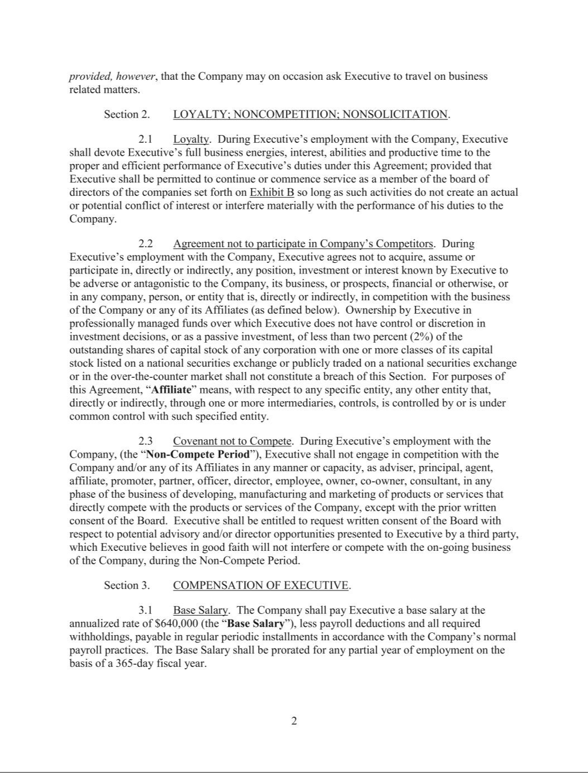

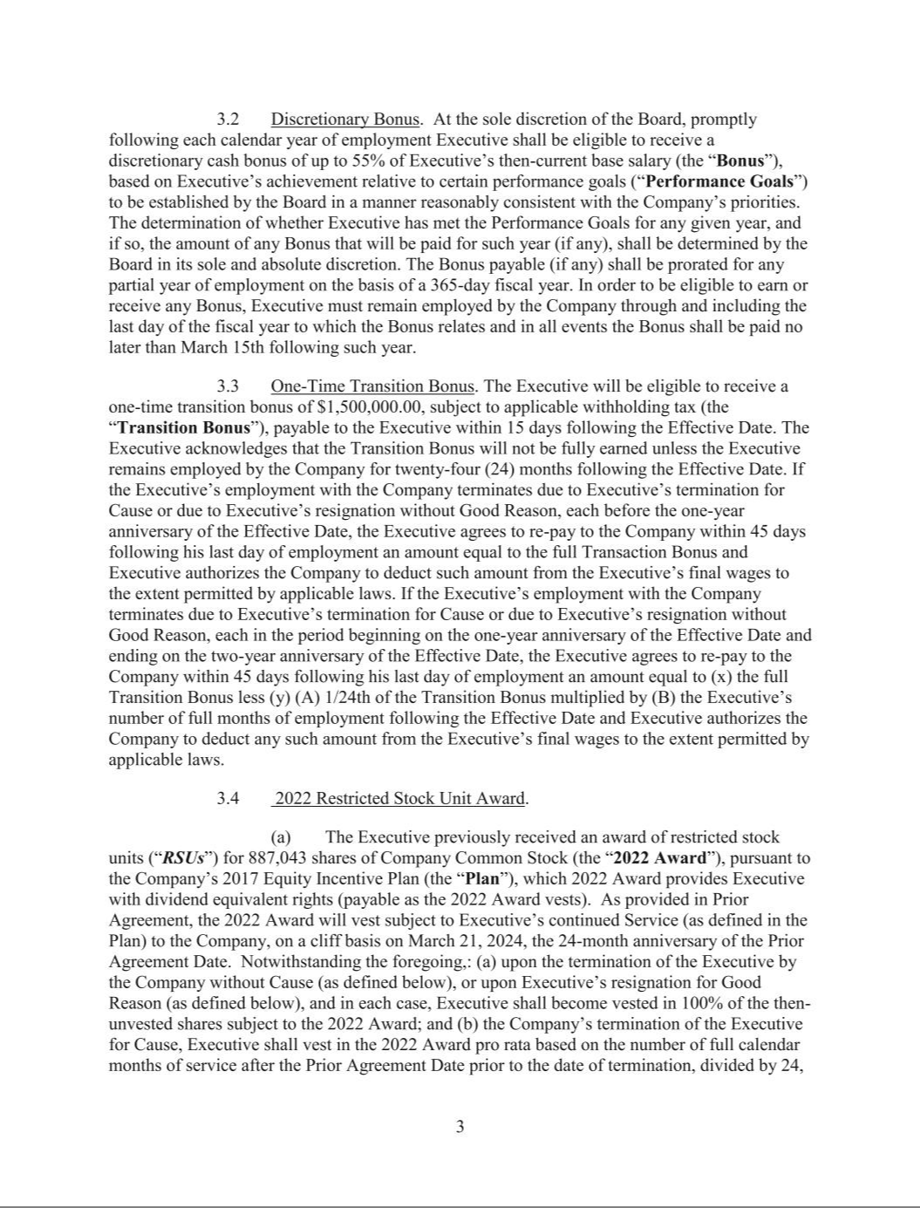

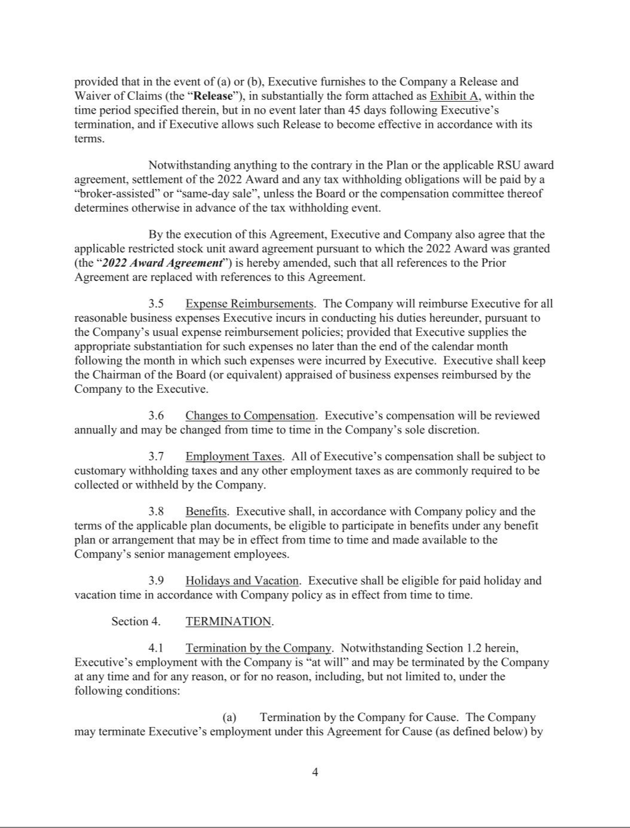

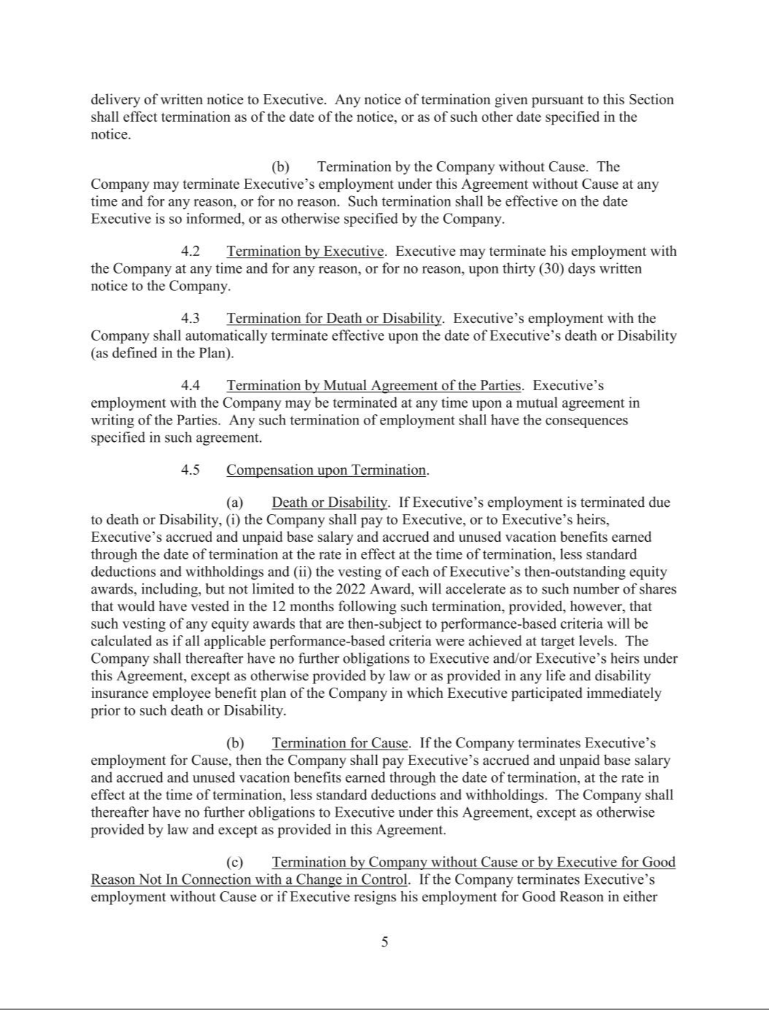

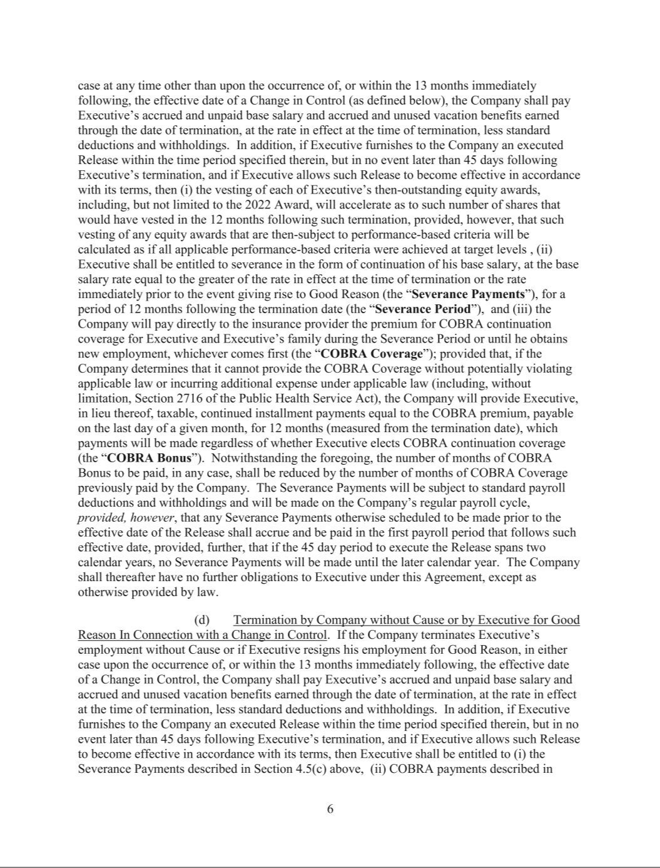

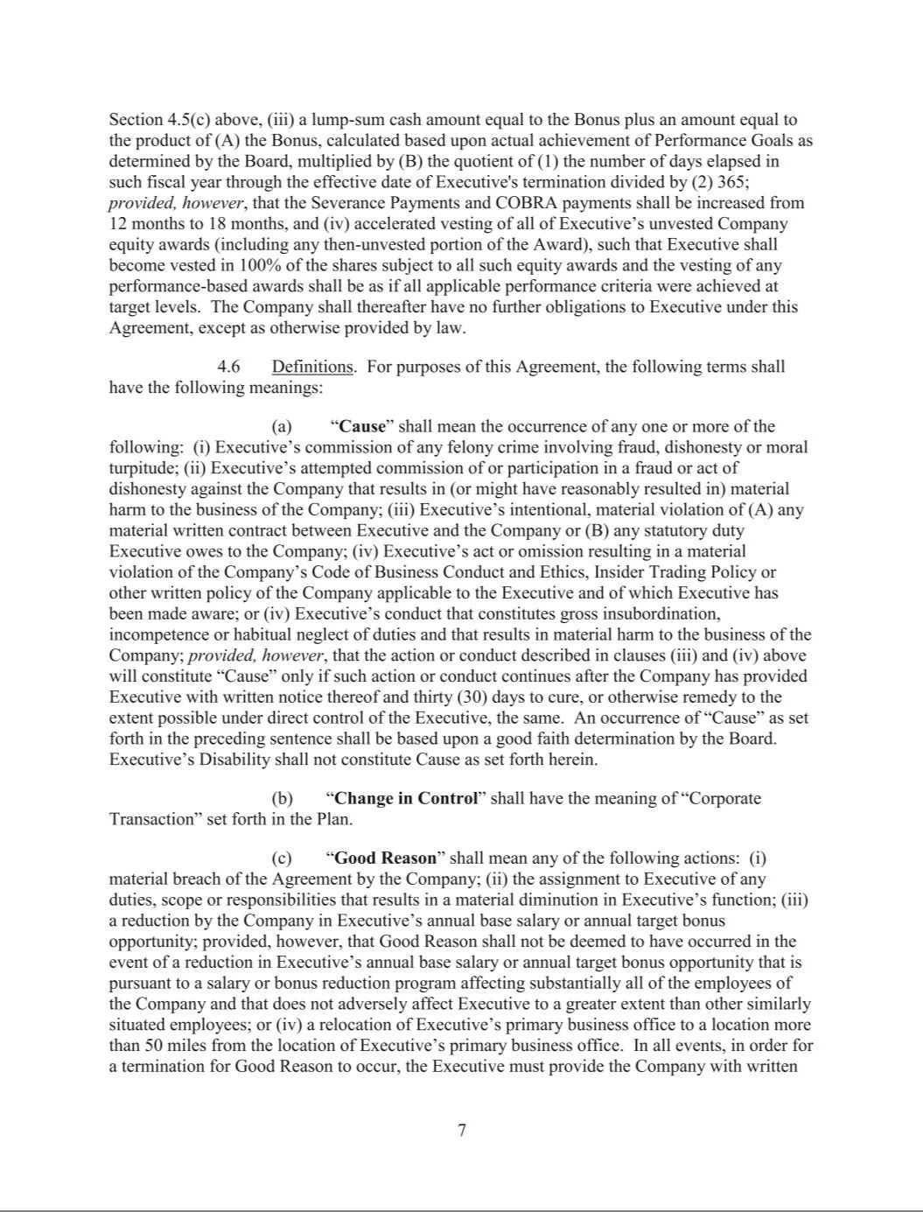

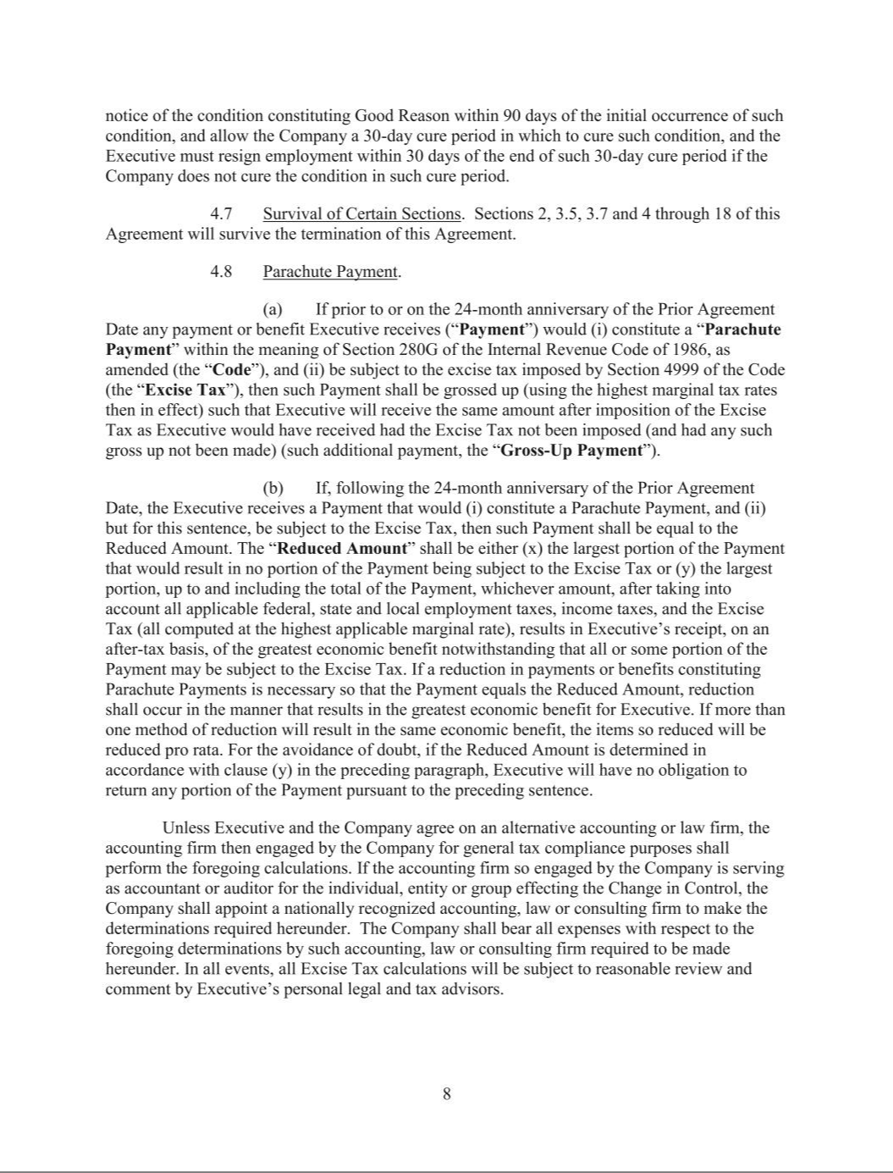

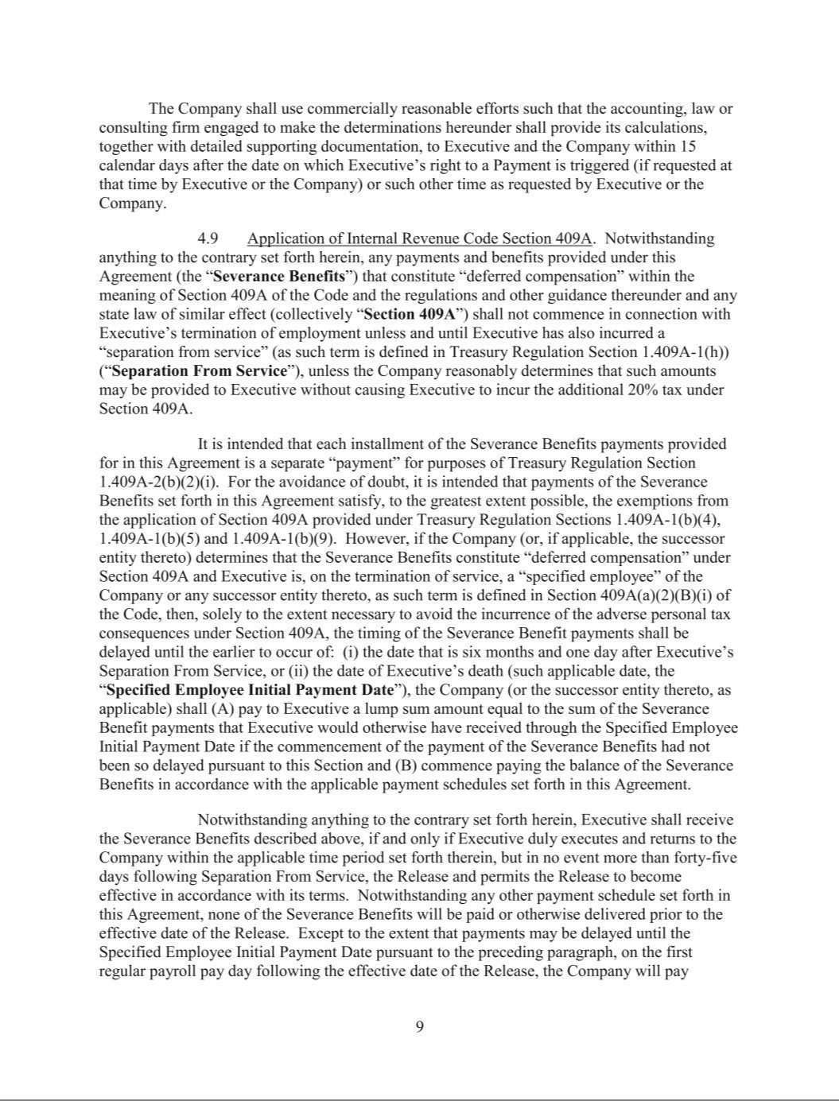

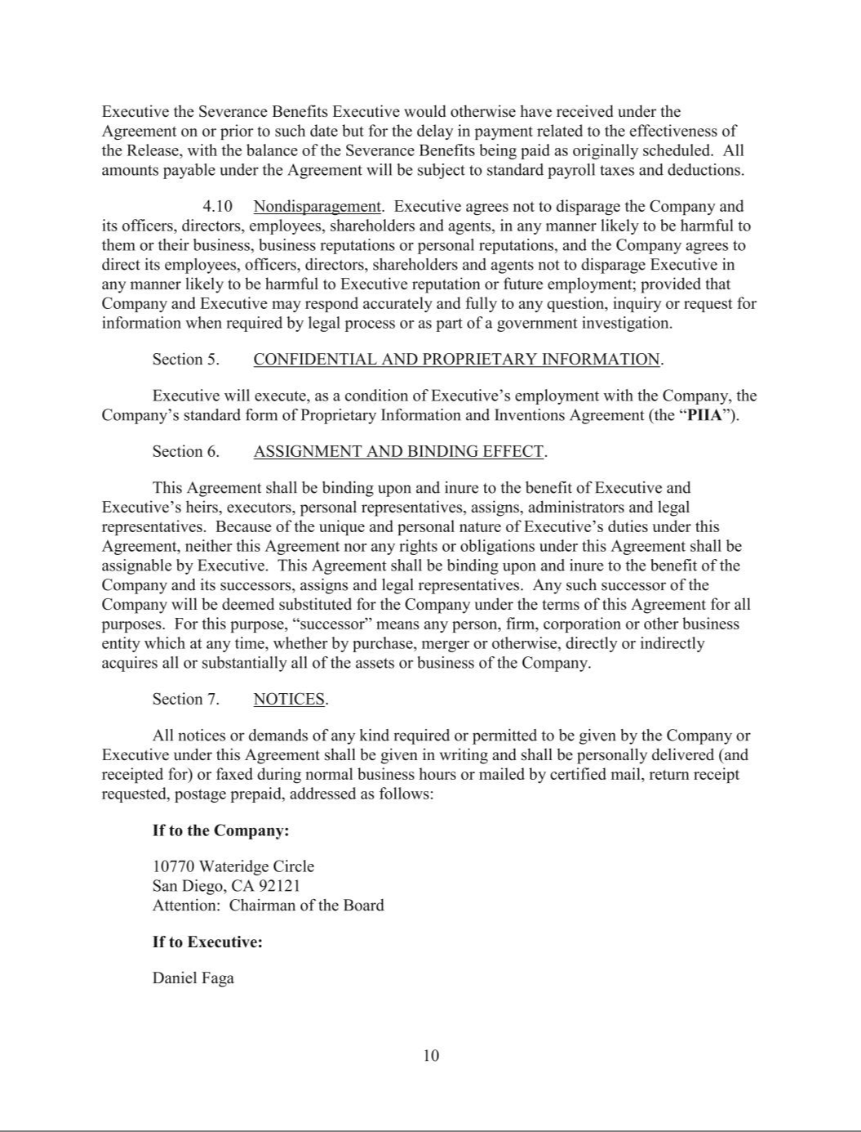

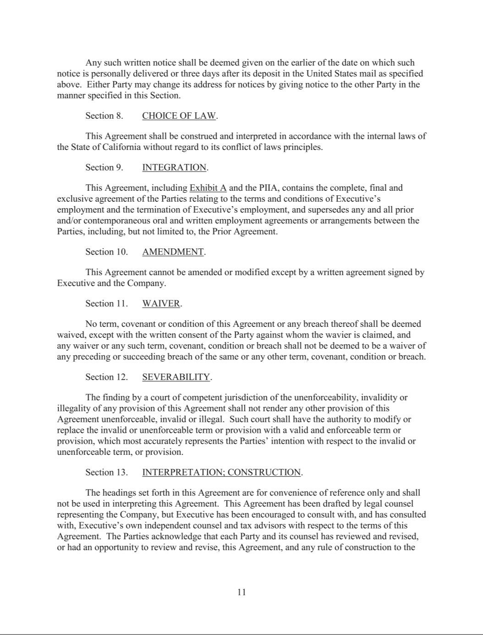

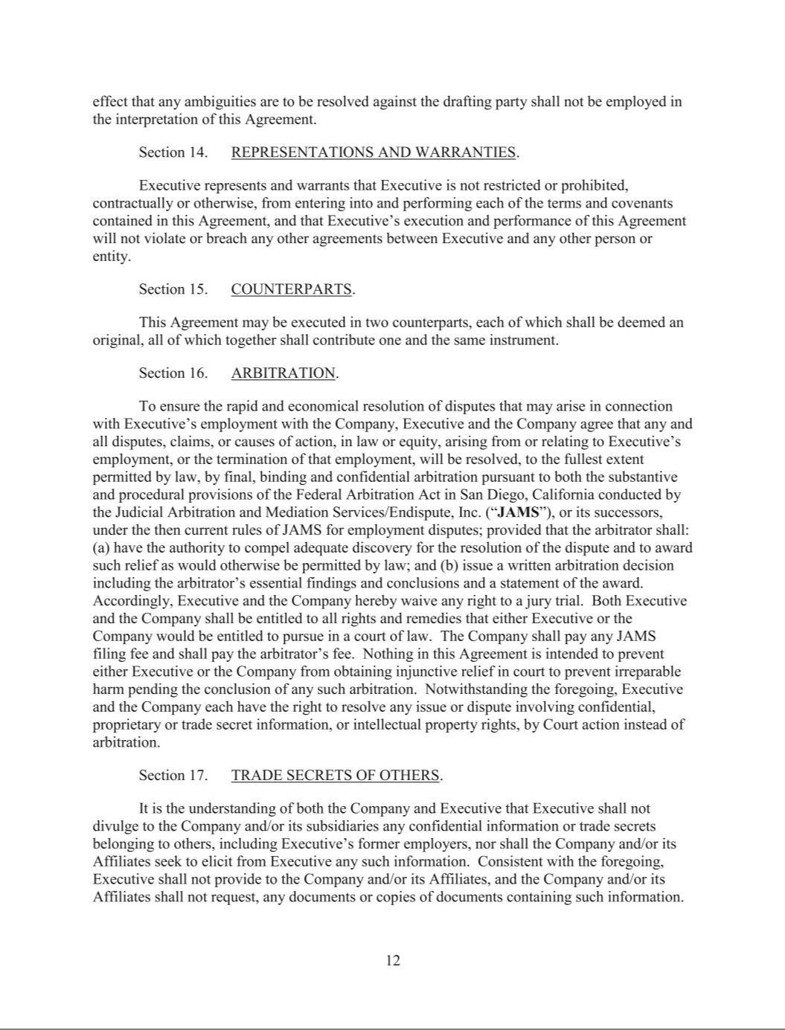

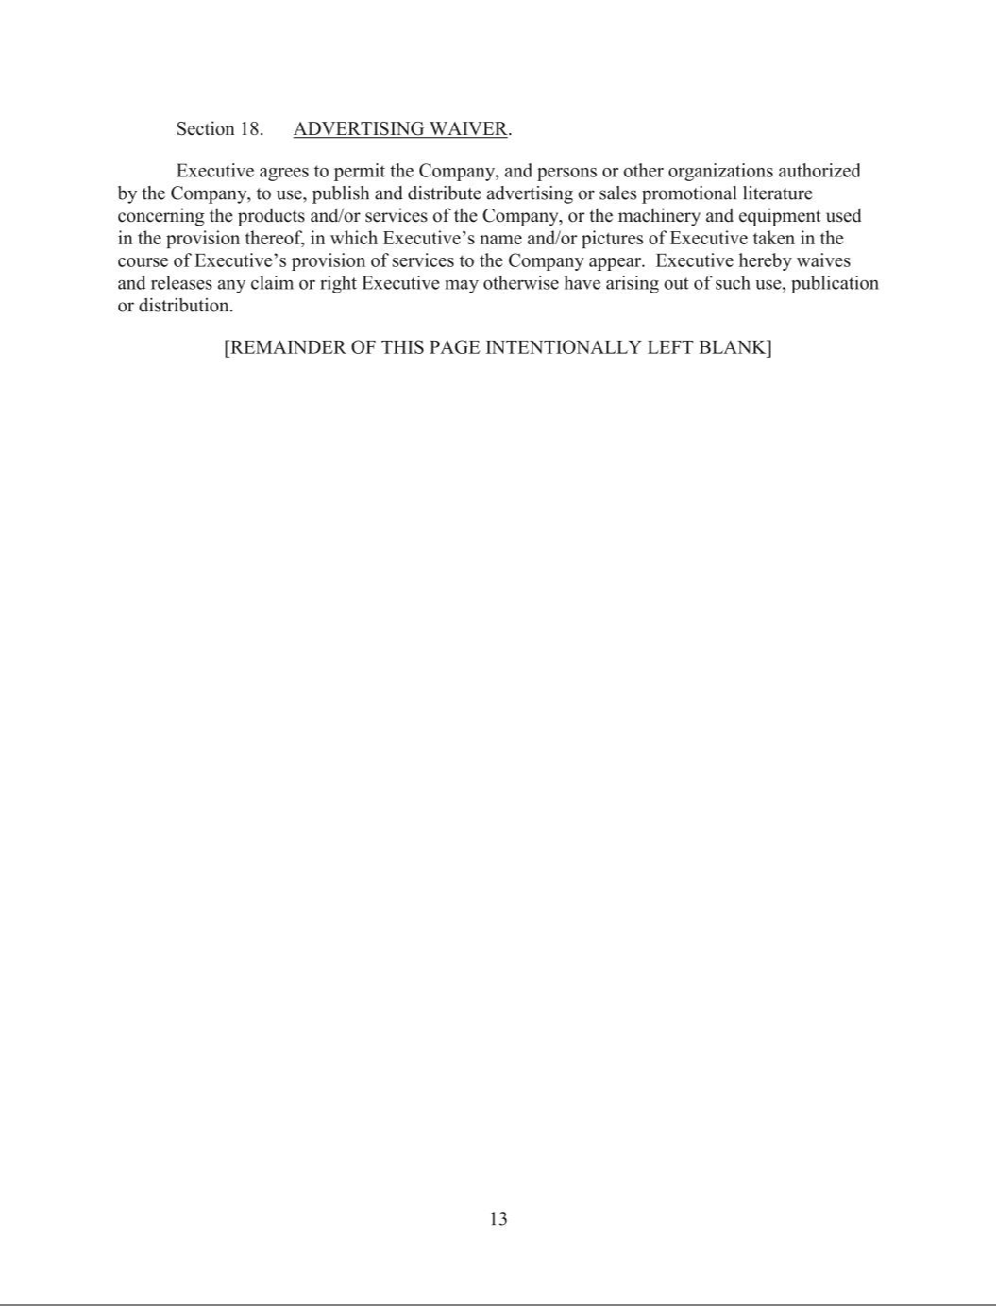

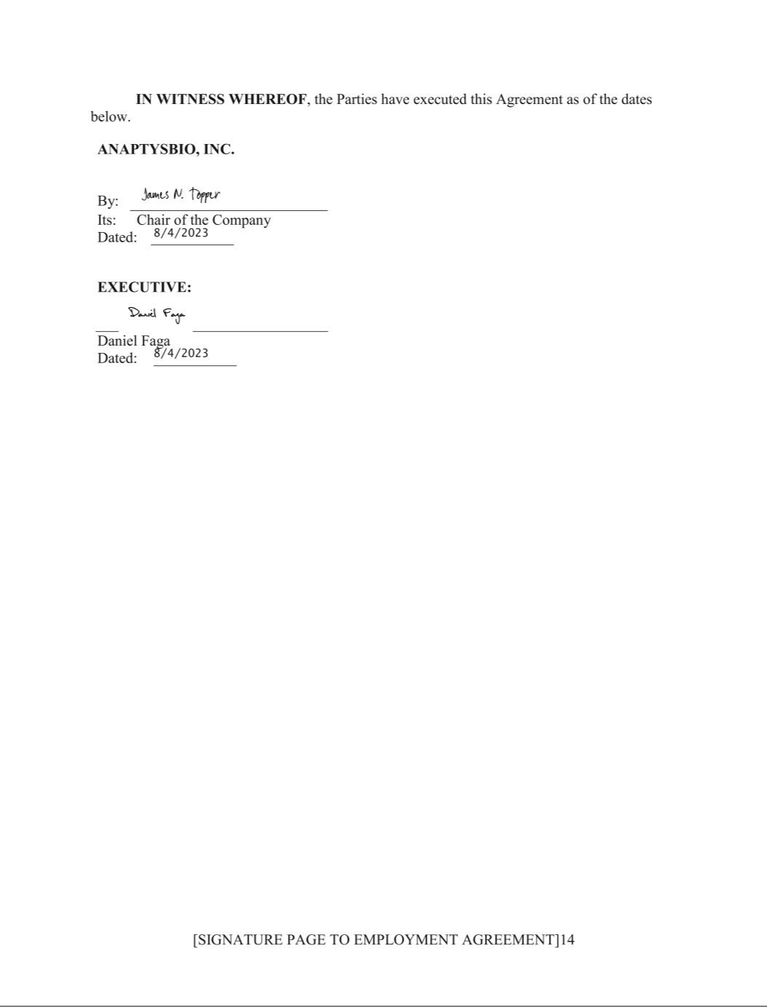

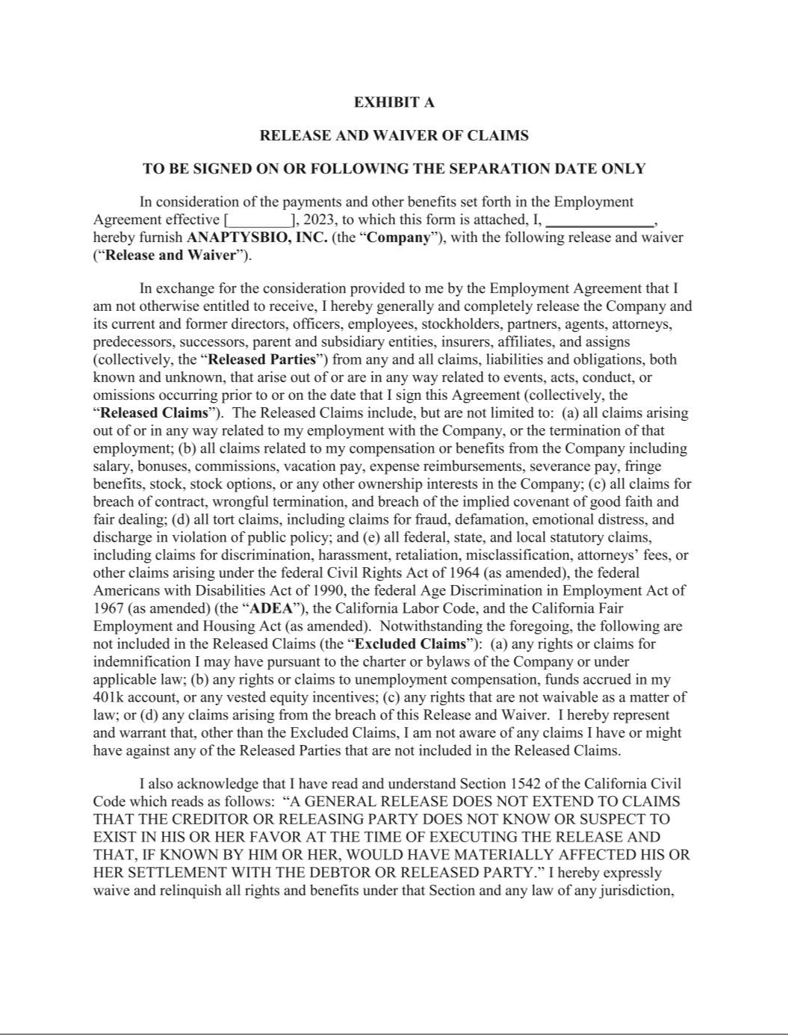

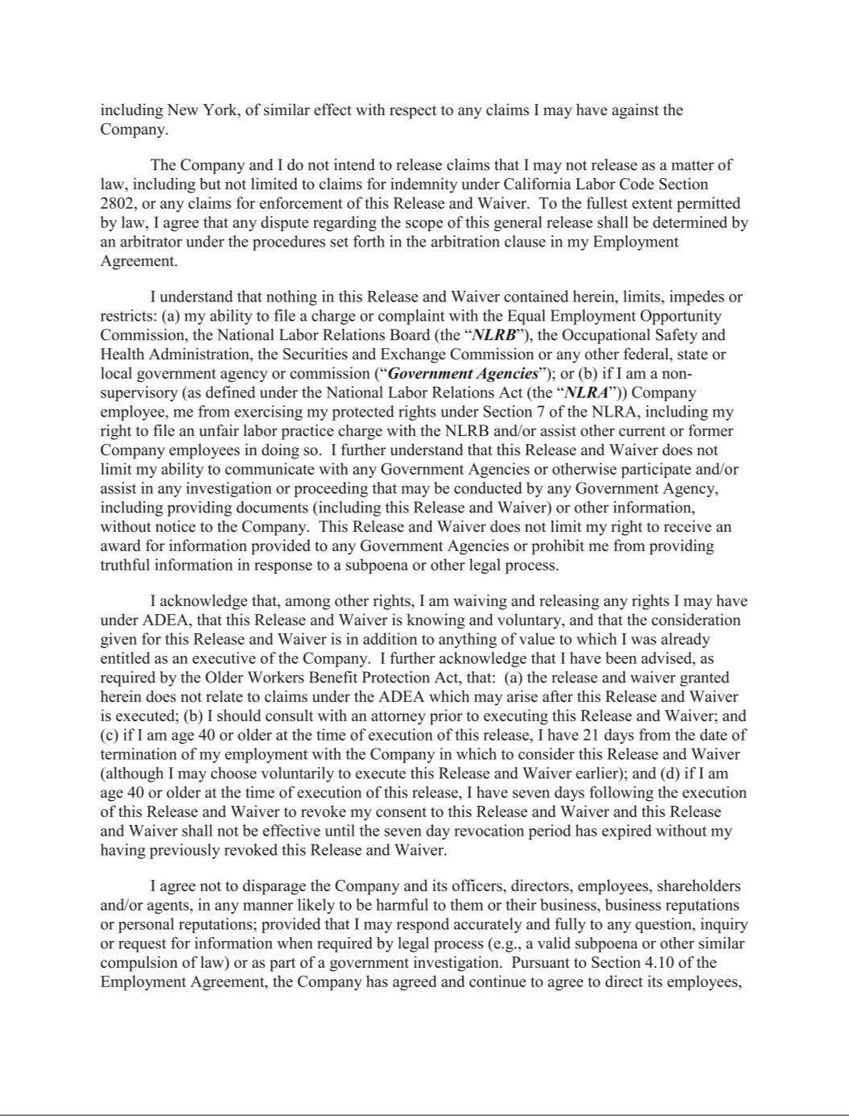

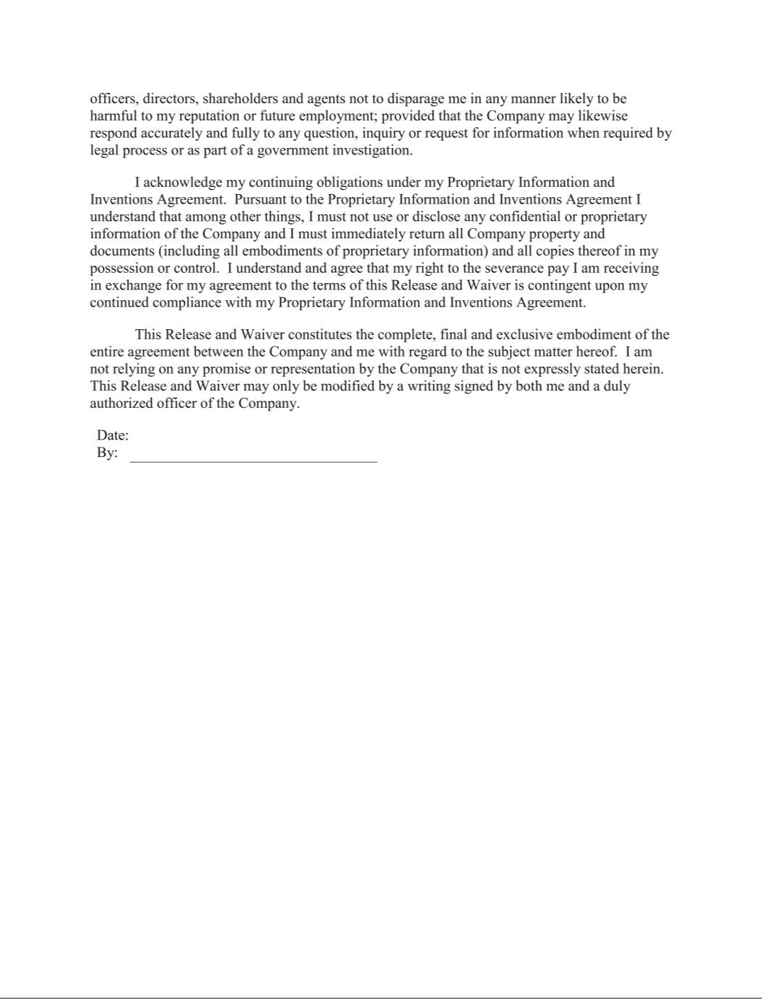

EXHIBIT 31.1

CERTIFICATION OF PERIODIC REPORT UNDER SECTION 302 OF

THE SARBANES-OXLEY ACT OF 2002

I, Daniel Faga, certify that:

- I have reviewed this quarterly report on Form 10-Q of AnaptysBio, Inc.;

- Based on my knowledge, this report does not contain any untrue statement of a material fact or omit to state a material fact necessary to make the statements made, in light of the circumstances under which such statements were made, not misleading with respect to the period covered by this report;

- Based on my knowledge, the financial statements, and other financial information included in this report, fairly present in all material respects the financial condition, results of operations and cash flows of the registrant as of, and for, the periods presented in this report;

- The registrant’s other certifying officer and I are responsible for establishing and maintaining disclosure controls and procedures (as defined in Exchange Act Rules 13a-15(e) and 15d-15(e)) and internal control over financial reporting (as defined in Exchange Act Rules 13a-15(f) and 15d-15(f)) for the registrant and have:

  - Designed such disclosure controls and procedures, or caused such disclosure controls and procedures to be designed under our supervision, to ensure that material information relating to the registrant, including its consolidated subsidiaries, is made known to us by others within those entities, particularly during the period in which this report is being prepared;

  - Designed such internal control over financial reporting, or caused such internal control over financial reporting to be designed under our supervision, to provide reasonable assurance regarding the reliability of financial reporting and the preparation of financial statements for external purposes in accordance with generally accepted accounting principles;

  - Evaluated the effectiveness of the registrant’s disclosure controls and procedures and presented in this report our conclusions about the effectiveness of the disclosure controls and procedures, as of the end of the period covered by this report based on such evaluation; and

  - Disclosed in this report any change in the registrant’s internal control over financial reporting that occurred during the registrant’s most recent fiscal quarter (the registrant’s fourth fiscal quarter in the case of an annual report) that has materially affected, or is reasonably likely to materially affect, the registrant’s internal control over financial reporting; and

- The registrant’s other certifying officer and I have disclosed, based on our most recent evaluation of internal control over financial reporting, to the registrant’s auditors and the audit committee of the registrant’s board of directors (or persons performing the equivalent functions):

  - All significant deficiencies and material weaknesses in the design or operation of internal control over financial reporting which are reasonably likely to adversely affect the registrant’s ability to record, process, summarize and report financial information; and

  - Any fraud, whether or not material, that involves management or other employees who have a significant role in the registrant’s internal control over financial reporting.

Date: November 2, 2023

/s/ Daniel Faga

Daniel Faga

President and Chief Executive Officer

(Principal Executive Officer)

EXHIBIT 31.2

CERTIFICATION OF PERIODIC REPORT UNDER SECTION 302 OF

THE SARBANES-OXLEY ACT OF 2002

I, Dennis Mulroy, certify that:

- I have reviewed this quarterly report on Form 10-Q of AnaptysBio, Inc.;

- Based on my knowledge, this report does not contain any untrue statement of a material fact or omit to state a material fact necessary to make the statements made, in light of the circumstances under which such statements were made, not misleading with respect to the period covered by this report;

- Based on my knowledge, the financial statements, and other financial information included in this report, fairly present in all material respects the financial condition, results of operations and cash flows of the registrant as of, and for, the periods presented in this report;

- The registrant’s other certifying officer and I are responsible for establishing and maintaining disclosure controls and procedures (as defined in Exchange Act Rules 13a-15(e) and 15d-15(e)) and internal control over financial reporting (as defined in Exchange Act Rules 13a-15(f) and 15d-15(f)) for the registrant and have:

  - Designed such disclosure controls and procedures, or caused such disclosure controls and procedures to be designed under our supervision, to ensure that material information relating to the registrant, including its consolidated subsidiaries, is made known to us by others within those entities, particularly during the period in which this report is being prepared;

  - Designed such internal control over financial reporting, or caused such internal control over financial reporting to be designed under our supervision, to provide reasonable assurance regarding the reliability of financial reporting and the preparation of financial statements for external purposes in accordance with generally accepted accounting principles;

  - Evaluated the effectiveness of the registrant’s disclosure controls and procedures and presented in this report our conclusions about the effectiveness of the disclosure controls and procedures, as of the end of the period covered by this report based on such evaluation; and

  - Disclosed in this report any change in the registrant’s internal control over financial reporting that occurred during the registrant’s most recent fiscal quarter (the registrant’s fourth fiscal quarter in the case of an annual report) that has materially affected, or is reasonably likely to materially affect, the registrant’s internal control over financial reporting; and

- The registrant’s other certifying officer and I have disclosed, based on our most recent evaluation of internal control over financial reporting, to the registrant’s auditors and the audit committee of the registrant’s board of directors (or persons performing the equivalent functions):

  - All significant deficiencies and material weaknesses in the design or operation of internal control over financial reporting which are reasonably likely to adversely affect the registrant’s ability to record, process, summarize and report financial information; and

  - Any fraud, whether or not material, that involves management or other employees who have a significant role in the registrant’s internal control over financial reporting.

Date: November 2, 2023

/s/ Dennis Mulroy

Dennis Mulroy

Chief Financial Officer

(Principal Financial Officer)

EXHIBIT 32.1

CERTIFICATION PURSUANT TO

18 U.S.C. SECTION 1350

AS ADOPTED PURSUANT TO SECTION 906

OF THE SARBANES-OXLEY ACT OF 2002

I, Daniel Faga, Chief Executive Officer of AnaptysBio, Inc. (Company), do hereby certify, pursuant to 18 U.S.C. Section 1350, as adopted pursuant to Section 906 of the Sarbanes-Oxley Act of 2002, that to the best of my knowledge:

- the Quarterly Report on Form 10-Q of the Company for the quarter ended September 30, 2023 (the “Report”), as filed with the Securities and Exchange Commission, fully complies with the requirements of Section 13(a) or 15(d) of the Securities Exchange Act of 1934; and

- the information contained in the Report fairly presents, in all material respects, the financial condition and results of operations of the Company for the periods presented therein.

Date: November 2, 2023

/s/ Daniel Faga

Daniel Faga

President and Chief Executive Officer

(Principal Executive Officer)

EXHIBIT 32.2

CERTIFICATION PURSUANT TO

18 U.S.C. SECTION 1350

AS ADOPTED PURSUANT TO SECTION 906

OF THE SARBANES-OXLEY ACT OF 2002

I, Dennis Mulroy, Chief Financial Officer of AnaptysBio, Inc. (Company), do hereby certify, pursuant to 18 U.S.C. Section 1350, as adopted pursuant to Section 906 of the Sarbanes-Oxley Act of 2002, that to the best of my knowledge:

- the Quarterly Report on Form 10-Q of the Company for the quarter ended September 30, 2023 (the “Report”), as filed with the Securities and Exchange Commission, fully complies with the requirements of Section 13(a) or 15(d) of the Securities Exchange Act of 1934; and

- the information contained in the Report fairly presents, in all material respects, the financial condition and results of operations of the Company for the periods presented therein.

Date: November 2, 2023

/s/ Dennis Mulroy

Dennis Mulroy

Chief Financial Officer

(Principal Financial Officer)

