UNITED STATES
SECURITIES AND EXCHANGE COMMISSION
Washington, D.C. 20549
FORM 10-Q
☒ |  |  | Quarterly Report pursuant to Section 13 or 15(d) of the Securities Exchange Act of 1934
For the quarterly period ended March 31, 2025
OR
☐ |  |  | Transition report pursuant to Section 13 or 15(d) of the Securities Exchange Act of 1934
For the transition period from to .
Commission File Number: 001-37985
ANAPTYSBIO, INC.
(Exact name of registrant as specified in its charter)
Delaware |  |  |  |  |  | 20-3828755
(State or other jurisdiction of  incorporation or organization) |  |  |  |  |  | (I.R.S. Employer  Identification Number)
10770 Wateridge Circle, Suite 210
San Diego, CA 92121
(Address of principal executive offices and zip code)
(858) 362-6295
(Registrant’s telephone number, including area code)

Securities registered pursuant to Section 12(b) of the Act:
Title of each class |  |  | Trading Symbol(s) |  |  | Name of each exchange on which registered
Common Stock, $0.001 par value |  |  | ANAB |  |  | The Nasdaq Stock Market LLC
Indicate by check mark whether the Registrant (1) has filed all reports required to be filed by Section 13 or 15(d) of the Securities Exchange Act of 1934 during the preceding 12 months (or for such shorter period that the Registrant was required to file such reports), and (2) has been subject to such filing requirements for the past 90 days: Yes ☒ No ☐
Indicate by check mark whether the Registrant has submitted electronically every Interactive Data File required to be submitted pursuant to Rule 405 of Regulation S-T (§232.405 of this chapter) during the preceding 12 months (or for such shorter period that the Registrant was required to submit such files). Yes ☒ No ☐
Indicate by check mark whether the Registrant is a large accelerated filer, an accelerated filer, a non-accelerated filer, a smaller reporting company, or an emerging growth company. See the definitions of “large accelerated filer,” “accelerated filer,” “smaller reporting company” and “emerging growth company” in Rule 12b-2 of the Exchange Act.
Large Accelerated Filer |  |  |  |  |  | ☐ |  |  |  |  |  | Accelerated Filer |  |  |  |  |  | ☐
Non-accelerated Filer |  |  |  |  |  | ☒ |  |  |  |  |  | Smaller Reporting Company |  |  |  |  |  | ☒
 |  |  |  |  |  |  |  |  |  |  |  | Emerging Growth Company |  |  |  |  |  | ☐
If an emerging growth company, indicate by check mark if the registrant has elected not to use the extended transition period for complying with any new or revised financial accounting standards provided pursuant to Section 13(a) of the Exchange Act. ☐
Indicate by check mark whether the Registrant is a shell company (as defined in Rule 12b-2 of the Exchange Act). Yes ☐ No ☒

As of April 30, 2025, there were 29,380,496 shares of the Registrant’s Common Stock outstanding.

AnaptysBio, Inc.
Table of Contents

 |  |  |  |  |  | Page Number
 |  |  | PART I. FINANCIAL INFORMATION
Item 1. |  |  | Consolidated Financial Statements (unaudited) |  |  | 1
 |  |  | Consolidated Balance Sheets as of March 31, 2025 and December 31, 2024 |  |  | 1
 |  |  | Consolidated Statements of Operations and Comprehensive Loss for the Three Months Ended March 31, 2025 and 2024 |  |  | 2
 |  |  | Consolidated Statements of Stockholders’ Equity for the Three Months Ended March 31, 2025 |  |  | 3
 |  |  | Consolidated Statements of Stockholders’ Equity for the Three Months Ended March 31, 2024 |  |  | 4
 |  |  | Consolidated Statements of Cash Flows for the Three Months Ended March 31, 2025 and 2024 |  |  | 5
 |  |  | Notes to the Unaudited Consolidated Financial Statements |  |  | 6
Item 2. |  |  | Management’s Discussion and Analysis of Financial Condition and Results of Operations |  |  | 24
Item 3. |  |  | Quantitative and Qualitative Disclosures About Market Risk |  |  | 32
Item 4. |  |  | Controls and Procedures |  |  | 32
 |  |  | PART II. OTHER INFORMATION
Item 1. |  |  | Legal Proceedings |  |  | 33
Item 1A. |  |  | Risk Factors |  |  | 33
Item 2. |  |  | Unregistered Sales of Equity Securities, Use of Proceeds and Issuer Purchases of Equity Securities |  |  | 67
Item 3. |  |  | Defaults Upon Senior Securities |  |  | 68
Item 4. |  |  | Mine Safety Disclosures |  |  | 69
Item 5. |  |  | Other Information |  |  | 69
Item 6. |  |  | Exhibits |  |  | 69
 |  |  | Exhibit Index |  |  | 69
 |  |  | Signatures |  |  | 71

PART I. FINANCIAL INFORMATION

Item 1. Consolidated Financial Statements (unaudited)

AnaptysBio, Inc.
Consolidated Balance Sheets
(in thousands, except par value data)
(unaudited)
 |  |  | March 31, 2025 |  |  |  |  |  | December 31, 2024
ASSETS
Current assets:
Cash and cash equivalents |  |  | $ | 98,637 |  |  |  |  | $ | 123,080
Receivables from collaborative partners |  |  | 17,884 |  |  |  |  |  | 40,765
Short-term investments |  |  | 241,299 |  |  |  |  |  | 262,293
Prepaid expenses and other current assets |  |  | 5,292 |  |  |  |  |  | 5,738
Total current assets |  |  | 363,112 |  |  |  |  |  | 431,876
Property and equipment, net |  |  | 1,741 |  |  |  |  |  | 1,849
Operating lease right-of-use assets |  |  | 13,923 |  |  |  |  |  | 14,383
Long-term investments |  |  | 43,021 |  |  |  |  |  | 35,470
Other long-term assets |  |  | 256 |  |  |  |  |  | 256
Total assets |  |  | $ | 422,053 |  |  |  |  | $ | 483,834
LIABILITIES AND STOCKHOLDERS’ EQUITY
Current liabilities:
Accounts payable |  |  | $ | 6,123 |  |  |  |  | $ | 4,002
Accrued expenses |  |  | 35,952 |  |  |  |  |  | 39,501
Current portion of operating lease liability |  |  | 1,962 |  |  |  |  |  | 1,925
Total current liabilities |  |  | 44,037 |  |  |  |  |  | 45,428
Liability related to sale of future royalties |  |  | 330,382 |  |  |  |  |  | 353,426
Operating lease liability, net of current portion |  |  | 13,613 |  |  |  |  |  | 14,112
Stockholders’ equity:
Preferred stock, $0.001 par value, 10,000 shares authorized and no shares, issued or outstanding at March 31, 2025 and December 31, 2024, respectively |  |  | — |  |  |  |  |  | —
Common stock, $0.001 par value, 500,000 shares authorized, 30,388 shares and 30,473 shares issued and outstanding at March 31, 2025 and December 31, 2024, respectively |  |  | 30 |  |  |  |  |  | 30
Additional paid in capital |  |  | 832,486 |  |  |  |  |  | 829,860
Accumulated other comprehensive gain |  |  | 161 |  |  |  |  |  | 305
Accumulated deficit |  |  | (798,656) |  |  |  |  |  | (759,327)
Total stockholders’ equity |  |  | 34,021 |  |  |  |  |  | 70,868
Total liabilities and stockholders’ equity |  |  | $ | 422,053 |  |  |  |  | $ | 483,834
See accompanying notes to unaudited consolidated financial statements.

1

AnaptysBio, Inc.
Consolidated Statements of Operations and Comprehensive Loss
(in thousands, except per share data)
(unaudited)
Three Months Ended
March 31,
 |  |  |  |  |  |  | 2025 |  |  |  |  |  | 2024
Collaboration revenue |  |  |  |  |  |  | $ | 27,771 |  |  |  |  | $ | 7,179
Operating expenses:
Research and development |  |  |  |  |  |  | 41,180 |  |  |  |  |  | 37,042
General and administrative |  |  |  |  |  |  | 14,130 |  |  |  |  |  | 12,338
Total operating expenses |  |  |  |  |  |  | 55,310 |  |  |  |  |  | 49,380
Loss from operations |  |  |  |  |  |  | (27,539) |  |  |  |  |  | (42,201)
Other income (expense), net:
Interest income |  |  |  |  |  |  | 4,413 |  |  |  |  |  | 4,584
Non-cash interest expense for the sale of future royalties |  |  |  |  |  |  | (18,061) |  |  |  |  |  | (6,317)
Other income (expense), net |  |  |  |  |  |  | 1,902 |  |  |  |  |  | (2)
Total other expense, net |  |  |  |  |  |  | (11,746) |  |  |  |  |  | (1,735)
Loss before income taxes |  |  |  |  |  |  | (39,285) |  |  |  |  |  | (43,936)
Provision for income taxes |  |  |  |  |  |  | (44) |  |  |  |  |  | —
Net loss |  |  |  |  |  |  | (39,329) |  |  |  |  |  | (43,936)
Unrealized (loss) gain on available for sale securities |  |  |  |  |  |  | (144) |  |  |  |  |  | 173
Comprehensive loss |  |  |  |  |  |  | $ | (39,473) |  |  |  |  | $ | (43,763)
Net loss per common share:
Basic and diluted |  |  |  |  |  |  | $ | (1.28) |  |  |  |  | $ | (1.64)
Weighted-average number of shares outstanding:
Basic and diluted |  |  |  |  |  |  | 30,644 |  |  |  |  |  | 26,801
See accompanying notes to unaudited consolidated financial statements.

2

AnaptysBio, Inc.
Consolidated Statement of Stockholders’ Equity
(in thousands)
(unaudited)
 |  |  | Common Stock |  |  |  |  |  |  |  |  |  |  |  | Additional  Paid-in  Capital |  |  |  |  |  | Accumulated Other Comprehensive Gain ( Loss) |  |  |  |  |  | Accumulated  Deficit |  |  |  |  |  | Total  Stockholders’  Equity
 |  |  | Shares |  |  |  |  |  | Amount
Balance, December 31, 2024 |  |  | 30,473 |  |  |  |  |  | $ | 30 |  |  |  |  | $ | 829,860 |  |  |  |  | $ | 305 |  |  |  |  | $ | (759,327) |  |  |  |  | $ | 70,868
Issuance of common stock from exercises of options and employee stock purchase plan |  |  | 44 |  |  |  |  |  | — |  |  |  |  |  | 290 |  |  |  |  |  | — |  |  |  |  |  | — |  |  |  |  |  | 290
Issuance of common stock upon vesting of restricted stock units |  |  | 262 |  |  |  |  |  | — |  |  |  |  |  | — |  |  |  |  |  | — |  |  |  |  |  | — |  |  |  |  |  | —
Net share settlement of restricted stock units |  |  | (98) |  |  |  |  |  | — |  |  |  |  |  | (1,451) |  |  |  |  |  | — |  |  |  |  |  | — |  |  |  |  |  | (1,451)
Repurchases and retirements of common stock |  |  | (293) |  |  |  |  |  |  |  |  |  |  |  | (5,383) |  |  |  |  |  |  |  |  |  |  |  |  |  |  |  |  |  | (5,383)
Stock-based compensation |  |  | — |  |  |  |  |  | — |  |  |  |  |  | 9,170 |  |  |  |  |  | — |  |  |  |  |  | — |  |  |  |  |  | 9,170
Comprehensive loss, net |  |  | — |  |  |  |  |  | — |  |  |  |  |  | — |  |  |  |  |  | (144) |  |  |  |  |  | — |  |  |  |  |  | (144)
Net loss |  |  | — |  |  |  |  |  | — |  |  |  |  |  | — |  |  |  |  |  | — |  |  |  |  |  | (39,329) |  |  |  |  |  | (39,329)
Balance, March 31, 2025 |  |  | 30,388 |  |  |  |  |  | $ | 30 |  |  |  |  | $ | 832,486 |  |  |  |  | $ | 161 |  |  |  |  | $ | (798,656) |  |  |  |  | $ | 34,021
See accompanying notes to unaudited consolidated financial statements.

3
AnaptysBio, Inc.
Consolidated Statement of Stockholders’ Equity
(in thousands)
(unaudited)
 |  |  | Common Stock |  |  |  |  |  |  |  |  |  |  |  | Additional  Paid-in  Capital |  |  |  |  |  | Accumulated Other Comprehensive Gain (Loss) |  |  |  |  |  | Accumulated  Deficit |  |  |  |  |  | Total  Stockholders’  Equity
 |  |  | Shares |  |  |  |  |  | Amount
Balance, December 31, 2023 |  |  | 26,597 |  |  |  |  |  | $ | 27 |  |  |  |  | $ | 702,969 |  |  |  |  | $ | (797) |  |  |  |  | $ | (614,096) |  |  |  |  | $ | 88,103
Issuance of common stock from exercises of options and employee stock purchase plan |  |  | 53 |  |  |  |  |  | — |  |  |  |  |  | 811 |  |  |  |  |  | — |  |  |  |  |  | — |  |  |  |  |  | 811
Issuance of common stock upon vesting of restricted stock units |  |  | 1,014 |  |  |  |  |  | — |  |  |  |  |  | — |  |  |  |  |  | — |  |  |  |  |  | — |  |  |  |  |  | —
Net share settlement of restricted stock units |  |  | (347) |  |  |  |  |  | — |  |  |  |  |  | (7,504) |  |  |  |  |  | — |  |  |  |  |  | — |  |  |  |  |  | (7,504)
Stock-based compensation |  |  | — |  |  |  |  |  | — |  |  |  |  |  | 10,131 |  |  |  |  |  | — |  |  |  |  |  | — |  |  |  |  |  | 10,131
Comprehensive gain, net |  |  | — |  |  |  |  |  | — |  |  |  |  |  | — |  |  |  |  |  | 173 |  |  |  |  |  | — |  |  |  |  |  | 173
Net loss |  |  | — |  |  |  |  |  | — |  |  |  |  |  | — |  |  |  |  |  | — |  |  |  |  |  | (43,936) |  |  |  |  |  | (43,936)
Balance, March 31, 2024 |  |  | 27,317 |  |  |  |  |  | $ | 27 |  |  |  |  | $ | 706,407 |  |  |  |  | $ | (624) |  |  |  |  | $ | (658,032) |  |  |  |  | $ | 47,778
See accompanying notes to unaudited consolidated financial statements.

4
AnaptysBio, Inc.
Consolidated Statements of Cash Flows
(in thousands)
(unaudited)
Three Months Ended
March 31,
 |  |  | 2025 |  |  |  |  |  | 2024
CASH FLOWS FROM OPERATING ACTIVITIES:
Net loss |  |  | $ | (39,329) |  |  |  |  | $ | (43,936)
Adjustments to reconcile net loss to net cash used in operating activities:
Depreciation and amortization |  |  | 146 |  |  |  |  |  | 163
Stock-based compensation |  |  | 9,170 |  |  |  |  |  | 10,131
Accretion/amortization of investments, net |  |  | (1,667) |  |  |  |  |  | (2,968)
Amortization of right-of-use assets – operating |  |  | 460 |  |  |  |  |  | 442
Non-cash interest expense |  |  | 18,061 |  |  |  |  |  | 6,317
Changes in operating assets and liabilities:
Receivables from collaborative partners |  |  | 22,881 |  |  |  |  |  | (238)
Prepaid expenses and other assets |  |  | 530 |  |  |  |  |  | (1,566)
Accounts payable and other liabilities |  |  | (24,034) |  |  |  |  |  | (5,172)
Deferred income |  |  | 3,544 |  |  |  |  |  | —
Operating lease liabilities |  |  | (462) |  |  |  |  |  | (426)
Net cash used in operating activities |  |  | (10,700) |  |  |  |  |  | (37,253)
CASH FLOWS FROM INVESTING ACTIVITIES:
Purchases of investments |  |  | (122,547) |  |  |  |  |  | (58,997)
Sales and maturities of investments |  |  | 137,429 |  |  |  |  |  | 127,640
Purchases of property and equipment |  |  | (35) |  |  |  |  |  | (27)
Net cash provided by investing activities |  |  | 14,847 |  |  |  |  |  | 68,616
CASH FLOWS FROM FINANCING ACTIVITIES:
Proceeds from issuance of common stock |  |  | 290 |  |  |  |  |  | 811
Repurchase and retirements of common stock |  |  | (4,424) |  |  |  |  |  | —
Payment for net share settlement of equity awards |  |  | (1,451) |  |  |  |  |  | (7,504)
Principal repayment of liability for sale of future royalties |  |  | (23,005) |  |  |  |  |  | (6,940)
Net cash used in financing activities |  |  | (28,590) |  |  |  |  |  | (13,633)
Net (decrease) increase in cash and cash equivalents |  |  | (24,443) |  |  |  |  |  | 17,730
Cash and cash equivalents, beginning of period |  |  | 123,080 |  |  |  |  |  | 35,965
Cash and cash equivalents, end of period |  |  | $ | 98,637 |  |  |  |  | $ | 53,695
SUPPLEMENTAL DISCLOSURE OF CASH FLOW INFORMATION
Interest portion of repayment for sale of future royalties |  |  | $ | 18,100 |  |  |  |  | $ | —
Income taxes paid |  |  | $ | 5 |  |  |  |  | $ | —
Non-cash investing and financing activities:
Amounts accrued for property and equipment |  |  | $ | 11 |  |  |  |  | $ | —
Amounts accrued for repurchases of common stock |  |  | $ | 959 |  |  |  |  | $ | —
See accompanying notes to unaudited consolidated financial statements.

5
AnaptysBio, Inc.
Notes to Unaudited Consolidated Financial Statements

1. Description of the Business
AnaptysBio, Inc. (“we,” “us,” “our,” or the “company”) was incorporated in the state of Delaware in November 2005. We are a clinical-stage biotechnology company focused on delivering innovative immunology therapeutics for autoimmune and inflammatory diseases. Our pipeline includes our lead program, rosnilimab, a depleter and agonist targeting PD-1+ T cells, in a Phase 2b trial for the treatment of moderate-to-severe rheumatoid arthritis (“RA”) and a Phase 2 trial for the treatment of moderate-to-severe ulcerative colitis (“UC”). We also have other antibodies in our portfolio, including ANB033, a CD122 antagonist, and ANB101, a BDCA2 modulator, both in Phase 1 trials. We have also discovered multiple therapeutic antibodies licensed to GlaxoSmithKline, Inc. (“GSK”) in a financial collaboration for immuno-oncology, including a PD-1 antagonist (Jemperli (dostarlimab-gxly) or “Jemperli”) and a TIM-3 antagonist (cobolimab, GSK4069889). We currently recognize revenue from milestones and royalties achieved under our immuno-oncology collaboration with GSK and license and transition services revenue from our collaboration with Vanda Pharmaceuticals Inc. (“Vanda”).
Since our inception, we have devoted our primary effort to research and development activities. Our financial support has been provided primarily from the sale of our common stock, royalty monetizations, as well as through funds received under our collaborative research and development agreements. Going forward, as we continue our expansion, we may seek additional financing and/or strategic investments. However, there can be no assurance that any additional financing or strategic investments will be available to us on acceptable terms, if at all. If events or circumstances occur such that we do not obtain additional funding, we will most likely be required to reduce our plans and/or certain discretionary spending, which could have a material adverse effect on our ability to achieve our intended business objectives. Our management believes our currently available resources will provide sufficient funds to enable us to meet our operating plans for at least the next 12 months from the issuance of our consolidated financial statements. The accompanying consolidated financial statements do not include any adjustments that might be necessary if we are unable to continue as a going concern.

2. Summary of Significant Accounting Policies
Basis of Presentation
The accompanying unaudited consolidated financial statements have been prepared pursuant to the rules and regulations of the Securities and Exchange Commission (the “SEC”). Certain information and note disclosures normally included in annual financial statements prepared in accordance with U.S. generally accepted accounting principles (“U.S. GAAP”) have been omitted. The accompanying unaudited consolidated financial statements include all known adjustments necessary for a fair presentation of the results of interim periods as required by U.S. GAAP. These adjustments consist primarily of normal recurring accruals and estimates that impact the carrying value of assets and liabilities. Operating results for the three months ended March 31, 2025 are not necessarily indicative of the results that may be expected for the year ending December 31, 2025. The financial statements should be read in conjunction with our audited financial statements for the year ended December 31, 2024 included in our Annual Report on Form 10-K.
Basis of Consolidation
The accompanying consolidated financial statements include us and our wholly owned Australian subsidiary. All intercompany accounts and transactions have been eliminated in consolidation. We operate in one reportable segment, and our functional and reporting currency is the U.S. dollar.
Use of Estimates
The preparation of the accompanying consolidated financial statements in conformity with U.S. GAAP requires our management to make estimates and assumptions that affect the reported amounts of assets and liabilities, disclosure of contingent assets and liabilities at the date of the financial statements, and reported amounts of revenues and expenses during the reporting periods. Actual results could differ from those estimates. We base our estimates and assumptions on historical experience when available and on various factors that we believe to be reasonable under the circumstances. Significant estimates relied upon in preparing these financial statements include estimates related to revenue recognition, accrued research and development expenses, stock-based compensation, and the liability related to the sale of future royalties. We evaluate our
6
estimates and assumptions on an ongoing basis. Our actual results could differ from these estimates under different assumptions or conditions.
Net Loss Per Common Share
Basic net loss per common share is computed by dividing net loss by the weighted-average number of common shares outstanding during the period. Diluted net loss per share is computed by dividing net loss by the weighted-average number of common equivalent shares outstanding for the period, as well as any dilutive effect from outstanding stock options and warrants using the treasury stock method. For each period presented, there is no difference in the number of shares used to calculate basic and diluted net loss per share.
The following table sets forth the weighted-average outstanding potentially dilutive securities that have been excluded in the calculation of diluted net loss per share because to do so would be anti-dilutive (in common stock equivalent shares):
Three Months Ended
March 31,
(in thousands) |  |  |  |  |  |  | 2025 |  |  |  |  |  | 2024
Options to purchase common stock |  |  |  |  |  |  | 7,668 |  |  |  |  |  | 6,078
Stock awards |  |  |  |  |  |  | 681 |  |  |  |  |  | 1,002
Total |  |  |  |  |  |  | 8,349 |  |  |  |  |  | 7,080
Accounting Pronouncements
We have implemented all new accounting pronouncements that are in effect and may have an impact on our consolidated financial statements. Unless otherwise discussed, we believe the impact of any recently issued and not yet effective pronouncements will not have a material impact on our consolidated financial statements.
In November 2023, the Financial Accounting Standards Board (“FASB”) issued Accounting Standard Update (“ASU”) 2023-07, Segment Reporting (Topic 280): Improvements to Reportable Segment Disclosures, which requires enhanced disclosure of significant segment expenses that are regularly provided to the chief operating decision maker (“CODM”) and included within each reported measure of segment profit or loss on an annual and interim basis and should be applied retrospectively to all prior periods presented in the financial statements. We adopted this standard retrospectively on December 31, 2024. For the purpose of the adoption of ASU 2023-07, we performed an evaluation of financial information regularly reviewed by the CODM for purposes of evaluating performance and allocating resources. Financial information provided to and used by the CODM is consistent with our consolidated GAAP financial statements including our Consolidated Statements of Operations, see Note 10.
Recent Accounting Pronouncements Not Yet Adopted
In December 2023, the FASB issued ASU No. 2023-09, Income Taxes (Topic 740): Improvements to Income Tax Disclosures Income Taxes, which improves the transparency of income tax disclosures by requiring consistent categories and greater disaggregation of information in the effective tax rate reconciliation and income taxes paid disaggregated by jurisdiction. It also includes certain other amendments to improve the effectiveness of income tax disclosures. This guidance will be effective for the annual periods beginning after December 15, 2024. Early adoption is permitted. Upon adoption, the guidance can be applied prospectively or retrospectively. We are currently assessing the impact that this standard will have on our consolidated financial statements.
In November 2024, the FASB issued ASU No. 2024-03, Income Statement—Reporting Comprehensive Income—Expense Disaggregation Disclosures (Subtopic 220-40): Disaggregation of Income Statement Expenses, which requires disclosure about the types of costs and expenses included in certain expense captions presented on the income statement. The new disclosure requirements are effective for annual reporting periods beginning after December 15, 2026, and interim reporting periods beginning after December 15, 2027. Early adoption is permitted. We are currently evaluating the provisions of this guidance and assessing the potential impact on our financial statement disclosures.

7
3. Balance Sheet Accounts and Supplemental Disclosures
Property and Equipment, Net
Property and equipment, net consist of the following:
(in thousands) |  |  | March 31, 2025 |  |  |  |  |  | December 31, 2024
Laboratory equipment |  |  | $ | 6,719 |  |  |  |  | $ | 6,715
Office furniture and equipment |  |  | 1,552 |  |  |  |  |  | 1,530
Leasehold improvements |  |  | 203 |  |  |  |  |  | 203
Property and equipment, gross |  |  | 8,474 |  |  |  |  |  | 8,448
Less: accumulated depreciation and amortization |  |  | (6,733) |  |  |  |  |  | (6,599)
Total property and equipment, net |  |  | $ | 1,741 |  |  |  |  | $ | 1,849

Accrued Expenses
Accrued expenses consist of the following:
(in thousands) |  |  | March 31, 2025 |  |  |  |  |  | December 31, 2024
Accrued compensation and related expenses |  |  | $ | 5,217 |  |  |  |  | $ | 8,449
Accrued professional fees and other expenses |  |  | 936 |  |  |  |  |  | 839
Deferred income - Vanda license |  |  | 3,544 |  |  |  |  |  | —
Accrued research, development and manufacturing expenses |  |  | 25,296 |  |  |  |  |  | 30,213
Accrued for repurchases of common stock |  |  | 959 |  |  |  |  |  | —
Total accrued expenses |  |  | $ | 35,952 |  |  |  |  | $ | 39,501

4. Collaborative Research and Development Agreements
GSK Collaboration
In March 2014, we entered into a Collaboration and Exclusive License Agreement (the “GSK Agreement”) with TESARO, Inc. (“Tesaro”), an oncology-focused biopharmaceutical company now a part of GSK (Tesaro and GSK are hereinafter referred to, collectively, as “GSK”). Currently, under the GSK Agreement, GSK is developing Jemperli (dostarlimab) as a monotherapy for various solid tumor indications. In addition, GSK is developing dostarlimab in combination with additional therapies under the collaboration, including with another development program from the GSK Agreement: cobolimab, a TIM-3 antibody, in 2L NSCLC. In October 2023, Amendment No. 5 to the GSK Agreement (the “GSK Amendment No. 5”) was agreed by both parties to terminate the LAG-3 antagonist antibody development program under the GSK Agreement. In accordance with the GSK Agreement and the GSK Amendment No. 5, we have regained full global rights to the LAG-3 antagonist antibody development program.
For each remaining development program under the GSK Agreement, we are eligible to receive milestone payments if certain clinical trial events are achieved by GSK, if certain U.S. and European regulatory submissions and approvals in multiple indications are achieved, and upon the achievement of specified levels of annual worldwide net sales. We will also be eligible to receive tiered 4-8% royalties related to worldwide net sales of products developed under the collaboration. On October 23, 2020, Amendment No. 3 to the GSK Agreement (the “GSK Amendment No. 3”) was agreed to by both parties to permit GSK to conduct development and commercialization in combination with any third party molecules of Zejula, an oral, once-daily poly (ADP-ribose) polymerase (PARP) inhibitor (“Zejula”). Under GSK Amendment No. 3, we were granted increased royalties upon sales of Jemperli, equal to 8% of net sales (as defined in the GSK Agreement) below $1.0 billion, 12% of net sales between $1.0 billion and $1.5 billion, 20% of net sales between $1.5 billion and $2.5 billion and 25% of net sales above $2.5 billion. Unless earlier terminated by either party upon specified circumstances, the GSK Agreement will terminate, with respect to each specific developed product, upon the later of the 12th anniversary of the first commercial sale of the product or the expiration of the last to expire of any patent.
8
We assessed these arrangements in accordance with Accounting Standards Codification (“ASC”) 606 and concluded that the contract counterparty, GSK, is a customer. We identified the following material promises under the GSK Agreement: (1) the licenses under certain patent rights and transfer of certain development and regulatory information, (2) research and development (“R&D”) services, and (3) joint steering committee meetings. We considered the research and discovery capabilities of GSK for these specific programs and the fact that the discovery and optimization of these antibodies is proprietary and could not, at the time of contract inception, be provided by other vendors, to conclude that the license does not have stand-alone functionality and is therefore not distinct. Additionally, we determined that the joint steering committee participation would not have been provided without the R&D services and GSK Agreement. Based on these assessments, we identified all services to be interrelated and therefore concluded that the promises should be combined into a single performance obligation at the inception of the arrangement.
As of March 31, 2025, the transaction price for the GSK Agreement and its associated amendments includes the upfront payment, research reimbursement revenue and milestones and royalties earned to date, which are allocated in their entirety to the single performance obligation.
We recognized $18.1 million in royalty revenue during the three months ended March 31, 2025 related to GSK’s net sales of Jemperli and Zejula during the period, which we estimate based on either GSK’s prior sales experience or actuals. Of the royalty revenue recognized during the three months ended March 31, 2025, $17.2 million is Jemperli non-cash revenue related to the Jemperli Royalty Monetization Agreement (as amended) and $0.9 million is Zejula non-cash revenue related to the Zejula Royalty Monetization Agreement, each of such agreements as described in Note 5. We recognized $7.2 million in royalty revenue during the three months ended March 31, 2024 related to GSK’s net sales of Jemperli and Zejula during the period based on GSK’s prior sales experience or actuals. Of the royalty revenue recognized during the three months ended March 31, 2024, $6.2 million is Jemperli non-cash revenue related to the Jemperli Royalty Monetization Agreement (as amended) and $1.0 million is Zejula non-cash revenue related to the Zejula Royalty Monetization Agreement. GSK reports sales information to us on a one quarter lag and differences between actual and estimated royalty revenues will be adjusted in the following quarter.
No clinical milestones were recognized during the three months ended March 31, 2025 and 2024. No other future clinical or regulatory milestones have been included in the transaction price, as all milestone amounts were subject to the revenue constraint. As part of the constraint evaluation, we considered numerous factors including the fact that the receipt of milestones is outside of our control and contingent upon success in future clinical trials, an outcome that is difficult to predict, and GSK’s efforts. Any consideration related to sales-based milestones, including royalties, will be recognized when the related sales occur as they were determined to relate predominantly to the intellectual property license granted to GSK and therefore have also been excluded from the transaction price. We will re-evaluate the variable transaction price in each reporting period and as uncertain events are resolved or other changes in circumstances occur.
9
Milestones under the GSK Agreement are as follows:
 |  |  | PD-1  (Jemperli/Dostarlimab) |  |  |  |  |  |  |  |  | TIM-3  (GSK4069889/Cobolimab)
Milestone Event |  |  | Amount |  |  | Quarter Recognized |  |  |  |  |  | Amount |  |  | Quarter Recognized
Initiated in vivo toxicology studies using good laboratory practices (GLPs) |  |  | $1.0M |  |  | Q2'15 |  |  |  |  |  | $1.0M |  |  | Q4'15
IND clearance from the FDA |  |  | $4.0M |  |  | Q1'16 |  |  |  |  |  | $4.0M |  |  | Q2'16
Phase 2 clinical trial initiation |  |  | $3.0M |  |  | Q2'17 |  |  |  |  |  | $3.0M |  |  | Q4'17
Phase 3 clinical trial initiation - first indication |  |  | $5.0M |  |  | Q3'18 |  |  |  |  |  | $5.0M |  |  | Q4'22
Phase 3 clinical trial initiation - second indication |  |  | $5.0M |  |  | Q2'19 |  |  |  |  |  | $5.0M |  |  | —
Filing of the first BLA(1) - first indication |  |  | $10.0M |  |  | Q1'20 |  |  |  |  |  | $10.0M |  |  | —
Filing of the first MAA(2) - first indication |  |  | $5.0M |  |  | Q1'20 |  |  |  |  |  | $5.0M |  |  | —
Filing of the first BLA - second indication |  |  | $10.0M |  |  | Q1'21 |  |  |  |  |  | $10.0M |  |  | —
First BLA approval - first indication |  |  | $20.0M |  |  | Q2'21 |  |  |  |  |  | $20.0M |  |  | —
First MAA approval - first indication |  |  | $10.0M |  |  | Q2'21 |  |  |  |  |  | $10.0M |  |  | —
First BLA approval - second indication |  |  | $20.0M |  |  | Q3'21 |  |  |  |  |  | $20.0M |  |  | —
Filing of the first MAA - second indication(3) |  |  | $5.0M |  |  | — |  |  |  |  |  | $5.0M |  |  | —
First MAA approval - second indication(3) |  |  | $10.0M |  |  | — |  |  |  |  |  | $10.0M |  |  | —
First commercial sales milestone(3) |  |  | $15.0M |  |  | Q3'24 |  |  |  |  |  | $15.0M |  |  | —
Second commercial sales milestone(3) |  |  | $25.0M |  |  | Q4'24 |  |  |  |  |  | $25.0M |  |  | —
Third commercial sales milestone(3) |  |  | $50.0M |  |  | — |  |  |  |  |  | $50.0M |  |  | —
Fourth commercial sales milestone (4) |  |  | $75.0M |  |  | — |  |  |  |  |  | $75.0M |  |  | —
Milestones recognized through March 31, 2025 |  |  | $133.0M |  |  | — |  |  |  |  |  | $13.0M |  |  | —
Milestones that may be recognized in the future |  |  | $140.0M |  |  | — |  |  |  |  |  | $260.0M |  |  | —
(1)Biologics License Application (“BLA”)
(2)Marketing Authorization Application (“MAA”)
(3)For Jemperli, the filing and approval of the first MAA for a second indication and first three commercial sales milestones are included as part of the royalty monetization agreement with Sagard (as defined below), see Note 5. Cash is generally received within 30 days of milestone achievement.
(4)For Jemperli, we retained the rights to a $75.0 million sales milestone when Jemperli annual net sales exceed $1.0 billion.
Vanda Collaboration
On January 31, 2025, we entered into an Exclusive License Agreement (the “Vanda License Agreement”) with Vanda pursuant to which we granted to Vanda an exclusive, global license for the development and commercialization of imsidolimab (IL-36R antagonist mAb), which has completed two registration-enabling global Phase 3 trials, GEMINI-1 and GEMINI-2, evaluating the safety and efficacy of imsidolimab in patients with Generalized Pustular Psoriasis (GPP).
Pursuant to the terms of the Vanda License Agreement, we received an upfront payment of $10.0 million for the license and a $5.0 million payment for existing drug supply. We allocated the total transaction price of $15.0 million on a relative standalone selling price in accordance with ASC 606. We recognized $9.6 million of license revenue and $0.1 million of transition services revenue, under ASC 606, and recognized $1.9 million related to existing drug supply transferred to Vanda as other income, under ASC 610. We expensed $2.5 million of related transaction costs for the period ending March 31, 2025, as we elected the practical expedient to expense the transaction costs as incurred as the expected amortization period was less than a year. We also recognized $3.5 million of deferred income on our consolidated balance sheet, for existing drug supply not yet transferred to Vanda, as of March 31, 2025, which we expect to recognize as other income during the second quarter of 2025.
10
We are also eligible to receive a 10% royalty on net sales as well as the following milestones under the Vanda License Agreement:
Milestone Event |  |  | Amount |  |  | Quarter Recognized
FDA regulatory approval for marketing of first licensed product in the USA for the treatment of active flares in GPP |  |  | $5.0M |  |  | —
Regulatory approval for marketing of the first licensed product in the EU |  |  | $5.0M |  |  | —
Commercial sales first exceed $100.0 million |  |  | $25.0M |  |  | —
Milestones recognized through March 31, 2025 |  |  | — |  |  | —
Milestones that may be recognized in the future |  |  | $35.0M |  |  | —
Centessa
On November 24, 2023, we entered into an exclusive license agreement (as amended, the “Centessa Agreement”) with Centessa Pharmaceuticals (UK) Limited (“Centessa”), pursuant to which we acquired the exclusive global development and commercialization rights to a blood dendritic cell antigen 2 (BDCA2) modulator antibody portfolio, including lead asset CBS004 (renamed ANB101), CBS008 (renamed ANB102) and the related family of backup antibodies, for the treatment of autoimmune and inflammatory diseases.
In connection with the Centessa Agreement, we paid Centessa an upfront cash payment of $4.0 million and an additional cash payment of $3.0 million as reimbursement to Centessa for manufacturing costs incurred. There were $0.3 million in transaction costs incurred. The total transaction amount of $7.3 million was expensed as in-process research and development and classified as an operating activity in the statement of cash flows. We accounted for the transaction as an asset acquisition as the set of acquired assets did not constitute a business.
Under the terms of the agreement, Centessa may be entitled to receive potential future payments of up to $10.0 million upon the achievement of a certain event-based milestone and would be entitled to receive on a product-by-product and country-by-country basis, a royalty of low single digits on annual net sales of any product in the territory in each calendar year. As of March 31, 2025, achievement of the milestone is not probable and, therefore, we have not recognized a liability for the associated $10.0 million contingent consideration.

5. Sale of Future Royalties
Jemperli Royalty Monetization Agreement
In October 2021, we signed a royalty monetization agreement (“Jemperli Royalty Monetization Agreement”) with Sagard Healthcare Royalty Partners, LP (“Sagard”). Under the terms of the Jemperli Royalty Monetization Agreement, we received $250.0 million in exchange for royalties and milestones payable to us under our GSK collaboration on annual global net sales of Jemperli.
In May 2024, we entered into an amendment to the Jemperli Royalty Monetization Agreement, Amendment No. 1 (the “Jemperli Amendment”) under which we sold additional receivables to Sagard in exchange for $50.0 million. The Jemperli Amendment includes all Jemperli sales, including any product containing Jemperli, whether or not such product constitutes a combination product, and the threshold amounts of aggregate Jemperli royalties and milestones to be received by Sagard under the Jemperli Amendment is either $600.0 million if received by the end of March 31, 2031, or $675.0 million if received thereafter. Once either of these thresholds are met, the Jemperli Royalty Monetization Agreement and the Jemperli Amendment will expire, resulting in us regaining all subsequent Jemperli royalties and milestones. As of March 31, 2025, Sagard has received a total of $104.0 million in royalties and milestones.
We retained the rights to a $75.0 million sales milestone when Jemperli annual net sales exceed $1.0 billion.
11
The proceeds received from Sagard of $250.0 million and $50.0 million were recorded as a liability, net of transaction costs of $0.4 million and $0.1 million, which will be amortized over the estimated life of the arrangement using the effective interest rate method. The aggregate future estimated payments, less the $299.5 million, net of proceeds, will be recognized as non-cash interest expense over the life of the agreement. Royalty and milestone revenue will be recognized as earned on net sales of Jemperli, and these payments to Sagard will be recorded as a reduction of the liability when paid. As such payments are made to Sagard, the balance of the liability will be effectively repaid over the life of the Jemperli Royalty Monetization Agreement.
We estimate the effective interest rate used to record non-cash interest expense under the Jemperli Royalty Monetization Agreement based on the estimate of future royalty payments to be received by Sagard. As of March 31, 2025, the estimated effective rate under the agreement was 24.0%. Over the life of the arrangement, the actual effective interest rate will be affected by the amount and the timing of the royalty payments received by Sagard and changes in our forecasted royalties. At each reporting date, we will reassess our estimate of total future royalty payments to be received and if such payments are materially different than our prior estimates, we will prospectively adjust the imputed interest rate and the related amortization of the royalty obligation.
We recognized Jemperli non-cash royalty revenue of approximately $17.2 million during the three months ended March 31, 2025 and approximately $6.2 million during the three months ended March 31, 2024.
We recognized non-cash interest expense of approximately $17.8 million during the three months ended March 31, 2025 and $6.1 million during the three months ended March 31, 2024. The interest and amortization of issuance costs are reflected as non-cash interest expense for the sale of future royalties in the Consolidated Statements of Operations.
The following table shows the activity within the liability account for the three months ended March 31, 2025:
(in thousands) |  |  |  |  |  | March 31, 2025
Liability related to sale of future Jemperli royalties and milestones – balance at 12/31/2024 |  |  |  |  |  | $ | 323,658
Amortization of issuance costs |  |  |  |  |  | 26
Royalty and milestone payments to Sagard |  |  |  |  |  | (40,156)
Non-cash interest expense recognized(1) |  |  |  |  |  | 17,794
Liability related to sale of future royalties and milestones – ending balance |  |  |  |  |  | $ | 301,322
(1) Of the non-cash interest expense recognized, none was negative amortization for the three months ended March 31, 2025.
Zejula Royalty Monetization Agreement
In October 2020, in connection with GSK Amendment No. 3, GSK agreed, under the terms of a settlement agreement (the “GSK Settlement Agreement”), to pay us a royalty of 0.5% on all GSK net sales of Zejula starting January 1, 2021.
In September 2022, we signed a purchase and sale agreement (the “Zejula Royalty Monetization Agreement”) with a wholly owned subsidiary of DRI to monetize all of our future royalties on global net sales of Zejula under the GSK Settlement Agreement. Under the terms of the Zejula Royalty Monetization Agreement, we received $35.0 million in exchange for all royalties payable by GSK to us under the GSK Settlement Agreement on global net sales of Zejula starting in July 2022. In addition, under the Zejula Royalty Monetization Agreement, we are entitled to receive an additional $10.0 million payment from DRI if Zejula is approved by the U.S. Food and Drug Administration for the treatment of endometrial cancer on or prior to December 31, 2025.
The proceeds received from DRI of $35.0 million were recorded as a liability, net of transaction costs of $0.2 million, which will be amortized over the estimated life of the arrangement using the effective interest rate method. Royalty revenue will be recognized as earned on net sales of Zejula, and these royalty payments to DRI will be recorded as a reduction of the liability when paid. The aggregate future estimated payments, less the $34.8 million, of net proceeds, will be recorded as non-cash interest expense over the life of the agreement. As such payments are made to DRI, the balance of the liability will be effectively repaid over the life of the Zejula Royalty Monetization Agreement.
We recognized Zejula non-cash royalty revenue of approximately $0.9 million during the three months ended March 31, 2025 and $1.0 million during the three months ended March 31, 2024.
12
We recognized non-cash interest expense of approximately $0.2 million during both the three months ended March 31, 2025 and the three months ended March 31, 2024. The interest and amortization of issuance costs is reflected as non-cash interest expense for the sale of future royalties in the Consolidated Statements of Operations.
The following table shows the activity within the liability account for the three months ended March 31, 2025:
(in thousands) |  |  |  |  |  | March 31, 2025
Liability related to sale of future Zejula royalties and milestones – balance at 12/31/2024 |  |  |  |  |  | $ | 29,768
Amortization of issuance costs |  |  |  |  |  | 7
Royalty and milestone payments to DRI |  |  |  |  |  | (949)
Non-cash interest expense recognized(1) |  |  |  |  |  | 234
Liability related to sale of future royalties and milestones – ending balance |  |  |  |  |  | $ | 29,060
(1) Of the non-cash interest expense recognized, none was negative amortization for the three months ended March 31, 2025.

6. Fair Value Measurements and Available for Sale Investments
Fair Value Measurements
Our financial instruments consist principally of cash, cash equivalents, short-term and long-term investments, receivables, and accounts payable. Certain of our financial assets and liabilities have been recorded at fair value in the consolidated balance sheet in accordance with the accounting standards for fair value measurements.
Fair value is defined as the price that would be received to sell an asset or paid to transfer a liability in an orderly transaction between market participants on the measurement date. Accounting guidance also establishes a fair value hierarchy that requires an entity to maximize the use of observable inputs and minimize the use of unobservable inputs when measuring fair value. The standard describes three levels of inputs that may be used to measure fair value:
Level 1 – Observable inputs that reflect quoted prices (unadjusted) for identical assets or liabilities in active markets.
Level 2 – Inputs are observable, unadjusted quoted prices in active markets for similar assets or liabilities, unadjusted quoted prices for identical or similar assets or liabilities in markets that are not active, or other inputs that are observable or can be corroborated by observable market data for substantially the full term of the related assets or liabilities; and
Level 3 – Unobservable inputs that are supported by little or no market activities, therefore requiring an entity to develop its own assumptions.
13
Assets and Liabilities Measured at Fair Value on a Recurring Basis
The following table summarizes our assets and liabilities that require fair value measurements on a recurring basis and their respective input levels based on the fair value hierarchy:
 |  |  | Fair Value Measurements at End of Period Using:
(in thousands) |  |  | Fair  Value |  |  |  |  |  | Quoted Market  Prices for  Identical Assets  (Level 1) |  |  |  |  |  | Significant  Other Observable  Inputs  (Level 2) |  |  |  |  |  | Significant  Unobservable  Inputs  (Level 3)
At March 31, 2025
Money market funds(1) |  |  | $ | 79,118 |  |  |  |  | $ | 79,118 |  |  |  |  | $ | — |  |  |  |  | $ | —
Mutual funds(1) |  |  | 7,650 |  |  |  |  |  | 7,650 |  |  |  |  |  | — |  |  |  |  |  | —
U.S. Treasury securities(1)(2) |  |  | 257,064 |  |  |  |  |  | 257,064 |  |  |  |  |  | — |  |  |  |  |  | —
Agency securities(2) |  |  | 15,079 |  |  |  |  |  | — |  |  |  |  |  | 15,079 |  |  |  |  |  | —
Commercial and corporate obligations(2) |  |  | 17,159 |  |  |  |  |  | — |  |  |  |  |  | 17,159 |  |  |  |  |  | —
At December 31, 2024
Money market funds(1) |  |  | $ | 104,553 |  |  |  |  | $ | 104,553 |  |  |  |  | $ | — |  |  |  |  | $ | —
Mutual funds(1) |  |  | 9,376 |  |  |  |  |  | 9,376 |  |  |  |  |  | — |  |  |  |  |  | —
U.S. Treasury securities(1)(2) |  |  | 284,495 |  |  |  |  |  | 284,495 |  |  |  |  |  | — |  |  |  |  |  | —
Agency securities(2) |  |  | 7,579 |  |  |  |  |  | — |  |  |  |  |  | 7,579 |  |  |  |  |  | —
Commercial and corporate obligations(2) |  |  | 10,652 |  |  |  |  |  | — |  |  |  |  |  | 10,652 |  |  |  |  |  | —
(1) Included in cash and cash equivalents in the accompanying consolidated balance sheets.
(2) Included in short-term or long-term investments in the accompanying consolidated balance sheets depending on the respective maturity date.
The following methods and assumptions were used to estimate the fair value of our financial instruments for which it is practicable to estimate that value:
Marketable Securities. For fair values determined by Level 1 inputs, which utilize quoted prices in active markets for identical assets, the level of judgment required to estimate fair value is relatively low. For fair values determined by Level 2 inputs, which utilize quoted prices in less active markets for similar assets, the level of judgment required to estimate fair value is also considered relatively low.
Fair Value of Other Financial Instruments
The carrying amounts of certain of our financial instruments, including cash and cash equivalents, receivables, accounts payable, and accrued expenses approximate fair value due to their short-term nature.
Available for Sale Investments
We invest our excess cash in agency securities, debt instruments of financial institutions and corporations, commercial obligations, and U.S. Treasury securities, which we classify as available-for-sale investments. These investments are carried at fair value and are included in the tables above. The aggregate market value, cost basis, and gross unrealized gains and losses of available-for-sale investments by security type, classified in short-term and long-term investments as of March 31, 2025 are as follows:
(in thousands) |  |  | Amortized  Cost |  |  |  |  |  | Gross  Unrealized Gains |  |  |  |  |  | Gross  Unrealized Losses |  |  |  |  |  | Total  Fair Value
Agency securities(1) |  |  | $ | 15,093 |  |  |  |  | $ | — |  |  |  |  | $ | (14) |  |  |  |  | $ | 15,079
Commercial and corporate obligations(2) |  |  | 17,148 |  |  |  |  |  | 15 |  |  |  |  |  | (4) |  |  |  |  |  | 17,159
U.S. Treasury securities(3) |  |  | 256,693 |  |  |  |  |  | 377 |  |  |  |  |  | (6) |  |  |  |  |  | 257,064
Total available for sale investments |  |  | $ | 288,934 |  |  |  |  | $ | 392 |  |  |  |  | $ | (24) |  |  |  |  | $ | 289,302
14
(1) Of our outstanding agency securities, $5.0 million have maturity dates of less than one year and $10.1 million have maturity dates between one to two years as of March 31, 2025.
(2) Of our outstanding commercial and corporate obligations, $12.1 million have maturity dates of less than one year and $5.1 million have a maturity date of between one to two years as of March 31, 2025.
(3) Of our outstanding U.S. Treasury securities, $229.2 million have maturity dates of less than one year and $27.9 million have a maturity date of between one to two years as of March 31, 2025.
The aggregate market value, cost basis, and gross unrealized gains and losses of available for sale investments by security type, classified in short-term and long-term investments as of December 31, 2024 are as follows:
(in thousands) |  |  | Amortized  Cost |  |  |  |  |  | Gross  Unrealized Gains |  |  |  |  |  | Gross  Unrealized Losses |  |  |  |  |  | Total  Fair Value
Agency securities(1) |  |  | $ | 7,587 |  |  |  |  | $ | — |  |  |  |  | $ | (8) |  |  |  |  | $ | 7,579
Commercial and corporate obligations(2) |  |  | 10,642 |  |  |  |  |  | 10 |  |  |  |  |  | — |  |  |  |  |  | 10,652
U.S. Treasury securities(3) |  |  | 283,985 |  |  |  |  |  | 517 |  |  |  |  |  | (7) |  |  |  |  |  | 284,495
Total available for sale investments |  |  | $ | 302,214 |  |  |  |  | $ | 527 |  |  |  |  | $ | (15) |  |  |  |  | $ | 302,726
(1) Of our outstanding agency securities, $7.6 million have maturity dates of less than one year and $0.0 million have a maturity date of between one to two years as of December 31, 2024.
(2) Of our outstanding commercial and corporate obligations, $10.7 million have maturity dates of less than one year and $0.0 million have a maturity date of between one to two years as of December 31, 2024.
(3) Of our outstanding U.S. Treasury securities, $249.0 million have maturity dates of less than one year and $35.5 million have a maturity date of between one to two years as of December 31, 2024.
The following tables present gross unrealized losses and fair values for those investments that were in an unrealized loss position as of March 31, 2025 and December 31, 2024, aggregated by investment category and the length of time that individual securities have been in a continuous loss position:
 |  |  | March 31, 2025
 |  |  | Less than 12 Months |  |  |  |  |  |  |  |  |  |  |  | 12 Months or Greater |  |  |  |  |  |  |  |  |  |  |  | Total
(in thousands) |  |  | Fair Value |  |  |  |  |  | Gross  Unrealized Losses |  |  |  |  |  | Fair Value |  |  |  |  |  | Gross  Unrealized Losses |  |  |  |  |  | Fair Value |  |  |  |  |  | Gross  Unrealized Losses
Agency securities |  |  | $ | 15,079 |  |  |  |  | $ | (14) |  |  |  |  | $ | — |  |  |  |  | $ | — |  |  |  |  | $ | 15,079 |  |  |  |  | $ | (14)
Commercial and corporate obligations |  |  | 6,758 |  |  |  |  |  | (4) |  |  |  |  |  | — |  |  |  |  |  | — |  |  |  |  |  | 6,758 |  |  |  |  |  | (4)
U.S. Treasury Securities |  |  | 61,775 |  |  |  |  |  | (6) |  |  |  |  |  | — |  |  |  |  |  | — |  |  |  |  |  | 61,775 |  |  |  |  |  | (6)
Total |  |  | $ | 83,612 |  |  |  |  | $ | (24) |  |  |  |  | $ | — |  |  |  |  | $ | — |  |  |  |  | $ | 83,612 |  |  |  |  | $ | (24)
 |  |  | December 31, 2024
 |  |  | Less than 12 Months |  |  |  |  |  |  |  |  |  |  |  | 12 Months or Greater |  |  |  |  |  |  |  |  |  |  |  | Total
(in thousands) |  |  | Fair Value |  |  |  |  |  | Gross  Unrealized Losses |  |  |  |  |  | Fair Value |  |  |  |  |  | Gross  Unrealized Losses |  |  |  |  |  | Fair Value |  |  |  |  |  | Gross  Unrealized Losses
Agency securities |  |  | $ | 7,579 |  |  |  |  | $ | (8) |  |  |  |  | $ | — |  |  |  |  | $ | — |  |  |  |  | $ | 7,579 |  |  |  |  | $ | (8)
U.S. Treasury Securities |  |  | 25,250 |  |  |  |  |  | (7) |  |  |  |  |  | — |  |  |  |  |  | — |  |  |  |  |  | 25,250 |  |  |  |  |  | (7)
Total |  |  | $ | 32,829 |  |  |  |  | $ | (15) |  |  |  |  | $ | — |  |  |  |  | $ | — |  |  |  |  | $ | 32,829 |  |  |  |  | $ | (15)
As of March 31, 2025 and December 31, 2024, unrealized losses on available-for-sale investments were less than $0.1 million for both periods, with no available for sale investments that were in an unrealized loss position for greater than 12
15
months as of March 31, 2025. We do not intend to sell the investments and it is not more likely than not that we will be required to sell the investments before recovery of their amortized cost basis, accordingly, no allowance for credit losses was recorded.

7. Stockholders’ Equity
Common Stock
Of the 500,000,000 shares of common stock authorized, 30,387,893 shares were issued and outstanding as of March 31, 2025.
Stock Repurchase Program
In March 2025, our Board of Directors authorized a stock repurchase program (the “2025 Repurchase Program”) to repurchase up to $75.0 million of our outstanding common stock.
The following table presents the repurchase activity through March 31, 2025:
 |  |  | Total number of shares purchased |  |  |  |  |  | Average price paid per share |  |  |  |  |  | Approximate dollar value of shares purchased  (in thousands)
First Quarter 2025 |  |  | 292,898 |  |  |  |  |  | $ | 18.35 |  |  |  |  | $ | 5,375
Total |  |  | 292,898 |  |  |  |  |  |  |  |  |  |  |  | $ | 5,375
The repurchased common stock was subsequently retired after the repurchase and the par value of the shares was charged to common stock. The excess of the repurchase price over the par value was applied against additional paid in capital. As of March 31, 2025, $69.6 million remained available for future shares of common stock to be repurchased under the 2025 Repurchase Program.

Open Market Sales Agreement
In November 2024, we entered into a sales agreement with TD Securities (USA) LLC (“TD Cowen”), through which we may offer and sell shares of our common stock, having an aggregate offering of up to $100.0 million through TD Cowen as our sales agent. Our prior sales agreement with Cowen terminated upon effectiveness of the registration statement on the Form S-3 we filed in connection with our sales agreement with TD Cowen. As of March 31, 2025, we had sold no shares under this agreement.
Underwriting Agreement
In August 2024, we entered into an underwriting agreement with TD Securities (USA) LLC and Leerink Partners LLC as representatives to the several underwriters listed therein (the “Underwriters”), pursuant to which we issued and sold an aggregate of 2,750,498 shares of our common stock to the Underwriters, at an offering price of $36.50 per share. The net proceeds from these sales were approximately $93.9 million, net of underwriting discounts and commissions and offering expenses of $6.5 million, in the aggregate.

8. Equity Incentive Plans
2017 Equity Incentive Plan
In January 2017, our Board of Directors and stockholders approved and adopted the 2017 Equity Incentive Plan (the “2017 Plan”). Under the 2017 Plan, we may grant stock options, stock appreciation rights, restricted stock, restricted stock units and other awards to individuals who are then our employees, officers, directors or consultants. In addition, the number of shares of stock available for issuance under the 2017 Plan were to be automatically increased each January 1, beginning on January 1, 2018, by 4% of the aggregate number of outstanding shares of our common stock as of the immediately preceding December 31 or such lesser number as determined by our Board of Directors. At our annual stockholder meeting on June 12, 2024, the 2017 Plan was amended, eliminating the automatic annual share increase and the number of shares available for issuance was increased by 2,700,000 shares. All future share increases will require stockholder approval. As of March 31, 2025, 845,138 shares were available for future issuance.
16
Employee Stock Purchase Plan
In January 2017, our Board of Directors and stockholders approved and adopted the 2017 Employee Stock Purchase Plan (“ESPP”). In addition, the number shares of stock available for issuance under the ESPP will be automatically increased each January 1, beginning on January 1, 2018, by 1% of the aggregate number of outstanding shares of our common stock as of the immediately preceding December 31 or such lesser number as determined by our Board of Directors. The Board of Directors determined that due to sufficient shares being available in the ESPP, the number of shares available as of January 1, 2025 would not increase. As of March 31, 2025, 181,078 shares have been issued under the ESPP and 1,917,729 shares were available for future issuance under the ESPP.
Stock Options
Stock options granted to employees and non-employees generally vest over a four-year period while stock options granted to directors generally vest over a one-year period. Each stock option award has a maximum term of 10 years from the date of grant, subject to earlier cancellation prior to vesting upon cessation of service to us. A summary of the activity related to stock option awards during the three months ended March 31, 2025 is as follows:

 |  |  | Shares  Subject to  Options |  |  |  |  |  | Weighted-Average  Exercise  Price per  Share |  |  |  |  |  | Weighted-Average  Remaining  Contractual  Term  (in years) |  |  |  |  |  | Aggregate  Intrinsic  Value (in  thousands)
Outstanding at January 1, 2025 |  |  | 6,086,289 |  |  |  |  |  | $ | 25.20 |  |  |  |  | 7.63 |  |  |  |  |  | $ | 534
Granted |  |  | 1,745,653 |  |  |  |  |  | $ | 14.83
Exercised |  |  | (43,437) |  |  |  |  |  | $ | 6.69
Forfeitures and cancellations |  |  | (154,893) |  |  |  |  |  | $ | 18.84
Outstanding at March 31, 2025 |  |  | 7,633,612 |  |  |  |  |  | $ | 23.06 |  |  |  |  | 7.91 |  |  |  |  |  | $ | 8,303
Exercisable at March 31, 2025 |  |  | 3,509,783 |  |  |  |  |  | $ | 27.46 |  |  |  |  | 6.60 |  |  |  |  |  | $ | 1,761
Total cash received from the exercise of stock options was approximately $0.3 million during the three months ended March 31, 2025.
Time-Based Restricted Stock Units
Each Restricted Stock Unit (“RSU”) represents one equivalent share of our common stock to be issued after satisfying the applicable continued service-based vesting criteria over a specified period. The fair value of these RSUs is based on the closing price of our common stock on the date of the grant. We measure compensation expense over the expected vesting period on a straight-line basis. The RSUs do not entitle the participants to the rights of holders of common stock, such as voting rights, until the shares are issued.
 |  |  | Number of Restricted Stock Units |  |  |  |  |  | Weighted-Average Grant Date Fair Value |  |  |  |  |  | Weighted-Average  Remaining  Contractual  Term  (in years) |  |  |  |  |  | Aggregate  Intrinsic  Value (in  thousands)
Outstanding at January 1, 2025 |  |  | 1,227,677 |  |  |  |  |  | $ | 21.79 |  |  |  |  | 1.46 |  |  |  |  |  | $ | 16,254
Granted |  |  | 610,428 |  |  |  |  |  | $ | 14.83
Released |  |  | (261,734) |  |  |  |  |  | $ | 21.91
Forfeitures and cancellations |  |  | (59,663) |  |  |  |  |  | $ | 18.84
Outstanding at March 31, 2025 |  |  | 1,516,708 |  |  |  |  |  | $ | 19.09 |  |  |  |  | 1.82 |  |  |  |  |  | $ | 28,196
RSU expected to vest at March 31, 2025 |  |  | 1,516,708 |  |  |  |  |  | $ | 19.09 |  |  |  |  | 1.82 |  |  |  |  |  | $ | 28,196
17
Performance Stock Units
A Performance Stock Unit (“PSU”) represents one equivalent share of our common stock to be issued after achievement of the performance metrics specified in the grant. The fair value of our PSUs is estimated as of the grant date of July 22, 2024, based upon the expected achievement of the performance metrics specified in the grant and the closing market price of our common stock on the date of grant. The grant date fair value is estimated using a Monte Carlo simulation using the following assumptions:
Three months ended
March 31,
 |  |  | 2025
Volatility of common stock |  |  | 59.0 |  |  | %
Risk-free interest rate |  |  | 4.1 |  |  | %
Contract term (in years) |  |  | 3.9
The compensation expense for the awards is recognized over the requisite service period regardless of whether the market conditions are achieved and will only be adjusted for pre-vesting forfeitures due to the termination of the recipient’s employment with the company prior to the expiration of the requisite service period. The requisite service period over which the compensation expense will be recognized is July 22, 2024 through July 1, 2028.
The following table presents a summary of activity with respect to our PSUs:
 |  |  | Number of Performance Stock Units |  |  |  |  |  | Weighted-Average Grant Date Fair Value |  |  |  |  |  | Weighted-Average Remaining Contractual Term (in years)
Outstanding at January 1, 2025 |  |  | 504,500 |  |  |  |  |  | $ | 24.69 |  |  |  |  | 3.52
Granted |  |  | — |  |  |  |  |  | $ | —
Released |  |  | — |  |  |  |  |  | $ | —
Forfeitures |  |  | (6,500) |  |  |  |  |  | $ | 24.69
Outstanding at March 31, 2025 |  |  | 498,000 |  |  |  |  |  | $ | 24.69 |  |  |  |  | 3.28
Stock-Based Compensation Expense
We recognize stock-based compensation expense for awards issued to employees and non-employees over the requisite service period based on the estimated grant-date fair value of such awards. We record the expense for stock-based compensation awards subject to performance-based milestone vesting over the requisite service period when management determines that achievement of the milestone is probable. Management evaluates when the achievement of a performance-based milestone is probable based on the expected satisfaction of the performance conditions at each reporting date. The estimated fair values of stock option awards granted were determined on the date of grant using the Black-Scholes option valuation model with the following weighted-average assumptions:
Three Months Ended
March 31,
 |  |  |  |  |  |  | 2025 |  |  |  | 2024
Risk-free interest rate |  |  |  |  |  |  |  |  |  |  |  |  |  | 4.5 |  |  | % |  |  |  |  |  |  |  |  | 3.9 |  |  | %
Expected volatility |  |  |  |  |  |  |  |  |  |  |  |  |  | 81.8 |  |  | % |  |  |  |  |  |  |  |  | 78.3 |  |  | %
Expected dividend yield |  |  |  |  |  |  |  |  |  |  |  |  |  | — |  |  | % |  |  |  |  |  |  |  |  | — |  |  | %
Expected term (in years) |  |  |  |  |  |  |  |  |  |  |  |  |  | 6.35 |  |  |  |  |  |  |  |  |  |  |  | 6.28
Weighted-average grant date fair value per share |  |  |  |  |  |  |  |  |  |  | $ |  |  | 10.95 |  |  |  |  |  |  |  |  | $ |  |  | 15.12
We determine the appropriate risk-free interest rate, expected term for employee stock-based awards, contractual term for non-employee stock-based awards, and volatility assumptions. The weighted-average expected option term for employee and non-employee stock-based awards reflects the historical option term. Expected volatility incorporates the historical volatility of our stock price. The risk-free interest rate is based upon U.S. Treasury securities with remaining terms similar to
18
the expected or contractual term of the stock-based payment awards. The assumed dividend yield is based on our expectation of not paying dividends in the foreseeable future.
Total non-cash stock-based compensation expense for all stock awards that was recognized in the consolidated statements of operations and comprehensive loss is as follows:
Three Months Ended
March 31,
(in thousands) |  |  | 2025 |  |  |  |  |  | 2024
Research and development |  |  | $ | 4,407 |  |  |  |  | $ | 3,454
General and administrative |  |  | 4,763 |  |  |  |  |  | 6,677 |  |  | (1)
Total |  |  | $ | 9,170 |  |  |  |  | $ | 10,131
(1) Includes $2.6 million related to two year RSU initially issued to our Chief Executive Officer in March 2022 and now fully recognized.
At March 31, 2025, there was $55.3 million of unrecognized compensation cost related to unvested stock option awards, which is expected to be recognized over a remaining weighted-average vesting period of 2.94 years, $25.6 million of unrecognized cost related to unvested RSU awards, which is expected to be recognized over a period of 2.92 years, $10.1 million of unrecognized cost related to unvested PSU awards, which is expected to be recognized over a period of 3.28 years, and $0.1 million of unrecognized compensation cost related to the ESPP, which is expected to be recognized over a remaining weighted-average vesting period of 0.12 years.

9. Commitments and Contingencies
Operating Leases
On May 4, 2020, we entered into a lease agreement with Wateridge Property Owner, LP, with respect to facilities in the building at 10770 Wateridge Circle, San Diego, California 92121 (the “Lease Agreement”). Under the Lease Agreement, we agreed to lease approximately 45,000 square feet of space for a term of 124 months, beginning on April 5, 2021. The terms of the Lease Agreement provide us with an option to extend the term of the lease for an additional five years, as well as a one-time option to terminate the lease after seven years with the payment of a termination fee. The exercise of the lease option is at our sole discretion, which we currently do not anticipate exercising and as such was not recognized as part of the right-of-use asset (the “ROU asset”) and lease liability. The monthly base rent was initially $4.20 per rentable square foot and is increased by 3% annually. Under the Lease Agreement, we are also responsible for our pro rata share of real estate taxes, building insurance, maintenance, direct expenses, and utilities. Upon lease commencement, on April 5, 2021, we recognized an ROU asset of $20.6 million, with a corresponding lease liability of $20.7 million on the consolidated balance sheets. The ROU asset includes adjustments for prepayments, initial direct costs, and lease incentives. As of March 31, 2025, we have recorded $0.3 million as a security deposit in accordance with the terms of the Lease Agreement.
Our lease payments are fixed, and we recognize lease expense for leases on a straight-line basis over the lease term. Operating lease ROU assets and lease liabilities are recorded based on the present value of the future minimum lease payments over the lease term at commencement date. As our lease does not provide an implicit rate, we used our incremental borrowing rate based on the information available at the lease commencement date in determining the present value of future payments. The weighted-average discount rate used was 4.0% and the weighted-average remaining lease term is approximately 6.4 years.
The following non-cancellable office lease costs are included in our consolidated statements of cash flow (in thousands):
Three Months Ended
March 31,
Leases |  |  |  |  |  | Classification on the Cash Flow |  |  |  |  |  | 2025 |  |  |  |  |  | 2024
Operating lease cost |  |  |  |  |  | Operating |  |  |  |  |  | $ | 619 |  |  |  |  | $ | 619
Cash paid for amounts included in the measurement of lease liabilities |  |  |  |  |  | Operating |  |  |  |  |  | 620 |  |  |  |  |  | 602
19
At March 31, 2025, the future minimum annual obligations for our operating lease liabilities are as follows (in thousands):
Years Ending December 31,
2025 |  |  | $ | 1,911
2026 |  |  | 2,607
2027 |  |  | 2,685
2028 |  |  | 2,766
2029 |  |  | 2,849
Thereafter |  |  | 4,939
Total minimum payments required |  |  | 17,757
Less imputed interest |  |  | (2,182)
Total |  |  | $ | 15,575

10. Segment Reporting
We operate as one reportable segment focused on research and development activities to deliver immunology therapeutics for autoimmune and inflammatory diseases. Segment profit or loss is measured as the net loss reported on our Consolidated Statements of Operations and Comprehensive Loss and net loss is used to monitor results. Our segment revenue consists of non-cash royalties and milestones, and is derived from collaboration agreements, see Note 4. The measure of segment assets is reported on our Consolidated Balance Sheets as total assets.
The CODM is our Chief Executive Officer. The CODM manages the business activities on a consolidated basis in making decisions regarding resource allocation and performance assessment.
20
The following table is a summary of segment revenue, loss and our significant expenses (in thousands):
Three Months Ended
March 31,
 |  |  | 2025 |  |  |  |  |  | 2024
Collaboration revenue |  |  | $ | 27,771 |  |  |  |  | $ | 7,179
Operating expenses:
External R&D
Rosnilimab |  |  | 15,026 |  |  |  |  |  | 10,038
ANB033 |  |  | 3,803 |  |  |  |  |  | 2,663
ANB032 |  |  | 3,536 |  |  |  |  |  | 4,866
ANB101 |  |  | 1,481 |  |  |  |  |  | 400
Imsidolimab |  |  | (189) |  |  |  |  |  | 4,496
Preclinical and other unallocated costs |  |  | 3,932 |  |  |  |  |  | 3,345
Total External R&D(1) |  |  | 27,589 |  |  |  |  |  | 25,808
Total Internal R&D(2) |  |  | 13,591 |  |  |  |  |  | 11,234
Total R&D |  |  | 41,180 |  |  |  |  |  | 37,042
External G&A(3) |  |  | 5,540 |  |  |  |  |  | 2,121
Internal G&A(1) |  |  | 8,590 |  |  |  |  |  | 10,217
Total G&A |  |  | 14,130 |  |  |  |  |  | 12,338
Total operating expenses |  |  | 55,310 |  |  |  |  |  | 49,380
Loss from operations |  |  | (27,539) |  |  |  |  |  | (42,201)
Interest income |  |  | 4,413 |  |  |  |  |  | 4,584
Non-cash interest expense |  |  | (18,061) |  |  |  |  |  | (6,317)
Other income (expense), net |  |  | 1,902 |  |  |  |  |  | (2)
Total other expense, net |  |  | (11,746) |  |  |  |  |  | (1,735)
Loss before income taxes |  |  | (39,285) |  |  |  |  |  | (43,936)
Provision for income taxes |  |  | (44) |  |  |  |  |  | —
Segment net loss |  |  | $ | (39,329) |  |  |  |  | $ | (43,936)
(1) External R&D consists of costs associated with our research and development activities, including drug discovery efforts, preclinical and clinical development of our programs, manufacturing, and allocated facility-related costs.
(2) Internal R&D and G&A consist of salaries and wages, stock-based compensation, recruiting and other employee benefits.
(3) External G&A consists of general and administrative expenses including transaction costs, legal services, insurance, professional fees for auditing, tax, and market research, and allocated facility-related costs not otherwise included in research and development expenses.

21
SPECIAL NOTE REGARDING FORWARD-LOOKING STATEMENTS
This Quarterly Report on Form 10-Q (“Quarterly Report”) contains forward-looking statements within the meaning of Section 21E of the Securities Exchange Act of 1934, as amended (the “Exchange Act”), and section 27A of the Securities Act of 1933, as amended (the “Securities Act”). The words “believe,” “may,” “will,” “potentially,” “estimate,” “continue,” “anticipate,” “intend,” “could,” “would,” “project,” “plan,” and “expect,” and similar expressions that convey uncertainty of future events or outcomes, are intended to identify forward-looking statements.
The forward-looking statements in this report include, among other things, statements about:
•the success, cost, and timing of our product candidate development activities and ongoing and planned clinical trials;
•our plans and ability to develop and commercialize antibodies;
•the likelihood that the clinical data generated in any study we performed, are performing, or plan to perform in a non-U.S. jurisdiction will be subsequently accepted by the U.S. Food and Drug Administration (“FDA”) and/or by foreign regulatory authorities outside of the jurisdiction where the study was being performed;
•the potential benefits and advantages of our product candidates and approaches versus those of our competitors;
•the success of competing therapies that are or may become available;
•the timing of and the ability to obtain and maintain regulatory approvals for our product candidates, partnered product candidates and/or product candidates for which we may receive royalties;
•the rate and degree of market acceptance and clinical utility of any approved product candidates;
•the size and growth potential of the markets for any approved product candidates, and our ability to serve those markets;
•regulatory developments in the U.S. and foreign countries;
•the impact of political, economic or public health events on our business and the United States (“U.S.”) and global economies;
•our ability to attract and retain key scientific or management personnel;
•general macro-economic factors, including volatility in equity markets, and fluctuations in interest rates, foreign exchange rates and tariffs;
•our ability to obtain funding for our operations on favorable terms or at all, including funding necessary to complete further development and commercialization of our product candidates;
•the timing and ability of our collaborators to develop and commercialize our partnered product candidates;
•our use of the net proceeds from our public offerings and other financing transactions; and
•our estimates regarding expenses, future revenue, capital requirements, and needs for additional financing.
These forward-looking statements are subject to a number of risks, uncertainties, and assumptions, including those described in Part II, Item 1A, “Risk Factors,” and elsewhere in this Quarterly Report. Moreover, we operate in a competitive and rapidly changing environment, and new risks emerge from time to time. It is not possible for our management to predict all risks, nor can we assess the impact of all factors on our business or the extent to which any factor, or combination of factors, may cause actual results to differ materially from those contained in any forward-looking statements we may make. In light of these risks, uncertainties, and assumptions, the forward-looking events and circumstances discussed in this Quarterly Report may not occur, and actual results could differ materially and adversely from those anticipated or implied in the forward-looking statements.
You should not rely upon forward-looking statements as predictions of future events. Although we believe that the expectations reflected in the forward-looking statements are reasonable, we cannot guarantee that the future results, levels of activity, performance, or events and circumstances reflected in the forward-looking statements will be achieved or occur. We undertake no obligation to update publicly any forward-looking statements to conform these statements to actual results or to changes in our expectations, except as required by law.
22
You should read this Quarterly Report with the understanding that our actual future results, levels of activity, performance, and events and circumstances may be materially different from what we expect.
Unless the context indicates otherwise, as used in this Quarterly Report, the terms “AnaptysBio,” “Anaptys,” “company,” “we,” “us” and “our” refer to AnaptysBio, Inc., a Delaware corporation, and its subsidiaries taken as a whole, unless otherwise noted. AnaptysBio is our common law trademark. This Quarterly Report contains additional trade names, trademarks, and service marks of other companies, which are the property of their respective owners. We do not intend our use or display of other companies’ trade names, trademarks, or service marks to imply a relationship with, or endorsement or sponsorship of us by, these other companies.

23

Item 2. Management’s Discussion and Analysis of Financial Condition and Results of Operations
You should read the following discussion and analysis of our financial condition and results of operations together with our unaudited consolidated financial statements and related notes for the three months ended March 31, 2025, included in Part I, Item 1 of this report and with our audited consolidated financial statements and related notes thereto for the year ended December 31, 2024 included in our Annual Report on Form 10-K. This discussion and other sections of this Quarterly Report contain forward-looking statements that involve risks and uncertainties, such as our plans, objectives, expectations, intentions, and beliefs. Our actual results could differ materially from those discussed in these forward-looking statements. Factors that could cause or contribute to such differences include, but are not limited to, those identified below and those discussed in the section entitled “Risk Factors” included in Part II, Item 1A of this Quarterly Report. You should also carefully read “Special Note Regarding Forward-Looking Statements.”
Overview
We are a clinical-stage biotechnology company focused on delivering innovative immunology therapeutics for autoimmune and inflammatory diseases. Our pipeline includes our lead program, rosnilimab, a depleter and agonist targeting PD-1+ T cells, in a Phase 2b trial for the treatment of moderate-to-severe rheumatoid arthritis (“RA”) and a Phase 2 trial for the treatment of moderate-to-severe ulcerative colitis (“UC”). We also have other antibodies in our portfolio, including ANB033, a CD122 antagonist, and ANB101, a BDCA2 modulator, both in Phase 1 trials. We have also discovered multiple therapeutic antibodies licensed to GlaxoSmithKline, Inc. (“GSK”) in a financial collaboration for immuno-oncology, including a PD-1 antagonist (Jemperli (dostarlimab-gxly) or “Jemperli”) and a TIM-3 antagonist (cobolimab, GSK4069889). We currently recognize revenue from milestones and royalties achieved under our immuno-oncology collaboration with GSK and license and transition services revenue from our collaboration with Vanda Pharmaceuticals Inc. (“Vanda”).
Our Wholly Owned Product Candidate Pipeline
Our immune cell modulating antibodies treat inflammatory disorders by down regulating immune responses mediated by multiple immune cell types including T cells. We believe these molecules have potential applicability across a broad range of autoimmune and inflammatory diseases including dermatology, rheumatology, gastroenterology, respiratory, and neurology therapeutic areas.
Rosnilimab
PD-1, or programmed cell death protein 1, is a co-inhibitory receptor that regulates T cell proliferation, and cytokine secretion. It is expressed preferentially on activated T cells, reducing the potential for off-target activity by rosnilimab. Genetic mutations in the PD-1 pathway are known to be associated with increased susceptibility to human inflammatory diseases which leads us to believe that rosnilimab is applicable to diseases where PD-1 co-inhibitory receptor function may be insufficient to maintain immune homeostasis.
Rosnilimab is an IgG1 antibody that directly targets PD-1+ T cells, resulting in their depletion or agonism, broadly impacting pathogenic drivers of autoimmune and inflammatory diseases. An IgG1 PD-1 agonist acts through three distinct mechanisms: depletion of PD-1high effector T cells, depletion of PD-1high Tfh and Tph cells, and agonism of PD-1int T cells. This drives specific immunological outcomes in both inflamed tissue and the periphery, such as reduction in T cell proliferation, migration, and cytokine secretion, and reduction of plasma cell generation and autoantibody levels. Rosnilimab is designed to enable formation of a tight immune synapse by binding to PD-1 on a membrane-proximal epitope, and simultaneously anchoring to an Fc receptor on an opposing cell, supporting crosslinking and excluding activating phosphatases such as CD45. Rosnilimab also facilitates depletion by bringing effector cells into closer proximity to pathogenically activated PD-1high T cells.
In in vitro studies, when PD-1+ T cells were cocultured in the presence of NK cells, rosnilimab demonstrated potent depletion of PD-1+ T cells. In separate in vitro studies, in which T cells were stimulated in the presence of only dendritic cells (in the absence of any cells capable of mediating depletion), rosnilimab demonstrated potent agonism properties such as a reduction in PD-1+ T cell proliferation and reduction in secretion of inflammatory cytokines.
We announced positive top-line data from a healthy volunteer Phase 1 trial of rosnilimab in November 2021. A total of 144 subjects were enrolled in the randomized, double-blind, placebo-controlled healthy volunteer Phase 1 trial, where single ascending dose (“SAD”) cohorts received subcutaneous or intravenous (“IV”) single doses of rosnilimab up to 600mg or placebo, while multiple ascending dose (“MAD”) cohorts received four weekly subcutaneous doses of rosnilimab ranging up to 400mg or placebo. Rosnilimab was generally well-tolerated and no dose limiting toxicities were observed.
24

Rosnilimab demonstrated a favorable pharmacokinetic (“PK”) profile with an estimated two-week half-life for subcutaneous and IV routes of administration. Full PD-1 receptor occupancy was observed rapidly and was maintained for at least 30 days. Potent and sustained reduction was observed in peripheral PD-1+ T cells for >30 days, including >90% reduction of PD-1high T cells and a >50% reduction of PD-1+ T cells bringing the overall T cell composition to a less activated state, without meaningfully reducing overall T cell numbers.
In February 2025, we announced top-line data from rosnilimab’s randomized, placebo-controlled, global 424-patient, Phase 2b clinical trial for moderate-to-severe rheumatoid arthritis. Patients were randomized to receive either 100mg of subcutaneous rosnilimab every four weeks (Q4W), 400mg Q4W, 600mg every two weeks, or placebo. The trial achieved its primary endpoint of the mean change from baseline in baseline disease activity score -- 28 joints (DAS-28) C-Reactive Protein (“CRP”) score at Week 12 for all three doses of rosnilimab compared to placebo.
Rosnilimab achieved statistical significance in at least one dose and numerical superiority at all doses, including once monthly administration, on key secondary endpoints of ACR20, ACR50 and clinical disease activity index (“CDAI”) low disease activity (“LDA”) score at Week 12. Following completion of the Week 14 visit, 69% (or 220 of the 318) rosnilimab-treated patients who achieved CDAI LDA and continued their assigned treatment in a blinded, all-active treatment period as of the December 10, 2024 data cutoff, appeared to show sustained CDAI LDA, ACR50 and ACR70 responses out to end-of-treatment at Week 28. These Phase 2b data to date have demonstrated a favorable safety and tolerability profile.
Translational blood biomarker data, across all doses in the Phase 2b trial, showed similar immunological impact with robust on-target pharmacological activity in rosnilimab-treated patients that was not observed in patients on placebo. Rosnilimab demonstrated rapid and sustained reduction of approximately 90% PD-1high T cells and approximately 50% of PD-1+ T cells, and an increase in total Tregs. Additionally, an approximate 50% reduction in the mean CRP from baseline was observed in rosnilimab-treated patients through the entire trial period that was not observed in patients on placebo.
We are also conducting a randomized placebo-controlled 132-patient, global Phase 2 trial assessing two dose levels of subcutaneously administered rosnilimab in moderate-to-severe UC. Rosnilimab will be dosed for up to 48 weeks on well-established endpoints including clinical remission on the modified Mayo score (“mMS”), clinical response on the mMS and endoscopic remission. We anticipate reporting initial Phase 2 data on the primary endpoint at Week 12 in the UC trial in the fourth quarter of 2025.
ANB033
ANB033 targets CD122, the common beta subunit shared by the IL-15 and IL-2 receptors. IL-15 and IL-2 signaling mediate the proliferation and survival of NK cells and certain CD8 T cell subsets. ANB033 is an antibody designed with an affinity to CD122 that inhibits IL-15 and IL-2 signaling through the low affinity IL-2 receptor (comprised of CD122 and the common gamma subunit, CD132) while sparing IL-2 signaling through the high affinity IL-2 receptor (comprised of CD122, CD132 and the alpha receptor subunit for IL-2, CD25) expressed by regulatory T cells. This leads to the potential to achieve and maintain remission of inflammation through the reduction of disease-causing NK cells and certain CD8 T cell subsets, while sparing regulatory T cells. By preventing the consumption of IL-2 by pathogenic cells that express the low affinity IL-2 receptor, circulating levels of IL-2 may increase, potentially enhancing regulatory T cell numbers that express the high affinity IL-2 receptor in the setting of inflammation. We initiated a Phase 1 clinical trial of ANB033 in October 2024.
ANB101
Blood dendritic cell antigen 2 (“BDCA2”) is a molecule specifically expressed on plasmacytoid dendritic cells (“pDCs”), a class of immune cells which, while found in relatively small numbers in healthy individuals, are enriched in patients with a variety of inflammatory diseases, that is critical to the regulation of toll-like receptor signaling and interferon secretion. pDCs are a key upstream node in the inflammatory cascade that serve as a bridge between innate and adaptive immunity. They have been shown to be prolific secretors of type I interferons, which drive activation of a variety of downstream cell types including T cells and monocytes. Together with their ability to present antigens to the adaptive immune system, this creates a pro-inflammatory environment for the establishment and perpetuation of autoimmune pathology. BDCA2 has been implicated in the pathophysiology of systemic lupus erythematosus (“SLE”), where there exists mechanistic clinical proof of concept for pDC modulation. ANB101 is a BDCA2 modulator antibody that targets pDCs and potently inhibits interferon secretion and modulates antigen presentation for the treatment of autoimmune and inflammatory diseases. We initiated a Phase 1 clinical trial of ANB101 in March 2025.
25

The following table summarizes certain key information about our wholly owned product candidates:
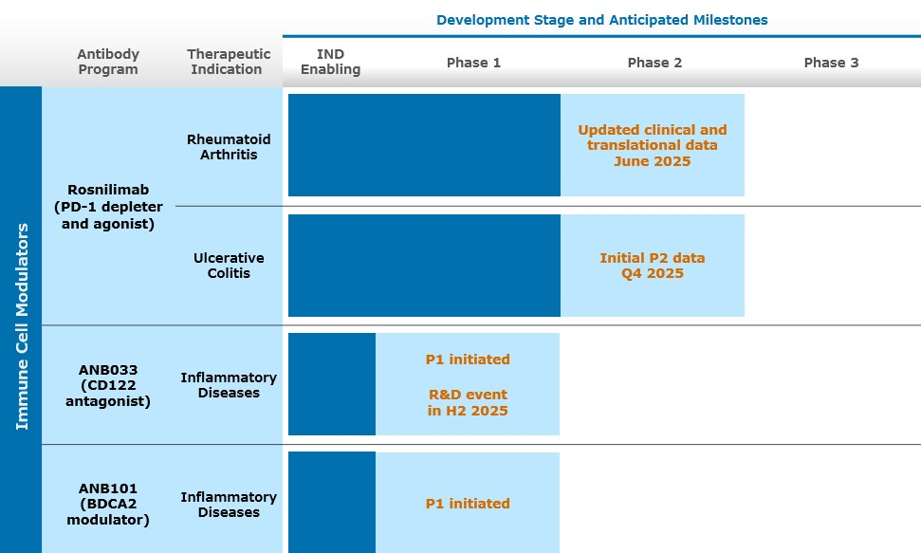
Collaborative Programs
GSK Collaboration
Multiple company-discovered antibody programs have been advanced to preclinical and clinical milestones under our collaborations. Our collaborations include an immuno-oncology-focused collaboration with GSK.
Under the GSK Agreement, a Biologics License Application (“BLA”) for our most advanced partnered program, which is a PD-1 antagonist antibody called Jemperli (dostarlimab), was approved by the FDA in April 2021 for the treatment of advanced or recurrent deficient mismatch repair endometrial cancer (“dMMREC”). In February 2023, the FDA granted full approval for this indication (from an accelerated approval). In addition, in April 2021 the European Medicines Agency (“EMA”) granted conditional marketing authorization in the European Union (“EU”) for Jemperli for use in women with mismatch repair deficient (“dMMR”)/microsatellite instability-high (“MSI-H”) recurrent or advanced endometrial cancer who have progressed on or following prior treatment with a platinum containing regimen. A second FDA approval was received in August 2021 for Jemperli in pan-deficient mismatch repair tumors (PdMMRT). In July 2023, the FDA approved Jemperli in combination with chemotherapy for the treatment of adult patients with dMMR MSI-H primary advanced or recurrent endometrial cancer. In December 2023, the EMA approved, in the EU, Jemperli plus chemotherapy for dMMR/MSI-H primary advanced or recurrent endometrial cancer. In August 2024, the FDA approved Jemperli plus chemotherapy for all adult patients with primary advanced or recurrent endometrial cancer. In January 2025, the EMA approved Jemperli plus chemotherapy for this same indication.
In addition, under the collaboration, GSK is developing dostarlimab in combination with another development program from the GSK Agreement, including cobolimab, a TIM-3 antibody. GSK is conducting a Phase 3 trial, COSTAR Lung, which is a randomized, open label 3-arm trial comparing cobolimab plus dostarlimab plus docetaxel to dostarlimab plus docetaxel to docetaxel alone in patients with advanced non-small-cell lung cancer (“NSCLC”) who have progressed on prior anti-PD-(L)1 therapy and chemotherapy with top-line results expected in the first half of 2025.
26

Vanda Collaboration
On January 31, 2025, we entered into an Exclusive License Agreement (the “Vanda License Agreement”) with Vanda pursuant to which we granted to Vanda an exclusive, global license for the development and commercialization of imsidolimab (IL-36R antagonist mAb), which has completed two registration-enabling global Phase 3 trials, GEMINI-1 and GEMINI-2, evaluating the safety and efficacy of imsidolimab in patients with Generalized Pustular Psoriasis (“GPP”).
Pursuant to the terms of the Vanda License Agreement, we received an upfront payment of $10.0 million and a $5.0 million payment for existing drug supply. We are also eligible to receive up to $35.0 million for future regulatory approval and sales milestones in addition to a 10% royalty on net sales.
For more information about these collaborations, see Note 4 — Collaborative Research and Development Agreements in the accompanying notes to the consolidated financial statements.
Components of Operating Results
Collaboration Revenue
Our revenue has been derived from amortization of upfront license payments, research and development funding, milestone and royalty payments under collaboration and license agreements with our collaborators. From inception through March 31, 2025, we have recognized $374.3 million in revenue from our collaborators. We have not generated any revenue from product sales.
Research and Development Expense
Research and development expenses consist of costs associated with our research and development activities, including drug discovery efforts, preclinical and clinical development of our programs, and manufacturing. Our research and development expenses include:
•External research and development expenses incurred under arrangements with third parties, such as contract research organizations (“CROs”), consultants, members of our scientific and therapeutic advisory boards, and contract manufacturing organizations (“CMOs”);
•Employee-related expenses, including salaries, benefits, travel, and stock-based compensation;
•Facilities, depreciation and other allocated expenses, which include direct and allocated expenses for rent and maintenance of facilities, depreciation of leasehold improvements and equipment, and laboratory supplies; and
•License and sub-license fees.
We may also incur in-process research and development expense as we acquire assets from other parties. Acquired in-process research and development costs that have no alternative future use are immediately expensed.
We expense research and development costs as incurred. We account for nonrefundable advance payments for goods and services that will be used in future research and development activities as expense when the service has been performed or when the goods have been received.
We are conducting research and development activities primarily on inflammation programs. We have a research and development team that conducts antibody discovery, characterization, translational studies, IND-enabling preclinical studies, and clinical development. We conduct some of our early research and preclinical activities internally and plan to rely on third parties, such as CROs and CMOs, for the execution of certain of our research and development activities, such as in vivo toxicology and pharmacology studies, drug product manufacturing, and clinical trials.
We expect our research and development expenses to be higher for the foreseeable future as we continue to advance our product candidates.
General and Administrative Expense
General and administrative expenses consist primarily of salaries and related benefits, including stock-based compensation for our executive, finance, legal, business development, human resource, and support functions. Other general
27

and administrative expenses include allocated facility-related costs not otherwise included in research and development expenses, travel expenses, transaction costs, and professional fees for auditing, tax, and legal services.
Non-Cash Interest Expense for the Sale of Future Royalties
Non-cash interest expense for the sale of future royalties consists of interest related to the liability for the sale of future royalties, as well as the amortization of debt issuance costs. We impute interest on the unamortized portion of the liability for the sale of future royalties using the effective interest method and record interest expense based on timing of the payments over the term of the Jemperli Royalty Monetization Agreement and the Zejula Royalty Monetization Agreement (the “Royalty Monetization” Agreements). Our estimate of the interest rate under the arrangements is based on forecasted royalty and milestone payments expected to be made over the life of the agreements.
Interest Income
Interest income consists primarily of interest earned on our short-term and long-term investments and is recognized when earned.
Critical Accounting Policies and Use of Estimates
Our management’s discussion and analysis of our financial condition and results of operations are based on our financial statements, which have been prepared in accordance with U.S. generally accepted accounting principles (“U.S. GAAP”). The preparation of these financial statements requires us to make judgments and estimates that affect the reported amounts of assets, liabilities, revenues, and expenses and the disclosure of contingent assets and liabilities in our financial statements. We base our estimates on historical experience, known trends and events, and various other factors that are believed to be reasonable under the circumstances. Actual results may differ from these estimates under different assumptions or conditions. On an ongoing basis, we evaluate our judgments and estimates in light of changes in circumstances, facts, and experience. We believe there have been no significant changes in our critical accounting policies as discussed in our Annual Report on Form 10-K filed with the Securities and Exchange Commission (the “SEC”) on February 27, 2025.
Results of Operations – Comparison of the Three Months Ended March 31, 2025 and 2024
Collaboration Revenue
Collaboration revenue consists of milestone payments, royalty payments, upfront license fees and transition services provided under our collaboration agreements. We recognized no milestone revenue during each of the three months ended March 31, 2025 and 2024. We expect that any collaboration revenue we generate will continue to fluctuate from period to period as a result of the timing and amount of milestones from our existing collaborations.
Royalty revenue is a function of our partners’ product sales and the applicable royalty rate. During the three months ended March 31, 2025 and 2024, we recognized $18.1 million and $7.2 million, respectively, of royalty revenue related to the net sales of GSK’s Jemperli and Zejula. All royalty revenue recognized for the three months ended March 31, 2025 and 2024 is non-cash revenue pursuant to the Royalty Monetization Agreements. For more information see Note 5 — Sale of Future Royalties in the accompanying notes to the consolidated financial statements.
During the three months ended March 31, 2025, we recognized $9.6 million in upfront license fees revenue and $0.1 million related to transition services provided under our Vanda License Agreement. No revenue was recognized under this agreement during the three months ended March 31, 2024.
Research and Development Expenses
Research and development expenses were $41.2 million during the three months ended March 31, 2025 compared to $37.0 million during the three months ended March 31, 2024 for an increase of $4.2 million, primarily due to a $2.3 million increase in clinical expenses, $2.4 million increase in salaries and related expenses, including stock-based compensation expense, and $0.1 million increase in other research and development expenses, offset by a decrease of $0.6 million in outside services for manufacturing expenses.
28

We do not track fully burdened research and development costs separately for each of our product candidates. We review our research and development expenses by focusing on external development and internal development costs. External development expenses consist of costs associated with our external preclinical and clinical trials, including pharmaceutical development and manufacturing. Included in preclinical and other unallocated costs are external corporate overhead costs that are not specific to any one program. Internal costs consist of salaries and wages, stock-based compensation and benefits, which are not tracked by product candidate as several of our departments support multiple product candidate research and development programs. The following table summarizes the external costs attributable to each program and internal costs:
Three Months Ended
March 31,
(in thousands) |  |  |  |  |  |  |  |  | 2025 |  |  |  |  |  | 2024 |  |  |  |  |  | Increase/(Decrease)
External Costs
Rosnilimab |  |  |  |  |  |  |  |  | $ | 15,026 |  |  |  |  | $ | 10,038 |  |  |  |  | $ | 4,988
ANB033 |  |  |  |  |  |  |  |  | 3,803 |  |  |  |  |  | 2,663 |  |  |  |  |  | 1,140
ANB032 |  |  |  |  |  |  |  |  | 3,536 |  |  |  |  |  | 4,866 |  |  |  |  |  | (1,330)
ANB101 |  |  |  |  |  |  |  |  | 1,481 |  |  |  |  |  | 400 |  |  |  |  |  | 1,081
Imsidolimab |  |  |  |  |  |  |  |  | (189) |  |  |  |  |  | 4,496 |  |  |  |  |  | (4,685)
Preclinical and other unallocated costs |  |  |  |  |  |  |  |  | 3,932 |  |  |  |  |  | 3,345 |  |  |  |  |  | 587
Total External Costs |  |  |  |  |  |  |  |  | 27,589 |  |  |  |  |  | 25,808 |  |  |  |  |  | 1,781
Internal Costs |  |  |  |  |  |  |  |  | 13,591 |  |  |  |  |  | 11,234 |  |  |  |  |  | 2,357
Total Costs |  |  |  |  |  |  |  |  | $ | 41,180 |  |  |  |  | $ | 37,042 |  |  |  |  | $ | 4,138
General and Administrative Expenses
General and administrative expenses were $14.1 million during the three months ended March 31, 2025 compared to $12.3 million during the three months ended March 31, 2024 for an increase of $1.8 million, primarily due to a $2.5 million increase in transaction costs related to our Vanda License Agreement, a $0.8 million increase in market research cost, a $0.3 million increase in personnel costs, and a $0.1 million increase in other general and administrative expenses, offset by a decrease of $1.9 million in stock-based compensation expense.
We expect that our general and administrative expenses will increase for the foreseeable future as we incur costs associated with being a publicly traded company, including stock compensation expense, legal, auditing and filing fees, additional insurance premiums, investor relations expenses and general compliance and consulting expenses. We also expect our intellectual property related legal expenses, including those related to preparing, filing, prosecuting and maintaining patent applications, to increase as our intellectual property portfolio expands.
Non-Cash Interest Expense for the Sale of Future Royalties
Non-cash interest expense was $18.1 million and $6.3 million during the three months ended March 31, 2025 and 2024, respectively. The increase of $11.8 million in non-cash interest expense is primarily due to the Jemperli Amendment which increased the threshold amounts of aggregate Jemperli royalties and milestones to be received by Sagard.
Interest Income
Interest income was $4.4 million and $4.6 million during the three months ended March 31, 2025 and 2024, respectively, which primarily related to our short-term and long-term investments. The decrease in interest income is primarily due to the timing of sales, maturities and purchases of our investments.
Other Income (Expense), Net
Other income (expense), net was $1.9 million of income and less than $0.1 million of expense for the three months ended March 31, 2025 and 2024, respectively. The increase was primarily related to $1.9 million of other income recognized from existing drug supply transferred to Vanda in accordance with our Vanda License Agreement.
29

Liquidity and Capital Resources
From our inception through March 31, 2025, we have received an aggregate of $1.3 billion to fund our operations, which included $738.4 million from the sale of equity securities, $335.0 million from the sale of future royalties, and $249.2 million from our collaboration agreements. As of March 31, 2025, we had $383.0 million in cash, cash equivalents and investments.
In addition to our existing cash, cash equivalents and investments, we are eligible to earn milestone and other contingent payments for the achievement of defined collaboration objectives and certain nonclinical, clinical, regulatory and sales-based events, and royalty payments under our collaboration agreements, including the GSK Agreement, the GSK Settlement Agreement, and the Vanda License Agreement. Our ability to earn these milestone and contingent payments and the timing of achieving these milestones is primarily dependent upon the outcome of our collaborators’ research and development activities. Our rights to payments under our collaboration agreements are our only committed external source of funds.
In November 2024, we entered into a sales agreement with TD Securities (USA) LLC (“TD Cowen”), through which we may offer and sell shares of our common stock, having an aggregate offering of up to $100.0 million through TD Cowen as our sales agent. As of March 31, 2025, we had sold no shares under this agreement.
In August 2024, we entered into an underwriting agreement with TD Cowen and Leerink Partners LLC as representatives to the several underwriters listed therein (the “Underwriters”), pursuant to which we issued and sold an aggregate of 2,750,498 shares of our common stock to the Underwriters, at an offering price of $36.50 per share. The net proceeds from these sales were approximately $93.9 million, net of underwriting discounts and commissions and offering expenses of $6.5 million, in the aggregate.
Funding Requirements
We may seek to obtain additional financing in the future through equity or debt financings or through collaborations or partnerships with other companies. If we are unable to obtain additional financing on commercially reasonable terms, our business, financial condition and results of operations will be materially adversely affected.
Our primary uses of capital are, and we expect will continue to be, third party clinical and preclinical research and development services, including manufacturing, laboratory and related supplies, compensation and related expenses, legal, patent and other regulatory expenses, and general overhead costs. We have entered into agreements with certain vendors for the provision of services, including services related to commercial manufacturing, that we are unable to terminate for convenience. Under such agreements, we are contractually obligated to make certain minimum payments to the vendors with the amounts to be based on the timing of the termination and the specific terms of the agreement.
Cash, cash equivalents and investments totaled $383.0 million as of March 31, 2025, compared to $420.8 million as of December 31, 2024. We believe that our existing cash, cash equivalents and investments will fund our current operating plan for at least the next twelve months from the issuance of our consolidated financial statements. We have based this estimate on assumptions that may prove to be wrong, and we could use our capital resources sooner than we expect. Additionally, the process of testing product candidates in clinical trials and seeking regulatory approval is costly, and the timing of progress and expenses in these trials is uncertain.
Cash Flows
The following table summarizes our cash flows for the three months ended March 31, 2025 and 2024:
Three Months Ended
March 31,
(in thousands) |  |  | 2025 |  |  |  |  |  | 2024
Net cash (used in) provided by:
Operating activities |  |  | $ | (10,700) |  |  |  |  | $ | (37,253)
Investing activities |  |  | 14,847 |  |  |  |  |  | 68,616
Financing activities |  |  | (28,590) |  |  |  |  |  | (13,633)
Net (decrease) increase in cash and cash equivalents |  |  | $ | (24,443) |  |  |  |  | $ | 17,730
30

Operating Activities
Net cash used in operating activities during the three months ended March 31, 2025 of $10.7 million was primarily due to our net loss of $39.3 million, adjusted for addbacks for non-cash expenses of $26.2 million, which includes stock-based compensation, amortization of operating ROU assets, non-cash interest expense, income from marketable securities and net increases in working capital of $2.4 million.
Net cash used in operating activities during the three months ended March 31, 2024 of $37.3 million was primarily due to our net loss of $43.9 million, adjusted for addbacks for non-cash expenses of $14.0 million, which includes stock-based compensation, amortization of operating ROU assets, non-cash interest expense, income from marketable securities, offset by net decreases in working capital of $7.4 million.
Investing Activities
Net cash provided by investing activities during the three months ended March 31, 2025 and 2024 of $14.8 million and $68.6 million, respectively, primarily relates to the timing of sales, maturities and purchases of our investments.
Financing Activities
Net cash used in financing activities during the three months ended March 31, 2025 of $28.6 million was primarily due to $23.0 million for repayments of the liability to the sale of future royalties, $4.4 million used for the repurchase and retirement of common stock, and $1.5 million for net share settlement of equity awards, partially offset by $0.3 million of cash received for the issuance of common stock.
Net cash used in financing activities during the three months ended March 31, 2024 of $13.6 million was primarily related to $6.9 million for repayments of the liability for the sale of future royalties, $7.5 million for net share settlement of equity awards, partially offset by $0.8 million of cash received for the issuance of common stock.
Contractual Obligations
We have entered into agreements with certain vendors for the provision of goods and services, which includes manufacturing services with contract manufacturing organizations and development services with contract research organizations. These agreements may include certain provisions for purchase obligations and termination obligations that could require payments for the cancellation of committed purchase obligations or for early termination of the agreements. The amount of the cancellation or termination payments vary and are based on the timing of the cancellation or termination and the specific terms of the agreement and therefore are cancellable contracts.
For further information related to our operating lease and future minimum annual obligations, see Note 9 — Commitments and Contingencies in the accompanying notes to the consolidated financial statements.

31

Item 3. Quantitative and Qualitative Disclosures About Market Risk
As of March 31, 2025, there have been no material changes surrounding our market risk, including interest rate risk, inflation risk, and foreign currency exchange risk from the discussion provided in Item 7A. Quantitative and Qualitative Disclosures About Market Risk of our Annual Report on Form 10-K filed with the SEC on February 27, 2025.

Item 4. Controls and Procedures
Evaluation of Disclosure Controls and Procedures
Our disclosure controls and procedures are designed to ensure that information required to be disclosed in the reports we file or submit under the Exchange Act is recorded, processed, summarized, and reported within the time periods specified in the Securities and Exchange Commission’s rules and forms and that such information is accumulated and communicated to our management, including the Chief Executive Officer and the Chief Financial Officer, to allow timely decisions regarding required disclosures. As of March 31, 2025, our management, with the participation of our Chief Executive Officer and Chief Financial Officer, performed an evaluation of the effectiveness of the design and operation of our disclosure controls and procedures as defined in Rules 13a-15(e) and 15d-15(e) of the Exchange Act. Based on this evaluation, our Chief Executive Officer and Chief Financial Officer concluded that the design and operation of our disclosure controls and procedures were effective at a reasonable assurance level.
Any controls and procedures, no matter how well designed and operated, can provide only reasonable assurance of achieving the desired control objective, and our management necessarily applies its judgment in evaluating the cost-benefit relationship of possible controls and procedures.
Changes in Internal Control over Financial Reporting
There were no changes in our internal control over financial reporting identified in connection with the evaluation required by Rules 13a-15(d) and 15d-15(d) of the Exchange Act that occurred during the quarter ended March 31, 2025 that have materially affected, or are reasonably likely to materially affect, our internal control over financial reporting.

32

PART II. OTHER INFORMATION

Item 1. Legal Proceedings
From time to time, we may be involved in legal proceedings arising in the ordinary course of our business. We investigate these claims as they arise and accrue estimates for resolution of legal and other contingencies when losses are probable and estimable. Regardless of outcome, litigation can have an adverse impact on us due to defense and settlement costs, diversion of management resources, negative publicity and reputational harm, and other factors.

Item 1A. Risk Factors
Investing in our common stock involves a high degree of risk. You should carefully consider the risks described below, as well as the other information in this report, including our consolidated financial statements and the related notes and “Management’s Discussion and Analysis of Financial Condition and Results of Operations,” before deciding whether to invest in our common stock. The occurrence of any of the events or developments described below could harm our business, financial condition, results of operations, and growth prospects. In such an event, the market price of our common stock could decline, and you may lose all or part of your investment.
Summary of Risk Factors
An investment in our common stock involves various risks, and prospective investors are urged to carefully consider the matters discussed in the section titled “Risk Factors” prior to making an investment in our common stock. These risks include, but are not limited to, the following:
•Our product candidates in development may fail or suffer delays that adversely affect their commercial viability. Results from our initial clinical trials may not be representative of the results we will experience in later clinical trials. If we or our collaborators are unable to complete development of or commercialize our product candidates or experience significant delays in doing so, our business will be materially harmed.
•Our ongoing and planned clinical trials or those of our collaborators may reveal significant adverse events, toxicities or other side effects and may result in a safety profile that could inhibit regulatory approval or market acceptance of any of our product candidates.
•We and/or our collaborators may be unable to obtain, or may be delayed in obtaining, required regulatory approvals in the United States or in foreign jurisdictions, which would materially impair our ability to commercialize and generate revenue from our product candidates.
•Even if our product candidates receive regulatory approval, they will be subject to significant post-marketing regulatory requirements.
•We may not be successful in our efforts to expand our pipeline of product candidates and develop marketable products.
•We are currently in Phase 2 clinical development of rosnilimab, and have no history of commercializing biotechnology products, which may make it difficult to evaluate the prospects for our future viability.
•We face significant competition, and if our competitors develop and market products that are more effective, safer or less expensive than our product candidates, our commercial opportunities will be negatively impacted.
•Our product candidates may not achieve adequate market acceptance among physicians, patients, health care payors and others in the medical community necessary for commercial success.
•We currently have no marketing and sales force. If we are unable to establish effective sales or marketing capabilities or enter into agreements with third parties to sell or market our product candidates, we may not be able to effectively sell or market our product candidates, if approved, or generate product revenue.
•The manufacture of biologics is complex, and our third party manufacturers may encounter difficulties in production. If any of our third party manufacturers encounter such difficulties, our ability to provide supply of our
33

product candidates for clinical trials, our ability to obtain marketing approval, or our ability to provide supply of our products for patients, if approved, could be delayed or stopped.
•Political, economic or public health events may have a material impact on the U.S. and global economies and could have a material adverse impact on our employees, contractors and patients, which could adversely and materially impact our business, financial condition and results of operations.
•We have limited operating revenue and a history of operational losses and may not achieve or sustain profitability.
•We have no products approved for commercial sale, and to date we have not generated any revenue or profit from sales of our product candidates.
•We will require additional capital to finance our operations, which may not be available to us on acceptable terms, or at all. As a result, we may not complete the development and commercialization of our product candidates or develop new product candidates.
•Our existing collaboration with GSK and other collaborations are important to our business, and other future collaborations may also be important to us. If we are unable to maintain the GSK collaboration, or if this collaboration is not successful, our business could be adversely affected.
•We may not succeed in establishing and maintaining additional development and commercialization collaborations, which could adversely affect our ability to develop and commercialize product candidates.
•If we are unable to obtain or protect intellectual property rights in the U.S. and throughout the world, we may not be able to compete effectively in our market.
•We must attract and retain highly skilled employees in order to succeed.
•The market price of our stock has been and may continue to be volatile, and you could lose all or part of your investment.
Risks Related to Discovery and Development of Our Product Candidates
Our product candidates in development may fail or suffer delays that adversely affect their commercial viability. Results from our initial clinical trials may not be representative of the results we will experience in later clinical trials. If we or our collaborators are unable to complete development of or commercialize our product candidates or experience significant delays in doing so, our business will be materially harmed.
We are developing therapeutic antibodies, including our wholly owned product candidates, as well as other programs that are being developed by our collaborators. However, all of our wholly owned and most of partnered product candidates are in various stages of development, and, for a wide variety of reasons discussed below, may fail in development or suffer delays that adversely affect their commercial viability.
A product candidate can unexpectedly fail at any stage of preclinical and clinical development. The historical failure rate for product candidates is high due to scientific feasibility, safety, efficacy, changing standards of medical care, and other variables. The results from preclinical testing or early clinical trials of a product candidate may not predict the results that will be obtained in later phase clinical trials of the product candidate. For example, in February 2025 we reported interim positive results for rosnilimab’s Phase 2b clinical trial in rheumatoid arthritis. However, the results we have received to date may not be predictive of the full, complete clinical trial results.
Furthermore, we may conduct clinical trials of a product candidate in multiple indications based on assumptions about the product candidate’s mechanism of action. However, it is possible that our assumptions regarding the effectiveness of a product candidate’s mechanism of action may be incorrect and that the product candidate may be ineffective in certain diseases or disorders. If this were the case, then the results from any clinical trials of a product candidate that we conduct are less likely to be positive. For example, even though we showed interim positive data for rosnilimab in our Phase 2b clinical trial in rheumatoid arthritis, data from rosnilimab’s ongoing Phase 2 clinical trial in ulcerative colitis may not be positive.
If our other ongoing or future clinical trials of any of our product candidates, including, rosnilimab, ANB033 or ANB101, are unsuccessful, whether for one of the reasons mentioned above or otherwise, our product candidates may be delayed in development or fail entirely, which would have a material adverse impact on our business.
34

The success of our current product candidates, and any other product candidates we may develop in the future, will depend on many factors, including the following:
•obtaining regulatory permission to initiate clinical trials;
•successful enrollment of patients in, and the completion of, our planned clinical trials;
•receiving marketing approvals from applicable regulatory authorities;
•establishing commercial manufacturing capabilities and/or making arrangements with third party manufacturers;
•obtaining and maintaining patent and trade secret protection and non-patent exclusivity for our product candidates and their components;
•enforcing and defending intellectual property rights and claims;
•achieving desirable therapeutic properties for our product candidates’ intended indications;
•launching commercial sales of our product candidates, if and when approved, whether alone or in collaboration with third parties;
•acceptance of our product candidates, if and when approved, by patients, the medical community and third party payors;
•effectively competing with other therapies; and
•maintaining an acceptable safety profile of our product candidates through clinical trials and following regulatory approval.
If we do not achieve one or more of these factors in a timely manner or at all, we could experience significant delays or an inability to successfully commercialize our product candidates, which would harm our business.
Furthermore, delays or difficulties in patient enrollment or difficulties in retaining trial participants can result in increased costs, longer development times, or termination of a clinical trial. Clinical trials of a new product candidate require the enrollment of a sufficient number of patients, including patients who are suffering from the disease the product candidate is intended to treat and who meet other eligibility criteria. Rates of patient enrollment are affected by many factors, including the size of the patient population, the eligibility criteria for the clinical trial, the age and condition of the patients, the stage and severity of disease, the nature of the protocol, the proximity of patients to clinical sites, and the availability of effective treatments for the relevant disease. We may not be able to initiate our planned clinical trials if we are unable to locate and enroll a sufficient number of eligible patients to participate in these trials as required by the FDA or foreign regulatory authorities.
Our ongoing and planned clinical trials or those of our collaborators may reveal significant adverse events, toxicities or other side effects and may result in a safety profile that could inhibit regulatory approval or market acceptance of any of our product candidates.
In order to obtain marketing approval for any of our product candidates, we must demonstrate the safety and efficacy of the product candidate for the relevant clinical indication or indications through preclinical studies and clinical trials as well as additional supporting data. If our product candidates are associated with undesirable side effects in preclinical studies or clinical trials or have characteristics that are unexpected, we may need to interrupt, delay or abandon their development or limit development to more narrow uses or subpopulations in which the undesirable side effects or other characteristics are less prevalent, less severe or more acceptable from a risk-benefit perspective.
It is not uncommon to observe results in human clinical trials that are unexpected based on preclinical testing, or to observe results in later stage clinical trials that are unexpected based on early clinical trials. Many product candidates fail in clinical trials despite promising preclinical and early clinical results. In addition, top-line results of a clinical trial, which generally reflect preliminary reviews of primary efficacy and/or safety results, do not necessarily predict final results, and any top-line findings or assessments are subject to change pending the completion of final data review procedures. Moreover, preclinical and clinical data are often susceptible to varying interpretations and analyses, and many companies that believed their product candidates performed satisfactorily in preclinical studies and clinical trials have nonetheless failed to obtain marketing approval for their products.
35

Some patients in our clinical trials have experienced adverse events, including SAEs. Subjects in our ongoing and planned clinical trials may in the future suffer significant adverse events or other side effects not observed in our preclinical studies or in our Phase 1, Phase 2 or Phase 3 clinical trials. The observed potency and kinetics of our product candidates in preclinical studies may not be observed in human clinical trials. We have tested the dosing frequency and route of administration of our product candidates in preclinical studies, which will inform our dosing strategy for future clinical trials, however such dose and route of administration may not result in sufficient exposure or pharmacological effect in humans and may lead to unforeseen toxicity not previously observed in preclinical testing. If preclinical studies of our product candidates fail to provide preliminary evidence of safety to the satisfaction of regulatory authorities or do not otherwise produce satisfactory results, we may incur additional costs or experience delays in initiating and/or advancing the development and commercialization of our product candidates. Further, if clinical trials of our product candidates fail to demonstrate safety and efficacy to the satisfaction of regulatory authorities or do not otherwise produce positive results, we or our collaborators may incur additional costs or experience delays in completing, or ultimately be unable to complete, the development and commercialization of our product candidates.
If further significant adverse events or other side effects are observed in any of our current or future clinical trials, we may have difficulty recruiting patients to the clinical trial, patients may drop out of our trial, or we may be required to abandon the trial or our development efforts of that product candidate altogether. We, the FDA, or other applicable regulatory authorities, or an institutional review board or ethics committee, may suspend clinical trials of a product candidate at any time for various reasons, including a belief that subjects in such clinical trials are being exposed to unacceptable health risks or adverse side effects. Some potential therapeutics developed in the biotechnology industry that initially showed therapeutic promise in early-stage studies have later been found to cause side effects that prevented their further development. Even if the side effects do not preclude a product candidate from obtaining or maintaining marketing approval, undesirable side effects may inhibit market acceptance of the approved product due to its tolerability versus other therapies. Any of these developments could materially harm our business, financial condition and prospects.
Further, if any of our product candidates obtain marketing approval, toxicities associated with our product candidates may also develop after such approval and lead to a requirement to conduct additional clinical safety trials, additional warnings being added to the labeling, significant restrictions on the use of the product or the withdrawal of the product from the market. We cannot predict whether our product candidates will cause toxicities in humans that would preclude or lead to the revocation of regulatory approval based on preclinical studies or early-stage clinical testing.
We and/or our collaborators may be unable to obtain, or may be delayed in obtaining, required regulatory approvals in the United States or in foreign jurisdictions, which would materially impair our ability to commercialize and generate revenue from our product candidates.
Our ability to continue to develop our product candidates, and to have the potential to achieve and sustain profitability, depends on the FDA and foreign regulatory authorities permitting us to conduct human clinical trials and, if our product candidates are safe and effective, obtaining approval from the FDA and foreign regulatory authorities to market them and subsequently successfully commercializing them, either alone or with our collaborators. The research, testing, manufacturing, labeling, approval, selling, marketing and distribution of drug and biologic products are subject to extensive regulation by the FDA and foreign regulatory authorities. Before commencing clinical trials in the United States for any product candidate, we must submit an IND to the FDA; foreign regulatory authorities enforce similar requirements for initiation of clinical trials in other countries. An IND or foreign equivalent requires extensive preclinical studies, and there is no guarantee that the FDA or foreign regulatory authorities will allow clinical trials to proceed based on the IND or equivalent submission. For example, although we have initiated toxicology studies for our product candidates, the FDA in the United States, or other foreign regulatory authorities, as applicable, may not allow our clinical trials to proceed in the regulatory authority’s jurisdiction if we are unable to show safety margins acceptable to the particular regulatory authority in appropriate animal species in our preclinical toxicology studies.
Even if we or our collaborators initiate and complete clinical trials for our product candidates, these product candidates will not be permitted to be marketed in the United States until approval of a BLA from the FDA is received, and will not be permitted to be marketed in other countries without marketing approval from foreign regulatory authorities. Obtaining approval of a BLA or other marketing approvals is often a lengthy, expensive and uncertain process over which the FDA and foreign regulatory authorities have substantial discretion. Other than submitting and receiving acceptance for initiation of our previous and current clinical trials in the United States and certain foreign jurisdictions, we have had only limited discussions with the FDA and no discussions with foreign regulatory authorities regarding the development plans for any of our product candidates
36

or the designs of any of our later-stage clinical studies. We thus may not have the full benefit of the FDA’s or foreign regulatory authorities’ current thinking on clinical trial designs or product development for our target indications.
Preclinical studies and clinical trials are expensive, difficult to design and implement, can take many years to complete, and are uncertain as to outcome. Product candidates, on average, take 10 to 15 years to be developed from the time they are discovered to the time they are approved and available for treating patients. The start or end of a clinical trial is often delayed or halted for many reasons, including:
•imposition of a clinical hold for safety reasons or following an inspection of clinical trial operations or site by the FDA or other regulatory authorities;
•manufacturing challenges;
•insufficient supply or quality of product candidates or other materials necessary to conduct clinical trials;
•delays in reaching or failure to reach agreement on acceptable clinical trial contracts or clinical trial protocols with prospective trial sites and CROs or failure by such CROs or trials sites to carry out the clinical trial in accordance with our agreed-upon terms;
•non-clinical or clinical sites becoming unavailable due to political, economic, or public health events;
•clinical sites electing to terminate their participation in one of our clinical trials;
•inability or unwillingness of patients or medical investigators to follow clinical trial protocols;
•required clinical trial administrative actions;
•slower than anticipated patient enrollment;
•changing standards of care;
•safety concerns;
•availability or prevalence of use of a comparative drug or required prior therapy; or
•clinical outcomes or financial constraints.
Our product candidates may not be effective, may be only moderately effective, or may prove to have undesirable or unintended side effects, toxicities or other characteristics that may preclude our obtaining marketing approval or prevent or limit commercial use. Regulatory authorities may refuse to accept any application or may decide that our data are insufficient for approval and require additional preclinical or other studies or clinical trials. In addition, varying interpretations of the data obtained from preclinical and clinical testing could delay, limit or prevent marketing approval of a product candidate. Moreover, regulatory authorities may determine that the clinical and other benefits of a product candidate do not outweigh the safety or other risks. Changes in marketing approval policies during the development period, changes in or the enactment of additional statutes or regulations, or changes in regulatory review for each submitted product application may also cause delays in or prevent the approval of an application.
If we or our collaborators experience any of the issues described above, or other similar or related issues, we or our collaborators may:
•be delayed in obtaining marketing approval for our product candidates;
•not obtain marketing approval at all;
•obtain marketing approval in some countries and not in others;
•obtain approval for indications or patient populations that are not as broad as intended or desired;
•obtain approval with labeling that includes significant use or distribution restrictions or safety warnings, including boxed warnings;
•be subject to additional post-marketing testing requirements; or
•have the product removed from the market after obtaining marketing approval.
37

Further, in June 2024, the U.S. Supreme Court reversed its longstanding approach under the Chevron doctrine, which provided for judicial deference to regulatory agencies, including the FDA. As a result of this decision, we cannot be sure whether there will be increased challenges to existing agency regulations or how lower courts will apply the decision in the context of other regulatory schemes without more specific guidance from the U.S. Supreme Court. For example, this decision may result in more companies bringing lawsuits against the FDA to challenge longstanding decisions and policies of the FDA, which could undermine the FDA’s authority, lead to uncertainties in the industry, and disrupt the FDA’s normal operations, which could impact the timely review of any regulatory filings or applications we submit to the FDA.
Even if our product candidates receive regulatory approval, they will be subject to significant post-marketing regulatory requirements.
Any regulatory approvals that we or our collaborators may receive for our product candidates will require surveillance to monitor the safety and efficacy of the product candidate, may contain significant limitations related to use restrictions for specified age groups, warnings, precautions or contraindications, and may include burdensome post-approval study or risk management requirements. For example, the FDA may require a risk evaluation and mitigation strategy in order to approve our product candidates, which could entail requirements for a medication guide, physician communication plans or additional elements to ensure safe use, such as restricted distribution methods, patient registries and other risk minimization tools. In addition, if the FDA or foreign regulatory authorities approve our product candidates, the manufacturing processes, labeling, packaging, distribution, adverse event reporting, storage, advertising, promotion, import, export and recordkeeping for our product candidates will be subject to extensive and ongoing regulatory requirements. These requirements include submissions of safety and other post-marketing information and reports, registration, as well as continued compliance with cGMPs and good clinical practices for any clinical trials that we conduct post-approval. In addition, manufacturers of drug products and their facilities are subject to continual review and periodic inspections by the FDA and other regulatory authorities for compliance with cGMP regulations and standards. If we, our collaborators or a regulatory agency discover previously unknown problems with a product, such as adverse events of unanticipated severity or frequency, or problems with the facilities where the product is manufactured, a regulatory agency may impose restrictions on that product, the manufacturing facility or us or our collaborators, including requiring recall or withdrawal of the product from the market or suspension of manufacturing. In addition, failure to comply with FDA and foreign regulatory requirements may, either before or after product approval, if any, subject our company or our collaborators to administrative or judicially imposed sanctions, including:
•restrictions on our ability to conduct clinical trials, including full or partial clinical holds on ongoing or planned trials;
•restrictions on the products, manufacturers or manufacturing process;
•warning or untitled letters;
•civil and criminal penalties;
•injunctions;
•suspension or withdrawal of regulatory approvals;
•product seizures, detentions or import bans;
•voluntary or mandatory product recalls and publicity requirements;
•total or partial suspension of production;
•imposition of restrictions on operations, including costly new manufacturing requirements; and
•refusal to approve pending BLAs or supplements to approved BLAs.
The occurrence of any event or penalty described above may inhibit our ability, alone or with our collaborators, to commercialize our product candidates and generate revenue.
Advertising and promotion of any product candidate that obtains approval in the United States will be heavily scrutinized by the FDA, the DOJ, the HHS Office of Inspector General, state attorneys general, members of Congress and the public. Violations, including promotion of our products for unapproved (or off-label) uses, are subject to enforcement letters, inquiries and investigations, and civil and criminal sanctions by the government. Additionally, comparable foreign regulatory
38

authorities will heavily scrutinize advertising and promotion of any product candidate that obtains approval outside of the United States.
In the United States, engaging in the impermissible promotion of our products for off-label uses can also subject us to false claims litigation under federal and state statutes, which can lead to civil and criminal penalties and fines and agreements that materially restrict the manner in which a company promotes or distributes drug products. These false claims statutes include the federal False Claims Act, which allows any individual to bring a lawsuit against a biotechnology company on behalf of the federal government alleging submission of false or fraudulent claims, or causing to present such false or fraudulent claims, for payment by a federal program such as Medicare or Medicaid. If the government prevails in the lawsuit, the individual will share in any fines or settlement funds. Such False Claims Act lawsuits against biotechnology companies have increased significantly in volume and breadth, leading to several substantial civil and criminal settlements regarding certain sales practices promoting off-label drug uses involving fines in excess of $1.0 billion. This growth in litigation has increased the risk that a biotechnology company will have to defend a false claim action, pay settlement fines or restitution, agree to comply with burdensome reporting and compliance obligations, and be excluded from Medicare, Medicaid and other federal and state health care programs. In addition, we may incur liability from claims initiated under the Lanham Act or other federal and state unfair competition laws with respect to how our products are marketed and promoted. Furthermore, the off-label use of our products may increase the risk of product liability claims. If we do not lawfully promote our approved products, we may become subject to such litigation and, if we do not successfully defend against such actions, those actions may have an adverse effect on our business, financial condition and results of operations.
We may not be successful in our efforts to expand our pipeline of product candidates and develop marketable products.
Because we have limited financial and managerial resources, we focus on research programs and product candidates that we identify for specific indications. Our business depends on our successful development and commercialization of the limited number of internal product candidates we have in preclinical and early-stage clinical development. Even if we are successful in continuing to build our pipeline, development of the potential product candidates that we identify will require substantial investment in additional clinical development, management of clinical, preclinical and manufacturing activities, regulatory approval in multiple jurisdictions, building a commercial organization, and significant marketing efforts before we generate any revenue from product sales. Furthermore, such product candidates may not be suitable for clinical development, including as a result of their harmful side effects, limited efficacy or other characteristics that indicate that they are unlikely to be products that will receive marketing approval and achieve market acceptance. If we cannot successfully develop, partner and/or commercialize product candidates, we may not be able to obtain product or partnership revenue in future periods, which would adversely affect our business, prospects, financial condition and results of operations.
As a result of our current focus on our lead product candidates, we may forego or delay pursuit of opportunities with other product candidates or for other indications that later prove to have greater commercial potential. Our resource allocation decisions may cause us to fail to capitalize on viable commercial products or profitable market opportunities. Our spending on current and future research and development programs and product candidates for specific indications may not yield any commercially viable products. Our understanding and evaluation of biological targets for the discovery and development of new product candidates may fail to identify challenges encountered in subsequent preclinical and clinical development. If we do not accurately evaluate the commercial potential or target market for a particular product candidate, we may relinquish valuable rights to that product candidate through collaboration, licensing or other royalty arrangements in cases in which it would have been more advantageous for us to retain sole development and commercialization rights.
We are currently in Phase 2 clinical development of rosnilimab, and have no history of commercializing biotechnology products, which may make it difficult to evaluate the prospects for our future viability.
Our operations to date have been largely limited to financing and staffing our company, developing our technology, and developing our wholly owned product candidates and other product candidates in partnerships with our collaborators. As a company, we have only very limited experience conducting pivotal Phase 3 clinical trials and have not had previous experience commercializing product candidates, including submitting a BLA to the FDA. In part because of this lack of experience, we cannot be certain that planned clinical trials will begin or be completed on time, if at all, that our planned development programs would be acceptable to the FDA or other regulatory authorities, or that, if approval is obtained, such product candidates can be successfully commercialized. Clinical trials and commercializing our wholly owned product candidates will require significant additional financial and management resources, and reliance on third party clinical investigators, CROs,
39

consultants or collaborators. Relying on third party clinical investigators, third party manufacturing, CROs or collaborators may result in delays that are outside of our control.
Furthermore, we may not have the financial resources to continue development of, or to enter into collaborations for, a product candidate if we experience any problems or other unforeseen events that delay or prevent regulatory approval of, or our ability to commercialize, product candidates, including:
•negative or inconclusive results from our clinical trials or the clinical trials of others for product candidates similar to ours, leading to a decision or requirement to conduct additional preclinical testing or clinical trials or abandon a program;
•a suspension or termination of a clinical trial once commenced;
•conditions imposed by the FDA or foreign regulatory authorities regarding the number, scope or design of our clinical trials;
•delays in enrolling research subjects in clinical trials;
•high drop-out rates of research subjects;
•inadequate supply or quality of clinical trial materials or other supplies necessary for the conduct of our clinical trials;
•greater than anticipated clinical trial costs;
•poor effectiveness of our product candidates during clinical trials;
•unfavorable FDA or other regulatory agency inspection and review of a clinical trial site;
•failure of our third party contractors or investigators to comply with regulatory requirements or otherwise meet their contractual obligations in a timely manner, or at all;
•serious and unexpected, or otherwise unacceptable, drug-related side effects experienced by participants in our planned clinical trials or by individuals using drugs similar to our product candidates;
•delays and changes in regulatory requirements, policy and guidelines, including the imposition of additional regulatory oversight around clinical testing generally or with respect to our technology in particular; or
•varying interpretations of data by the FDA and foreign regulatory authorities.
Consequently, any predictions you make about our future success or viability based on our operating history may not be as accurate as they could be if we had an established track record in conducting clinical trials or commercializing products.
Further, as a clinical stage business, we may encounter unforeseen expenses, difficulties, complications, delays, and other known and unknown factors. We will need to transition from a company with a research focus to a company capable of supporting commercial activities. We may not be successful in such a transition.
We face significant competition, and if our competitors develop and market products that are more effective, safer or less expensive than our product candidates, our commercial opportunities will be negatively impacted.
The biotechnology industry is highly competitive and subject to rapid and significant technological change. Products we may develop in the future are also likely to face competition from other drugs and therapies, some of which we may not currently be aware of. We have competitors both in the United States and internationally, including major multinational pharmaceutical and biotechnology companies, established biotechnology companies, specialty biotechnology companies, emerging and start-up companies, universities and other research institutions. Many of our competitors have significantly greater financial, manufacturing, marketing, drug development, technical and human resources and commercial expertise than we do. Large pharmaceutical and biotechnology companies, in particular, have extensive experience in clinical testing, obtaining regulatory approvals, recruiting patients and manufacturing biotechnology products. These companies also have significantly greater research and marketing capabilities than we do and may also have products that have been approved or are in late stages of development and collaborative arrangements in our target markets with leading companies and research institutions. Established pharmaceutical and biotechnology companies may also invest heavily to accelerate discovery and development of novel compounds or to in-license novel compounds that could make the product candidates that we develop
40

obsolete. As a result of all of these factors, our competitors may succeed in obtaining patent protection and/or approval from the FDA or foreign regulatory authorities or discovering, developing and commercializing products in our field before we do.
For our PD-1 agonist antibody program, our competitors include other PD-1 agonist antibodies GS-0151 (Gilead) in Phase 1b development for the treatment of rheumatoid arthritis, a PD-1 agonist antibody (Boehringer Ingelheim) in Phase 1 development, and a PD-1 agonist antibody (Seismic) in Phase 1 development. Our commercial-stage competitors in moderate-to-severe rheumatoid arthritis include monoclonal antibodies targeting anti-TNF (Humira; Abbvie), IL-6 (Actemra; Roche and Kevzara; Regeneron), CD-80/86 (Orencia; BMS), CD-20 (Rituxan; Roche), and janus kinase inhibitors (Rinvoq; AbbVie, Olumiant; Eli Lilly, and Xeljanz; Pfizer). Commercial-stage competitors in moderate-to-severe ulcerative colitis include monoclonal antibodies targeting anti-TNF (Humira; Abbvie and Remicade; Johnson & Johnson), anti-α4β7 (Entyvio; Takeda), anti-IL-23 (Stelara; Johnson & Johnson, Omvoh; Eli Lilly, Tremfya; Johnson & Johnson, and Skyrizi; AbbVie) and S1P inhibitors (Zeposia; Bristol Myers Squibb and Velsipity; Pfizer) and janus kinase inhibitors (Rinvoq; AbbVie, and Xeljanz; Pfizer) as well as monoclonal antibodies targeting anti-TL1A (PRA023; Merck, RVT-3101; Roche and duvakitug; Teva/Sanofi) in Phase 2 and 3 development.
For our anti-CD122 antagonist antibody program, our clinical competitors include other anti-CD122 antagonist antibodies, auremolimab (Incyte), in Phase 1 development for the treatment of vitiligo, and FB-102 (Forte Bioscience) in Phase 1b development for the treatment of celiac disease and vitiligo, and two anti-IL-15 monoclonal antibodies, CALY-002 (Novartis), in Phase 1b development for the treatment of celiac disease and eosinophilic esophagitis, and TEV-‘408 (Teva), in Phase 2 development for the treatment of celiac disease and vitiligo.
For our anti-BDCA2 program, our competitors include another anti-BDCA2 antibody, litifilimab (Biogen) in Phase 3 development for SLE and CLE, and an anti-ILT7 antibody, daxdilimab (Amgen) in Phase 2 development for dermatomyositis or anti-synthetase inflammatory myositis, and discoid lupus erythematosus.
Our commercial opportunity could be reduced or eliminated if our competitors develop and commercialize products that are safer, more effective, have fewer or less severe effects, are more convenient, are less expensive or capture significant market share prior to or during our commercialization. Our competitors also may obtain FDA or other regulatory approval for their products more rapidly than we may obtain approval for ours, which could result in our competitors establishing a strong market position before we are able to enter the market. In addition, our ability to compete may be affected in many cases by insurers or other third party payors seeking to encourage the use of biosimilar products. Even if our product candidates achieve marketing approval, they may be priced at a significant premium over competitive biosimilar products if any have been approved by then.
Smaller and other early-stage companies may also prove to be significant competitors, particularly through collaborative arrangements with large and established companies. These companies compete with us in recruiting and retaining qualified scientific and management personnel, establishing clinical trial sites and patient registration for planned clinical trials and acquiring technologies complementary to, or necessary for, our programs. In addition, the biotechnology industry is characterized by rapid technological change. If we fail to stay at the forefront of technological change, we may be unable to compete effectively. Technological advances or products developed by our competitors may render our technologies or product candidates obsolete, less competitive or not economical.
Our product candidates may not achieve adequate market acceptance among physicians, patients, health care payors and others in the medical community necessary for commercial success.
Even if our product candidates receive regulatory approval, they may not gain adequate market acceptance among physicians, patients, health care payors and others in the medical community. The degree of market acceptance of any of our approved product candidates will depend on a number of factors, including:
•the efficacy and safety profile as demonstrated in planned clinical trials;
•the timing of market introduction of the product candidate as well as competitive products;
•the clinical indications for which the product candidate is approved;
•restrictions on the use of our products, if approved, such as boxed warnings or contraindications in labeling or a REMS, if any, which may not be required of alternative treatments and competitor products;
•acceptance of the product candidate as a safe and effective treatment by physicians, clinics and patients;
41

•the potential and perceived advantages of product candidates over alternative treatments, including any similar generic treatments;
•the cost of treatment in relation to alternative treatments;
•the availability of coverage and adequate reimbursement and pricing by third parties and government authorities;
•relative convenience and ease of administration;
•the frequency and severity of adverse events;
•the effectiveness of sales and marketing efforts; and
•unfavorable publicity relating to the product candidate.
If any product candidate is approved but does not achieve an adequate level of acceptance by physicians, hospitals, health care payors and patients, we may not generate or derive sufficient revenue from that product candidate and may not become or remain profitable.
We currently have no marketing and sales force. If we are unable to establish effective sales or marketing capabilities or enter into agreements with third parties to sell or market our product candidates, we may not be able to effectively sell or market our product candidates, if approved, or generate product revenue.
We currently do not have a marketing or sales team for the marketing, sales and distribution of any of our product candidates that are able to obtain regulatory approval. In order to commercialize any product candidates, we must build on a territory-by-territory basis marketing, sales, distribution, managerial and other non-technical capabilities or make arrangements with third parties to perform these services, and we may not be successful in doing so. If our product candidates receive regulatory approval, we may decide to establish an internal sales or marketing team with technical expertise and supporting distribution capabilities to commercialize our product candidates, which will be expensive and time-consuming and will require significant attention of our executive team to manage. Any failure or delay in the development of our internal sales, marketing and distribution capabilities would adversely impact the commercialization of any of our product candidates that we obtain approval to market. With respect to the commercialization of all or certain of our product candidates, we may choose to collaborate, either globally or on a territory-by-territory basis, with third parties that have direct sales forces and established distribution systems, either to augment our own sales force and distribution systems or in lieu of our own sales force and distribution systems. If we are unable to enter into such arrangements when needed on acceptable terms, or at all, we may not be able to successfully commercialize any of our product candidates that receive regulatory approval, or any such commercialization may experience delays or limitations. If we are not successful in commercializing our product candidates, either on our own or through collaborations with one or more third parties, our future product revenue will suffer and we may incur significant additional losses.
The manufacture of biologics is complex, and our third party manufacturers may encounter difficulties in production. If any of our third party manufacturers encounter such difficulties, our ability to provide supply of our product candidates for clinical trials, our ability to obtain marketing approval, or our ability to provide supply of our products for patients, if approved, could be delayed or stopped.
The process of manufacturing biologics is complex, highly regulated and subject to multiple risks, and requires significant expertise and capital investment, including the development of advanced manufacturing techniques and process controls. Manufacturing biologics is highly susceptible to product loss due to contamination, equipment failure, improper installation or operation of equipment, vendor or operator error, inconsistency in yields, variability in product characteristics and difficulties in scaling the production process. Even minor deviations from normal manufacturing processes could result in reduced production yields, product defects and other supply or supply chain disruptions. If microbial, viral or other contaminations are discovered at the facilities of our manufacturer, such facilities may need to be closed for an extended period of time to investigate and remedy the contamination, which could delay clinical trials and adversely harm our business. We rely, and expect to continue to rely, on third parties, including manufacturers based in China, for the manufacture of our product candidates and future product candidates. We and our contract manufacturers must comply with cGMPs for the manufacturing of biologics used in clinical trials and, if approved, marketed products. Moreover, if the FDA determines that our manufacturer is not in compliance with FDA laws and regulations, including cGMPs, the FDA may deny BLA approval until the deficiencies are corrected or we replace the manufacturer in our BLA with a manufacturer that is in compliance.
42

Furthermore, all of our therapeutic antibodies are manufactured by starting with cells which are stored in a cell bank. We have one master cell bank for each antibody manufactured in accordance with cGMP and create working cell banks to support cGMP manufacturing, and believe we would have adequate backup should any cell bank be lost in a catastrophic event. However, it is possible that we could lose multiple cell banks and have our manufacturing severely impacted by the need to replace the cell banks.
Scaling up a biologic manufacturing process is a difficult and uncertain task, and we may not be successful in transferring our production system or the manufacturer may not have the necessary capabilities to complete the implementation and development process. If we are unable to adequately validate or scale-up the manufacturing process with our current manufacturers, we will need to transfer to other manufacturers and complete the manufacturing validation process, which can be lengthy and costly. Even if we are able to adequately validate and scale-up the manufacturing process for our product candidates with contract manufacturers, we will still need to negotiate with such contract manufacturers agreements for commercial supply, and it is not certain we will be able to come to agreement on terms acceptable to us. Accordingly, failures or difficulties faced at any level of our manufacturing process could adversely affect our business and delay or impede the development and commercialization of our product candidates or products and could have an adverse effect on our business, prospects, financial condition and results of operations.
In addition, there are risks associated with large scale manufacturing for clinical trials or commercial scale including, among others, cost overruns, potential problems with process scale-up, process reproducibility, stability issues, compliance with good manufacturing practices, lot consistency and timely availability of raw materials. Even if we or our collaborators obtain regulatory approval for any of our product candidates, there is no assurance that manufacturers will be able to manufacture the approved product to specifications acceptable to the FDA or other regulatory authorities, to produce it in sufficient quantities to meet the requirements for the potential launch of the product or to meet potential future demand. Moreover, we source certain of the raw materials needed for our product candidates from outside the United States. Although we have not experienced any material supply interruptions to date, it is possible that political, economic or public health events could cause such interruptions in the future. Further, legislation has been introduced in Congress to limit certain U.S. biotechnology companies from using equipment or services produced or provided by select Chinese biotechnology companies, and others in Congress have advocated for the use of existing executive branch authorities to limit those Chinese service providers’ ability to engage in business in the United States. We cannot predict what actions may ultimately be taken with respect to trade relations between the United States and China or other countries, what products and services may be subject to such actions or what actions may be taken by the other countries in retaliation. Any unfavorable government policies on international trade, such as export controls, capital controls or tariffs, new legislation or regulations, renegotiation of existing trade agreements, or any retaliatory trade actions due to recent or future trade tension, may impede, delay, limit, or increase the cost of manufacturing our product candidates. Such events could result in our clinical or commercial supply of drug, packaging and other services being interrupted or limited, which could harm our business. If our manufacturers are unable to produce sufficient quantities for clinical trials or for commercialization, commercialization efforts would be impaired, which would have an adverse effect on our business, financial condition, results of operations and growth prospects. Any delay or interruption in the supply of clinical trial supplies could delay the completion of planned clinical trials, increase the costs associated with maintaining clinical trial programs and, depending upon the period of delay, require us to commence new clinical trials at additional expense or terminate clinical trials completely. Any adverse developments affecting clinical or commercial manufacturing of our product candidates or products may result in shipment delays, inventory shortages, lot failures, product withdrawals or recalls, or other interruptions in the supply of our product candidates or products.
Some of our suppliers may experience disruption to their respective supply chain due to the effects of macroeconomic conditions, which could delay, prevent or impair our development or commercialization efforts.
We obtain certain drug intermediates of our drug candidate supply from countries affected by macroeconomic events and conditions, including inflation, interest rate fluctuations, uncertainty with respect to the federal budget and debt ceiling and potential government shutdowns related thereto, increasing financial market volatility and uncertainty, the impact of war or military conflict, including regional conflicts around the world, and public health pandemics. Supply chain disruptions and delays as a result of any new tariff policies or trade restrictions could also negatively impact our cost of materials, production processes, and ability to conduct clinical trials. If we are unable to obtain certain drug intermediates of our drug candidate supply in sufficient quantity and in a timely manner due to disruptions in the global supply chain caused by macroeconomic events and conditions, the development, testing and clinical trials of that drug candidate may be delayed or infeasible, and
43

regulatory approval or commercial launch of any resulting product may be delayed or not obtained, which could significantly harm our business.
The macroeconomic and geopolitical environment may have a material impact on the U.S. and global economies and could materially impact our business, financial condition and results of operations.
The macroeconomic and geopolitical environment, including inflation, increased volatility in interest rates, tariffs and the debt and equity markets, instability in the global banking system, global health crises and pandemics and geopolitical conflict have had, and may continue to have, an adverse impact on global economic conditions, which could have an adverse effect on our business and financial condition, including impairing our ability to raise additional capital on favorable terms. The extent to which any such factors impact our business and operations will depend on future developments that are highly uncertain and cannot be predicted, including new information that may emerge concerning the severity of the event and the actions to contain its impact.
We are subject to risks associated with foreign trade policy, including recent tariffs imposed or proposed by the United States on its trading partners, as well as retaliatory actions that have or may be imposed by other countries in response. The recent U.S. tariff actions against trading partners and specific sectors of the global economy may have an adverse effect on our business and financial condition. At this time, the impact of the recently imposed and proposed tariff actions with respect to our operations remains uncertain given ongoing bilateral negotiations between the United States and trading partners, changes in U.S. policy, and the commencement of a Section 232 investigation by the U.S. Department of Commerce, which may result in the imposition of an additional tariff rate on U.S. imports of pharmaceuticals and pharmaceutical ingredients. Our products involve pharmaceutical ingredients that are partially sourced from outside of the United States, including China, the cost of which may increase due to additional tariff rates. Higher material costs may negatively impact our gross margins and operating results and our ability to be competitive in the global market.
Changes in government trade policies, including changes to tariffs and other non-tariff barriers, may have a material impact on our results of operations.
Risks Related to Our Financial Position and Capital Needs
We have limited operating revenue and a history of operational losses and may not achieve or sustain profitability. We have no products approved for commercial sale, and to date we have not generated any revenue or profit from sales of our product candidates.
We are a clinical-stage biotechnology company with a limited operating history. We have no approved products. To date, our revenue has been primarily derived from our GSK research collaboration and license agreement and royalty monetization agreements based on our GSK collaboration, and we are significantly dependent on such collaborators for the successful development of product candidates in these collaborations. Our ability to generate revenue and become profitable depends upon our ability, alone or with our collaborators, to successfully complete the development of our product candidates for our target indications and to obtain necessary regulatory approvals.
Since our inception, we have incurred significant operating losses in every year except fiscal year 2014. For the three months ended March 31, 2025, we had $27.8 million in collaboration revenue and a net loss of $39.3 million. For the three months ended March 31, 2024, we had $7.2 million in collaboration revenue and a net loss of $43.9 million. As of March 31, 2025, we had an accumulated deficit of $798.7 million.
We have financed our operations primarily through our initial public offering of common stock in January 2017, our follow-on public offerings of common stock in October 2017, September 2018, and August 2024, and royalty monetization transactions such as our Jemperli Royalty Monetization Agreement and Jemperli Amendment. We have devoted substantially all of our efforts to research and development. Rosnilimab is in Phase 2 clinical development, and we expect that it will be several years, if ever, before any of our active product candidates are ready for commercialization. We expect to continue to incur significant expenses and increasing operating losses for the foreseeable future, and the net losses we incur may fluctuate significantly from quarter to quarter. Our revenue has been historically derived from amortization of upfront payments, research and development funding, and milestone and royalty payments under collaboration and license agreements with our collaborators. Our ability to generate future product revenue from our current or future product candidates depends on a number of additional factors, including our ability (or as applicable our collaborators’ ability) to:
•continue research and preclinical development of our product candidates;
44

•identify additional product candidates;
•maintain existing and enter into new collaboration agreements;
•conduct additional preclinical studies and initiate clinical trials for our product candidates;
•obtain approvals for the product candidates that we develop or are developed under our collaboration arrangements;
•establish a sales, marketing and distribution infrastructure to commercialize any product candidates for which we may obtain marketing approval;
•maintain, expand and protect our intellectual property portfolio;
•hire additional executive, clinical, quality control and scientific personnel;
•add operational, financial and management information systems and personnel, including personnel to support our product development and commercialization efforts;
•establish and maintain supply and manufacturing relationships with third parties and ensure adequate and legally compliant manufacturing of our product candidates;
•obtain coverage and adequate product reimbursement from third party payors, including government payors;
•acquire or in-license other product candidates and technologies; and
•achieve market acceptance for our or our collaborators’ products, if any.
We are unable to predict the timing or amount of increased expenses, or when, or if, we will be able to achieve or maintain profitability because of the numerous risks and uncertainties associated with product development. In addition, our expenses could increase significantly beyond expectations if we are required by the FDA or other regulatory authorities to perform studies or clinical trials in addition to those that we currently anticipate. Even if any of our product candidates are approved for commercial sale, we anticipate incurring significant costs associated with the commercial launch of any product candidate.
We are currently only in the clinical development stages for our most advanced product candidates. In order to become and remain profitable we must, alone or with our collaborators, develop and eventually commercialize a product or products with significant market potential. This may require us to be successful in a range of challenging activities, including completing clinical trials of our product candidates, successfully developing companion diagnostics, obtaining marketing approval for these product candidates and manufacturing, marketing and selling those products for which we may obtain marketing approval. We may never succeed in these activities and, even if we do, may never generate revenues that are significant or large enough to achieve profitability. If we do achieve profitability, we may not be able to sustain or increase profitability on a quarterly or annual basis. Our failure to become and remain profitable would decrease the value of our company and could impair our ability to raise capital, maintain or expand our research and development efforts, expand our business or continue our operations. A decline in the value of our company would also cause you to lose part or even all of your investment.
We will require additional capital to finance our operations, which may not be available to us on acceptable terms, or at all. As a result, we may not complete the development and commercialization of our product candidates or develop new product candidates.
As a research and development company, our operations have consumed substantial amounts of cash since our inception. We expect our research and development expenses to increase in connection with our ongoing activities, which expenses may substantially increase if we conduct Phase 3 clinical trials or seek marketing approval for our product candidates without any partnerships. In addition, if we obtain marketing approval for any of our product candidates, we expect to incur significant commercialization expenses related to product sales, marketing, manufacturing and distribution. Furthermore, we incur additional costs associated with operating as a public company. We believe that our existing cash, cash equivalents and investments will fund our current operating plan for at least the next 12 months. However, circumstances may cause us to consume capital more rapidly than we currently anticipate. For example, as we continue to move our product candidates into and through clinical trials, we may have adverse results requiring us to find new product candidates. Any of these events may increase our development costs more than we expect. We may need to raise additional funds or otherwise obtain funding through collaboration agreements to continue development of our product candidates.
45

In addition, we cannot guarantee that future financing will be available in sufficient amounts or on terms acceptable to us, if at all. If we do not raise additional capital when required or on acceptable terms, we may need to:
•significantly delay, scale back or discontinue the development or commercialization of our product candidates or cease operations altogether;
•seek strategic alliances for research and development programs at an earlier stage than we would otherwise desire or on terms less favorable than might otherwise be available;
•relinquish, or license on unfavorable terms, our rights to technologies or future product candidates that we otherwise would seek to develop or commercialize ourselves; or
•eliminate staff to conserve resources.
If we need to conduct additional fundraising activities and we do not raise additional capital in sufficient amounts or on terms acceptable to us, we may be prevented from pursuing development and commercialization efforts, which will have a material adverse effect on our business, operating results and prospects. Adverse macro-economic conditions, including volatility in equity capital markets, fluctuating interest rates, tariffs, actual or perceived instability in the U.S. and global banking systems, and fluctuations in foreign exchange rates, could prevent us from raising additional capital in sufficient amounts or on terms acceptable to us or at all. Our forecast of the period of time through which our financial resources will adequately support our operations is a forward-looking statement and involves risks and uncertainties, and actual results could vary as a result of a number of factors, including the factors discussed elsewhere in this “Risk Factors” section. We have based this estimate on assumptions that may prove to be wrong, and we could use our available capital resources sooner than we currently expect. Our future funding requirements, both short and long-term, will depend on many factors, including:
•the initiation, progress, timing, costs and results of preclinical studies and clinical trials for our product candidates and future product candidates we may develop;
•the number and size of clinical trials needed to show safety, efficacy and an acceptable risk/benefit profile for any of our product candidates;
•the outcome, timing and cost of seeking and obtaining regulatory approvals from the FDA and foreign regulatory authorities, including the potential for such authorities to require that we perform more studies or trials than those that we currently expect;
•the commercial success or failure of products sold by our collaborators, such as Jemperli by GSK, and the timing thereof;
•our ability to maintain existing and enter into new collaboration agreements;
•the cost to establish, maintain, expand and defend the scope of our intellectual property portfolio, including the amount and timing of any payments we may be required to make, or that we may receive, in connection with licensing, preparing, filing, prosecuting, defending and enforcing of any patents or other intellectual property rights;
•the effect of competing technological and market developments;
•market acceptance of any approved product candidates;
•the costs of acquiring, licensing or investing in additional businesses, products, product candidates and technologies;
•the cost of recruiting and retaining key employees;
•the costs and fees associated with any delays or cancellations of forecasted manufacturing batches;
•the cost and timing of selecting, auditing and potentially validating manufacturing sites for commercial-scale manufacturing; and
•the cost of establishing sales, marketing and distribution capabilities for our product candidates for which we may receive regulatory approval and that we determine to commercialize ourselves or in collaboration with our collaborators.
If we cannot expand our operations or otherwise capitalize on our business opportunities due to a lack of capital, our business, financial condition and results of operations could be adversely affected.
46

Raising additional capital may cause dilution to our existing stockholders, restrict our operations or require us to relinquish rights to our product candidates on unfavorable terms to us.
We may seek additional capital through a variety of means, including through public or private equity, debt financings or other sources, including up-front payments and milestone payments from strategic collaborations, license agreements and royalty agreements. To the extent that we raise additional capital through the sale of equity or convertible debt securities, your ownership interest will be diluted, and the terms may include liquidation or other preferences that adversely affect your rights as a stockholder. Such financing may result in dilution to stockholders, imposition of debt covenants, increased fixed payment obligations, or other restrictions that may affect our business. If we raise additional funds through up-front payments or milestone payments pursuant to strategic collaborations with third parties, we may have to relinquish valuable rights to our product candidates or grant licenses on terms that are not favorable to us. In addition, we may seek additional capital due to favorable market conditions or strategic considerations even if we believe we have sufficient funds for our current or future operating plans.
Risks Related to Our Dependence on Third Parties
Our existing collaboration with GSK and other collaborations are important to our business, and other future collaborations may also be important to us. If we are unable to maintain the GSK collaboration, or if this collaboration is not successful, our business could be adversely affected.
We have entered into a collaboration with GSK to develop certain of our product candidates. GSK has advanced multiple antibodies generated through our collaboration into clinical trials. If our collaboration with GSK were terminated, we may not receive all or any of the funding potentially coming from such collaboration, which could adversely affect our business or financial condition. For example, in October 2023, we agreed with GSK to terminate the LAG-3 antagonist antibody development program under our existing collaboration. As a result, we will not receive any additional milestones or any royalties from GSK for that development program.
We are unable to predict the success of our collaborations. Our collaborators have discretion in determining and directing the efforts and resources, including the ability to discontinue all efforts and resources, they apply to the development and, if approval is obtained, commercialization and marketing of the product candidates covered by such collaborations. As a result, our collaborators may elect to de-prioritize our programs, change their strategic focus or pursue alternative technologies in a manner that results in reduced, delayed or no revenue to us. Our collaborators may have other marketed products and product candidates under collaboration with other companies, including some of our competitors, and their corporate objectives may not be consistent with our best interests. Our collaborators may also be unsuccessful in developing or commercializing our products. If our collaborations are unsuccessful, our business, financial condition, results of operations and prospects could be adversely affected. In addition, any dispute or litigation proceedings we may have with our collaborators in the future could delay development programs, create uncertainty as to ownership of intellectual property rights, distract management from other business activities and generate substantial expense. For example, in October 2020, we settled a matter with GSK related to an alleged breach of our collaboration agreement in connection with GSK’s use of certain antibodies originally developed by us for the development of a drug not covered by the agreement. There can be no assurance that we will not encounter such issues under our collaborations with GSK or other parties in the future.
We may not succeed in establishing and maintaining additional development and commercialization collaborations, which could adversely affect our ability to develop and commercialize product candidates.
In addition to our current licensing arrangements, a part of our strategy is to enter into additional strategic product development and commercialization collaborations in the future, including collaborations to broaden and accelerate clinical development and potential commercialization of our product candidates. We may face significant competition in seeking appropriate development partners, and the negotiation process is time-consuming and complex. Moreover, we may not succeed in our efforts to establish collaborations or other alternative arrangements for any of our other existing or future product candidates and programs because our research and development pipeline may be insufficient, our product candidates and programs may be deemed to be at too early a stage of development for collaborative effort, and/or third parties may not view our product candidates and programs as having the requisite potential to demonstrate safety and efficacy or to be commercially viable. Even if we are successful in our efforts to establish new collaborations, the terms that we agree upon may not be favorable to us, and we may not be able to maintain such collaborations if, for example, development or approval of a product candidate is delayed or sales of an approved product candidate are disappointing. Any delay in entering into new collaboration
47

agreements related to our product candidates could delay the development and commercialization of our product candidates and reduce their competitiveness if they reach the market.
Moreover, if we fail to establish and maintain additional collaborations related to our product candidates:
•the development of certain of our current or future product candidates may be terminated or delayed;
•our cash expenditures related to development of certain of our current or future product candidates would increase significantly and we may need to seek additional financing;
•we may be required to hire additional employees or otherwise develop expertise, such as sales and marketing expertise, for which we have not budgeted; and
•we will bear all of the risk related to the development and commercialization of any such product candidates.
If third parties on which we depend to conduct our planned preclinical studies and clinical trials do not perform as contractually required, fail to satisfy regulatory or legal requirements or miss expected deadlines, our development programs could be delayed with adverse effects on our business, financial condition, results of operations and prospects.
We rely on third party clinical investigators, CROs, CMOs and consultants to design, conduct, supervise and monitor key activities relating to, discovery, manufacturing, non-clinical studies and clinical trials of our product candidates, and we intend to do the same for future activities relating to existing and future programs. Because we rely on third parties and do not have the ability to conduct all required discovery, manufacturing, preclinical studies or clinical trials independently, we have less control over the timing, quality and other aspects of discovery, manufacturing, preclinical studies and clinical trials than we would if we conducted them on our own. These investigators, CROs, CMOs and consultants are not our employees, and we have limited control over the amount of time and resources that they dedicate to our programs. These third parties may have contractual relationships with other entities, some of which may be our competitors, which may draw time and resources from our programs. The third parties we contract with might not be diligent, careful or timely in conducting our discovery, manufacturing, preclinical studies or clinical trials, resulting in discovery, manufacturing, preclinical studies or clinical trials being delayed or unsuccessful, in whole or in part.
If we cannot contract with acceptable third parties on commercially reasonable terms, or at all, or if these third parties do not carry out their contractual duties, satisfy legal and regulatory requirements for the conduct of preclinical studies or clinical trials or meet expected deadlines, our clinical development programs could be delayed and otherwise adversely affected. In all events, we are responsible for ensuring that each of our preclinical studies and clinical trials is conducted in accordance with the general investigational plan and protocols for the trial. Our reliance on third parties that we do not control does not relieve us of these responsibilities and requirements. Any such event could have an adverse effect on our business, financial condition, results of operations and prospects.
We rely completely on third parties to manufacture our nonclinical, clinical and future commercial drug supplies of any approved products.
We outsource the manufacture of our product candidates. We do not currently have the infrastructure or internal capability to manufacture supplies of our product candidates for use in development and commercialization. If we were to experience an unexpected loss of supply of our product candidates for any reason, whether as a result of manufacturing, supply or storage issues or otherwise, our business would be harmed, and we could experience delays, disruptions, suspensions or terminations of, or be required to restart or repeat, any pending or ongoing clinical trials. Although we generally do not begin a clinical trial unless we believe we have a sufficient supply of a product candidate to complete the clinical trial, we may be required to manufacture additional supplies of our product candidates to the extent our estimates of the amounts required prove inaccurate, we suffer unexpected losses of product candidate supplies, or we are required to have fresh product candidate supplies manufactured to satisfy regulatory requirements or specifications. Any significant delay or discontinuation in the supply of a product candidate, or the raw material components thereof, due to the need to replace a contract manufacturer or other third party manufacturer or otherwise, could considerably harm our business and ability to generate revenue and delay completion of our clinical trials, product testing and potential regulatory approval of our product candidates.
Any delays in our preclinical or clinical development could lead to delays or cancellations of forecasted manufacturing batches, which would typically result in significant fees owed by us to the manufacture and an uncertainty as to when the
48

manufacturer will have the availability for a new time slot to manufacture the batch, which could lead to further delays in the development of the product candidate and have an adverse effect on our business.
Reliance on third party manufacturers entails additional risks, including the possible breach of the manufacturing agreement by the manufacturer and the possible termination or nonrenewal of the agreement by the manufacturer at a time that is costly or inconvenient for us. If our contract manufacturers were to breach or terminate their manufacturing arrangements with us, the development or commercialization of the affected product candidates could be significantly delayed, which could have an adverse effect on our business. Any change in our manufacturers could be costly because the commercial terms of any new arrangement could be less favorable and because the expenses relating to the transfer of necessary technology and processes could be significant.
We depend on a small number of suppliers for the raw materials necessary to produce our product candidates. The loss of these suppliers, or their failure to supply us with these raw materials, would materially and adversely affect our business.
We depend on the availability of key raw materials for our product candidates from a small number of third party suppliers. Because there are a limited number of suppliers for the raw materials that we use to manufacture our product candidates, we may need to engage alternate suppliers to prevent a possible disruption of the manufacture of the materials necessary to produce our product candidates for our clinical trials. We do not have any control over the availability of raw materials. If we or our manufacturers are unable to purchase these raw materials on acceptable terms, at sufficient quality levels, or in adequate quantities, if at all, the development of our product candidates would be delayed or there would be a shortage in supply, which would impair our ability to meet our development objectives for our product candidates or generate revenues from the sale of any approved products. If either we or any third parties in the supply chain for materials used in the production of our product candidates are disrupted, including by political, economic or public health events, it could limit our ability to manufacture our product candidates for our preclinical or clinical studies.
Risks Related to Regulatory Approval of Our Product Candidates and Other Legal Compliance Matters
The failure to obtain regulatory approval in international jurisdictions would prevent us or our collaborators from marketing our product candidates outside the United States.
In order to market and sell our products in other jurisdictions, we or our collaborators must obtain separate marketing approvals and comply with numerous and varying regulatory requirements. The approval procedure varies among countries and can involve additional testing. The time required to obtain approval may differ substantially from that required to obtain FDA approval. The regulatory approval process outside the United States generally includes all of the risks associated with obtaining FDA approval. In addition, in many countries outside the United States, we or our collaborators must secure product reimbursement approvals before regulatory authorities will approve the product for sale in that country. Obtaining foreign regulatory approvals and compliance with foreign regulatory requirements could result in significant delays, difficulties and costs for us and could delay or prevent the introduction of our products in certain countries.
If we or our collaborators fail to comply with the regulatory requirements in international markets and receive applicable marketing approvals, our target market will be reduced and our ability to realize the full market potential of our product candidates will be harmed, and our business will be adversely affected. We may not obtain foreign regulatory approvals on a timely basis, if at all. The failure to obtain approval of any of our product candidates by regulatory authorities in another country may significantly diminish the commercial prospects of that product candidate and our business prospects could decline.
Any drugs we develop may become subject to unfavorable third party reimbursement practices and pricing regulations.
The availability and extent of coverage and adequate reimbursement by governmental and private payors is essential for most patients to be able to afford expensive treatments. Sales of any of our product candidates that receive marketing approval will depend substantially, both in the United States and internationally, on the extent to which the costs of our product candidates will be paid by health maintenance, managed care, pharmacy benefit and similar health care management organizations or reimbursed by government health administration authorities, private health coverage insurers and other third party payors. If reimbursement is not available, or is available only to limited levels, we or our collaborators may not be able to successfully commercialize our product candidates. Even if coverage is provided, the approved reimbursement amount may not
49

be high enough to allow us to establish or maintain pricing sufficient to realize a sufficient return on our investment. Coverage and reimbursement may impact the demand for, or the price of, any product candidate for which marketing approval is obtained. If coverage and reimbursement are not available or reimbursement is available only at limited levels, we or our collaborators may not successfully commercialize any product candidate for which marketing approval is obtained.
There is significant uncertainty related to the insurance coverage and reimbursement of newly approved products. In the United States, the principal decisions about reimbursement for new products are typically made by the Centers for Medicare & Medicaid Services (“CMS”), an agency within the U.S. Department of Health and Human Services, because CMS decides whether and to what extent a new product will be covered and reimbursed under Medicare. Private payors often follow CMS’s decisions regarding coverage and reimbursement to a substantial degree. However, one payor’s determination to provide coverage for a drug product does not assure that other payors will also provide coverage for the drug product. As a result, the coverage determination process is often a time-consuming and costly process that will require us or our collaborators to provide scientific and clinical support for the use of our products to each payor separately, with no assurance that coverage and adequate reimbursement will be applied consistently or obtained in the first instance.
Increasingly, third party payors are requiring that drug companies provide them with predetermined discounts from list prices and are challenging the prices charged for medical products. Further, such payors are increasingly examining the medical necessity and reviewing the cost effectiveness of medical drug products. There may be especially significant delays in obtaining coverage and reimbursement for newly approved drugs. Third party payors may limit coverage to specific drug products on an approved list, known as a formulary, which might not include all FDA-approved drugs for a particular indication. We or our collaborators may need to conduct expensive pharmaco-economic studies to demonstrate the medical necessity and cost effectiveness of our products. Nonetheless, our product candidates may not be considered medically necessary or cost effective. We cannot be sure that coverage and reimbursement will be available for any product that we or our collaborators commercialize and, if reimbursement is available, what the level of reimbursement and the timing of achieving a reimbursement determination will be.
Outside the United States, international operations are generally subject to extensive governmental price controls and other market regulations, and we believe the increasing emphasis on cost containment initiatives in Europe, Canada and other countries has and will continue to put pressure on the pricing and usage of therapeutics, including our product candidates. In many countries, particularly the countries of the EU, the prices of medical products are subject to varying price control mechanisms as part of national health systems. In these countries, pricing negotiations with governmental authorities can take considerable time after the receipt of marketing approval for a product. To obtain reimbursement or pricing approval in some countries, we or our collaborators may be required to conduct a clinical trial that compares the cost effectiveness of our product candidate to other available therapies. In general, the prices of products under such systems are substantially lower than in the United States. Other countries allow companies to fix their own prices for products but monitor and control company profits. Additional foreign price controls or other changes in pricing regulation could restrict the amount that we are able to charge for our product candidates. Accordingly, in markets outside the United States, the reimbursement for our product candidates may be reduced compared with the United States and may be insufficient to generate commercially reasonable revenue and profits.
Moreover, increasing efforts by governmental and third party payors, in the United States and internationally, to cap or reduce health care costs may cause such organizations to limit both coverage and level of reimbursement for new products approved, and, as a result, they may not cover or provide adequate payment for our product candidates. We expect to experience pricing pressures in connection with the sale of any of our product candidates due to the trend toward managed health care, the increasing influence of health maintenance organizations and additional legislative changes. The downward pressure on health care costs in general, particularly prescription drugs and surgical procedures and other treatments, has become very intense. As a result, increasingly high barriers are being erected to the entry of new products into the health care market.
In addition to CMS and private payors, professional organizations such as the American Medical Association can influence decisions about reimbursement for new products by determining standards for care. In addition, many private payors contract with commercial vendors who sell software that provide guidelines that attempt to limit utilization of, and therefore reimbursement for, certain products deemed to provide limited benefit to existing alternatives. Such organizations may set guidelines that limit reimbursement or utilization of our product candidates.
If we or our collaborators are unable to establish or sustain coverage and adequate reimbursement for any future product candidates from third party payors, the adoption of those product candidates and sales revenue will be adversely affected, which, in turn, could adversely affect the ability to market or sell those product candidates, if approved. Coverage policies and
50

third party reimbursement rates may change at any time. Even if favorable coverage and reimbursement status is attained for one or more products for which we or our collaborators receive regulatory approval, less favorable coverage policies and reimbursement rates may be implemented in the future.
Healthcare legislative reform measures may increase the difficulty and cost for us or our collaborators to obtain marketing approval of and commercialize our product candidates and affect the pricing of our product candidates.
In the United States and some foreign jurisdictions, there have been a number of legislative and regulatory changes and proposed changes regarding the healthcare system that could, among other things, prevent or delay marketing approval of our product candidates, restrict or regulate post-approval activities and affect our or our collaborators’ ability to profitably sell any product candidates for which marketing approval is obtained. The commercial potential for our product candidates, if any, could be affected by changes in healthcare spending and policy in the United States and abroad. New laws, regulations, or judicial decisions or new interpretations of existing laws, regulations, or decisions, related to healthcare availability, the method of delivery, or payment for healthcare products and services could adversely affect our business, operations, and financial condition, if and when we or our collaborators are able to obtain marketing approval and commercialize our product candidates.
For example, the ACA was enacted in 2010, which substantially changed the way healthcare is financed by both governmental and private insurers, and significantly impacts the U.S. pharmaceutical industry. While there have been legislative and judicial efforts to modify, repeal or otherwise invalidate all or certain aspects of the ACA or its implementing regulations, the ACA remains in effect in its current form. It is unclear how any such efforts in the future will impact the ACA or our business.
In addition, other legislative changes have been proposed and adopted in the United States federal and state levels to reduce healthcare expenditures. For example, several healthcare reform initiatives culminated in the enactment of the IRA, in August 2022, which allows, among other things, the HHS to negotiate the selling price of certain drugs and biologics that CMS reimburses under Medicare Part B and Part D, although this only applies to high-expenditure single-source drugs that have been approved for at least 7 years (11 years for biologics). The negotiated prices, which will first become effective in 2026, will be capped at a statutory ceiling price. For 2026, the first year in which negotiated prices become effective, CMS selected 10 high-cost Medicare Part D products in 2023, negotiations began in 2024, and the negotiated maximum fair price for each product has been announced. These negotiations resulted in significant price reductions for the products from their 2023 list prices, ranging from 38 to 79 percent, with an average price reduction of 59.4 percent. CMS has selected 15 additional Medicare Part D drugs for negotiated maximum fair pricing in 2027. For 2028, an additional 15 drugs, which may be covered under either Medicare Part B or Part D, will be selected, and for 2029 and subsequent years, 20 Part B or Part D drugs will be selected. The negotiated prices have represented, and will continue to represent, a significant discount from average prices to wholesalers and direct purchasers. The IRA also imposes rebates on Medicare Part B and Part D drugs whose prices have increased at a rate greater than the rate of inflation. In addition, the law eliminated the “donut hole” under Medicare Part D beginning in 2025 by significantly lowering the beneficiary maximum out-of-pocket cost and requiring manufacturers to subsidize, through a newly established manufacturer discount program, 10% of Part D enrollees’ prescription costs for brand drugs below the out-of-pocket maximum, and 20% once the out-of-pocket maximum has been reached. The IRA permits the Secretary of HHS to implement many of these provisions through guidance, as opposed to regulation, for the initial years. Manufacturers that fail to comply with the IRA may be subject to various penalties, including civil monetary penalties. The IRA also extends enhanced subsidies for individuals purchasing health insurance coverage in ACA marketplaces through plan year 2025. These provisions are taking effect progressively starting in 2023, although they are subject to legal challenges. For example, the provisions related to the negotiation of selling prices of high-expenditure single-source drugs and biologics have been challenged in multiple lawsuits. Thus, it is unclear how the IRA will be implemented but it will likely have a significant impact on the pharmaceutical industry and the pricing of our products and product candidates. The adoption of restrictive price controls in new jurisdictions, more restrictive controls in existing jurisdictions or the failure to obtain or maintain timely or adequate pricing could also adversely impact revenue. We expect pricing pressures will continue globally.
It is likely that federal and state legislatures within the United States and foreign governments will continue to consider changes to existing healthcare legislation. For example, the ACA has faced ongoing legal challenges, including litigation seeking to invalidate some of or all of the law or the manner in which it has been implemented. More recently, the 2017 Tax Cuts and Jobs Act was signed into law, which eliminated certain requirements of the ACA, including the individual mandate. We cannot predict the reform initiatives that may be adopted in the future or whether initiatives that have been adopted will be repealed or modified.
We expect that the ACA, the IRA and other state or federal healthcare reform measures that may be adopted in the future, may result in more rigorous coverage criteria and in additional downward pressure on the price that we receive for any
51

approved product. The implementation of cost containment measures or other healthcare reforms may prevent us from being able to generate revenue, attain profitability, or commercialize our products.
Our business entails a significant risk of product liability, and our ability to obtain sufficient insurance coverage could have an adverse effect on our business, financial condition, results of operations or prospects.
Our business exposes us to significant product liability risks inherent in the development, testing, manufacturing and marketing of therapeutic treatments. Product liability claims could delay or prevent completion of our development programs. If we or our collaborators succeed in marketing any of our product candidates, such claims could result in an FDA investigation of the safety and effectiveness of our product candidates, our manufacturing processes and facilities or our marketing programs and potentially a recall of our products or more serious enforcement action, limitations on the approved indications for which they may be used or suspension or withdrawal of approvals. Regardless of the merits or eventual outcome, liability claims may also result in decreased demand for our products, injury to our reputation, costs to defend the related litigation, a diversion of management’s time and our resources, substantial monetary awards to trial participants or patients and a decline in our stock price. We currently have product liability insurance that we believe is appropriate for our stage of development and may need to obtain higher levels prior to marketing any of our product candidates. Any insurance we have or may obtain may not provide sufficient coverage against potential liabilities. Furthermore, clinical trial and product liability insurance is becoming increasingly expensive. As a result, we may be unable to obtain sufficient insurance at a reasonable cost to protect us against losses caused by product liability claims that could have an adverse effect on our business.
Our relationships with customers and third party payors will be subject to applicable anti-kickback, fraud and abuse, transparency and other health care laws and regulations, which could expose us to, among other things, criminal sanctions, civil penalties, contractual damages, reputational harm, administrative burdens and diminished profits and future earnings.
Health care providers and third party payors play a primary role in the recommendation and prescription of any product candidates for which we or our collaborators obtain marketing approval. Our future arrangements with third party payors and customers may expose us to broadly applicable fraud and abuse and other health care laws and regulations that may constrain the business or financial arrangements and relationships through which we or our collaborators market, sell and distribute our product candidates for which marketing approval is obtained. Restrictions under applicable federal and state health care laws and regulations include the following:
•the federal Anti-Kickback Statute prohibits, among other things, persons and entities from knowingly and willfully soliciting, offering, receiving or providing remuneration, directly or indirectly, in cash or in kind, to induce or reward, or in return for, either the referral of an individual for, or the purchase, order or recommendation of, any good or service, for which payment may be made under a federal health care program such as Medicare and Medicaid;
•the federal false claims and civil monetary penalties laws, including the civil False Claims Act, impose criminal and civil penalties, including civil whistleblower or qui tam actions, against individuals or entities for, among other things, knowingly presenting, or causing to be presented, to the federal government, claims for payment that are false or fraudulent or making a false statement to avoid, decrease or conceal an obligation to pay money to the federal government;
•HIPAA imposes criminal and civil liability for, among other things, executing or attempting to execute a scheme to defraud any health care benefit program or making false statements relating to health care matters;
•HIPAA, as amended by the Health Information Technology for Economic and Clinical Health Act and its implementing regulations, also imposes obligations, including mandatory contractual terms, with respect to safeguarding the privacy, security and transmission of individually identifiable health information;
•the federal Physician Payments Sunshine Act requires applicable manufacturers of covered drugs, devices, biologics, and medical supplies for which payment is available under Medicare, Medicaid, or the Children’s Health Insurance Program, with specific exceptions, to report to CMS annually information regarding payments and other transfers of value to physicians and teaching hospitals as well as information regarding ownership and investment interests held by physicians and their immediate family members. The information was initially made publicly available on a searchable website in September 2014 and is disclosed on an annual basis; and
52

•analogous state and foreign laws and regulations, such as state anti-kickback and false claims laws, may apply to sales or marketing arrangements and claims involving health care items or services reimbursed by non-governmental third party payors, including private insurers.
The ACA, among other things, amended the intent standard of the federal Anti-Kickback Statute and criminal health care fraud statutes to a stricter standard such that a person or entity no longer needs to have actual knowledge of this statute or specific intent to violate it. In addition, the ACA codified case law that a claim including items or services resulting from a violation of the federal Anti-Kickback Statute constitutes a false or fraudulent claim for purposes of the federal False Claims Act.
Some state laws require biotechnology companies to comply with the biotechnology industry’s voluntary compliance guidelines and the relevant compliance guidance promulgated by the federal government and may require drug manufacturers to report information related to payments and other transfers of value to physicians and other health care providers or marketing expenditures. For example, several states now require prescription drug companies to report certain expenses relating to the marketing and promotion of drug products and to report gifts and payments to individual health care practitioners in these states. Other states prohibit various marketing-related activities, such as the provision of certain kinds of gifts or meals. Still other states require the posting of information relating to clinical studies and their outcomes. Some states require the reporting of certain pricing information, including information pertaining to and justifying price increases. Some states further require pharmaceutical companies to implement compliance programs and/or marketing codes. Compliance with these laws is difficult and time consuming, and companies that do not comply with these state laws face civil penalties.
Our failure to comply with privacy and data security laws, regulations and standards may cause our business to be materially adversely affected.
We process a quantity of sensitive, confidential and/or regulated information, including confidential business and patient health information in connection with our clinical trials, and are subject to U.S. and international laws and regulations governing the privacy and security of such information. Each of these laws is subject to varying interpretations and constantly evolving. In the United States, there are numerous federal and state privacy and data security laws and regulations governing the collection, use, disclosure, processing and protection of personal information, including federal and state health information privacy laws, federal and state security breach notification laws, and federal and state consumer protection laws. In the EU and United Kingdom (“UK”), their respective General Data Protection Regulations (collectively, “GDPR”), which apply extraterritorially, impose several strict requirements for controllers and processors of personal information. These include higher standards for obtaining consent from individuals to process their personal information, increased requirements pertaining to the processing of special categories of personal information (such as health information) and pseudonymized (i.e., key-coded) data, and heightened transfer requirements of personal information from the European Economic Area/UK/Switzerland to countries not deemed to have adequate data protections laws (including the United States). Companies that must comply with the GDPR face increased compliance obligations and risk, including more robust regulatory enforcement of data protection requirements and potential fines for noncompliance of up to €20 million (approximately $22.6 million) or 4 percent of the annual global revenues of the noncompliant company, whichever is greater.
In the United States, in addition to HIPAA, various federal (for example, the Federal Trade Commission) and state regulators have adopted, or are considering adopting, laws and regulations concerning personal information and data security. Certain state laws may be more stringent or broader in scope, or offer greater individual rights, with respect to personal information than federal, international, or other state laws, and such laws may differ from each other, all of which may impact our compliance efforts. For example, California enacted the California Consumer Privacy Act (as amended, the “CCPA”). Failure to comply with the CCPA may result in significant civil penalties, injunctive relief, or statutory or actual damages as determined by the California Privacy Protection Agency or the California Attorney General. Following California’s lead, over a third of U.S. states have adopted comprehensive privacy and security laws and regulations, which govern the privacy, processing and protection of personal information, including certain specific requirements and laws with respect to health-related information. For example, Washington state has passed the My Health My Data Act, which is focused on the collection of consumer health data, has a broader scope than HIPAA and includes a private right of action. In addition, various comprehensive federal privacy bills have been proposed in Congress.
We cannot provide assurance that (i) current or future legislation will not prevent us from generating or maintaining personal information, or (ii) patients will consent to the use of their personal information (as necessary). Either of these circumstances may prevent us from undertaking or continuing essential research and development, manufacturing, and
53

commercialization, which could have a material adverse effect on our business, results of operations, financial condition, and prospects.
Federal, state, and foreign government requirements include obligations to notify regulators and/or individuals of security breaches or other similar reportable incidents experienced by us, or our vendors, contractors, or organizations with whom we had specific contractual obligations to protect our data. Further, the improper access to, use of, or disclosure of our data or a third party’s personal information could subject us to individual or consumer class action litigation and governmental investigations and proceedings by federal, state, and local regulatory entities in the U.S. and by international regulatory entities. Compliance with these and any other applicable privacy and data security laws and regulations is a rigorous and time-intensive process, and we may be required to put in place additional mechanisms ensuring compliance with existing and new data protection rules and possible government oversight.
In addition to government regulation, privacy advocates and industry groups have and may in the future propose self-regulatory standards from time to time. These and other industry standards may legally or contractually apply to us, or we may elect to comply with such standards. It is possible that if our practices are not consistent or viewed as not consistent with legal and regulatory requirements, including changes in laws, regulations and standards or new interpretations or applications of existing laws, regulations and standards, we may become subject to audits, inquiries, whistleblower complaints, adverse media coverage, investigations, loss of export privileges, or severe criminal or civil sanctions, all of which may have a material adverse effect on our business, operating results, reputation, and financial condition. All of these evolving compliance and operational requirements impose significant costs, such as costs related to organizational changes, implementing additional protection technologies, training employees and engaging consultants, which are likely to increase over time. In addition, such requirements may require us to modify our data processing practices and policies, distract management or divert resources from other initiatives and projects, all of which could have a material adverse effect on our business, financial condition, results of operations and prospects. Any failure or perceived failure by us to comply with any applicable federal, state, or similar foreign laws and regulations relating to data privacy and security could result in damage to our reputation, as well as proceedings or litigation by governmental agencies or other third parties, including class action privacy litigation in certain jurisdictions, which would subject us to significant fines, sanctions, awards, injunctions, penalties, or judgments. Any of the foregoing could have a material adverse effect on our business, results of operations, financial condition, and prospects.
Our employees may engage in misconduct or other improper activities, including noncompliance with regulatory standards and requirements and insider trading.
We are exposed to the risk of employee fraud or other misconduct. Misconduct by employees could include failures to comply with FDA regulations, to provide accurate information to the FDA, to comply with federal and state health care fraud and abuse laws and regulations, to report financial information or data accurately or to disclose unauthorized activities to us. In particular, sales, marketing and business arrangements in the health care industry are subject to extensive laws and regulations intended to prevent fraud, misconduct, kickbacks, self-dealing and other abusive practices. These laws and regulations may restrict or prohibit a wide range of pricing, discounting, marketing and promotion, sales commission, customer incentive programs and other business arrangements. Employee misconduct could also involve the improper use of information obtained in the course of clinical trials, which could result in regulatory sanctions and serious harm to our reputation. We have adopted a code of conduct, but it is not always possible to identify and deter employee misconduct. The precautions we take to detect and prevent this activity may not be effective in controlling unknown or unmanaged risks or losses or in protecting us from governmental investigations or other actions or lawsuits stemming from a failure to comply with these laws or regulations. If any such actions are instituted against us, and we are not successful in defending ourselves or asserting our rights, those actions could have a significant impact on our business, including the imposition of significant fines or other sanctions.
Risks Related to Intellectual Property
If we are unable to obtain or protect intellectual property rights, we may not be able to compete effectively in our market.
Our success depends in significant part on our and our licensors’, licensees’ or collaborators’ ability to establish, maintain and protect patents and other intellectual property rights and operate without infringing the intellectual property rights of others. We have filed numerous patent applications both in the United States and in foreign jurisdictions to obtain patent rights to inventions we have discovered. We have also licensed from third parties rights to patent portfolios. Some of these licenses give us the right to prepare, file and prosecute patent applications and maintain and enforce patents we have licensed,
54

and other licenses may not give us such rights. The patent prosecution process is expensive and time-consuming, and we and our current or future licensors, licensees or collaborators may not be able to prepare, file and prosecute all necessary or desirable patent applications at a reasonable cost or in a timely manner. It is also possible that we or our licensors, licensees or collaborators will fail to identify patentable aspects of inventions made in the course of development and commercialization activities before it is too late to obtain patent protection on them. Moreover, in some circumstances, we may not have the right to control the preparation, filing and prosecution of patent applications, or to maintain the patents, covering technology that we license from or license to third parties and are reliant on our licensors, licensees or collaborators. Therefore, these patents and applications may not be prosecuted and enforced in a manner consistent with the best interests of our business. If our current or future licensors, licensees or collaborators fail to establish, maintain or protect such patents and other intellectual property rights, such rights may be reduced or eliminated. If our licensors, licensees or collaborators are not fully cooperative or disagree with us as to the prosecution, maintenance or enforcement of any patent rights, such patent rights could be compromised.
The patent position of biotechnology companies generally is highly uncertain, involves complex legal and factual questions and has in recent years been the subject of much litigation. As a result, the issuance, scope, validity, enforceability and commercial value of our and our current or future licensors’, licensees’ or collaborators’ patent rights are highly uncertain. Our and our licensors’, licensees’ or collaborators’ pending and future patent applications may not result in patents being issued which protect our technology or products, in whole or in part, or which effectively prevent others from commercializing competitive technologies and products. The patent examination process may require us or our licensors, licensees or collaborators to narrow the scope of the claims of our or our licensors’, licensees’ or collaborators’ pending and future patent applications, which may limit the scope of patent protection that may be obtained. In the past, we have not always been able to obtain the full scope of patent protection we have initially sought in our patent applications, and as described above and as is typical for most biotechnology patent prosecution, we have been required to narrow or eliminate patent claims as part of the patent prosecution process. In addition, some patent applications that we or our licensors have filed have not resulted in issued patents because we or our licensors have abandoned those patent applications as changes in business and/or legal strategies dictated.
We cannot assure you that all of the potentially relevant prior art relating to our patents and patent applications has been found. If such prior art exists, it can invalidate a patent or prevent a patent from issuing from a pending patent application. Even if patents do successfully issue and even if such patents cover our product candidates, third parties may initiate opposition, interference, re-examination, post-grant review, inter partes review, nullification or derivation action in court or before patent offices or similar proceedings challenging the validity, enforceability or scope of such patents, which may result in the patent claims being narrowed or invalidated. Our and our licensors’, licensees’ or collaborators’ patent applications cannot be enforced against third parties practicing the technology claimed in such applications unless and until a patent issues from such applications, and then only to the extent the issued claims cover the technology.
Because patent applications in the United States and most other countries are confidential for a period of time after filing, and some remain so until issued, we cannot be certain that we or our licensors, licensees, or collaborators were the first to file any patent application related to a product candidate. Furthermore, if third parties have filed such patent applications on or before March 15, 2013, an interference proceeding in the United States can be initiated by such third parties to determine who was the first to invent any of the subject matter covered by the patent claims of our applications. If third parties have filed such applications after March 15, 2013, a derivation proceeding in the United States can be initiated by such third parties to determine whether our invention was derived from theirs. Even where we have a valid and enforceable patent, we may not be able to exclude others from practicing our invention where the other party can show that they used the invention in commerce before our filing date or the other party benefits from a compulsory license. In addition, patents have a limited lifespan. In the United States, if all maintenance fees are timely paid, the natural expiration of a patent is generally 20 years from its earliest U.S. filing date. Various extensions may be available, but the life of a patent, and the protection it affords, is limited. Even if patents covering our product candidates are obtained, once the patent life has expired for a product, we may be open to competition from competitive medications, including biosimilar or generic medications.
Furthermore, given the amount of time required for the development, testing and regulatory review of new product candidates, patents protecting such candidates might expire before or shortly after such candidates are commercialized. As a result, our owned and licensed patent portfolio may not provide us with sufficient rights to exclude others from commercializing products similar or identical to ours. We expect to seek extensions of patent terms where these are available in any countries where we are prosecuting patents. This includes in the United States under the Drug Price Competition and Patent Term Restoration Act of 1984, which permits a patent term extension of up to five years beyond the expiration of the patent. However the applicable authorities, including the FDA and the U.S. Patent and Trademark Office (“USPTO”) in the United
55

States, and any equivalent foreign regulatory authority, may not agree with our assessment of whether such extensions are available and may refuse to grant extensions to our patents or may grant more limited extensions than we request. If this occurs, our competitors may take advantage of our investment in development and clinical trials by referencing our clinical and preclinical data and launch their product earlier than might otherwise be the case.
We may not be able to protect our intellectual property rights throughout the world.
Filing, prosecuting, enforcing and defending patents on product candidates in all countries throughout the world would be prohibitively expensive, and our or our licensors’, licensees’ or collaborators’ intellectual property rights may not exist in some countries outside the United States or may be less extensive in some countries than in the United States. In addition, the laws of some foreign countries do not protect intellectual property rights to the same extent as federal and state laws in the United States. Consequently, we and our licensors, licensees or collaborators may not be able to prevent third parties from practicing our and our licensors’, licensees’ or collaborators’ inventions in all countries outside the United States or from selling or importing products made using our and our licensors’, licensees’ or collaborators’ inventions in and into the United States or other jurisdictions. Competitors may use our and our licensors’, licensees’ or collaborators’ technologies in jurisdictions where we have not obtained patent protection to develop their own products and, further, may export otherwise infringing products to territories where we and our licensors, licensees or collaborators have patent protection but enforcement is not as strong as that in the United States. These products may compete with our product candidates, and our and our licensors’, licensees’ or collaborators’ patents or other intellectual property rights may not be effective or sufficient to prevent them from competing.
Many companies have encountered significant problems in protecting and defending intellectual property rights in foreign jurisdictions. The legal systems of certain countries, particularly certain developing countries, do not favor the enforcement of patents and other intellectual property protection, particularly those relating to biotechnology, which could make it difficult for us and our licensors, licensees or collaborators to stop the infringement of our and our licensors’, licensees’ or collaborators’ patents or marketing of competing products in violation of our and our licensors’, licensees’ or collaborators’ proprietary rights generally. Proceedings to enforce our and our licensors’, licensees’ or collaborators’ patent rights in foreign jurisdictions could result in substantial costs and divert our and our licensors’, licensees’ or collaborators’ efforts and attention from other aspects of our business, could put our and our licensors’, licensees’ or collaborators’ patents at risk of being invalidated or interpreted narrowly and our and our licensors’, licensees’ or collaborators’ patent applications at risk of not issuing and could provoke third parties to assert claims against us or our licensors, licensees or collaborators. We or our licensors, licensees or collaborators may not prevail in any lawsuits that we or our licensors, licensees or collaborators initiate, and the damages or other remedies awarded, if any, may not be commercially meaningful.
Changes in patent law could diminish the value of patents in general, thereby impairing our ability to protect our product candidates.
As is the case with other biopharmaceutical companies, our success is heavily dependent on intellectual property, particularly patents. Obtaining and enforcing patents in the biopharmaceutical industry involve technological and legal complexity, and obtaining and enforcing biopharmaceutical patents is costly, time-consuming, and inherently uncertain.
Patent reform legislation could increase the uncertainties and costs surrounding the prosecution of our and our licensors’, licensees’ or collaborators’ patent applications and the enforcement or defense of our or our licensors’, licensees’ or collaborators’ issued patents. On September 16, 2011, the Leahy-Smith America Invents Act (the “AIA”) was signed into law. The AIA includes a number of significant changes to U.S. patent law. These include provisions that affect the way patent applications are prosecuted and may also affect patent litigation.
An important change introduced by the AIA is that, as of March 16, 2013, the United States transitioned to a “first-to-file” system for deciding which party should be granted a patent when two or more patent applications are filed by different parties claiming the same invention. A third party that files a patent application in the USPTO after that date but before us could therefore be awarded a patent covering an invention of ours even if we had made the invention before it was made by the third party. This will require us to be cognizant going forward of the time from invention to filing of a patent application, but circumstances could prevent us from promptly filing patent applications on our inventions.
Among some of the other changes introduced by the AIA are changes that limit where a patentee may file a patent infringement suit and providing opportunities for third parties to challenge any issued patent in the USPTO. This applies to all of our U.S. patents, even those issued before March 16, 2013. Because of a lower evidentiary standard in USPTO proceedings
56

compared to the evidentiary standard in United States federal courts necessary to invalidate a patent claim, a third party could potentially provide evidence in a USPTO proceeding sufficient for the USPTO to hold a claim invalid even though the same evidence would be insufficient to invalidate the claim if first presented in a district court action. Accordingly, a third party may attempt to use the USPTO procedures to invalidate our patent claims that would not have been invalidated if first challenged by the third party as a defendant in a district court action. The AIA and its implementation could increase the uncertainties and costs surrounding the prosecution of our patent applications and the enforcement or defense of our issued patents.
Moreover, future and recent past changes in the patent laws in the U.S. and abroad could impact or could increase the uncertainties and costs surrounding the prosecution of our and our licensors’, licensees’ or collaborators’ patent applications and the enforcement or defense of our or our licensors’, licensees’ or collaborators’ issued patents, which could have an impact on our business and financial conditions. For example, the U.S. Supreme Court and the U.S. Court of Appeals for the Federal Circuit rendered decisions in several patent cases such as Association for Molecular Pathology v. Myriad Genetics, Inc., BRCA1- & BRCA2-Based Hereditary Cancer Test Patent Litig., Mayo Collaborative Services v. Prometheus Laboratories, Inc., and Alice Corporation Pty. Ltd. v. CLS Bank International, either narrowing the scope of patent protection available in certain circumstances or weakening the rights of patent owners in certain situations. In addition to increasing uncertainty with regard to our and our licensors’, licensees’ or collaborators’ ability to obtain patents in the future, these type of changes in the patent laws have created uncertainty with respect to the value of patents, once obtained. Depending on decisions by Congress, the federal courts, and the USPTO, the laws and regulations governing patents could change in unpredictable ways that would weaken our and our licensors’, licensees’ or collaborators’ ability to obtain new patents or to enforce existing patents and patents that we and our licensors, licensees or collaborators may obtain in the future.
Obtaining and maintaining our patent protection depends on compliance with various procedural, document submission, fee payment, and other requirements imposed by governmental patent agencies, and our patent protection could be reduced or eliminated for non-compliance with these requirements.
Periodic maintenance and annuity fees on any issued patent are due to be paid to the USPTO and foreign patent agencies in several stages over the lifetime of the patent. The USPTO and various foreign governmental patent agencies require compliance with a number of procedural, documentary, fee payment and other similar provisions during the patent application process. While an inadvertent lapse can in many cases be cured by payment of a late fee or by other means in accordance with the applicable rules, there are situations in which noncompliance can result in abandonment or lapse of the patent or patent application, resulting in partial or complete loss of patent rights in the relevant jurisdiction. Non-compliance events that could result in abandonment or lapse of a patent or patent application include failure to respond to official actions within prescribed time limits, non-payment of fees and failure to properly legalize and submit formal documents. If we or our licensors, licensees or collaborators fail to maintain the patents and patent applications covering our product candidates, our competitors might be able to enter the market, which would have an adverse effect on our business.
Our reliance on third parties requires us to share our trade secrets, which increases the possibility that a competitor will discover them or that our trade secrets will be misappropriated or disclosed.
Because we collaborate with various collaborators on the development and commercialization of one or more of our product candidates and because we rely on third parties to manufacture our product candidates, we must, at times, share trade secrets with them. We seek to protect our wholly owned technology in part by entering into confidentiality agreements and, if applicable, material transfer agreements, consulting agreements or other similar agreements with our advisors, employees, third party contractors and consultants prior to disclosing proprietary information. These agreements typically limit the rights of the third parties to use or disclose our confidential information, including our trade secrets. Despite the contractual provisions employed when working with third parties, the need to share trade secrets and other confidential information increases the risk that such trade secrets become known by our competitors, are inadvertently incorporated into the technology of others, or are disclosed or used in violation of these agreements. Given that our proprietary position is based, in part, on our know-how and trade secrets, a competitor’s discovery of our trade secrets or other unauthorized use or disclosure would impair our competitive position and may have an adverse effect on our business.
In addition, these agreements typically restrict the ability of our advisors, employees, third party contractors and consultants to publish data potentially relating to our trade secrets, although our agreements may contain certain limited publication rights. For example, any academic institution that we may collaborate with in the future may be granted rights to publish data arising out of such collaboration, provided that we are notified in advance and given the opportunity to delay publication for a limited time period in order for us to secure patent protection of intellectual property rights arising from the
57

collaboration, in addition to the opportunity to remove confidential or trade secret information from any such publication. Our existing collaborative research and development programs may require us to share trade secrets under the terms of our research and development collaborations or similar agreements. Despite our efforts to protect our trade secrets, our competitors may discover our trade secrets through breach of our agreements with third parties, independent development or publication of information by any of our third party collaborators. A competitor’s discovery of our trade secrets would impair our competitive position and have an adverse impact on our business.
We may become involved in lawsuits to protect or enforce our intellectual property, which could be expensive, time-consuming and unsuccessful and have an adverse effect on the success of our business.
Third parties may infringe our or our licensors’, licensees’ or collaborators’ patents or misappropriate or otherwise violate our or our licensors’, licensees’ or collaborators’ intellectual property rights. In the future, we or our licensors, licensees or collaborators may initiate legal proceedings to enforce or defend our or our licensors’, licensees’ or collaborators’ intellectual property rights to protect our or our licensors’, licensees’ or collaborators’ trade secrets or to determine the validity or scope of intellectual property rights we own or control. Also, third parties may initiate legal proceedings against us or our licensors, licensees or collaborators to challenge the validity or scope of intellectual property rights we own or control. These proceedings can be expensive and time-consuming, and many of our or our licensors’, licensees’ or collaborators’ adversaries in these proceedings may have the ability to dedicate substantially greater resources to prosecuting these legal actions than we or our licensors, licensees or collaborators. In addition, in an infringement proceeding, a court may decide that a patent owned by or licensed to us is invalid or unenforceable, or may refuse to stop the other party from using the technology at issue on the grounds that our or our licensors’, licensees’ or collaborators’ patents do not cover the technology in question. Furthermore, an adverse result in any litigation or administrative proceeding could put one or more of our or our licensors’, licensees’ or collaborators’ patents at risk of being invalidated, held unenforceable or interpreted narrowly.
Accordingly, despite our or our licensors’, licensees’ or collaborators’ efforts, we or our licensors, licensees or collaborators may not prevent third parties from infringing upon or misappropriating intellectual property rights we own or control, particularly in countries where the laws may not protect those rights as fully as in the United States. In addition, litigation and administrative proceedings could result in substantial costs and diversion of management resources, which could harm our business and financial results.
Within and outside of the United States, there has been a substantial amount of litigation and administrative proceedings regarding patent and other intellectual property rights in the pharmaceutical industry including opposition, derivation, reexamination, inter partes review or interference proceedings, or other preissuance or post-grant proceedings. Such proceedings may be provoked by third parties or by us or our licensors, licensees or collaborators to protect or enforce our or our licensors’, licensees’ or collaborators’ patents or patent applications. Additionally, third party preissuance submission of prior art to the USPTO or other foreign jurisdictions may jeopardize the issuance or scope of our or our licensors’, licensees’ or collaborators’ patent applications. An unfavorable outcome in any such proceedings could require us or our licensors, licensees or collaborators to cease using the related technology, or to attempt to license rights to it from the prevailing party. Our business could be harmed if the prevailing party does not offer us or our licensors, licensees or collaborators a license on commercially reasonable terms or at all, and we could be forced to stop commercializing our product candidates. Even if we or our licensors, licensees or collaborators obtain a license, it may be non-exclusive, thereby giving our competitors access to the same technologies licensed to us or our licensors, licensees or collaborators.
In addition, if the breadth or strength of protection provided by our or our licensors’, licensees’ or collaborators’ patents and patent applications is threatened, it could dissuade companies from collaborating with us to license, develop or commercialize current or future product candidates. Even if we successfully defend such litigation or proceeding, we may incur substantial costs, and it may distract our management and other employees. We could be found liable for monetary damages, including treble damages and attorneys’ fees, if we are found to have willfully infringed a patent.
Furthermore, because of the substantial amount of discovery required in connection with intellectual property litigation, there is a risk that some of our confidential information could be compromised by disclosure during this type of litigation. There could also be public announcements of the results of hearings, motions or other interim proceedings or developments. If securities analysts or investors perceive these results to be negative, it could have an adverse effect on the price of shares of our common stock.
58

If we breach the license agreements related to our product candidates, we could lose the ability to continue the development and commercialization of our product candidates.
Our commercial success depends upon our ability, and the ability of our licensors, licensees and collaborators, to develop, manufacture, market and sell our product candidates and use our and our licensors’, licensees’ or collaborators’ wholly owned technologies without infringing the proprietary rights of third parties. A third party may hold intellectual property, including patent rights that are important or necessary to the development of our products. As a result, we may enter into license agreements in the future with others in order to advance our existing or future research or allow commercialization of our existing or future product candidates. These licenses may not provide exclusive rights to use such intellectual property and technology in all relevant fields of use and in all territories in which we may wish to develop or commercialize our technology and product candidates in the future. If we fail to comply with the obligations under any such agreement, including payment and diligence terms, our licensors may have the right to terminate these agreements, in which event we may not be able to develop, manufacture, market or sell any product that is covered by these agreements or may face other penalties under the agreements. Such an occurrence could adversely affect the value of the product candidate being developed under any such agreement. Termination of these agreements or reduction or elimination of our rights under these agreements may result in our having to negotiate new or reinstated agreements, which may not be available to us on equally favorable terms, or at all, or cause us to lose our rights under these agreements, including our rights to intellectual property or technology important to our development programs.
Disputes may arise regarding intellectual property subject to a licensing agreement, including:
•the scope of rights granted under the license agreement and other interpretation-related issues;
•the extent to which our technology and processes infringe on intellectual property of the licensor that is not subject to the licensing agreement;
•the sublicensing of patent and other rights under any collaboration relationships we might enter into in the future;
•our diligence obligations under the license agreement and what activities satisfy those diligence obligations;
•the ownership of inventions and know-how resulting from the joint creation or use of intellectual property by us and our licensors, licensees or collaborators; and
•the priority of invention of patented technology.
If disputes over intellectual property that we have licensed prevent or impair our ability to maintain any future licensing arrangements on acceptable terms, we may be unable to successfully develop and commercialize the affected product candidates.
Third parties may initiate legal proceedings against us alleging that we infringe their intellectual property rights, or we may initiate legal proceedings against third parties to challenge the validity or scope of intellectual property rights controlled by third parties, the outcome of which would be uncertain and could have an adverse effect on the success of our business.
Third parties may initiate legal proceedings against us or our licensors, licensees or collaborators alleging that we or our licensors, licensees or collaborators infringe their intellectual property rights or we or our licensors, licensees or collaborators may initiate legal proceedings against third parties to challenge the validity or scope of intellectual property rights controlled by third parties, including in oppositions, interferences, reexaminations, post-grant reviews, inter partes reviews or derivation proceedings in the United States or other jurisdictions. These proceedings can be expensive and time-consuming, and many of our or our licensors’, licensees’ or collaborators’ adversaries in these proceedings may have the ability to dedicate substantially greater resources to prosecuting these legal actions than we or our licensors, licensees or collaborators.
Parties making claims against us may obtain injunctive or other equitable relief, which could effectively block our ability to further develop and commercialize one or more of our product candidates. Defense of these claims, regardless of their merit, would involve substantial litigation expense and would be a substantial diversion of management and employee resources from our business. An unfavorable outcome could require us or our licensors, licensees or collaborators to cease using the related technology, to cease developing or commercializing our product candidates or to attempt to license rights to it from the prevailing party. Our business could be harmed if the prevailing party does not offer us or our licensors, licensees or collaborators a license on commercially reasonable terms or at all. Even if we or our licensors, licensees or collaborators obtain
59

a license, it may be non-exclusive, thereby giving our competitors access to the same technologies licensed to us or our licensors, licensees or collaborators. In addition, we could be found liable for monetary damages, including treble damages and attorneys’ fees, if we are found to have willfully infringed a patent. A finding of infringement could prevent us from commercializing our product candidates or force us to cease some of our business operations, which could harm our business.
We may be subject to claims by third parties asserting that our employees or we have misappropriated their intellectual property or claiming ownership of what we regard as our own intellectual property.
Many of our employees, including our senior management, were previously employed at universities or at other biopharmaceutical companies, including our competitors or potential competitors. Some of these employees executed proprietary rights, non-disclosure and non-competition agreements in connection with such previous employment. Although we try to ensure that our employees do not use the proprietary information or know-how of others in their work for us, we may be subject to claims that we or these employees have used or disclosed confidential information or intellectual property, including trade secrets or other proprietary information, of any such employee’s former employer. Litigation may be necessary to defend against these claims.
If we fail in prosecuting or defending any such claims, in addition to paying monetary damages, we may lose valuable intellectual property rights or personnel or sustain damages. Such intellectual property rights could be awarded to a third party, and we could be required to obtain a license from such third party to commercialize our technology or products, which license could be non-exclusive, thereby giving our competitors access to the same technologies licensed to us. Such a license may not be available on commercially reasonable terms or at all. Even if we successfully prosecute or defend against such claims, litigation could result in substantial costs and distract management.
Our inability to protect our confidential information and trade secrets would harm our business and competitive position.
In addition to seeking patents for some of our technology and products, we also rely on trade secrets, including unpatented know-how, technology and other proprietary information, to maintain our competitive position. We seek to protect these trade secrets, in part, by entering into non-disclosure and confidentiality agreements with parties who have access to them, such as our employees, corporate collaborators, outside scientific collaborators, contract manufacturers, consultants, advisors and other third parties. We also enter into confidentiality and invention or patent assignment agreements with our employees and consultants. Despite these efforts, any of these parties may breach the agreements and disclose our proprietary information, including our trade secrets, and we may not be able to obtain adequate remedies for such breaches. Enforcing a claim that a party illegally disclosed or misappropriated a trade secret is difficult, expensive and time-consuming, and the outcome is unpredictable. In addition, some courts both within and outside the United States may be less willing or unwilling to protect trade secrets. Furthermore, if a competitor lawfully obtained or independently developed any of our trade secrets, we would have no right to prevent such competitor from using that technology or information to compete with us, which could harm our competitive position. Additionally, if the steps taken to maintain our trade secrets are deemed inadequate, we may have insufficient recourse against third parties for misappropriating the trade secret.
If we do not obtain protection under the Hatch-Waxman Amendments and similar foreign legislation for extending the term of patents covering each of our product candidates, our business may be harmed.
Depending upon the timing, duration and conditions of FDA marketing approval of our product candidates, one or more of our U.S. patents may be eligible for limited patent term extension under the Drug Price Competition and Patent Term Restoration Act of 1984 (the “Hatch-Waxman Amendments”). The Hatch-Waxman Amendments permit a patent term extension of up to five years for a patent covering an approved product as compensation for effective patent term lost during product development and the FDA regulatory review process. However, we may not receive an extension if we fail to apply within applicable deadlines, fail to apply prior to expiration of relevant patents or otherwise fail to satisfy applicable requirements. Moreover, the length of the extension could be less than we request. If we are unable to obtain patent term extension or the term of any such extension is less than we request, the period during which we can enforce our patent rights for that product will be shortened, and our competitors may obtain approval to market competing products sooner. As a result, our revenue from applicable products could be reduced, possibly materially.
Risks Related to Managing Growth, Operations and Macroeconomic Conditions
60

We must attract and retain highly skilled employees in order to succeed.
To succeed, we must recruit, retain, manage and motivate qualified clinical, scientific, technical and management personnel, and we face significant competition for experienced personnel. This is especially critical as we ramp up our hiring needs entering into later-stage product development of our product candidates. If we do not succeed in attracting and retaining qualified personnel, particularly at the management level, it could adversely affect our ability to execute our business plan, harm our operating results and adversely affect our ability to successfully commercialize our product candidates. In particular, we believe that our future success is highly dependent upon the contributions of our senior management, as well as our senior scientists. The loss of services of any of these individuals, who all have at-will employment arrangements with us, could delay or prevent the successful development of our product pipeline, completion of our planned clinical trials or the commercialization of our product candidates, if approved.
Many of the other biotechnology companies that we compete against for qualified personnel have greater financial and other resources, different risk profiles and a longer history in the industry than we do. They also may provide more diverse opportunities and better chances for career advancement. Some of these characteristics may be more appealing to high-quality candidates than what we have to offer. If we are unable to continue to attract and retain high-quality personnel, the rate and success at which we can discover and develop product candidates and our business will be limited.
We expect to expand our development and regulatory capabilities, and as a result, we may encounter difficulties in managing our growth, which could disrupt our operations.
We expect to experience growth in the number of our employees and the scope of our operations, particularly in the areas of product candidate development and growing our capability to conduct clinical trials. To manage our anticipated future growth, we must continue to implement and improve our managerial, operational and financial systems, expand our facilities and continue to recruit and train additional qualified personnel. Due to our limited financial resources and the limited experience of our management team in managing a company with such anticipated growth, we may not be able to effectively manage the expansion of our operations or recruit and train additional qualified personnel. The expansion of our operations may lead to significant costs and may divert our management and business development resources. Any inability to manage growth could delay the execution of our business plans or disrupt our operations.
Our internal computer systems, or those of our third party collaborators or other service providers, may fail or suffer security breaches and cyber-attacks, which could result in a material disruption of our development programs.
We are increasingly dependent on information technology systems, infrastructure and data to operate our business. In the ordinary course of our business, we collect, store, process and transmit large amounts of confidential and sensitive information. It is critical that we do so in a secure manner to maintain the confidentiality, integrity and availability of such information. We have established physical, electronic and organizational measures to safeguard and secure our systems which are designed to prevent data compromise, and rely on commercially available systems, software, tools and monitoring to provide security for our information technology systems and the processing, transmission and storage of our information. We have also outsourced elements of our information technology infrastructure, resulting in a number of third party vendors that may or could have access to our information. Despite the implementation of security measures, any of the internal technology systems belonging to us, our collaborators or our third party service providers are vulnerable to damage from computer viruses, bugs, worms, malware, hacking, supply chain attacks and vulnerabilities, distributed denial-of-service attacks, credential stuffing or harvesting, unauthorized access, natural disasters, terrorism, war and telecommunication and electrical failure. Any system failure, accident or security breach that causes interruptions in our own, in collaborators’ or in third party service providers’ operations could result in a material disruption of our drug discovery and development programs. For example, the loss of clinical trial data from completed or future clinical trials could result in delays in our or our collaborators’ regulatory approval efforts and significantly increase our costs in order to recover or reproduce the lost data. To the extent that any disruption or security breach results in a loss or damage to our data or applications, or inappropriate disclosure of confidential, sensitive or proprietary information, we may incur liability as a result, our drug discovery programs and competitive position may be adversely affected, and the further development of our product candidates may be delayed. Furthermore, we may incur additional costs to remedy the damages caused by these disruptions or security breaches.
Our system protections may be ineffective or inadequate, or we could be impacted by software bugs or other technical malfunctions, as well as employee error or malfeasance. Additionally, laws and regulations regarding privacy and data protection are evolving, and it is possible that they may be interpreted and applied in a manner that is inconsistent with our data
61

handling safeguards and practices that could result in fines, lawsuits, and other penalties, and significant changes to our or our collaborators or third party service providers’ business practices and products and service offerings. To the extent that the measures we or our collaborators or third party service providers have taken prove to be insufficient or inadequate, we may become subject to litigation, breach notification obligations, or regulatory or administrative sanctions, which could result in significant fines, penalties, damages, harm to our reputation, or loss of customers. While we have not experienced any material losses as a result of any system failure, accident or security breach to date, we have been the subject of certain phishing attempts in the past. If such an event were to occur and cause interruptions in our operations, it could result in a material disruption of our development programs and our business operations, whether due to a loss of our trade secrets or other proprietary information or other similar disruptions. Additionally, a party who circumvents our security measures could, among other effects, appropriate proprietary data, cause interruptions in our operations, or expose our collaborators to hacks, viruses, and other disruptions. For example, the loss of clinical trial data from completed or future clinical trials could result in delays in our regulatory approval efforts and significantly increase our costs to recover or reproduce the data. In addition, while we maintain cybersecurity insurance coverage, we cannot be sure that such coverage will be adequate or sufficient to compensate for any losses associated with such events, that such coverage will continue to be available on commercially reasonable terms or at all, or that such coverage will pay future claims. The development and maintenance of our information technology systems, controls and processes is costly and requires ongoing monitoring and updating as technologies change and efforts to overcome security measures become increasingly sophisticated.
Our operations, or the third parties upon whom we depend, are vulnerable to interruption by fire, earthquake, power loss, telecommunications failure, terrorist activity, health epidemics or pandemics and other events beyond our control, which could harm our business.
Our facilities are located in San Diego, California, which is a seismically active region, and has also historically been subject to wildfires and electrical blackouts as a result of a shortage of available electrical power. We have not undertaken a systematic analysis of the potential consequences to our business and financial results from a major earthquake, fire, power loss, terrorist activity, health epidemics or pandemics or other disasters, including those resulting from or amplified by climate change, and do not have a recovery plan for such disasters. In addition, we do not carry sufficient insurance to compensate us for actual losses from interruption of our business that may occur, and any losses or damages incurred by us could harm our business. We maintain multiple copies of each of our antibody sequences and electronic data records, most of which we maintain at our headquarters. If our facility was impacted by a seismic or wildfire event, we could lose some of our antibody sequences, which would have an adverse effect on our ability to perform our obligations under our collaborations and discover new targets.
Furthermore, integral parties in our supply chain are geographically concentrated and operating from single sites, increasing their vulnerability to natural disasters or other sudden, unforeseen and severe and/or material disruptions. If such an event were to affect our supply chain, it could have a material adverse effect on our business.
Risks Related to Ownership of Our Common Stock
The market price of our stock has been and may continue to be volatile, and you could lose all or part of your investment.
The trading price of our common stock may be highly volatile and subject to wide fluctuations in response to various factors, some of which we cannot control. In addition to the factors discussed in this “Risk Factors” section and elsewhere in this report, these factors include:
•the success of competitive products;
•regulatory actions with respect to our products or our competitors’ products;
•actual or anticipated changes in our growth rate relative to our competitors;
•announcements by us or our competitors of significant acquisitions, strategic collaborations, joint ventures, collaborations or capital commitments;
•results of preclinical studies and clinical trials of our product candidates or those of our competitors;
•regulatory or legal developments in the United States and other countries;
62

•developments or disputes concerning patent applications, issued patents or other proprietary rights;
•the recruitment or departure of key personnel;
•the level of expenses related to any of our product candidates or clinical development programs;
•developments with respect to our existing collaboration agreements and announcements of new collaboration agreements;
•disputes, breaches and terminations of our manufacturing agreements, collaborations agreements or other important agreements;
•the results of our efforts to in-license or acquire additional product candidates or products;
•actual or anticipated changes in estimates as to financial results, development timelines or recommendations by securities analysts;
•variations in our financial results or those of companies that are perceived to be similar to us;
•fluctuations in the valuation of companies perceived by investors to be comparable to us;
•share price and volume fluctuations attributable to inconsistent trading volume levels of our shares;
•announcement or expectation of additional financing efforts;
•sales of our common stock by us, our insiders or our other stockholders;
•purchases of our common stock by us pursuant to a stock repurchase program;
•changes in the structure of health care payment systems;
•market conditions in the biotechnology sector; and
•general economic uncertainty and capital markets disruptions, which have been substantially impacted by geopolitical instability, actual or perceived instability in the U.S. and global banking systems, uncertainty with respect to the U.S. federal budget, and fluctuating interest rates, tariffs and inflation.
In addition, the stock market in general, and the Nasdaq Global Select Market and biotechnology companies in particular, have experienced extreme price and volume fluctuations that have often been unrelated or disproportionate to the operating performance of these companies. Broad market and industry factors may negatively affect the market price of our common stock, regardless of our actual operating performance. In the past, following periods of volatility in the overall market and the market price of a particular company’s securities, securities class action litigation has often been instituted against these companies. We have been subject to securities litigation in the past, and any future securities litigation could result in substantial costs and a diversion of our management’s attention and resources. The realization of any of the above risks or any of a broad range of other risks, including those described in this “Risk Factors” section, could have a dramatic and adverse impact on the market price of our common stock.
We have broad discretion in the use of the net proceeds from our public offerings and may not use them effectively.
Our management has broad discretion in the application of the net proceeds from our public offerings, and you will be relying on the judgment of our management regarding the application of these proceeds. Our management might not apply the net proceeds from our public offerings in ways that ultimately increase the value of your investment. If we do not invest or apply the net proceeds from our public offerings in ways that enhance stockholder value, we may fail to achieve expected financial results, which could cause our stock price to decline.
We may be subject to securities litigation, which is expensive and could divert management attention.
The market price of our common stock is volatile and, in the past, companies that have experienced volatility in the market price of their stock have been subject to securities class action litigation. We have been, and may in the future be, the target of this type of litigation. Regardless of the outcome, future litigation against us could result in substantial costs and divert our management’s attention from other business concerns, which could seriously harm our business.
63

The requirements of being a public company may strain our resources, divert management’s attention, and affect our ability to attract and retain additional executive management and qualified board members.
We are subject to the reporting requirements of the Exchange Act, the Sarbanes-Oxley Act, the Dodd-Frank Wall Street Reform and Protection Act, as well as rules adopted, and to be adopted, by the SEC and the Nasdaq Global Select Market. Our management and other personnel devote a substantial amount of time to these compliance initiatives. In addition, changing laws, regulations, and standards relating to corporate governance and public disclosure are creating uncertainty for public companies, increasing legal and financial compliance costs, and making some activities more time consuming. We intend to continue to invest resources to comply with evolving laws, regulations, and standards, and this investment may result in increased general and administrative expenses and a diversion of management’s time and attention. If our efforts to comply with new laws, regulations, and standards differ from the activities intended by regulatory or governing bodies due to ambiguities related to their application and practice, regulatory authorities may initiate legal proceedings against us and our business may be adversely affected. For example, we expect these rules and regulations to make it more difficult and more expensive for us to obtain director and officer liability insurance, and we may be required to incur substantial costs to maintain sufficient coverage. We cannot predict or estimate the amount or timing of additional costs we may incur to respond to these and future requirements. The impact of these requirements could also make it more difficult for us to attract and retain qualified persons to serve on our Board of Directors, our Board committees or as executive officers.
In addition, we are required to maintain internal control over financial reporting and to report any material weaknesses in such internal control. Section 404 of the Sarbanes-Oxley Act requires that we evaluate and determine the effectiveness of our internal control over financial reporting and provide a management report on our internal controls on an annual basis. If we have material weaknesses in our internal control over financial reporting, we may not detect errors on a timely basis and our financial statements may be materially misstated. While we have compiled the systems, processes and documentation necessary to comply with Section 404 of the Sarbanes-Oxley Act, we will need to maintain and enhance these processes and controls as we grow, and we may require additional management and staff resources to do so. Additionally, even if we conclude our internal controls are effective for a given period, we may in the future identify one or more material weaknesses in our internal controls, in which case our management will be unable to conclude that our internal control over financial reporting is effective. Regardless of compliance with Section 404, any failure of our internal control over financial reporting could have a material adverse effect on our reported operating results and harm our reputation. Internal control deficiencies could also result in a restatement of our financial results.
Future sales and issuances of our common stock or rights to purchase common stock, including pursuant to our equity incentive plans, could result in additional dilution of the percentage ownership of our stockholders and could cause our stock price to fall.
We expect that significant additional capital may be needed in the future to continue our planned operations, including conducting clinical trials, commercialization efforts, expanded research and development activities and costs associated with operating a public company. To raise capital, we may sell common stock, convertible securities or other equity securities in one or more transactions at prices and in a manner we determine from time to time. If we sell common stock, convertible securities or other equity securities, investors may be materially diluted. We also have registered all shares of common stock that we may issue under our equity incentive plans or that are issuable upon exercise of outstanding options, or upon vesting of outstanding awards. These shares can be freely sold in the public market upon issuance and once vested, subject to volume limitations applicable to affiliates. If any of these additional shares are sold, or if it is perceived that they will be sold, in the public market, the market price of our common stock could decline. Such sales may also result in material dilution to our existing stockholders, and new investors could gain rights, preferences and privileges senior to the holders of our common stock. In November 2024, we entered into a sales agreement with TD Securities (USA) LLC (“TD Cowen”), through which we may offer and sell shares of our common stock, having an aggregate offering of up to $100.0 million through TD Cowen as our sales agent.
Our disclosure controls and procedures may not prevent or detect all errors or acts of fraud.
We are subject to the periodic reporting requirements of the Exchange Act. We designed our disclosure controls and procedures to reasonably assure that information we must disclose in reports we file or submit under the Exchange Act is accumulated and communicated to management and recorded, processed, summarized and reported within the time periods specified in the rules and forms of the SEC. We believe that any disclosure controls and procedures or internal controls and
64

procedures, no matter how well-conceived and operated, can provide only reasonable, not absolute, assurance that the objectives of the control system are met.
These inherent limitations include the realities that judgments in decision-making can be faulty and that breakdowns can occur because of simple error or mistake. Additionally, controls can be circumvented by the individual acts of some persons, by collusion of two or more people or by an unauthorized override of the controls. Accordingly, because of the inherent limitations in our control system, misstatements due to error or fraud may occur and not be detected.
We do not intend to pay dividends on our common stock, so any returns will be limited to the value of our stock.
We have never declared or paid any cash dividend on our common stock. We currently anticipate that we will retain future earnings for the development, operation and expansion of our business and do not anticipate declaring or paying any cash dividends for the foreseeable future. Any return to stockholders will therefore be limited to the appreciation of their stock.
Our cash and investments could be adversely affected if the financial institutions in which we hold our cash and investments fail.
We regularly maintain cash balances at third party financial institutions in excess of the Federal Deposit Insurance Corporation insurance limit. Further, if we enter into a credit, loan or other similar facility with a financial institution, certain covenants included in such facility may require as security that we keep a significant portion of our cash with the institution providing such facility. If a depository institution where we maintain deposits fails or is subject to adverse conditions in the financial or credit markets, we may not be able to recover all, if any, of our deposits, which could adversely impact our operating liquidity and financial performance.
Provisions in our restated certificate of incorporation and restated bylaws and Delaware law might discourage, delay or prevent a change in control of our company or changes in our management and, therefore, depress the market price of our common stock.
Our amended and restated certificate of incorporation, or restated certificate, and second amended and restated bylaws, or restated bylaws, contain provisions that could depress the market price of our common stock by acting to discourage, delay or prevent a change in control of our company or changes in our management that the stockholders of our company may deem advantageous. These provisions, among other things:
•establish a classified Board of Directors so that not all members of our Board of Directors are elected at one time;
•permit only the Board of Directors to establish the number of directors and fill vacancies on the Board of Directors;
•provide that directors may only be removed “for cause” and only with the approval of two-thirds of our stockholders;
•require super-majority voting to amend some provisions in our restated certificate of incorporation and restated bylaws;
•authorize the issuance of “blank check” preferred stock that our Board of Directors could use to implement a stockholder rights plan (also known as a “poison pill”);
•eliminate the ability of our stockholders to call special meetings of stockholders;
•prohibit stockholder action by written consent, which requires all stockholder actions to be taken at a meeting of our stockholders;
•prohibit cumulative voting; and
•establish advance notice requirements for nominations for election to our Board of Directors or for proposing matters that can be acted upon by stockholders at annual stockholder meetings.
In addition, Section 203 of the Delaware General Corporation Law (“DGCL”) may discourage, delay or prevent a change in control of our company. Section 203 of the DGCL imposes certain restrictions on mergers, business combinations and other transactions between us and holders of 15% or more of our common stock.
65

The exclusive forum provisions in our organizational documents may limit a stockholder’s ability to bring a claim in a judicial forum that it finds favorable for disputes with us or any of our directors, officers, or employees, or the underwriters of any offering giving rise to such claim, which may discourage lawsuits with respect to such claims.
Our restated certificate of incorporation, to the fullest extent permitted by law, provides that the Court of Chancery of the State of Delaware is the exclusive forum for: any derivative action or proceeding brought on our behalf; any action asserting a breach of fiduciary duty; any action asserting a claim against us arising pursuant to the DGCL, our restated certificate of incorporation, or our restated bylaws; or any action asserting a claim that is governed by the internal affairs doctrine. This exclusive forum provision does not apply to suits brought to enforce a duty or liability created by the Securities Exchange Act of 1934, as amended, or Exchange Act. It could apply, however, to a suit that falls within one or more of the categories enumerated in the exclusive forum provision.
This choice of forum provision may limit a stockholder’s ability to bring a claim in a judicial forum that it finds favorable for disputes with us or any of our directors, officers, or other employees, or the underwriters of any offering giving rise to such claims, which may discourage lawsuits with respect to such claims. Alternatively, if a court were to find the choice of forum provisions contained in our restated certificate of incorporation to be inapplicable or unenforceable in an action, we may incur additional costs associated with resolving such action in other jurisdictions, which could harm our business, financial condition, results of operations and prospects.
Section 22 of the Securities Act creates concurrent jurisdiction for federal and state courts over all claims brought to enforce any duty or liability created by the Securities Act or the rules and regulations thereunder. Our restated bylaws provide that the federal district courts of the United States of America will, to the fullest extent permitted by law, be the exclusive forum for resolving any complaint asserting a cause of action arising under the Securities Act, or the Federal Forum Provision, including for all causes of action asserted against any defendant named in such complaint. For the avoidance of doubt, this provision is intended to benefit and may be enforced by us, our officers and directors, the underwriters to any offering giving rise to such complaint, and any other professional entity whose profession gives authority to a statement made by that person or entity and who has prepared or certified any part of the documents underlying the offering. Our decision to adopt a Federal Forum Provision followed a decision by the Supreme Court of the State of Delaware holding that such provisions are facially valid under Delaware law. While federal or other state courts may not follow the holding of the Delaware Supreme Court or may determine that the Federal Forum Provision should be enforced in a particular case, application of the Federal Forum Provision means that suits brought by our stockholders to enforce any duty or liability created by the Securities Act must be brought in federal court and cannot be brought in state court, and our stockholders cannot waive compliance with the federal securities laws and the rules and regulations thereunder. Section 27 of the Exchange Act creates exclusive federal jurisdiction over all claims brought to enforce any duty or liability created by the Exchange Act or the rules and regulations thereunder. In addition, neither the exclusive forum provision nor the Federal Forum Provision applies to suits brought to enforce any duty or liability created by the Exchange Act. Accordingly, actions by our stockholders to enforce any duty or liability created by the Exchange Act or the rules and regulations thereunder must be brought in federal court, and our stockholders cannot waive compliance with the federal securities laws and the rules and regulations thereunder.
Any person or entity purchasing or otherwise acquiring or holding any interest in any of our securities shall be deemed to have notice of and consented to our exclusive forum provisions, including the Federal Forum Provision. These provisions may limit a stockholders’ ability to bring a claim, and may result in increased costs for a stockholder to bring such a claim, in a judicial forum of their choosing for disputes with us or our directors, officers, other employees or agents, which may discourage lawsuits against us and our directors, officers, other employees or agents.
If securities or industry analysts do not publish research or reports about our business, or if they issue an adverse or misleading opinion regarding our stock, our stock price and trading volume could decline.
The trading market for our common stock is influenced by the research and reports that industry or securities analysts publish about us or our business. If any of the analysts who cover us issue an adverse or misleading opinion regarding us, our business model, our intellectual property or our stock performance, or if our clinical trial results or operating results fail to meet the expectations of analysts, our stock price would likely decline. If one or more of these analysts cease coverage of us or fail to publish reports on us regularly, we could lose visibility in the financial markets, which in turn could cause our stock price or trading volume to decline.
66

We plan to use our federal and state net operating loss (“NOL”) carryforwards to offset taxable income from revenue generated from operations or corporate collaborations. However, our ability to use NOL carryforwards to offset taxable income in future years could be limited.
We plan to use our current year operating losses to offset taxable income from any revenue generated from operations or corporate collaborations. To the extent we have taxable income in excess of current year operating losses, we plan to use our NOL carryforwards to offset income that would otherwise be taxable. However, the benefits from the use of our NOL carryforwards may be limited under Section 382 of the Code, if we undergo an “ownership change,” which is generally defined as a greater than 50 percentage point change (by value) in its equity ownership by certain stockholders over a three-year period. We experienced ownership changes as defined by Section 382 of the Code during 2007, 2017 and 2021. Our use of federal and state NOLs could be further limited if we experience one or more ownership changes subsequent to December 31, 2024.
Under legislative changes made by the Tax Cuts and Jobs Act, the U.S. federal NOLs incurred in 2018 and in future years may be carried forward indefinitely, but the ability to utilize such federal NOLs to offset taxable income is limited to 80% of our taxable income (without regard to certain deductions). Our significant state NOLs were generated in the state of California, which provides for a 20 year carry forward. State NOL carryforwards may be similarly limited by cumulative ownership changes. In addition, there may be periods during which the use of NOL carryforwards is suspended or otherwise limited at the state level, which could also impact our ability to utilize NOL carryforwards. Any such limitations on the use of our NOLs may result in greater tax liabilities than we would incur in the absence of such a limitation, and any increased liabilities could adversely affect our business, results of operations, financial condition and cash flow.
As of December 31, 2024, we had federal NOLs of approximately $300.7 million. Of this, $38.6 million will expire beginning in 2031 through 2037, if not used to reduce income taxes payable in the future and $262.0 million carry forward indefinitely. Due to ownership changes as defined by Section 382 of the Code, there are $114.6 million of federal NOLs available to offset taxable income in future years without Section 382 limitation, while $186.1 million of federal NOLs are subject to annual limitations over future periods. We had state NOLs of approximately $73.0 million, which will expire beginning in 2028 through 2044.
We are a smaller reporting company and may elect to comply with reduced public company reporting requirements applicable to smaller reporting companies, which could make our common stock less attractive to investors.
We are a “smaller reporting company,” meaning that we are not an investment company, an asset-backed issuer, or a majority-owned subsidiary of a parent company that is not a “smaller reporting company,” and have either: (i) a public float of less than $250 million as of our most recently completed second fiscal quarter or (ii) annual revenues of less than $100 million during the most recently completed fiscal year and (A) no public float or (B) a public float of less than $700 million as of our most recently completed second fiscal quarter. As a “smaller reporting company,” we are subject to reduced disclosure obligations in our SEC filings compared to other issuers, including with respect to disclosure obligations regarding executive compensation in our periodic reports and proxy statements. Until such time as we cease to be a “smaller reporting company,” such reduced disclosure in our SEC filings may make it harder for investors to analyze our operating results and financial prospects.
If some investors find our common stock less attractive as a result of any choices to reduce future disclosure we may make, there may be a less active trading market for our common stock and our stock price may be more volatile.

Item 2. Unregistered Sales of Equity Securities, Use of Proceeds and Issuer Purchases of Equity Securities
Purchases of Equity Securities by the Issuer
On March 24, 2025, our board of directors approved a stock repurchase program to repurchase up to $75.0 million of shares of our outstanding common stock, par value $0.001 per share (the “2025 Repurchase Program”). The following table contains information with respect to repurchases made by us during the month ended March 31, 2025:
67

Period |  |  |  |  |  | (a) Total number of shares repurchased |  |  |  |  |  | (b) Average price paid per share |  |  |  |  |  | (c) Total number of shares repurchased as part of publicly announced plans or programs |  |  |  |  |  | (d) Maximum approximate dollar value of shares that may yet be purchased under the plans or programs  (in thousands)
March 24, 2025 - March 31, 2025 |  |  |  |  |  | 292,898 |  |  |  |  |  | $ | 18.35 |  |  |  |  | 292,898 |  |  |  |  |  | $ | 69,625
 |  |  |  |  |  | 292,898 |  |  |  |  |  |  |  |  |  |  |  | 292,898

Item 3. Defaults upon Senior Securities
Not applicable.

68

Item 4. Mine Safety Disclosures
Not applicable.

Item 5. Other Information
Rule 10b5-1 Trading Arrangements
On January 9, 2025, John Schmid, a director of the company, terminated a written 10b5-1 Plan dated August 30, 2024.
On January 10, 2025, Daniel Faga, chief executive officer of the company, entered into a written plan for the potential sale of common stock. The plan was intended to satisfy the affirmative defense conditions of Rule 10b5-1(c) under the Exchange Act. No shares were sold under the plan and it was subsequently terminated on March 18, 2025, before the 90 day “cooling off period”.
On March 18, 2025, Dennis Mulroy, chief financial officer of the company, terminated a written 10b5-1 Plan dated June 14, 2024.
On March 18, 2025, Eric Loumeau, chief legal officer of the company, terminated a written 10b5-1 Plan dated June 10, 2024.
Other than as disclosed above, during the three months ended March 31, 2025, none of the company’s directors or officers adopted or terminated any “Rule 10b5-1 trading arrangements” or any “non-Rule 10b5-1 trading arrangements,” as each term is defined in Item 408 of Regulation S-K.

Item 6. Exhibits
The exhibits filed or furnished as part of this Quarterly Report on Form 10-Q are set forth on the Exhibit Index, below.

EXHIBIT INDEX
Exhibit  Number |  |  |  |  |  | Exhibit Description
10.22‡++ |  |  |  |  |  | Exclusive License Agreement, dated January 31, 2025, by and between the Company and Vanda Pharmaceuticals Inc.
31.1 |  |  |  |  |  | Certification of Principal Executive Officer, pursuant to Rule 13a-14(a)/15d-14(a), as adopted pursuant to Section 302 of the Sarbanes-Oxley Act of 2002.
31.2 |  |  |  |  |  | Certification of Principal Financial Officer, pursuant to Rule 13a-14(a)/15d-14(a), as adopted pursuant to Section 302 of the Sarbanes-Oxley Act of 2002.
32.1** |  |  |  |  |  | Certification of Chief Executive Officer, pursuant to 18 U.S.C. Section 1350, as adopted pursuant to Section 906 of the Sarbanes-Oxley Act of 2002.
32.2** |  |  |  |  |  | Certification of Chief Financial Officer, pursuant to 18 U.S.C. Section 1350, as adopted pursuant to Section 906 of the Sarbanes-Oxley Act of 2002.
101.INS |  |  |  |  |  | Inline XBRL Report Instance Document - The Instance document does not appear in the Interactive Data File because its XBRL tags are embedded within the Inline XBRL document
101.SCH |  |  |  |  |  | Inline XBRL Taxonomy Extension Schema Document
101.CAL |  |  |  |  |  | Inline XBRL Taxonomy Calculation Linkbase Document
101.LAB |  |  |  |  |  | Inline XBRL Taxonomy Label Linkbase Document
101.PRE |  |  |  |  |  | Inline XBRL Presentation Linkbase Document
101.DEF |  |  |  |  |  | Inline XBRL Taxonomy Extension Definition Linkbase Document
104 |  |  |  |  |  | Cover Page Interactive Data File - (formatted in Inline XBRL and contained in Exhibit 101)

** This certification is deemed not filed for purpose of section 18 of the Exchange Act or otherwise subject to the liability of that section, nor shall it be deemed incorporated by reference into any filing under the Securities Act or the Exchange Act.
++ Certain portions of this exhibit have been omitted by means of marking such portions with asterisks because the Registrant has determined that the information is not material and is the type that the Registrant treats as private or confidential.
69

‡ Exhibits and schedules to this agreement have been omitted pursuant to the rules of the SEC. The Registrant will submit copies of such exhibits and schedules to the SEC upon request.

70

SIGNATURES
Pursuant to the requirements of the Securities Exchange Act of 1934, the Registrant has duly caused this report to be signed on its behalf by the undersigned, thereunto duly authorized.

 |  |  |  |  |  | AnaptysBio, Inc.
Date: |  |  | May 5, 2025 |  |  | By: |  |  | /s/ Daniel Faga
 |  |  |  |  |  |  |  |  | Daniel Faga
 |  |  |  |  |  |  |  |  | President and Chief Executive Officer
 |  |  |  |  |  |  |  |  | (Principal Executive Officer)
Date: |  |  | May 5, 2025 |  |  | By: |  |  | /s/ Dennis Mulroy
 |  |  |  |  |  |  |  |  | Dennis Mulroy
 |  |  |  |  |  |  |  |  | Chief Financial Officer
 |  |  |  |  |  |  |  |  | (Principal Financial and Accounting Officer)
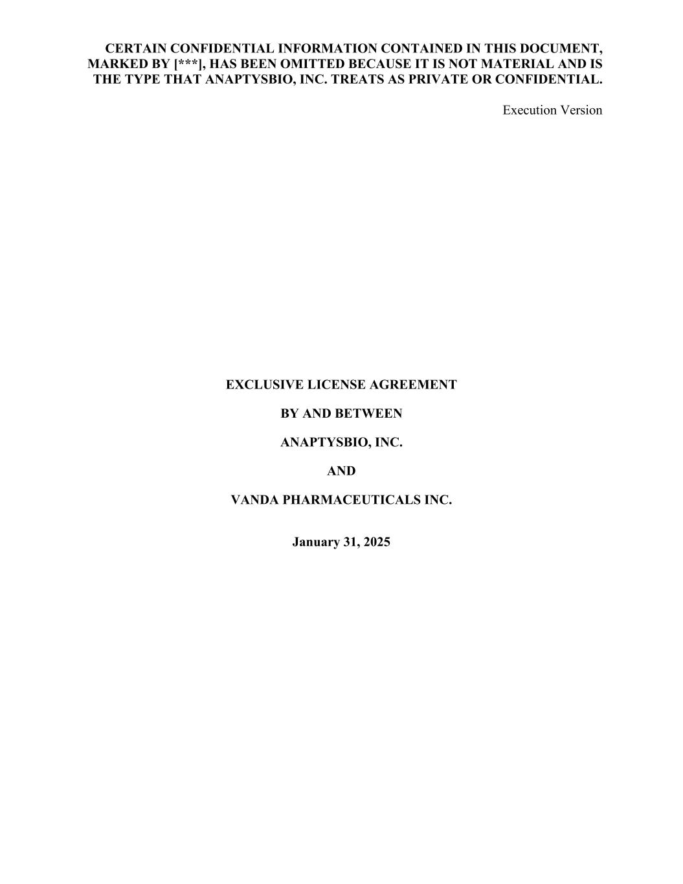
71
CERTAIN CONFIDENTIAL INFORMATION CONTAINED IN THIS DOCUMENT, MARKED BY [***], HAS BEEN OMITTED BECAUSE IT IS NOT MATERIAL AND IS THE TYPE THAT ANAPTYSBIO, INC. TREATS AS PRIVATE OR CONFIDENTIAL. Execution Version EXCLUSIVE LICENSE AGREEMENT BY AND BETWEEN ANAPTYSBIO, INC. AND VANDA PHARMACEUTICALS INC. January 31, 2025

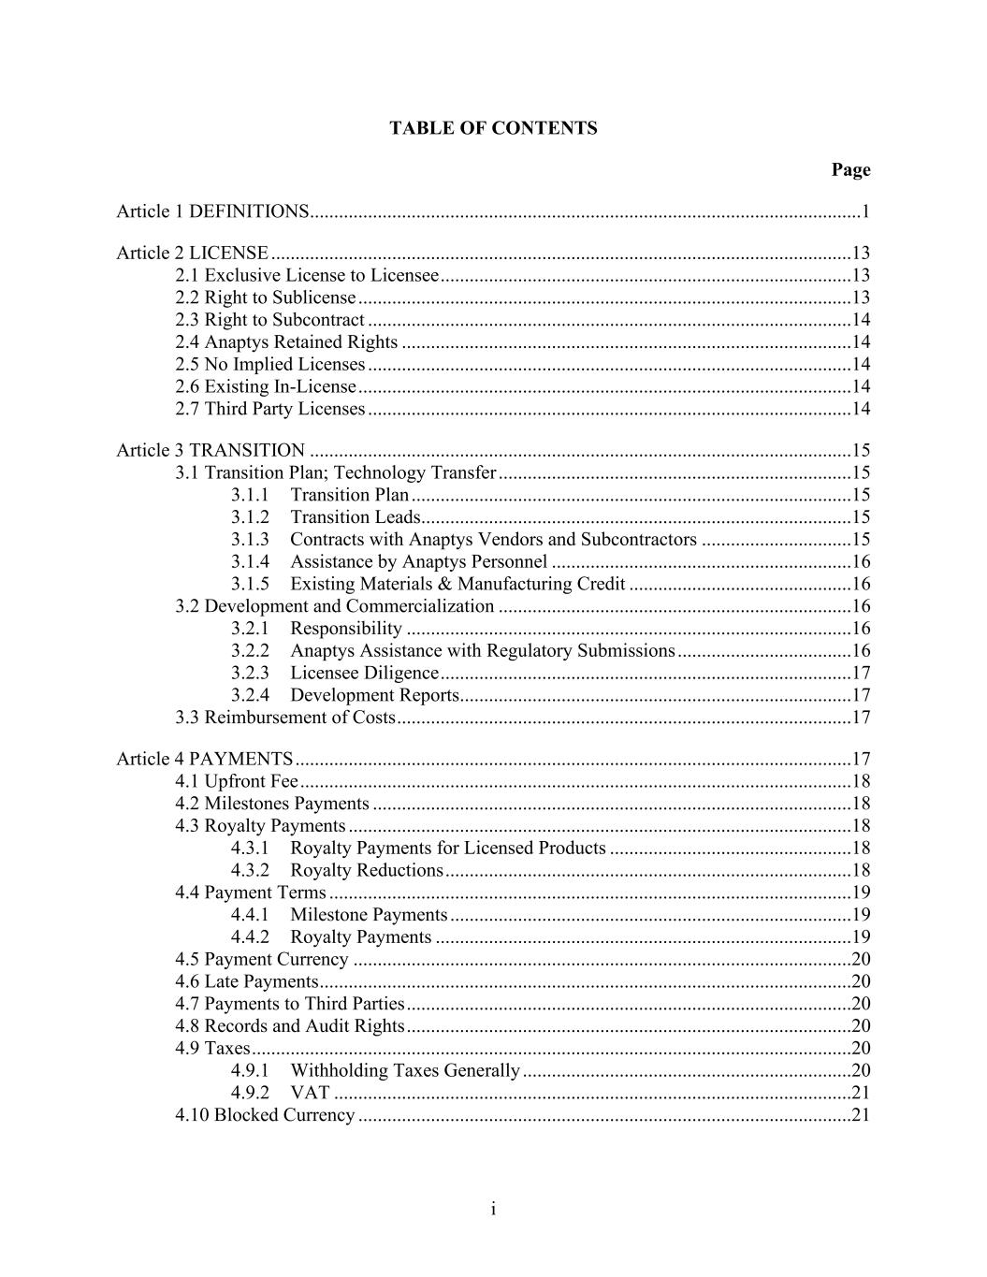
i TABLE OF CONTENTS Page Article 1 DEFINITIONS..................................................................................................................1 Article 2 LICENSE ........................................................................................................................13 2.1 Exclusive License to Licensee .....................................................................................13 2.2 Right to Sublicense ......................................................................................................13 2.3 Right to Subcontract ....................................................................................................14 2.4 Anaptys Retained Rights .............................................................................................14 2.5 No Implied Licenses ....................................................................................................14 2.6 Existing In-License ......................................................................................................14 2.7 Third Party Licenses ....................................................................................................14 Article 3 TRANSITION ................................................................................................................15 3.1 Transition Plan; Technology Transfer .........................................................................15 3.1.1 Transition Plan ...........................................................................................15 3.1.2 Transition Leads.........................................................................................15 3.1.3 Contracts with Anaptys Vendors and Subcontractors ...............................15 3.1.4 Assistance by Anaptys Personnel ..............................................................16 3.1.5 Existing Materials & Manufacturing Credit ..............................................16 3.2 Development and Commercialization .........................................................................16 3.2.1 Responsibility ............................................................................................16 3.2.2 Anaptys Assistance with Regulatory Submissions ....................................16 3.2.3 Licensee Diligence .....................................................................................17 3.2.4 Development Reports.................................................................................17 3.3 Reimbursement of Costs ..............................................................................................17 Article 4 PAYMENTS ...................................................................................................................17 4.1 Upfront Fee ..................................................................................................................18 4.2 Milestones Payments ...................................................................................................18 4.3 Royalty Payments ........................................................................................................18 4.3.1 Royalty Payments for Licensed Products ..................................................18 4.3.2 Royalty Reductions ....................................................................................18 4.4 Payment Terms ............................................................................................................19 4.4.1 Milestone Payments ...................................................................................19 4.4.2 Royalty Payments ......................................................................................19 4.5 Payment Currency .......................................................................................................20 4.6 Late Payments ..............................................................................................................20 4.7 Payments to Third Parties ............................................................................................20 4.8 Records and Audit Rights ............................................................................................20 4.9 Taxes ............................................................................................................................20 4.9.1 Withholding Taxes Generally ....................................................................20 4.9.2 VAT ...........................................................................................................21 4.10 Blocked Currency ......................................................................................................21

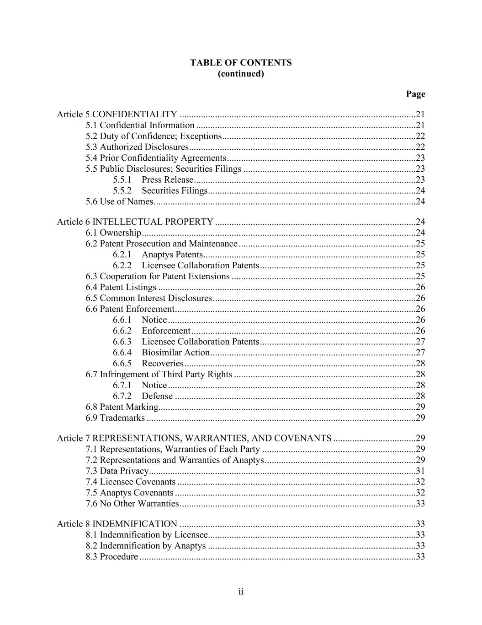
ii TABLE OF CONTENTS (continued) Page Article 5 CONFIDENTIALITY ....................................................................................................21 5.1 Confidential Information .............................................................................................21 5.2 Duty of Confidence; Exceptions ..................................................................................22 5.3 Authorized Disclosures ................................................................................................22 5.4 Prior Confidentiality Agreements ................................................................................23 5.5 Public Disclosures; Securities Filings .........................................................................23 5.5.1 Press Release ..............................................................................................23 5.5.2 Securities Filings ........................................................................................24 5.6 Use of Names ...............................................................................................................24 Article 6 INTELLECTUAL PROPERTY .....................................................................................24 6.1 Ownership ....................................................................................................................24 6.2 Patent Prosecution and Maintenance ...........................................................................25 6.2.1 Anaptys Patents ..........................................................................................25 6.2.2 Licensee Collaboration Patents ..................................................................25 6.3 Cooperation for Patent Extensions ..............................................................................25 6.4 Patent Listings .............................................................................................................26 6.5 Common Interest Disclosures ......................................................................................26 6.6 Patent Enforcement ......................................................................................................26 6.6.1 Notice .........................................................................................................26 6.6.2 Enforcement ...............................................................................................26 6.6.3 Licensee Collaboration Patents ..................................................................27 6.6.4 Biosimilar Action .......................................................................................27 6.6.5 Recoveries ..................................................................................................28 6.7 Infringement of Third Party Rights .............................................................................28 6.7.1 Notice .........................................................................................................28 6.7.2 Defense ......................................................................................................28 6.8 Patent Marking.............................................................................................................29 6.9 Trademarks ..................................................................................................................29 Article 7 REPRESENTATIONS, WARRANTIES, AND COVENANTS ...................................29 7.1 Representations, Warranties of Each Party .................................................................29 7.2 Representations and Warranties of Anaptys ................................................................29 7.3 Data Privacy.................................................................................................................31 7.4 Licensee Covenants .....................................................................................................32 7.5 Anaptys Covenants ......................................................................................................32 7.6 No Other Warranties ....................................................................................................33 Article 8 INDEMNIFICATION ....................................................................................................33 8.1 Indemnification by Licensee........................................................................................33 8.2 Indemnification by Anaptys ........................................................................................33 8.3 Procedure .....................................................................................................................33

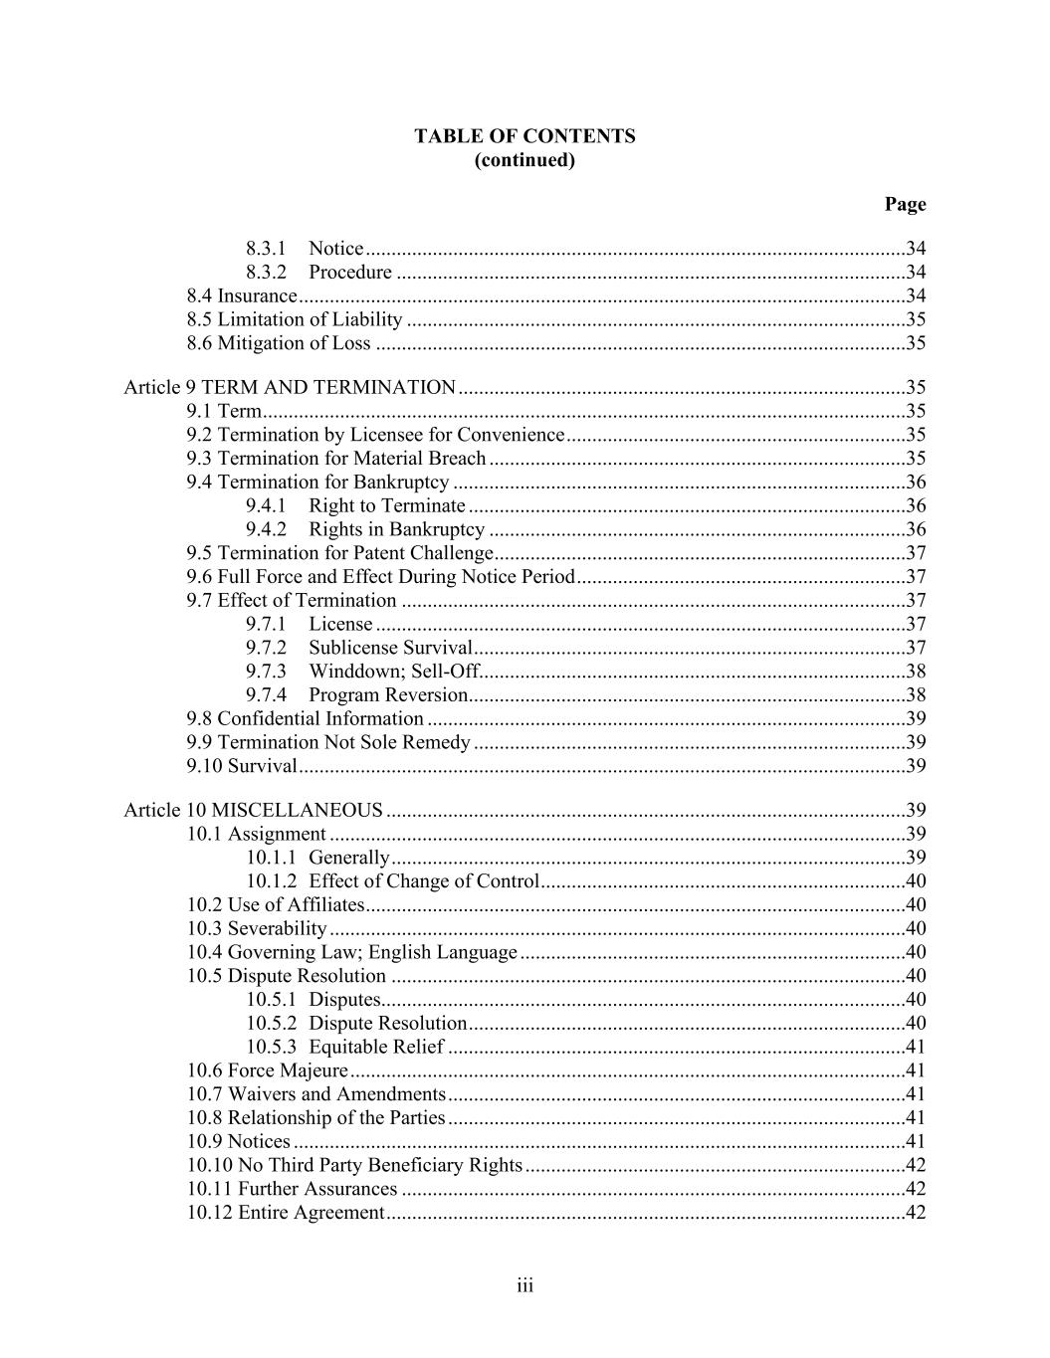
iii TABLE OF CONTENTS (continued) Page 8.3.1 Notice .........................................................................................................34 8.3.2 Procedure ...................................................................................................34 8.4 Insurance ......................................................................................................................34 8.5 Limitation of Liability .................................................................................................35 8.6 Mitigation of Loss .......................................................................................................35 Article 9 TERM AND TERMINATION .......................................................................................35 9.1 Term .............................................................................................................................35 9.2 Termination by Licensee for Convenience ..................................................................35 9.3 Termination for Material Breach .................................................................................35 9.4 Termination for Bankruptcy ........................................................................................36 9.4.1 Right to Terminate .....................................................................................36 9.4.2 Rights in Bankruptcy .................................................................................36 9.5 Termination for Patent Challenge ................................................................................37 9.6 Full Force and Effect During Notice Period ................................................................37 9.7 Effect of Termination ..................................................................................................37 9.7.1 License .......................................................................................................37 9.7.2 Sublicense Survival ....................................................................................37 9.7.3 Winddown; Sell-Off...................................................................................38 9.7.4 Program Reversion.....................................................................................38 9.8 Confidential Information .............................................................................................39 9.9 Termination Not Sole Remedy ....................................................................................39 9.10 Survival ......................................................................................................................39 Article 10 MISCELLANEOUS .....................................................................................................39 10.1 Assignment ................................................................................................................39 10.1.1 Generally ....................................................................................................39 10.1.2 Effect of Change of Control .......................................................................40 10.2 Use of Affiliates .........................................................................................................40 10.3 Severability ................................................................................................................40 10.4 Governing Law; English Language ...........................................................................40 10.5 Dispute Resolution ....................................................................................................40 10.5.1 Disputes......................................................................................................40 10.5.2 Dispute Resolution .....................................................................................40 10.5.3 Equitable Relief .........................................................................................41 10.6 Force Majeure ............................................................................................................41 10.7 Waivers and Amendments .........................................................................................41 10.8 Relationship of the Parties .........................................................................................41 10.9 Notices .......................................................................................................................41 10.10 No Third Party Beneficiary Rights ..........................................................................42 10.11 Further Assurances ..................................................................................................42 10.12 Entire Agreement .....................................................................................................42

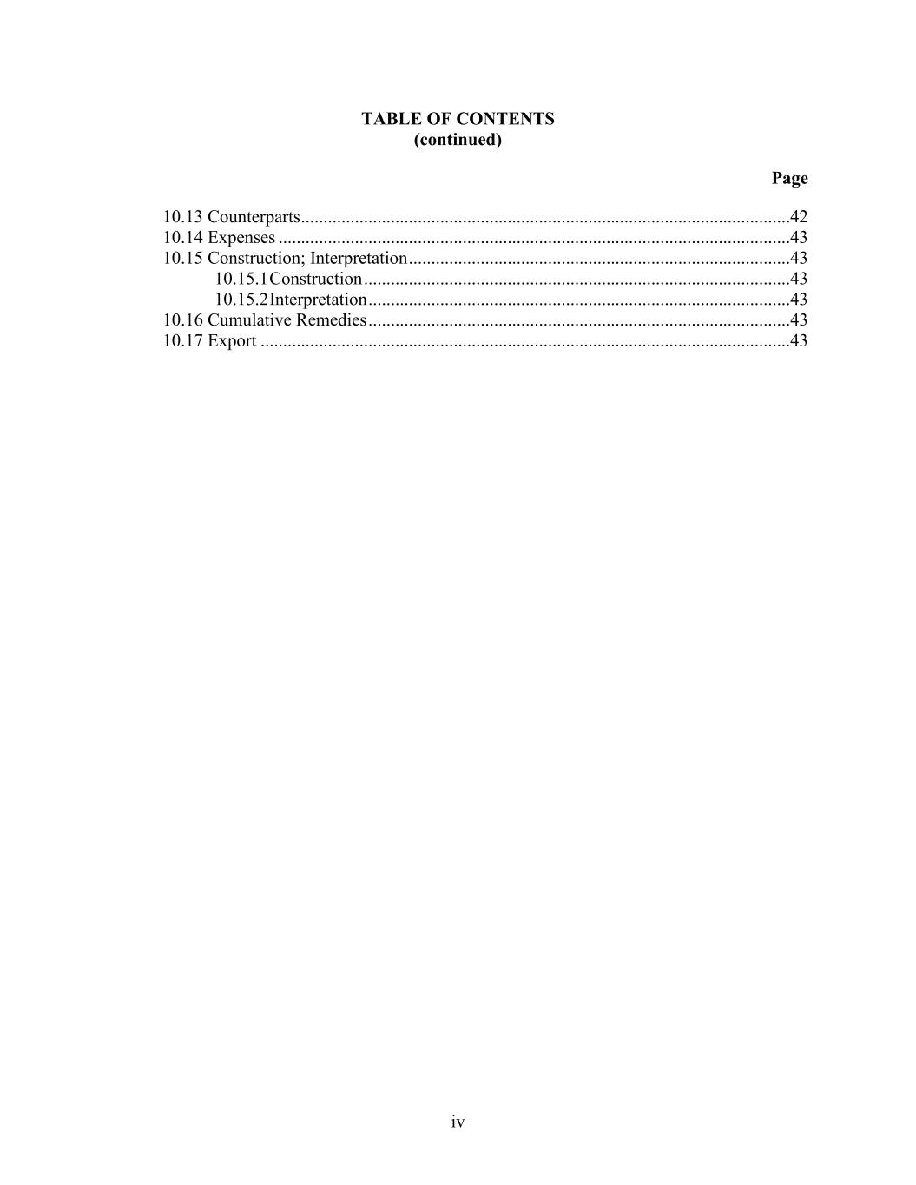
iv TABLE OF CONTENTS (continued) Page 10.13 Counterparts .............................................................................................................42 10.14 Expenses ..................................................................................................................43 10.15 Construction; Interpretation .....................................................................................43 10.15.1 Construction ...............................................................................................43 10.15.2 Interpretation ..............................................................................................43 10.16 Cumulative Remedies ..............................................................................................43 10.17 Export ......................................................................................................................43

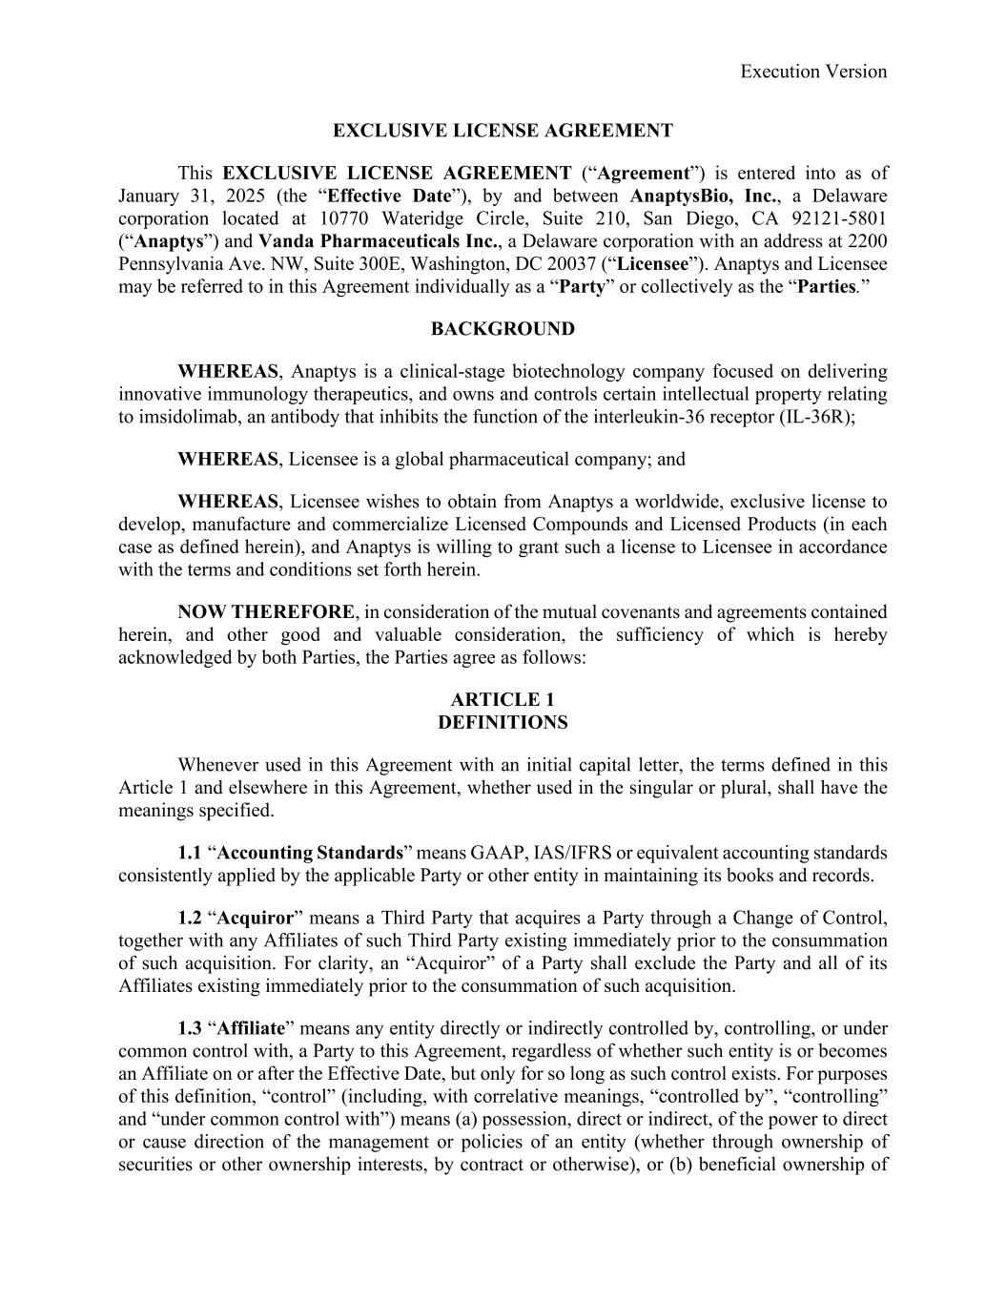
Execution Version EXCLUSIVE LICENSE AGREEMENT This EXCLUSIVE LICENSE AGREEMENT (“Agreement”) is entered into as of January 31, 2025 (the “Effective Date”), by and between AnaptysBio, Inc., a Delaware corporation located at 10770 Wateridge Circle, Suite 210, San Diego, CA 92121-5801 (“Anaptys”) and Vanda Pharmaceuticals Inc., a Delaware corporation with an address at 2200 Pennsylvania Ave. NW, Suite 300E, Washington, DC 20037 (“Licensee”). Anaptys and Licensee may be referred to in this Agreement individually as a “Party” or collectively as the “Parties.” BACKGROUND WHEREAS, Anaptys is a clinical-stage biotechnology company focused on delivering innovative immunology therapeutics, and owns and controls certain intellectual property relating to imsidolimab, an antibody that inhibits the function of the interleukin-36 receptor (IL-36R); WHEREAS, Licensee is a global pharmaceutical company; and WHEREAS, Licensee wishes to obtain from Anaptys a worldwide, exclusive license to develop, manufacture and commercialize Licensed Compounds and Licensed Products (in each case as defined herein), and Anaptys is willing to grant such a license to Licensee in accordance with the terms and conditions set forth herein. NOW THEREFORE, in consideration of the mutual covenants and agreements contained herein, and other good and valuable consideration, the sufficiency of which is hereby acknowledged by both Parties, the Parties agree as follows: ARTICLE 1 DEFINITIONS Whenever used in this Agreement with an initial capital letter, the terms defined in this Article 1 and elsewhere in this Agreement, whether used in the singular or plural, shall have the meanings specified. 1.1 “Accounting Standards” means GAAP, IAS/IFRS or equivalent accounting standards consistently applied by the applicable Party or other entity in maintaining its books and records. 1.2 “Acquiror” means a Third Party that acquires a Party through a Change of Control, together with any Affiliates of such Third Party existing immediately prior to the consummation of such acquisition. For clarity, an “Acquiror” of a Party shall exclude the Party and all of its Affiliates existing immediately prior to the consummation of such acquisition. 1.3 “Affiliate” means any entity directly or indirectly controlled by, controlling, or under common control with, a Party to this Agreement, regardless of whether such entity is or becomes an Affiliate on or after the Effective Date, but only for so long as such control exists. For purposes of this definition, “control” (including, with correlative meanings, “controlled by”, “controlling” and “under common control with”) means (a) possession, direct or indirect, of the power to direct or cause direction of the management or policies of an entity (whether through ownership of securities or other ownership interests, by contract or otherwise), or (b) beneficial ownership of

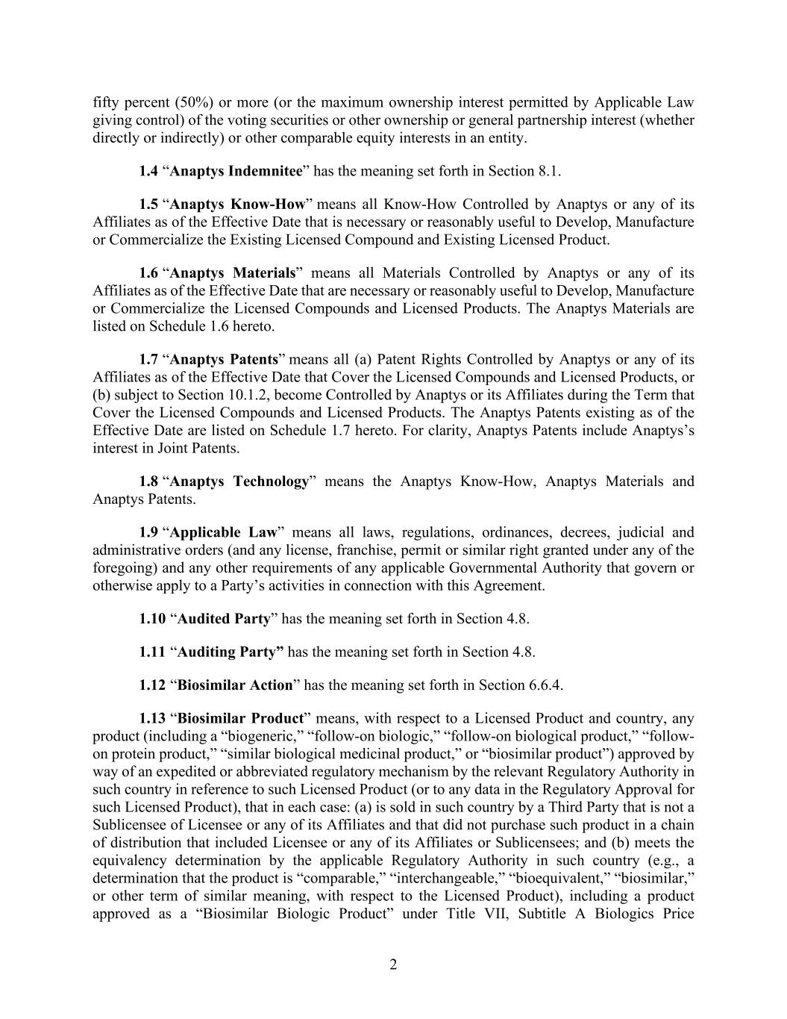
2 fifty percent (50%) or more (or the maximum ownership interest permitted by Applicable Law giving control) of the voting securities or other ownership or general partnership interest (whether directly or indirectly) or other comparable equity interests in an entity. 1.4 “Anaptys Indemnitee” has the meaning set forth in Section 8.1. 1.5 “Anaptys Know-How” means all Know-How Controlled by Anaptys or any of its Affiliates as of the Effective Date that is necessary or reasonably useful to Develop, Manufacture or Commercialize the Existing Licensed Compound and Existing Licensed Product. 1.6 “Anaptys Materials” means all Materials Controlled by Anaptys or any of its Affiliates as of the Effective Date that are necessary or reasonably useful to Develop, Manufacture or Commercialize the Licensed Compounds and Licensed Products. The Anaptys Materials are listed on Schedule 1.6 hereto. 1.7 “Anaptys Patents” means all (a) Patent Rights Controlled by Anaptys or any of its Affiliates as of the Effective Date that Cover the Licensed Compounds and Licensed Products, or (b) subject to Section 10.1.2, become Controlled by Anaptys or its Affiliates during the Term that Cover the Licensed Compounds and Licensed Products. The Anaptys Patents existing as of the Effective Date are listed on Schedule 1.7 hereto. For clarity, Anaptys Patents include Anaptys’s interest in Joint Patents. 1.8 “Anaptys Technology” means the Anaptys Know-How, Anaptys Materials and Anaptys Patents. 1.9 “Applicable Law” means all laws, regulations, ordinances, decrees, judicial and administrative orders (and any license, franchise, permit or similar right granted under any of the foregoing) and any other requirements of any applicable Governmental Authority that govern or otherwise apply to a Party’s activities in connection with this Agreement. 1.10 “Audited Party” has the meaning set forth in Section 4.8. 1.11 “Auditing Party” has the meaning set forth in Section 4.8. 1.12 “Biosimilar Action” has the meaning set forth in Section 6.6.4. 1.13 “Biosimilar Product” means, with respect to a Licensed Product and country, any product (including a “biogeneric,” “follow-on biologic,” “follow-on biological product,” “follow- on protein product,” “similar biological medicinal product,” or “biosimilar product”) approved by way of an expedited or abbreviated regulatory mechanism by the relevant Regulatory Authority in such country in reference to such Licensed Product (or to any data in the Regulatory Approval for such Licensed Product), that in each case: (a) is sold in such country by a Third Party that is not a Sublicensee of Licensee or any of its Affiliates and that did not purchase such product in a chain of distribution that included Licensee or any of its Affiliates or Sublicensees; and (b) meets the equivalency determination by the applicable Regulatory Authority in such country (e.g., a determination that the product is “comparable,” “interchangeable,” “bioequivalent,” “biosimilar,” or other term of similar meaning, with respect to the Licensed Product), including a product approved as a “Biosimilar Biologic Product” under Title VII, Subtitle A Biologics Price

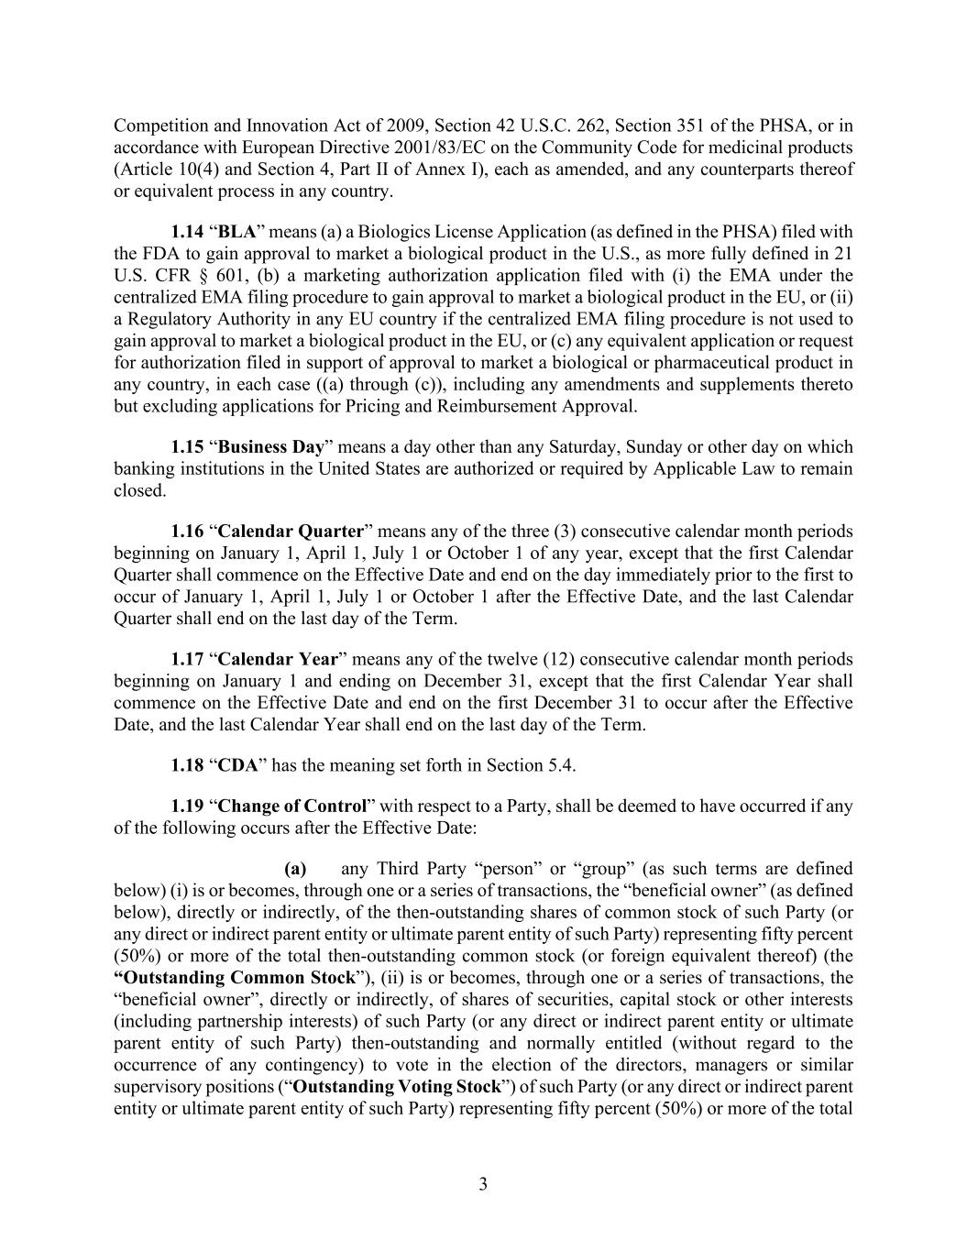
3 Competition and Innovation Act of 2009, Section 42 U.S.C. 262, Section 351 of the PHSA, or in accordance with European Directive 2001/83/EC on the Community Code for medicinal products (Article 10(4) and Section 4, Part II of Annex I), each as amended, and any counterparts thereof or equivalent process in any country. 1.14 “BLA” means (a) a Biologics License Application (as defined in the PHSA) filed with the FDA to gain approval to market a biological product in the U.S., as more fully defined in 21 U.S. CFR § 601, (b) a marketing authorization application filed with (i) the EMA under the centralized EMA filing procedure to gain approval to market a biological product in the EU, or (ii) a Regulatory Authority in any EU country if the centralized EMA filing procedure is not used to gain approval to market a biological product in the EU, or (c) any equivalent application or request for authorization filed in support of approval to market a biological or pharmaceutical product in any country, in each case ((a) through (c)), including any amendments and supplements thereto but excluding applications for Pricing and Reimbursement Approval. 1.15 “Business Day” means a day other than any Saturday, Sunday or other day on which banking institutions in the United States are authorized or required by Applicable Law to remain closed. 1.16 “Calendar Quarter” means any of the three (3) consecutive calendar month periods beginning on January 1, April 1, July 1 or October 1 of any year, except that the first Calendar Quarter shall commence on the Effective Date and end on the day immediately prior to the first to occur of January 1, April 1, July 1 or October 1 after the Effective Date, and the last Calendar Quarter shall end on the last day of the Term. 1.17 “Calendar Year” means any of the twelve (12) consecutive calendar month periods beginning on January 1 and ending on December 31, except that the first Calendar Year shall commence on the Effective Date and end on the first December 31 to occur after the Effective Date, and the last Calendar Year shall end on the last day of the Term. 1.18 “CDA” has the meaning set forth in Section 5.4. 1.19 “Change of Control” with respect to a Party, shall be deemed to have occurred if any of the following occurs after the Effective Date: (a) any Third Party “person” or “group” (as such terms are defined below) (i) is or becomes, through one or a series of transactions, the “beneficial owner” (as defined below), directly or indirectly, of the then-outstanding shares of common stock of such Party (or any direct or indirect parent entity or ultimate parent entity of such Party) representing fifty percent (50%) or more of the total then-outstanding common stock (or foreign equivalent thereof) (the “Outstanding Common Stock”), (ii) is or becomes, through one or a series of transactions, the “beneficial owner”, directly or indirectly, of shares of securities, capital stock or other interests (including partnership interests) of such Party (or any direct or indirect parent entity or ultimate parent entity of such Party) then-outstanding and normally entitled (without regard to the occurrence of any contingency) to vote in the election of the directors, managers or similar supervisory positions (“Outstanding Voting Stock”) of such Party (or any direct or indirect parent entity or ultimate parent entity of such Party) representing fifty percent (50%) or more of the total

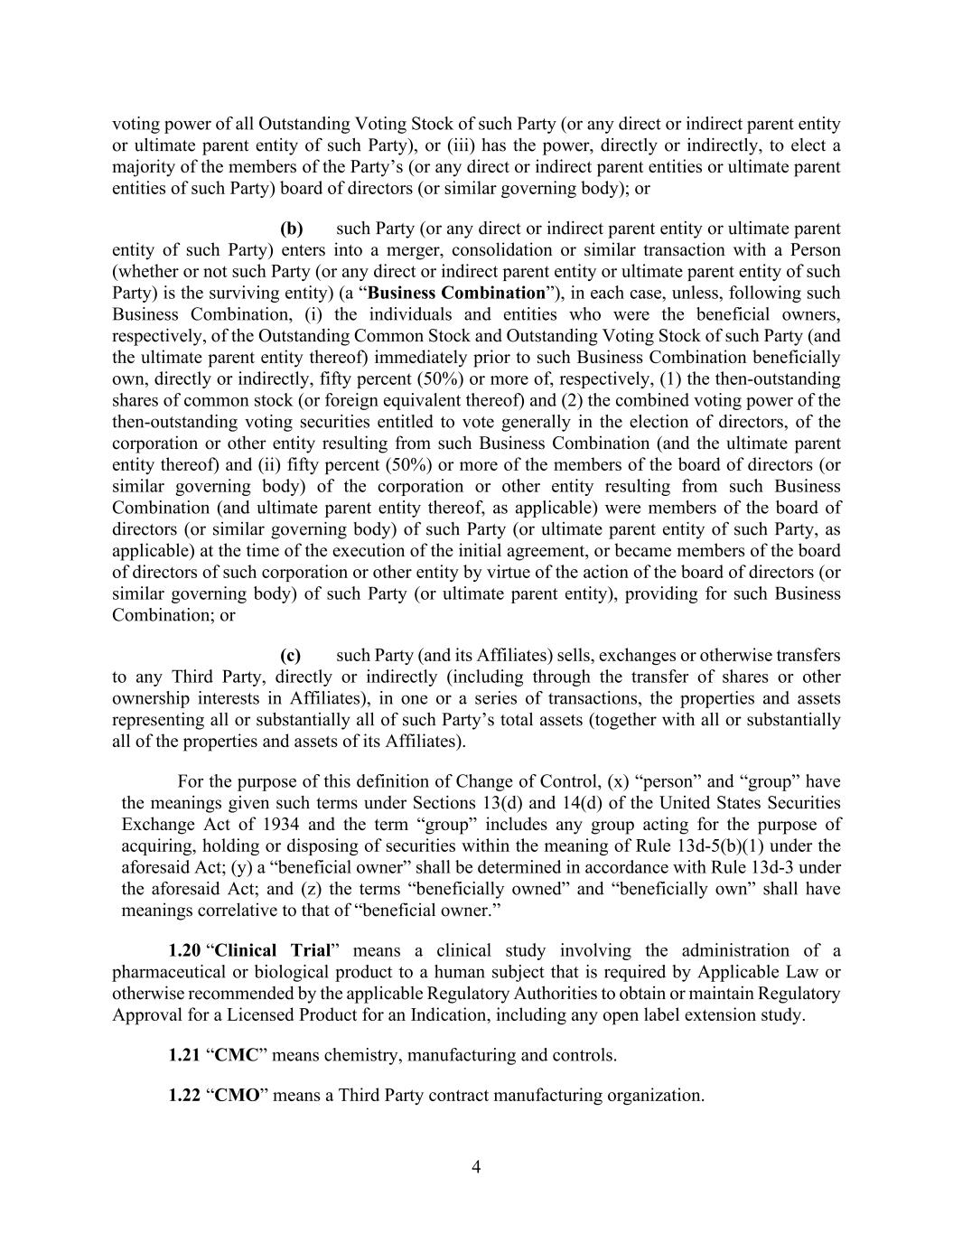
4 voting power of all Outstanding Voting Stock of such Party (or any direct or indirect parent entity or ultimate parent entity of such Party), or (iii) has the power, directly or indirectly, to elect a majority of the members of the Party’s (or any direct or indirect parent entities or ultimate parent entities of such Party) board of directors (or similar governing body); or (b) such Party (or any direct or indirect parent entity or ultimate parent entity of such Party) enters into a merger, consolidation or similar transaction with a Person (whether or not such Party (or any direct or indirect parent entity or ultimate parent entity of such Party) is the surviving entity) (a “Business Combination”), in each case, unless, following such Business Combination, (i) the individuals and entities who were the beneficial owners, respectively, of the Outstanding Common Stock and Outstanding Voting Stock of such Party (and the ultimate parent entity thereof) immediately prior to such Business Combination beneficially own, directly or indirectly, fifty percent (50%) or more of, respectively, (1) the then-outstanding shares of common stock (or foreign equivalent thereof) and (2) the combined voting power of the then-outstanding voting securities entitled to vote generally in the election of directors, of the corporation or other entity resulting from such Business Combination (and the ultimate parent entity thereof) and (ii) fifty percent (50%) or more of the members of the board of directors (or similar governing body) of the corporation or other entity resulting from such Business Combination (and ultimate parent entity thereof, as applicable) were members of the board of directors (or similar governing body) of such Party (or ultimate parent entity of such Party, as applicable) at the time of the execution of the initial agreement, or became members of the board of directors of such corporation or other entity by virtue of the action of the board of directors (or similar governing body) of such Party (or ultimate parent entity), providing for such Business Combination; or (c) such Party (and its Affiliates) sells, exchanges or otherwise transfers to any Third Party, directly or indirectly (including through the transfer of shares or other ownership interests in Affiliates), in one or a series of transactions, the properties and assets representing all or substantially all of such Party’s total assets (together with all or substantially all of the properties and assets of its Affiliates). For the purpose of this definition of Change of Control, (x) “person” and “group” have the meanings given such terms under Sections 13(d) and 14(d) of the United States Securities Exchange Act of 1934 and the term “group” includes any group acting for the purpose of acquiring, holding or disposing of securities within the meaning of Rule 13d-5(b)(1) under the aforesaid Act; (y) a “beneficial owner” shall be determined in accordance with Rule 13d-3 under the aforesaid Act; and (z) the terms “beneficially owned” and “beneficially own” shall have meanings correlative to that of “beneficial owner.” 1.20 “Clinical Trial” means a clinical study involving the administration of a pharmaceutical or biological product to a human subject that is required by Applicable Law or otherwise recommended by the applicable Regulatory Authorities to obtain or maintain Regulatory Approval for a Licensed Product for an Indication, including any open label extension study. 1.21 “CMC” means chemistry, manufacturing and controls. 1.22 “CMO” means a Third Party contract manufacturing organization.

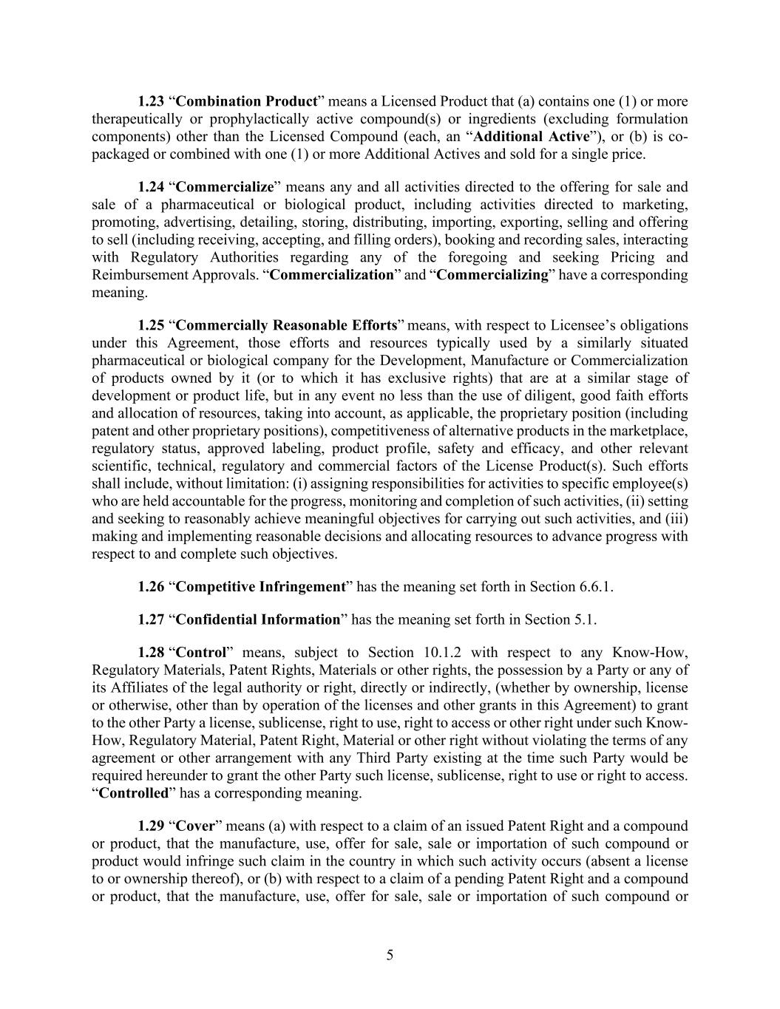
5 1.23 “Combination Product” means a Licensed Product that (a) contains one (1) or more therapeutically or prophylactically active compound(s) or ingredients (excluding formulation components) other than the Licensed Compound (each, an “Additional Active”), or (b) is co- packaged or combined with one (1) or more Additional Actives and sold for a single price. 1.24 “Commercialize” means any and all activities directed to the offering for sale and sale of a pharmaceutical or biological product, including activities directed to marketing, promoting, advertising, detailing, storing, distributing, importing, exporting, selling and offering to sell (including receiving, accepting, and filling orders), booking and recording sales, interacting with Regulatory Authorities regarding any of the foregoing and seeking Pricing and Reimbursement Approvals. “Commercialization” and “Commercializing” have a corresponding meaning. 1.25 “Commercially Reasonable Efforts” means, with respect to Licensee’s obligations under this Agreement, those efforts and resources typically used by a similarly situated pharmaceutical or biological company for the Development, Manufacture or Commercialization of products owned by it (or to which it has exclusive rights) that are at a similar stage of development or product life, but in any event no less than the use of diligent, good faith efforts and allocation of resources, taking into account, as applicable, the proprietary position (including patent and other proprietary positions), competitiveness of alternative products in the marketplace, regulatory status, approved labeling, product profile, safety and efficacy, and other relevant scientific, technical, regulatory and commercial factors of the License Product(s). Such efforts shall include, without limitation: (i) assigning responsibilities for activities to specific employee(s) who are held accountable for the progress, monitoring and completion of such activities, (ii) setting and seeking to reasonably achieve meaningful objectives for carrying out such activities, and (iii) making and implementing reasonable decisions and allocating resources to advance progress with respect to and complete such objectives. 1.26 “Competitive Infringement” has the meaning set forth in Section 6.6.1. 1.27 “Confidential Information” has the meaning set forth in Section 5.1. 1.28 “Control” means, subject to Section 10.1.2 with respect to any Know-How, Regulatory Materials, Patent Rights, Materials or other rights, the possession by a Party or any of its Affiliates of the legal authority or right, directly or indirectly, (whether by ownership, license or otherwise, other than by operation of the licenses and other grants in this Agreement) to grant to the other Party a license, sublicense, right to use, right to access or other right under such Know- How, Regulatory Material, Patent Right, Material or other right without violating the terms of any agreement or other arrangement with any Third Party existing at the time such Party would be required hereunder to grant the other Party such license, sublicense, right to use or right to access. “Controlled” has a corresponding meaning. 1.29 “Cover” means (a) with respect to a claim of an issued Patent Right and a compound or product, that the manufacture, use, offer for sale, sale or importation of such compound or product would infringe such claim in the country in which such activity occurs (absent a license to or ownership thereof), or (b) with respect to a claim of a pending Patent Right and a compound or product, that the manufacture, use, offer for sale, sale or importation of such compound or

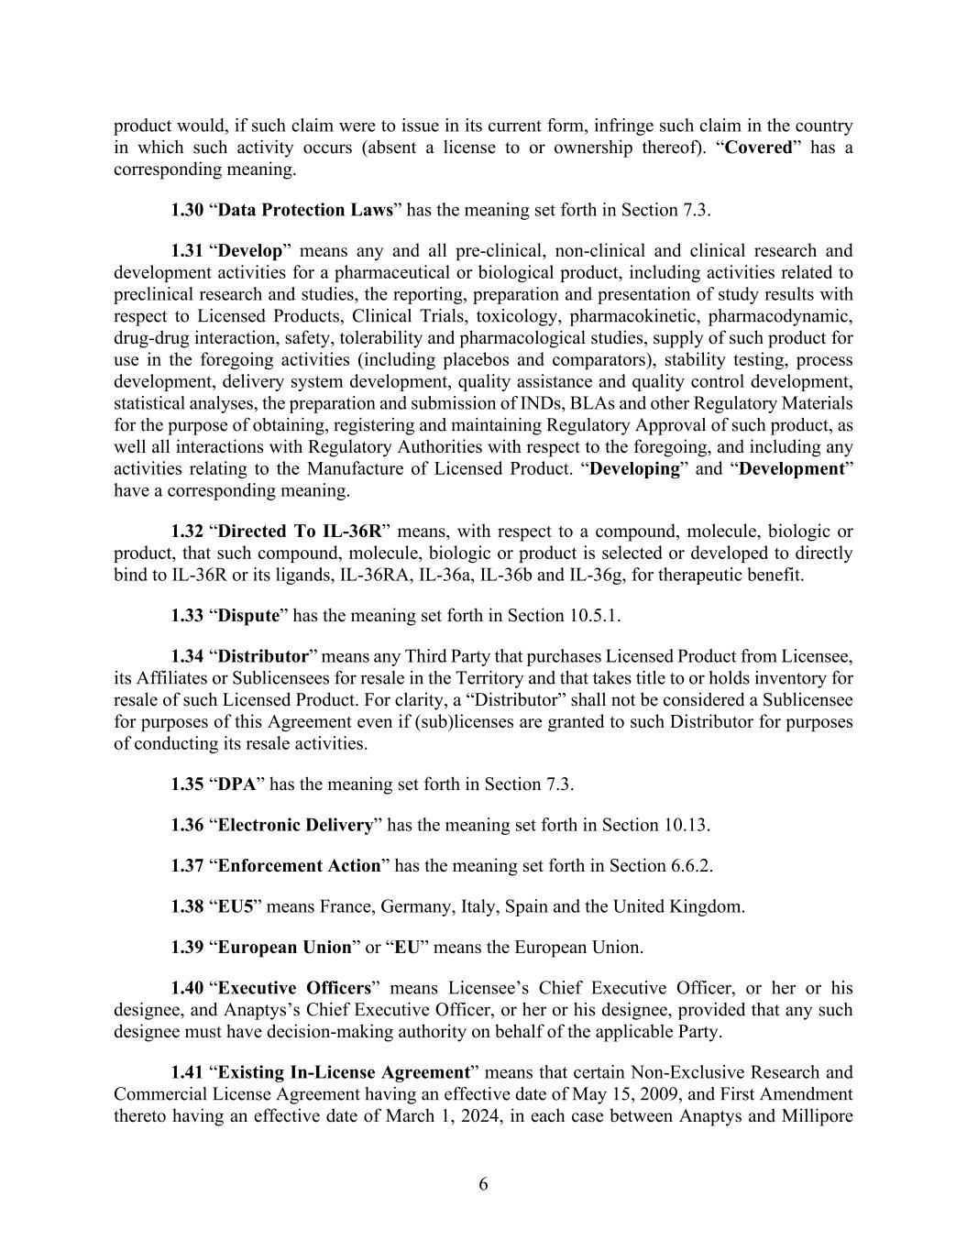
6 product would, if such claim were to issue in its current form, infringe such claim in the country in which such activity occurs (absent a license to or ownership thereof). “Covered” has a corresponding meaning. 1.30 “Data Protection Laws” has the meaning set forth in Section 7.3. 1.31 “Develop” means any and all pre-clinical, non-clinical and clinical research and development activities for a pharmaceutical or biological product, including activities related to preclinical research and studies, the reporting, preparation and presentation of study results with respect to Licensed Products, Clinical Trials, toxicology, pharmacokinetic, pharmacodynamic, drug-drug interaction, safety, tolerability and pharmacological studies, supply of such product for use in the foregoing activities (including placebos and comparators), stability testing, process development, delivery system development, quality assistance and quality control development, statistical analyses, the preparation and submission of INDs, BLAs and other Regulatory Materials for the purpose of obtaining, registering and maintaining Regulatory Approval of such product, as well all interactions with Regulatory Authorities with respect to the foregoing, and including any activities relating to the Manufacture of Licensed Product. “Developing” and “Development” have a corresponding meaning. 1.32 “Directed To IL-36R” means, with respect to a compound, molecule, biologic or product, that such compound, molecule, biologic or product is selected or developed to directly bind to IL-36R or its ligands, IL-36RA, IL-36a, IL-36b and IL-36g, for therapeutic benefit. 1.33 “Dispute” has the meaning set forth in Section 10.5.1. 1.34 “Distributor” means any Third Party that purchases Licensed Product from Licensee, its Affiliates or Sublicensees for resale in the Territory and that takes title to or holds inventory for resale of such Licensed Product. For clarity, a “Distributor” shall not be considered a Sublicensee for purposes of this Agreement even if (sub)licenses are granted to such Distributor for purposes of conducting its resale activities. 1.35 “DPA” has the meaning set forth in Section 7.3. 1.36 “Electronic Delivery” has the meaning set forth in Section 10.13. 1.37 “Enforcement Action” has the meaning set forth in Section 6.6.2. 1.38 “EU5” means France, Germany, Italy, Spain and the United Kingdom. 1.39 “European Union” or “EU” means the European Union. 1.40 “Executive Officers” means Licensee’s Chief Executive Officer, or her or his designee, and Anaptys’s Chief Executive Officer, or her or his designee, provided that any such designee must have decision-making authority on behalf of the applicable Party. 1.41 “Existing In-License Agreement” means that certain Non-Exclusive Research and Commercial License Agreement having an effective date of May 15, 2009, and First Amendment thereto having an effective date of March 1, 2024, in each case between Anaptys and Millipore

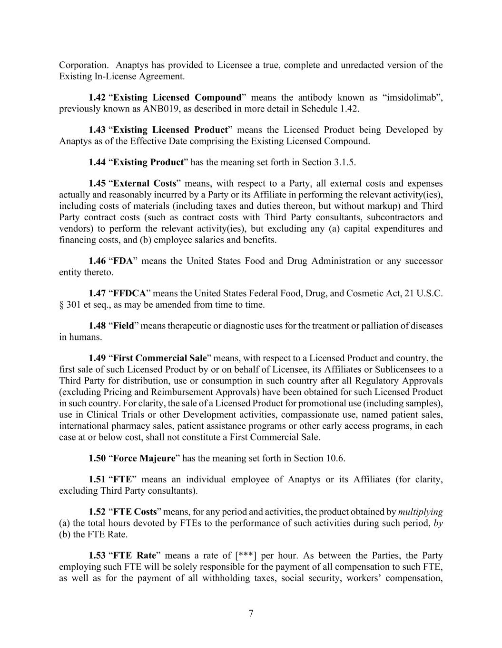
7 Corporation. Anaptys has provided to Licensee a true, complete and unredacted version of the Existing In-License Agreement. 1.42 “Existing Licensed Compound” means the antibody known as “imsidolimab”, previously known as ANB019, as described in more detail in Schedule 1.42. 1.43 “Existing Licensed Product” means the Licensed Product being Developed by Anaptys as of the Effective Date comprising the Existing Licensed Compound. 1.44 “Existing Product” has the meaning set forth in Section 3.1.5. 1.45 “External Costs” means, with respect to a Party, all external costs and expenses actually and reasonably incurred by a Party or its Affiliate in performing the relevant activity(ies), including costs of materials (including taxes and duties thereon, but without markup) and Third Party contract costs (such as contract costs with Third Party consultants, subcontractors and vendors) to perform the relevant activity(ies), but excluding any (a) capital expenditures and financing costs, and (b) employee salaries and benefits. 1.46 “FDA” means the United States Food and Drug Administration or any successor entity thereto. 1.47 “FFDCA” means the United States Federal Food, Drug, and Cosmetic Act, 21 U.S.C. § 301 et seq., as may be amended from time to time. 1.48 “Field” means therapeutic or diagnostic uses for the treatment or palliation of diseases in humans. 1.49 “First Commercial Sale” means, with respect to a Licensed Product and country, the first sale of such Licensed Product by or on behalf of Licensee, its Affiliates or Sublicensees to a Third Party for distribution, use or consumption in such country after all Regulatory Approvals (excluding Pricing and Reimbursement Approvals) have been obtained for such Licensed Product in such country. For clarity, the sale of a Licensed Product for promotional use (including samples), use in Clinical Trials or other Development activities, compassionate use, named patient sales, international pharmacy sales, patient assistance programs or other early access programs, in each case at or below cost, shall not constitute a First Commercial Sale. 1.50 “Force Majeure” has the meaning set forth in Section 10.6. 1.51 “FTE” means an individual employee of Anaptys or its Affiliates (for clarity, excluding Third Party consultants). 1.52 “FTE Costs” means, for any period and activities, the product obtained by multiplying (a) the total hours devoted by FTEs to the performance of such activities during such period, by (b) the FTE Rate. 1.53 “FTE Rate” means a rate of [***] per hour. As between the Parties, the Party employing such FTE will be solely responsible for the payment of all compensation to such FTE, as well as for the payment of all withholding taxes, social security, workers’ compensation,

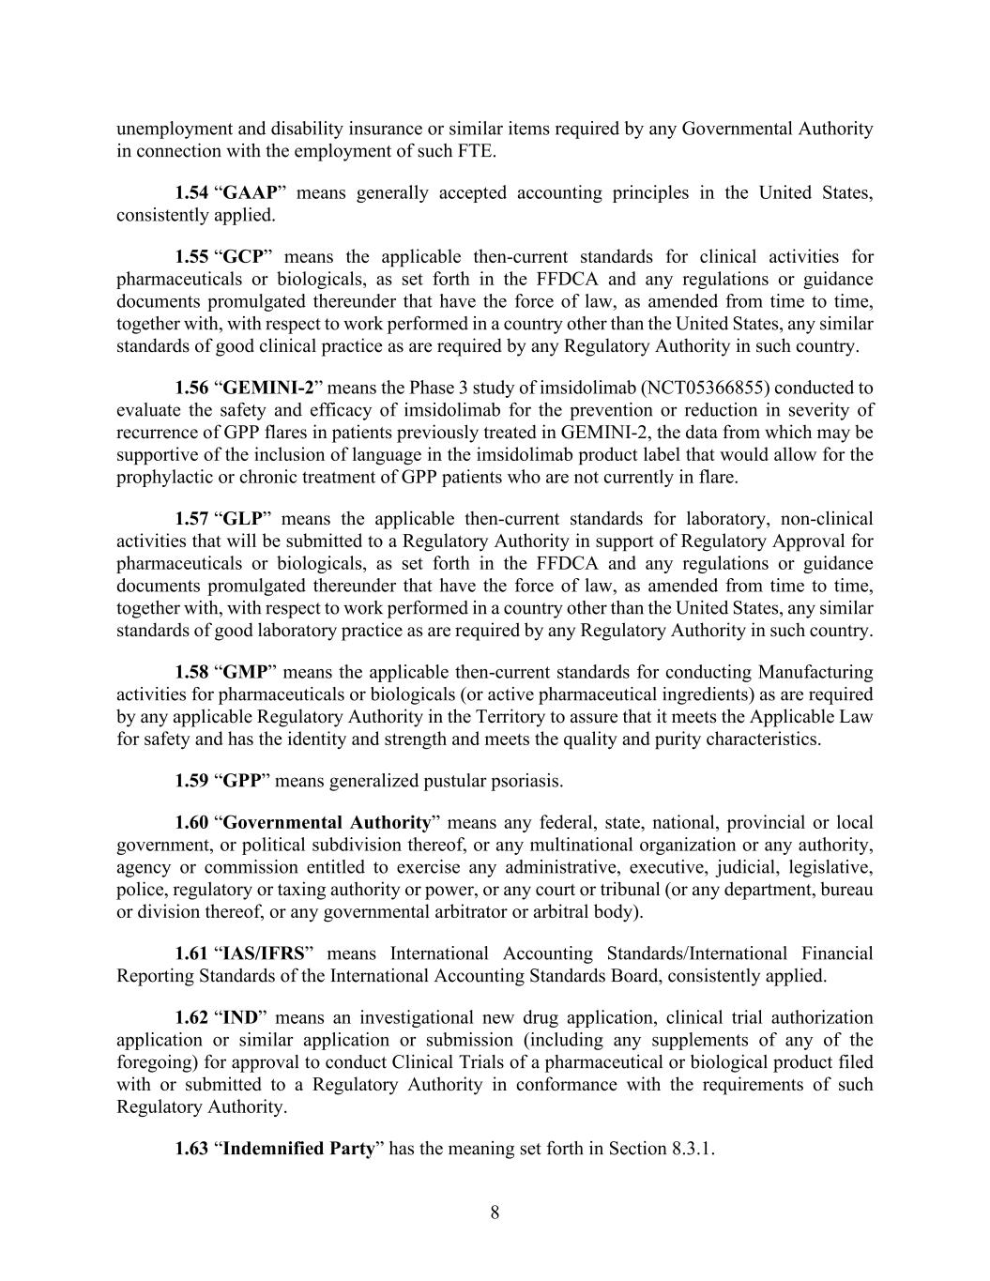
8 unemployment and disability insurance or similar items required by any Governmental Authority in connection with the employment of such FTE. 1.54 “GAAP” means generally accepted accounting principles in the United States, consistently applied. 1.55 “GCP” means the applicable then-current standards for clinical activities for pharmaceuticals or biologicals, as set forth in the FFDCA and any regulations or guidance documents promulgated thereunder that have the force of law, as amended from time to time, together with, with respect to work performed in a country other than the United States, any similar standards of good clinical practice as are required by any Regulatory Authority in such country. 1.56 “GEMINI-2” means the Phase 3 study of imsidolimab (NCT05366855) conducted to evaluate the safety and efficacy of imsidolimab for the prevention or reduction in severity of recurrence of GPP flares in patients previously treated in GEMINI-2, the data from which may be supportive of the inclusion of language in the imsidolimab product label that would allow for the prophylactic or chronic treatment of GPP patients who are not currently in flare. 1.57 “GLP” means the applicable then-current standards for laboratory, non-clinical activities that will be submitted to a Regulatory Authority in support of Regulatory Approval for pharmaceuticals or biologicals, as set forth in the FFDCA and any regulations or guidance documents promulgated thereunder that have the force of law, as amended from time to time, together with, with respect to work performed in a country other than the United States, any similar standards of good laboratory practice as are required by any Regulatory Authority in such country. 1.58 “GMP” means the applicable then-current standards for conducting Manufacturing activities for pharmaceuticals or biologicals (or active pharmaceutical ingredients) as are required by any applicable Regulatory Authority in the Territory to assure that it meets the Applicable Law for safety and has the identity and strength and meets the quality and purity characteristics. 1.59 “GPP” means generalized pustular psoriasis. 1.60 “Governmental Authority” means any federal, state, national, provincial or local government, or political subdivision thereof, or any multinational organization or any authority, agency or commission entitled to exercise any administrative, executive, judicial, legislative, police, regulatory or taxing authority or power, or any court or tribunal (or any department, bureau or division thereof, or any governmental arbitrator or arbitral body). 1.61 “IAS/IFRS” means International Accounting Standards/International Financial Reporting Standards of the International Accounting Standards Board, consistently applied. 1.62 “IND” means an investigational new drug application, clinical trial authorization application or similar application or submission (including any supplements of any of the foregoing) for approval to conduct Clinical Trials of a pharmaceutical or biological product filed with or submitted to a Regulatory Authority in conformance with the requirements of such Regulatory Authority. 1.63 “Indemnified Party” has the meaning set forth in Section 8.3.1.

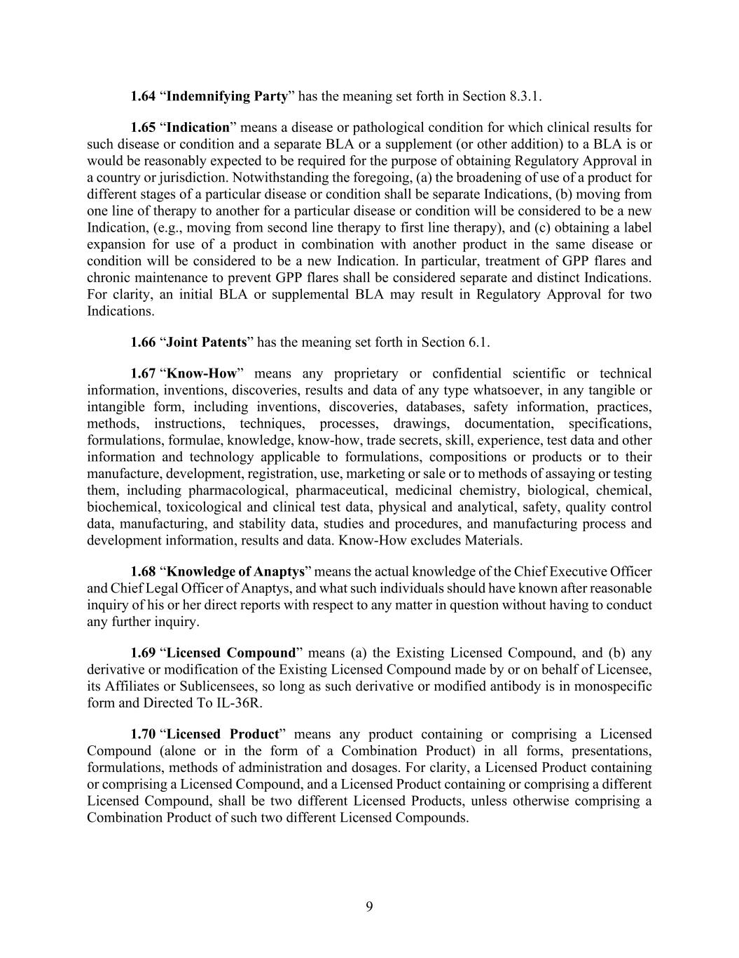
9 1.64 “Indemnifying Party” has the meaning set forth in Section 8.3.1. 1.65 “Indication” means a disease or pathological condition for which clinical results for such disease or condition and a separate BLA or a supplement (or other addition) to a BLA is or would be reasonably expected to be required for the purpose of obtaining Regulatory Approval in a country or jurisdiction. Notwithstanding the foregoing, (a) the broadening of use of a product for different stages of a particular disease or condition shall be separate Indications, (b) moving from one line of therapy to another for a particular disease or condition will be considered to be a new Indication, (e.g., moving from second line therapy to first line therapy), and (c) obtaining a label expansion for use of a product in combination with another product in the same disease or condition will be considered to be a new Indication. In particular, treatment of GPP flares and chronic maintenance to prevent GPP flares shall be considered separate and distinct Indications. For clarity, an initial BLA or supplemental BLA may result in Regulatory Approval for two Indications. 1.66 “Joint Patents” has the meaning set forth in Section 6.1. 1.67 “Know-How” means any proprietary or confidential scientific or technical information, inventions, discoveries, results and data of any type whatsoever, in any tangible or intangible form, including inventions, discoveries, databases, safety information, practices, methods, instructions, techniques, processes, drawings, documentation, specifications, formulations, formulae, knowledge, know-how, trade secrets, skill, experience, test data and other information and technology applicable to formulations, compositions or products or to their manufacture, development, registration, use, marketing or sale or to methods of assaying or testing them, including pharmacological, pharmaceutical, medicinal chemistry, biological, chemical, biochemical, toxicological and clinical test data, physical and analytical, safety, quality control data, manufacturing, and stability data, studies and procedures, and manufacturing process and development information, results and data. Know-How excludes Materials. 1.68 “Knowledge of Anaptys” means the actual knowledge of the Chief Executive Officer and Chief Legal Officer of Anaptys, and what such individuals should have known after reasonable inquiry of his or her direct reports with respect to any matter in question without having to conduct any further inquiry. 1.69 “Licensed Compound” means (a) the Existing Licensed Compound, and (b) any derivative or modification of the Existing Licensed Compound made by or on behalf of Licensee, its Affiliates or Sublicensees, so long as such derivative or modified antibody is in monospecific form and Directed To IL-36R. 1.70 “Licensed Product” means any product containing or comprising a Licensed Compound (alone or in the form of a Combination Product) in all forms, presentations, formulations, methods of administration and dosages. For clarity, a Licensed Product containing or comprising a Licensed Compound, and a Licensed Product containing or comprising a different Licensed Compound, shall be two different Licensed Products, unless otherwise comprising a Combination Product of such two different Licensed Compounds.

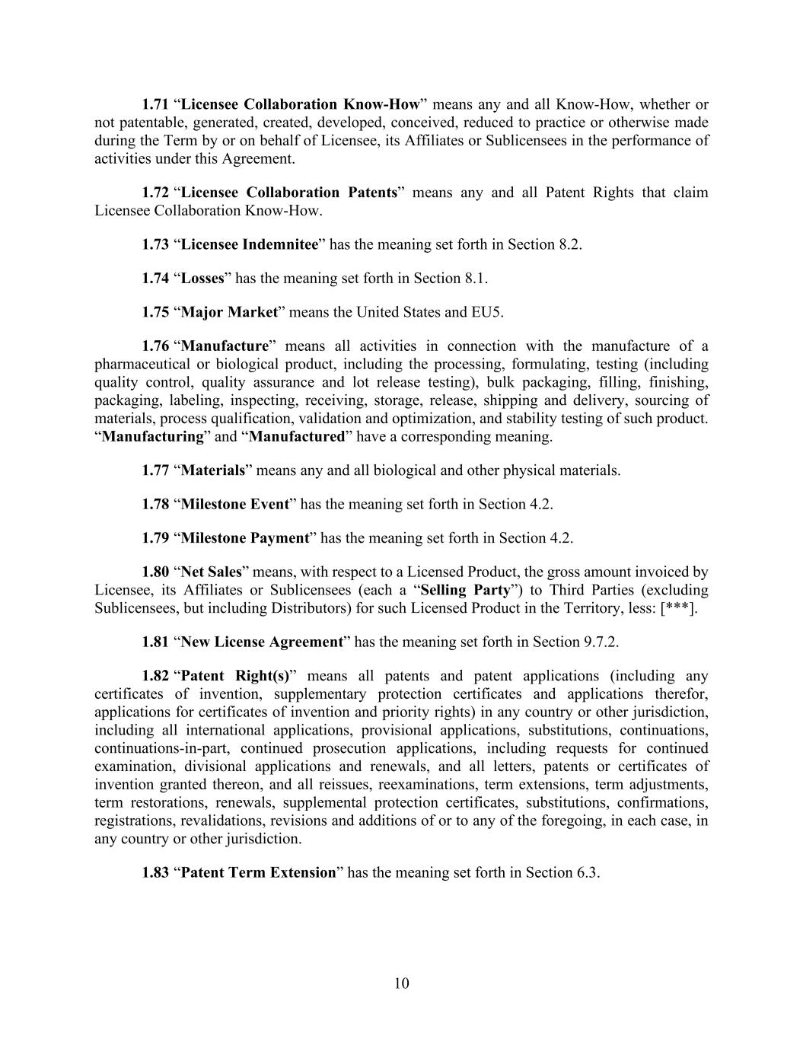
10 1.71 “Licensee Collaboration Know-How” means any and all Know-How, whether or not patentable, generated, created, developed, conceived, reduced to practice or otherwise made during the Term by or on behalf of Licensee, its Affiliates or Sublicensees in the performance of activities under this Agreement. 1.72 “Licensee Collaboration Patents” means any and all Patent Rights that claim Licensee Collaboration Know-How. 1.73 “Licensee Indemnitee” has the meaning set forth in Section 8.2. 1.74 “Losses” has the meaning set forth in Section 8.1. 1.75 “Major Market” means the United States and EU5. 1.76 “Manufacture” means all activities in connection with the manufacture of a pharmaceutical or biological product, including the processing, formulating, testing (including quality control, quality assurance and lot release testing), bulk packaging, filling, finishing, packaging, labeling, inspecting, receiving, storage, release, shipping and delivery, sourcing of materials, process qualification, validation and optimization, and stability testing of such product. “Manufacturing” and “Manufactured” have a corresponding meaning. 1.77 “Materials” means any and all biological and other physical materials. 1.78 “Milestone Event” has the meaning set forth in Section 4.2. 1.79 “Milestone Payment” has the meaning set forth in Section 4.2. 1.80 “Net Sales” means, with respect to a Licensed Product, the gross amount invoiced by Licensee, its Affiliates or Sublicensees (each a “Selling Party”) to Third Parties (excluding Sublicensees, but including Distributors) for such Licensed Product in the Territory, less: [***]. 1.81 “New License Agreement” has the meaning set forth in Section 9.7.2. 1.82 “Patent Right(s)” means all patents and patent applications (including any certificates of invention, supplementary protection certificates and applications therefor, applications for certificates of invention and priority rights) in any country or other jurisdiction, including all international applications, provisional applications, substitutions, continuations, continuations-in-part, continued prosecution applications, including requests for continued examination, divisional applications and renewals, and all letters, patents or certificates of invention granted thereon, and all reissues, reexaminations, term extensions, term adjustments, term restorations, renewals, supplemental protection certificates, substitutions, confirmations, registrations, revalidations, revisions and additions of or to any of the foregoing, in each case, in any country or other jurisdiction. 1.83 “Patent Term Extension” has the meaning set forth in Section 6.3.

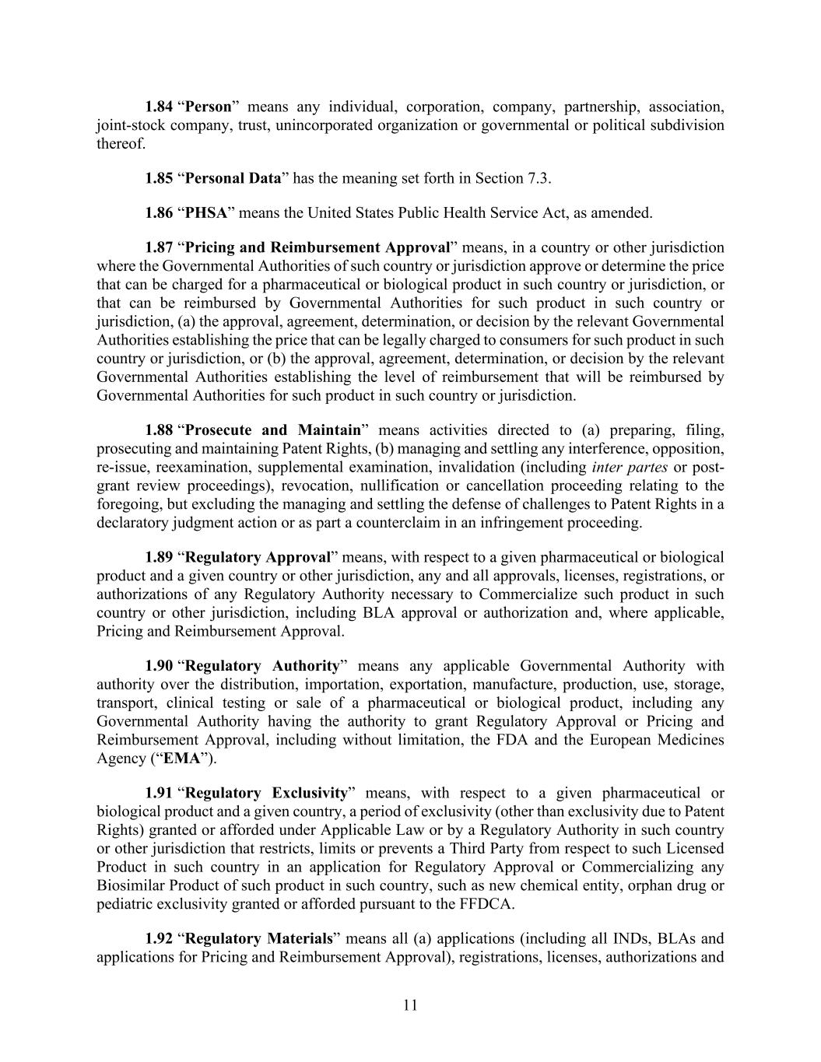
11 1.84 “Person” means any individual, corporation, company, partnership, association, joint-stock company, trust, unincorporated organization or governmental or political subdivision thereof. 1.85 “Personal Data” has the meaning set forth in Section 7.3. 1.86 “PHSA” means the United States Public Health Service Act, as amended. 1.87 “Pricing and Reimbursement Approval” means, in a country or other jurisdiction where the Governmental Authorities of such country or jurisdiction approve or determine the price that can be charged for a pharmaceutical or biological product in such country or jurisdiction, or that can be reimbursed by Governmental Authorities for such product in such country or jurisdiction, (a) the approval, agreement, determination, or decision by the relevant Governmental Authorities establishing the price that can be legally charged to consumers for such product in such country or jurisdiction, or (b) the approval, agreement, determination, or decision by the relevant Governmental Authorities establishing the level of reimbursement that will be reimbursed by Governmental Authorities for such product in such country or jurisdiction. 1.88 “Prosecute and Maintain” means activities directed to (a) preparing, filing, prosecuting and maintaining Patent Rights, (b) managing and settling any interference, opposition, re-issue, reexamination, supplemental examination, invalidation (including inter partes or post- grant review proceedings), revocation, nullification or cancellation proceeding relating to the foregoing, but excluding the managing and settling the defense of challenges to Patent Rights in a declaratory judgment action or as part a counterclaim in an infringement proceeding. 1.89 “Regulatory Approval” means, with respect to a given pharmaceutical or biological product and a given country or other jurisdiction, any and all approvals, licenses, registrations, or authorizations of any Regulatory Authority necessary to Commercialize such product in such country or other jurisdiction, including BLA approval or authorization and, where applicable, Pricing and Reimbursement Approval. 1.90 “Regulatory Authority” means any applicable Governmental Authority with authority over the distribution, importation, exportation, manufacture, production, use, storage, transport, clinical testing or sale of a pharmaceutical or biological product, including any Governmental Authority having the authority to grant Regulatory Approval or Pricing and Reimbursement Approval, including without limitation, the FDA and the European Medicines Agency (“EMA”). 1.91 “Regulatory Exclusivity” means, with respect to a given pharmaceutical or biological product and a given country, a period of exclusivity (other than exclusivity due to Patent Rights) granted or afforded under Applicable Law or by a Regulatory Authority in such country or other jurisdiction that restricts, limits or prevents a Third Party from respect to such Licensed Product in such country in an application for Regulatory Approval or Commercializing any Biosimilar Product of such product in such country, such as new chemical entity, orphan drug or pediatric exclusivity granted or afforded pursuant to the FFDCA. 1.92 “Regulatory Materials” means all (a) applications (including all INDs, BLAs and applications for Pricing and Reimbursement Approval), registrations, licenses, authorizations and

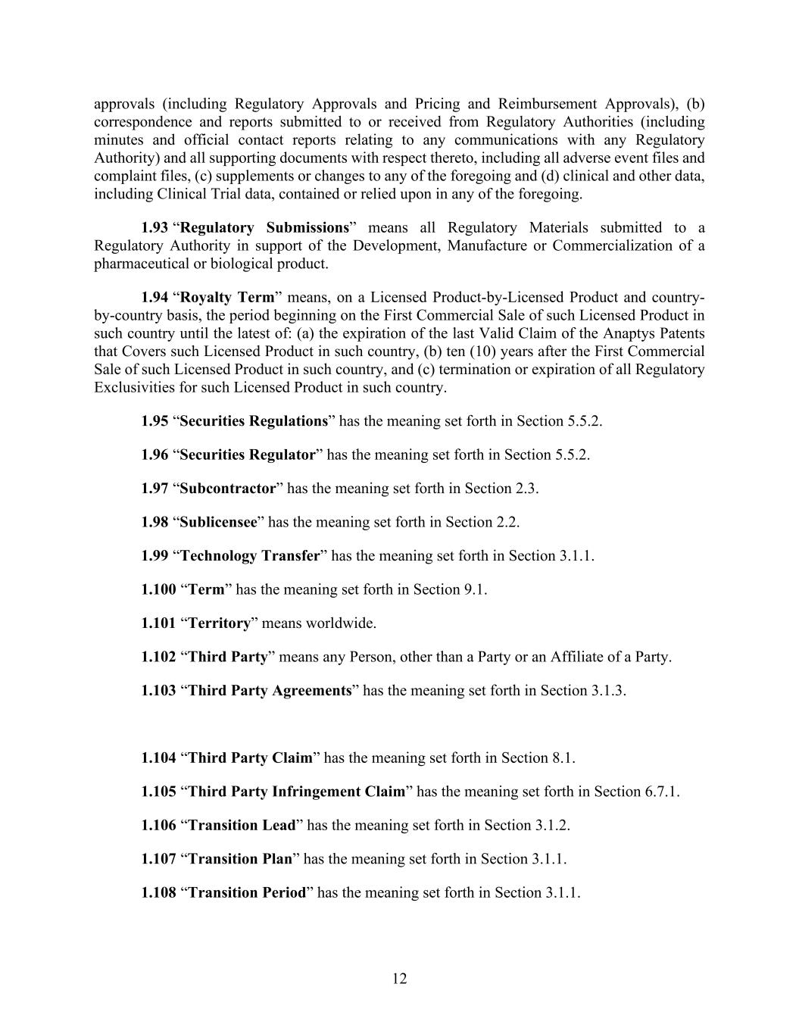
12 approvals (including Regulatory Approvals and Pricing and Reimbursement Approvals), (b) correspondence and reports submitted to or received from Regulatory Authorities (including minutes and official contact reports relating to any communications with any Regulatory Authority) and all supporting documents with respect thereto, including all adverse event files and complaint files, (c) supplements or changes to any of the foregoing and (d) clinical and other data, including Clinical Trial data, contained or relied upon in any of the foregoing. 1.93 “Regulatory Submissions” means all Regulatory Materials submitted to a Regulatory Authority in support of the Development, Manufacture or Commercialization of a pharmaceutical or biological product. 1.94 “Royalty Term” means, on a Licensed Product-by-Licensed Product and country- by-country basis, the period beginning on the First Commercial Sale of such Licensed Product in such country until the latest of: (a) the expiration of the last Valid Claim of the Anaptys Patents that Covers such Licensed Product in such country, (b) ten (10) years after the First Commercial Sale of such Licensed Product in such country, and (c) termination or expiration of all Regulatory Exclusivities for such Licensed Product in such country. 1.95 “Securities Regulations” has the meaning set forth in Section 5.5.2. 1.96 “Securities Regulator” has the meaning set forth in Section 5.5.2. 1.97 “Subcontractor” has the meaning set forth in Section 2.3. 1.98 “Sublicensee” has the meaning set forth in Section 2.2. 1.99 “Technology Transfer” has the meaning set forth in Section 3.1.1. 1.100 “Term” has the meaning set forth in Section 9.1. 1.101 “Territory” means worldwide. 1.102 “Third Party” means any Person, other than a Party or an Affiliate of a Party. 1.103 “Third Party Agreements” has the meaning set forth in Section 3.1.3. 1.104 “Third Party Claim” has the meaning set forth in Section 8.1. 1.105 “Third Party Infringement Claim” has the meaning set forth in Section 6.7.1. 1.106 “Transition Lead” has the meaning set forth in Section 3.1.2. 1.107 “Transition Plan” has the meaning set forth in Section 3.1.1. 1.108 “Transition Period” has the meaning set forth in Section 3.1.1.

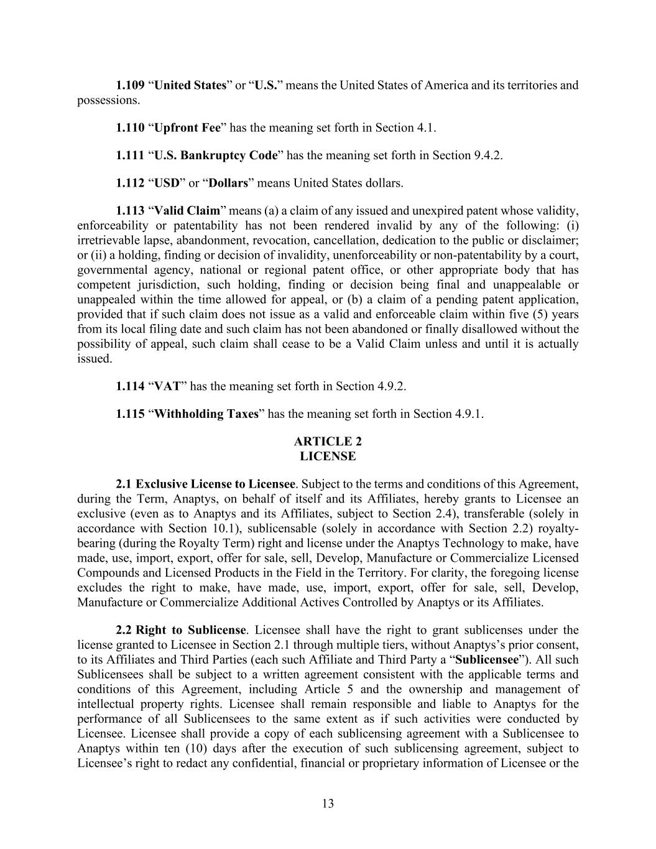
13 1.109 “United States” or “U.S.” means the United States of America and its territories and possessions. 1.110 “Upfront Fee” has the meaning set forth in Section 4.1. 1.111 “U.S. Bankruptcy Code” has the meaning set forth in Section 9.4.2. 1.112 “USD” or “Dollars” means United States dollars. 1.113 “Valid Claim” means (a) a claim of any issued and unexpired patent whose validity, enforceability or patentability has not been rendered invalid by any of the following: (i) irretrievable lapse, abandonment, revocation, cancellation, dedication to the public or disclaimer; or (ii) a holding, finding or decision of invalidity, unenforceability or non-patentability by a court, governmental agency, national or regional patent office, or other appropriate body that has competent jurisdiction, such holding, finding or decision being final and unappealable or unappealed within the time allowed for appeal, or (b) a claim of a pending patent application, provided that if such claim does not issue as a valid and enforceable claim within five (5) years from its local filing date and such claim has not been abandoned or finally disallowed without the possibility of appeal, such claim shall cease to be a Valid Claim unless and until it is actually issued. 1.114 “VAT” has the meaning set forth in Section 4.9.2. 1.115 “Withholding Taxes” has the meaning set forth in Section 4.9.1. ARTICLE 2 LICENSE 2.1 Exclusive License to Licensee. Subject to the terms and conditions of this Agreement, during the Term, Anaptys, on behalf of itself and its Affiliates, hereby grants to Licensee an exclusive (even as to Anaptys and its Affiliates, subject to Section 2.4), transferable (solely in accordance with Section 10.1), sublicensable (solely in accordance with Section 2.2) royalty- bearing (during the Royalty Term) right and license under the Anaptys Technology to make, have made, use, import, export, offer for sale, sell, Develop, Manufacture or Commercialize Licensed Compounds and Licensed Products in the Field in the Territory. For clarity, the foregoing license excludes the right to make, have made, use, import, export, offer for sale, sell, Develop, Manufacture or Commercialize Additional Actives Controlled by Anaptys or its Affiliates. 2.2 Right to Sublicense. Licensee shall have the right to grant sublicenses under the license granted to Licensee in Section 2.1 through multiple tiers, without Anaptys’s prior consent, to its Affiliates and Third Parties (each such Affiliate and Third Party a “Sublicensee”). All such Sublicensees shall be subject to a written agreement consistent with the applicable terms and conditions of this Agreement, including Article 5 and the ownership and management of intellectual property rights. Licensee shall remain responsible and liable to Anaptys for the performance of all Sublicensees to the same extent as if such activities were conducted by Licensee. Licensee shall provide a copy of each sublicensing agreement with a Sublicensee to Anaptys within ten (10) days after the execution of such sublicensing agreement, subject to Licensee’s right to redact any confidential, financial or proprietary information of Licensee or the

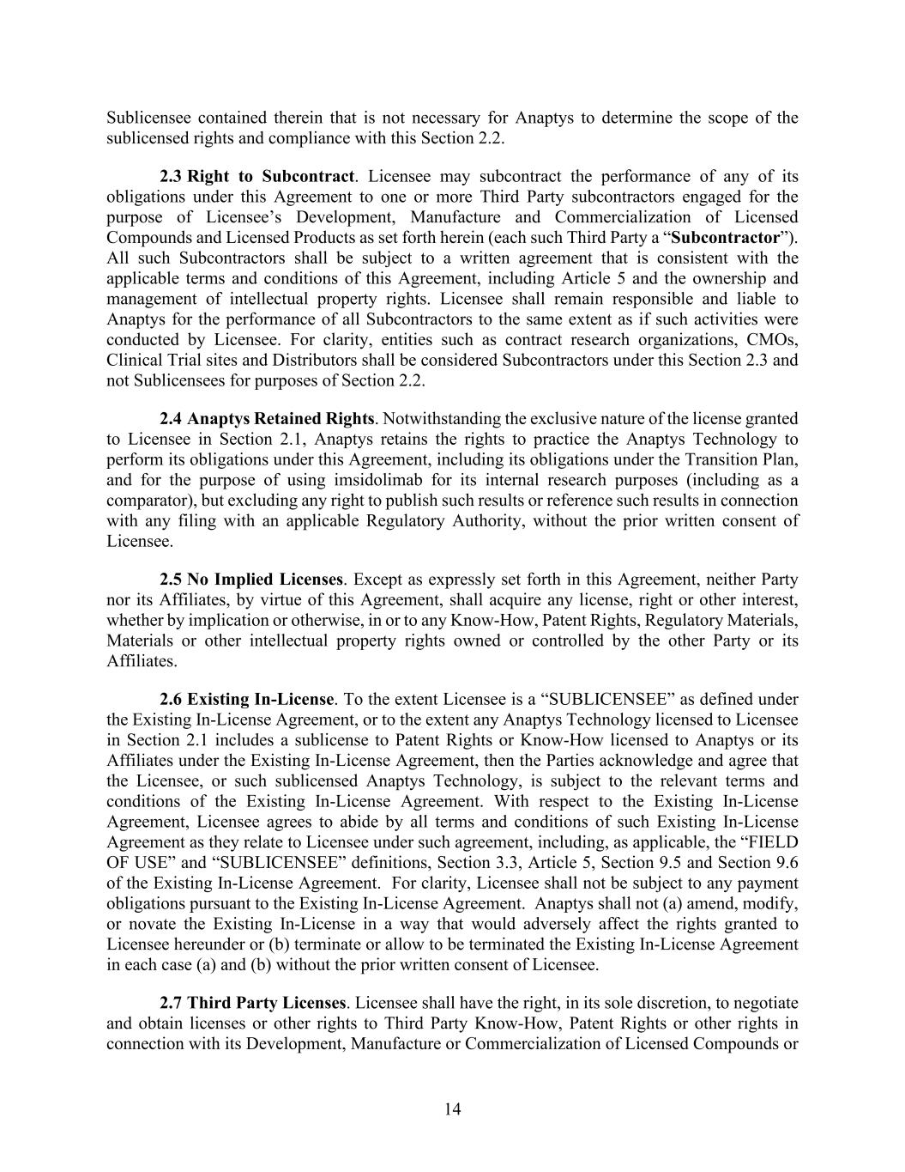
14 Sublicensee contained therein that is not necessary for Anaptys to determine the scope of the sublicensed rights and compliance with this Section 2.2. 2.3 Right to Subcontract. Licensee may subcontract the performance of any of its obligations under this Agreement to one or more Third Party subcontractors engaged for the purpose of Licensee’s Development, Manufacture and Commercialization of Licensed Compounds and Licensed Products as set forth herein (each such Third Party a “Subcontractor”). All such Subcontractors shall be subject to a written agreement that is consistent with the applicable terms and conditions of this Agreement, including Article 5 and the ownership and management of intellectual property rights. Licensee shall remain responsible and liable to Anaptys for the performance of all Subcontractors to the same extent as if such activities were conducted by Licensee. For clarity, entities such as contract research organizations, CMOs, Clinical Trial sites and Distributors shall be considered Subcontractors under this Section 2.3 and not Sublicensees for purposes of Section 2.2. 2.4 Anaptys Retained Rights. Notwithstanding the exclusive nature of the license granted to Licensee in Section 2.1, Anaptys retains the rights to practice the Anaptys Technology to perform its obligations under this Agreement, including its obligations under the Transition Plan, and for the purpose of using imsidolimab for its internal research purposes (including as a comparator), but excluding any right to publish such results or reference such results in connection with any filing with an applicable Regulatory Authority, without the prior written consent of Licensee. 2.5 No Implied Licenses. Except as expressly set forth in this Agreement, neither Party nor its Affiliates, by virtue of this Agreement, shall acquire any license, right or other interest, whether by implication or otherwise, in or to any Know-How, Patent Rights, Regulatory Materials, Materials or other intellectual property rights owned or controlled by the other Party or its Affiliates. 2.6 Existing In-License. To the extent Licensee is a “SUBLICENSEE” as defined under the Existing In-License Agreement, or to the extent any Anaptys Technology licensed to Licensee in Section 2.1 includes a sublicense to Patent Rights or Know-How licensed to Anaptys or its Affiliates under the Existing In-License Agreement, then the Parties acknowledge and agree that the Licensee, or such sublicensed Anaptys Technology, is subject to the relevant terms and conditions of the Existing In-License Agreement. With respect to the Existing In-License Agreement, Licensee agrees to abide by all terms and conditions of such Existing In-License Agreement as they relate to Licensee under such agreement, including, as applicable, the “FIELD OF USE” and “SUBLICENSEE” definitions, Section 3.3, Article 5, Section 9.5 and Section 9.6 of the Existing In-License Agreement. For clarity, Licensee shall not be subject to any payment obligations pursuant to the Existing In-License Agreement. Anaptys shall not (a) amend, modify, or novate the Existing In-License in a way that would adversely affect the rights granted to Licensee hereunder or (b) terminate or allow to be terminated the Existing In-License Agreement in each case (a) and (b) without the prior written consent of Licensee. 2.7 Third Party Licenses. Licensee shall have the right, in its sole discretion, to negotiate and obtain licenses or other rights to Third Party Know-How, Patent Rights or other rights in connection with its Development, Manufacture or Commercialization of Licensed Compounds or

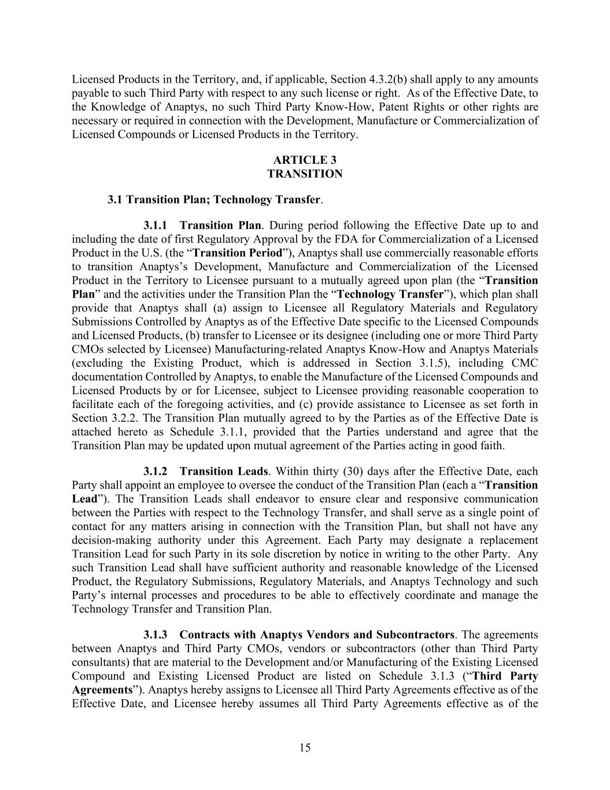
15 Licensed Products in the Territory, and, if applicable, Section 4.3.2(b) shall apply to any amounts payable to such Third Party with respect to any such license or right. As of the Effective Date, to the Knowledge of Anaptys, no such Third Party Know-How, Patent Rights or other rights are necessary or required in connection with the Development, Manufacture or Commercialization of Licensed Compounds or Licensed Products in the Territory. ARTICLE 3 TRANSITION 3.1 Transition Plan; Technology Transfer. 3.1.1 Transition Plan. During period following the Effective Date up to and including the date of first Regulatory Approval by the FDA for Commercialization of a Licensed Product in the U.S. (the “Transition Period”), Anaptys shall use commercially reasonable efforts to transition Anaptys’s Development, Manufacture and Commercialization of the Licensed Product in the Territory to Licensee pursuant to a mutually agreed upon plan (the “Transition Plan” and the activities under the Transition Plan the “Technology Transfer”), which plan shall provide that Anaptys shall (a) assign to Licensee all Regulatory Materials and Regulatory Submissions Controlled by Anaptys as of the Effective Date specific to the Licensed Compounds and Licensed Products, (b) transfer to Licensee or its designee (including one or more Third Party CMOs selected by Licensee) Manufacturing-related Anaptys Know-How and Anaptys Materials (excluding the Existing Product, which is addressed in Section 3.1.5), including CMC documentation Controlled by Anaptys, to enable the Manufacture of the Licensed Compounds and Licensed Products by or for Licensee, subject to Licensee providing reasonable cooperation to facilitate each of the foregoing activities, and (c) provide assistance to Licensee as set forth in Section 3.2.2. The Transition Plan mutually agreed to by the Parties as of the Effective Date is attached hereto as Schedule 3.1.1, provided that the Parties understand and agree that the Transition Plan may be updated upon mutual agreement of the Parties acting in good faith. 3.1.2 Transition Leads. Within thirty (30) days after the Effective Date, each Party shall appoint an employee to oversee the conduct of the Transition Plan (each a “Transition Lead”). The Transition Leads shall endeavor to ensure clear and responsive communication between the Parties with respect to the Technology Transfer, and shall serve as a single point of contact for any matters arising in connection with the Transition Plan, but shall not have any decision-making authority under this Agreement. Each Party may designate a replacement Transition Lead for such Party in its sole discretion by notice in writing to the other Party. Any such Transition Lead shall have sufficient authority and reasonable knowledge of the Licensed Product, the Regulatory Submissions, Regulatory Materials, and Anaptys Technology and such Party’s internal processes and procedures to be able to effectively coordinate and manage the Technology Transfer and Transition Plan. 3.1.3 Contracts with Anaptys Vendors and Subcontractors. The agreements between Anaptys and Third Party CMOs, vendors or subcontractors (other than Third Party consultants) that are material to the Development and/or Manufacturing of the Existing Licensed Compound and Existing Licensed Product are listed on Schedule 3.1.3 (“Third Party Agreements”). Anaptys hereby assigns to Licensee all Third Party Agreements effective as of the Effective Date, and Licensee hereby assumes all Third Party Agreements effective as of the

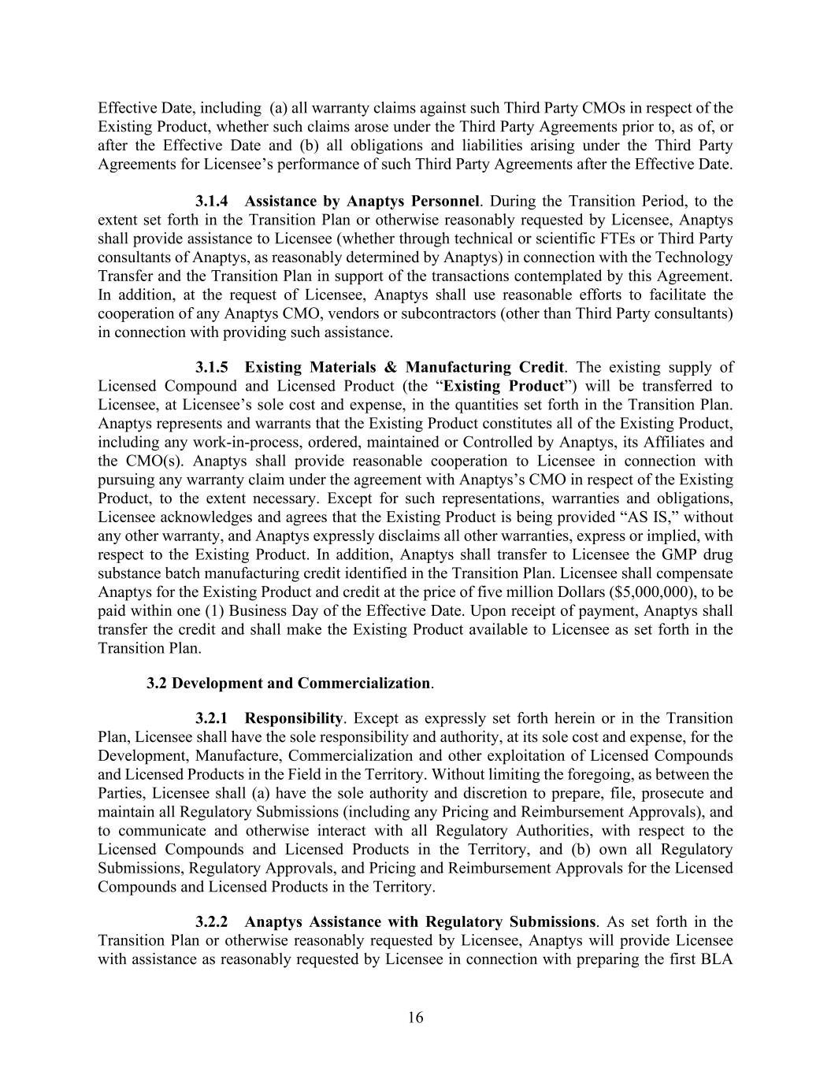
16 Effective Date, including (a) all warranty claims against such Third Party CMOs in respect of the Existing Product, whether such claims arose under the Third Party Agreements prior to, as of, or after the Effective Date and (b) all obligations and liabilities arising under the Third Party Agreements for Licensee’s performance of such Third Party Agreements after the Effective Date. 3.1.4 Assistance by Anaptys Personnel. During the Transition Period, to the extent set forth in the Transition Plan or otherwise reasonably requested by Licensee, Anaptys shall provide assistance to Licensee (whether through technical or scientific FTEs or Third Party consultants of Anaptys, as reasonably determined by Anaptys) in connection with the Technology Transfer and the Transition Plan in support of the transactions contemplated by this Agreement. In addition, at the request of Licensee, Anaptys shall use reasonable efforts to facilitate the cooperation of any Anaptys CMO, vendors or subcontractors (other than Third Party consultants) in connection with providing such assistance. 3.1.5 Existing Materials & Manufacturing Credit. The existing supply of Licensed Compound and Licensed Product (the “Existing Product”) will be transferred to Licensee, at Licensee’s sole cost and expense, in the quantities set forth in the Transition Plan. Anaptys represents and warrants that the Existing Product constitutes all of the Existing Product, including any work-in-process, ordered, maintained or Controlled by Anaptys, its Affiliates and the CMO(s). Anaptys shall provide reasonable cooperation to Licensee in connection with pursuing any warranty claim under the agreement with Anaptys’s CMO in respect of the Existing Product, to the extent necessary. Except for such representations, warranties and obligations, Licensee acknowledges and agrees that the Existing Product is being provided “AS IS,” without any other warranty, and Anaptys expressly disclaims all other warranties, express or implied, with respect to the Existing Product. In addition, Anaptys shall transfer to Licensee the GMP drug substance batch manufacturing credit identified in the Transition Plan. Licensee shall compensate Anaptys for the Existing Product and credit at the price of five million Dollars ($5,000,000), to be paid within one (1) Business Day of the Effective Date. Upon receipt of payment, Anaptys shall transfer the credit and shall make the Existing Product available to Licensee as set forth in the Transition Plan. 3.2 Development and Commercialization. 3.2.1 Responsibility. Except as expressly set forth herein or in the Transition Plan, Licensee shall have the sole responsibility and authority, at its sole cost and expense, for the Development, Manufacture, Commercialization and other exploitation of Licensed Compounds and Licensed Products in the Field in the Territory. Without limiting the foregoing, as between the Parties, Licensee shall (a) have the sole authority and discretion to prepare, file, prosecute and maintain all Regulatory Submissions (including any Pricing and Reimbursement Approvals), and to communicate and otherwise interact with all Regulatory Authorities, with respect to the Licensed Compounds and Licensed Products in the Territory, and (b) own all Regulatory Submissions, Regulatory Approvals, and Pricing and Reimbursement Approvals for the Licensed Compounds and Licensed Products in the Territory. 3.2.2 Anaptys Assistance with Regulatory Submissions. As set forth in the Transition Plan or otherwise reasonably requested by Licensee, Anaptys will provide Licensee with assistance as reasonably requested by Licensee in connection with preparing the first BLA

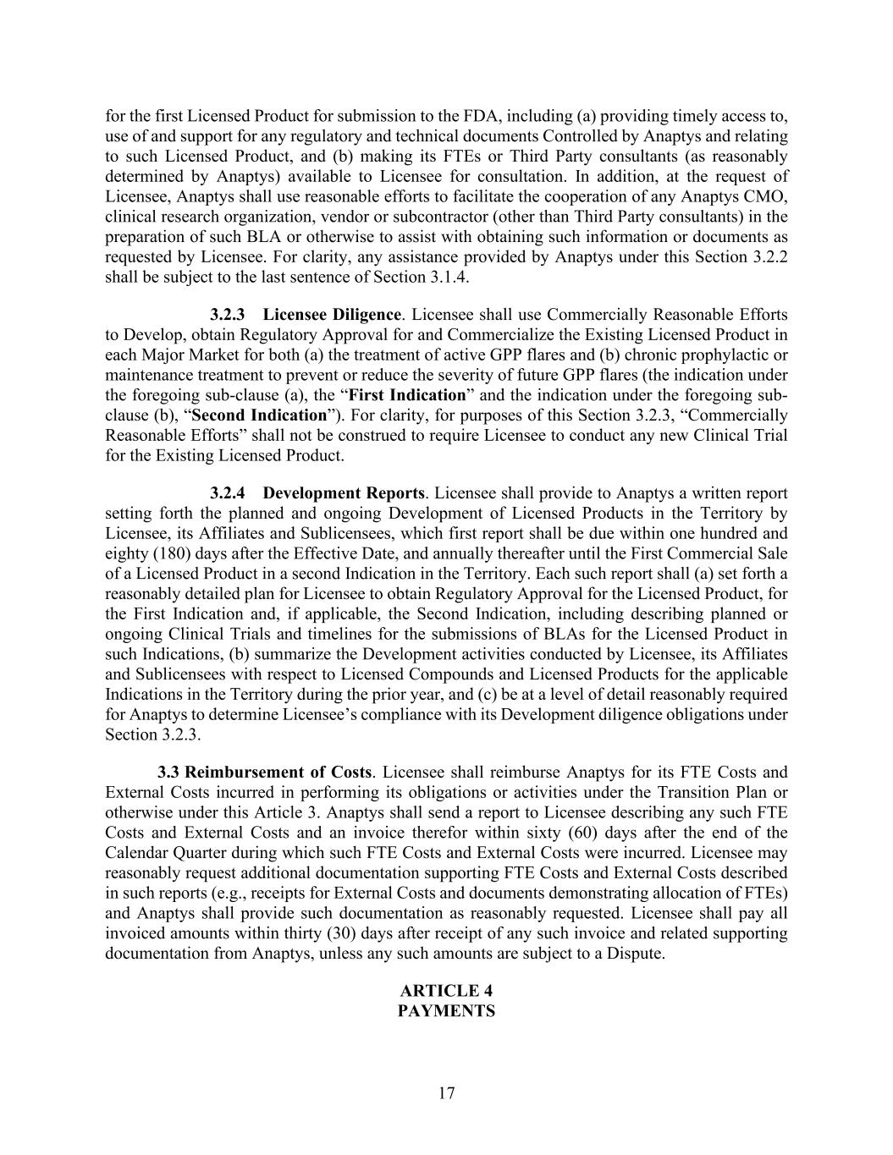
17 for the first Licensed Product for submission to the FDA, including (a) providing timely access to, use of and support for any regulatory and technical documents Controlled by Anaptys and relating to such Licensed Product, and (b) making its FTEs or Third Party consultants (as reasonably determined by Anaptys) available to Licensee for consultation. In addition, at the request of Licensee, Anaptys shall use reasonable efforts to facilitate the cooperation of any Anaptys CMO, clinical research organization, vendor or subcontractor (other than Third Party consultants) in the preparation of such BLA or otherwise to assist with obtaining such information or documents as requested by Licensee. For clarity, any assistance provided by Anaptys under this Section 3.2.2 shall be subject to the last sentence of Section 3.1.4. 3.2.3 Licensee Diligence. Licensee shall use Commercially Reasonable Efforts to Develop, obtain Regulatory Approval for and Commercialize the Existing Licensed Product in each Major Market for both (a) the treatment of active GPP flares and (b) chronic prophylactic or maintenance treatment to prevent or reduce the severity of future GPP flares (the indication under the foregoing sub-clause (a), the “First Indication” and the indication under the foregoing sub- clause (b), “Second Indication”). For clarity, for purposes of this Section 3.2.3, “Commercially Reasonable Efforts” shall not be construed to require Licensee to conduct any new Clinical Trial for the Existing Licensed Product. 3.2.4 Development Reports. Licensee shall provide to Anaptys a written report setting forth the planned and ongoing Development of Licensed Products in the Territory by Licensee, its Affiliates and Sublicensees, which first report shall be due within one hundred and eighty (180) days after the Effective Date, and annually thereafter until the First Commercial Sale of a Licensed Product in a second Indication in the Territory. Each such report shall (a) set forth a reasonably detailed plan for Licensee to obtain Regulatory Approval for the Licensed Product, for the First Indication and, if applicable, the Second Indication, including describing planned or ongoing Clinical Trials and timelines for the submissions of BLAs for the Licensed Product in such Indications, (b) summarize the Development activities conducted by Licensee, its Affiliates and Sublicensees with respect to Licensed Compounds and Licensed Products for the applicable Indications in the Territory during the prior year, and (c) be at a level of detail reasonably required for Anaptys to determine Licensee’s compliance with its Development diligence obligations under Section 3.2.3. 3.3 Reimbursement of Costs. Licensee shall reimburse Anaptys for its FTE Costs and External Costs incurred in performing its obligations or activities under the Transition Plan or otherwise under this Article 3. Anaptys shall send a report to Licensee describing any such FTE Costs and External Costs and an invoice therefor within sixty (60) days after the end of the Calendar Quarter during which such FTE Costs and External Costs were incurred. Licensee may reasonably request additional documentation supporting FTE Costs and External Costs described in such reports (e.g., receipts for External Costs and documents demonstrating allocation of FTEs) and Anaptys shall provide such documentation as reasonably requested. Licensee shall pay all invoiced amounts within thirty (30) days after receipt of any such invoice and related supporting documentation from Anaptys, unless any such amounts are subject to a Dispute. ARTICLE 4 PAYMENTS

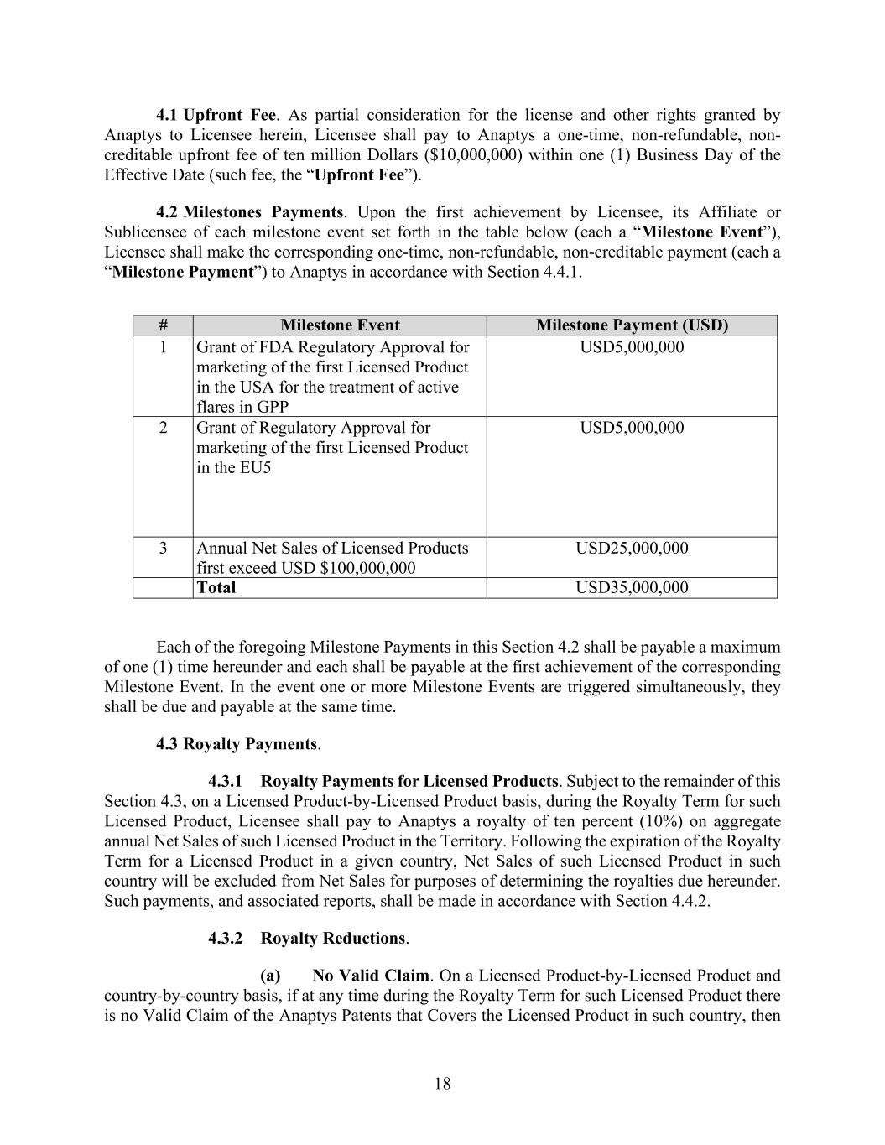
18 4.1 Upfront Fee. As partial consideration for the license and other rights granted by Anaptys to Licensee herein, Licensee shall pay to Anaptys a one-time, non-refundable, non- creditable upfront fee of ten million Dollars ($10,000,000) within one (1) Business Day of the Effective Date (such fee, the “Upfront Fee”). 4.2 Milestones Payments. Upon the first achievement by Licensee, its Affiliate or Sublicensee of each milestone event set forth in the table below (each a “Milestone Event”), Licensee shall make the corresponding one-time, non-refundable, non-creditable payment (each a “Milestone Payment”) to Anaptys in accordance with Section 4.4.1. # Milestone Event Milestone Payment (USD) 1 Grant of FDA Regulatory Approval for marketing of the first Licensed Product in the USA for the treatment of active flares in GPP USD5,000,000 2 Grant of Regulatory Approval for marketing of the first Licensed Product in the EU5 USD5,000,000 3 Annual Net Sales of Licensed Products first exceed USD $100,000,000 USD25,000,000 Total USD35,000,000 Each of the foregoing Milestone Payments in this Section 4.2 shall be payable a maximum of one (1) time hereunder and each shall be payable at the first achievement of the corresponding Milestone Event. In the event one or more Milestone Events are triggered simultaneously, they shall be due and payable at the same time. 4.3 Royalty Payments. 4.3.1 Royalty Payments for Licensed Products. Subject to the remainder of this Section 4.3, on a Licensed Product-by-Licensed Product basis, during the Royalty Term for such Licensed Product, Licensee shall pay to Anaptys a royalty of ten percent (10%) on aggregate annual Net Sales of such Licensed Product in the Territory. Following the expiration of the Royalty Term for a Licensed Product in a given country, Net Sales of such Licensed Product in such country will be excluded from Net Sales for purposes of determining the royalties due hereunder. Such payments, and associated reports, shall be made in accordance with Section 4.4.2. 4.3.2 Royalty Reductions. (a) No Valid Claim. On a Licensed Product-by-Licensed Product and country-by-country basis, if at any time during the Royalty Term for such Licensed Product there is no Valid Claim of the Anaptys Patents that Covers the Licensed Product in such country, then

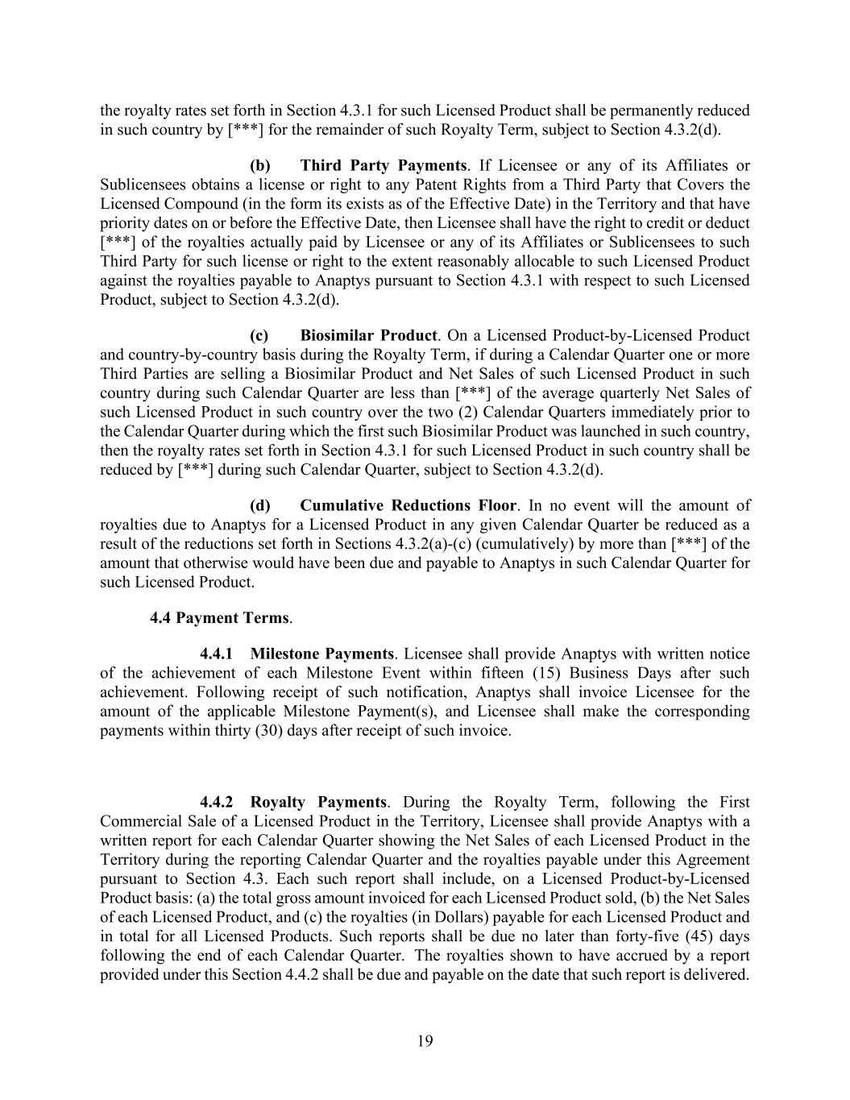
19 the royalty rates set forth in Section 4.3.1 for such Licensed Product shall be permanently reduced in such country by [***] for the remainder of such Royalty Term, subject to Section 4.3.2(d). (b) Third Party Payments. If Licensee or any of its Affiliates or Sublicensees obtains a license or right to any Patent Rights from a Third Party that Covers the Licensed Compound (in the form its exists as of the Effective Date) in the Territory and that have priority dates on or before the Effective Date, then Licensee shall have the right to credit or deduct [***] of the royalties actually paid by Licensee or any of its Affiliates or Sublicensees to such Third Party for such license or right to the extent reasonably allocable to such Licensed Product against the royalties payable to Anaptys pursuant to Section 4.3.1 with respect to such Licensed Product, subject to Section 4.3.2(d). (c) Biosimilar Product. On a Licensed Product-by-Licensed Product and country-by-country basis during the Royalty Term, if during a Calendar Quarter one or more Third Parties are selling a Biosimilar Product and Net Sales of such Licensed Product in such country during such Calendar Quarter are less than [***] of the average quarterly Net Sales of such Licensed Product in such country over the two (2) Calendar Quarters immediately prior to the Calendar Quarter during which the first such Biosimilar Product was launched in such country, then the royalty rates set forth in Section 4.3.1 for such Licensed Product in such country shall be reduced by [***] during such Calendar Quarter, subject to Section 4.3.2(d). (d) Cumulative Reductions Floor. In no event will the amount of royalties due to Anaptys for a Licensed Product in any given Calendar Quarter be reduced as a result of the reductions set forth in Sections 4.3.2(a)-(c) (cumulatively) by more than [***] of the amount that otherwise would have been due and payable to Anaptys in such Calendar Quarter for such Licensed Product. 4.4 Payment Terms. 4.4.1 Milestone Payments. Licensee shall provide Anaptys with written notice of the achievement of each Milestone Event within fifteen (15) Business Days after such achievement. Following receipt of such notification, Anaptys shall invoice Licensee for the amount of the applicable Milestone Payment(s), and Licensee shall make the corresponding payments within thirty (30) days after receipt of such invoice. 4.4.2 Royalty Payments. During the Royalty Term, following the First Commercial Sale of a Licensed Product in the Territory, Licensee shall provide Anaptys with a written report for each Calendar Quarter showing the Net Sales of each Licensed Product in the Territory during the reporting Calendar Quarter and the royalties payable under this Agreement pursuant to Section 4.3. Each such report shall include, on a Licensed Product-by-Licensed Product basis: (a) the total gross amount invoiced for each Licensed Product sold, (b) the Net Sales of each Licensed Product, and (c) the royalties (in Dollars) payable for each Licensed Product and in total for all Licensed Products. Such reports shall be due no later than forty-five (45) days following the end of each Calendar Quarter. The royalties shown to have accrued by a report provided under this Section 4.4.2 shall be due and payable on the date that such report is delivered.

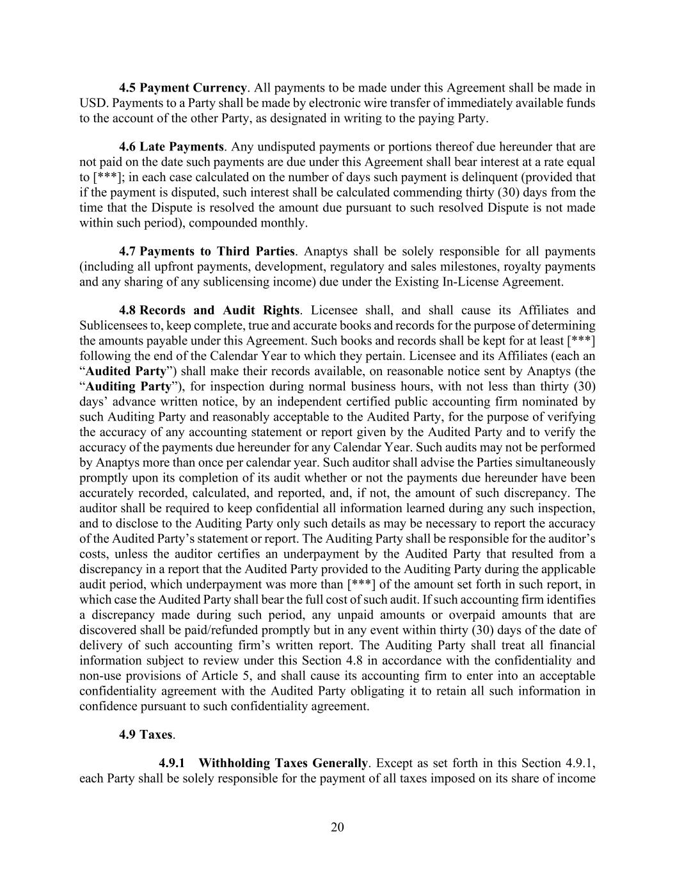
20 4.5 Payment Currency. All payments to be made under this Agreement shall be made in USD. Payments to a Party shall be made by electronic wire transfer of immediately available funds to the account of the other Party, as designated in writing to the paying Party. 4.6 Late Payments. Any undisputed payments or portions thereof due hereunder that are not paid on the date such payments are due under this Agreement shall bear interest at a rate equal to [***]; in each case calculated on the number of days such payment is delinquent (provided that if the payment is disputed, such interest shall be calculated commending thirty (30) days from the time that the Dispute is resolved the amount due pursuant to such resolved Dispute is not made within such period), compounded monthly. 4.7 Payments to Third Parties. Anaptys shall be solely responsible for all payments (including all upfront payments, development, regulatory and sales milestones, royalty payments and any sharing of any sublicensing income) due under the Existing In-License Agreement. 4.8 Records and Audit Rights. Licensee shall, and shall cause its Affiliates and Sublicensees to, keep complete, true and accurate books and records for the purpose of determining the amounts payable under this Agreement. Such books and records shall be kept for at least [***] following the end of the Calendar Year to which they pertain. Licensee and its Affiliates (each an “Audited Party”) shall make their records available, on reasonable notice sent by Anaptys (the “Auditing Party”), for inspection during normal business hours, with not less than thirty (30) days’ advance written notice, by an independent certified public accounting firm nominated by such Auditing Party and reasonably acceptable to the Audited Party, for the purpose of verifying the accuracy of any accounting statement or report given by the Audited Party and to verify the accuracy of the payments due hereunder for any Calendar Year. Such audits may not be performed by Anaptys more than once per calendar year. Such auditor shall advise the Parties simultaneously promptly upon its completion of its audit whether or not the payments due hereunder have been accurately recorded, calculated, and reported, and, if not, the amount of such discrepancy. The auditor shall be required to keep confidential all information learned during any such inspection, and to disclose to the Auditing Party only such details as may be necessary to report the accuracy of the Audited Party’s statement or report. The Auditing Party shall be responsible for the auditor’s costs, unless the auditor certifies an underpayment by the Audited Party that resulted from a discrepancy in a report that the Audited Party provided to the Auditing Party during the applicable audit period, which underpayment was more than [***] of the amount set forth in such report, in which case the Audited Party shall bear the full cost of such audit. If such accounting firm identifies a discrepancy made during such period, any unpaid amounts or overpaid amounts that are discovered shall be paid/refunded promptly but in any event within thirty (30) days of the date of delivery of such accounting firm’s written report. The Auditing Party shall treat all financial information subject to review under this Section 4.8 in accordance with the confidentiality and non-use provisions of Article 5, and shall cause its accounting firm to enter into an acceptable confidentiality agreement with the Audited Party obligating it to retain all such information in confidence pursuant to such confidentiality agreement. 4.9 Taxes. 4.9.1 Withholding Taxes Generally. Except as set forth in this Section 4.9.1, each Party shall be solely responsible for the payment of all taxes imposed on its share of income

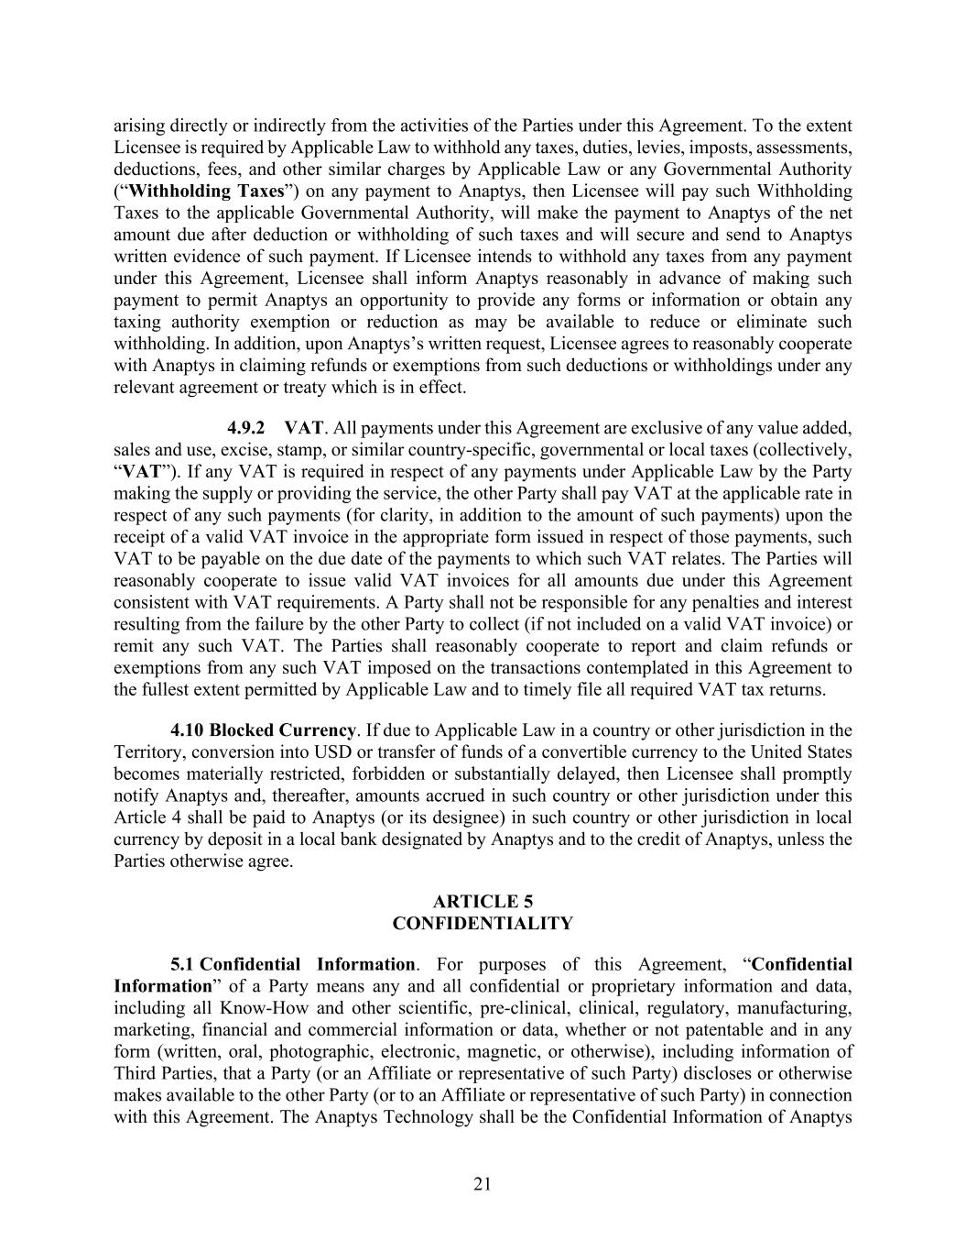
21 arising directly or indirectly from the activities of the Parties under this Agreement. To the extent Licensee is required by Applicable Law to withhold any taxes, duties, levies, imposts, assessments, deductions, fees, and other similar charges by Applicable Law or any Governmental Authority (“Withholding Taxes”) on any payment to Anaptys, then Licensee will pay such Withholding Taxes to the applicable Governmental Authority, will make the payment to Anaptys of the net amount due after deduction or withholding of such taxes and will secure and send to Anaptys written evidence of such payment. If Licensee intends to withhold any taxes from any payment under this Agreement, Licensee shall inform Anaptys reasonably in advance of making such payment to permit Anaptys an opportunity to provide any forms or information or obtain any taxing authority exemption or reduction as may be available to reduce or eliminate such withholding. In addition, upon Anaptys’s written request, Licensee agrees to reasonably cooperate with Anaptys in claiming refunds or exemptions from such deductions or withholdings under any relevant agreement or treaty which is in effect. 4.9.2 VAT. All payments under this Agreement are exclusive of any value added, sales and use, excise, stamp, or similar country-specific, governmental or local taxes (collectively, “VAT”). If any VAT is required in respect of any payments under Applicable Law by the Party making the supply or providing the service, the other Party shall pay VAT at the applicable rate in respect of any such payments (for clarity, in addition to the amount of such payments) upon the receipt of a valid VAT invoice in the appropriate form issued in respect of those payments, such VAT to be payable on the due date of the payments to which such VAT relates. The Parties will reasonably cooperate to issue valid VAT invoices for all amounts due under this Agreement consistent with VAT requirements. A Party shall not be responsible for any penalties and interest resulting from the failure by the other Party to collect (if not included on a valid VAT invoice) or remit any such VAT. The Parties shall reasonably cooperate to report and claim refunds or exemptions from any such VAT imposed on the transactions contemplated in this Agreement to the fullest extent permitted by Applicable Law and to timely file all required VAT tax returns. 4.10 Blocked Currency. If due to Applicable Law in a country or other jurisdiction in the Territory, conversion into USD or transfer of funds of a convertible currency to the United States becomes materially restricted, forbidden or substantially delayed, then Licensee shall promptly notify Anaptys and, thereafter, amounts accrued in such country or other jurisdiction under this Article 4 shall be paid to Anaptys (or its designee) in such country or other jurisdiction in local currency by deposit in a local bank designated by Anaptys and to the credit of Anaptys, unless the Parties otherwise agree. ARTICLE 5 CONFIDENTIALITY 5.1 Confidential Information. For purposes of this Agreement, “Confidential Information” of a Party means any and all confidential or proprietary information and data, including all Know-How and other scientific, pre-clinical, clinical, regulatory, manufacturing, marketing, financial and commercial information or data, whether or not patentable and in any form (written, oral, photographic, electronic, magnetic, or otherwise), including information of Third Parties, that a Party (or an Affiliate or representative of such Party) discloses or otherwise makes available to the other Party (or to an Affiliate or representative of such Party) in connection with this Agreement. The Anaptys Technology shall be the Confidential Information of Anaptys

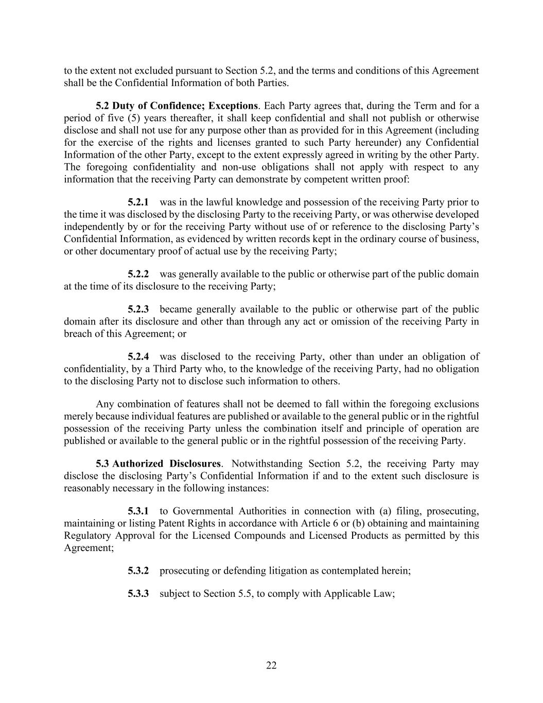
22 to the extent not excluded pursuant to Section 5.2, and the terms and conditions of this Agreement shall be the Confidential Information of both Parties. 5.2 Duty of Confidence; Exceptions. Each Party agrees that, during the Term and for a period of five (5) years thereafter, it shall keep confidential and shall not publish or otherwise disclose and shall not use for any purpose other than as provided for in this Agreement (including for the exercise of the rights and licenses granted to such Party hereunder) any Confidential Information of the other Party, except to the extent expressly agreed in writing by the other Party. The foregoing confidentiality and non-use obligations shall not apply with respect to any information that the receiving Party can demonstrate by competent written proof: 5.2.1 was in the lawful knowledge and possession of the receiving Party prior to the time it was disclosed by the disclosing Party to the receiving Party, or was otherwise developed independently by or for the receiving Party without use of or reference to the disclosing Party’s Confidential Information, as evidenced by written records kept in the ordinary course of business, or other documentary proof of actual use by the receiving Party; 5.2.2 was generally available to the public or otherwise part of the public domain at the time of its disclosure to the receiving Party; 5.2.3 became generally available to the public or otherwise part of the public domain after its disclosure and other than through any act or omission of the receiving Party in breach of this Agreement; or 5.2.4 was disclosed to the receiving Party, other than under an obligation of confidentiality, by a Third Party who, to the knowledge of the receiving Party, had no obligation to the disclosing Party not to disclose such information to others. Any combination of features shall not be deemed to fall within the foregoing exclusions merely because individual features are published or available to the general public or in the rightful possession of the receiving Party unless the combination itself and principle of operation are published or available to the general public or in the rightful possession of the receiving Party. 5.3 Authorized Disclosures. Notwithstanding Section 5.2, the receiving Party may disclose the disclosing Party’s Confidential Information if and to the extent such disclosure is reasonably necessary in the following instances: 5.3.1 to Governmental Authorities in connection with (a) filing, prosecuting, maintaining or listing Patent Rights in accordance with Article 6 or (b) obtaining and maintaining Regulatory Approval for the Licensed Compounds and Licensed Products as permitted by this Agreement; 5.3.2 prosecuting or defending litigation as contemplated herein; 5.3.3 subject to Section 5.5, to comply with Applicable Law;

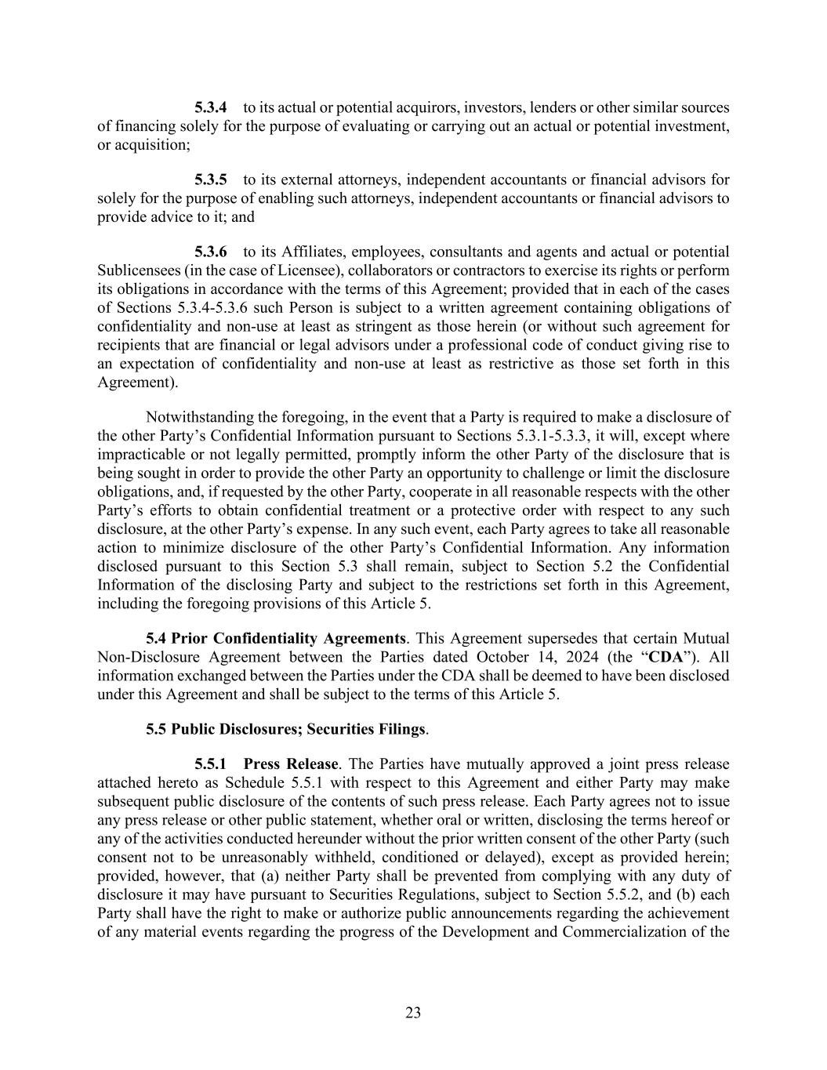
23 5.3.4 to its actual or potential acquirors, investors, lenders or other similar sources of financing solely for the purpose of evaluating or carrying out an actual or potential investment, or acquisition; 5.3.5 to its external attorneys, independent accountants or financial advisors for solely for the purpose of enabling such attorneys, independent accountants or financial advisors to provide advice to it; and 5.3.6 to its Affiliates, employees, consultants and agents and actual or potential Sublicensees (in the case of Licensee), collaborators or contractors to exercise its rights or perform its obligations in accordance with the terms of this Agreement; provided that in each of the cases of Sections 5.3.4-5.3.6 such Person is subject to a written agreement containing obligations of confidentiality and non-use at least as stringent as those herein (or without such agreement for recipients that are financial or legal advisors under a professional code of conduct giving rise to an expectation of confidentiality and non-use at least as restrictive as those set forth in this Agreement). Notwithstanding the foregoing, in the event that a Party is required to make a disclosure of the other Party’s Confidential Information pursuant to Sections 5.3.1-5.3.3, it will, except where impracticable or not legally permitted, promptly inform the other Party of the disclosure that is being sought in order to provide the other Party an opportunity to challenge or limit the disclosure obligations, and, if requested by the other Party, cooperate in all reasonable respects with the other Party’s efforts to obtain confidential treatment or a protective order with respect to any such disclosure, at the other Party’s expense. In any such event, each Party agrees to take all reasonable action to minimize disclosure of the other Party’s Confidential Information. Any information disclosed pursuant to this Section 5.3 shall remain, subject to Section 5.2 the Confidential Information of the disclosing Party and subject to the restrictions set forth in this Agreement, including the foregoing provisions of this Article 5. 5.4 Prior Confidentiality Agreements. This Agreement supersedes that certain Mutual Non-Disclosure Agreement between the Parties dated October 14, 2024 (the “CDA”). All information exchanged between the Parties under the CDA shall be deemed to have been disclosed under this Agreement and shall be subject to the terms of this Article 5. 5.5 Public Disclosures; Securities Filings. 5.5.1 Press Release. The Parties have mutually approved a joint press release attached hereto as Schedule 5.5.1 with respect to this Agreement and either Party may make subsequent public disclosure of the contents of such press release. Each Party agrees not to issue any press release or other public statement, whether oral or written, disclosing the terms hereof or any of the activities conducted hereunder without the prior written consent of the other Party (such consent not to be unreasonably withheld, conditioned or delayed), except as provided herein; provided, however, that (a) neither Party shall be prevented from complying with any duty of disclosure it may have pursuant to Securities Regulations, subject to Section 5.5.2, and (b) each Party shall have the right to make or authorize public announcements regarding the achievement of any material events regarding the progress of the Development and Commercialization of the

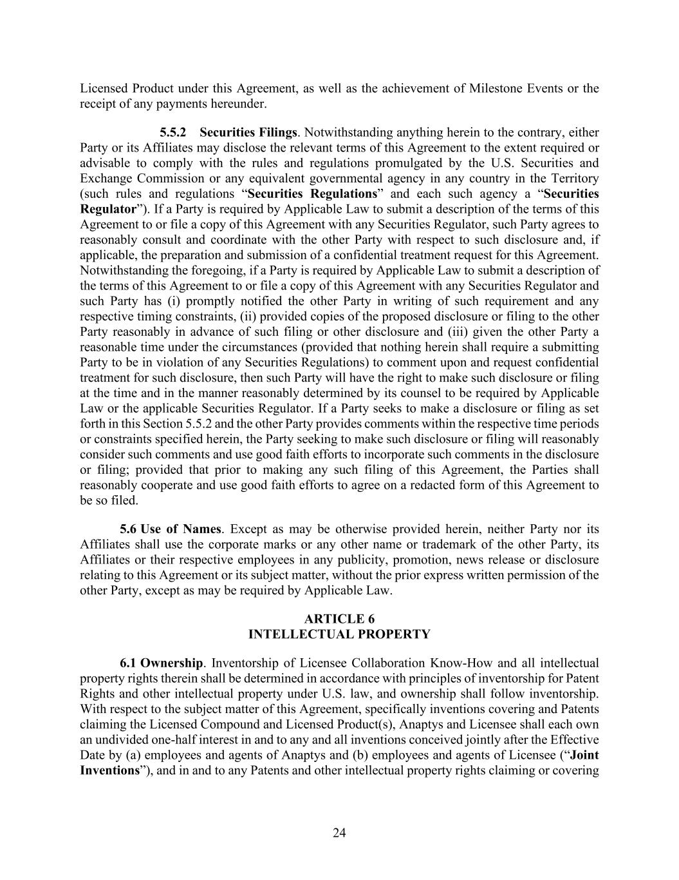
24 Licensed Product under this Agreement, as well as the achievement of Milestone Events or the receipt of any payments hereunder. 5.5.2 Securities Filings. Notwithstanding anything herein to the contrary, either Party or its Affiliates may disclose the relevant terms of this Agreement to the extent required or advisable to comply with the rules and regulations promulgated by the U.S. Securities and Exchange Commission or any equivalent governmental agency in any country in the Territory (such rules and regulations “Securities Regulations” and each such agency a “Securities Regulator”). If a Party is required by Applicable Law to submit a description of the terms of this Agreement to or file a copy of this Agreement with any Securities Regulator, such Party agrees to reasonably consult and coordinate with the other Party with respect to such disclosure and, if applicable, the preparation and submission of a confidential treatment request for this Agreement. Notwithstanding the foregoing, if a Party is required by Applicable Law to submit a description of the terms of this Agreement to or file a copy of this Agreement with any Securities Regulator and such Party has (i) promptly notified the other Party in writing of such requirement and any respective timing constraints, (ii) provided copies of the proposed disclosure or filing to the other Party reasonably in advance of such filing or other disclosure and (iii) given the other Party a reasonable time under the circumstances (provided that nothing herein shall require a submitting Party to be in violation of any Securities Regulations) to comment upon and request confidential treatment for such disclosure, then such Party will have the right to make such disclosure or filing at the time and in the manner reasonably determined by its counsel to be required by Applicable Law or the applicable Securities Regulator. If a Party seeks to make a disclosure or filing as set forth in this Section 5.5.2 and the other Party provides comments within the respective time periods or constraints specified herein, the Party seeking to make such disclosure or filing will reasonably consider such comments and use good faith efforts to incorporate such comments in the disclosure or filing; provided that prior to making any such filing of this Agreement, the Parties shall reasonably cooperate and use good faith efforts to agree on a redacted form of this Agreement to be so filed. 5.6 Use of Names. Except as may be otherwise provided herein, neither Party nor its Affiliates shall use the corporate marks or any other name or trademark of the other Party, its Affiliates or their respective employees in any publicity, promotion, news release or disclosure relating to this Agreement or its subject matter, without the prior express written permission of the other Party, except as may be required by Applicable Law. ARTICLE 6 INTELLECTUAL PROPERTY 6.1 Ownership. Inventorship of Licensee Collaboration Know-How and all intellectual property rights therein shall be determined in accordance with principles of inventorship for Patent Rights and other intellectual property under U.S. law, and ownership shall follow inventorship. With respect to the subject matter of this Agreement, specifically inventions covering and Patents claiming the Licensed Compound and Licensed Product(s), Anaptys and Licensee shall each own an undivided one-half interest in and to any and all inventions conceived jointly after the Effective Date by (a) employees and agents of Anaptys and (b) employees and agents of Licensee (“Joint Inventions”), and in and to any Patents and other intellectual property rights claiming or covering

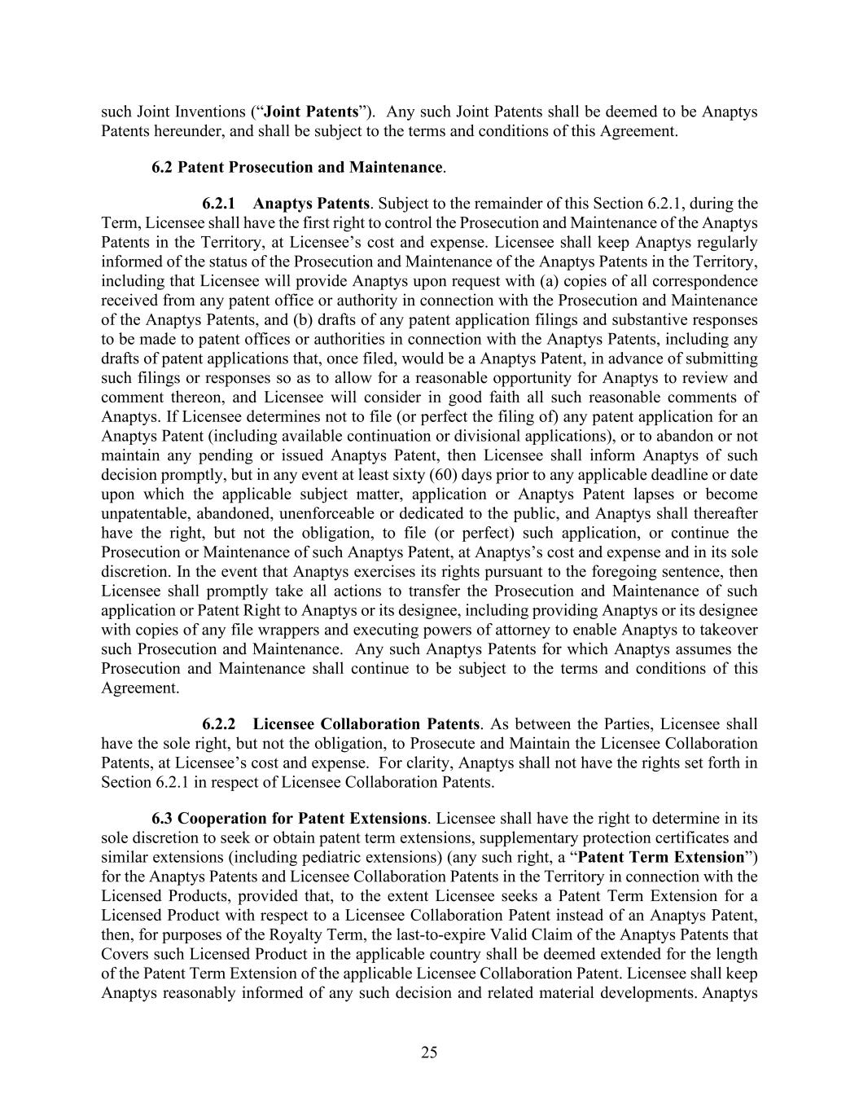
25 such Joint Inventions (“Joint Patents”). Any such Joint Patents shall be deemed to be Anaptys Patents hereunder, and shall be subject to the terms and conditions of this Agreement. 6.2 Patent Prosecution and Maintenance. 6.2.1 Anaptys Patents. Subject to the remainder of this Section 6.2.1, during the Term, Licensee shall have the first right to control the Prosecution and Maintenance of the Anaptys Patents in the Territory, at Licensee’s cost and expense. Licensee shall keep Anaptys regularly informed of the status of the Prosecution and Maintenance of the Anaptys Patents in the Territory, including that Licensee will provide Anaptys upon request with (a) copies of all correspondence received from any patent office or authority in connection with the Prosecution and Maintenance of the Anaptys Patents, and (b) drafts of any patent application filings and substantive responses to be made to patent offices or authorities in connection with the Anaptys Patents, including any drafts of patent applications that, once filed, would be a Anaptys Patent, in advance of submitting such filings or responses so as to allow for a reasonable opportunity for Anaptys to review and comment thereon, and Licensee will consider in good faith all such reasonable comments of Anaptys. If Licensee determines not to file (or perfect the filing of) any patent application for an Anaptys Patent (including available continuation or divisional applications), or to abandon or not maintain any pending or issued Anaptys Patent, then Licensee shall inform Anaptys of such decision promptly, but in any event at least sixty (60) days prior to any applicable deadline or date upon which the applicable subject matter, application or Anaptys Patent lapses or become unpatentable, abandoned, unenforceable or dedicated to the public, and Anaptys shall thereafter have the right, but not the obligation, to file (or perfect) such application, or continue the Prosecution or Maintenance of such Anaptys Patent, at Anaptys’s cost and expense and in its sole discretion. In the event that Anaptys exercises its rights pursuant to the foregoing sentence, then Licensee shall promptly take all actions to transfer the Prosecution and Maintenance of such application or Patent Right to Anaptys or its designee, including providing Anaptys or its designee with copies of any file wrappers and executing powers of attorney to enable Anaptys to takeover such Prosecution and Maintenance. Any such Anaptys Patents for which Anaptys assumes the Prosecution and Maintenance shall continue to be subject to the terms and conditions of this Agreement. 6.2.2 Licensee Collaboration Patents. As between the Parties, Licensee shall have the sole right, but not the obligation, to Prosecute and Maintain the Licensee Collaboration Patents, at Licensee’s cost and expense. For clarity, Anaptys shall not have the rights set forth in Section 6.2.1 in respect of Licensee Collaboration Patents. 6.3 Cooperation for Patent Extensions. Licensee shall have the right to determine in its sole discretion to seek or obtain patent term extensions, supplementary protection certificates and similar extensions (including pediatric extensions) (any such right, a “Patent Term Extension”) for the Anaptys Patents and Licensee Collaboration Patents in the Territory in connection with the Licensed Products, provided that, to the extent Licensee seeks a Patent Term Extension for a Licensed Product with respect to a Licensee Collaboration Patent instead of an Anaptys Patent, then, for purposes of the Royalty Term, the last-to-expire Valid Claim of the Anaptys Patents that Covers such Licensed Product in the applicable country shall be deemed extended for the length of the Patent Term Extension of the applicable Licensee Collaboration Patent. Licensee shall keep Anaptys reasonably informed of any such decision and related material developments. Anaptys

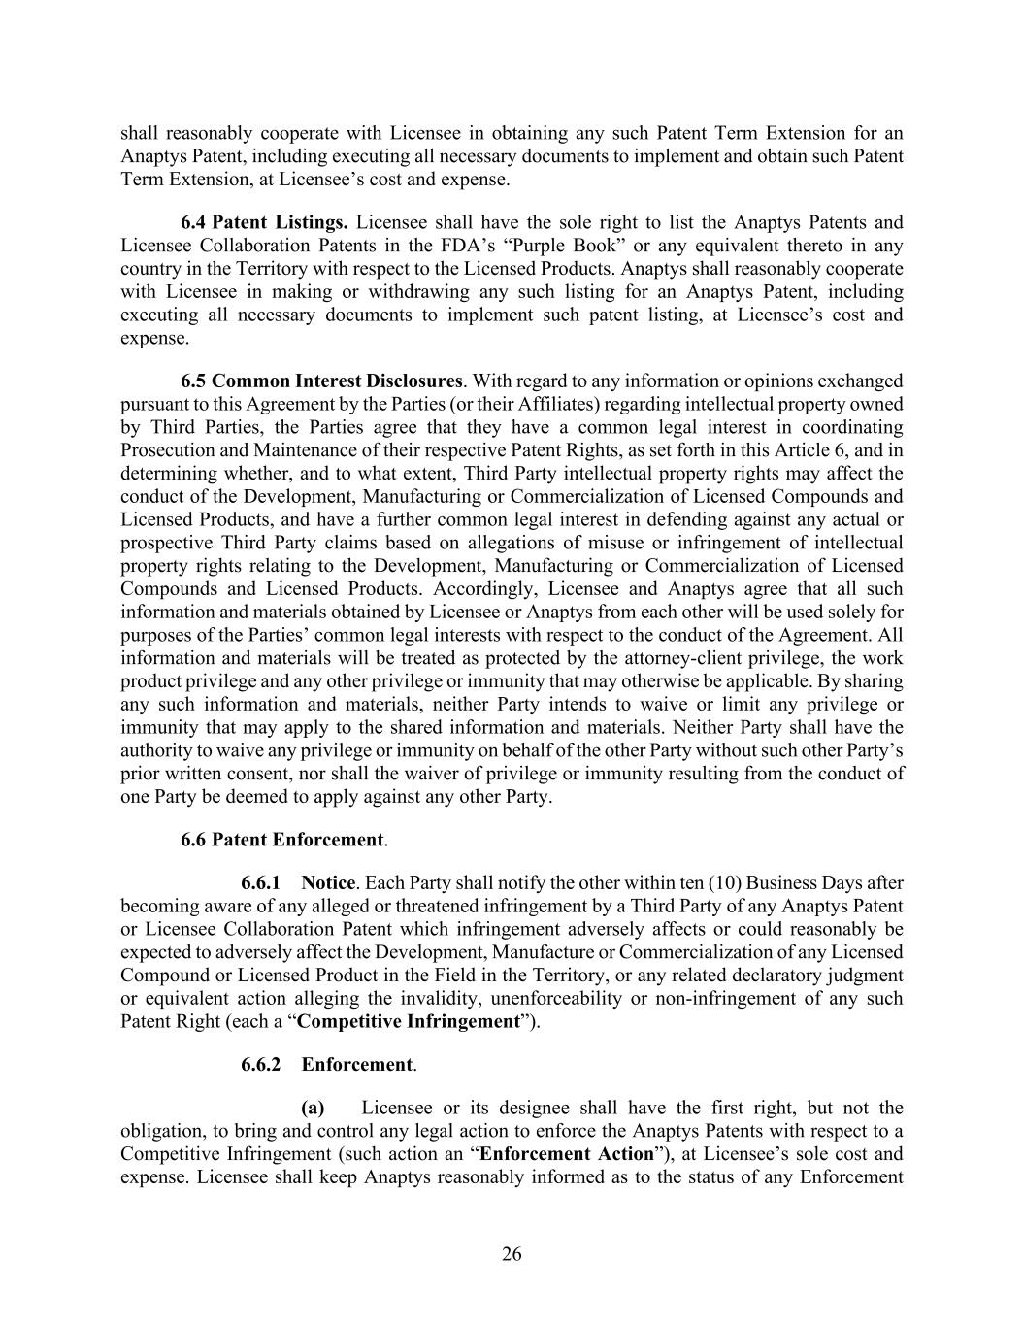
26 shall reasonably cooperate with Licensee in obtaining any such Patent Term Extension for an Anaptys Patent, including executing all necessary documents to implement and obtain such Patent Term Extension, at Licensee’s cost and expense. 6.4 Patent Listings. Licensee shall have the sole right to list the Anaptys Patents and Licensee Collaboration Patents in the FDA’s “Purple Book” or any equivalent thereto in any country in the Territory with respect to the Licensed Products. Anaptys shall reasonably cooperate with Licensee in making or withdrawing any such listing for an Anaptys Patent, including executing all necessary documents to implement such patent listing, at Licensee’s cost and expense. 6.5 Common Interest Disclosures. With regard to any information or opinions exchanged pursuant to this Agreement by the Parties (or their Affiliates) regarding intellectual property owned by Third Parties, the Parties agree that they have a common legal interest in coordinating Prosecution and Maintenance of their respective Patent Rights, as set forth in this Article 6, and in determining whether, and to what extent, Third Party intellectual property rights may affect the conduct of the Development, Manufacturing or Commercialization of Licensed Compounds and Licensed Products, and have a further common legal interest in defending against any actual or prospective Third Party claims based on allegations of misuse or infringement of intellectual property rights relating to the Development, Manufacturing or Commercialization of Licensed Compounds and Licensed Products. Accordingly, Licensee and Anaptys agree that all such information and materials obtained by Licensee or Anaptys from each other will be used solely for purposes of the Parties’ common legal interests with respect to the conduct of the Agreement. All information and materials will be treated as protected by the attorney-client privilege, the work product privilege and any other privilege or immunity that may otherwise be applicable. By sharing any such information and materials, neither Party intends to waive or limit any privilege or immunity that may apply to the shared information and materials. Neither Party shall have the authority to waive any privilege or immunity on behalf of the other Party without such other Party’s prior written consent, nor shall the waiver of privilege or immunity resulting from the conduct of one Party be deemed to apply against any other Party. 6.6 Patent Enforcement. 6.6.1 Notice. Each Party shall notify the other within ten (10) Business Days after becoming aware of any alleged or threatened infringement by a Third Party of any Anaptys Patent or Licensee Collaboration Patent which infringement adversely affects or could reasonably be expected to adversely affect the Development, Manufacture or Commercialization of any Licensed Compound or Licensed Product in the Field in the Territory, or any related declaratory judgment or equivalent action alleging the invalidity, unenforceability or non-infringement of any such Patent Right (each a “Competitive Infringement”). 6.6.2 Enforcement. (a) Licensee or its designee shall have the first right, but not the obligation, to bring and control any legal action to enforce the Anaptys Patents with respect to a Competitive Infringement (such action an “Enforcement Action”), at Licensee’s sole cost and expense. Licensee shall keep Anaptys reasonably informed as to the status of any Enforcement

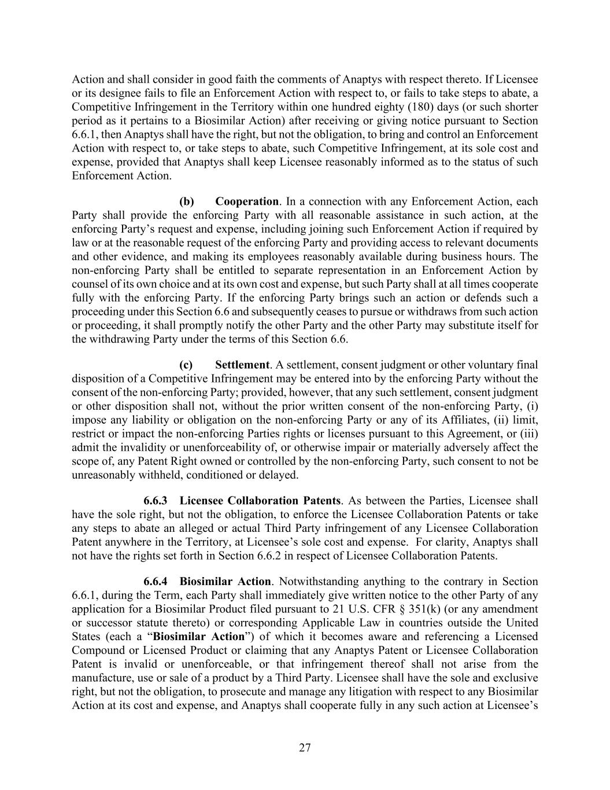
27 Action and shall consider in good faith the comments of Anaptys with respect thereto. If Licensee or its designee fails to file an Enforcement Action with respect to, or fails to take steps to abate, a Competitive Infringement in the Territory within one hundred eighty (180) days (or such shorter period as it pertains to a Biosimilar Action) after receiving or giving notice pursuant to Section 6.6.1, then Anaptys shall have the right, but not the obligation, to bring and control an Enforcement Action with respect to, or take steps to abate, such Competitive Infringement, at its sole cost and expense, provided that Anaptys shall keep Licensee reasonably informed as to the status of such Enforcement Action. (b) Cooperation. In a connection with any Enforcement Action, each Party shall provide the enforcing Party with all reasonable assistance in such action, at the enforcing Party’s request and expense, including joining such Enforcement Action if required by law or at the reasonable request of the enforcing Party and providing access to relevant documents and other evidence, and making its employees reasonably available during business hours. The non-enforcing Party shall be entitled to separate representation in an Enforcement Action by counsel of its own choice and at its own cost and expense, but such Party shall at all times cooperate fully with the enforcing Party. If the enforcing Party brings such an action or defends such a proceeding under this Section 6.6 and subsequently ceases to pursue or withdraws from such action or proceeding, it shall promptly notify the other Party and the other Party may substitute itself for the withdrawing Party under the terms of this Section 6.6. (c) Settlement. A settlement, consent judgment or other voluntary final disposition of a Competitive Infringement may be entered into by the enforcing Party without the consent of the non-enforcing Party; provided, however, that any such settlement, consent judgment or other disposition shall not, without the prior written consent of the non-enforcing Party, (i) impose any liability or obligation on the non-enforcing Party or any of its Affiliates, (ii) limit, restrict or impact the non-enforcing Parties rights or licenses pursuant to this Agreement, or (iii) admit the invalidity or unenforceability of, or otherwise impair or materially adversely affect the scope of, any Patent Right owned or controlled by the non-enforcing Party, such consent to not be unreasonably withheld, conditioned or delayed. 6.6.3 Licensee Collaboration Patents. As between the Parties, Licensee shall have the sole right, but not the obligation, to enforce the Licensee Collaboration Patents or take any steps to abate an alleged or actual Third Party infringement of any Licensee Collaboration Patent anywhere in the Territory, at Licensee’s sole cost and expense. For clarity, Anaptys shall not have the rights set forth in Section 6.6.2 in respect of Licensee Collaboration Patents. 6.6.4 Biosimilar Action. Notwithstanding anything to the contrary in Section 6.6.1, during the Term, each Party shall immediately give written notice to the other Party of any application for a Biosimilar Product filed pursuant to 21 U.S. CFR § 351(k) (or any amendment or successor statute thereto) or corresponding Applicable Law in countries outside the United States (each a “Biosimilar Action”) of which it becomes aware and referencing a Licensed Compound or Licensed Product or claiming that any Anaptys Patent or Licensee Collaboration Patent is invalid or unenforceable, or that infringement thereof shall not arise from the manufacture, use or sale of a product by a Third Party. Licensee shall have the sole and exclusive right, but not the obligation, to prosecute and manage any litigation with respect to any Biosimilar Action at its cost and expense, and Anaptys shall cooperate fully in any such action at Licensee’s

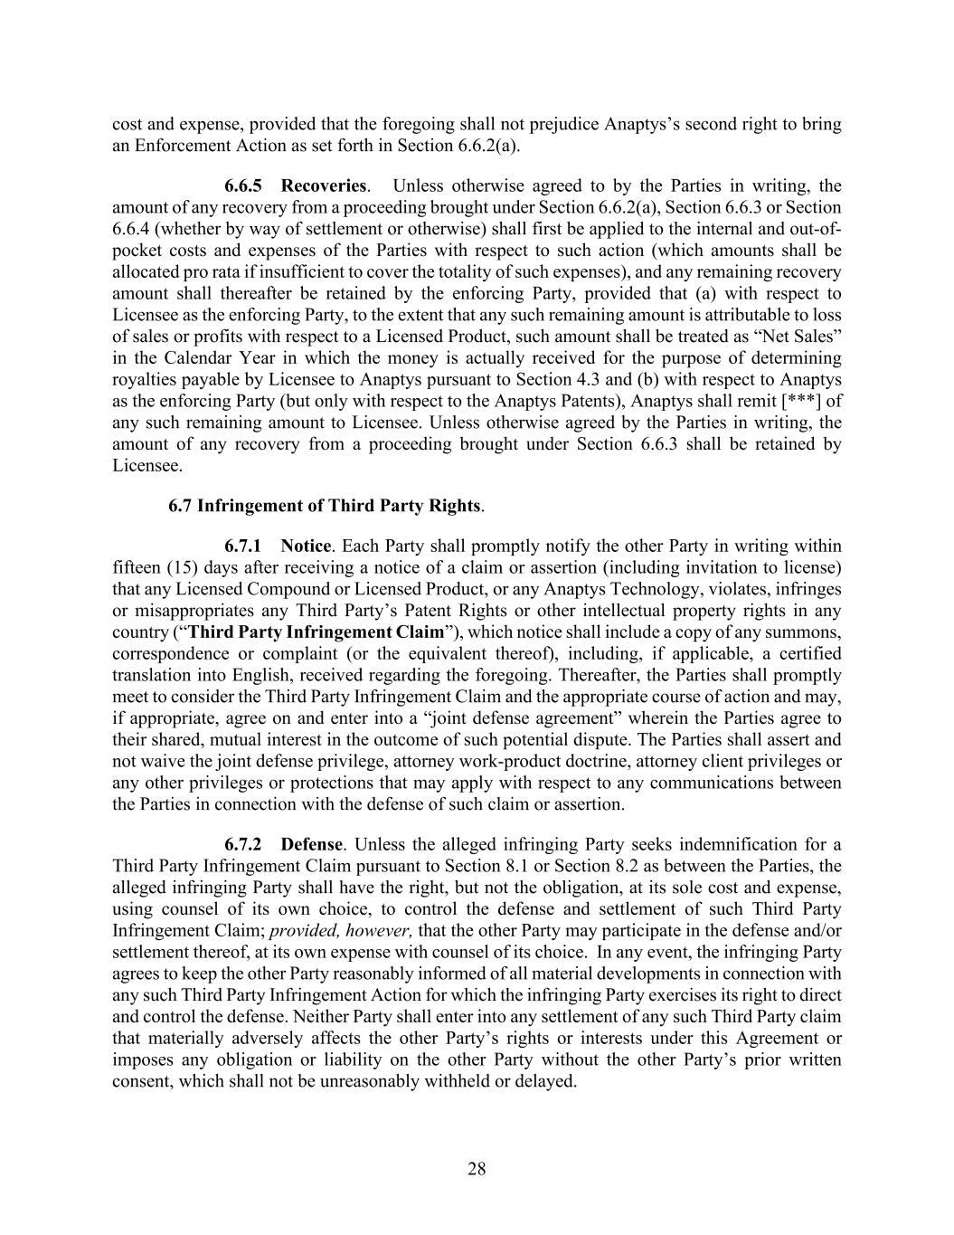
28 cost and expense, provided that the foregoing shall not prejudice Anaptys’s second right to bring an Enforcement Action as set forth in Section 6.6.2(a). 6.6.5 Recoveries. Unless otherwise agreed to by the Parties in writing, the amount of any recovery from a proceeding brought under Section 6.6.2(a), Section 6.6.3 or Section 6.6.4 (whether by way of settlement or otherwise) shall first be applied to the internal and out-of- pocket costs and expenses of the Parties with respect to such action (which amounts shall be allocated pro rata if insufficient to cover the totality of such expenses), and any remaining recovery amount shall thereafter be retained by the enforcing Party, provided that (a) with respect to Licensee as the enforcing Party, to the extent that any such remaining amount is attributable to loss of sales or profits with respect to a Licensed Product, such amount shall be treated as “Net Sales” in the Calendar Year in which the money is actually received for the purpose of determining royalties payable by Licensee to Anaptys pursuant to Section 4.3 and (b) with respect to Anaptys as the enforcing Party (but only with respect to the Anaptys Patents), Anaptys shall remit [***] of any such remaining amount to Licensee. Unless otherwise agreed by the Parties in writing, the amount of any recovery from a proceeding brought under Section 6.6.3 shall be retained by Licensee. 6.7 Infringement of Third Party Rights. 6.7.1 Notice. Each Party shall promptly notify the other Party in writing within fifteen (15) days after receiving a notice of a claim or assertion (including invitation to license) that any Licensed Compound or Licensed Product, or any Anaptys Technology, violates, infringes or misappropriates any Third Party’s Patent Rights or other intellectual property rights in any country (“Third Party Infringement Claim”), which notice shall include a copy of any summons, correspondence or complaint (or the equivalent thereof), including, if applicable, a certified translation into English, received regarding the foregoing. Thereafter, the Parties shall promptly meet to consider the Third Party Infringement Claim and the appropriate course of action and may, if appropriate, agree on and enter into a “joint defense agreement” wherein the Parties agree to their shared, mutual interest in the outcome of such potential dispute. The Parties shall assert and not waive the joint defense privilege, attorney work-product doctrine, attorney client privileges or any other privileges or protections that may apply with respect to any communications between the Parties in connection with the defense of such claim or assertion. 6.7.2 Defense. Unless the alleged infringing Party seeks indemnification for a Third Party Infringement Claim pursuant to Section 8.1 or Section 8.2 as between the Parties, the alleged infringing Party shall have the right, but not the obligation, at its sole cost and expense, using counsel of its own choice, to control the defense and settlement of such Third Party Infringement Claim; provided, however, that the other Party may participate in the defense and/or settlement thereof, at its own expense with counsel of its choice. In any event, the infringing Party agrees to keep the other Party reasonably informed of all material developments in connection with any such Third Party Infringement Action for which the infringing Party exercises its right to direct and control the defense. Neither Party shall enter into any settlement of any such Third Party claim that materially adversely affects the other Party’s rights or interests under this Agreement or imposes any obligation or liability on the other Party without the other Party’s prior written consent, which shall not be unreasonably withheld or delayed.

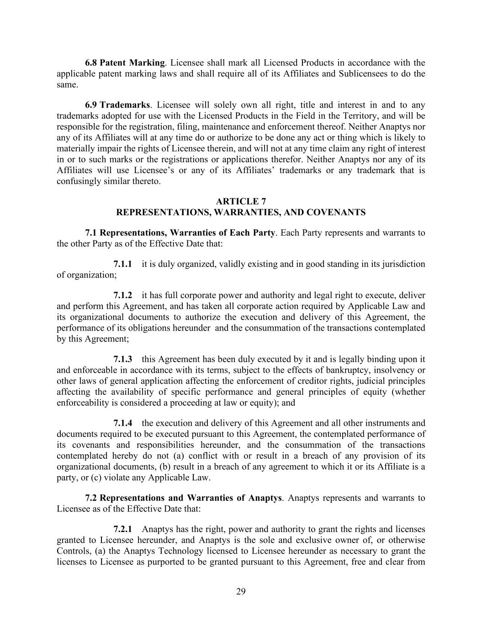
29 6.8 Patent Marking. Licensee shall mark all Licensed Products in accordance with the applicable patent marking laws and shall require all of its Affiliates and Sublicensees to do the same. 6.9 Trademarks. Licensee will solely own all right, title and interest in and to any trademarks adopted for use with the Licensed Products in the Field in the Territory, and will be responsible for the registration, filing, maintenance and enforcement thereof. Neither Anaptys nor any of its Affiliates will at any time do or authorize to be done any act or thing which is likely to materially impair the rights of Licensee therein, and will not at any time claim any right of interest in or to such marks or the registrations or applications therefor. Neither Anaptys nor any of its Affiliates will use Licensee’s or any of its Affiliates’ trademarks or any trademark that is confusingly similar thereto. ARTICLE 7 REPRESENTATIONS, WARRANTIES, AND COVENANTS 7.1 Representations, Warranties of Each Party. Each Party represents and warrants to the other Party as of the Effective Date that: 7.1.1 it is duly organized, validly existing and in good standing in its jurisdiction of organization; 7.1.2 it has full corporate power and authority and legal right to execute, deliver and perform this Agreement, and has taken all corporate action required by Applicable Law and its organizational documents to authorize the execution and delivery of this Agreement, the performance of its obligations hereunder and the consummation of the transactions contemplated by this Agreement; 7.1.3 this Agreement has been duly executed by it and is legally binding upon it and enforceable in accordance with its terms, subject to the effects of bankruptcy, insolvency or other laws of general application affecting the enforcement of creditor rights, judicial principles affecting the availability of specific performance and general principles of equity (whether enforceability is considered a proceeding at law or equity); and 7.1.4 the execution and delivery of this Agreement and all other instruments and documents required to be executed pursuant to this Agreement, the contemplated performance of its covenants and responsibilities hereunder, and the consummation of the transactions contemplated hereby do not (a) conflict with or result in a breach of any provision of its organizational documents, (b) result in a breach of any agreement to which it or its Affiliate is a party, or (c) violate any Applicable Law. 7.2 Representations and Warranties of Anaptys. Anaptys represents and warrants to Licensee as of the Effective Date that: 7.2.1 Anaptys has the right, power and authority to grant the rights and licenses granted to Licensee hereunder, and Anaptys is the sole and exclusive owner of, or otherwise Controls, (a) the Anaptys Technology licensed to Licensee hereunder as necessary to grant the licenses to Licensee as purported to be granted pursuant to this Agreement, free and clear from

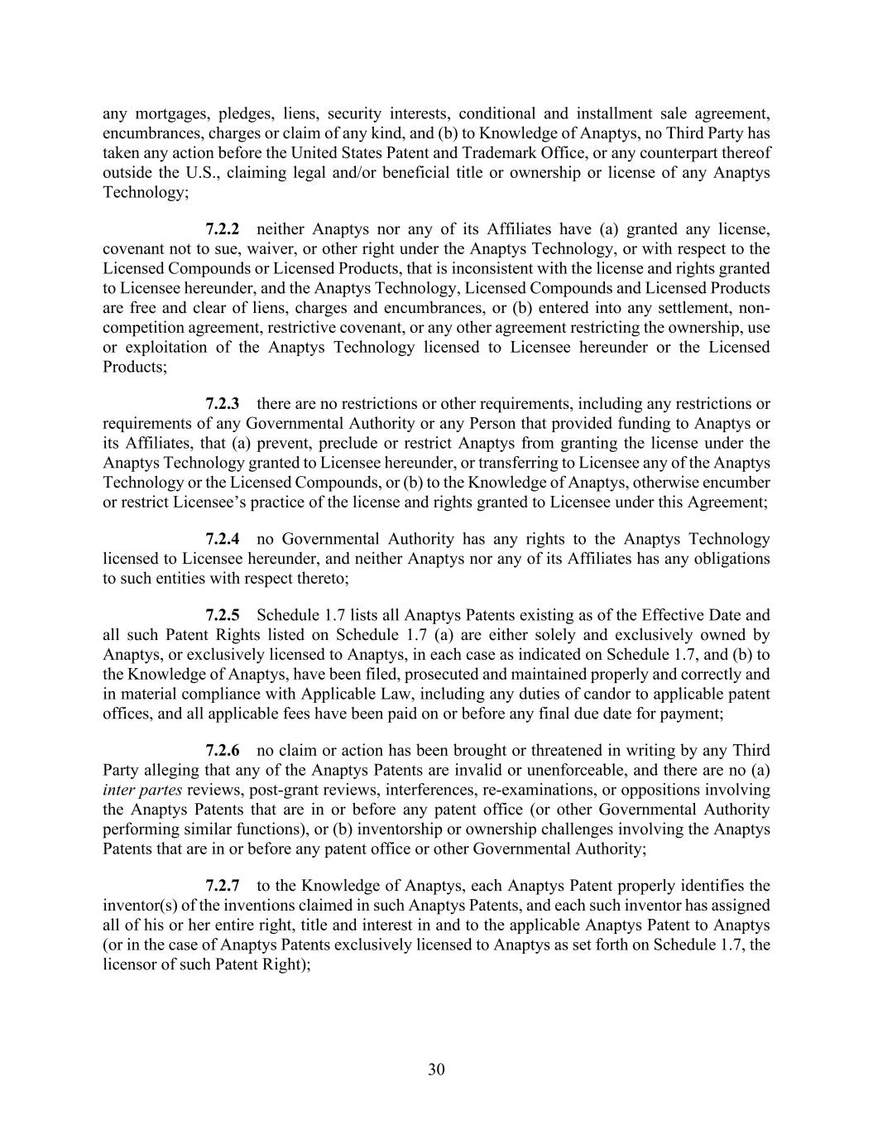
30 any mortgages, pledges, liens, security interests, conditional and installment sale agreement, encumbrances, charges or claim of any kind, and (b) to Knowledge of Anaptys, no Third Party has taken any action before the United States Patent and Trademark Office, or any counterpart thereof outside the U.S., claiming legal and/or beneficial title or ownership or license of any Anaptys Technology; 7.2.2 neither Anaptys nor any of its Affiliates have (a) granted any license, covenant not to sue, waiver, or other right under the Anaptys Technology, or with respect to the Licensed Compounds or Licensed Products, that is inconsistent with the license and rights granted to Licensee hereunder, and the Anaptys Technology, Licensed Compounds and Licensed Products are free and clear of liens, charges and encumbrances, or (b) entered into any settlement, non- competition agreement, restrictive covenant, or any other agreement restricting the ownership, use or exploitation of the Anaptys Technology licensed to Licensee hereunder or the Licensed Products; 7.2.3 there are no restrictions or other requirements, including any restrictions or requirements of any Governmental Authority or any Person that provided funding to Anaptys or its Affiliates, that (a) prevent, preclude or restrict Anaptys from granting the license under the Anaptys Technology granted to Licensee hereunder, or transferring to Licensee any of the Anaptys Technology or the Licensed Compounds, or (b) to the Knowledge of Anaptys, otherwise encumber or restrict Licensee’s practice of the license and rights granted to Licensee under this Agreement; 7.2.4 no Governmental Authority has any rights to the Anaptys Technology licensed to Licensee hereunder, and neither Anaptys nor any of its Affiliates has any obligations to such entities with respect thereto; 7.2.5 Schedule 1.7 lists all Anaptys Patents existing as of the Effective Date and all such Patent Rights listed on Schedule 1.7 (a) are either solely and exclusively owned by Anaptys, or exclusively licensed to Anaptys, in each case as indicated on Schedule 1.7, and (b) to the Knowledge of Anaptys, have been filed, prosecuted and maintained properly and correctly and in material compliance with Applicable Law, including any duties of candor to applicable patent offices, and all applicable fees have been paid on or before any final due date for payment; 7.2.6 no claim or action has been brought or threatened in writing by any Third Party alleging that any of the Anaptys Patents are invalid or unenforceable, and there are no (a) inter partes reviews, post-grant reviews, interferences, re-examinations, or oppositions involving the Anaptys Patents that are in or before any patent office (or other Governmental Authority performing similar functions), or (b) inventorship or ownership challenges involving the Anaptys Patents that are in or before any patent office or other Governmental Authority; 7.2.7 to the Knowledge of Anaptys, each Anaptys Patent properly identifies the inventor(s) of the inventions claimed in such Anaptys Patents, and each such inventor has assigned all of his or her entire right, title and interest in and to the applicable Anaptys Patent to Anaptys (or in the case of Anaptys Patents exclusively licensed to Anaptys as set forth on Schedule 1.7, the licensor of such Patent Right);

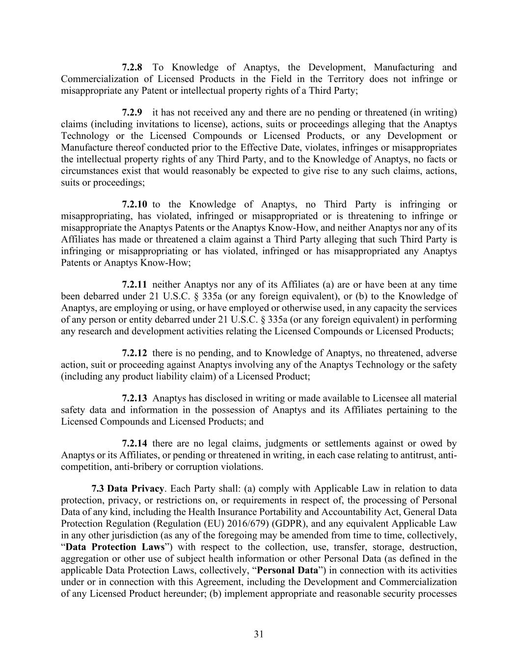
31 7.2.8 To Knowledge of Anaptys, the Development, Manufacturing and Commercialization of Licensed Products in the Field in the Territory does not infringe or misappropriate any Patent or intellectual property rights of a Third Party; 7.2.9 it has not received any and there are no pending or threatened (in writing) claims (including invitations to license), actions, suits or proceedings alleging that the Anaptys Technology or the Licensed Compounds or Licensed Products, or any Development or Manufacture thereof conducted prior to the Effective Date, violates, infringes or misappropriates the intellectual property rights of any Third Party, and to the Knowledge of Anaptys, no facts or circumstances exist that would reasonably be expected to give rise to any such claims, actions, suits or proceedings; 7.2.10 to the Knowledge of Anaptys, no Third Party is infringing or misappropriating, has violated, infringed or misappropriated or is threatening to infringe or misappropriate the Anaptys Patents or the Anaptys Know-How, and neither Anaptys nor any of its Affiliates has made or threatened a claim against a Third Party alleging that such Third Party is infringing or misappropriating or has violated, infringed or has misappropriated any Anaptys Patents or Anaptys Know-How; 7.2.11 neither Anaptys nor any of its Affiliates (a) are or have been at any time been debarred under 21 U.S.C. § 335a (or any foreign equivalent), or (b) to the Knowledge of Anaptys, are employing or using, or have employed or otherwise used, in any capacity the services of any person or entity debarred under 21 U.S.C. § 335a (or any foreign equivalent) in performing any research and development activities relating the Licensed Compounds or Licensed Products; 7.2.12 there is no pending, and to Knowledge of Anaptys, no threatened, adverse action, suit or proceeding against Anaptys involving any of the Anaptys Technology or the safety (including any product liability claim) of a Licensed Product; 7.2.13 Anaptys has disclosed in writing or made available to Licensee all material safety data and information in the possession of Anaptys and its Affiliates pertaining to the Licensed Compounds and Licensed Products; and 7.2.14 there are no legal claims, judgments or settlements against or owed by Anaptys or its Affiliates, or pending or threatened in writing, in each case relating to antitrust, anti- competition, anti-bribery or corruption violations. 7.3 Data Privacy. Each Party shall: (a) comply with Applicable Law in relation to data protection, privacy, or restrictions on, or requirements in respect of, the processing of Personal Data of any kind, including the Health Insurance Portability and Accountability Act, General Data Protection Regulation (Regulation (EU) 2016/679) (GDPR), and any equivalent Applicable Law in any other jurisdiction (as any of the foregoing may be amended from time to time, collectively, “Data Protection Laws”) with respect to the collection, use, transfer, storage, destruction, aggregation or other use of subject health information or other Personal Data (as defined in the applicable Data Protection Laws, collectively, “Personal Data”) in connection with its activities under or in connection with this Agreement, including the Development and Commercialization of any Licensed Product hereunder; (b) implement appropriate and reasonable security processes

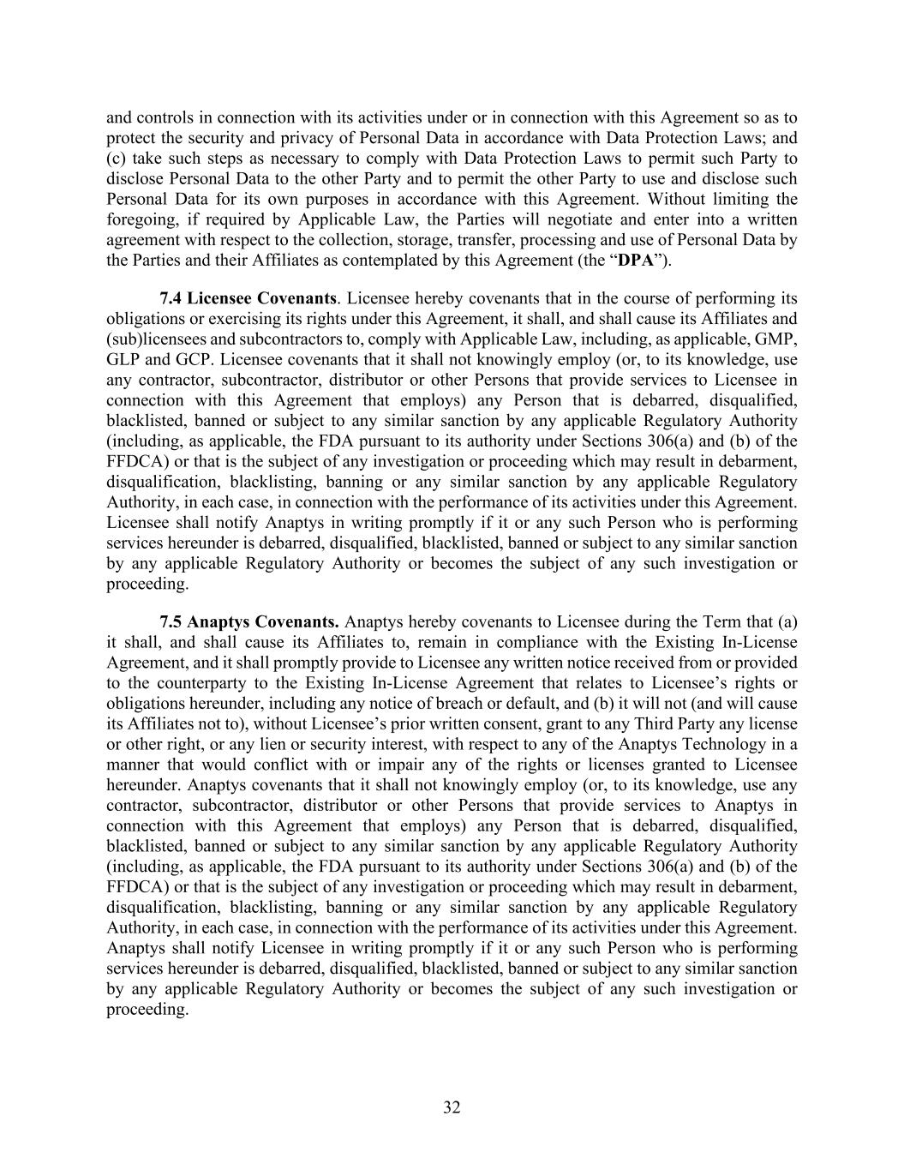
32 and controls in connection with its activities under or in connection with this Agreement so as to protect the security and privacy of Personal Data in accordance with Data Protection Laws; and (c) take such steps as necessary to comply with Data Protection Laws to permit such Party to disclose Personal Data to the other Party and to permit the other Party to use and disclose such Personal Data for its own purposes in accordance with this Agreement. Without limiting the foregoing, if required by Applicable Law, the Parties will negotiate and enter into a written agreement with respect to the collection, storage, transfer, processing and use of Personal Data by the Parties and their Affiliates as contemplated by this Agreement (the “DPA”). 7.4 Licensee Covenants. Licensee hereby covenants that in the course of performing its obligations or exercising its rights under this Agreement, it shall, and shall cause its Affiliates and (sub)licensees and subcontractors to, comply with Applicable Law, including, as applicable, GMP, GLP and GCP. Licensee covenants that it shall not knowingly employ (or, to its knowledge, use any contractor, subcontractor, distributor or other Persons that provide services to Licensee in connection with this Agreement that employs) any Person that is debarred, disqualified, blacklisted, banned or subject to any similar sanction by any applicable Regulatory Authority (including, as applicable, the FDA pursuant to its authority under Sections 306(a) and (b) of the FFDCA) or that is the subject of any investigation or proceeding which may result in debarment, disqualification, blacklisting, banning or any similar sanction by any applicable Regulatory Authority, in each case, in connection with the performance of its activities under this Agreement. Licensee shall notify Anaptys in writing promptly if it or any such Person who is performing services hereunder is debarred, disqualified, blacklisted, banned or subject to any similar sanction by any applicable Regulatory Authority or becomes the subject of any such investigation or proceeding. 7.5 Anaptys Covenants. Anaptys hereby covenants to Licensee during the Term that (a) it shall, and shall cause its Affiliates to, remain in compliance with the Existing In-License Agreement, and it shall promptly provide to Licensee any written notice received from or provided to the counterparty to the Existing In-License Agreement that relates to Licensee’s rights or obligations hereunder, including any notice of breach or default, and (b) it will not (and will cause its Affiliates not to), without Licensee’s prior written consent, grant to any Third Party any license or other right, or any lien or security interest, with respect to any of the Anaptys Technology in a manner that would conflict with or impair any of the rights or licenses granted to Licensee hereunder. Anaptys covenants that it shall not knowingly employ (or, to its knowledge, use any contractor, subcontractor, distributor or other Persons that provide services to Anaptys in connection with this Agreement that employs) any Person that is debarred, disqualified, blacklisted, banned or subject to any similar sanction by any applicable Regulatory Authority (including, as applicable, the FDA pursuant to its authority under Sections 306(a) and (b) of the FFDCA) or that is the subject of any investigation or proceeding which may result in debarment, disqualification, blacklisting, banning or any similar sanction by any applicable Regulatory Authority, in each case, in connection with the performance of its activities under this Agreement. Anaptys shall notify Licensee in writing promptly if it or any such Person who is performing services hereunder is debarred, disqualified, blacklisted, banned or subject to any similar sanction by any applicable Regulatory Authority or becomes the subject of any such investigation or proceeding.

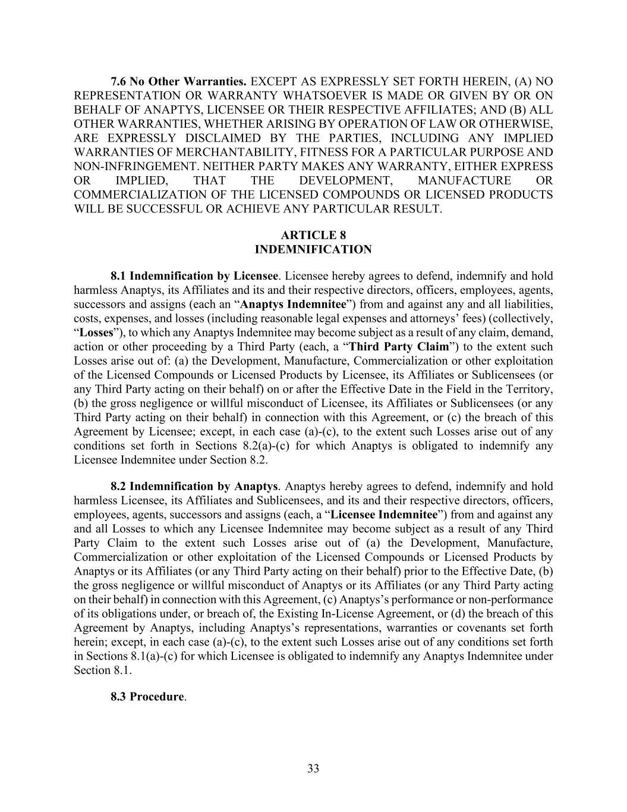
33 7.6 No Other Warranties. EXCEPT AS EXPRESSLY SET FORTH HEREIN, (A) NO REPRESENTATION OR WARRANTY WHATSOEVER IS MADE OR GIVEN BY OR ON BEHALF OF ANAPTYS, LICENSEE OR THEIR RESPECTIVE AFFILIATES; AND (B) ALL OTHER WARRANTIES, WHETHER ARISING BY OPERATION OF LAW OR OTHERWISE, ARE EXPRESSLY DISCLAIMED BY THE PARTIES, INCLUDING ANY IMPLIED WARRANTIES OF MERCHANTABILITY, FITNESS FOR A PARTICULAR PURPOSE AND NON-INFRINGEMENT. NEITHER PARTY MAKES ANY WARRANTY, EITHER EXPRESS OR IMPLIED, THAT THE DEVELOPMENT, MANUFACTURE OR COMMERCIALIZATION OF THE LICENSED COMPOUNDS OR LICENSED PRODUCTS WILL BE SUCCESSFUL OR ACHIEVE ANY PARTICULAR RESULT. ARTICLE 8 INDEMNIFICATION 8.1 Indemnification by Licensee. Licensee hereby agrees to defend, indemnify and hold harmless Anaptys, its Affiliates and its and their respective directors, officers, employees, agents, successors and assigns (each an “Anaptys Indemnitee”) from and against any and all liabilities, costs, expenses, and losses (including reasonable legal expenses and attorneys’ fees) (collectively, “Losses”), to which any Anaptys Indemnitee may become subject as a result of any claim, demand, action or other proceeding by a Third Party (each, a “Third Party Claim”) to the extent such Losses arise out of: (a) the Development, Manufacture, Commercialization or other exploitation of the Licensed Compounds or Licensed Products by Licensee, its Affiliates or Sublicensees (or any Third Party acting on their behalf) on or after the Effective Date in the Field in the Territory, (b) the gross negligence or willful misconduct of Licensee, its Affiliates or Sublicensees (or any Third Party acting on their behalf) in connection with this Agreement, or (c) the breach of this Agreement by Licensee; except, in each case (a)-(c), to the extent such Losses arise out of any conditions set forth in Sections 8.2(a)-(c) for which Anaptys is obligated to indemnify any Licensee Indemnitee under Section 8.2. 8.2 Indemnification by Anaptys. Anaptys hereby agrees to defend, indemnify and hold harmless Licensee, its Affiliates and Sublicensees, and its and their respective directors, officers, employees, agents, successors and assigns (each, a “Licensee Indemnitee”) from and against any and all Losses to which any Licensee Indemnitee may become subject as a result of any Third Party Claim to the extent such Losses arise out of (a) the Development, Manufacture, Commercialization or other exploitation of the Licensed Compounds or Licensed Products by Anaptys or its Affiliates (or any Third Party acting on their behalf) prior to the Effective Date, (b) the gross negligence or willful misconduct of Anaptys or its Affiliates (or any Third Party acting on their behalf) in connection with this Agreement, (c) Anaptys’s performance or non-performance of its obligations under, or breach of, the Existing In-License Agreement, or (d) the breach of this Agreement by Anaptys, including Anaptys’s representations, warranties or covenants set forth herein; except, in each case (a)-(c), to the extent such Losses arise out of any conditions set forth in Sections 8.1(a)-(c) for which Licensee is obligated to indemnify any Anaptys Indemnitee under Section 8.1. 8.3 Procedure.

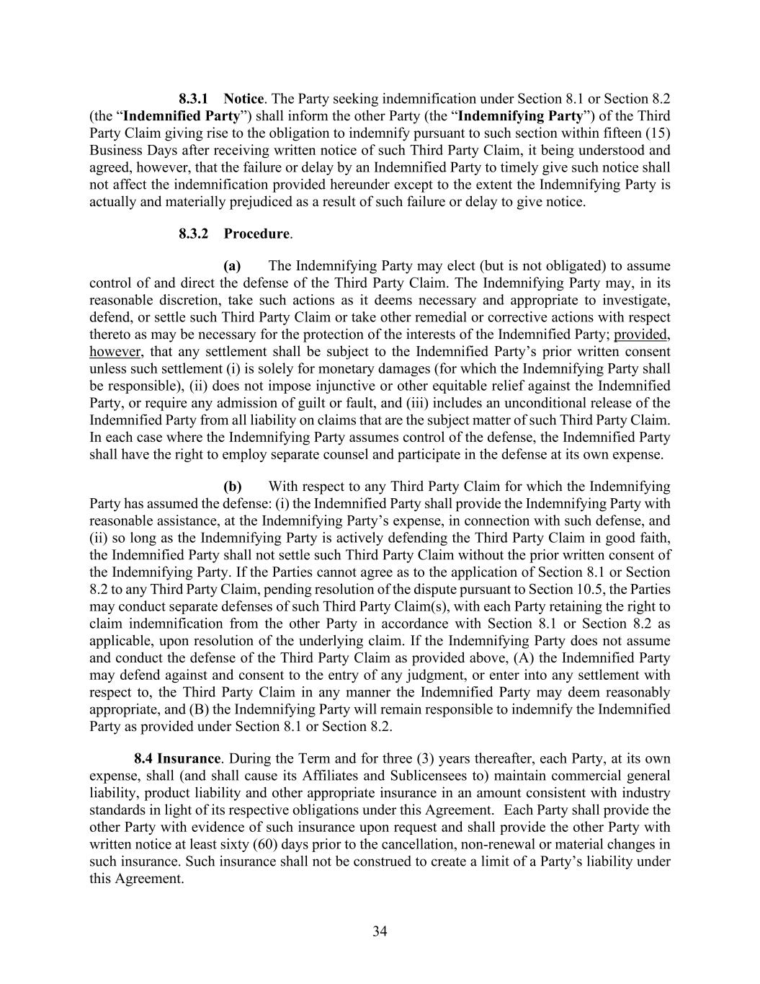
34 8.3.1 Notice. The Party seeking indemnification under Section 8.1 or Section 8.2 (the “Indemnified Party”) shall inform the other Party (the “Indemnifying Party”) of the Third Party Claim giving rise to the obligation to indemnify pursuant to such section within fifteen (15) Business Days after receiving written notice of such Third Party Claim, it being understood and agreed, however, that the failure or delay by an Indemnified Party to timely give such notice shall not affect the indemnification provided hereunder except to the extent the Indemnifying Party is actually and materially prejudiced as a result of such failure or delay to give notice. 8.3.2 Procedure. (a) The Indemnifying Party may elect (but is not obligated) to assume control of and direct the defense of the Third Party Claim. The Indemnifying Party may, in its reasonable discretion, take such actions as it deems necessary and appropriate to investigate, defend, or settle such Third Party Claim or take other remedial or corrective actions with respect thereto as may be necessary for the protection of the interests of the Indemnified Party; provided, however, that any settlement shall be subject to the Indemnified Party’s prior written consent unless such settlement (i) is solely for monetary damages (for which the Indemnifying Party shall be responsible), (ii) does not impose injunctive or other equitable relief against the Indemnified Party, or require any admission of guilt or fault, and (iii) includes an unconditional release of the Indemnified Party from all liability on claims that are the subject matter of such Third Party Claim. In each case where the Indemnifying Party assumes control of the defense, the Indemnified Party shall have the right to employ separate counsel and participate in the defense at its own expense. (b) With respect to any Third Party Claim for which the Indemnifying Party has assumed the defense: (i) the Indemnified Party shall provide the Indemnifying Party with reasonable assistance, at the Indemnifying Party’s expense, in connection with such defense, and (ii) so long as the Indemnifying Party is actively defending the Third Party Claim in good faith, the Indemnified Party shall not settle such Third Party Claim without the prior written consent of the Indemnifying Party. If the Parties cannot agree as to the application of Section 8.1 or Section 8.2 to any Third Party Claim, pending resolution of the dispute pursuant to Section 10.5, the Parties may conduct separate defenses of such Third Party Claim(s), with each Party retaining the right to claim indemnification from the other Party in accordance with Section 8.1 or Section 8.2 as applicable, upon resolution of the underlying claim. If the Indemnifying Party does not assume and conduct the defense of the Third Party Claim as provided above, (A) the Indemnified Party may defend against and consent to the entry of any judgment, or enter into any settlement with respect to, the Third Party Claim in any manner the Indemnified Party may deem reasonably appropriate, and (B) the Indemnifying Party will remain responsible to indemnify the Indemnified Party as provided under Section 8.1 or Section 8.2. 8.4 Insurance. During the Term and for three (3) years thereafter, each Party, at its own expense, shall (and shall cause its Affiliates and Sublicensees to) maintain commercial general liability, product liability and other appropriate insurance in an amount consistent with industry standards in light of its respective obligations under this Agreement. Each Party shall provide the other Party with evidence of such insurance upon request and shall provide the other Party with written notice at least sixty (60) days prior to the cancellation, non-renewal or material changes in such insurance. Such insurance shall not be construed to create a limit of a Party’s liability under this Agreement.

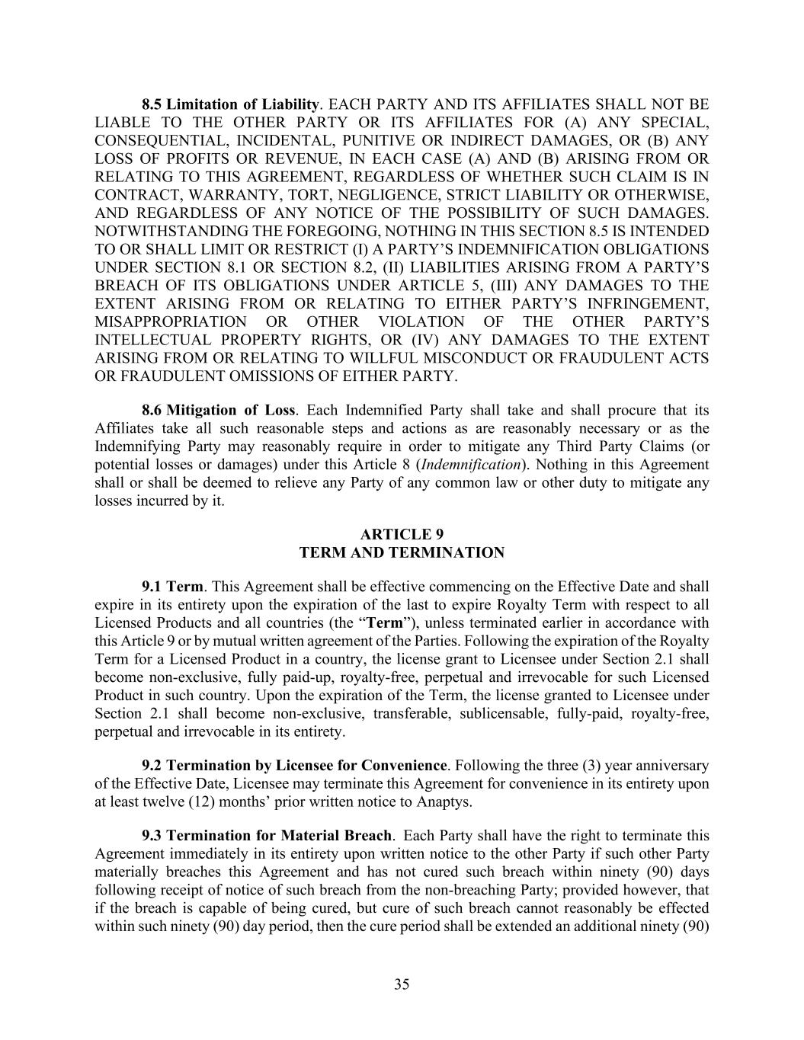
35 8.5 Limitation of Liability. EACH PARTY AND ITS AFFILIATES SHALL NOT BE LIABLE TO THE OTHER PARTY OR ITS AFFILIATES FOR (A) ANY SPECIAL, CONSEQUENTIAL, INCIDENTAL, PUNITIVE OR INDIRECT DAMAGES, OR (B) ANY LOSS OF PROFITS OR REVENUE, IN EACH CASE (A) AND (B) ARISING FROM OR RELATING TO THIS AGREEMENT, REGARDLESS OF WHETHER SUCH CLAIM IS IN CONTRACT, WARRANTY, TORT, NEGLIGENCE, STRICT LIABILITY OR OTHERWISE, AND REGARDLESS OF ANY NOTICE OF THE POSSIBILITY OF SUCH DAMAGES. NOTWITHSTANDING THE FOREGOING, NOTHING IN THIS SECTION 8.5 IS INTENDED TO OR SHALL LIMIT OR RESTRICT (I) A PARTY’S INDEMNIFICATION OBLIGATIONS UNDER SECTION 8.1 OR SECTION 8.2, (II) LIABILITIES ARISING FROM A PARTY’S BREACH OF ITS OBLIGATIONS UNDER ARTICLE 5, (III) ANY DAMAGES TO THE EXTENT ARISING FROM OR RELATING TO EITHER PARTY’S INFRINGEMENT, MISAPPROPRIATION OR OTHER VIOLATION OF THE OTHER PARTY’S INTELLECTUAL PROPERTY RIGHTS, OR (IV) ANY DAMAGES TO THE EXTENT ARISING FROM OR RELATING TO WILLFUL MISCONDUCT OR FRAUDULENT ACTS OR FRAUDULENT OMISSIONS OF EITHER PARTY. 8.6 Mitigation of Loss. Each Indemnified Party shall take and shall procure that its Affiliates take all such reasonable steps and actions as are reasonably necessary or as the Indemnifying Party may reasonably require in order to mitigate any Third Party Claims (or potential losses or damages) under this Article 8 (Indemnification). Nothing in this Agreement shall or shall be deemed to relieve any Party of any common law or other duty to mitigate any losses incurred by it. ARTICLE 9 TERM AND TERMINATION 9.1 Term. This Agreement shall be effective commencing on the Effective Date and shall expire in its entirety upon the expiration of the last to expire Royalty Term with respect to all Licensed Products and all countries (the “Term”), unless terminated earlier in accordance with this Article 9 or by mutual written agreement of the Parties. Following the expiration of the Royalty Term for a Licensed Product in a country, the license grant to Licensee under Section 2.1 shall become non-exclusive, fully paid-up, royalty-free, perpetual and irrevocable for such Licensed Product in such country. Upon the expiration of the Term, the license granted to Licensee under Section 2.1 shall become non-exclusive, transferable, sublicensable, fully-paid, royalty-free, perpetual and irrevocable in its entirety. 9.2 Termination by Licensee for Convenience. Following the three (3) year anniversary of the Effective Date, Licensee may terminate this Agreement for convenience in its entirety upon at least twelve (12) months’ prior written notice to Anaptys. 9.3 Termination for Material Breach. Each Party shall have the right to terminate this Agreement immediately in its entirety upon written notice to the other Party if such other Party materially breaches this Agreement and has not cured such breach within ninety (90) days following receipt of notice of such breach from the non-breaching Party; provided however, that if the breach is capable of being cured, but cure of such breach cannot reasonably be effected within such ninety (90) day period, then the cure period shall be extended an additional ninety (90)

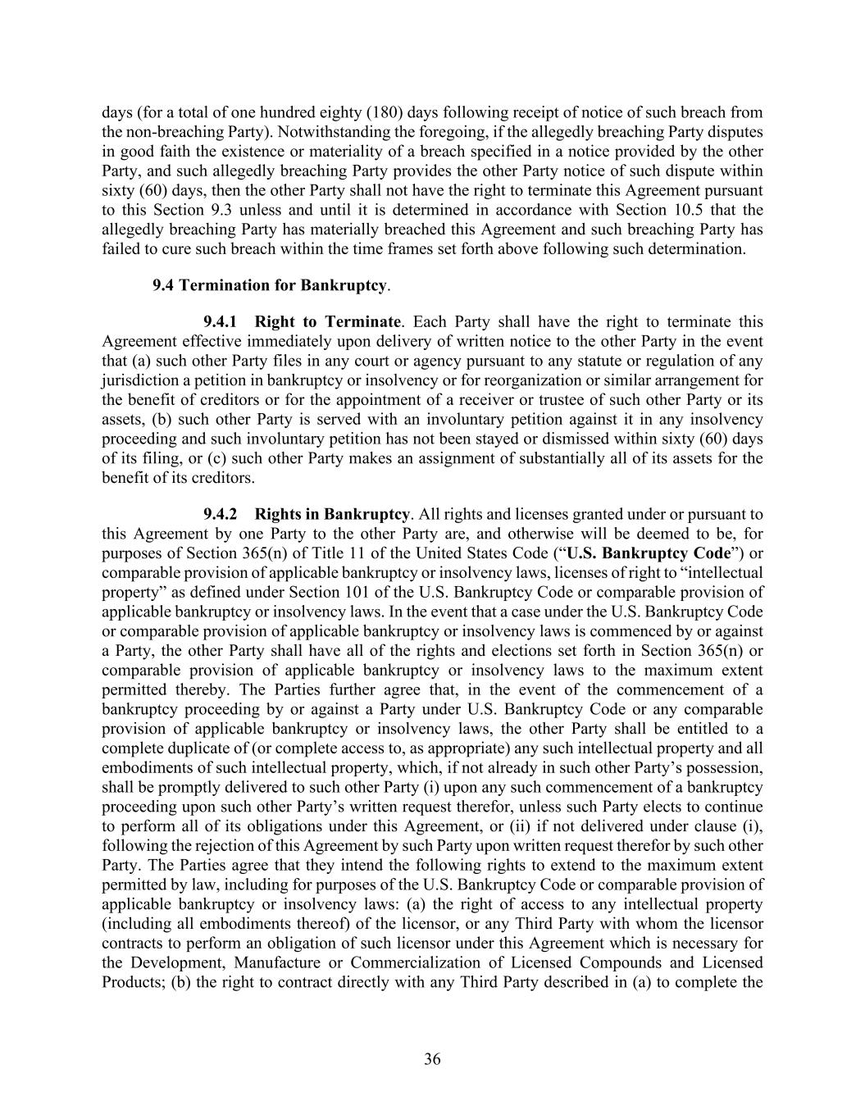
36 days (for a total of one hundred eighty (180) days following receipt of notice of such breach from the non-breaching Party). Notwithstanding the foregoing, if the allegedly breaching Party disputes in good faith the existence or materiality of a breach specified in a notice provided by the other Party, and such allegedly breaching Party provides the other Party notice of such dispute within sixty (60) days, then the other Party shall not have the right to terminate this Agreement pursuant to this Section 9.3 unless and until it is determined in accordance with Section 10.5 that the allegedly breaching Party has materially breached this Agreement and such breaching Party has failed to cure such breach within the time frames set forth above following such determination. 9.4 Termination for Bankruptcy. 9.4.1 Right to Terminate. Each Party shall have the right to terminate this Agreement effective immediately upon delivery of written notice to the other Party in the event that (a) such other Party files in any court or agency pursuant to any statute or regulation of any jurisdiction a petition in bankruptcy or insolvency or for reorganization or similar arrangement for the benefit of creditors or for the appointment of a receiver or trustee of such other Party or its assets, (b) such other Party is served with an involuntary petition against it in any insolvency proceeding and such involuntary petition has not been stayed or dismissed within sixty (60) days of its filing, or (c) such other Party makes an assignment of substantially all of its assets for the benefit of its creditors. 9.4.2 Rights in Bankruptcy. All rights and licenses granted under or pursuant to this Agreement by one Party to the other Party are, and otherwise will be deemed to be, for purposes of Section 365(n) of Title 11 of the United States Code (“U.S. Bankruptcy Code”) or comparable provision of applicable bankruptcy or insolvency laws, licenses of right to “intellectual property” as defined under Section 101 of the U.S. Bankruptcy Code or comparable provision of applicable bankruptcy or insolvency laws. In the event that a case under the U.S. Bankruptcy Code or comparable provision of applicable bankruptcy or insolvency laws is commenced by or against a Party, the other Party shall have all of the rights and elections set forth in Section 365(n) or comparable provision of applicable bankruptcy or insolvency laws to the maximum extent permitted thereby. The Parties further agree that, in the event of the commencement of a bankruptcy proceeding by or against a Party under U.S. Bankruptcy Code or any comparable provision of applicable bankruptcy or insolvency laws, the other Party shall be entitled to a complete duplicate of (or complete access to, as appropriate) any such intellectual property and all embodiments of such intellectual property, which, if not already in such other Party’s possession, shall be promptly delivered to such other Party (i) upon any such commencement of a bankruptcy proceeding upon such other Party’s written request therefor, unless such Party elects to continue to perform all of its obligations under this Agreement, or (ii) if not delivered under clause (i), following the rejection of this Agreement by such Party upon written request therefor by such other Party. The Parties agree that they intend the following rights to extend to the maximum extent permitted by law, including for purposes of the U.S. Bankruptcy Code or comparable provision of applicable bankruptcy or insolvency laws: (a) the right of access to any intellectual property (including all embodiments thereof) of the licensor, or any Third Party with whom the licensor contracts to perform an obligation of such licensor under this Agreement which is necessary for the Development, Manufacture or Commercialization of Licensed Compounds and Licensed Products; (b) the right to contract directly with any Third Party described in (a) to complete the

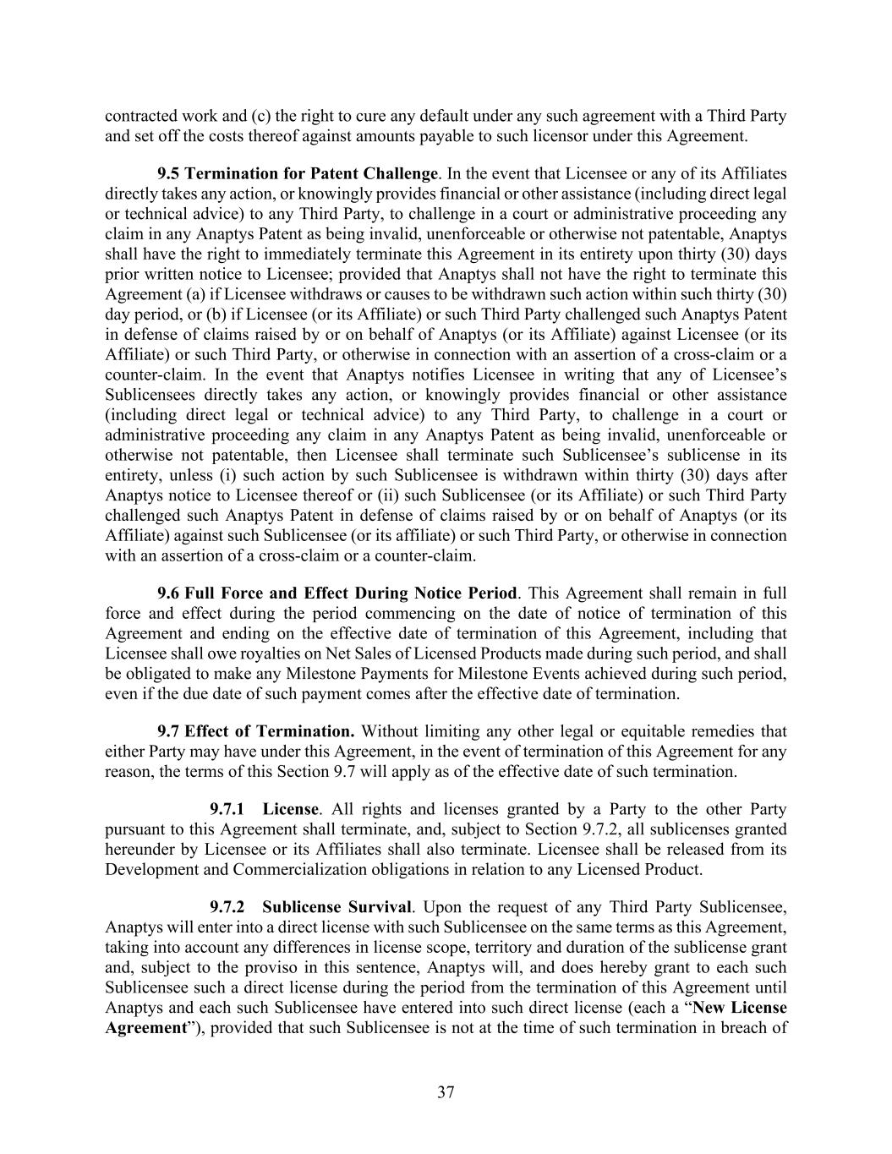
37 contracted work and (c) the right to cure any default under any such agreement with a Third Party and set off the costs thereof against amounts payable to such licensor under this Agreement. 9.5 Termination for Patent Challenge. In the event that Licensee or any of its Affiliates directly takes any action, or knowingly provides financial or other assistance (including direct legal or technical advice) to any Third Party, to challenge in a court or administrative proceeding any claim in any Anaptys Patent as being invalid, unenforceable or otherwise not patentable, Anaptys shall have the right to immediately terminate this Agreement in its entirety upon thirty (30) days prior written notice to Licensee; provided that Anaptys shall not have the right to terminate this Agreement (a) if Licensee withdraws or causes to be withdrawn such action within such thirty (30) day period, or (b) if Licensee (or its Affiliate) or such Third Party challenged such Anaptys Patent in defense of claims raised by or on behalf of Anaptys (or its Affiliate) against Licensee (or its Affiliate) or such Third Party, or otherwise in connection with an assertion of a cross-claim or a counter-claim. In the event that Anaptys notifies Licensee in writing that any of Licensee’s Sublicensees directly takes any action, or knowingly provides financial or other assistance (including direct legal or technical advice) to any Third Party, to challenge in a court or administrative proceeding any claim in any Anaptys Patent as being invalid, unenforceable or otherwise not patentable, then Licensee shall terminate such Sublicensee’s sublicense in its entirety, unless (i) such action by such Sublicensee is withdrawn within thirty (30) days after Anaptys notice to Licensee thereof or (ii) such Sublicensee (or its Affiliate) or such Third Party challenged such Anaptys Patent in defense of claims raised by or on behalf of Anaptys (or its Affiliate) against such Sublicensee (or its affiliate) or such Third Party, or otherwise in connection with an assertion of a cross-claim or a counter-claim. 9.6 Full Force and Effect During Notice Period. This Agreement shall remain in full force and effect during the period commencing on the date of notice of termination of this Agreement and ending on the effective date of termination of this Agreement, including that Licensee shall owe royalties on Net Sales of Licensed Products made during such period, and shall be obligated to make any Milestone Payments for Milestone Events achieved during such period, even if the due date of such payment comes after the effective date of termination. 9.7 Effect of Termination. Without limiting any other legal or equitable remedies that either Party may have under this Agreement, in the event of termination of this Agreement for any reason, the terms of this Section 9.7 will apply as of the effective date of such termination. 9.7.1 License. All rights and licenses granted by a Party to the other Party pursuant to this Agreement shall terminate, and, subject to Section 9.7.2, all sublicenses granted hereunder by Licensee or its Affiliates shall also terminate. Licensee shall be released from its Development and Commercialization obligations in relation to any Licensed Product. 9.7.2 Sublicense Survival. Upon the request of any Third Party Sublicensee, Anaptys will enter into a direct license with such Sublicensee on the same terms as this Agreement, taking into account any differences in license scope, territory and duration of the sublicense grant and, subject to the proviso in this sentence, Anaptys will, and does hereby grant to each such Sublicensee such a direct license during the period from the termination of this Agreement until Anaptys and each such Sublicensee have entered into such direct license (each a “New License Agreement”), provided that such Sublicensee is not at the time of such termination in breach of

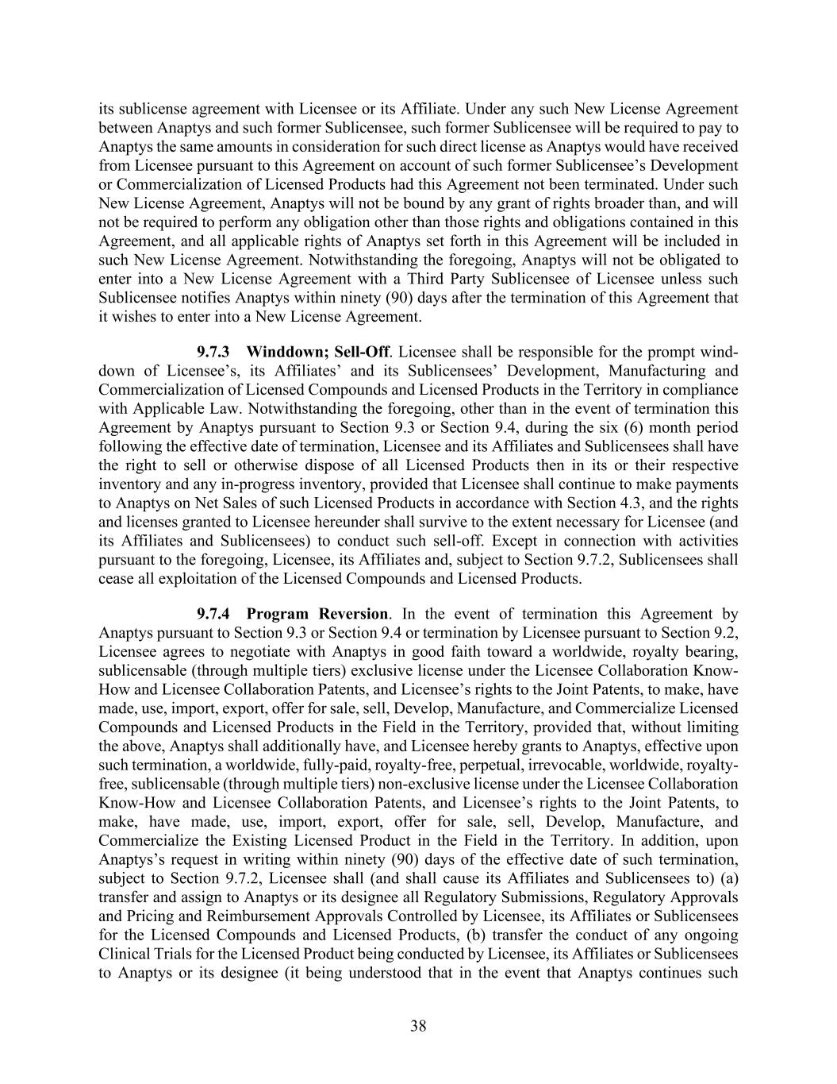
38 its sublicense agreement with Licensee or its Affiliate. Under any such New License Agreement between Anaptys and such former Sublicensee, such former Sublicensee will be required to pay to Anaptys the same amounts in consideration for such direct license as Anaptys would have received from Licensee pursuant to this Agreement on account of such former Sublicensee’s Development or Commercialization of Licensed Products had this Agreement not been terminated. Under such New License Agreement, Anaptys will not be bound by any grant of rights broader than, and will not be required to perform any obligation other than those rights and obligations contained in this Agreement, and all applicable rights of Anaptys set forth in this Agreement will be included in such New License Agreement. Notwithstanding the foregoing, Anaptys will not be obligated to enter into a New License Agreement with a Third Party Sublicensee of Licensee unless such Sublicensee notifies Anaptys within ninety (90) days after the termination of this Agreement that it wishes to enter into a New License Agreement. 9.7.3 Winddown; Sell-Off. Licensee shall be responsible for the prompt wind- down of Licensee’s, its Affiliates’ and its Sublicensees’ Development, Manufacturing and Commercialization of Licensed Compounds and Licensed Products in the Territory in compliance with Applicable Law. Notwithstanding the foregoing, other than in the event of termination this Agreement by Anaptys pursuant to Section 9.3 or Section 9.4, during the six (6) month period following the effective date of termination, Licensee and its Affiliates and Sublicensees shall have the right to sell or otherwise dispose of all Licensed Products then in its or their respective inventory and any in-progress inventory, provided that Licensee shall continue to make payments to Anaptys on Net Sales of such Licensed Products in accordance with Section 4.3, and the rights and licenses granted to Licensee hereunder shall survive to the extent necessary for Licensee (and its Affiliates and Sublicensees) to conduct such sell-off. Except in connection with activities pursuant to the foregoing, Licensee, its Affiliates and, subject to Section 9.7.2, Sublicensees shall cease all exploitation of the Licensed Compounds and Licensed Products. 9.7.4 Program Reversion. In the event of termination this Agreement by Anaptys pursuant to Section 9.3 or Section 9.4 or termination by Licensee pursuant to Section 9.2, Licensee agrees to negotiate with Anaptys in good faith toward a worldwide, royalty bearing, sublicensable (through multiple tiers) exclusive license under the Licensee Collaboration Know- How and Licensee Collaboration Patents, and Licensee’s rights to the Joint Patents, to make, have made, use, import, export, offer for sale, sell, Develop, Manufacture, and Commercialize Licensed Compounds and Licensed Products in the Field in the Territory, provided that, without limiting the above, Anaptys shall additionally have, and Licensee hereby grants to Anaptys, effective upon such termination, a worldwide, fully-paid, royalty-free, perpetual, irrevocable, worldwide, royalty- free, sublicensable (through multiple tiers) non-exclusive license under the Licensee Collaboration Know-How and Licensee Collaboration Patents, and Licensee’s rights to the Joint Patents, to make, have made, use, import, export, offer for sale, sell, Develop, Manufacture, and Commercialize the Existing Licensed Product in the Field in the Territory. In addition, upon Anaptys’s request in writing within ninety (90) days of the effective date of such termination, subject to Section 9.7.2, Licensee shall (and shall cause its Affiliates and Sublicensees to) (a) transfer and assign to Anaptys or its designee all Regulatory Submissions, Regulatory Approvals and Pricing and Reimbursement Approvals Controlled by Licensee, its Affiliates or Sublicensees for the Licensed Compounds and Licensed Products, (b) transfer the conduct of any ongoing Clinical Trials for the Licensed Product being conducted by Licensee, its Affiliates or Sublicensees to Anaptys or its designee (it being understood that in the event that Anaptys continues such

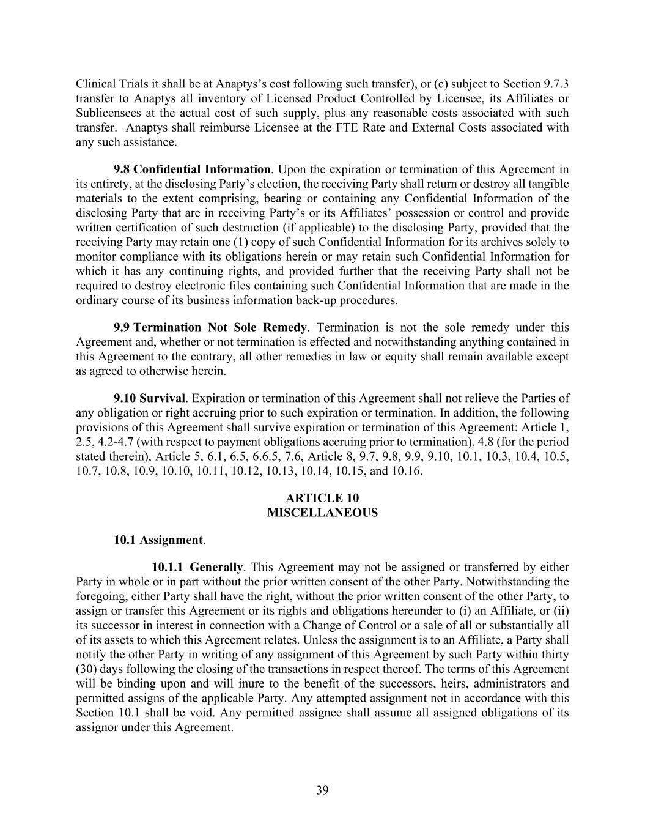
39 Clinical Trials it shall be at Anaptys’s cost following such transfer), or (c) subject to Section 9.7.3 transfer to Anaptys all inventory of Licensed Product Controlled by Licensee, its Affiliates or Sublicensees at the actual cost of such supply, plus any reasonable costs associated with such transfer. Anaptys shall reimburse Licensee at the FTE Rate and External Costs associated with any such assistance. 9.8 Confidential Information. Upon the expiration or termination of this Agreement in its entirety, at the disclosing Party’s election, the receiving Party shall return or destroy all tangible materials to the extent comprising, bearing or containing any Confidential Information of the disclosing Party that are in receiving Party’s or its Affiliates’ possession or control and provide written certification of such destruction (if applicable) to the disclosing Party, provided that the receiving Party may retain one (1) copy of such Confidential Information for its archives solely to monitor compliance with its obligations herein or may retain such Confidential Information for which it has any continuing rights, and provided further that the receiving Party shall not be required to destroy electronic files containing such Confidential Information that are made in the ordinary course of its business information back-up procedures. 9.9 Termination Not Sole Remedy. Termination is not the sole remedy under this Agreement and, whether or not termination is effected and notwithstanding anything contained in this Agreement to the contrary, all other remedies in law or equity shall remain available except as agreed to otherwise herein. 9.10 Survival. Expiration or termination of this Agreement shall not relieve the Parties of any obligation or right accruing prior to such expiration or termination. In addition, the following provisions of this Agreement shall survive expiration or termination of this Agreement: Article 1, 2.5, 4.2-4.7 (with respect to payment obligations accruing prior to termination), 4.8 (for the period stated therein), Article 5, 6.1, 6.5, 6.6.5, 7.6, Article 8, 9.7, 9.8, 9.9, 9.10, 10.1, 10.3, 10.4, 10.5, 10.7, 10.8, 10.9, 10.10, 10.11, 10.12, 10.13, 10.14, 10.15, and 10.16. ARTICLE 10 MISCELLANEOUS 10.1 Assignment. 10.1.1 Generally. This Agreement may not be assigned or transferred by either Party in whole or in part without the prior written consent of the other Party. Notwithstanding the foregoing, either Party shall have the right, without the prior written consent of the other Party, to assign or transfer this Agreement or its rights and obligations hereunder to (i) an Affiliate, or (ii) its successor in interest in connection with a Change of Control or a sale of all or substantially all of its assets to which this Agreement relates. Unless the assignment is to an Affiliate, a Party shall notify the other Party in writing of any assignment of this Agreement by such Party within thirty (30) days following the closing of the transactions in respect thereof. The terms of this Agreement will be binding upon and will inure to the benefit of the successors, heirs, administrators and permitted assigns of the applicable Party. Any attempted assignment not in accordance with this Section 10.1 shall be void. Any permitted assignee shall assume all assigned obligations of its assignor under this Agreement.

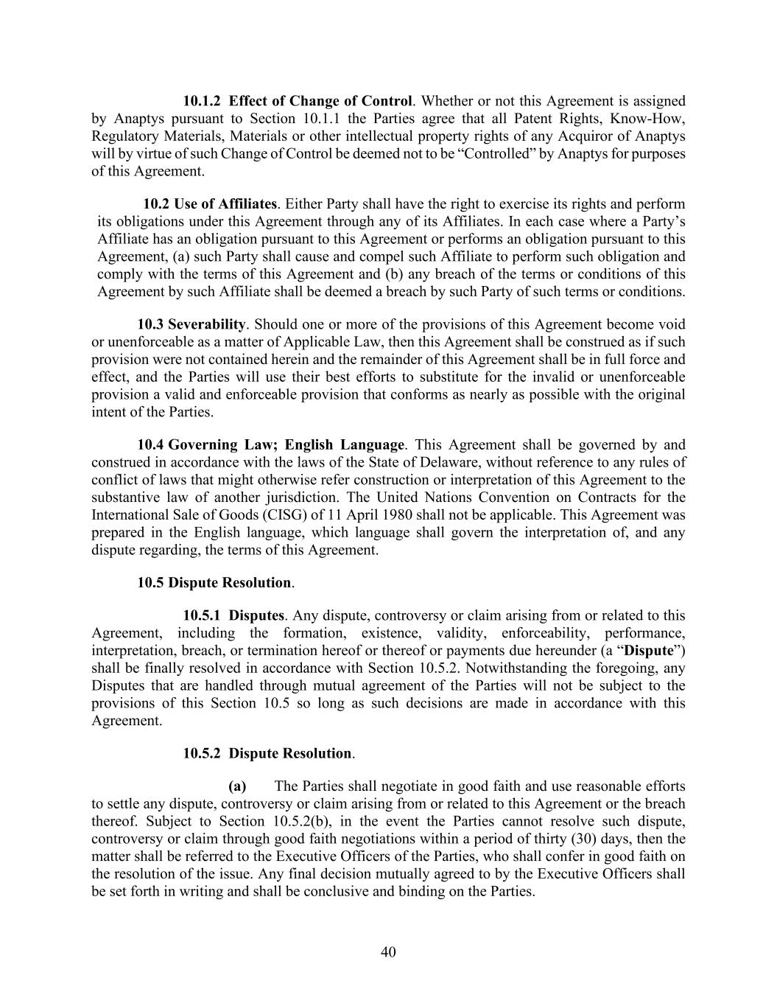
40 10.1.2 Effect of Change of Control. Whether or not this Agreement is assigned by Anaptys pursuant to Section 10.1.1 the Parties agree that all Patent Rights, Know-How, Regulatory Materials, Materials or other intellectual property rights of any Acquiror of Anaptys will by virtue of such Change of Control be deemed not to be “Controlled” by Anaptys for purposes of this Agreement. 10.2 Use of Affiliates. Either Party shall have the right to exercise its rights and perform its obligations under this Agreement through any of its Affiliates. In each case where a Party’s Affiliate has an obligation pursuant to this Agreement or performs an obligation pursuant to this Agreement, (a) such Party shall cause and compel such Affiliate to perform such obligation and comply with the terms of this Agreement and (b) any breach of the terms or conditions of this Agreement by such Affiliate shall be deemed a breach by such Party of such terms or conditions. 10.3 Severability. Should one or more of the provisions of this Agreement become void or unenforceable as a matter of Applicable Law, then this Agreement shall be construed as if such provision were not contained herein and the remainder of this Agreement shall be in full force and effect, and the Parties will use their best efforts to substitute for the invalid or unenforceable provision a valid and enforceable provision that conforms as nearly as possible with the original intent of the Parties. 10.4 Governing Law; English Language. This Agreement shall be governed by and construed in accordance with the laws of the State of Delaware, without reference to any rules of conflict of laws that might otherwise refer construction or interpretation of this Agreement to the substantive law of another jurisdiction. The United Nations Convention on Contracts for the International Sale of Goods (CISG) of 11 April 1980 shall not be applicable. This Agreement was prepared in the English language, which language shall govern the interpretation of, and any dispute regarding, the terms of this Agreement. 10.5 Dispute Resolution. 10.5.1 Disputes. Any dispute, controversy or claim arising from or related to this Agreement, including the formation, existence, validity, enforceability, performance, interpretation, breach, or termination hereof or thereof or payments due hereunder (a “Dispute”) shall be finally resolved in accordance with Section 10.5.2. Notwithstanding the foregoing, any Disputes that are handled through mutual agreement of the Parties will not be subject to the provisions of this Section 10.5 so long as such decisions are made in accordance with this Agreement. 10.5.2 Dispute Resolution. (a) The Parties shall negotiate in good faith and use reasonable efforts to settle any dispute, controversy or claim arising from or related to this Agreement or the breach thereof. Subject to Section 10.5.2(b), in the event the Parties cannot resolve such dispute, controversy or claim through good faith negotiations within a period of thirty (30) days, then the matter shall be referred to the Executive Officers of the Parties, who shall confer in good faith on the resolution of the issue. Any final decision mutually agreed to by the Executive Officers shall be set forth in writing and shall be conclusive and binding on the Parties.

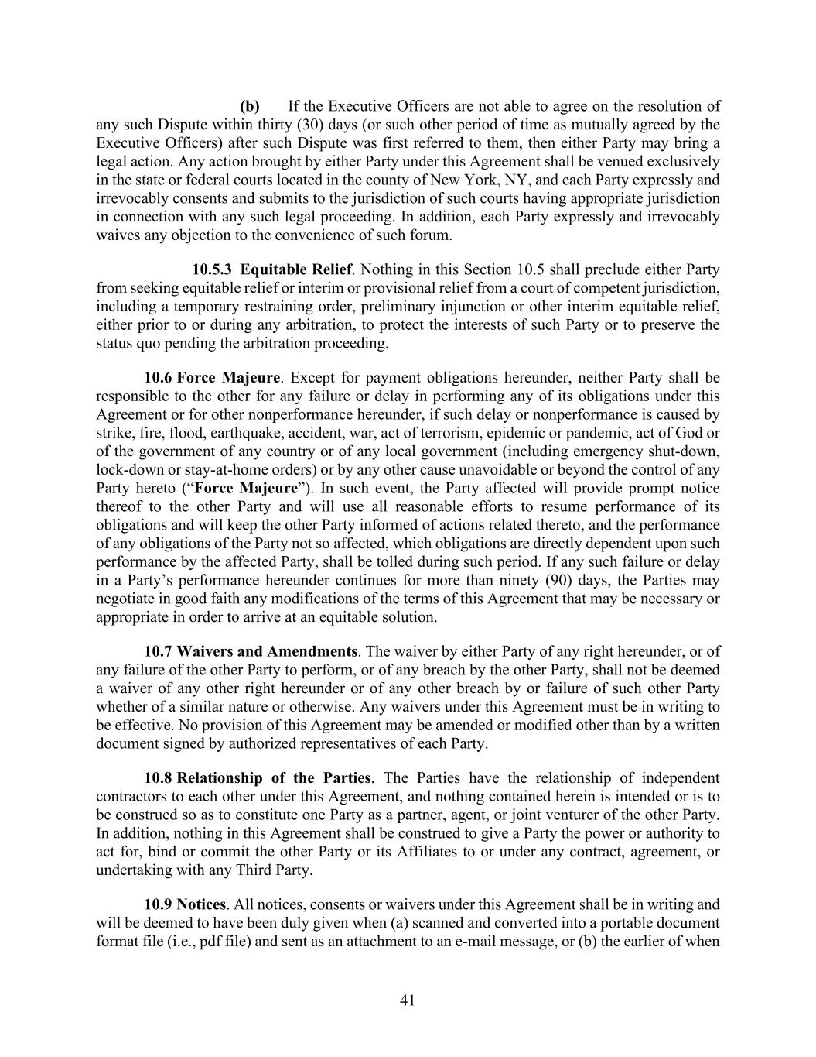
41 (b) If the Executive Officers are not able to agree on the resolution of any such Dispute within thirty (30) days (or such other period of time as mutually agreed by the Executive Officers) after such Dispute was first referred to them, then either Party may bring a legal action. Any action brought by either Party under this Agreement shall be venued exclusively in the state or federal courts located in the county of New York, NY, and each Party expressly and irrevocably consents and submits to the jurisdiction of such courts having appropriate jurisdiction in connection with any such legal proceeding. In addition, each Party expressly and irrevocably waives any objection to the convenience of such forum. 10.5.3 Equitable Relief. Nothing in this Section 10.5 shall preclude either Party from seeking equitable relief or interim or provisional relief from a court of competent jurisdiction, including a temporary restraining order, preliminary injunction or other interim equitable relief, either prior to or during any arbitration, to protect the interests of such Party or to preserve the status quo pending the arbitration proceeding. 10.6 Force Majeure. Except for payment obligations hereunder, neither Party shall be responsible to the other for any failure or delay in performing any of its obligations under this Agreement or for other nonperformance hereunder, if such delay or nonperformance is caused by strike, fire, flood, earthquake, accident, war, act of terrorism, epidemic or pandemic, act of God or of the government of any country or of any local government (including emergency shut-down, lock-down or stay-at-home orders) or by any other cause unavoidable or beyond the control of any Party hereto (“Force Majeure”). In such event, the Party affected will provide prompt notice thereof to the other Party and will use all reasonable efforts to resume performance of its obligations and will keep the other Party informed of actions related thereto, and the performance of any obligations of the Party not so affected, which obligations are directly dependent upon such performance by the affected Party, shall be tolled during such period. If any such failure or delay in a Party’s performance hereunder continues for more than ninety (90) days, the Parties may negotiate in good faith any modifications of the terms of this Agreement that may be necessary or appropriate in order to arrive at an equitable solution. 10.7 Waivers and Amendments. The waiver by either Party of any right hereunder, or of any failure of the other Party to perform, or of any breach by the other Party, shall not be deemed a waiver of any other right hereunder or of any other breach by or failure of such other Party whether of a similar nature or otherwise. Any waivers under this Agreement must be in writing to be effective. No provision of this Agreement may be amended or modified other than by a written document signed by authorized representatives of each Party. 10.8 Relationship of the Parties. The Parties have the relationship of independent contractors to each other under this Agreement, and nothing contained herein is intended or is to be construed so as to constitute one Party as a partner, agent, or joint venturer of the other Party. In addition, nothing in this Agreement shall be construed to give a Party the power or authority to act for, bind or commit the other Party or its Affiliates to or under any contract, agreement, or undertaking with any Third Party. 10.9 Notices. All notices, consents or waivers under this Agreement shall be in writing and will be deemed to have been duly given when (a) scanned and converted into a portable document format file (i.e., pdf file) and sent as an attachment to an e-mail message, or (b) the earlier of when

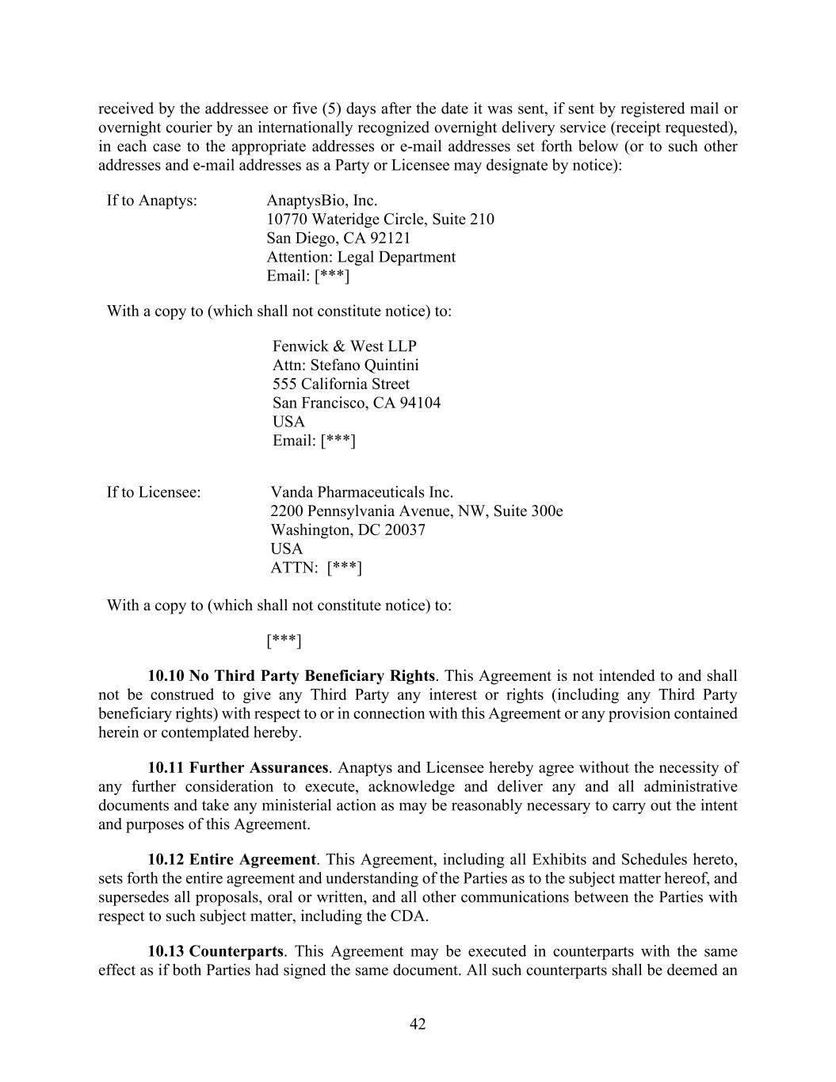
42 received by the addressee or five (5) days after the date it was sent, if sent by registered mail or overnight courier by an internationally recognized overnight delivery service (receipt requested), in each case to the appropriate addresses or e-mail addresses set forth below (or to such other addresses and e-mail addresses as a Party or Licensee may designate by notice): If to Anaptys: AnaptysBio, Inc. 10770 Wateridge Circle, Suite 210 San Diego, CA 92121 Attention: Legal Department Email: [***] With a copy to (which shall not constitute notice) to: Fenwick & West LLP Attn: Stefano Quintini 555 California Street San Francisco, CA 94104 USA Email: [***] If to Licensee: Vanda Pharmaceuticals Inc. 2200 Pennsylvania Avenue, NW, Suite 300e Washington, DC 20037 USA ATTN: [***] With a copy to (which shall not constitute notice) to: [***] 10.10 No Third Party Beneficiary Rights. This Agreement is not intended to and shall not be construed to give any Third Party any interest or rights (including any Third Party beneficiary rights) with respect to or in connection with this Agreement or any provision contained herein or contemplated hereby. 10.11 Further Assurances. Anaptys and Licensee hereby agree without the necessity of any further consideration to execute, acknowledge and deliver any and all administrative documents and take any ministerial action as may be reasonably necessary to carry out the intent and purposes of this Agreement. 10.12 Entire Agreement. This Agreement, including all Exhibits and Schedules hereto, sets forth the entire agreement and understanding of the Parties as to the subject matter hereof, and supersedes all proposals, oral or written, and all other communications between the Parties with respect to such subject matter, including the CDA. 10.13 Counterparts. This Agreement may be executed in counterparts with the same effect as if both Parties had signed the same document. All such counterparts shall be deemed an

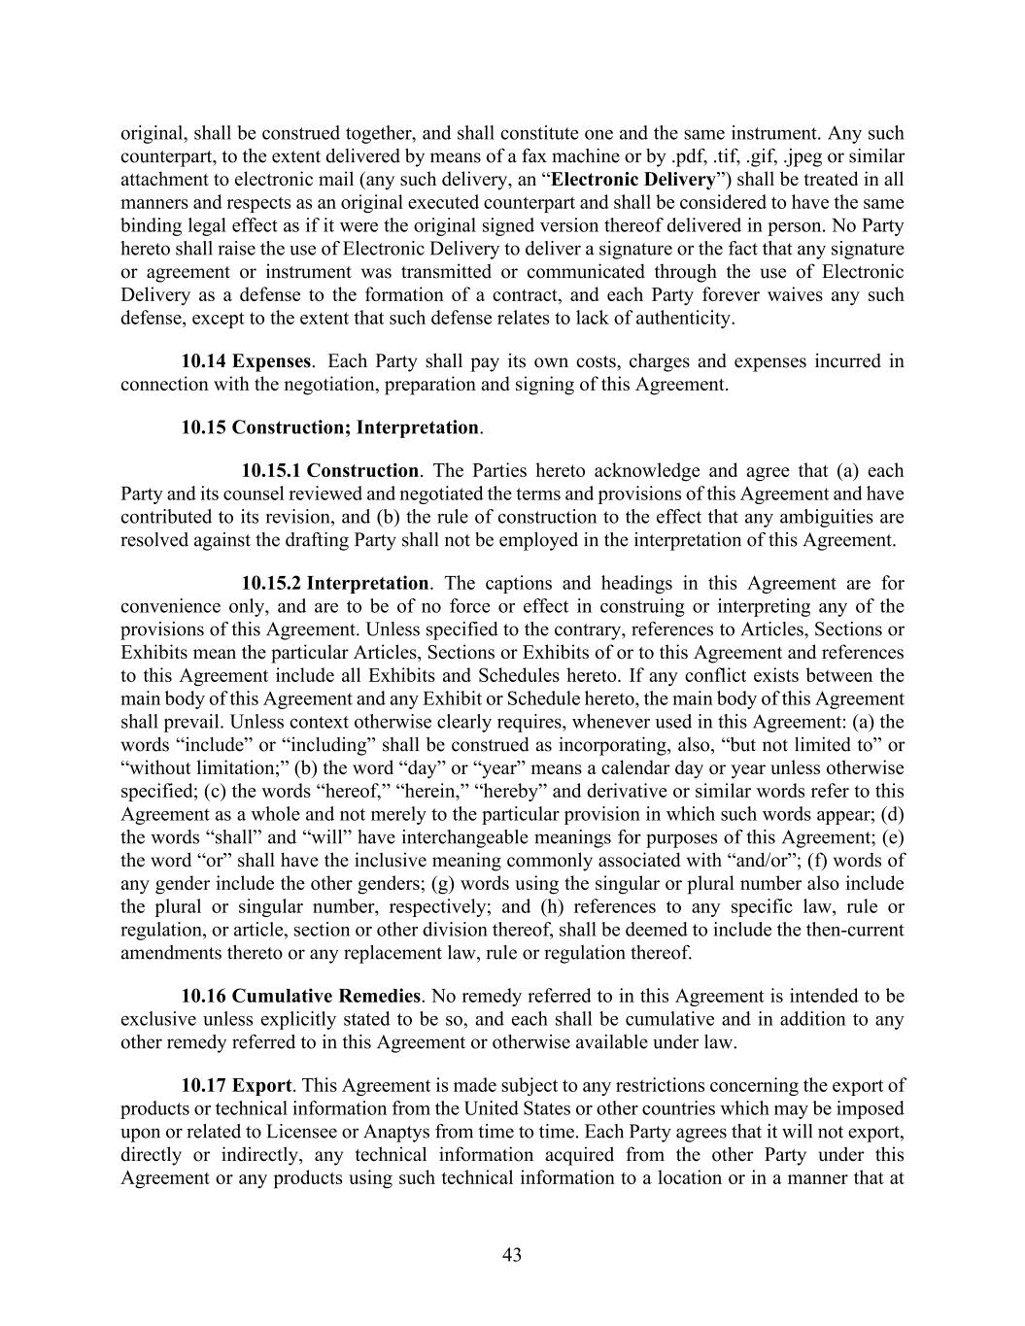
43 original, shall be construed together, and shall constitute one and the same instrument. Any such counterpart, to the extent delivered by means of a fax machine or by .pdf, .tif, .gif, .jpeg or similar attachment to electronic mail (any such delivery, an “Electronic Delivery”) shall be treated in all manners and respects as an original executed counterpart and shall be considered to have the same binding legal effect as if it were the original signed version thereof delivered in person. No Party hereto shall raise the use of Electronic Delivery to deliver a signature or the fact that any signature or agreement or instrument was transmitted or communicated through the use of Electronic Delivery as a defense to the formation of a contract, and each Party forever waives any such defense, except to the extent that such defense relates to lack of authenticity. 10.14 Expenses. Each Party shall pay its own costs, charges and expenses incurred in connection with the negotiation, preparation and signing of this Agreement. 10.15 Construction; Interpretation. 10.15.1 Construction. The Parties hereto acknowledge and agree that (a) each Party and its counsel reviewed and negotiated the terms and provisions of this Agreement and have contributed to its revision, and (b) the rule of construction to the effect that any ambiguities are resolved against the drafting Party shall not be employed in the interpretation of this Agreement. 10.15.2 Interpretation. The captions and headings in this Agreement are for convenience only, and are to be of no force or effect in construing or interpreting any of the provisions of this Agreement. Unless specified to the contrary, references to Articles, Sections or Exhibits mean the particular Articles, Sections or Exhibits of or to this Agreement and references to this Agreement include all Exhibits and Schedules hereto. If any conflict exists between the main body of this Agreement and any Exhibit or Schedule hereto, the main body of this Agreement shall prevail. Unless context otherwise clearly requires, whenever used in this Agreement: (a) the words “include” or “including” shall be construed as incorporating, also, “but not limited to” or “without limitation;” (b) the word “day” or “year” means a calendar day or year unless otherwise specified; (c) the words “hereof,” “herein,” “hereby” and derivative or similar words refer to this Agreement as a whole and not merely to the particular provision in which such words appear; (d) the words “shall” and “will” have interchangeable meanings for purposes of this Agreement; (e) the word “or” shall have the inclusive meaning commonly associated with “and/or”; (f) words of any gender include the other genders; (g) words using the singular or plural number also include the plural or singular number, respectively; and (h) references to any specific law, rule or regulation, or article, section or other division thereof, shall be deemed to include the then-current amendments thereto or any replacement law, rule or regulation thereof. 10.16 Cumulative Remedies. No remedy referred to in this Agreement is intended to be exclusive unless explicitly stated to be so, and each shall be cumulative and in addition to any other remedy referred to in this Agreement or otherwise available under law. 10.17 Export. This Agreement is made subject to any restrictions concerning the export of products or technical information from the United States or other countries which may be imposed upon or related to Licensee or Anaptys from time to time. Each Party agrees that it will not export, directly or indirectly, any technical information acquired from the other Party under this Agreement or any products using such technical information to a location or in a manner that at


44 the time of export requires an export license or other Governmental Authority approval, without first obtaining the written consent to do so from the appropriate Governmental Authority. [Signature Page follows]

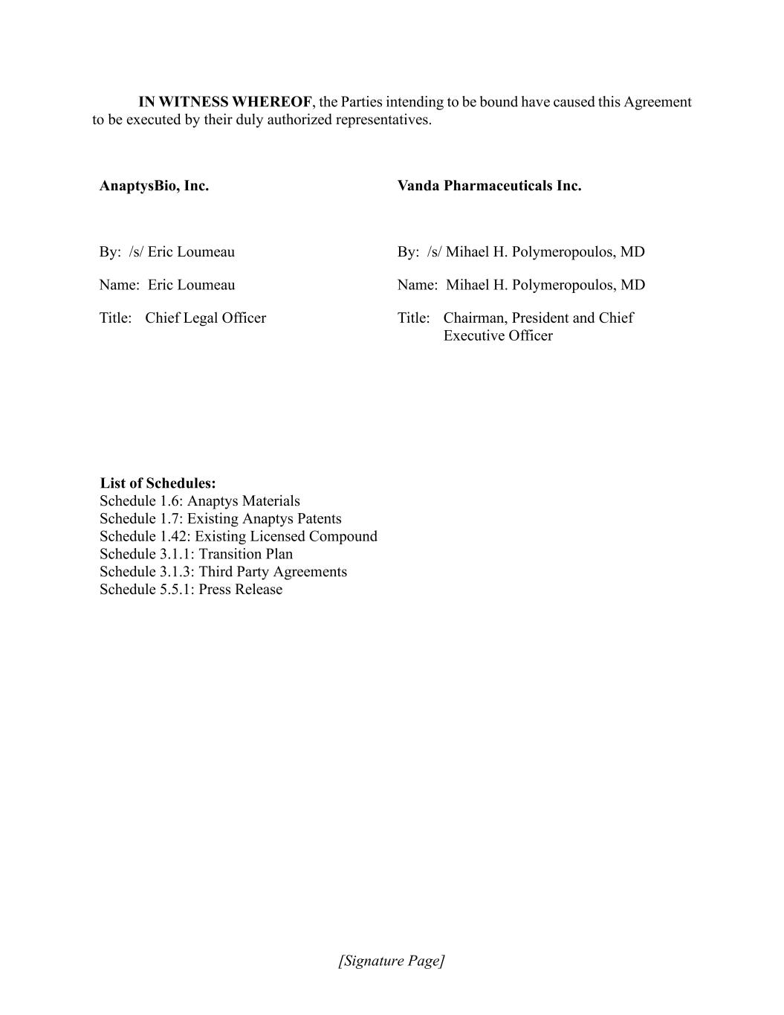
[Signature Page] IN WITNESS WHEREOF, the Parties intending to be bound have caused this Agreement to be executed by their duly authorized representatives. AnaptysBio, Inc. By: /s/ Eric Loumeau Name: Eric Loumeau Title: Chief Legal Officer Vanda Pharmaceuticals Inc. By: /s/ Mihael H. Polymeropoulos, MD Name: Mihael H. Polymeropoulos, MD Title: Chairman, President and Chief Executive Officer List of Schedules: Schedule 1.6: Anaptys Materials Schedule 1.7: Existing Anaptys Patents Schedule 1.42: Existing Licensed Compound Schedule 3.1.1: Transition Plan Schedule 3.1.3: Third Party Agreements Schedule 5.5.1: Press Release

EXHIBIT 31.1
CERTIFICATION OF PERIODIC REPORT UNDER SECTION 302 OF
THE SARBANES-OXLEY ACT OF 2002
I, Daniel Faga, certify that:
1. I have reviewed this quarterly report on Form 10-Q of AnaptysBio, Inc.;
2. Based on my knowledge, this report does not contain any untrue statement of a material fact or omit to state a material fact necessary to make the statements made, in light of the circumstances under which such statements were made, not misleading with respect to the period covered by this report;
3. Based on my knowledge, the financial statements, and other financial information included in this report, fairly present in all material respects the financial condition, results of operations and cash flows of the registrant as of, and for, the periods presented in this report;
4. The registrant’s other certifying officer and I are responsible for establishing and maintaining disclosure controls and procedures (as defined in Exchange Act Rules 13a-15(e) and 15d-15(e)) and internal control over financial reporting (as defined in Exchange Act Rules 13a-15(f) and 15d-15(f)) for the registrant and have:
a) Designed such disclosure controls and procedures, or caused such disclosure controls and procedures to be designed under our supervision, to ensure that material information relating to the registrant, including its consolidated subsidiaries, is made known to us by others within those entities, particularly during the period in which this report is being prepared;
b) Designed such internal control over financial reporting, or caused such internal control over financial reporting to be designed under our supervision, to provide reasonable assurance regarding the reliability of financial reporting and the preparation of financial statements for external purposes in accordance with generally accepted accounting principles;
c) Evaluated the effectiveness of the registrant’s disclosure controls and procedures and presented in this report our conclusions about the effectiveness of the disclosure controls and procedures, as of the end of the period covered by this report based on such evaluation; and
d) Disclosed in this report any change in the registrant’s internal control over financial reporting that occurred during the registrant’s most recent fiscal quarter (the registrant’s fourth fiscal quarter in the case of an annual report) that has materially affected, or is reasonably likely to materially affect, the registrant’s internal control over financial reporting; and
5. The registrant’s other certifying officer and I have disclosed, based on our most recent evaluation of internal control over financial reporting, to the registrant’s auditors and the audit committee of the registrant’s board of directors (or persons performing the equivalent functions):
a) All significant deficiencies and material weaknesses in the design or operation of internal control over financial reporting which are reasonably likely to adversely affect the registrant’s ability to record, process, summarize and report financial information; and
b) Any fraud, whether or not material, that involves management or other employees who have a significant role in the registrant’s internal control over financial reporting.
Date: May 5, 2025

/s/ Daniel Faga
Daniel Faga
President and Chief Executive Officer
(Principal Executive Officer)

EXHIBIT 31.2
CERTIFICATION OF PERIODIC REPORT UNDER SECTION 302 OF
THE SARBANES-OXLEY ACT OF 2002
I, Dennis Mulroy, certify that:
1. I have reviewed this quarterly report on Form 10-Q of AnaptysBio, Inc.;
2. Based on my knowledge, this report does not contain any untrue statement of a material fact or omit to state a material fact necessary to make the statements made, in light of the circumstances under which such statements were made, not misleading with respect to the period covered by this report;
3. Based on my knowledge, the financial statements, and other financial information included in this report, fairly present in all material respects the financial condition, results of operations and cash flows of the registrant as of, and for, the periods presented in this report;
4. The registrant’s other certifying officer and I are responsible for establishing and maintaining disclosure controls and procedures (as defined in Exchange Act Rules 13a-15(e) and 15d-15(e)) and internal control over financial reporting (as defined in Exchange Act Rules 13a-15(f) and 15d-15(f)) for the registrant and have:
a) Designed such disclosure controls and procedures, or caused such disclosure controls and procedures to be designed under our supervision, to ensure that material information relating to the registrant, including its consolidated subsidiaries, is made known to us by others within those entities, particularly during the period in which this report is being prepared;
b) Designed such internal control over financial reporting, or caused such internal control over financial reporting to be designed under our supervision, to provide reasonable assurance regarding the reliability of financial reporting and the preparation of financial statements for external purposes in accordance with generally accepted accounting principles;
c) Evaluated the effectiveness of the registrant’s disclosure controls and procedures and presented in this report our conclusions about the effectiveness of the disclosure controls and procedures, as of the end of the period covered by this report based on such evaluation; and
d) Disclosed in this report any change in the registrant’s internal control over financial reporting that occurred during the registrant’s most recent fiscal quarter (the registrant’s fourth fiscal quarter in the case of an annual report) that has materially affected, or is reasonably likely to materially affect, the registrant’s internal control over financial reporting; and
5. The registrant’s other certifying officer and I have disclosed, based on our most recent evaluation of internal control over financial reporting, to the registrant’s auditors and the audit committee of the registrant’s board of directors (or persons performing the equivalent functions):
a) All significant deficiencies and material weaknesses in the design or operation of internal control over financial reporting which are reasonably likely to adversely affect the registrant’s ability to record, process, summarize and report financial information; and
b) Any fraud, whether or not material, that involves management or other employees who have a significant role in the registrant’s internal control over financial reporting.
Date: May 5, 2025

/s/ Dennis Mulroy
Dennis Mulroy
Chief Financial Officer
(Principal Financial Officer)

EXHIBIT 32.1
CERTIFICATION PURSUANT TO
18 U.S.C. SECTION 1350
AS ADOPTED PURSUANT TO SECTION 906
OF THE SARBANES-OXLEY ACT OF 2002
I, Daniel Faga, Chief Executive Officer of AnaptysBio, Inc. (Company), do hereby certify, pursuant to 18 U.S.C. Section 1350, as adopted pursuant to Section 906 of the Sarbanes-Oxley Act of 2002, that to the best of my knowledge:
•the Quarterly Report on Form 10-Q of the Company for the quarter ended March 31, 2025 (the “Report”), as filed with the Securities and Exchange Commission, fully complies with the requirements of Section 13(a) or 15(d) of the Securities Exchange Act of 1934; and
•the information contained in the Report fairly presents, in all material respects, the financial condition and results of operations of the Company for the periods presented therein.
Date: May 5, 2025

/s/ Daniel Faga
Daniel Faga
President and Chief Executive Officer
(Principal Executive Officer)

EXHIBIT 32.2
CERTIFICATION PURSUANT TO
18 U.S.C. SECTION 1350
AS ADOPTED PURSUANT TO SECTION 906
OF THE SARBANES-OXLEY ACT OF 2002
I, Dennis Mulroy, Chief Financial Officer of AnaptysBio, Inc. (Company), do hereby certify, pursuant to 18 U.S.C. Section 1350, as adopted pursuant to Section 906 of the Sarbanes-Oxley Act of 2002, that to the best of my knowledge:
•the Quarterly Report on Form 10-Q of the Company for the quarter ended March 31, 2025 (the “Report”), as filed with the Securities and Exchange Commission, fully complies with the requirements of Section 13(a) or 15(d) of the Securities Exchange Act of 1934; and
•the information contained in the Report fairly presents, in all material respects, the financial condition and results of operations of the Company for the periods presented therein.
Date: May 5, 2025

/s/ Dennis Mulroy
Dennis Mulroy
Chief Financial Officer
(Principal Financial Officer)

