OMB APPROVAL

OMB Number: 3235-0145
Estimated average burden hours per response ….11

UNITED STATES

SECURITIES AND EXCHANGE COMMISSION
Washington, D.C. 20549

SCHEDULE 13G

Under the Securities Exchange Act of 1934

(Amendment No. 3*)

ANAPTYSBIO, INC.

(Name of Issuer)

COMMON STOCK

(Title of Class of Securities)

032724106

(CUSIP Number)

January 31, 2023

(Date of Event Which Requires Filing of this Statement)

Check the appropriate box to designate the rule pursuant to which this Schedule is filed:

- Rule 13d-1(b) Rule 13d-1(c) Rule 13d-1(d)

*The remainder of this cover page shall be filled out for a reporting person’s initial filing on this form with respect to the subject class of securities, and for any subsequent amendment containing information which would alter the disclosures provided in a prior cover page.

The information required in the remainder of this cover page shall not be deemed to be “filed” for the purpose of Section 18 of the Securities Exchange Act of 1934 (“Act”) or otherwise subject to the liabilities of that section of the Act but shall be subject to all other provisions of the Act (however, see the Notes).

Persons who respond to the collection of information contained in this form are not required to respond unless the form displays a currently valid OMB control number.

CUSIP No.: 032724106

- Names of Reporting Persons

I.R.S. Identification Nos. of above persons (entities only) Federated Hermes, Inc.
- Check the Appropriate Box if a Member of a Group (See Instructions)

(a)

(b)

- SEC Use Only

- Citizenship or place of Organization: Pennsylvania
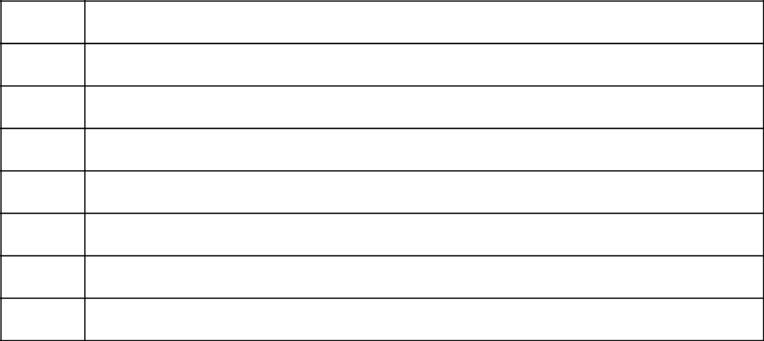

Number of Shares | 5. | Sole Voting Power: 1,401,559
Beneficially Owned
by Each Reporting | 6. | Shared Voting Power
Person With:
 | 7. | Sole Dispositive Power: 1,401,559
 | 8. | Shared Dispositive Power

- Aggregate Amount Beneficially Owned by Each Reporting Person: 1,401,559

- Check if the Aggregate Amount in Row (9) Excludes Certain Shares (See Instructions)

- Percent of Class Represented by Amount in Row (9): 4.93%

- Type of Reporting Person (See Instructions): HC
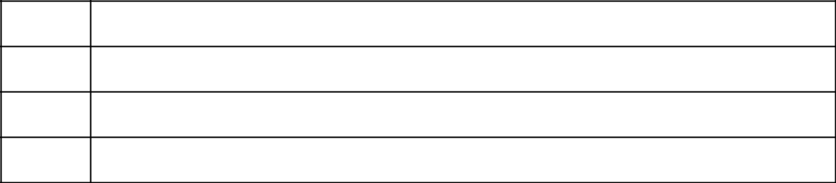

- Names of Reporting Persons

I.R.S. Identification Nos. of above persons (entities only) Voting Shares Irrevocable Trust
- Check the Appropriate Box if a Member of a Group (See Instructions)

(a)

(b)

- SEC Use Only

- Citizenship or place of Organization: Pennsylvania

Number of Shares | 5. | Sole Voting Power: 1,401,559
Beneficially Owned
by Each Reporting | 6. | Shared Voting Power
Person With:
 | 7. | Sole Dispositive Power: 1,401,559
 | 8. | Shared Dispositive Power

- Aggregate Amount Beneficially Owned by Each Reporting Person: 1,401,559

- Check if the Aggregate Amount in Row (9) Excludes Certain Shares (See Instructions)

- Percent of Class Represented by Amount in Row (9): 4.93%

- Type of Reporting Person (See Instructions): OO

- Names of Reporting Persons

I.R.S. Identification Nos. of above persons (entities only) Thomas R. Donahue
- Check the Appropriate Box if a Member of a Group (See Instructions)

(a)

(b)

- SEC Use Only

- Citizenship or place of Organization: United States

Number of Shares | 5. | Sole Voting Power:
Beneficially Owned
by Each Reporting | 6. | Shared Voting Power: 1,401,559
Person With:
 | 7. | Sole Dispositive Power
 | 8. | Shared Dispositive Power: 1,401,559

- Aggregate Amount Beneficially Owned by Each Reporting Person: 1,401,559

- Check if the Aggregate Amount in Row (9) Excludes Certain Shares (See Instructions)

- Percent of Class Represented by Amount in Row (9): 4.93%

- Type of Reporting Person (See Instructions): IN

- Names of Reporting Persons

I.R.S. Identification Nos. of above persons (entities only) Ann C. Donahue
- Check the Appropriate Box if a Member of a Group (See Instructions)

(a)

(b)

- SEC Use Only

- Citizenship or place of Organization: United States

Number of Shares | 5. | Sole Voting Power:
Beneficially Owned
by Each Reporting | 6. | Shared Voting Power: 1,401,559
Person With:

  - Sole Dispositive Power

  - Shared Dispositive Power: 1,401,559

- Aggregate Amount Beneficially Owned by Each Reporting Person: 1,401,559

- Check if the Aggregate Amount in Row (9) Excludes Certain Shares (See Instructions)

- Percent of Class Represented by Amount in Row (9): 4.93%

- Type of Reporting Person (See Instructions):IN
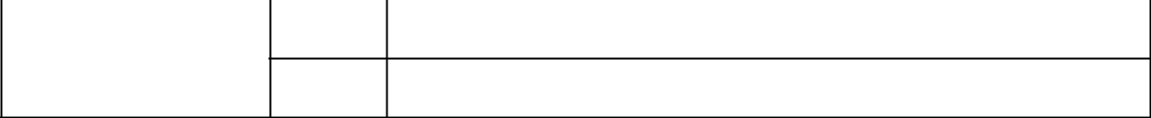

- Names of Reporting Persons

I.R.S. Identification Nos. of above persons (entities only) J. Christopher Donahue
- Check the Appropriate Box if a Member of a Group (See Instructions)

(a)

(b)

- SEC Use Only

- Citizenship or place of Organization: United States
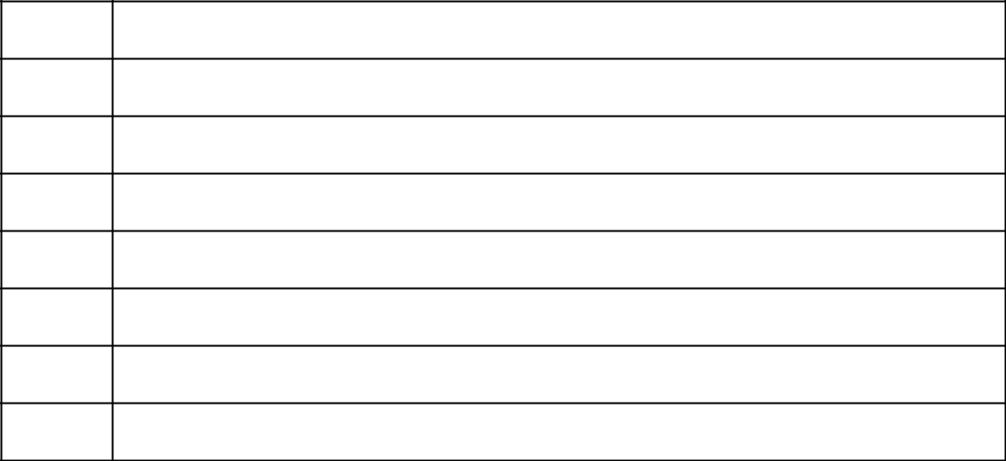

Number of Shares | 5. | Sole Voting Power:
Beneficially Owned
by Each Reporting | 6. | Shared Voting Power: 1,401,559
Person With:
 | 7. | Sole Dispositive Power
 | 8. | Shared Dispositive Power: 1,401,559

- Aggregate Amount Beneficially Owned by Each Reporting Person: 1,401,559

- Check if the Aggregate Amount in Row (9) Excludes Certain Shares (See Instructions)

- Percent of Class Represented by Amount in Row (9): 4.93%

- Type of Reporting Person (See Instructions): IN

Item 1.

- Name of Issuer

ANAPTYSBIO, INC.

- Address of Issuer’s Principal Executive Offices 10770 Wateridge Circle, Suite 210
San Diego, CA 92121
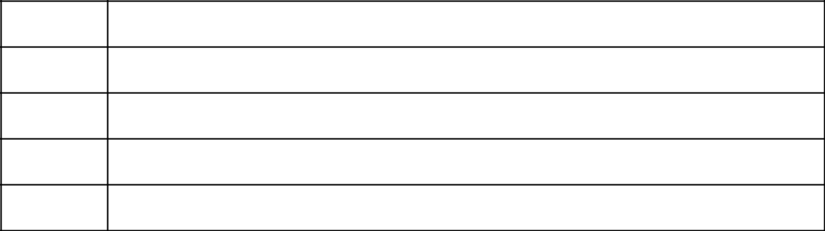

Item 2.

- Name of Person Filing: Federated Hermes, Inc.

- Address Of Principal Business Office or, if none, Residence

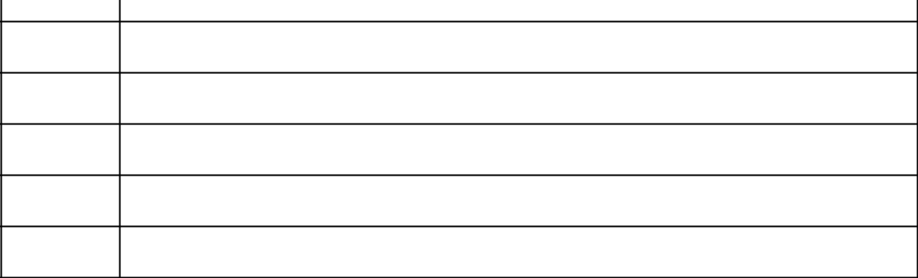
1001 Liberty Avenue, Pittsburgh, PA 15222-3779

- Citizenship: Pennsylvania

- Title of Class of Securities Common Stock
- CUSIP Number: 032724106

Item 3. If this statement is filed pursuant to §§240.113d-1(b) or 240.13d-2(b) or (c), check whether the person filing is a:

 | (a) |  |  | Broker or dealer registered under section 15 of the Act (15 U.S.C. 78o).
 | (b) |  |  | Bank as defined in section 3(a)(6) of the Act (15 U.S.C. 78c).
 | (c) |  |  | Insurance company as defined in section 3(a)(19) of the Act (15 U.S.C. 78c).
 | (d) |  |  | Investment company registered under section 8 of the Investment Company Act of 1940 (15
 |  |  |  | U.S.C. 80a-8).
 | (e) |  |  | An investment adviser in accordance with §204.13d-1(b)(1)(ii)(E);
 | (f) |  |  | An employee benefit plan or endowment fund in accordance with §240.13d-19b)(1)(ii)(F);
 | (g) |  | X | A parent holding company or control person in accordance with §240.13d-1(b)(1)(ii)(G);
 | (h) |  |  | A savings associations as defined in Section 3(b) of the Federal Deposit Insurance Act (12 U.S.C.
 |  |  |  | 1813);
 | (i) |  |  | A church plan that is excluded from the definition of an investment company under section 3(c)
 |  |  |  | (14) of the Investment Company Act of 1940 (15 U.S.C. 80a-3);
 | (j) |  |  | Group, in accordance with §240.13d-1(b)(1)(ii)(J).
Item 4. |  | Ownership

Provide the following information regarding the aggregate number and percentage of the class of securities of the issuer identified in Item 1.

A. | Federated Hermes, Inc.
(a) | Amount beneficially owned: | 1,401,559
(b) | Percent of class: 4.93%
(c) | Number of shares to which the person has:
 | (i) Sole power to vote or to direct the vote: 1,401,559
 | (ii) Shared power to vote or to direct the vote: 0
 | (iii) Sole power to dispose or to direct the disposition of: 1,401,559
 | (iv) Shared power to dispose or to direct the disposition of: 0
B. | Voting Shares Irrevocable Trust
(a) | Amount beneficially owned: | 1,401,559
(b) | Percent of class: 4.93%
(c) | Number of shares to which the person has:
 | (i) Sole power to vote or to direct the vote: 1,401,559
 | (ii) Shared power to vote or to direct the vote: 0

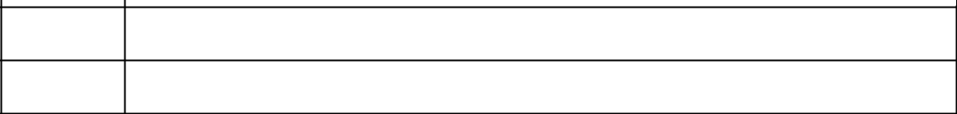
(iii) Sole power to dispose or to direct the disposition of: 1,401,559

(iv) Shared power to dispose or to direct the disposition of: 0

C. | Thomas R. Donahue
(a) | Amount beneficially owned: | 1,401,559
(b) | Percent of class: 4.93%
(c) | Number of shares to which the person has:
 | (i) Sole power to vote or to direct the vote: 0
 | (ii) Shared power to vote or to direct the vote: 1,401,559
 | (iii) Sole power to dispose or to direct the disposition of: 0
 | (iv) Shared power to dispose or to direct the disposition of: 1,401,559
D. | Ann C. Donahue
(a) | Amount beneficially owned: | 1,401,559
(b) | Percent of class: 4.93%
(c) | Number of shares to which the person has:
 | (i) Sole power to vote or to direct the vote: 0
 | (ii) Shared power to vote or to direct the vote: 1,401,559
 | (iii) Sole power to dispose or to direct the disposition of: 0
 | (iv) Shared power to dispose or to direct the disposition of: 1,401,559

- J. Christopher Donahue
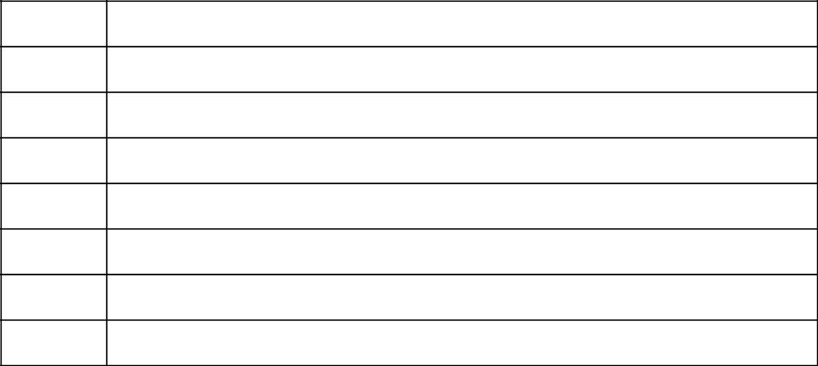

- Amount beneficially owned: 1,401,559

- Percent of class: 4.93%

- Number of shares to which the person has:

  - Sole power to vote or to direct the vote: 0

  - Shared power to vote or to direct the vote: 1,401,559

  - Sole power to dispose or to direct the disposition of: 0

  - Shared power to dispose or to direct the disposition of: 1,401,559

Instruction: Dissolution of a group requires a response to this item.

Item 5. Ownership of Five Percent or Less of a Class

If this statement is being filed to report the fact that as of the date hereof the reporting person has ceased to be the beneficial owner of more than five percent of the class of securities, check the following: X

Instruction: Dissolution of a group requires a response to this item.

Item 6. Ownership of More than Five Percent on Behalf of Another Person. NOT APPLICABLE

Item 7. Identification and Classification of the Subsidiary Which Acquired the Security Being Reported on By the Parent Holding Company. See Exhibit “1” Attached

Item 8. Identification and Classification of Members of the Group: NOT APPLICABLE Item 9. Notice of Dissolution of Group: NOT APPLICABLE Item 10. Certification

- The following certification shall be included if the statement is filed pursuant to §240.13d-1(b);

By signing below I certify that, to the best of my knowledge and belief, the securities referred to above were acquired and are held in the ordinary course of business and were not acquired and are not held for the purpose of or with the effect of changing or influencing the control of the issuer of the securities and were not acquired and are not held in connection with or as a participant in any transaction having the purpose or effect.

- The following certification shall be included if the statement is filed pursuant to §204.13d-1(c):

By signing below I certify that, to the best of my knowledge and belief, the securities referred to above were not acquired and are not held for the purpose of or with the effect of changing or influencing the control of the issuer of the securities and were not acquired and are not held in connection with or as a participant in any transaction having that purpose or effect.
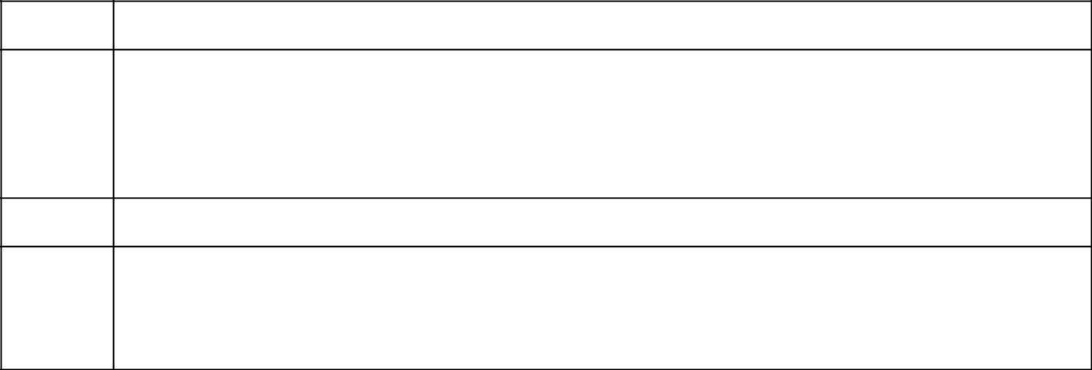

SIGNATURE

After reasonable inquiry and to the best of my knowledge and belief, I certify that the information set forth in this statement is true, complete and correct.

Date: | February 9, 2023
By: | /s/J. Christopher Donahue
Name/Title: | J. Christopher Donahue, as President of Federated Hermes, Inc.
Date: | February 9, 2023
By: | /s/Thomas R. Donahue
Name/Title | Thomas R. Donahue individually and as Trustee of Voting Shares Irrevocable Trust
Date: | February 9, 2023
By: | /s/Ann C. Donahue
Name/Title: | Ann C. Donahue individually and as Trustee of Voting Shares Irrevocable Trust
Date: | February 9, 2023
By: | /s/J. Christopher Donahue
Name/Title | J. Christopher Donahue individually and as Trustee of Voting Shares Irrevocable Trust

The original statement shall be signed by each person on whose behalf the statement is filed or his authorized representative. If the statement is signed on behalf of a person by his authorized representative other than an executive officer or general partner of the filing person, evidence of the representative’s authority to sign on behalf of such person shall be filed with the statement, provided, however, that a power of attorney for this purpose which is already on file with the Commission may be

incorporated by reference. The name and any title of each person who signs the statement shall be typed or printed beneath his signature.

NOTE: Schedules filed in paper format shall include a signed original and five copies of the schedule, including all exhibits. See §240.13d-7 for other parties for whom copies are to be sent.

Attention: Intentional misstatements or omissions of fact constitute Federal criminal violations (See U.S.C. 1001)

EXHIBIT “1”

ITEM 3 CLASSIFICATION OF REPORTING PERSONS

Identity and Classification of Each Reporting Person

IDENTITY | CLASSIFICATION UNDER ITEM 3
Federated Hermes Equity Funds | (d) Investment company registered under Section 8 of the Investment Company
 | Act of 1940 (15 U.S.C. 80a-8)
Federated Hermes Insurance Series | (d) Investment company registered under Section 8 of the Investment Company
 | Act of 1940 (15 U.S.C. 80a-8)
Federated Hermes MDT Series | (d) Investment company registered under Section 8 of the Investment Company
 | Act of 1940 (15 U.S.C. 80a-8)
Federated Equity Management Company | (e) Investment Adviser registered under Section 203 of the Investment Advisers
of Pennsylvania | Act of 1940
Federated Global Investment | (e) Investment Adviser registered under Section 203 of the Investment Advisers
Management Corp. | Act of 1940
Federated Investment Counseling | (e) Investment Adviser registered under Section 203 of the Investment Advisers
 | Act of 1940
Federated MDTA LLC | (e) Investment Adviser registered under Section 203 of the Investment Advisers
 | Act of 1940
Federated Hermes, Inc. | (g) parent Holding Company or control person, in accordance with Section
 | 240.13d-1(b)(ii)(G)
FII Holdings, Inc. | (g) parent Holding Company or control person, in accordance with Section
 | 240.13d-1(b)(ii)(G)
Voting Shares Irrevocable Trust | (g) parent Holding Company or control person, in accordance with Section
 | 240.13d-1(b)(ii)(G)
Thomas R. Donahue | (g) parent Holding Company or control person, in accordance with Section
 | 240.13d-1(b)(ii)(G)
Ann C. Donahue | (g) parent Holding Company or control person, in accordance with Section
 | 240.13d-1(b)(ii)(G)
J. Christopher Donahue | (g) parent Holding Company or control person, in accordance with Section
 | 240.13d-1(b)(ii)(G)

Federated Hermes, Inc. (the “Parent”) is filing this schedule 13G because it is the parent holding company of Federated Equity Management Company of Pennsylvania, Federated Global Investment Management Corp., Federated Investment Counseling and Federated MDTA LLC (the “Investment Advisers”), which act as investment advisers to registered investment companies and separate accounts that own shares of common stock in ANAPTYSBIO, INC. (the “Reported Securities”). The Investment Advisers are wholly owned subsidiaries of FII Holdings, Inc., which is wholly owned subsidiary of Federated Hermes, Inc., the Parent. All of the Parent’s outstanding voting stock is held in the Voting Shares Irrevocable Trust (the “Trust”) for which Thomas R. Donahue, Ann C. Donahue and J. Christopher Donahue act as trustees (collectively, the “Trustees”). The Trustees have joined in filing this Schedule 13G because of the collective voting control that they exercise over the Parent. In accordance with Rule 13d-4 under the Securities Act of 1934, as amended, the Parent, the Trust, and each of the Trustees declare that this statement should not be construed as an admission that they are the beneficial owners of the Reported Securities, and the Parent, the Trust, and each of the Trustees expressly disclaim beneficial ownership of the Reported Securities.

EXHIBIT “2”

AGREEMENT FOR JOINT FILING OF

SCHEDULE 13G

The following parties hereby agree to file jointly the statement on Schedule 13G to which this Agreement is attached and any amendments thereto which may be deemed necessary pursuant to Regulation 13D-G under the Securities Exchange Act of 1934:

- Federated Hermes, Inc. as parent holding company of the investment advisers to registered investment companies that beneficially own the securities.

Voting Shares Irrevocable Trust, as holder of all the voting shares of Federated Hermes, Inc.

Thomas R. Donahue, individually and as Trustee

Ann C. Donahue, individually and as Trustee

J. Christopher Donahue, individually and as Trustee

It is understood and agreed that each of the parties hereto is responsible for the timely filing of such statement any amendments thereto, and for the completeness and accuracy of the information concerning such party contained therein, but such party is not responsible for the completeness or accuracy of information concerning the other parties unless such party knows or has reason to believe that such information is incomplete or inaccurate.

It is understood and agreed that the joint filing of Schedule 13G shall not be construed as an admission that the reporting persons named herein constitute a group for purposes of Regulation 13D-G of the Securities Exchange Act of 1934, nor is a joint venture for purposes of the Investment Company Act of 1940.

Date: February 9, 2023

By: | /s/J. Christopher Donahue
Name/Title: | J. Christopher Donahue, as President of Federated Hermes, Inc.
By: | /s/Thomas R. Donahue
Name/Title | Thomas R. Donahue, individually and as Trustee of Voting Shares Irrevocable Trust.
By: | /s/Ann C. Donahue
Name/Title | Ann C. Donahue, individually and as Trustee of Voting Shares Irrevocable Trust
By: | /s/J. Christopher Donahue
Name/Title | J. Christopher Donahue, individually and as Trustee of Voting Shares Irrevocable Trust

- The number of shares indicated represent shares beneficially owned by registered investment companies and separate accounts advised by subsidiaries of Federated Hermes, Inc. that have been delegated the power to direct investment and power to vote the securities by the registered investment companies’ board of trustees or directors and by the separate accounts’ principals. All of the voting securities of Federated Hermes, Inc. are held in the Voting Shares Irrevocable Trust (“Trust”), the trustees of which are Thomas R. Donahue, Ann C. Donahue and J. Christopher Donahue (“Trustees”). In accordance with Rule 13d-4 under the 1934 Act, the Trust, Trustees, and parent holding company declare that the filing of this statement should not be construed as an admission that any of the investment advisers, parent holding company, Trust, and Trustees are beneficial owners (for the purposes of Sections 13(d) and/or 13(g) of the Act) of any securities covered by this statement, and such advisers, parent holding company, Trust, and Trustees expressly disclaim that they are the beneficial owners of such securities.

EXHIBIT “3”
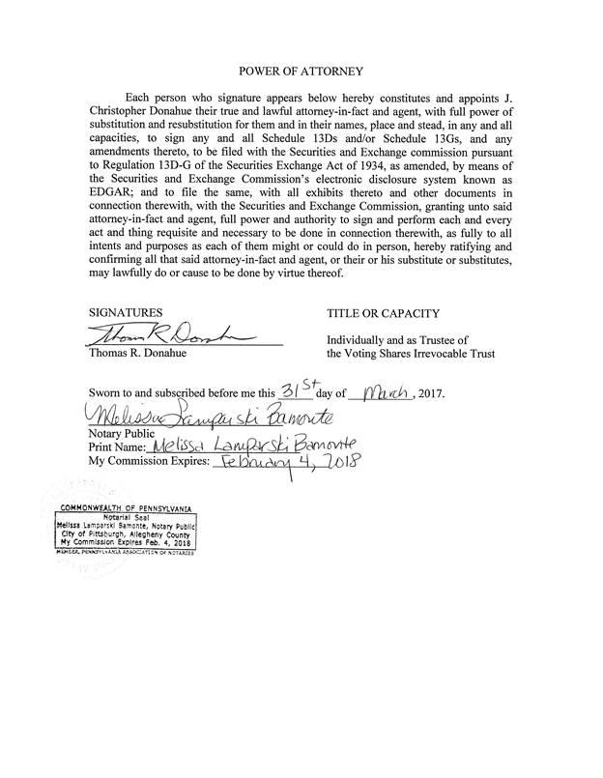

EXHIBIT “3”



